**Reviewer’s Comments**

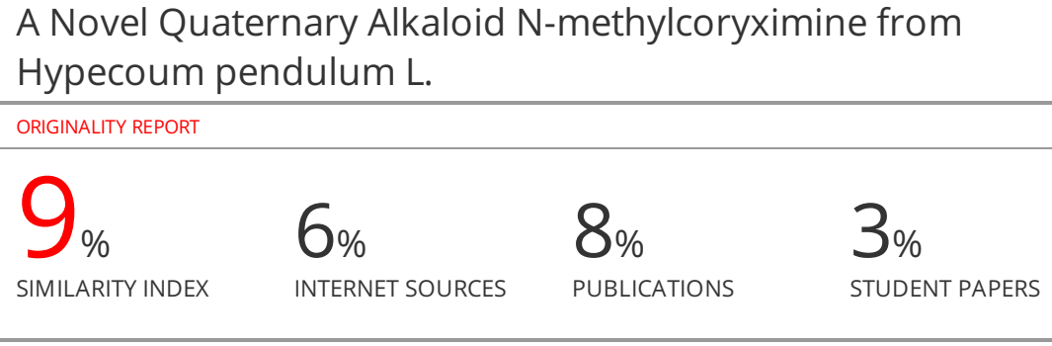

**A Novel Quaternary Alkaloid *N*-methylcoryximine from *Hypecoum pendulum* L.**

# Abstract

**Objective:**In this study, it was aimed to elucidate the chemical structure of an alkaloid obtained purely in the isolation and purification studies we carried out on the *Hypecoum pendulum* L.

**Material and Methods**: Column and preparative thin layer chromatographic methods were utilized for the purification of the compound. The structure elucidation was obtained by spectroscopic methods such as IR, NMR, 2D NMR and Mass spectroscopy.

**Results:***N*-methylcoryximine, a quaternary alkaloid from secoberbine subgroup of isoquinoline alkaloidswas isolated  and the structure of this compound was elucidated.

**Conclusion:** The natural occurrence and spectral data of *N*-methylcoryximine is reported for the first time.

***Keywords*: *N*-methylcoryximine; quaternary alkaloid; *Hypecoum pendulum***

**INTRODUCTION**

*Hypecoum* species are traditionally used as analgesic in Russia1. Protopine, isolated from *Hypecoum* species, was reported to have antihistaminic, anticholinergic, antispasmodic and antibacterial activities1-4. Protopine, 8-Methoxydihydrosanguinarine, Oxysanguinarine, Oxyhydrastine, Stylopine, Turkiyenine, Dihydrosanguinarine, Hypecorine, (+)-Oxoturkiyenine, Bulbocapnine, Glaucine, Corydalisol were previously isolated from *Hypecoum pendulum*L5-6. In our studies of the chemical constituents of *Hypecoum pendulum*, a new quaternary isoquinoline alkaloid was isolated. This paper describes the extraction procedure and spectral data of the new natural compound, ***N*-methylcoryximine.**

**MATERIALS AND METHODS**

***PLANT MATERIAL***

*Hypecoum pendulum* L. (Papaveraceae) collected from Usak-Gediz-Izmir road, and the voucher specimen No. 1031 was deposited in the Herbarium of the Department of Pharmacognosy, Faculty of Pharmacy, Ege University, Izmir Türkiye.

***EXTRACTION AND PURIFICATON***

The dried and powdered plant material was extracted with ethanol. The ethanolic extract was acidified with 5% hydrochloric acid. The resulting aqueous solution was extracted with petroleum ether. The aqueous solution was then treated with hydrochloric acid in order to get 3% acidic solution. The acidic aqueous solution was extracted with chloroform. After the evaporation of the organic solvent, the acidic extract was placed on a silica gel column (70-230 mesh). The initial solvent was chloroform. Final purification was by preparative thin layer chromatography using the solvent system CHCl3-MeOH (70:30).

***GENERAL EXPERIMENTAL PROCEDURES***

Spectroscopic methods were used to determine the structure of the alkaloid.

**Infrared (IR) spectrum**

IR spectrum was taken by preparing pellets of the compound in potassium bromide in JASCO FT/IR-430 Infrared spectrophotometer.

**Nuclear Magnetic Resonance(NMR) Spectrum**

1H NMR spectrum and 2D NMR spectrum of the compound (1H-1H DQF COSY, 1H-13C HSQC, TOCSY, HMBC and ROESY) were taken in DMSO on a Bruker AMX-600 spectrophotometer.

**Mass Spectrum**

Electrospray ionisation mass spectra (ESI) were acquired on the Finnigan MAT TSQ 700 spectrometer**.**

**RESULTS AND DISCUSSION**

**SPECTRAL DATA**

Thespectraldata of thecompound is as follows:

**(α)D (MeOH, c 0.1)** –0.1050 ;

**IR (KBr):** 3485, 3005, 1690, 1490, 1235, 1065, 925 cm-1

**1H-NMR** (600 MHz, DMSO-d6): δ 6.93 (1 H, *d*, *J* 8.0 Hz, H-5′), 6.83 (1H, s, H-5), 6.36 (1H, *d*, *J* 8.0 Hz, H-6′), 6.10 (1H, s, OCH2O), 6.09 (1H, s, OCH2O), 5.94 (1H, s, OCH2O), 5.84 (1 H, s, OCH2O), 5.58 (1H, s, H-8), 4.59 (1H, *dd*, *J* 4.2, 10.5 Hz, H-1), 3.90-3.85 (1H, m, H-3), 3.81 (1H, *dd*, *J* 4.3, 12.5 Hz, H-7′), 3.62 (1H, *dd*, *J* 7.4, 13 Hz, H-3), 3.16-3.08 (3 H, m, H-4, H-7′), 3.02 (3 H, s, *N*-CH3); 3.30 (3 H, s, *N*-CH3)

**13C-NMR** (150 MHz, DMSO-d6): δ 23.3 (C-4), 34.7 (C-7′), 50.6 (*N*-CH3), 51.7 (*N*-CH3), 53.1 (C-3), 71.4 (C-1), 101.0 (OCH2O), 101.7 (OCH2O), 108.2 (C-8), 108.3 (C-5), 110.2 (C-5′), 114.5 (C-2′), 122.6 (C-4a), 122.7 (C-8a), 125.7 (C-6′), 128.2 (C-1′), 144.9 (C-7), 147.1 (C-4′), 147.3 (C-6), 147.8 (C-3′), 165.9 (C=O)

2D NMR spectrums 1H-13 C NMR, DEPT, 1H-1H DQF COSY, HSQC, HMBC, ROESYandTOCSY

**ESI-MS** m/z (rel. int%): 384 [M]+ (100). Calcd. for**C21H22NO6**

**(Spectrum 1-10)**

**STRUCTURE ELUCIDATION**

The compound (1.9479g), obtained by fractionation and purification from *Hypecoum pendulum* L. plant, gave a positive alkaloid reaction withDragendorff’s spray reagent. The compound has been found to be optically active.

In the 1H NMR spectrum taken in dimethyl sulfoxide (DMSO), two doublets (*J* 8.0 Hz) observed at  6.93 and 6.36 in the aromatic field indicated the presence of two hydrogens with ortho substitution to each other.One singlet proton was also observed at 6.93 in the aromatic region. In the high frequency region, sharp singlets with one hydrogen value each were observed at6.10, 6.09, 5.94 and 5.89 suggested that these signals may belong to two methylenedioxy groups. The signal observed at  5.58 seems to be at upper field for aromatic hydrogen.

The most striking sharp singlet of protons at  3.02 in the aliphatic field with the chemical shift value suggested the presence of a downfield-shifted *N*-methyl group due to its chemical environment. In addition to this signal, signals corresponding to the presence of seven hydrogens, almost all of which have shifted considerably downfield, were observed. The signals at  4.59, 3.81 and 3.62 were in the form of doublets whose spin-spin coupling constants*J*could be easily determined.In contrast, a three-hydrogen signal between 3.90-3.85 and a three-hydrogen signal between 3.16-30.8 weremultiplets with undetectable interaction coefficients.

According to the first findings from the evaluation of the 1H NMR spectrum, it was concluded that there are 18 hydrogens in the compound.Signals of 21 carbons were observed in the 13C NMR spectrum (150 MHz). TheDistortionlessEnhancement byPolarization transfer (DEPT) spectrum showed that one of these signals belonged to methyl carbon, five signals belong to methylene group, six signalswere belonging tomethinegroup and nine signals were observed as quaternary carbons**.**Whilethesignal at165.9ppmfromthequaternarycarbonsindicatesthe presence of a carbonylgroup in thecompound.Thechemicalshiftvalue of thissignalalsorevealedthatthiscarbonylmust be a functionalgroupotherthanthe ester group. Thesharpcarbonylsignalseen at 1690 cm-1 in the IR spectrum of thecompoundalsoconfirmsthepredictions.In the same DEPT spectrum, signals at 101.2 and 101.3 ppm confirm two methylenedioxy substituents.It was not possible to reach a definite judgment about whether the signal at 51.7 ppm belongs to the methyl or methine carbon.Also, a corresponding hydrogen signal was not seen in 1H NMR. In this case, both spectra were carefully evaluatedagainand it was concluded that the hydrogens on this carbon might be masked by the broad and strong methanol solvent signal seen at  3.30 in the 1H NMR spectrum.

To clarify the structure, double-dimension NMR experiments (H-1H DQF COSY, HSQC, TOCSY, HMBC and ROESY) were performed on the compound.Hydrogens on the carbons were paired with the HSQC experiment giving 1JCH correlations.In this context, it has been revealed that the two hydrogens located in the upper field of the 3.16-3.08 cluster are geminal protons and they are bound to the carbon at 23.3 ppm, and the third hydrogen located in the lower field of the same cluster is geminal with the hydrogen signaling at 3.81 and is located on the carbon at 34.7 ppm.Hydrogens forming the third geminal pair give signals at 3.90-3.85 and 3.62.This methylene group is located on the carbon at 53.1 ppm.It has certainly been demonstrated that the hydrogen located at the carbon with 51.7 ppm, which is problematic in one-dimensional NMR experiments, is indeed masked by the3.30 solvent signal. However, it was not possible to make a judgment as to whether this signal corresponds to methine or methyl hydrogens.In the 1H-1H DQF COSY experiment, it was observed that the methylene group formed by hydrogen signaling at d 3.81 and hydrogen signaling at d 3.16-3.08 in the lower area of ​​the cluster formed a triple-spin system with hydrogen at d 4.59. In the same spectrum, it was seen that the methylene group consisting of two hydrogens signaling in the upper field of the d 3.16-3.08 signal cluster forms an isolated quadrupolar -spin pairs with the methylene hydrogens giving the d3.62 and 3.90 signals. The existence of these systems has been confirmed by the data obtained from the TOCSY experiment.

The most important information describing the structure of the compound was obtained from the HeteronuclearMultiple Bond Correlation (HMBC)spectrum showing the 2JCH and 3JCHcorrelations.Evaluation of this spectrum was started from the signals belonging to the hydrogens, which were observed as singlets and therefore thought to be in para position relative to each other on the aromatic ring.The carbons with which both 6.83 and 5.58 signals interact via two and three bonds were determined, and the chemical shift values ​​of the carbons and hydrogens of the phenyl ring, represented as the A ring, were placed.An important three-bond interaction is the correlation of the 6.83 proton signal with the carbon signaling at 23.3 ppm as this carbon is a member of the quadrupolar-spin system. In this case, it turned out that it forms a phenethyl residue by binding to the ring A.

The interaction of the 5.58 signal belonging to the other aromatic hydrogen of the ring A with the carbon signaling at 71.4 ppm is an equally important correlation that provides information as this carbon is a member of the isolated three-spin-system. Thus, ring A was determined to be a 1,2,4,5-tetrasubstitutedbenzene. In this ring, there is a methylenedioxy group and hydrogens with two para-positions, as well as a triple and a quadripol spin system bonded at ortho positions relative to each other (Fig.1).

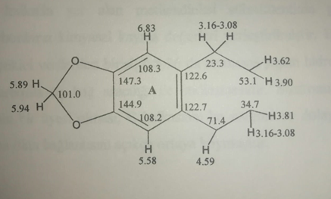

**Figure 1.**Methylenedioxy group and hydrogens with two para-positions, a triple and a quadripol spin system bonded at ortho positions

During the interpretation of one-dimensional NMR experiments, it was predicted that the three sharp singlets observed at 3.02 in 1H NMR spectrum would be the *N*-methyl group shifted down to the lower field due to its chemical environment.The fact that these hydrogens exhibited the same activity 3JCH correlations with the three carbons signaling at 53.1, 71.4, and 51.7 ppm provided conclusive evidence both for the completion of the ring B and for elucidating the nature of not fullyresolved carbon signal at 51.7 ppm.  3.30 signalswere the hydrogens also belong to an *N*-methyl group.Thus, it turns out that the signals at 50.6 and 51.7 ppm in the 13C NMR spectrum belong to two methyl groups on nitrogen atom. According to these correlations, the B ring is completed as shown in Figure 2.

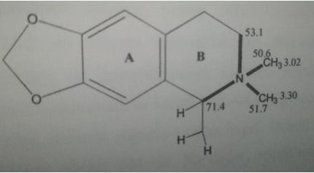

**Figure 2.**Methylgroups on Nitrogen atom

Consequently, it has been proven that rings A and B form a quaternizedisoquinoline core with 6,7-methylenedioxy-*N,N*-dimethyl substituents, and there is also a substitution at the 1-position of this ring. In order to elucidate the structure of this substituent, the data obtained from the HMBC experiment was used.

In order to define this aromatic structure, symbolized as the ring C, the 3JCH and 2JCHinteractions of ortho-related hydrogens, which were at 6.93 and 6.36, in the HMBC experiment were evaluated. By evaluating the data in question, in adddition to the relative positions of the aromatic hydrogens and the methylenedioxy substituent in the ring were determined the chemical shift values ​​of the carbons were also determined. One of the most interesting data during these evaluations is that the hydrogen (H-6) resonating at 6.36 interacts via three bonds with carbon at 34.7 ppm. The fact that the carbon in question is a member of the isolated triple-spin-system has clearly demonstrated the connection of the C-ring to this system and thus to the B-ring to which the system is attached.

Another critical information about the structure is provided by the interaction of the 6.36 proton signal with the carbonyl carbon signaling at 165.9ppm. Thus, the presence of a carbonyl residue on the 2nd carbon of the C ring has emerged (Fig 3.)

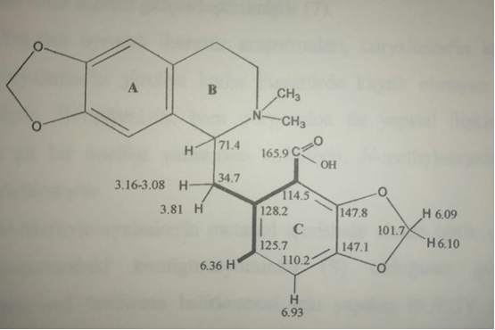

**Figure 3**.Carbonyl residue, geminal aliphatic protons and aromatic protons onthe ring C

The nature of the carbonyl group is evidenced by the broad signal of the hydrogen of the carboxylic acid observed at 13.2 in the 1HNMR spectrum repeated for sweep offset. This finding is also consistent with the value of the carbonyl signal in the IR spectrum. Thus, the presence of a carboxylic acid in the second position of the C ring has become certain.

The molecular formula written in the light of all the above data is C21H22NO6. The molecular weight calculated for this formula is 384. This value is in full agreement with the molecular ion seen at m/z 384 in the ESI-Ms spectrum of the compound.

A single *N*-methyl-bearing derivative of thenon quaternary compound is known as coryximine.Coryximine was isolated from a Papaveraceae plant called *Corydalis hsuchowensis*W. Y. Liannov. ined. by Chinese researchers in 1991 and its structure was elucidated7. However, its total synthesis was also performed by Chrzanowska and Sulima in Poland in 19988.Coryximine was also isolated from *Corydaliscurviflora*Maxim. anditslarvicidalactivitywasdemonstratedagainsttwomosquito species9.

A detailed literature search has shown that the quaternary derivative of coryximine, as namely *N*-methylcoryximine, is a new compound that has not been registered in the literature until now. The optical rotationof *N*-methylcoryximine in methanol is levorotatory, indicating that at the C-1 position it has*S*configuration. Although clearinformation is not provided from the ROESY experiment performed to determine the conformational preference of the compound, it was thought that the C ring moved away from the *N,N*-dimethyl groups and approached to the ring A due to the steric density. This suggestion also explains the fact that H-8 has shifted to a very high field like 5.58. Therefore, it was concluded that the chemical formula of ***N*-methyl coryximine** has the following structuralformula (Figure 4).

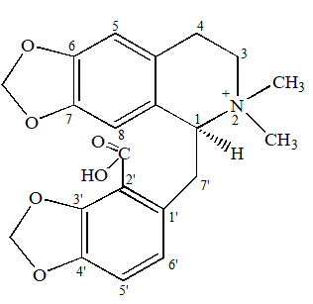

**Figure4.*N*-methylcoryximine**

The natural occurrence and spectral data of ***N*-methylcoryximine**from secoberbine subgroup of isoquinoline alkaloids, unprecedented to our knowledge, is reported  for the first time. Further bioliogical activity studies on this new compound are planned to be conducted.

**Supplementarydata (Spectrum 1-10)**

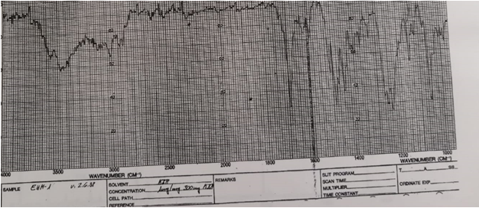

**Spectrumno 1.**IR Spectrum of *N*-Methyl-coryximine

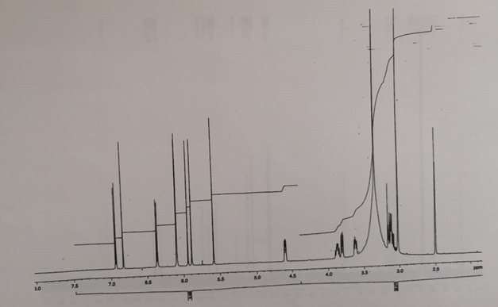

**Spectrumno 2.**1H NMR Spectrum*N*-Methyl-coryximine

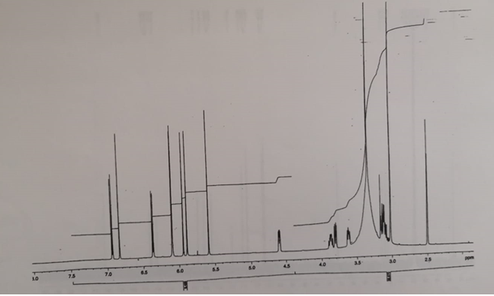

**Spectrumno2a.**Extended1H NMR Spectrum of N-methylcoryximine

,

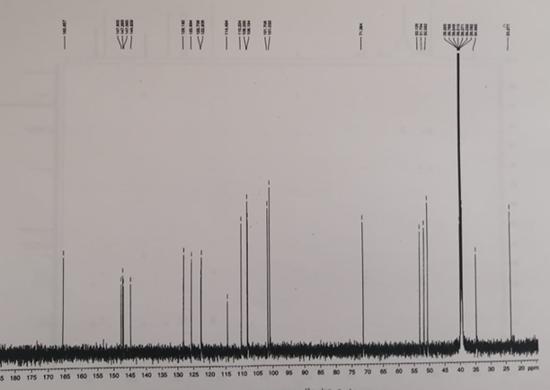

**Spectrumno3.**13C NMR Spectrum of *N*-methylcoryximine

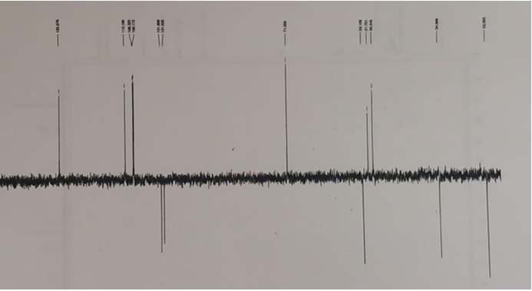

**Spectrum No 4.** DEPT Spectrumof *N*-methylcoryximine

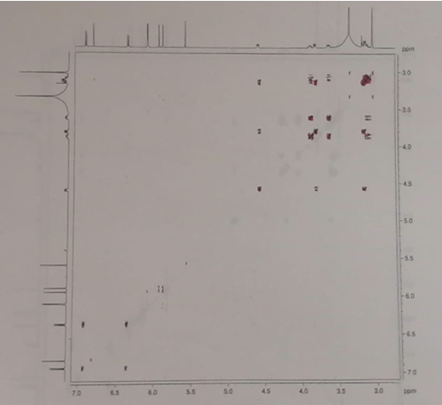

**Spectrumno 5.**  1H-1H DQF COSY Spectrum*N*-methylcoryximine

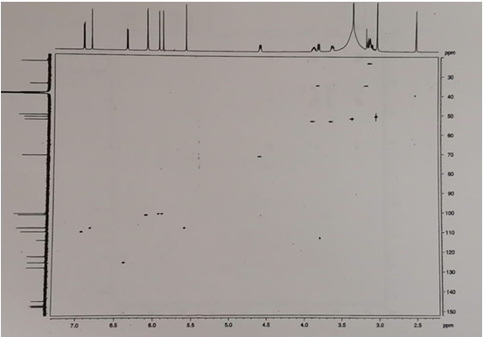

**Spectrum No 6.**HSQC Spectrum*N*-methylcoryximine

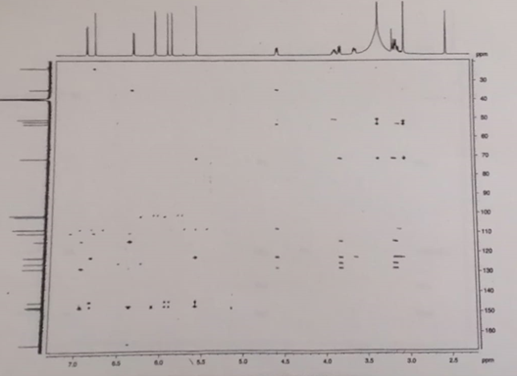

**Spectrumno 7.** HMBC Spectrum*N*-methylcoryximine

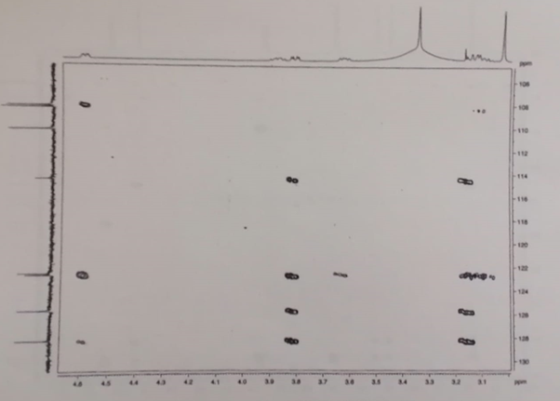

**Spectrumno7a.**Extended HMBC Spectrum*N*-methylcoryximine

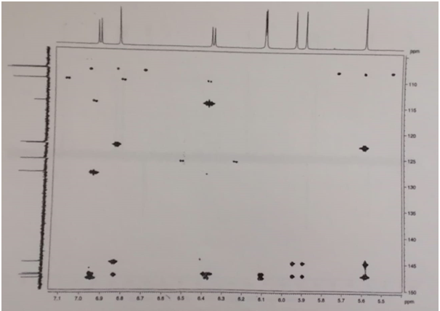

**Spectrumno 7b.**Extended HMBC Spectrumof *N*-methylcoryximine

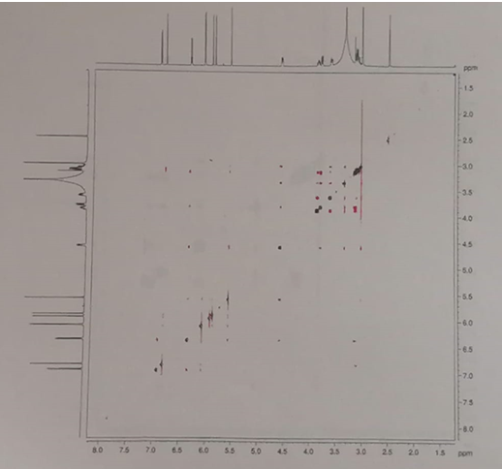

**Spectrumno 8.**  ROESY Spectrum*N*-methylcoryximine

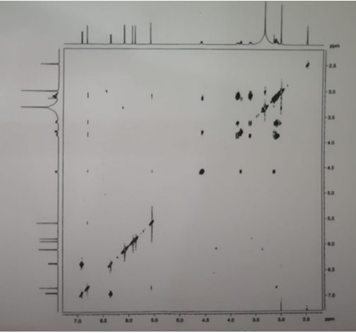

**Spectrum No 9.**TocsySpectrum of *N*-methylcoryximine

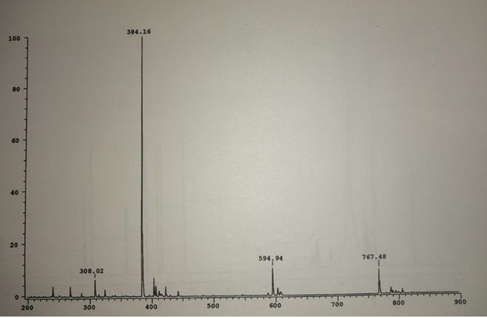

**Spectrum No 10.**ESI MSSpectrum of *N*-methylcoryximine

**Acknowledgement**

We woudlike to thank to Prof. Dr. TekantGözler and Prof. Dr. BelkısGözler for their assisting in interpreting spectral analyses. This project was funded as Ege University Scientific Research Project (98/ECZ/012).

**Conflict of interest**

**Author’s Contribution**

**References**

1-Efros RS. Finding alkaloid-bearing folk-remedy plants in the Trans-Baikal. RegionFarmatsiya 1976; 9(5):22-23.

2-Dil AH.  Activité anti-histaminique de la fumarine. Therapie 1973; 28: 767-774.

3- Bhakuni DS, Chatuverdi, RJ.  [The alkaloids of *Corydalis meifolia*](https://pubs.acs.org/doi/pdf/10.1021/np50028a006?casa_token=ZrhsObnEHYEAAAAA:BwLIwr-YlQSY3JYUp8w00iOvEDpGcYimrFbpNTRXJ4LRRHrDXZnzwLhUmHjGHBOZbmxf8ai33UoTeuFhyw). Nat Prod 1983; 46: 466-470.

4-Coşar G, Bilgehan H, Gözler T. The antibacterial effects of some alkaloids isolated from *Glaucim flavum crantz*. Mikrobiyol. Bul.  1981; 15(2):105-109.

5- Kiryakov KG, Panov P. Med. Probl. 1969; 21: 91 (1969); in “The Alkaloids," 1979, ManskeRHF  and Rodrigo RGA. eds., Academic Press, NY, vol 17,  *p*. 394.

6-Mete E, Gözler T. (+)-Oxoturkiyenıne: an isoquinoline-derived alkaloid from *Hypecoum pendulum*. J Nat Prod 1988; 51:272-274.

7-[Zhou](https://pubmed.ncbi.nlm.nih.gov/?term=Zhou+JY&cauthor_id=17226140) JY, [Tong](https://pubmed.ncbi.nlm.nih.gov/?term=Tong+XJ&cauthor_id=17226140) XJ,  [Lian](https://pubmed.ncbi.nlm.nih.gov/?term=Lian+WY&cauthor_id=17226140) WY,  [Fang](https://pubmed.ncbi.nlm.nih.gov/?term=Fang+QC&cauthor_id=17226140) QC. Chemical Study on the Alkaloids of *Corydalis hsuchowensis*. Planta Med 1991; 57(2): 156-158.

8-Chrzanowska M, Sulima A. Total synthesis of coryximine, a sicophthalideisoquinoline alkaloid. Pol J Chem 1998; 72 (9): 2202-2203.

9-[Xia](https://pubmed.ncbi.nlm.nih.gov/?term=Xia+J&cauthor_id=32020760) JK, [Liu](https://pubmed.ncbi.nlm.nih.gov/?term=Liu+Y&cauthor_id=32020760)Y, [Zhou](https://pubmed.ncbi.nlm.nih.gov/?term=Zhou+Y&cauthor_id=32020760) Y ,  [Zhang](https://pubmed.ncbi.nlm.nih.gov/?term=Zhang+J&cauthor_id=32020760) JY, [Li](https://pubmed.ncbi.nlm.nih.gov/?term=Li+C&cauthor_id=32020760) CH , [Yin](https://pubmed.ncbi.nlm.nih.gov/?term=Yin+X&cauthor_id=32020760) X, [Tian](https://pubmed.ncbi.nlm.nih.gov/?term=Tian+X&cauthor_id=32020760) XR, [Zhang](https://pubmed.ncbi.nlm.nih.gov/?term=Zhang+X&cauthor_id=32020760) XY. Two novel alkaloids from *Corydalis curviflora* Maxim. and their insecticidal activity. Pest Manag Sci 2020; 76(7): 2360-2367.