Original Research Article

Cardiovascular risk and HIV infection in patients aged 50 years and older at the Ahala District Medical Center

Abstract
Older people living with HIV (P50+) are living longer and longer and are therefore prone to age-related comorbidities. The objective of this study was to investigate the cardiovascular risk of P50+ followed in an HIV care unit in Cameroon. The proportion of P50+ was 13.9% and 80 patients were included in the study. The following prevalence of cardiovascular risk factors (CVRF) were found sedentary lifestyle (77.5%), chronic smoking (5%).Fifteen percent reported having hypertension and 25% of the P50+ had high blood pressure during physical examination. Similarly, 2.5% of the patients reported diabetes and 7.5% of the P50+ had high blood sugar levels. The examinations performed revealed 2.5% of LDL-cholesterol dyslipidemia, 23.1% of glomerular filtration rate abnormalities, 5.7% of left ventricular hypertrophy (LVH), and 22.9% of electrocardiographic signs of myocardial ischemia. The study of the interdependence between CVRF and the characteristics of the population revealed a relationship of dependence between physical activity and age (p=0.002), diabetes and age (p=0.004), diabetes and duration of HIV (p=0.007), LVH and duration of HIV (p=0.001). Cardiovascular risk is high in P50+ which could make them vulnerable to cardiovascular events. It is therefore necessary or even essential that cardiovascular risk assessment be integrated into the continuum of care of PLWH in general and P50+ particularly in HIV care units.
Keywords: Cardiovascular risk, HIV, elderly, Cameroon
Abbreviations: CVRF: cardiovascular risk factor; LDL: low-density lipoprotein; PLWH: people living with HIV.

Introduction
Human immunodeficiency virus (HIV) infection is a health problem that has had and continues to have an impact on global health. Since its discovery in the 1980s, HIV has continued to alarm the world with its high morbidity and mortality. In 1999, 3.16 million new HIV cases were detected; in 2006, 1.95 million deaths were attributed to HIV and in 2017, 36.8 million people were living with HIV[1]. Numerous efforts to eradicate the pandemic, such as the availability of antiretroviral drugs, the routine initiation to antiretroviral treatment for newly tested HIV positive individuals, and many other HIV control strategies, have yielded satisfactory results. In 2020, the Joint United Nations Programme on HIV/AIDS (UNAIDS) released statistics that showed a decline in HIV-related morbidity and mortality with 680,000 deaths, 1.5 million new cases and 37.7 million people living with HIV[2]. These results are even more palpable with the increase in life expectancy of PLWH who are now more likely to reach the third age (P50+). This age is associated with a physiological alteration of the body's functions. The cardiovascular system is one of the systems that is affected by aging on the one hand and by HIV infection on the other in P50+. Cardiovascular pathologies represent the 2nd cause of non-HIV related mortality in PLWH[3][4]. It is therefore important to know the cardiovascular profile of P50+ to better focus their management. The objective of this study was to determine the cardiovascular risk of elderly PLWH (P50+).
- Location and duration of the study
This was a descriptive study conducted from October 2021 to March 2022 at the HIV unit care of the Ahala District Medical Center.
- Selection criteria
All the PLWH followed at HIV unit care and aged 50 years and over (P50+) were included.
- Sampling and procedure
The sampling was consecutive. The data collection procedure was carried out using a pre-established questionnaire. ModifiableCVRFwere assessed and the following paraclinical exams were donefasting blood glucose, lipid profile, creatinine level with calculation of glomerular filtration rate according to the Cockcroft and Gault formula and resting electrocardiogram.
- Data analysis
Data were entered into CsPro 7.1 software and analyzed via SPSS 23 software. Because the data did not follow a normal distribution, quantitative data were expressed as median and interquartile range, whereas qualitative data were expressed as frequency and percentage. The Chi-square test was used to investigate the relationship between CVRF and other population characteristics.
- Ethical considerations
This study was approved by the Ethics Committee of the Faculty of Medicine and Biomedical Sciences of the University of Yaounde I (FMBS) and was conducted in strict compliance with the fundamental principles of the Declaration of Helsinki.
Results
- Clinical data
At the time of the study, 13.9% of PLWH aged 50 years and older were being followed in the HIV care unit at the Ahala district medical center and 80 were included in this study. Data collected during the interview revealed that 62/80 (77.5%) were not physically active, 6/80 (7.5%) were alcohol abusers and 4/80 (5%) were chronic smokers. Fifteen percent (12/80) reported hypertension and 2.5% (2/80) diabetes. On physical examination, 44/76 (57.9%) P50+ were overweight or obese with a BMI ≥25 kg/m². Elevated blood pressure (≥ 140/90 mmHg) and blood glucose (≥ 1.26 g/l) were found in 20/80 (25%) and 6/80 (7.5%) patients, respectively.
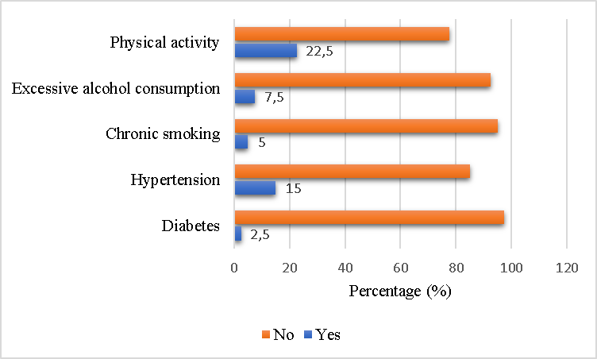
Figure 1: Clinical data
- Biological and electrocardiographic data
Cardiovascular risk factor assessment in the paraclinical evaluation revealed dyslipidemia with HDL (<0.4 g/l) in 10/80 (12.5%) P50+ and LDL (≥1.6 g/l) in 2/80 (2.5%) patients. Eighteen of 78 (23.1%) P50+ had suspicious renal disease (GFR<60 ml/min/1.73m²).On electrocardiographic examination, rhythm, depolarization, and conduction disorders (bundle branch block) were found in 8/70 (11.4%), 4/70 (5.7%), and 18/70 (25.7%) of the P50+, respectively. Left ventricular hypertrophy was present in 4/70 (5.7%) patients, abnormal Twave in 6/70 (8.6%) and signs of myocardial ischemia in 16/70 (22.9%).

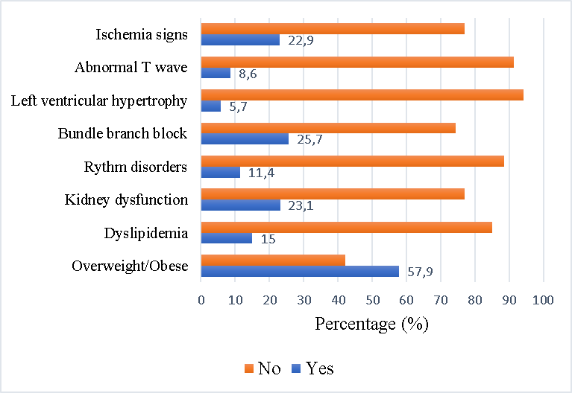
Figure 2: Biological and electrocardiographic data
- Factors associated with CVRF
Investigation of the relationship between CVRF and population characteristics found that many CVRF were significantly dependent on the sociodemographic profile of the population. These were physical activity and gender (p=0.002) (Table I); diabetes and age (p=0.004) and diabetes and duration of HIV disease (p=0.007) (Table II);GFR, indicator of the existence of nephropathy, and gender (p=0.003) on one hand and the level of education on the other hand (p=0.037) (Table III); rhythm disorders and the duration of HIV (p=0.001) (Table IV). Left ventricular hypertrophy (p=0.001) and T-wave abnormalities (p=0.024) were dependent on the duration of HIV (Tables V and VI).
Table I: Factors associated with physical activity
 | Physical activity
 | Categories | Yes | No | Chi-square | p
Sex | Female | 2 | 24 | 9,341 | 0,002
 | Male | 7 | 7
Age (years) | 50-54 | 6 | 12 | 3,361 | 0,499
 | 55-59 | 2 | 6
 | 60-64 | 1 | 8
 | 65-69 | 0 | 4
 | ≥70 | 0 | 1
Marital status | Single | 3 | 11 | 1,359 | 0,929
 | Married | 4 | 10
 | Common-law | 1 | 1
 | Widowed | 1 | 2
 | Divorced | 0 | 6
Sector of activity | Unemployed | 1 | 11 | 5,145 | 0,273
 | Public | 1 | 3
 | Private | 1 | 0
 | Informal | 5 | 13
 | Retired | 1 | 4
Level of education | Not in school | 1 | 2 | 3,338 | 0,342
 | Primary | 1 | 11
 | Secondary | 5 | 16
 | University | 2 | 2
Duration of HIV (years) | < 1 | 1 | 0 | 4,363 | 0,359
 | 1-4 | 5 | 15
 | 5-9 | 2 | 12
 | 10-14 | 1 | 3
 | 15-19 | 0 | 1

Table II: Factors associated with diabetes
 | Diabetes
 | Categories | Yes | No | Chi-square | p
Sex | Female | 2 | 24 | 0,004 | 0,950
 | Male | 1 | 13
Age (years) | 50-54 | 1 | 17 | 15,576 | 0,004
 | 55-59 | 0 | 8
 | 60-64 | 0 | 9
 | 65-69 | 1 | 3
 | ≥70 | 1 | 0
Marital status | Single | 0 | 14 | 6,023 | 0,304
 | Married | 3 | 11
 | Common-law | 0 | 1
 | Widowed | 0 | 3
 | Divorced | 0 | 7
Sector of activity | Unemployed | 2 | 10 | 4,444 | 0,349
 | Public | 0 | 4
 | Private | 0 | 1
 | Informal | 0 | 18
 | Retired | 1 | 4
Level of education | Not in school | 0 | 3 | 2,248 | 0,523
 | Primary | 2 | 10
 | Secondary | 1 | 20
 | University | 0 | 4
Duration of HIV (years) | < 1 | 0 | 1 | 14,054 | 0,007
 | 1-4 | 2 | 18
 | 5-9 | 2 | 14
 | 10-14 | 0 | 4
 | 15-19 | 1 | 0

Discussion
This study found a proportion of 13.9% of the P50+ currently being followed at the Ahala district medical center. This result is similar to the findings of Mbezele Essomba & al who found a proportion of P50+ of 13,3%[5]. It is also comparable to the result of Christine S. Autenrieth & al who, in their projections of the world population aged 50 years and over and infected by HIV, estimated that this population would increase from 16 to 20% from 2016 to 2020 [6]. This study shows that the P50+ population will be a growing one worldwide. This highlights the benefits of antiretroviral treatment for PLHIV, whose life expectancy is prolonged [7]. The main cardiovascular risk factors found in our study were physical inactivity (77.5%), overweight/obesity (57.9%), elevated blood pressure (25%), dyslipidemia (15%) and elevated blood sugar (7.5%). These results are comparable to those of Mbezele Essomba & al who found physical inactivity (22.5%), elevated blood pressure (24.3%), hyperglycemia (7.5%) as predominant CVRF [5]. It is also similar to the findings of P. Belaunzaran & al who, in a comparative study of non-communicable diseases between PLWH aged less than 50 years and those aged 50 years and over, found prevalence of dyslipidemia, arterial hypertension and diabetes of 28%, 18% and 12% respectively [8]. These results are also consistent with the work of Judith A. Aberg who reported high proportions of PLWH with age-related comorbidities [9]. This again suggests that P50+ are carriers of many cardiovascular risk factors that could negatively impact their cardiovascular health and increase non-HIV related mortality. It may be suggested following Priscilla Y. Sue & al that it is time to recognize that HIV infection may be a major cardiovascular risk factor along with traditional CVRF [10]. This would allow a better knowledge of the CVRF, prevention and early management of cardiovascular events, whose associated factors identified by Rimke B. & al are advanced age, hypertension, dyslipidemia and high BMI [11].
Many efforts should therefore be made to promote the integration of these diseases in the follow-up of P50+.

Table III: Factors associated with GFR
 | GFR (ml/min/1,73m²)
 | Categories | < 60 | ≥ 60 | Chi-square | p
Sex | Female | 2 | 23 | 8,918 | 0,003
 | Male | 7 | 7
Age (years) | 50-54 | 5 | 12 | 3,548 | 0,471
 | 55-59 | 3 | 5
 | 60-64 | 1 | 8
 | 65-69 | 0 | 4
 | ≥70 | 0 | 1
Marital status | Single | 2 | 11 | 7,604 | 0,179
 | Married | 5 | 10
 | Common-law | 2 | 1
 | Widowed | 0 | 7
 | Divorced | 0 | 1
Sector of activity | Unemployed | 2 | 9 | 3,023 | 0,554
 | Public | 1 | 3
 | Private | 0 | 1
 | Informal | 6 | 12
 | Retired | 0 | 5
Level of education | Not in school | 2 | 1 | 8,486 | 0,037
 | Primary | 0 | 12
 | Secondary | 5 | 15
 | University | 2 | 2
Duration of HIV (years) | < 1 | 0 | 1 | 2,436 | 0,656
 | 1-4 | 3 | 16
 | 5-9 | 5 | 9
 | 10-14 | 1 | 3
 | 15-19 | 0 | 1

Table IV: Factors associated with rhythm disorders
 | Rhythm disorders
 | Categories | Yes | No | Chi-square | p
Sex | Female | 2 | 20 | 0,320 | 0,572
 | Male | 2 | 11
Age (years) | 50-54 | 3 | 12 | 4,704 | 0,319
 | 55-59 | 0 | 7
 | 60-64 | 0 | 9
 | 65-69 | 1 | 2
 | ≥70 | 0 | 1
Marital status | Single | 2 | 9 | 2,116 | 0,833
 | Married | 2 | 12
 | Common-law | 0 | 3
 | Widowed | 0 | 6
 | Divorced | 0 | 1
Sector of activity | Unemployed | 1 | 10 | 8,731 | 0,068
 | Public | 0 | 3
 | Private | 1 | 0
 | Informal | 2 | 4
 | Retired | 0 | 14
Level of education | Not in school | 0 | 2 | 1,156 | 0,764
 | Primary | 2 | 9
 | Secondary | 2 | 17
 | University | 0 | 3
Duration of HIV (years) | < 1 | 1 | 0 | 18,329 | 0,001
 | 1-4 | 1 | 15
 | 5-9 | 0 | 13
 | 10-14 | 1 | 3
 | 15-19 | 1 | 0

Table V: Factors associated with left ventricular hypertrophy
 | Left ventricular hypertrophy
 | Categories | Yes | No | Chi-square | p
Sex | Female | 2 | 20 | 1,253 | 0,263
 | Male | 0 | 13
Age (years) | 50-54 | 0 | 15 | 6,717 | 0,152
 | 55-59 | 1 | 6
 | 60-64 | 0 | 9
 | 65-69 | 1 | 2
 | ≥70 | 0 | 1
Marital status | Single | 0 | 11 | 2,400 | 0,791
 | Married | 1 | 13
 | Common-law | 0 | 3
 | Widowed | 1 | 6
 | Divorced | 0 | 1
Sector of activity | Unemployed | 2 | 9 | 4,628 | 0,328
 | Public | 0 | 3
 | Private | 0 | 1
 | Informal | 0 | 16
 | Retired | 0 | 4
Level of education | Not in school | 0 | 2 | 0,543 | 0,909
 | Primary | 1 | 10
 | Secondary | 1 | 18
 | University | 0 | 3
Duration of HIV (years) | < 1 | 0 | 1 | 17,867 | 0,001
 | 1-4 | 0 | 16
 | 5-9 | 1 | 12
 | 10-14 | 0 | 4
 | 15-19 | 1 | 0

Table VI : Factors associated with anormal T wave
 | Abnormal T wave
 | Categories | Yes | No | Chi-square | p
Sex | Female | 2 | 20 | 0,020 | 0,886
 | Male | 1 | 12
Age (years) | 50-54 | 2 | 13 | 4,375 | 0,358
 | 55-59 | 0 | 7
 | 60-64 | 0 | 9
 | 65-69 | 1 | 2
 | ≥70 | 0 | 1
Marital status | Single | 1 | 10 | 3,114 | 0,682
 | Married | 1 | 13
 | Common-law | 1 | 2
 | Widowed | 0 | 6
 | Divorced | 0 | 1
Sector of activity | Unemployed | 1 | 10 | 2,930 | 0,570
 | Public | 1 | 2
 | Private | 0 | 1
 | Informal | 1 | 15
 | Retired | 0 | 4
Level of education | Not in school | 0 | 2 | 2,031 | 0,566
 | Primary | 2 | 9
 | Secondary | 1 | 18
 | University | 0 | 3
Duration of HIV (years) | < 1 | 0 | 1 | 11,258 | 0,024
 | 1-4 | 1 | 15
 | 5-9 | 1 | 12
 | 10-14 | 0 | 4
 | 15-19 | 1 | 0

Conclusion
The issue of cardiovascular risk in aging PLWH is still a topical one. This work reinforces the idea that PLWH in general and P50+ in particular, represent populations that public policies should consider when developing cardiovascular disease management strategies. Indeed, antiretroviral treatment has certainly favored the survival of PLWH, but it has also highlighted their cardiovascular health, which should be considered during their follow-up and even be integrated into the continuum of their care. The question that arises from this is how to manage cardiovascular disease in P50+ patients as part of their continuum of care.
Conflict of Interest
The authors declare no conflicts of interest.
Author Contributions
All authors contributed to the writing of this article.
References
- GBD 2017 HIV collaborators. Global, regional, and national incidence, prevalence, and mortality of HIV, 1980-2017, and forecasts to 2030, for 195 countries and territories: a systematic analysis for the Global Burden of Diseases, Injuries, and Risk Factors Study 2017. Lancet HIV. déc 2019;6(12):e831‑59.
- UNAIDS. Global HIV & AIDS statistics- FACT SHEET - WORLD AIDS DAY 2021. 2021.
- So-Armah K, Freiberg M. CVD risk in an aging HIV population – not just a question of biology. Curr Opin HIV AIDS. juill 2014;9(4):346.
- So-Armah K, Freiberg MS. HIV and Cardiovascular Disease: Update on Clinical Events, Special Populations, and Novel Biomarkers. Curr HIV/AIDS Rep. juin 2018;15(3):233‑44.
- Mbezele Essomba T, Edo’o VD, Ntsama Essomba MJ, Essi M-JM. Epidemiological profile of PLWH aged 50 and over at the Ahala district medical center, Yaounde. J Clin Images Med Case Rep. 2022;3(5):1835.
- Autenrieth CS, Beck EJ, Stelzle D, Mallouris C, Mahy M, Ghys P. Global and regional trends of people living with HIV aged 50 and over: Estimates and projections for 2000–2020. PLoS ONE. 29 nov 2018;13(11).
- Kaplan-Lewis E, Aberg JA, Lee M. Aging with HIV in the ART era. Semin Diagn Pathol. 1 juill 2017;34(4):384‑97.
- Belaunzaran-Zamudio PF, Caro-Vega Y, Giganti MJ, Castilho JL, Crabtree-Ramirez BE, Shepherd BE, et al. Frequency of non-communicable diseases in people 50 years of age and older receiving HIV care in Latin America. PloS One. 2020;15(6):e0233965.
- Aberg JA. Aging and HIV Infection: Focus on Cardiovascular Disease Risk. Top Antivir Med. 1 janv 2020;27(4):102‑5.
- Hsue PY, Waters DD. Time to Recognize HIV Infection As a Major Cardiovascular Risk Factor. Circulation. 11 sept 2018;138(11):1113‑5.
- Bijker R, Jiamsakul A, Uy E, Kumarasamy N, Ditango R, Chaiwarith R, et al. Cardiovasculardisease-related mortality and factors associated with cardiovascular events in the TREAT Asia HIV Observational Database (TAHOD). HIV Med. mars 2019;20(3):183‑91.

