**Reviewer’s Comments**

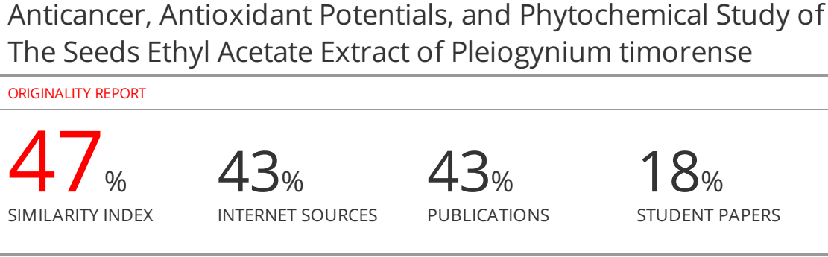

**Anticancer, Antioxidant Potentials, and Phytochemical Study of The Seeds Ethyl Acetate Extract of *Pleiogyniumtimorense***

**ABSTRACT**

**Objective:** The aim of the current research was to evaluate the cytotoxicity of *Pleiogyniumtimorense*seeds against different human cancer cell lines, its antioxidant activity and to investigate its phytoconstituents.

**Methods**:  Ethyl acetate extract of*pleiogynium timorense* seeds was assayed for the cytotoxic effectagainst liver cancer cell line (HepG2), ovarian cancer cell line (SKOV-3) and prostate cancer cell line (PC-3) using SRB (Sulforhodamine B) assay. The antioxidant activity was evaluated by the DPPH radical scavenging assay using Trolox as a standard. The polyphenolic contents of the extract were determined by using high performance liquid chromatography (HPLC).

**Results:** The result revealed that the seed extract exhibited very potent activity against liver cancer cell line (HEPG-2) with IC50 =1.62 μg/mL, andthe ovarian cancer cell line (SKOV-3) with IC50 =6.37 μg/mL, while a moderate activity against the prostate cancer cell line (PC-3) with IC50 = 46μg/mL, by comparing with that of Doxorubicin. Moreover, IC50 values of Trolox and the seed extract were 24.42 ± 0.87 and 90.4 ± 0.32 μg/ml, respectively. HPLC analysis of polyphenolic compounds revealed the identification of ten polyphenolic compounds in ethyl acetate extract of *Pleiogyniumtimorense*seeds representing 87.2% of the total area, where chlorogenic acid (24.7%), catechin (17.2%), Coumaric acid (7.4%), and gallic acid (7.3%) represent the major compounds.

**Conclusion:** In conclusion, the current study highlights the effect of ethyl acetate extract of*pleiogyniumtimorense* seeds as antioxidant and a potent cytotoxic agent against different human cell lines aiming to be the first step towards the discovery of safe natural anticancer drug.

**Keywords**: Antioxidant; cytotoxic; ethyl acetate extract; phytoconstituents;*Pleiogyniumtimorense*seeds*.*

**INTRODUCTION**

Anticancer medications are regarded as the first choice for the treatment of many kinds of cancer 1**.** There are numerous anticancer medications with various sources and modes of action; nevertheless, majority of these medications have detrimental side effects. Thus, it is necessary to create new anticancer medications with less adverse effects 2. Nowadays, medicinal plants are used to cure serious diseases like cancer. These plants contain several phytochemicals such as tannins, triterpenes, alkaloids and ﬂavonoids which showed promising biological activities 3**.**

*Pleiogyniumtimorense* (DC.) Leenh. From the family of Anacardiaceae, is commonly known as Gambozia. The plant is a rich source of biologically active compounds which play a vital role in the plant bioactivities such as polyphenolic compounds 3-5**.** Gallic acid and catechin isolated from *Pleiogyniumtimorense* bark methanol extract showed a potentialactivity against HepG2 cancer cell line 4.In addition, trihydroxy alkylcyclohexenones isolated from *Pleiogyniumtimorense*bark dichloromethane extract exhibited cytotoxic activity against the A2780 cancer cell line6**.** The methanol extract of *Pleiogynium timorense* seeds, pericarp and fruits exhibited a potent antioxidant activity due to the presence of polyphenolic compounds 7,8. The volatile constituents of the fruits exhibited a promising cytotoxic activity against different human cell lines9**.** In addition, *Pleiogyniumtimorense* seeds methanol extract exhibited antihyperlipidemic and antihyperglycaemic activities10**.** The leaves of the plant exhibited promising biological activities such as antimicrobial, anti-inflammatory, and hypoglycaemic, activities due to the presence of polyphenolic compounds 11, 12**.** Recently, *pleiogyniumtimorense*leaves ethyl acetate extract exhibited a powerful cytotoxic activity against (SKOV-3), a reasonable activity against (HepG-2) with lower activity against (PC- 3)**3.**

Nothing could be found in the literature that is currently available that discusses phytoconstituents or bioactivities. of the ethyl acetate extract of*Pleiogyniumtimorense*seeds. Thus, the aim of this study is to evaluate antioxidant and anticancer potentials of *Pleiogyniumtimorense*seeds ethyl acetate extract against different human cancer cell lines, as well as to investigate its phytoconstituents.

**MATERIALS AND METHODS**

**Plant material**

Fruits of *Pleiogyniumtimorense* plant were collected from Zoo Garden, Giza, Egypt, and identified by Dr Mohammed El-Gebaly, Department of Botany, National Research Centre (NRC), Egypt. Voucher specimen was deposited in the Herbarium of NRC, with the possessing number of 2001.The seeds were separated from fruits, dried, powdered, and were kept in dark well-closed containers.

**Phytochemical analysis**

**Preparation of plant extract**

The air-dried powder (1.5kg) of *Pleiogyniumtimorense* seeds was extracted by maceration with ethyl acetate at room temperature several times until exhaustion. The extract was filtered and concentrated to dryness under reduced pressure at 40°C by using rotatory evaporator*.*

**Phytochemical screening**

The constituents of the plant extract were identified by standard procedures as previously described by 13, 14**.**

**HPLC analysis**

HPLC analysis was carried out using an Agilent 1260 series. The separation was carried out using Kromasil C18 column (4.6 mm x 250 mm i.d., 5 μm). The mobile phase consists of water (A) and 0.05% trifluoroacetic acid in acetonitrile (B) at a flow rate 1 ml/min. The mobile phase was programmed consecutively in a linear gradient as follows: 0 min (82% A); 0–5 min (80% A); 5-8 min (60% A); 8-12 min (60% A); 12-15 min (85% A) and 15-16 min (82% A). The multi-wavelength detector was monitored at 280 nm. The injection volume was 10 μLfor each of the sample solutions. The column temperature was maintained at 35°C. Peaks were identified by congruent retention times and UV spectra in comparison with those of the standards 15.

**Biological Activities**

***In vitro* cytotoxic activity**

**Cancer cell lines**

The cytotoxicity assay was carried out against human cancer cell lines such as HepG2 (liver cancer cell line), PC-3 (Prostate cancer cell line) and SKOV-3 (Ovarian cancer cell line). These cell lines were obtained from Nawah Scientific Inc., (Mokatam, Cairo, Egypt).

**Cell culture**

Cells were maintained in RPMI media supplemented with 100 mg/ml of streptomycin, 100 units/ml of penicillin and 10% of heat-inactivated fetal bovine serum in humidified, 5% (v/v) CO2atmosphere at 37°C**16, 17.**

**SRB assay**

Cell viability was assessed by SRB assay. Aliquots of 100μL cell suspension (5x10^3 cells) were seeded in 96-well plates and were incubated in complete media for 24 h. Cells were treated with another aliquot of 100μL media containing drugs at various concentrations ranging from (0.01,0.1,1,10,100 ug/mL). After 72 h of drug exposure, cells were fixed by replacing media with 150μL of 10% TCA and incubated at 4°C for 1 h. The TCA solution was removed, and the cells were washed 5 times with distilled water. Aliquots of 70μL SRB solution (0.4% w/v) were added and incubated in a dark place at room temperature for 10 min. Plates were washed 3 times with 1% acetic acid and allowed to air-dry overnight. About 150μL of TRIS (10mM) was then added to dissolve protein-bound SRB stain and the absorbance was measured at 540 nm using a BMG LABTECH®- FLUO star Omega microplate reader (Ortenberg, Germany)**16, 17.**

***In vitro* antioxidant activity**

**Sample preparation**

**Initial screening step:**

Solutions of the ethyl acetate extract of *Pleiogyniumtimorense* seeds was prepared in concentrations of 1000 and 100 μg/mL in DMSO.

**IC50 determination:**

Extracts that exceeded 50% inhibition in any of the initial screening step concentrationswere serially diluted to provide 5 concentrations.

**Trolox standard preparation:**

Astock solution of 100μMof trolox was prepared in methanol in which 7concentrations were prepared including 50, 40, 30, 20, 15, 10 and 5 μM.

**DPPH Assay**

**DPPH** (2,2-diphenyl-1-picryl-hydrazyl-hydrate) free radical assay was carried out according to the method of  **Boly*et al***18**.** Briefly, 100μL of freshly prepared DPPH reagent (0.1% in methanol) were added to 100μL of the sample in 96 wells plate (*n*=3), the reaction wasincubated at room temperature for 30 min in dark. At the end of incubation time the resulting

reduction in DPPH color intensity was measured at 540 nm. Data are represented as means ±

SD according to the following equation.

(Absorbance of the control - absorbance of the sample/ absorbance of the control) ×100

**Data analysis:**

Data was analyzed using *Microsoft Excel®* and the IC50 value was calculated using *Graph pad Prism 5®* by converting the concentrations to their logarithmic value and selecting nonlinearinhibitor regression equation (log (inhibitor) vs. normalized response – variable slopeequation) 19**.** IC50, the concentration of the extract that reduces 50% of the DPPH molecules, was used to evaluate the antioxidant activity of the extract.

**RESULT AND DISCUSSION**

**Phytochemical study**

***Phytochemical screening***

The results of the phytochemical screening of ethyl acetate extract of *Pleiogyniumtimorense* seeds were compiled in Table 1. The results revealed the presence of the flavonoids,tannins and triterpenes and/or sterols in the plant extract. While it revealed the absence of coumarins, alkaloids, saponins and carbohydrate and/or glycosides from the plant extract. These results confirmed that ethyl acetate extract of *Pleiogyniumtimorense* seeds is a rich source with the phytochemical constituents that play an important role in the plant bioactivities. This result was in agreement with what were reported by previous studies which found that flavonoids, terpenoids, saponins, carbohydrate, tannins and coumarins, were detected in the leaves, bark and fruits of *Pleiogyniumtimorense* with absence of alkaloids 3,4,10**.**

**Table 1: Phytochemical screening ofethyl acetate extract of*Pleiogyniumtimorense seeds***

|  |  |
| --- | --- |
| **Constituents** | ***Pleiogyniumtimorense*seeds** |
| Carbohydrates and/or Glycosides | -ve |
| Tannins | +ve |
| Alkaloids and/or nitrogenous bases | -ve |
| Flavonoids | +ve |
| Sterols and/or triterpenes | +ve |
| Saponins | -ve |
| Coumarins | -ve |

 +ve   denotes the presence of the constituents

          - ve    denotes the absence of the constituents

**HPLC Analysis**

HPLC analysis of polyphenolic compounds revealed the identification of ten polyphenolic compounds in ethyl acetate extract of *Pleiogyniumtimorense* seeds representing 87.2% of the total area, where chlorogenic acid (24.7%), catechin (17.2%), Coumaric acid (7.4%), and gallic acid (7.3%) represent the major compounds (Table 2 and Figure 1). The result was in agreement with previous studies which reported that *Pleiogyniumtimorense* is a rich source with polyphenolic compounds 3-5**.**

**Said *et al*** reported that the methanol extracts of pericarp and seeds of *Pleiogyniumtimorense* were analyzed by HPLC–ESI-MS/MS, the result revealed the presence of diversity of polyphenolic compounds in each extract5**. Abdel Raoof*et al*** stated that the polyphenolic compounds of *Pleiogyniumtimorense* bark were analyzed by HPLC, the result revealed the identification of 16 phenolic compounds and 14 flavonoidal compounds4**.** Recently**,** ethyl acetate extract of *Pleiogyniumtimorense*leaves was analyzed by HPLC analysisand the study identified11 polyphenolic compounds in which chlorogenic acid, gallic acid, catechin and taxifolin were the major compounds 3 **.**

**Table 2: HPLC analysis of polyphenolic compounds in ethyl acetate extract of *Pleiogyniumtimorense*seeds**

|  |  |  |
| --- | --- | --- |
| **No.** | **Polyphenols** | **Area %** |
| 1 | Gallic acid | 7.3 |
| 2 | Chlorogenic acid | 24.7 |
| 3 | Catechin | 17.2 |
| 4 | Methyl gallate | 5.5 |
| 5 | Caffeic acid | 3.9 |
| 6 | Coumaric acid | 7.4 |
| 7 | Ellagic acid | 4.5 |
| 8 | Vanillin | 6.3 |
| 9 | Naringenin | 5.9 |
| 10 | Taxifolin | 4.5 |
| **Total identified compounds** | | **87.2%** |

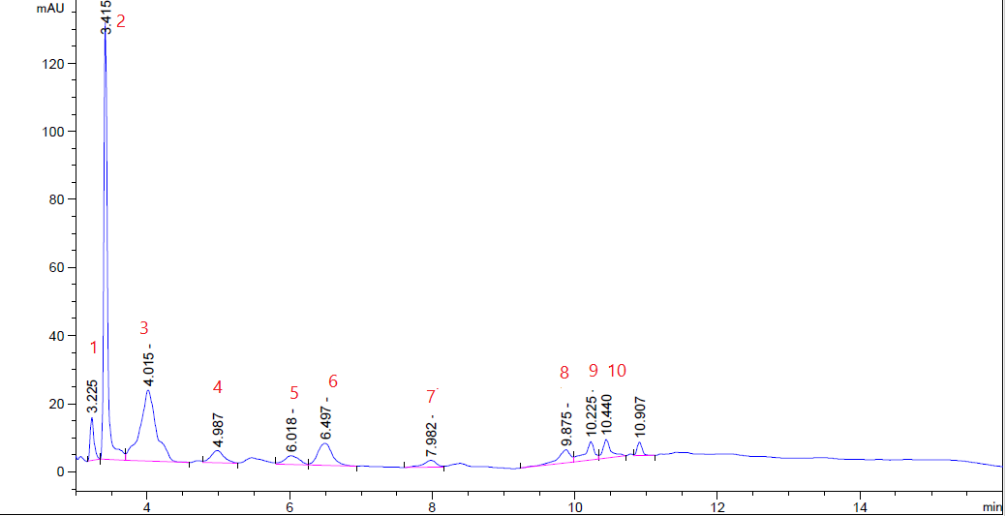

**Figure 1: HPLC analysis of polyphenolic compounds in ethyl acetate extract of *Pleiogyniumtimorense*seeds**

***Cytotoxicity activity***

Ethyl acetate extract of *Pleiogyniumtimorense*seeds was evaluated for its *in vitro* cytotoxic activity against different cancer cell lines using Doxorubicin as a reference anticancer agent. The results revealed that the plant extract exhibited a reasonable cytotoxic activity in dose dependent manner. The percentage of viability of the tested cancer cell lines was markedly decreased by the plant extract (figures 2-4). Moreover, the result revealed that the plant extract exhibited a very potent activity against liver cancer cell line (HEPG-2) with IC50 =**1.62** μg/mL, a potent cytotoxic activity against the ovarian cancer cell line (SKOV-3) with IC50 =**6.37** μg/mL, while it showed a moderate activity against the prostate cancer cell line (PC-3) with IC50 = 46μg/mL, by comparing with that of Doxorubicin (Table 3).

Previous studies confirmed the cytotoxic activity of *Pleiogyniumtimorense*on different human cancer cell lines4, 6, 9**.** *Pleiogyniumtimorense*bark exhibited potent cytotoxic effectagainst theA2780 human ovarian cancer cell line6**,**andliver cancer cell line (HEPG-2)**4.** In addition, thevolatile constituents of *Pleiogyniumtimorense*fruits exhibited potent cytotoxic effect against breast (MCF7) andlaryngeal (HEp2) human cancer cell lines9.Recent research reported that*pleiogyniumtimorense*leaves ethyl acetate extract exhibited a powerful cytotoxic activity against (SKOV-3), a reasonable activity against (HEPG-2) with lower activity against (PC- 3)**3.** The phytoconstituents of *Pleiogyniumtimorense*play a vital role as cytotoxic agent4,6**.** Where, trihydroxy alkylcyclohexenones isolated from *Pleiogyniumtimorense*bark dichloromethane extract, exhibited cytotoxic activity against the A27806. Moreover, gallic acid and catechin isolated from *Pleiogyniumtimorense* bark methanol extract showed a reasonable activity against HepG2 cell line 4.In addition, *Pleiogyniumtimorense* was nontoxic up to 5g/kg that indicated that the plant was safe and nontoxic for the normal cells 7**.**

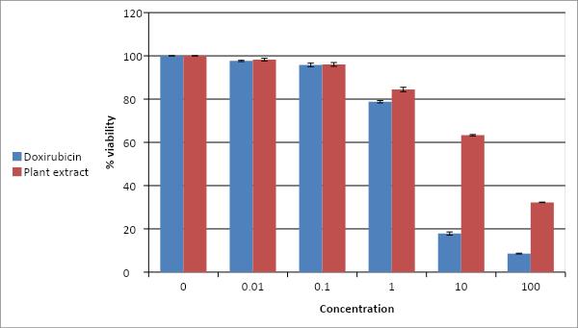

**Figure 2: Cytotoxic activity of ethyl acetate extract of *Pleiogyniumtimorense*seeds against PC-3 human cell line *in vitro***  
  
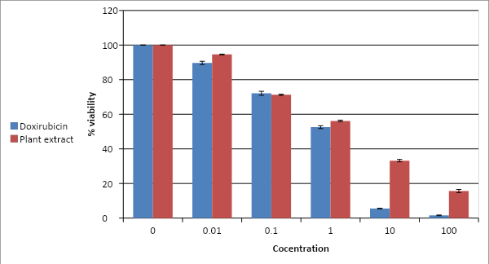

**Figure 3: Cytotoxic activity of ethyl acetate extract of *Pleiogyniumtimorense*seeds against HEPG-2human cell line *in vitro***

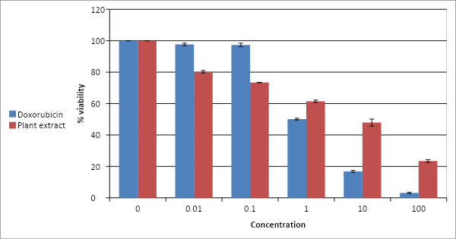

**Figure 4: Cytotoxic activity of ethyl acetate extract of *Pleiogyniumtimorense*seeds against SKOV-3human cell line *in vitro***

**Table 3:   IC50 values (µg/ml) of ethyl acetate extract of *Pleiogyniumtimorense* seeds *invitro*on different human cell lines.**

|  |  |  |
| --- | --- | --- |
| **Type of cell line** | **IC50μg/ml** | |
| **Ethyl acetate extract of *Pleiogyniumtimorense*seeds** | **Doxorubicin** |
| **SKOV-3** | **6.37** | **0.96** |
| **PC-3** | **46.00** | **5.38** |
| **HEPG-2** | **1.62** | **0.66** |

**Antioxidant activity**

The antioxidant activity of ethyl acetate extract of *Pleiogyniumtimorense*seeds was evaluated by the DPPH radical scavenging assay using Trolox as a standard. IC50 values of Trolox and the extract were 24.42 ± 0.87 and 90.4 ± 0.32 μg/ml, respectively. This result revealed the antioxidant activity of the plant that was in agreement with previous study which stated that the methanol extract of *Pleiogyniumtimorense*seeds, pericarp and fruits exhibited a potent antioxidant activity due to the presence of polyphenolic compounds 7, 8 .

**LIMITATIONS OF THE STUDY**

**CONCLUSION**

*Pleiogyniumtimorense*ethyl acetate extract of the seedsexhibited a promising cytotoxic activity against different human cancer cell lines and a potent antioxidant activity. The plant extract is a rich source for polyphenolic compounds which play a vital role in the bioactivities of the plant. Further contributions by researchers are needed to isolate and identify the biologically active compounds of the plant extract, and to perform clinical trials to enter the field of drug discovery.

**Author’s Contribution**

**ACKNOWLEDGEMENTS**

The authors would like to appreciate National Research Centre for providing technical knowledge, assistance, and facilities for this study.

**CONFLICTS OF INTEREST**

The authors have no conflict of interests to declare.

**REFERENCES**

1. Asai A, Koseki J, Konno M *et al.* Drug discovery of anticancer drugs targeting methylenetetrahydrofolate dehydrogenase 2. Heliyon 2018; 4(12), e01021. <https://doi.org/10.1016%2Fj.heliyon.2018.e01021.>
2. Sergazy S, Vetrova A, Orhan, I, Senol Deniz F, Kahraman A, Zhang J, Aljofan M.  Antiproliferative and cytotoxic activity of Geraniaceae plant extracts against five tumor cell lines. Future Science OA 2022; 8(2). <https://doi.org/10.2144/fsoa-2021-0109>
3. Abdel Raoof G F, Said A A, Ismail S A, El-anssary A A. A New Insight into *Pleiogyniumtimorense* Leaves: A Focus on The Anticancer and Antimicrobial Potentials.  Egypt J Chem. 2021; 64 (3): 1541 - 1551.<https://dx.doi.org/10.21608/ejchem.2020.52093.3070>
4. Abdel Raoof GF, Said AA , Mohamed KY, Gomaa HA. Phytoconstituents and bioactivities of the bark of *Pleiogyniumtimorense* (DC.) Leenh (Anacardiaceae). J HerbmedPharmacol 2020;9(1):20-27. <https://doi.org/10.15171/jhp.2020.03>
5. Said A, Aboutabl E A, Fawzy G.  Identification of constituents from *Pleiogyniumtimorense*(Dc.) Leenhpericarp and seeds using high performance liquid chromatography with electrospray ionization mass spectrometry. J chem 2017; 3(4): 30-36.
6. Eaton AL, Rakotondraibe LH, Brodie P J, Goetz M, Kingston D G.  Antiproliferative trihydroxyalkylcyclohexenones from *Pleiogyniumtimoriense*, J Nat Prod 2015; 78(7): 1752-1755. <http://dx.doi.org/10.1055/s-0032-1320970>
7. Said A, AbuotablEA,  AbdelRaoof GF,  Huefner A, Nada S A.  Phenolic contents and bioactivities of pericarp and seeds of *Pleiogynium solandri* (Benth.) Engl. (Anacardiaceae). Iran J  Basic Med  Sci 2015; 18(2): 165-171.
8. Netzel M, NetzelG,Tian Q, Schwartz S, Konczak I. Native Australian Fruits- A novel source of antioxidants for food. Innov Food Sci Emerg Technol 2007; 8: 339-346. <https://doi.org/10.1016/j.ifset.2007.03.007>
9. Said A, Omer E A, El Gendy MAM, Fawzy G, Abd EL-Kader A E,  Fouad  R. Volatile constituents and cytotoxic activity of the fruits of *Pleiogyniumtimorense*(Dc.) Leenh. J  Mater Environ  Sci 2018a; 9(8): 2274-2279.
10. Said A, Abuotabl E A, Abdel Raoof GF, Mohamed KY. Antihyperglycaemic and antihyperlipidemic activities of *Pleiogyniumtimorense*seeds and identification of bioactive compounds. International Journal of Biomedical Engineering and Clinical Science 2018b; 4(2): 30-35. <http://dx.doi.org/10.11648/j.ijbecs.20180402.11>
11. El-Fiki N M, Ahmed FI.  Phytochemical study of *Pleiogyniumsolandri*  (Benth.) Engl. Azhar J Pharm Sci 1999; 24: 38-50.
12. Al Sayed E, Martiskainen O, Sinkkonen J, PihlajaK,  Ayoub N,  Singab A, El-Azizi M.  Chemical composition and bioactivity of *Pleiogyniumtimorense*(Anacardiaceae). Nat  ProdCommun2010; 5(4): 545 – 550.
13. Harbone JB. Phytochemical methods: a guide to modern techniques of plant analysis. London: Chapman & Hall; 1973. p. 49.
14. Sofowora A. Medicinal plants and traditional medicine in Africa. Ibadan, Nigeria: Spectrum Books Ltd; 1993. p. 289.
15. Mishra GJ, Reddy M N, Rana J S.  Isolation of flavonoid constituent from *Launaea procumbens*Roxb. by preparative HPTLC method. IOSR JPharmacy 2012; 2: 5–11. <http://dx.doi.org/10.9790/3013-2430511>
16. Skehan P, StorengR,  Scudiero D, Monks A,  Mahon J M,  Vistica D. New colorimetric cytotoxicity assay for anticancer-drug screening. J Natl Cancer Inst 1990; 82(13): 1107-1112.  <https://doi.org/10.1093/jnci/82.13.1107>
17. Allam RM, Al-Abd A M, Khedr A, Sharaf O A. Fingolimod interrupts the cross talk between estrogen metabolism and sphingolipid metabolism within prostate cancer cells. Toxicol Lett 2018; 11(291):77-85. <https://doi.org/10.1016/j.toxlet.2018.04.008>
18. Boly R, Lamkami T, Lompo M, Dubois J, Guissou I. DPPH free radical scavenging activity of two extracts from *Agelanthusdodoneifolius*(Loranthaceae) leaves. International Journal of Toxicological and Pharmacological Research 2016; 8(1); 29-34.
19. Zheng C, Riccardo B, Guglielmina F. EC50 estimation of antioxidant activity in DPPH_assay using several statistical programs. Food Chemistry 2013;138:  414–420. <https://doi.org/10.1016/j.foodchem.2012.11.001>