Reviewer’s Comments

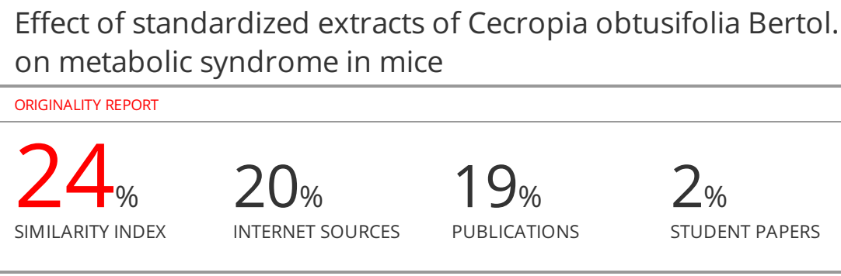Effect of standardized extracts of Cecropia obtusifolia Bertol. on metabolic syndrome in mice

ABSTRACT
In Mexican traditional medicine, Cecropia obtusifolia is extensively used, from central to southeast regions, to treat diabetes and some inflammation-related disorders, including renal illness and obesity.
Objetive: The aim of this study was to evaluate the effect of the hydroalcoholic and methanolic extracts, standardized in chlorogenic acid, on some metabolic syndrome-related signs induced by hypercaloric diet in mice.
Methods: C57BL/6 mice were administered the hydroalcoholic or the methanolic extract for 8 weeks. CoM extract was able to reduce insulin resistance, clotting time, adipose tissue content, food consumption, weight gain, and hypertension. It also decreased renal inflammation, as assessed by the quantification of IL-6, TNF-α and IL-10. On the other hand, the CoHA extract decreased the pro-inflammatory cytokines and increased IL-10.
Conclusion: Overall, the methanolic extract had higher efficacy, since it reduced insulin resistance and visceral fat and showed a tendency to reduce clotting time, which may be related to improved liver function.

Keywords: Cecropia obtusifolia, chlorogenic acid, IL-6, IL-10, metabolic syndrome, TNF-α.

\INTRODUCTION
Metabolic syndrome (MS) is a set of disorders associated to insulin resistance (IR), like obesity, glucose intolerance, atherogenic dyslipidemia, and arterial hypertension. Together, this generates a chronic pro-inflammatory environment and increases the risk of myocardial infarction, cerebrovascular accident, and renal insufficiency^{1,2}, which are among the leading causes of death in Mexico^{3,4}. In Mexico, based on WHO criteria, MS has a prevalence of 31%⁵, similar to the 36% nationwide obesity rate⁶. The multifactorial origin of MS has been well established and is closely related to obesity, sedentary lifestyle, and unbalanced diet, in addition to genetic factors^{2,7}.
In Mexican traditional medicine, the leaves, bark, flowers, stems and roots from Cecropia obtusifolia Bertol. (Cecropiaceae) have been used to treat a variety of disorders, some of which are related to inflammation, such as type 2 diabetes mellitus (DM2) and for weight loss⁸⁻¹⁰. Pharmacological studies of the species have reported hypotensive activity in rats¹¹ (50 mg kg⁻¹ i.v.), vasorelaxation¹², and inhibition of type AT1 Angiotensin II receptors and endothelin ET_{A} receptors (ET₁)¹³. The anti-hyperglycemic effect in animals was proved after alloxan/streptozotocin-induced diabetes¹⁴⁻¹⁶. It has also been shown to have anti-inflammatory effects when used topically and systemically¹⁷ and a diuretic effect, without increasing electrolyte excretion and weight reduction¹⁸.
It has been proposed that phenolic compounds such as chlorogenic acid (CAc, Fig. 1) and iso-orientin are responsible for this biological activity¹⁹, although additional compounds may improve or strengthen the individual activity of these or other compounds. Indeed, Andrade-Cetto and Wiedenfeld¹⁹ found stigmasterol and β-sitosterol in the butanolic fraction, which had the strongest hypoglycemic effect. Furthermore, β-sitosterol showed, among other activities, significant anti-hyperglycemic, anti-hypercholesterolemic and antioxidant capacities in obesity and DM2 under different experimental approaches²⁰. CAc has antioxidant and hypolipidemic activity and is a specific inhibitor of glucose-6-phosphate translocase in hepatic microsomes in rats²¹, which explains the decrease in hepatic gluconeogenesis and glycogenolysis⁸. Iso-orientin has similar antioxidant and hypolipemic effects²².

Fig. 1. Chemical structure of chlorogenic acid

Clinical studies with aqueous extracts of C. obtusifolia have shown a hypoglycemic effect in patients with DM2^{23,24}. In addition, a hypolipemic effect was reported, with a 14.6% decrease in total cholesterol and a 42% reduction in plasma free fatty acids²³. Using 3T3-F442A preadipocytes of murine origin, it was found that an aqueous extract of C. obtusifolia and CAc stimulated the entrance of glucose into insulin-sensitive and insulin-resistant cells without significantly promoting adipogenesis²⁵. In addition to the afore mentioned clinical studies where there was no evidence of toxic effects on kidney or liver²³, the low toxicity of the aqueous extract administered intraperitoneally was demonstrated in a mice model (LD₅₀ 1450 ± 70 mg kg⁻¹)¹⁷. Martínez et al.,²⁶ reported no cytotoxic or genotoxic outcome in the lymphocytes of patients diagnosed with DM2 and treated for a period of 32-85 days with 13.5 g day⁻¹ of the aqueous extract of C. obtusifolia, equivalent to an extract dose of 192 mg kg⁻¹ in subjects with an average weight of 70 kg.
The objective of this work was the evaluation of two different extracts from Cecropia obtusifolia, standardized on CAc, in a murine model of MS induced by feeding with hypercaloric diet (HF). Major variables associated with MS were assessed, including insulin resistance, visceral adipose tissue content, plasmatic cholesterol and triglyceride concentrations, and some markers of vascular alterations such as systolic and diastolic blood pressure (BP); clotting time (CT) and kidney vascular damage through the quantification of pro-inflammatory cytokines.

METHODS

Chemicals
Losartan® (Sigma-Aldrich Corporate, St. Louis, MO, USA). Pentobarbital (PISA Agropecuaria, Atitalaquia, Hgo., Mexico) …………..

Plant material and extracts
Leaves of C. obtusifolia were collected at Tuxpanguillo, Ixtaczoquitlán municipality, Veracruz de Ignacio de la Llave, Mexico, located at 97°00’44’’ east longitude and 18°46’52’’ north latitude (September, 2018). A voucher specimen was deposited in the IMSSM Herbarium with accession number, 13601. Six kg of the collected plant material was dried under controlled light and temperature conditions, then ground and divided into two equal lots. The first one (CoM) was exhaustively macerated with methanol (MeOH, Merck) for 24 hours (3 times). The second portion (CoHA) was extracted for 3 hours with a solution of MeOH: H₂O (6:4) at 60°C. The solvent was removed at low pressure in a Heidolph rotary evaporator (Hei. VAP Value “The Collegiate”) and the sample was lyophilized (Heto Drywinner modelo DW3).
HPLC analysis of chlorogenic acid content
CAc was analyzed and quantified as reported in the literature, using a Waters 2695 separation module system equipped with a Waters 996 photodiode array detector and Empower Pro software (Waters Corporation, USA). Chemical separation was achieved using a Supelcosil LC-F column (4.6mm×250mm i.d., 5-μm particle size) (Sigma-Aldrich, Bellefonte, PA, USA). The mobile phase consisted of a 0.5% trifluoroacetic acid aqueous solution (solvent A) and acetonitrile (solvent B). The gradient system was as follows: 0–1 min, 0% B; 2–3 min, 5% B; 4–20 min, 30% B; 21–23 min, 50% B; 24–25 min, 80% B; 26–27 100% B and 28–30 min, 0% B. The flow rate was maintained at 0.9 mL/min and the sample injection volume was 10 μL. Absorbance was measured at 325 nm²⁷. The retention time of CAc in the extracts were compared with an authentic standard (C3878 Sigma Chemical), and the amount was estimated by interpolation of peak areas. Correlation with a calibration curve constructed with 6.25, 12.5, 25, 50, 100 and 200 µg/mL of pure CAc and showed an R² of 0.996. The results are expressed as mg/g of dry extract.

Animal model of MS and treatments
All procedures were conducted in accordance with Official Mexican Norm (NOM-062-ZOO-1999) regarding technical specifications for the production, care and use of laboratory animals, The Guide for the Care use of laboratory animals, and The international ethical guidelines for the care and use of laboratory animals. This research study was approved by the ethical committee of the Mexican Social Security Institute (R-2011-1701-64). The minimum number of animals and minimum duration of observation required to obtain consistent data were employed. Male C57BL/6 mice weighing between 17–19 g (ENVIGO RMS Co., Mexico City), were fed a hypercaloric diet (HF) containing 24% saturated fat, 24% soluble protein, and 41% complex carbohydrates, of which 22% was fructose. This treatment lasted for 8 weeks; from the ninth week on, in addition to the HF, the different treatments were administered for an additional 8-week period. Control groups were fed with the standard diet (StD) containing 18% crude protein, 5% crude fat, and 5% crude fiber (2018S Harland Tekland) through 16 weeks.
All animals were randomly assigned to treatment groups, housed eight per cage, and maintained under regular laboratory conditions with free access to food and water. The treatments were as follows: G0) Fed with StD; G1) fed HF; G2) positive control group, received the HF + Losartan® (Los) (10 mg kg⁻¹/day v.o.); G3) HF + C. obtusifolia hydroalcoholic extract (CoHA) (100 mg kg⁻¹), and G4) HF + C. obtusifolia methanolic extract (CoM) (100 mg kg⁻¹). The content of CAc in both C. obtusifolia products were quantified.

Evaluation of vascular alterations associated with MS
Body weight and food consumption were recorded weekly. Insulin resistance (IR) was recorded at week 15, measured as the area under the curve (AUC) of plasma glucose concentration with the administration of a dose of insulin (0.8 UI kg⁻¹). During week 16, BP measurements were recorded under surgical anesthesia (sodium pentobarbital 50 mg kg⁻¹, i.p.) using a non-invasive BP detector, LETICA (LE 5002 Biopac-Panlab). One day before the BP measurement, bleeding time was obtained as follows: The tail of the mouse was warmed in water at 37°C for one min., and then a cut was made with a tail-guillotine 4 mm from the tip of the tail. Bleeding time started when the first drop touched a Whatman paper and was checked at 10 s intervals until bleeding stopped.
After 16 weeks of treatment, the mice were placed under surgical anesthesia (sodium pentobarbital 50 mg kg⁻¹ i.p.), and blood samples (500 µL) were obtained through cardiac puncture to obtain serum. The left kidney was preserved in 0.01 mM of phenyl methyl sulfonyl fluoride (PMSF) in phosphate-buffered saline (PBS) solution and frozen at -20 °C until use for the quantification of cytokines using the enzyme-linked immunosorbent assay (ELISA) method.

Serum Triglycerides determination
Triglycerides were quantified from the blood samples obtained from each individual using a commercial kit for the enzymatic determination of triglycerides (TG Color GPO/PAP AA from Wiener lab.), following the manufacturer’s instructions. The positive standard was a 2.26 mmol/L glycerol solution (equivalent to 2 g/L triolein). The samples were read in an ELISA microplate reader (Stat Fax-2100), at λ = 492 nm.

Serum cholesterol determination
Cholesterol was quantified for each specimen using a commercial kit for the enzymatic determination of cholesterol (Colestat Enzimático AA from Wiener lab.), following the manufacturer’s instructions. The positive standard consisted of a 2 g L⁻¹ cholesterol solution. The assays were done in a 96-well microplate, and the sample absorbances were recorded on an ELISA microplate reader (Stat Fax-2100), at λ = 492 nm.

Determination by ELISA of cytokines IL-6, IL-10 and TNF-α
Cytokine concentrations were determined by the ELISA method using a commercial kit (BD OptEIATM kit, USA), following the manufacturer’s instructions. The antibodies were incubated at 4°C overnight, thoroughly washed with PBS solution and Tween 20 at 0.05%. Later, they were incubated again in PBS plus fetal bovine serum (FBS) at room temperature for one hour, finally washed with a solution of PBS and Tween 20 at 0.05%. Calibration curves were constructed with standard solutions at concentrations of 15.6, 31.2, 62.5, 125, 250, 500 and 1000 pg/mL in the case of IL-6 and TNF-α and at 31.2, 62.5, 125, 250, 500,1000 and 2000 pg/mL for IL-10. Fifty µL of the samples were used for IL-10 and TNF-α quantification and 75 µL for IL-6. All samples were washed with a solution of PBS with Tween 20 at 0.05%.
The samples were incubated for one hour, after, 40 µL of detection antibody plus 40 µL of quantification enzyme for IL-6 and IL-10; in the case of TNF-α, this was 20 µL and 40 µL of the quantification enzyme. The samples were washed with a solution of PBS with Tween 20 at 0.05%. Finally, the samples were incubated in the dark for 30 min, with 200 µL of O- phenylenediamine (OPD); the reaction was stopped by adding hydrofluoric acid. The plate was read on an ELISA reader (Stat fax-2100) at 37°C following the manufacturer’s instructions.

Statistical analyses
The data were analyzed with a one-way ANOVA followed by Tukey post hoc test, with a significance level of *p < 0.05. The statistical software SPSS (11.0) was used for the analysis.

RESULTS

High performance liquid chromatography (HPLC) analysis
The yield of CoM, and CoHA from dry leaf extracts were 5.3%, and 6.6%, respectively. Analysis by HPLC of the CoM and CoHA extracts (Fig. 2) allowed the identification of a majority compound in both extracts that presented a retention time of 8.63 min, nearly identical to the CAc standard’s retention time of 8.64 min. In the UV light spectrum, the CAc showed the two bands (λ₁ = 244 and λ₂ =328 nm) previously reported for this compound (Belay and Gholap, 2009). Interpolating the calibration curve of the peak areas, the CAc concentration was 16.27 mg/g in CoHA and 8.65 mg/g in CoM.
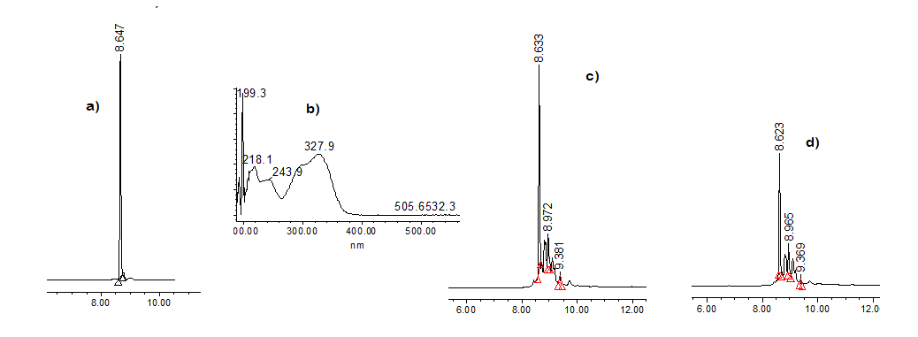

Fig. 2. a) HPLC chromatogram and b) the UV light spectrum of chlorogenic acid standard; b) and c) HPLC chromatogram of CoHA= hydroalcoholic extract and CoM= methanolic extract, respectively.

Insulin resistance
Figure 3 shows the results of the area under the curve (AUC) of plasma glucose concentration after the administration of a dose of insulin (0.8 UI/kg) in all treatment groups. Group HF had the highest AUC (2952.2±704.7 mg/dL·min), which was statistically different from StD basal group (AUC=1799±192.3 mg/dL·min). Treatment with HF + Los, led to a decrease in AUC (1855.7±553.0 mg/dL·min), which was not significantly different from the negative control group (HF) or the StD group. The two experimental treatments with C. obtusifolia differed in their IR outcomes; CoHA had no effect (AUC 2649.5 ± 248.7 mg/dL·min), while CoM led to a significant reduction (*p <0.05), with an AUC value of 1780.3 ± 429.6 mg/dL·min.

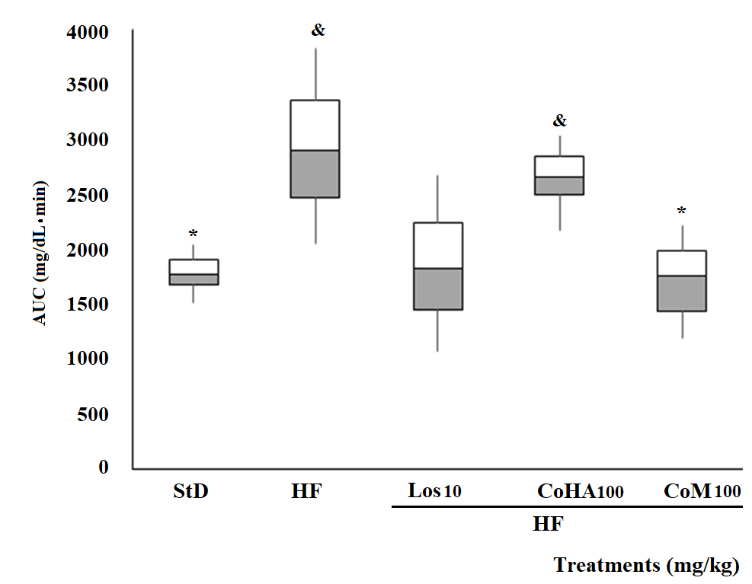

Fig. 3. Area under the curve (AUC) of glucose in response to the administration of 0.8 UI/Kg of insulin in mice with MS induced by hypercaloric diet. The results are expressed as averages ± S.D., n = 8. ANOVA plus Tukey test p≤0.05, (*) compared with HF and (&) compared with StD (Basal group); HF=negative control group with hypercaloric diet; Los10= Losartan® 10 mg kg⁻¹; CoHA= hydroalcoholic extract 100 mg kg⁻¹; CoM= methanolic extract 100 mg kg⁻¹.

Body density
Figure 4 shows the results of body density with respect to treatment. The StD group exhibited a density of ρ=1.27 ± 0.05 g/mL, which not significantly different (p >0.05) from the other treatment groups (HF: 1.21 ± 0.11; Los: 1.25 ± 0.09; CoHA: 1.21 ± 0.16; CoM: 1.20 ± 0.12 g/mL).

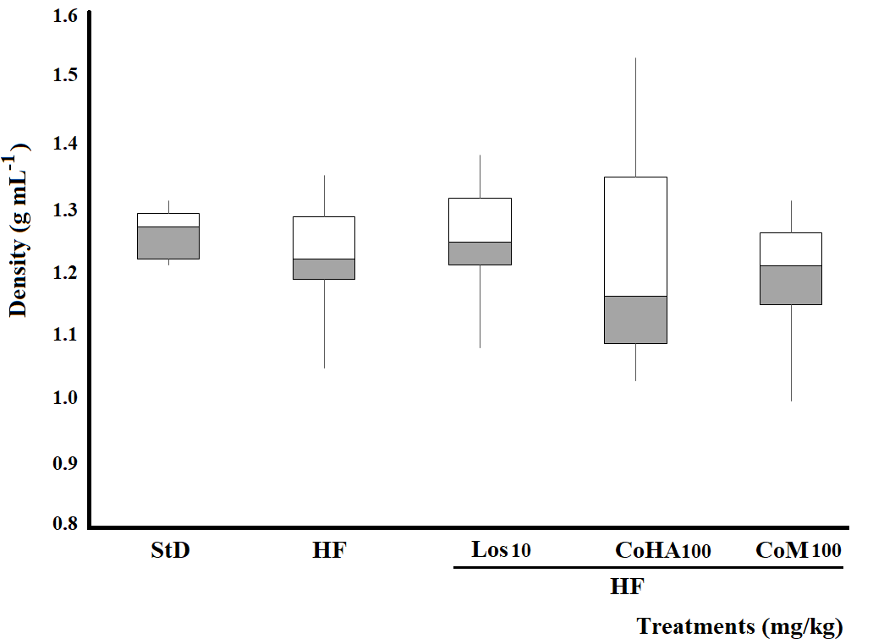

Fig. 4. Body density of mice with MS induced hypercaloric diet. The results are expressed as averages ± S.D., n = 8. ANOVA plus Tukey test p≤0.05, (*) compared with HF and (&) compared with StD (Basal group); HF=negative control group with hypercaloric diet; Los= Losartan® 10 mg kg⁻¹; CoHA= hydroalcoholic extract 100 mg kg⁻¹; CoM= methanolic extract 100 mg kg⁻¹.

Clotting time
Figure 5 shows the results of the test of CT between the HF and StD groups (104.75 ± 58.0 s and 42.2 ± 2.9 s, respectively), which differed significantly from each other (p <0.05). The Los (63.7 ± 17.57 s) and CoM (55.5 ± 9.33 s) groups had a tendency to decrease in CT compared to the HF group, though this trend did not reach statistical significance (p> 0.05). CoHA (92.77 ± 29.79 s) did not induce a difference in this variable compared to the HF group. The three treatment groups differed significantly from the StD group (p <0.05).

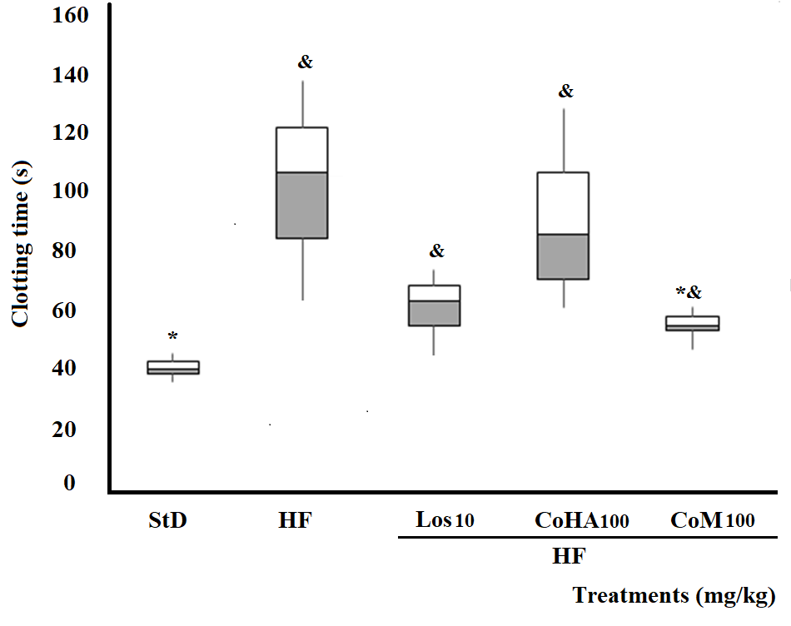
Fig. 5. Clotting time in mice with MS induced by hypercaloric diet. The results are expressed as averages ± S.D., n = 8. ANOVA plus Tukey test p≤0.05, (*) compared with HF and (&) compared with StD (Basal group); HF=negative control group with hypercaloric diet; Los= Losartan® 10 mg kg⁻¹; CoHA= hydroalcoholic extract 100 mg kg⁻¹; CoM= methanolic extract 100 mg kg⁻¹.

Food consumption
Figure 6 shows the results for food consumption, in g/100 g of mouse body mass. The StD group had a consumption of 29.3 ± 2.00 g, which was significantly lower than that of the HF group (*p <0.05), which consumed 68% more food than the StD group. The Los group consumed 9% more food than the StD group and was significantly different from the HF group (p <0.05). In the groups treated with C. obtusifolia, CoHA consumed 28% and CoM 20.6% more food than the StD group. Only CoM differed significantly from the HF group (p< 0.05).

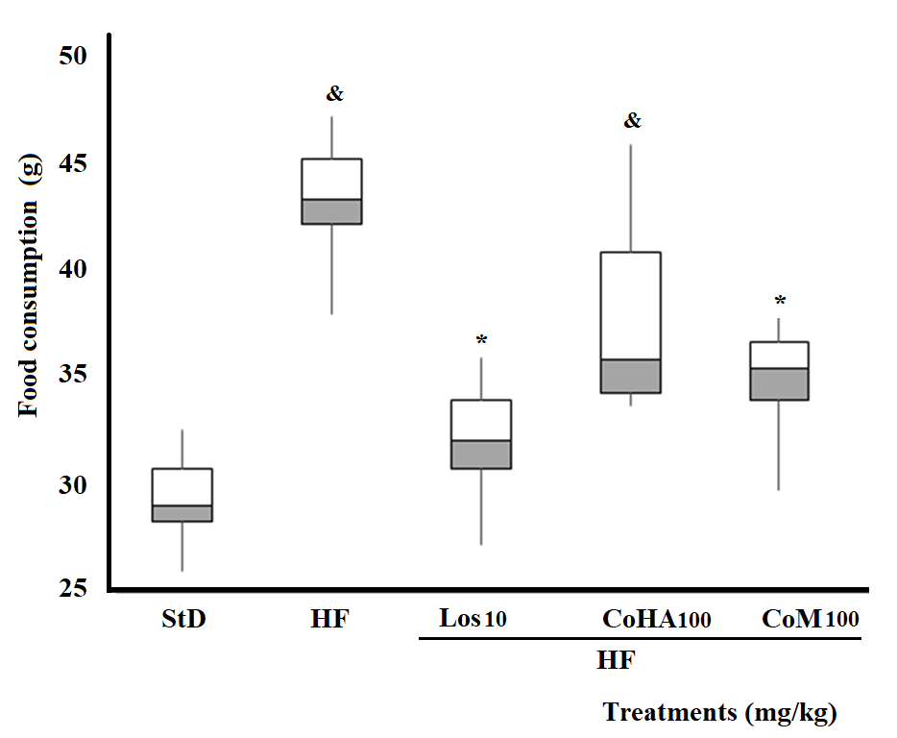
Fig. 6. Food consumption in mice with MS induced by hypercaloric diet. The results are expressed as averages ± S.D, n = 8. ANOVA plus Tukey test p≤0.05, (*) compared with HF and (&) compared with StD (Basal group); HF=negative control group with hypercaloric diet; Los= Losartan® 10 mg kg⁻¹; CoHA= hydroalcoholic extract 100 mg kg⁻¹; CoM= methanolic extract 100 mg kg⁻¹.

Adipose tissue content
Figure 7 shows the outcome of the relative amount of perigonadal and mesenteric adipose tissue. The basal group, StD, had a relative ratio of visceral adipose tissue of 1.75 ± 0.34%. The HF group had a value of 3.15 ± 0.39%, which was significantly higher than the StD group (p <0.05). The Los treatment group had a relative adipose tissue percentage of 1.84± 0.32%, while CoM had a value of 1.95 ± 0.33%, both of which were significantly lower than the HF group.
Meanwhile, CoHA had an adipose accumulation of 3.75 ± 0.46%, which was significantly higher than StD (p <0.05) and did not differ significantly from HF.

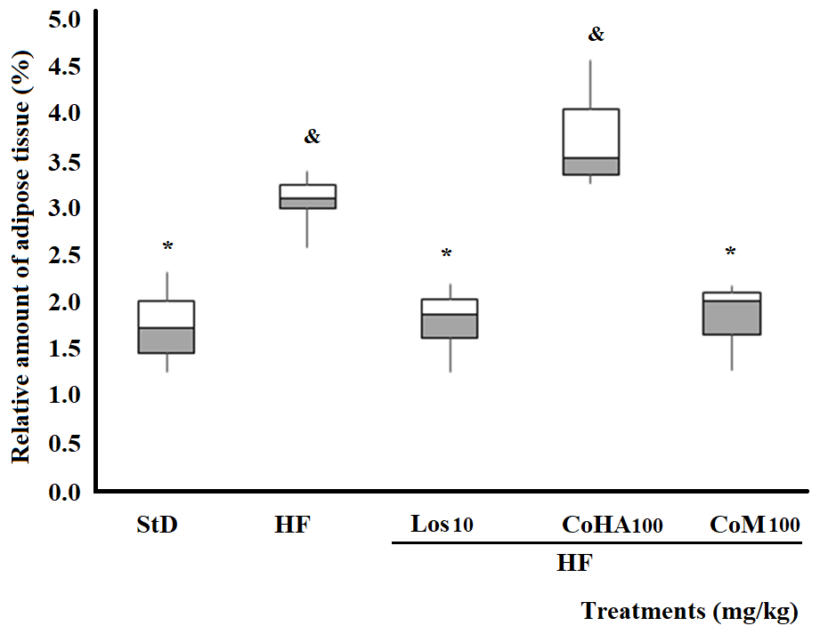

Fig. 7. Relative amount of adipose tissue in mice with MS induced by hypercaloric diet. The results are expressed as averages ± S.D., n = 8. ANOVA plus Tukey test p≤0.05, (*) compared with HF and (&) compared with StD (Basal group); HF=negative control group with hypercaloric diet; Los= Losartan® 10 mg kg⁻¹; CoHA= hydroalcoholic extract 100 mg kg⁻¹; CoM= methanolic extract 100 mg kg⁻¹.

Growth rate
Figure 8 shows that animals receiving only StD presented a growth rate of 0.0095 ± 0.0016 day⁻¹, which was significantly lower than those that received HF, which had a value of 0.0244 ± 0.005 day⁻¹. Thus, the rate in HF was 155% higher than in healthy animals, and the two groups differed significantly (p <0.05). Treatment with Los at 10 mg kg⁻¹ (0.019 ± 0.001 day⁻¹) or with CoHA at 100 mg kg⁻¹ (0.015 ± 0.002 day⁻¹) caused a numerical decrease in growth rate, but this value was not significantly different from the HF group (p >0.05). The CoHA group (100 mg kg⁻¹) did induce a significant decrease in growth rate with respect to the HF group (p <0.05) with a value of 0.011 ± 0.003 day⁻¹.

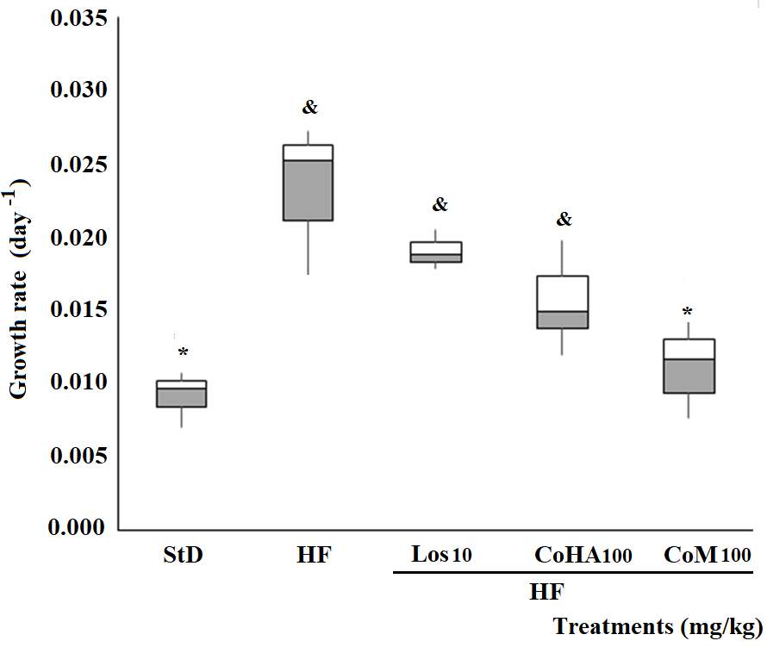

Fig. 8. Growth rates in mice with MS induced by hypercaloric diet. The results are expressed as averages ± S.D, n = 8. ANOVA plus Tukey test p≤0.05, (*) compared with HF and (&) compared with StD (Basal group); HF=negative control group with hypercaloric diet; Los= Losartan® 10 mg kg⁻¹; CoHA= hydroalcoholic extract 100 mg kg⁻¹; CoM= methanolic extract 100 mg kg⁻¹.

Systolic blood pressure
Figure 9 shows the behavior of the systolic blood pressure (SBP). During the last week of treatments, animals that received only StD had a SBP of 103.4 ± 7.9 mmHg; this was significantly lower than the HF group, which had an average SBP of 171.9 ± 11.5 mmHg (p <0.05). Treatment with Los at 10 mg kg⁻¹ (SBP= 120.0 ± 10.3 mmHg), CoHA (SBP=137.8 ± 13.0 mmHg) and CoM (SBP = 126.0 ± 11.1 mmHg) all significantly decreased SBP relative to the HF group (p <0.05).

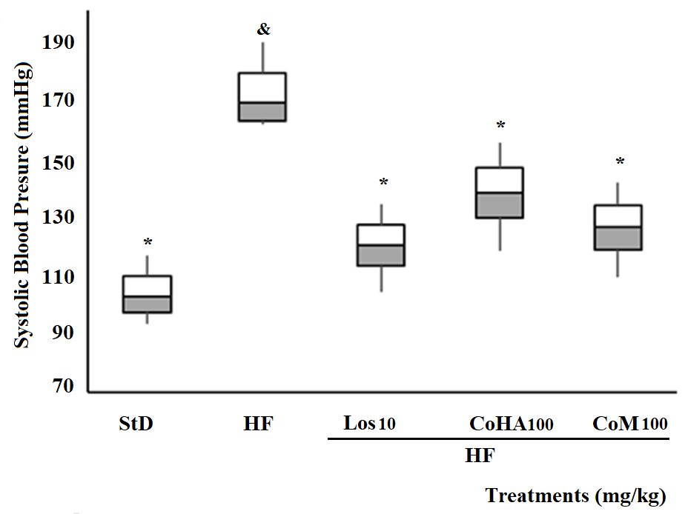

Fig. 9. Systolic blood pressure in mice with MS induced by hypercaloric diet. The results are expressed as averages ± S.D., n = 8. ANOVA plus Tukey test p≤0.05, (*) compared with HF and (&) compared with StD (Basal group); HF=negative control group with hypercaloric diet; Los= Losartan® 10 mg kg⁻¹; CoHA= hydroalcoholic extract 100 mg kg⁻¹; CoM= methanolic extract 100 mg kg⁻¹.

Diastolic blood pressure
With respect to diastolic blood pressure (DBP), Fig. 10 shows that the basal group with the StD diet had a DBP of 75.7 ± 4.8 mmHg. This was significantly lower than the HF group, with an average DBP of 114.7 ± 7.9 mmHg (p <0.05). Individuals treated with Los (DBP = 78.7 ± 7.14 mmHg) or with CoM (DBP = 83.6 ± 13.5 mmgH) showed significantly decreased DBP compared to HF, to the point that they were statistically similar to the StD group (p <0.05). The administration of CoHA tended to decrease DBP, but this trend was not statistically significant compared to the HF group (p >0.05).

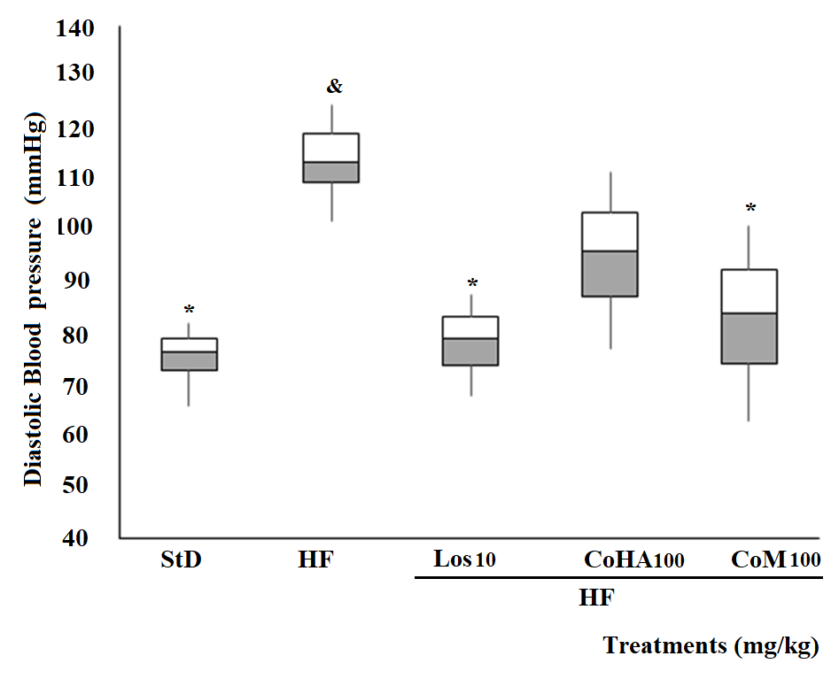

Fig. 10. Diastolic blood pressure in mice with MS induced by hypercaloric diet. The results are expressed as averages ± S.D., n = 8. ANOVA plus Tukey test p≤0.05, (*) compared with HF and (&) compared with StD (Basal group); HF=negative control group with hypercaloric diet; Los10= Losartan® 10 mg kg⁻¹; CoHA= hydroalcoholic extract 100 mg kg⁻¹; CoM= methanolic extract 100 mg kg⁻¹.

Triglycerides and cholesterol
Average plasma concentration of triglycerides in the healthy group (StD) and HF were 1.06 and 1.50 g/L (p <0.05) respectively, (Fig. 11). The groups that received Los, CoHA and CoM showed a decrease in triglyceride concentration but did not differ significantly from the HF group (p >0.05). Regarding total cholesterol concentrations, there were no significant differences between groups (p >0.05), data not shown.

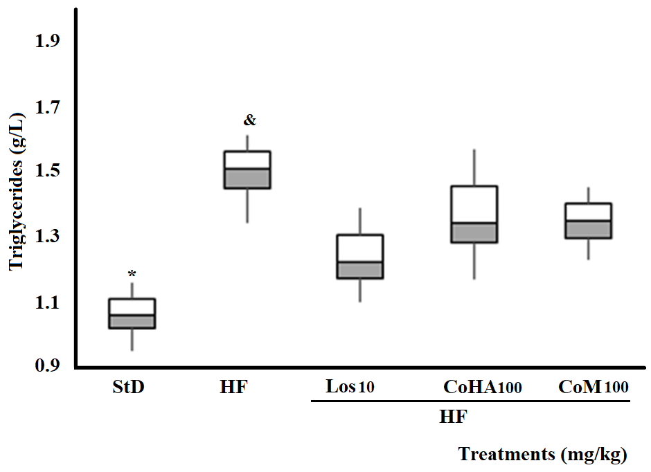

Fig. 11. Plasma triglyceride concentration in mice with MS induced by hypercaloric diet. The results are expressed as averages ± S.D., n = 8. ANOVA plus Tukey test p≤0.05, (*) compared with HF and (&) compared with StD (Basal group); HF=negative control group with hypercaloric diet; Los= Losartan® 10 mg kg⁻¹; CoHA= hydroalcoholic extract 100 mg kg⁻¹; CoM= methanolic extract 100 mg kg⁻¹.

Renal Inflammation
Figure 12 shows the concentration of IL-6 in kidney homogenate; in the healthy group, StD, the mean value was 1032.02 ± 12.0 pg/mg of protein, which was significantly lower than in HF mice (6243.43 ± 71.3 pg/mg of protein; p <0.05). Treatment with Los (10 mg/kg), CoHA (100 mg/kg), or CoM (100 mg/kg), caused a decrease in this inflammation variable with values of 4056.6 ± 93.3, 2553 ± 75.9, and 4524.9 ± 64.4 pg/mg of protein, respectively. Each of these groups differed significantly from both the StD and HF groups (p <0.05).
Figure 13 shows renal tissue concentration of TNF-α. Mice in the HF group presented a significant elevation in this cytokine (7467.8 ± 1325.1 pg/mg of protein) relative to the StD group (1588.9 ± 367.4 pg/mg of protein; p <0.05). The Los, CoHA, and CoM treatments induced a decrease in the concentration of this pro-inflammatory molecule, with 943.2 ± 388.7, 1340.0 ± 251.8 and 1518.8 ± 357.7 pg/mg of protein, respectively. All were statistically different from the HF group (p <0.05).
Figure 14 shows the renal tissue concentration of IL-10, where the StD group had a concentration of 7757.4 ± 1600 pg/mg of protein, while in the HF group the level of IL-10 reached was 12174.6 ± 1781.0 pg/mg of protein. The Los and CoM groups had values of 12763.5 ± 9435 and 13188.6 ± 1543.2 pg/mg of protein, respectively, which did not differ significantly from the HF group. The CoHA group had a significantly higher concentration of IL-10 than the HF group (17033.5 ± 1933.6, p <0.05).

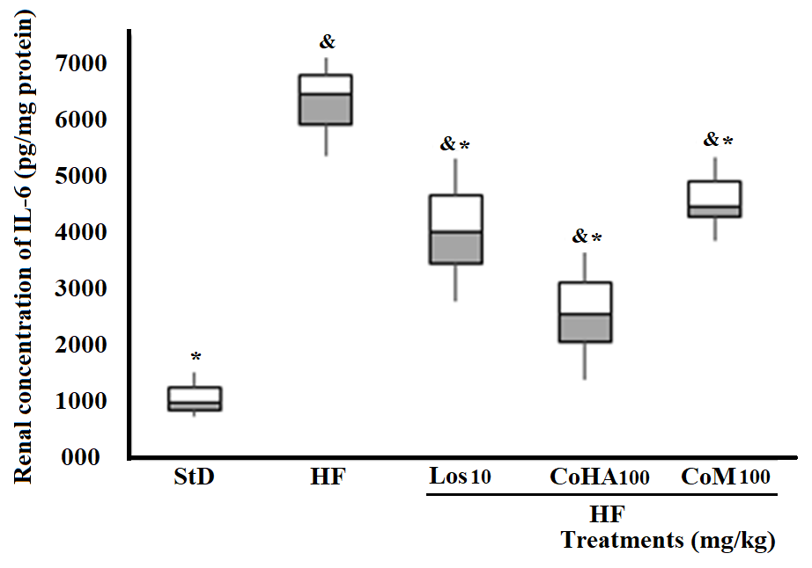
Fig. 12. Plasma concentration of IL-6 in renal tissue of mice with MS induced by hypercaloric diet. The results are expressed as averages ± S.D., n = 8. ANOVA plus Tukey test p≤0.05, (*) compared with HF and (&) compared with StD (Basal group); HF=negative control group with hypercaloric diet; Los= Losartan® 10 mg kg⁻¹; CoHA= hydroalcoholic extract 100 mg kg⁻¹; CoM= methanolic extract 100 mg kg⁻¹.

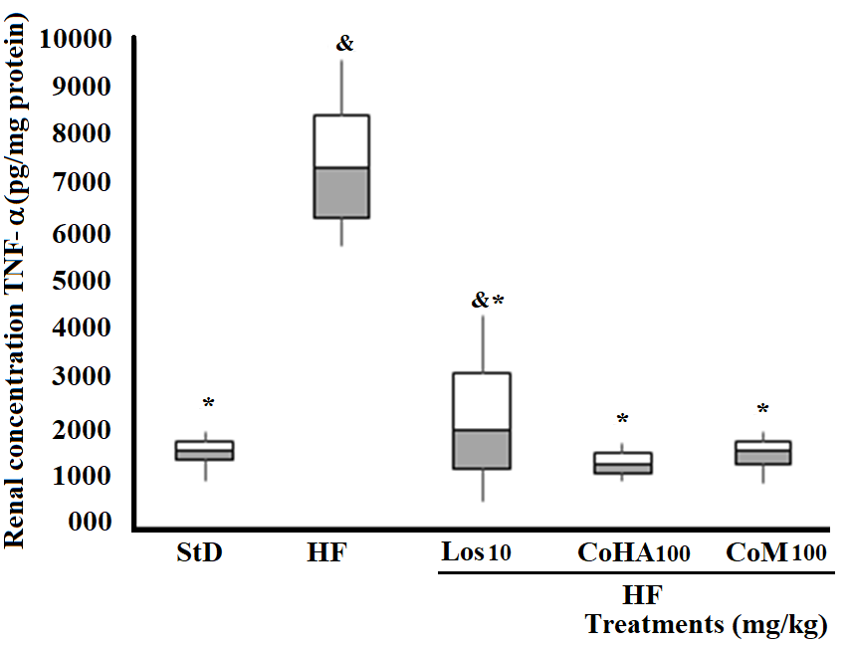
Fig. 13. Plasma concentration of TNF-α in renal tissue of mice with MS induced by hypercaloric diet. The results are expressed as averages ± S.D., n = 8. ANOVA plus Tukey test p≤0.05, (*) compared with HF and (&) compared with StD (Basal group); HF=negative control group with hypercaloric diet; Los= Losartan® 10 mg kg⁻¹; CoHA= hydroalcoholic extract 100 mg kg⁻¹; CoM= methanolic extract 10 mg kg⁻¹.

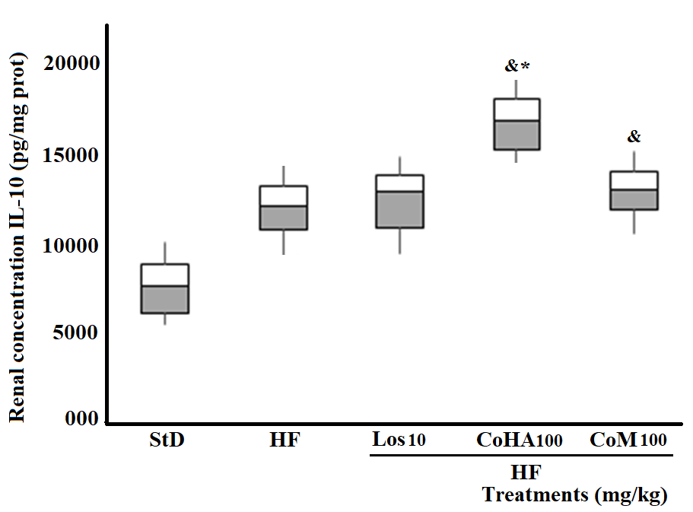

Fig. 14. Plasma concentration of IL-10 in renal tissue of mice with MS induced by hypercaloric diet. The results are expressed as averages ± S.D., n = 8. ANOVA plus Tukey test p≤0.05, (*) compared with HF and (&) compared with StD (Basal group); HF=negative control group with hypercaloric diet; Los= Losartan® 10 mg kg⁻¹; CoHA= hydroalcoholic extract 100 mg kg⁻¹; CoM= methanolic extract 100 mg kg⁻¹.

DISCUSSION

In this study the effect of two extracts of C. obtusifolia, both standardized in CAc, were evaluated using a model of MS induced with a hypercaloric diet in mice. The study is based on the medicinal uses of the plant, which include obesity, hypertension, diabetes, hepatic illness and edema⁸, conditions that are strongly associated with obesity and MS. One link among these conditions is the installation of a persistent pro-inflammatory response, resulting in systemic degenerative damage.

The pharmacological studies described so far indicate that the high-polarity extracts of C. obtusifolia possess anti-inflammatory, antihypertensive and antidiabetic activity in pre-clinical trials. Intravenous administration of the aqueous extract of the leaves of this plant produced an antihypertensive effect in spontaneously hypertensive rats²⁸. Later, Pérez-Guerrero et al.,¹⁷ reported that oral administration of the aqueous extract of leaves of the plant at doses of 125, 250 and 500 mg kg⁻¹ decreased plantar edema induced by carrageenan in rats, and that topical administration inhibited auricular edema induced with 12-O-Tetradecanoylphorbol-13-acetate (TPA). The hypoglycemic effect of the aqueous extract in mice with streptozotocin-induced diabetes was also recently published²⁹.
The present work evaluates the effect of two extracts of high and medium polarity from the leaves of C. obtusifolia, CoM and CoHA, which were standardized in their CAc content. Some of the effects of this medicinal species have been attributed to CAc, together with isoorientin. In this study, the administration of a hypercaloric diet (HF group) led to an increase in IR, in the percentage of adipose tissue, in the growth rate (obesity), in systolic and diastolic BP, in CT and in triglycerides; all of these alterations were counteracted by the administration of CoM at 100 mg kg⁻¹, which is equivalent to a dose of 865 µg kg⁻¹ of CAc. Meanwhile, CoHA (100 mg kg⁻¹), with a higher CAc dose equivalence (1627 µg kg-¹), was not able to reduce these variables, all associated with metabolic syndrome and endothelial dysfunction.
The HF-induced metabolic syndrome was accompanied by an increase in the renal concentration of the cytokines IL-6 and TNF-α. The administration of CoM extract causes a decrease in renal levels of pro-inflammatory mediators.
CoM was also able to decrease the insulin resistance curve, visceral fat and growth rate relative to the HF group. This is consistent with the medicinal use of the plant, in which its usefulness to reduce weight is mentioned⁸. The decrease in IR favors the adequate capture of glucose by sensitive or IR adipocytes and pre-adipocytes (3T3), as reported with an aqueous extract of C. obtusifolia and with CAc directly²⁵. On the other hand, this could be related to the inhibition of glucosidase activity. Other studies have reported that this inhibition is one of the ways already used to control IR and thus, DM2, since their inhibition reduces the decomposition of complex carbohydrates into absorbable monosaccharides, which reduces postprandial glucose and the “need” for insulin within the cell³⁰. The positive effect on IR could also be related to the decrease in the activity of glucose-6-P translocase and gluconeogenesis, as has been observed with both the aqueous and butanolic extracts of C. peltata and C. obtusifolia³¹.
The CoM extract reduced CT, which is likely related to better liver function. Liver damage due to poor diet, in addition to other factors, could cause damage to the liver tissue such as hepatic fibrosis and hepatomegaly with or without ascites. This liver dysfunction is the cause of the main clotting disorders, due mainly to a deficiency in protein C and clotting factors V and VII, which are directly related to the production of prothrombin. In a healthy liver, the clotting cascade functions properly and CT is low³². Upon administration of the aqueous extract of C. obtusifolia for 30 days in mice with streptozotozin, glycogen storage and glycogen synthase levels increased, without changes in gluconeogenesis, which is associated with the hypoglycemic and hepatoprotective effects of the plant by reducing collagen fibers, reducing inflammation, and increasing the levels of IL-10 and adiponectin and decreasing IL-6 and TNF-α²⁹.
In the present work, CoHA and CoM extracts had similar effects on the renal concentration of these cytokines. Obesity is associated with chronic inflammation and is also a risk factor for disorders including chronic kidney disease, diabetes, and cardiovascular events. Inflammation, and hence the molecules that regulate this process, can cause kidney damage to worsen. Thus, an increase in the release of IL-10 as a regulator of inflammation or the decrease in the pro-inflammatory cytokines such as IL-6 and TNF-α induced by some treatments can significantly improve the condition of this organ and of the organism in general.
IL-10 is one of the main modulatory cytokines of the inflammatory response produced by M2 macrophages and T-regulatory cells, and its administration results in the suppression of inflammation and improvement of kidney damage in obese animals and those with diabetes^{33,34}. Increased IL-10 concentration can counteract increased TNF-α concentration³⁵. The CoHA and CoM extracts showed a decrease in the concentration of TNF-α. This cytokine is released by the immune system and contributes to inflammatory processes. It is generated by macrophages in adipose tissue at elevated levels in MS. It is also one of the mediators of IR, since it deactivates insulin receptors and reduces adiponectin concentration. Additionally, the concentrations of IL-6 were lower in both extract treatment groups in comparison with animals fed with HF that received no treatment. This molecule is another cytokine that is implicated in the inflammatory process and is produced by visceral adipose cells that in high levels in plasma is positively associated with obesity and IR. High IL-6 concentrations are predictive of the development of DM2 and future coronary events, since it increases the expression of adhesion molecules in the endothelium and vascular smooth muscle cells. Therefore, IL-6 levels and the expression of its IL-6R receptor have been positively correlated with an increase in body mass index and adiposity, suggesting that obesity is a positive modulator of IL-6 in adipose tissue³⁶. TNF-α and IL-6 have been shown to mediate inflammation in several models of kidney damage, such as glomerulonephritis, acute renal failure, and damage to the interstitial tubule³⁷. The elevation in IL-6 and TNF-α¹¹ levels in kidney homogenate following the administration of hypercaloric diet in this study were counteracted by CoM extract (though the trend of increased IL-10 did not reach statistical significance), thus it consistently improved all of the parameters that were recorded in association with the HF diet. While CoM positively counteracts associated inflammation, it is even the only treatment that significantly elevates IL-10, however, that activity apparently had no influence on the other parameters measured.
A probable explanation for the differences observed between the two C. obtusifolia extract treatments is the difference in the CAc content of each standardized product, together with the presence of other unknown compounds. CAc has various positive biological effects on the damage variables associated with hypercaloric diet. For example, it was recently published that in rats fed a diet high in fat and carbohydrates supplemented with approximately 100 mg kg⁻¹/day of CAc for eight weeks, showed a reduction in visceral fat and both diastolic and systolic blood pressure, counteracting inflammation and liver fat deposition, although it did not modify the lipid profile (Bhandarkar et al., 2019). In addition, Fortis-Barrera et al.,²⁹ found that an aqueous extract of C. obtusifolia containing 0.0052 mg/g of CAc improved lipid metabolism in an animal model of DM. As mentioned above, the concentration of CAc in CoHA extract is almost twice that of the CoM extract, which could indicate that a lower dose of CAc may be even better. However, it should also be taken into account that the evaluated extracts of C. obtusifolia contained other metabolites in addition to CAc that may participate in their actions.
LIMITATIONS OF THE STUDY

CONCLUSION

The methanolic extract (CoM) of C. obtusifolia leaves had high efficacy; it reduced IR (a triggering factor for diabetes) and had a tendency to reduce CT, which may be related to better liver function. It also reduced visceral fat and increased the presence of the anti-inflammatory IL-10, while decreasing IL-6 and TNF-α levels. The CoHA extract content of CAc was higher than that of CoM, and notably decreased the renal levels of the quantified pro-inflammatory cytokines, without modifying other variables in mice fed with HF.
Acknowledgments
This work was supported by “Fondo de Investigación en Salud-IMSS” (FIS/IMSS/PROT/G11-2/1023) grants.
Declaration of Competing Interest
The authors declare that they have no competing interests.
Author contributions:
A-S L obtained the funding resources; J-F E, A-S L, designed the experiments and wrote the paper. M-H Y, A-S L, performed experiments; H-R M analyzed data. G-R A, G-C M, and Z A did chemical analysis. All authors have read and approved the final manuscript.

REFERENCES

- Palomo I, Morre-Carrasco R, Alarcón M, Rojas A, Mujica V, Hasbun S. Fisiología del estado protrombótico en el síndrome metabólico. Acta Médica Colombiana 2009; 32:80-84.
- Rochlani Y, Pothineni NV, Kovelamudi S, Mehta JL. Metabolic syndrome: pathophysiology, management, and modulation by natural compounds. Ther Adv Cardiovasc Dis 2017; 11:215–225. https://doi.org/10.1177/1753944717711379
- Shamah LT. Encuesta Nacional de Salud y Nutrición de Medio Camino 2016. Instituto Nacional de Salud Pública, Cuernavaca, México. 2016; pp. 36–64. https://www.insp.mx
- INEGI (Instituto Nacional de Estadística y Geografía) Características de las defunciones registradas en México durante 2019. Comunicado de Prensa Núm. 480/20, 29 de octubre de 2020 https://www.inegi.org.mx (Consulted April 22, 2020).
- Gutiérrez-Solís AL, Datta BS, Méndez-González RM, Prevalence of metabolic syndrome in Mexico: A systematic review and meta-analysis. Metab Syndr Relat Disord 2018; 16:395-405. http://doi.org/10.1089/met.2017.0157
- Barquera S, Hernández-Barrera L, Trejo-Valdivia B, Shamah T, Campos-Nonato I, Rivera-Dommarco J. Obesidad en México, prevalencia y tendencias en adultos Ensanut 2018-19. Salud Pública de México 2020; 62:682-692. https://doi.org/10.21149/11630
- Alberti KG, Zimmet P, Shaw J. Metabolic syndrome a new world-wide definition. A Consensus Statement from the International Diabetes Federation. Diabetic Medicine 2006; 23:469–480. https://doi.org/10.1111/j.1464-5491.2006.01858.x
- Argueta AL, Cano L, Asselein L, Rodarte ME, Coords. Atlas de las plantas de la medicina tradicional mexicana. Instituto Nacional Indigenista (INI) II. Cd México, México, 1994; pp. 706-707.
- Andrade-Cetto A, Heinrich M. Mexican plants with hypoglycemic effect used in the treatment of diabetes. J Ethnopharmacol 2005; 99:248-325. https://doi.org/10.1016/j.jep.2005.04.019
- Esquivel-Gutiérrez E, Noriega-Cisneros R, Saavedra-Molina A, Salgado-Garciglia R. Plants used in Mexican folk medicine with antidiabetic and antihypertensive properties. Pharmacology on Line 2013; 2:15-23.
- Vidrio H, García-Márquez F, Reyes J, Soto R. Hypotensive activity of Cecropia obtusifolia. Journal of Pharmaceutical Sciences 1982; 71:475-476. https://doi.org/10.1002/jps.2600710433
- Guerrero EI, Morán-Pinzón JA, Ortíz LG, Olmedo D, del Olmo E, López-Pérez JL, San Feliciano A, Gupta MP. Vasoactive effects of different fractions from two Panamanians plants used in Amerindian traditional medicine J Ethnopharmacol 2010; 131:497-501. https://doi.org/10.1016/j.jep.2010.06.036
- Caballero-George C, Vanderheyden PML, Solis PN, Pierter L, Shahat AA, Gupta MP, Vauquelin G, Vlietinck AJ. Biological screening of selected medicinal Panamanian plants by radioligand-binding techniques. Phytomedicine 2001; 8:59-70. https://doi.org/10.1078/0944-7113-00011
- Mellado V, Lozoya M. Effect of the aqueous extract of Cecropia obtusifolia on the blood sugar of normal and pancreatectomized dogs. Int J Crude Drug Res 1985; 22:11-16. https://doi.org/10.3109/13880208409070645
- Pérez G, Ocegueda Z, Muñoz L, Ávila A, Morrow W. A study of the hypoglucemic effect of some Mexican plants. J Ethnopharmacol 1984; 12:253-262. https://doi.org/10.1016/0378-8741(84)90054-0
- Román-Ramos R, Flores-Sáenz J, Partida-Hernández G, Lara-Lemus A, Alarcón-Aguilar F. Experimental study of the hypoglycemic effect of some antidiabetic plants. Archivos de Investigación Médica 1991; 22:87-93.
- Pérez-Guerrero C, Herrera M, Ortiz R, Alvares M, Ángeles M. A pharmacological study of Cecropia obtusifolia Bertol. aqueous extract. J Ethnopharmacol 2001; 76:279-284. https://doi.org/10.1016/S0378-8741(01)00253-7
- Vargas H, Ulate M. Diabetic effect of Cecropia obtusifolia (Moraceae) on albino rats. Rev Biol Trop 1996; 44:93-96.
- Andrade-Cetto A, Wiedenfeld H. Hypoglycemic effect of Cecropia obtusifolia on streptozotocin diabetic rats. J Ethnopharmacol 2001; 2-3:145-149 https://doi.org/10.1016/S0378-8741(01)00335-X
- Babu S, Jayaraman S. An update on β-sitosterol: A potential herbal nutraceutical for diabetic management. Biomed Pharmacother 2020; 131:110702. https://doi.org/10.1016/j.biopha.2020.110702
- Hemmerle H, Burger H, Below P, Shubert G, Rippel R, Schindler P, Paulus E, Herling A. Chlorogenic acid and synthetic chlorogenic acid derivatives: novel inhibitors of glucose-6-phosphate translocase. J Med Chem 1997; 40:137-145. https://doi.org/10.1021/jm9607360
- Sezik E, Aslan M, Yesilada E, Ito S. Hypoglycaemic activity of Gentiana olivieri and isolation of the active constituent through bioassay-directed fractionation techniques. Life Sci 2005; 76:1223-1238. https://doi.org/10.1016/j.lfs.2004.07.024
- Herrera-Arellano A, Aguilar-Santamaría L, García-Hernández B, Nicasio-Torres P, Tortoriello J. Clinical trial of Cecropia obtusifolia and Marrubium vulgare leaf extracts on blood glucose and serum lipids in type 2 diabetics. Phytomedicine 2004; 11:561-566. https://doi.org/10.1016/j.phymed.2004.01.006
- Revilla-Monsalve M, Andrade-Cetto A, Palomino-Garibay M, Wiedenfeld H, Islas-Andrade S. Hypoglycemic effect of Cecropia obtusifolia Bertol. aqueous extract of type 2 diabetic. J Ethnopharmacol 2007; 111:636-640. https://doi.org/10.1016/j.jep.2007.01.014
- Alonso-Castro A, Miranda-Torres A, González-Chávez M, Salazar-Olivo L. Cecropia obtusifolia Bertol. and its active compound, chlorogenic acid, stimulates 2-NBDglucose uptake in both insulin-sensitive and insulin-resistant 3T3 adipocytes. J Ethnopharmacol 2008; 120:458-464. https://doi.org/10.1016/j.jep.2008.09.019
- Martínez TV, Ordáz TM, Castañeda SAN, Andrade-Cetto A, Rodríguez-Arnaiz R. Genotoxicity testing of Cecropia obtusifolia extracts in two in vivo assays: the wing somatic mutation and recombination test of Drosophila and the human cytokynesis-block micronucleus test. J Ethnopharmacol 2008; 116:58-63. https://doi.org/10.1016/j.jep.2007.10.041
- Gómez-Rivera A, González-Cortazar, Gallegos-García AJ, Escobar-Ramos A, Flores-Franco G, Lobato-García CE. Spasmolytic, anti-inflammatory, and antioxidant activities of Salvia gesneriflora Lindley. African Journal of Traditional, Complementary and Alternative Medicines 2018; 15:72-82. https://doi.org/10.21010/ajtcam.v15i4.10.
- Salas I, Brenes JR, Morales OM. Antihypertensive effect of Cecropia obtusifolia (Moraceae) leaf extract on rats. Revista de Biología Tropical 1987; 35:127-30.
- Fortis-Barrera MA, Alarcón-Aguilar FJ, Becerril-García A, Flores-Sáenz JLE, Almanza-Pérez JC, García-Lorenzana M, Lazzarini-Lechuga RC, Román-Ramos R, Blancas-Flores G. Mechanism of the hypoglycemic activity and hepatoprotective effect of the aqueous extract of Cecropia obtusifolia Bertol. J Med Food 2020; 23:783-792. https://doi.org/10.1089/jmf.2019.0126
- Andrade-Cetto A, Becerra-Jiménez J, Cárdenas-Vázquez R. Alfa-glucosidase-inhibiting activity of some Mexican plants used in the treatment of type 2 diabetes. J Ethnopharmacol 2008; 116:27-32. https://doi.org/10.1016/j.jep.2007.10.031
- Andrade-Cetto A, Cárdenas-Vázquez R. Gluconeogenesis inhibition and phytochemical composition of two Cecropia species. J Ethnopharmacol 2010. 130:93-97. https://doi.org/10.1016/j.jep.2010.04.016
- Nieuwenhuizer V, Peters M, Lubbers L, Trip M, Tijssen J, Mulder B. Abnormalities in liver function and coagulation profile following the Fontan procedure. Heart 1999; 82:40-46. http://dx.doi.org/10.1136/hrt.82.1.40
- Mu W, Ouyang X, Agarwal A, Zhang L, Long DA, Cruz PE, Roncal CA, Glushakova OY, Chiodo VA, Atkinson MA, Hauswirth WW, Flotte TR, Rodriguez-Iturbe B, Johnson RJ. IL-10 suppresses chemokines, inflammation, and fibrosis in a model of chronic renal disease. J Am Soc Nephrol 2005; 16:3651–3660. https://doi.org/10.1681/ASN.2005030297
- Ogura M, Urabe M, Akimoto T, Onishi A, Ito C, Ito T, Tsukahara T, Mizukami H, Kume A, Muto S, Kusano E, Ozawa K. Interleukin-10 expression induced by adeno-associated virus vector suppresses proteinuria in Zucker obese rats. Gene Ther 2012; 19:476–482. https://doi.org/10.1038/gt.2011.183
- Meador BM, Krzyszton CP, Johnson RW, Huey KA. Effects of IL-10 and age on IL-6, IL-1β, and TNF-α responses in mouse skeletal and cardiac muscle to an acute inflammatory insult. J Appl Physiol 2008;104:991-997. https://doi.org/10.1152/japplphysiol.01079.2007
- Sindhu S, Thomas R, Shihab P, Sriraman D, Behbehani K, Ahmad R. Obesity is a positive modulator of IL-6R and IL-6 expression in the subcutaneous adipose tissue: significance for metabolic inflammation. PLoS ONE 2015; 10:E0133494. https://doi.org/10.1371/journal.pone.0133494
- Ihab M, Robert H. Obesity and obesity-initiated Metabolic Syndrome: mechanistic links to chronic kidney disease. Clin J Am Soc Nephrol 2007; 2:550-562. https://doi: 10.2215/CJN.04071206

