**Reviewer’s Comments**

**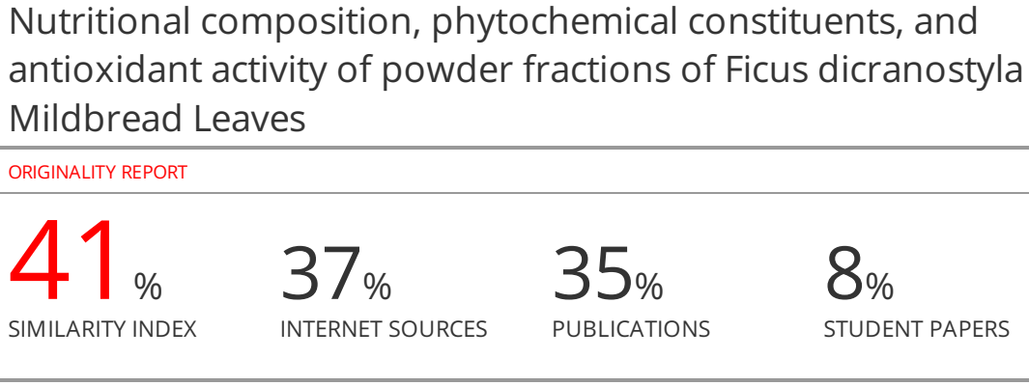**

**Nutritional composition, phytochemical constituents, and antioxidant activity of powder fractions of** *Ficus dicranostyla*Mildbread Leaves

Abstract

**Background and objective:**The research on nutritional and health-benefiting compounds has increased in leafy vegetables such as *Ficus dicranostyla****.***The current study was conducted to evaluate the effect of sieved-based fractionation on nutrient content, polyphenolic components, and antioxidant activities of *Ficusdicranostyla* leavespowder.

**Methods:** Driedleavespowderwassieved at threesize classes (<125 µm, between 250 and 125µm, ≥ 250 µm) and unsievedpowderwasproduced and characterized for proximate composition, minerals, total phenolic, and flavonoids contents, as well as antioxidant activity. Nutrient quantities were expressed in g/100g of crude leaves.

**Results:** Statisticsresultsrevealed a significant difference among fractions composition, as well as antioxidant activity with DPPH and FRAP assays. Proteins (19.60 - 26.08), lipids (5.33 - 10.40), and ash (11.44 - 16.60) contents were increased in small size fractions, while carbohydrates (40.19 – 50.88) and fibers (9.08 – 15.04) contents were lowered. Similarly, minerals namely iron, copper, magnesium, and zinc increased (3.26 - 9.68, 9.09 - 24.41, 1.38 - 2.33, and 3.79 - 8.55 g/100 g, respectively). In addition, phenolic compounds and flavonoids, as well as antioxidant activity were also higher in smaller powder particles. The powder fraction of < 125 µm (smaller particle) showed the highest phenolic content and antioxidant activity, demonstrating the importance of sizing in the profitability of functional food ingredients.

**Conclusion:** Data analysisclearly demonstrates that *Ficus dicranostyla*leaf powder could be recognized as a source of nutritive compounds and antioxidants. *Ficus dicranostyla-*derived functional ingredients could be prepared for the nutritive purpose and oxidative stress-related disease prevention.

**Keywords**:*Ficus dicranostyla*, mineral compositions, antioxidant.

**Introduction**

Wild edible plants are consumed across the world and often traded in urban markets, particularly in African countries. In Cameroon, they serve as food sources, herb tea, and for health purposes 1-4. Leafy vegetables existing in nature represent an important source of phytochemicals including phenolic compounds along with nutrients such as proteins, fats, carbohydrates, and minerals3,5,6. Research approaches have confirmed that some of these species have therapeutic value, due to the presence of biologically active compounds, and therefore, can be considered food-medicine or functional food7,4. Of paramount functional importance, antioxidant activity is supposed to be the basis of numerous bioactivities in plants. Indeed, some phytochemicals are potent antioxidant agents against free radicals and have several potential health benefits including treatment of oxidative stress-related diseases or improving the nutritional status of consumers8,9.

*Ficus dicranostyla* (*Moraceae*family) is a wild edible plant found in savannas and Guinean forests, on rocky hills, and laterite slabs10. It has been found from Senegal to Cameroon and is highly distributed from Uganda to Zambia 11,12. This plant is almost entirely edible, and its inflorescences, leaves, barks as well as stems, are part of traditional meals in the Far North Region of Cameroon13.Similar to another *Ficus* species, its leaves could be considered a source of nutritional elements and phytochemicals14. A Previous study has reported the antioxidant activity of polyphenolic solvent extracts of *F. dicranostyla*1. These leaves could therefore fit the description of an ideal complementary food matrix and a significant challenge that can increase consumption is keeping its nutritional value through its supply chains and/or processing into functional food.

Recently, successive grinding followed by sieving fractionation powder as a new tool or a novel approach for improving plant nutrients, polyphenols, and antioxidants of plant matrices has received great attention15. Indeed, particle size affects extraction yield and thus health-promoting compounds. Fine particle fractionation has been associated with the enrichment of nutrients in several plant parts, including fruits, leaves, roots, and barks16-20, where it has been found that molecules are distributed according to the size of the particle. Therefore, this study aimed to assess the influence of particle size fractionation by sieving on proximate, minerals, and phenolic phytochemical compounds as well as the antioxidant activity of *F. dicranostyla*powders.

Materials and Methods

Plant material

The Plant materialused in the presentstudyconsist of *Ficus dicranostyla*Milabread(Collector: R. Letouzeynumber 6951; Herbariumnumber 8618 SRF/ Cam). Leaveswereharvested in July 2021 in the locality of Mokolo, situated in Maroua, the capital of the Far Nord Region of Cameroon.Fresh mature leaveswerepluckedcarefully and gentlyusing hands in the morning. The leaveswerecleaned and washedwithtap water to removedust, dirt, and anyother type of stickymaterial. The clean leavesweredrained and air-dried in a ventilatedoven at 40 °C for 24 h. Driedleaveswerethenground to obtain a fine powdersuitable for sievedfractionation.

**Plant grinding**

The electric BIOBASE Disintegrator grinder (Model MPD-102, No : 61 South Gongye Road Jinan City, China ; Serial No: 20020020) suppliedwith a sievedrilledwith 1 mm trapezoidalholeswereused for grindingdried*Ficus dicranostyla*leaves. Grindingwasoperated at 1400 r/min for 1 min in ambient air.

**Powder sieving**

Milled *Ficus dicranostyla* leaves were fractionated with an electriclaboratorysieve shaker(MINOR.) according to their particle size. The sieving process is based on the separation of particles from agranular material through several sieves ofdecreasing mesh size.Practically, *Ficus dicranostyla*leafpowder was divided into two lots: the first lot of unsieved powder served as control. The second batch was sieved in different particle sizes (**Figure 1**). Twoselectedsieves of various apertures (125 and 250 µm) wereinstalled on the MINOR sieveshaken operating by vertical vibration at 0.5 mm vibration amplitude. For each batch, 50 g of motherpowderwaspoured on the top sieve, and sievingwasperformed in the permanent mode for 15 min. Afterthat, the powder mass retained on eachsievedwascollected and weighed. This permit to produce of threepowder fractions according to their particle size class: less than125 µm (called < 125 µm), between 125 and 250 µm (noted 125 - 250 µm), and greater than 250 µm (referred to as ≥ 250 µm) and herein they were referred to large (L), medium (M) and Small (S). The obtained powder fractions werepackagedintopolyethylenebottles and stored at 4°C untilfurtheranalysis.

Powder recovery or fraction mass (%) was calculated and defined as the ratio of the mass of powder dry matter collected on each sieve to the weight of the total sieved powder. It is an indicator for the industry since a higher yield means more benefit. Fraction mass was calculated according to the following formula:

$$Fraction mass \left(\%\right)=\frac{Weight of each powder fraction }{weight of total sieved powder}×100$$

**Proximate analysis of plant powders**

The content of moisture, fat, fiber, proteins, carbohydrates, and ash of vegetable fractions wasdetermined. The determination of moisture content wascarried outfollowing the official AOAC21method. Briefly, vegetableleafpowder (5 g) wasoven-dried at 103 ± 2°C for 24 h, transferred to a desiccator, and allowed to cool at room temperature. The sampleweightwasrecordedwith a digital balance. Ash content wasevaluated by incinerating 5 g of powder in a mufflefurnace at 550 °C for about 12 h or until a constant weight of greyish white ashwas obtained21. Total protein content wasdeterminedaftermineralization by the Kjeldahl method22, and colorimetricdeterminationwasdescribed by Devani*et al*.23, with a nitrogen conversion factor of 6.25. Crude fat content wasdeterminedin 5 g of powdersample by soxhlet extraction methodusing hexane as extraction (8 h) solvent24. Carbohydrate content wasdeterminedaccording to Dubois *et al.*25methodsusingsulfuricacid. The experiment was done in three replicates.

**Determination of minerals**

The mineral composition was determined on ash, obtained by incineration of powders in a mufflefurnace at 550°C26. All minerals were extracted after the dissolution of ash (1 g) in 10 mL of hydrochloric acid (1.5 N) and the mixture was heated on a hot plate until complete dryness. A few drops of H2O2 and 5 mL of de-ionized water were then added and completed to 25 mL in a calibrated flask. The resulting solutions were used for determination in triplicate of iron (Fe), copper (Cu), magnesium (Mg), and zinc (Zn) on Atomic Absorption Spectrophotometry (AAS) (Hitachi, Tokyo, Japan).

**Determination of phenolic bioactive compounds**

**Extraction of phenolic compounds from powder samples**

The selective extraction of the phenolic compounds was achieved through the Deli *et al.*16protocol, in which the maceration of dried plant powder with solvent was chosen as an extraction method to minimize possible degradation of the matrix active compounds. About 2 g of powder were solubilized in extracted 20 mL of solvent mixture methanol/water (70/30, v/v). The mixture was allowed to stir at 300 rpm using a magnetic stirrer (Pierron MT 15140) for 24 hr at room temperature and then filtered through Whatman N°1 filter paper to remove insoluble residues. The filtrate was then completed to 15 mL by addition of extraction solvent and stored at 4°C until analysis for their contents in phenolics and antioxidant activities.

**Determination of total phenolic content (TPC)**

The determination of total phenolic content (TPC) wasconducted as previously27using a Folin-Ciocalteureagent (diluted up to 10-fold). Briefly, 20 µL of hydromethanolicextract of sampleswas mixed with 2.980 µL distilled water. Then, 500 µL of 10% (v/v) Folin–Ciocalteureagentfreshlyprepared and 400 µL of a saturated solution of sodiumcarbonate Na2CO3 (20%, w/v) wereadded. The mixture was mixed well and allowed to equilibrate for 30 min at room temperature in dark. All readingswererecorded in triplicates at 760 nm in a UV-Vis spectrophotometer. A calibration curve (R2 = 0.98) waspreparedusing standard solutions of gallicacid (40 to 280 g/L, R2 = 0.99). The total phenolic content wasexpressed as milligramgallicacidequivalents per gram dry weight basis (mg GAE/g DW).

**Determination of flavonoid content (FLC)**

Flavonoid content was determined by spectrophotometry according to the method of Dewanto*et al.*28. Practically, to a 0.1 mL of extract, 2.4 mL of distilled water followed by 0.15 mL of 5% (w/v) sodium nitrite (Na2NO2) were added. After 6 min, 0.3 mL of 10% aluminium chloride (AlCl3·6H2O) (w/v) was added. The mixture was kept at room temperature for 5 min, and 1 mL 4% (w/v) sodium hydroxide (NaOH, 1 M) was added. The absorbance of the solution was measured at 510 nm using UV/visible spectrophotometry against the extraction solvent as blank. The results were expressed in milligrams of rutin equivalents per gram of dry weight (mg RE/g DW), based on a calibration curve derived by linear regression, established from different concentrations (20 to 140 g/L; R2 = 0.99) of rutin as standards.

**Determination of *in vitro* antioxidant activities**

**DPPH radical scavenging assay**

Antioxidant activity was first evaluated by the 1,1-diphenyl-2-picrylhydrazyl (DPPH) radical scavenging method which measures the hydrogen atom or electron-donation ability of the extracts29. Briefly, 0.5 mL of hydromethanolic extract of plant powder or ascorbic acid (employed as reference) at different concentrations (0.025, 0.05, 0.1, 0.5, 1, and 5, 10, 100 mg/mL) were allowed to react with 2 mL of 0.1 mM DPPH methanolic solution in the dark for 1 h at room temperature and absorbance (Abs) was taken at 517 nm using UV/visible spectrophotometry. The radical scavenging activity was estimated as a percentage of DPPH discoloration using the equation 8:

$Radical scavenging activity (\%)=\frac{(Control Abs – Sample Abs}{Control Abs} x 100$ (equation 8)

IC50 value, which is the inhibitory concentration of the crude extract that could scavenge 50% DPPH radical or inhibit oxidation by 50% was determined from a plot of inhibition percentage against extract concentration. The IC50 value is inversely related to the activity and a lower IC50 value means higher antioxidant activity.Ascorbic acid standard showed the IC50 value of 15.69 ± 1.96 µg/mL.

**Ferric reducing antioxidant power**

Ferric reducing antioxidant power (FRAP) was also chosen for specification Fe3+ reducing to Fe2+ capability of analyzed powder extracts30. Practically, 1 mL of the extract of each powder sample was mixed with 2.5 mL of phosphate buffer (200 mM, pH 6.6) and 2.5 mL of potassium ferricyanide [K3Fe (CN)6] solution (1 %, w/v). The mixture was incubated in a water bath at 50 ˚C for 30 min, cooled, mixed with 2.5 mL of trichloroacetic acid solution (10 %, w/v), and centrifuged at 3000 rpm for 10 min. The supernatant (2.5 mL) was removed and mixed with 2.5 mL of distilled water and 0.5 mL of FeCl3 (1 %, w/v), allowed to react for 10 min at room temperature, and the absorbance values were measured at 700 nm. A calibration curve was plotted from the line obtained with the ascorbic acid solution used as a reference at different concentrations. Ferric reducing antioxidant power is determined by referring to this calibration curve of ascorbic acid and expressed in terms of mg ascorbic acid equivalent per g of dry weight (mg AAE/g DW) of a sample. The formation of an intense blue color indicates a stronger antioxidant capacity.

**Statistical analysis**

Data were presented as mean ± standard deviation with three replications per sample. A one-way ANOVA test with one factor (particle size) was used to determine the occurrence of statistically significant differences. The level of statistical significance was set at p < 0.05. Duncan’s multiple range test was used to determine the degree of significance of the difference between the two means. Stat graphics centurion version 16.1 was used for this purpose. Sigma plot 11.0 was used to plot graphs. Pearson correlation coefficients were used to examine correlations between total phenolic and mineral content, and antioxidant activity in *Ficus dicranostyla*leaves powders. Principal Component Analysis (PCA) was conducted to analyze the degree of correlation between chemical composition and antioxidant properties of powders.

Results and discussion

**Powder recovery**

From the analysis, a small fraction of < 125 µm was observed to be more represented in the crude powder of *F. dicranostyla*(43.89%), followed by the medium (32.46%) and the large (23.65%) fraction. The sieving process provided sufficient amounts of all considered granulometric classes, as the lower mass fraction retained on sieves of different meshes was still superior to 23%. Thus, sieving allowed particles of *F. dicranostyla*leaves to be separated in granulometric classes composed of particles well different in size. Noumi*et al*.20 reported similar observations on *Eucalyptus* leaves powder which passes freely through the sieved openings. Also, the sieving procedure was reported efficient for *H. sabdariffa* and *D. glomerata* powders, as obtained granulometric had well different in size17.

**Proximate value**

The moisture, lipid, proteins, ash, carbohydrates, and fiber contents of *F. dicranostyla*leaves powderwere: 4.07, 6.33, 21.93, 13.60, 44.97, and 12.80 g/100 g of dried weight (DW), respectively (**Table 1**).The low level of moisture of *F. dicranostyla*leaves powder (generally lower than 10%) was highly predictable, as a good storage ability of analyzed powders31. This nutritional value of *F. dicranostyla* leaves powder was higher than those reported for three consumed leafy vegetables of the North-West Region of Cameroon, namely *Xymalosmonospora*, *Mentha longifolia,* and *Amaranthus sp*(12.23; 10.34 and 7.8 g/100 g DW, respectively), lipids (1.032; 14.67 and 1.44 g/100 g DW, respectively) and carbohydrates (17.73; 27.05 and 20.13 g/100 g DW, respectively)3. Interestingly, higher ash content suggests that *F. dicranostyla*leaf powder could be a source of minerals. If 100 g of *F. dicranostyla*leaves powder provides 21.93 g/100 g DW of proteins, this indicates that vegetable leaves could be rich sources of protein. The Recommended Dietary Allowance (RDA) of protein for children, adult males, adult females, pregnant women, and lactating mothers are 28; 63; 50; 60, and 65 g, respectively. On the other hand, its fiber contents are important in improving the digestive system, controlling blood glucose levels in diabetes and cholesterol levels in cardiovascular diseases, preventing constipation as well as reducing the risk of colon cancer32-34.

It can be also noted that fractionation of *F. dicranostyla*leaves powder according to the particle size resulted in significant (p < 0.05) differences in the powder composition (**Table 1**). The moisture (4.07 to 5.73 g/100 g), lipid (5.33 to 10.40 g/100 g), protein (19.60 to 26.08 g/100 g), and ash (11.44 to 16.60 g/100 g) contents expressed in dried basis, indicated an increase with reducing powder particle size, contrary to carbohydrate and fiber contents which were more concentrated the larger fractions. Therefore, the larger powder fraction was enriched in fiber and carbohydrate contents, whereas the smallest powder fraction was enriched in lipid, proteins, ash, and moisture contents. Results of the present study were consistent with the fact that the smaller particle is richer in ash, lipid, and proteins, because fibrous plant parts are harder to grind, resulting in larger particles35-37. On other hand, the results of moisture may be explained by the high surface of small particles, facilitating the absorption of surrounding air humidity. Similar observations were previously made for *Dichrostachys glomerata*, *Boscia senegalensis*and *Hibiscus sabdariffa* powders16 and *on Eucalyptus grandis* powders38. According to these reports, powder fraction with smaller particle size was found to possess higher ash content and smaller fiber contents (hemicellulose and cellulose).

**Mineral analysis**

A total of four mineral elements namelyiron, copper, magnesium, and zinc were determined in powder fractions and unsieved powder from *F. dicranostyla*leaves, as shown in **Table 1**. From the results, there was a demarcation in the amount of copper (15.10 ± 0.14 mg/100 g DW) followed by iron and zinc with 5.58 ± 0.10 mg/100 g DW and 4.69 ± 0.10 mg/100 g DW, respectively, while magnesium content (1.50 ± 0.14 mg/100 g DW) was the lowest. The mineral contents of *F. dicranostyla*leave powder were higher than those of some leafy vegetables of the South-West Region of Cameroon; *Amaranthus dubius* (0.06; 0.069 and 0.26mg/100g), *Gnetumafricanum* (0.75; 0.02 and 0.71 mg/100 g) and *Vernonia amygdalina* (0.17; 0.05 and 0.80 mg/100 g) for copper, iron, and zinc respectively39.

In addition, results showed that the four mineral contents varied significantly (p < 0.05) depending on the powder particle sizes. The mineral values for different particle sizes increased from 3.26 to 9.68 g/100 g; 9.09 to 24.41 g/100 g; 1.38 to 2.33g/100 g and 3.79 to 8.55 g/100 g DW, respectively, for iron, copper, magnesium, and zinc. Thus, the mineral contents increased inversely to the particle sizes of *F. dicranostyla*fractions. Overall, the small fraction showed the highest mineral contents, while the large fraction showed the lowest. Similar results in terms of the effect of particle size on mineral contents were observed by Deli *et al*.18,19for *Hibiscus sabdariffa* calyx and *Dichrostachys glomerata*fruit powders. Obtained results in this study also support the earlier reported hypothesis in several research studies35,38, which suggested that the finest powders from grounded and sieved vegetable matrices would be more concentrated in minerals than large particle powders. These authors reported the highest ash contents in the smallest particle sizes, as the higher ash contents suppose the higher mineral contents of the food matrix. Minerals contained in this leafy vegetable could be of great interest for health such as antioxidant capacity.

**Total phenolic and flavonoid contents**

Total phenolic content (TPC) and flavonoid content (FLC) in *F. dicranostyla*at different particle sizes are shown in **Figures 2 A** and **B**. It was found that TPC and FLC were significantly affected by the particle size (p < 0.05). With the decrease in particle size processed by plant grinding and sieve fractionation, the highest TPC and FLC (31.04 mg GAE/g DW and 138.45 RE/g DW, respectively) were observed in a small fraction (< 125 µm particle size), while particle size of ≥ 250 µm exhibited the lowest TPC and FLC (16.86 mg GAE/g DW and 108.58 RE/g DW, respectively). Meanwhile, the TPC and FLC of powder fraction of medium fraction (125 – 250 µm) and that of unsieved powder (UP) were: 20.29 mg AGE/g and 113.75 RE/g DW; 20.21 mg AGE/g and 128.66 mg RE/g DW, respectively. Obtained results permitted to sort of the *F. dicranostyla*powder samples by descending order according to their TPC, as well as in FLC: Smaller particle sizes ˃ medium ˃ unsieved powder ˃ larger particle. Yao *et al*.1reported the total phenolic content of 1.78 mg GAE/g from an ethanolic extract from *F. dicranostyla*leaves. Interestingly, the total phenolic content of *F. dicranostyla*leaves in this study was higher than those of previous studies on aqueous and methanolic extracts of *Ficus carica* leaves with TPC ranging from 4.72 to 6.90 mg GAE/g WD40. Also, the *F. dicranostyla*leaves powders to have the highest TPC compared to other wild edible leafy vegetables, including *Xymalosmonospora*, *Mentha longifolia,* and *Amaranthus sp* leaves with 18.1; 24.2, and 16.7 mg/g GAE/g, respectively3. Results are consistent with other studies in terms of the effect on particle size16,35,41. The high amount of total polyphenol and flavonoid compounds are indicative of stronger antioxidant capacity.Indeed, phenolic compounds such as flavonoids have been reported to possess antioxidant properties. Therefore, a matrix rich in phenolic and flavonoids has many essential roles in decreasing the risk of various human diseases42.

**Antioxidant activity**

**DPPH radical scavenging activity**

Results of the scavenging activity of *F. dicranostyla*leave powders with different particle sizes on DPPH radicals are shown in **Table 2**. Powder fractions extracts and the unsieved powder showed noticeable free radical scavenging activities in a concentration-dependent manner. The scavenging activity increased as the concentration increased for each individual powder extract. Similar to this observation, previous research studies also reported that plant extracts are capable of trapping the DPPH free radical in a dose-dependent manner43,44. Particularly, the IC50 value, which is the inhibitory concentration of the crude extract that could scavenge 50% DPPH radical or inhibit oxidation by 50% was determined from a plot of inhibition percentage against extract concentration. The IC50 value is inversely related to the activity and a lower IC50 value means higher antioxidant activity. The obtained IC50 values varied significantly (p < 0.05) depending on the powder particle sizes. The smaller powder with a particle size of < 125 µm showed the highest DPPH scavenging activity with an IC50 of 1.15 mg/mL followed by 125 - 250 µm and unsieved powder with IC50 of 1.15 and 1.45 mg/mL, whereas powder fraction of ≥ 250 µm had the lowest DPPH free radical scavenging activities (IC50 of 1.65 mg/mL). Compared to ascorbic acid (IC50 value of 0.015 mg/mL) used in this study as a reference antioxidant, powder fractions of *F. dicranostyla* were 7-11 times less active against DPPH free radicals. These results correlate well with the obtained above results on total polyphenol content and flavonoids. Antiradical activity depends on the content of phenolic compounds that behave like antioxidants, due to the reactivity of phenols45. This suggests a contribution of these phenolic compounds to the antioxidant activity of *F. dicranostyla* powders.

**Ferric reducing antioxidant power**

FRAP is another assay used to determine the antioxidant property of *F. dicranostyla*powder samples (**Figure 3**). Generally, FRAP values indicate all electron–donating reductants in the sample extracts. FRAP values of analyzed powder extracts varied from 8.95 (powder fraction of ≥ 250 µm) to 17.44 mg AAE/g of the dried sample (powder fraction of <125 µm), showing the highest in < 125 µm powder, while powder fraction of ≥ 250 µm revealed the lowest activity. Similar to DPPH, the high activity of the powder extracts may be ascribed to their phenolic antioxidant compounds such as TPC and FLC. These phytochemicals contribute significantly to the antioxidant properties of plant extract, which could react with free radicals to stabilize and terminate radical chain reactions by donating an electron. The antioxidant activity of phenolics is mainly because of their redox properties, which allow them to act as reducing agents, hydrogen donors, singlet oxygen quenchers, and metal chelators46,47.

**Principal components analysis**

Principal components analysis (PAC) was performed to compare all powder fractions and unsieved powder on the basis of their proximate and phytochemical constituents, and antioxidant activity. Thus, analyzed parameters were organized into principal components using axes PC1 and PC2, which expressed 98.49% variation among *F. dicranostyla* powder samples. The first ax (PC1) explains 81.50% of total variability, while PC2 explained only 16.69 variations. The representation of powder samples on the PC1 × PC2 plot denoted a separation of powder samples according to the particle size effect (Figure 4). Globally, it was observed that variables were organized into two main groups: powder fractions of < 125 µm (smaller) and that of 125 - 250 µm (medium) were mostly positioned on the right side of PC1, while powder fractions of 250 ≥ µm (larger) and unsieved powder (control sample), on the left side of the PC1. In general, total phenolic, flavonoid, minerals elements (zinc, copper, magnesium, and iron), lipids, and proteins contents were positively correlated with each other and higher in the smallest powders of < 125 µm and 125 - 250 µm when compared to powder with large particle size (≥ 250 µm), richer in carbohydrates and fibers contents. The powder fraction of ≥ 250 µm (larger particle powders) and unsieved powder were lesser rich in minerals and phenols and lower FRAP and DPPH radical scavenging. Indeed, IC50 radical scavenging was negatively correlated with DPPH radical scavenging. It was observed in Figure 5 that the total phenolic and flavonoids among other constituents contributed to increasing in FRAP and DPPH radical scavenging. Highly significant correlations (r ˃ 0.99; p < 0.001) were revealed between total phenolic contents and FRAP, total phenolic contents and DPPH radical scavenging (r ˃ -0.95; p < 0.001). A stronger correlation significantly between FRAP and DPPH radical scavenging assays (r ˃ -0.94; p < 0.001) can be attributed to the fact that both methods are based on similar reactions mechanism. Moreover, significant correlations were found between flavonoids and FRAP (r ˃ 0.73; p < 0.01) and between flavonoids and DPPH radical scavenging (r ˃ -0.69; p < 0.01). Additionally, a positive correlation was seen between total phenolic and flavonoid contents (r ˃ 0.79; p < 0.01) with was in agreement with the studies reported by Nguimbou*et al*.48. Several studies showed that the antioxidant capacity of plant material is very well-correlated with total phenolic compounds and the contribution of phenolic compounds to the overall antioxidant activity is mainly due to their redox properties, which allow them to act as reducing agents, hydrogen donors, singlet oxygen quenchers and metal chelators46,47. Similar correlations were reported on other plant extracts16,48.

**LIMITATIONS OF THE STUDY**

Conclusion

The study revealed that *F. dicranostyla*is rich in protein, lipids, ash, minerals,flavonoids, and phenolic compounds and possesspotential antioxidant activities. The total phenolic, flavonoids, minerals, lipids, and protein contents, and the highest antioxidant activity were more concentrated in small particle fractions (< 125 µm), contrary to carbohydrates and fibers contents that were more found in large size plant fractions (≥ 250 µm). The relationship between the particle size distribution and antioxidants analyses demonstrated that sizing in functional food ingredients is important.*F. dicranostyla* could be a natural source of nutrients and a candidate for the development of alternative solutions to treat oxidative stress-related illnesses.

**Acknowledgments**

The authors would like to thank the University of Ngaoundere (Cameroon) for its infrastructural support. The authors would also like to thank members of LABBAN (Laboratory of Biophysics, Food Biochemistry and Nutrition of ENSAI, University of Ngaoundere, Cameroon) and Professor Fokunang Charles, head of the Animal House for preclinical toxicology studies,Faculty of Medicine and Biomedical Sciences, University of Yaounde I, Yaounde, Cameroon.

**Competing Interests**

Authors have declared that no competing interests exist.

**Author's contribution**

**Tabi Omgba Yves, TsagueMarthe Valentine, Deli Markusse:** Methodology

**Deli Markusse, TembeAchick Estella, NgonoMballa Rose, Fokunang N. Charles:** Analysis and interpretation of data

**Tabi Omgba Yves, TsagueMarthe Valentine, Deli Markusse,** Manuscript writing

**TsagueMarthe Valentine, Deli Markusse, NdongoEmbola Judith:** Critical revision

**Deli Markusse, NdongoEmbola Judith:** Statistical analysis

**NgadjuiTchaleu Bonaventure, DimoThéophile, NdongoEmbola Judith, Ze Minkande Jacqueline:** Study supervision

**References**

1.Yao K, Koné MW, Bonfoh B, Kamanzi Ke. (2014). Antioxidant activity and total phenolic content of nine plants from Côte d’Ivoire (West Africa). Journal of Applied Pharmaceutical Science4(8): 036-04. https://doi.org/[10.7324/JAPS.2014.40807](http://dx.doi.org/10.7324/JAPS.2014.40807)

2. Cernansky R. (2015). The rise of Africa's super vegetables. Nature 11, 522(7555): 146-8. <https://doi.org/10.1038/522146a>.

3. Achou SB, Tongwa QM, TchuenchieuAD,Ntube NEE, Enjei SA, DibandaRF,Nama GM and Tanya A. (2019). Nutritional potential of three lesser-consumed wild leafyvegetables of the North-West region of Cameroon. International Journal of Agronomy and Agricultural Research 14(6): 8-15.<http://www.innspub.net>

4. Mateos-Maces L, Chávez-Servia JL, Vera-Guzmán AM, Aquino-Bolaños EN, Alba-Jiménez JE and Villagómez-González BB (2020). Edible leafy plants from Mexico as sources of antioxidant compounds, and their nutritional, nutraceutical and antimicrobial potential: A Review. Antioxidants 9: 541.<https://doi.org/10.3390/antiox906054>.

5. Garekae H, and Shackleton CM. (2020). Foraging wild food in urban spaces: the contribution of wild foods to urban dietary diversity in South Africa. Sustainability 12: 678.

<https://doi.org/10.3390/su12020678>.

6. [Kissanga](https://www.frontiersin.org/people/u/1510471) R, [Sales](https://www.frontiersin.org/people/u/1569861) J, [Moldão](https://www.frontiersin.org/people/u/1513081) M, [Alves](https://www.frontiersin.org/people/u/217286) V, Mendes H, [Romeiras](https://www.frontiersin.org/people/u/520836) MM, Lages F and [Catarino](https://www.frontiersin.org/people/u/1216341) L (2021). Nutritional and functional properties of wild leafy vegetables for improving food security in Southern Angola. [Frontiers in Sustainable Food Systems](https://www.frontiersin.org/journals/sustainable-food-systems)08 December 2021 <https://doi.org/10.3389/fsufs.2021.791705>.

7. Vanzani P, Rossetto M, de Marco V, Sacchetti LE, Paoletti MG &Rigo A. (2011). Wild Mediterranean plants as traditionalfood:Avaluable source of antioxidants. Journal of Food Science76(1): C46-51.

<https://doi.org/10.1111/j.1750-3841.2010.01949.x>.

8. Blasa M, Gennari L, Angelino D &Ninfali P. (2010). Fruit and vegetableantioxidants in health. In Bioactive Foods in PromotingHealth: Fruits and Vegetables (pp. 37-58). San Diego, CA: Academic Press.

9. Kim EK, Kim H, Kwon O & Chang N. (2017). Associations between fruits, vegetables, vitamin A, β-carotene and flavonol dietary intake, and age-related macular degeneration in elderly women in Korea: The Fifth Korea National Health and Nutrition Examination Survey. European Journal of Clinical Nutrition 72(1): 161-167.https://doi.org/10.1038/ejcn.2017.152.

10. Diop D, Mbaye MS, Sane S, Noba K et Ba AT. (2010a). Étude des caractères anatomiques du limbe des *Ficus* L. (Moraceae) au Sénégal Afrique Science 06(3) : 54-63 http://www.afriquescience.info

11. Loutfy MHA, Karakish EAK 1, Khalifa SF, Mira ERA. (2005). Numerical taxonomic evaluation of leaf architecture of some species of genus *Ficus* L. International Journal of Agriculture & Biology**7**(3): 352–357.Project: [Hydrogenstorage](https://www.researchgate.net/project/Hydrogen-storage-20)

12. Diop D, Mbaye MS, Sane S, Noba K et Ba AT. (2018b). Taxonomie du genre Ficus au Sénégal : apport des caractères morphologiques. International Journal of Biological and Chemical Sciences 12(6): 2713-2737.http://www.ifgdg.org

13. Malzy, 1954. Quelques plantes du nord Cameroun et leurs utilisations. Journal d’Agriculture Traditionnelle et de Botanique Appliquée 1(5-6): 148-179.

14. Zaitun Y, Nurul AB, Nurul SR. (2012). Determination of total polyphenols and nutritional composition of two different types of *Ficus carica*leaves cultivated in Saudi Arabia. Pakistan Journal of Nutrition 11(11): 1061-1065.

https://doi:10.3923/pjn.2012.1016.106

15. Baudelaire E. (2013). Comminution and controlled differential screening method for the dry extraction of natural active principles. Brevet: PCT/FR2011/000561, 6.

16. Deli M, Ndjantou EB, Ngatchic MJT, Petit J, Njintang YN &Scher J. (2019a). Successive grinding and sieving as a new tool to fractionate polyphenols and antioxidants of plants powders: Application to *Boscia senegalensis* seeds, *Dichrostachys glomerata* fruits, and *Hibiscus sabdariffa* calyx powders. Food Science & Nutrition 22(7): 1795-1806.<https://doi.org/10.1002/fsn3.1022>.

17. Deli M, Petit J, Nguimbou RM, Djantou EB, Njintang YN &ScherJ. (2019b). Effect of sieved fractionation on the physical, flow and hydration properties of *Boscia senegalensis* Lam., *Dichostachys glomerata*Forssk. and *Hibiscus sabdariffa* L. powders. Food Science and Biotechnology 28: 1375-1389.<https://doi.org/10.1007/s10068-019-00597-6>.

18. Deli M, Baudelaire ED, Nguimbou RM, NjintangYanou N. and Scher J. (2020a). Micronutrients and *in vivo* antioxidant properties of powder fractions and ethanolic extract of *Dichrostachys glomerata* Forssk. fruits. Food Science & Nutrition 8(7): 3287-3297.<https://doi.org/10.1002/fsn3.1606>.

19. Deli M, Nguimbou RM, Djantou EB, Njintang NY, Scher J &Mbofung CM. (2020b). Effect of Controlled Differential Sieving processing (CDSp) on micronutrients contents and *in vivo* antioxidant activities of *Hibiscus sabdariffa* L. calyxes powder. Food Science and Technology 29 (12): 1741-1753. <https://doi.org/10.1007/s10068-020-00828-1>.

20. Noumi VD, Nguimbou RM, Tsague MV, Deli M,Rup-Jacques S, Amadou D, Sokeng S, Njintang YN. (2021). Phytochemical profile and *in vitro* antioxidant properties of essential oils from powder fractions of *Eucalyptus camaldulensis* Leaves. American Journal of Plant Sciences 12: 329-346.<https://www.scirp.org/journal/ajps>.

21. AOAC. (1990). (Association of Official AnalyticalChemists) Official method of analysis (13th ed.). Washington, DC: Association of Official AnalyticalChemists

22. Bradstreet RB. (1954). Kjeldahl method for organochloridenitrogen. Analytical Chemistry. 26(1): 185-187.

23. Devani MB, Shishoo JC, Shal SA, Suhagia BN. (1989). Spectrophotometrical method for determination of nitrogen in Kjeldahl digests. Journal of Association of Official AnalyticalChemists72: 953-956.<https://doi.org/10.1093/jaoac/72.6.953>

24. Bourely J. (1982). Observation sur le dosage de l’huile des graines de cotonnier. Coton et fibre. Tropicale. Food and Nutrition Sciences 27(2): 183-196.https://agritrop.cirad.fr/455410/

25. Dubois M, Gilles AK, Hamilton JK, Ribers PA & Smith F. (1956). Colorimetric method for determination of sugars and related substances. Analytical Chemistry 28: 350-356.

 [https://doi.org/](https://doi.org/10.1093/jaoac/72.6.953)[10.1038/168167a0](https://doi.org/10.1038/168167a0" \t "_blank)

26. Bouhlali EDT, Chakib Alem A, Jamal Ennassir B, Mohamed Benlyas A, Addi Nait MbarkC , Younes Filali Zegzouti A. (2015). Phytochemical compositions and antioxidantcapacity of three date (*Phoenix dactylifera* L.) seedsvarietiesgrown in the South East Morocco. Journal of the Saudi Society of Agricultural Sciences. http://dx.doi.org/10.1016/j.jssas.2015.11.002

27. Jiang L, Xu QX, Qiao M, Ma FF, Thakur K, Wei ZJ. (2017). Effect of superfine grinding on properties of *Vaccinium bracteatum*Thunbleavespowder. Food Science and Biotechnology 26(6): 1571-1578. <https://doi.org/>10.1007/s10068-017-0126-y.

28. Dewanto V, Wu X, Adom KK & Liu RH. (2002). Thermal processing enhances the nutritional value of tomatoes by increasing total antioxidant activity. Journal of Agricultural and Food Chemistry 50: 3010-3014. <https://doi.org/10.1021/jf0115589>.

29. AthamenaS,ChalghemI,Kassah-laouarA,LarouiS,Khebri S. (2010).Activiteanti- oxydante etantimicrobienne d’extraitsde*CuminumcyminumL*.LebaneseScience Journal, 11(1): 72-73.https://lsj.cnrs.edu.lb/wp-content/uploads/2015/12/athamena.pdf

30. Oyaizu M. (1986). Studies on Products of Browning Reaction:AntioxidativeActivities of Products of Browning ReactionPreparedfrom Glucosamine. Japanese Journal of Nutrition and Dietetics44: 307-315. http://dx.doi.org/10.5264/eiyogakuzashi.44.307

31. Kaur M, Kaushal P, Sandhu SK. (2011). Studies on physicochemical and pastingproperties of Taro (*Colocasiaesculenta* L.) flour in comparisonwith a cereal, tuber and legumeflour. Journal of Food Science and Technology 50(1): 94–100.

https://doi.org/10.1007/s13197-010-0227-6.

32. Approved Methods of the American Association of CerealChemists, 10th Edition, 2000. Ed. B. Grami. American Association of CerealChemists, St. Paul, MN, USA.

https://www.cerealsgrains.org/resources/definitions/

33. Pillai SL, Nair RB. 2013. Proximate composition, mineral elements and antinutritional factors in *Cleome viscose* L. and *Cleome burmanni*W. & A. (Cleomaceae). International Journal of Pharmacy and Pharmaceutical Sciences 5(1): 5384-387.

https://innovareacademics.in/journal/ijpps/Vol5Issue1/6288.pdf

34. Slavin J (2013). Fiber and prebiotics:mechanisms and healthbenefits. Nutrients*5*(4): 1417-143.<https://doi.org/10.3390/nu5041417>

35. Becker L, Zaiter A, Petit J, Zimmer D, Karam M-C, Baudelaire DE, Scher J, Dicko A (2016). Improvement of antioxidantactivity and polyphenol content of *Hypericumperforatum* and *Achilleamillefolium*powdersusing successive grinding and sieving. IndustrialCrops and Products87: 116-123. <https://doi.org/10.1016/j.indcrop.2016.04.036>.

36. Becker L, Zaiter A, Petit J, Karam M-C, Sudol M, Baudelaire E, Scher J, Dicko A. (2017). How do grinding and sieving impact on physicochemicalproperties, polyphenol content, and antioxidantactivity of *Hieraciumpilosella* L. powders. Journal of FunctionalFoods35: 666-672. <https://doi.org/10.1016/j.jff.2017.06.043>

37. Zaiter A, Becker L, Petit J, Baudelaire E, Zimmer D, Karam M-C, Dicko A. (2016). Antioxidant and antiacetylcholinesterase activities of different granulometric classes of *Salix alba* (L.) bark powders. Powder Technology 301: 649-656.https://doi.org/10.1016/j.powtec.2016.07.014.

38. Flávia SPPN, Edwil AL & Fernando M. (2016). Particle size influence on the chemical composition from waste *Eucalyptus* in the processing for industrial production of cellulose pulp. Chemical Engineering Transactions 50: 337-342.https://doi.org/10.3303/CET1650057

39. Mih AM, Ngone AM, Ndam LM. (2017). Assessment of nutritional composition of wildvegetablesconsumed by the people of Lebialem Highlands, South Western Cameroon. Food and Nutrition Sciences 8(6): 647-657.https://doi.org/[10.4236/fns.2017.86046](https://doi.org/10.4236/fns.2017.86046)

40. Konyalioglu S, Saǧlam H, Kivçak B. (2005). α-tocopherol, flavonoid, and phenol contents and antioxidantactivity of Ficus caricaleaves. Pharmaceutical Biology43: 683-686.

<https://doi.org/10.1080/13880200500383538>

41. Ngatchic MTJ, Fomekong GC, Ndjantou EB and Njintang YN. (2020). Antioxidant and Antihyperlipidemic properties of different granulometric classes of *Adansonia digitata* pulp powder. Pakistan Journal of Nutrition 19 (8): 393-403.

https://doi.org/[10.3923/pjn.2020.393.403](https://dx.doi.org/10.3923/pjn.2020.393.403" \t "_blank)

42. Afzal M, Safer AM and Menon M. (2015). Green tea polyphenols and their potential role in health and disease. Inflammopharmacology23(4):151-61.https://doi.org/10.1007/s10787-015-0236-1.

43. Popovici C, Saykova I, Tylkowski B. (2009). Evaluation de l’activité antioxydant des composés phénoliques par la réactivité avec le radical libre DPPH Revue de génie industriel 4: 25-39.<http://www.revue-genie-industriel.info>

44. [Subhaswaraj P, Sowmya M, Bhavana V, Dyavaiah M, Siddhardha B.J. (2017). Determination of antioxidantactivity of *Hibiscus sabdariffa* and *Croton caudatus* in *Saccharomyces cerevisiae* model system.](https://pubmed.ncbi.nlm.nih.gov/28928512/) Journal of Food Science and Technology 54(9):2728-2736. https://doi.org/10.1007/s13197-017-2709-2.

45. Leja M, Kamińska I, Kramer M, Maksylewicz-Kaul A, Kammerer D, Carle R, Baranski R. (2013). The content of phenolic compounds and radical scavenging activity varies with carrot origin and root color. Plant Foods Hum Nutrition 68(2): 163-170.

 https://doi.org/[10.1007/s11130-013-0351-3](https://doi.org/10.1007%2Fs11130-013-0351-3)

46. Shukla RK, Painuly D, Porval A, Shukla A. (2014). Proximate analysis, nutritional value, phytochemical evaluation, and biological activity of *Litchi chinensis* Sonn. leaves. Journal of Herbs, Spices&Medicinal Plants 20: 196-208.<https://doi.org/10.1080/10496475.2013.848830>

47. Islary A, Sarmah J, Basumatary S. (2016). Proximate composition, mineral content, phytochemical analysis and *in vitro* antioxidant activities of a wild edible fruit (*Grewia sapida*Roxb. ex DC.) found in Assam of North-East India. [Journal of InvestigationalBiochemistry](https://www.researchgate.net/journal/Journal-of-Investigational-Biochemistry-2146-8338)  5(1):21-31.https://doi.org/[10.5455/jib.20160422015354](http://dx.doi.org/10.5455/jib.20160422015354)

48. Nguimbou RM, Fomekong GC, Deli M, Tsague MV, Elie NB &Njintang YN (2020). Enhancing the quality of overripe plantain powder by adding superfne fractions of *Adansonia digitata* L. pulp and *Hibiscussabdarifa*L. calyces :Characterization and antioxidant activity assessment. SN Applied Sciences 2: 1832. <https://doi.org/10.1007/s42452-020-03638-6>

**Tables and figures**

**Table 1.** Changes in contents of proximate composition and some minerals of *Ficus dicranostyla*leave powders of different sizes.

|  |  |  |  |  |
| --- | --- | --- | --- | --- |
| **Constituents**  **(g/100 g DW)** | **Powder fractions** | | | **Unsieved**  **powder** |
| **< 125 µm** | **125 – 250 µm** | **≥ 250 µm** |
| Moisture | 5.73 ± 0.30b | 5.33 ± 0.29b | 4.07 ±0.30a | 4.07 ± 0.40a |
| Total proteins | 26.08 ± 1.59c | 24.49 ± 1.72c | 19.60 ± 0.66a | 21.93 ± 1.22b |
| Total lipids | 10.40 ± 0.40d | 8.20 ± 0.20c | 5.33 ± 0.23a | 6.33 ± 0.50b |
| Carbohydrates | 38.04 ± 1.31a | 40.19 ± 1.76b | 50.88 ± 1.91d | 44.97 ± 1.12c |
| Total fibers | 9.08 ± 0.51a | 10.71 ± 0.63b | 15.04 ± 0.51d | 12.80 ± 0.48c |
| Total ash  Iron  Copper Magnesium Zinc | 16.60 ± 1.20d  9.68 ± 0.66c  24.41 ± 2.01d  2.33 ± 0.01c  8.55 ± 0.08d | 12.02 ± 1.00ab  9.79 ± 0.57c  15.98 ± 1.10c  0.16 ± 0.01a  6.23 ± 0.08c | 11. 3.26 ±0.24a  44 ± 0.70a  9.09 ± 0.08a  1.38 ± 0.01b  3.79 ± 0.06a | 13.60 ± 0.9bc  5.58 ± 0.10b  15.10 ± 0.14b  1.50 ± 0.14b  4.69 ± 0.10b |

Values are expressed as mean ± standard deviation of three independent determinations. Values in the same row followed by the same letter are not significantly different (p < 0.05) according to Duncan’s multiple range test (n = 3).

**Table 2**. Percentage DPPH scavenging activity (%) and IC50 (mg/mL) values of *F. dicranostyla* powder extracts.

|  |  |  |  |  |
| --- | --- | --- | --- | --- |
| **Concentrations**  **(mg/mL)** | **Powder fractions** | | | **Unsieved**  **powder** |
| **< 125 µm** | **125 – 250 µm** | **≥ 250 µm** |
| 0.25 | 16.91 ± 2.18d | 6.46 ± 0.54b | 2.42 ± 0.80a | 10.65 ± 2.78c |
| 0.50 | 25.53 ± 1.40d | 18.75 ± 0.55b | 13.28 ± 4.83a | 22.39 ± 1.89c |
| 1.00 | 39.17 ± 1.63c | 35.31 ± 2.56b | 27.05 ± 1.36a | 38.90 ± 2.91bc |
| 1.50 | 63.98 ± 3.25b | 59.01 ± 2.35b | 51.01 ± 3.56a | 56.02 ± 3.58ab |
| 2.00 | 74.74 ± 1.56c | 72.63 ± 4.14b | 63.53 ± 1.17a | 71.78 ± 0.74b |
| IC50 (mg/mL) | 1.15 ± 0.05a | 1.40 ± 0.04b | 1.65 ± 0.05d | 1.45 ± 0.05c |

Values are given in mean ± standard deviation of three independent determinations (n = 3). Values in the same row followed by the same letter are not significantly different at p < 0.05, according to Duncan’s multiple range tests.

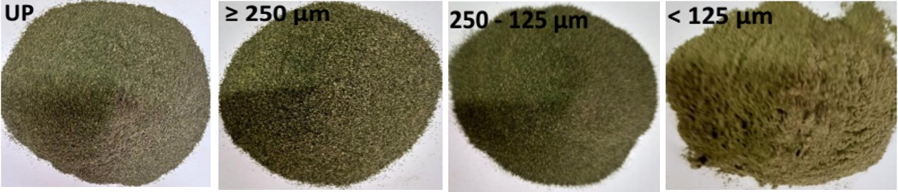

**Figure 1**: Photos of unsieved powder (UP) from dried leaves of *Ficusdicranostyla*and its corresponding powder fractions (< 125, 125 – 250, and ≥ 250 µm) with different particle sizes.

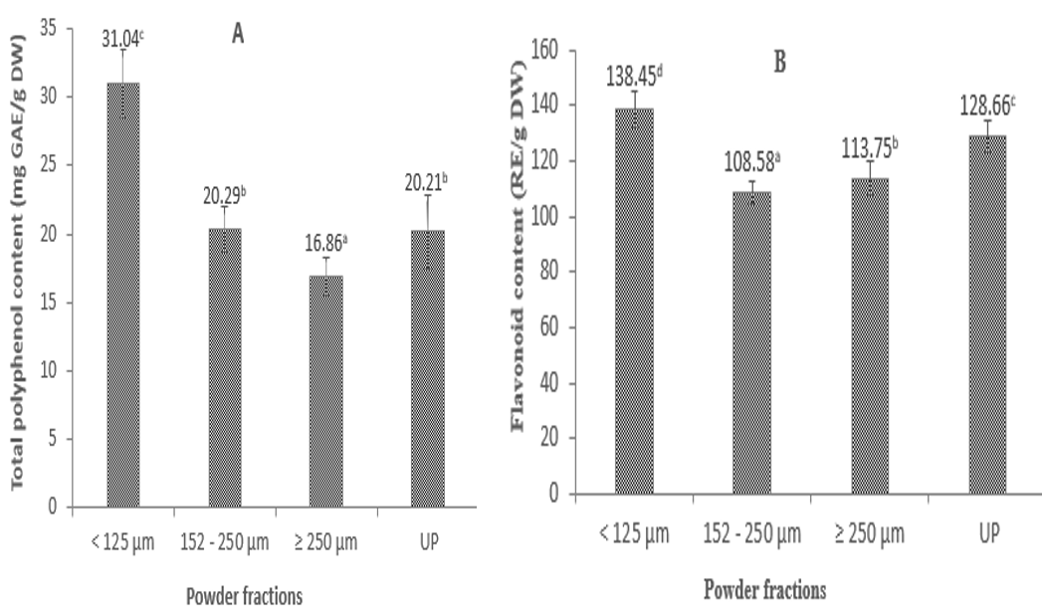

**Figure 2.** Total phenolic contents (**A**) and flavonoid contents (**B**) in *Ficus dicranostyla*leavesat different particle sizes.

**GAE:** gallic acid equivalents, **RE:**rutin equivalents, **UP:**unsieved powder. Bars with different superscripted letters differ significantly (p < 0.05) according to Duncan’s multiple range test (n = 3).

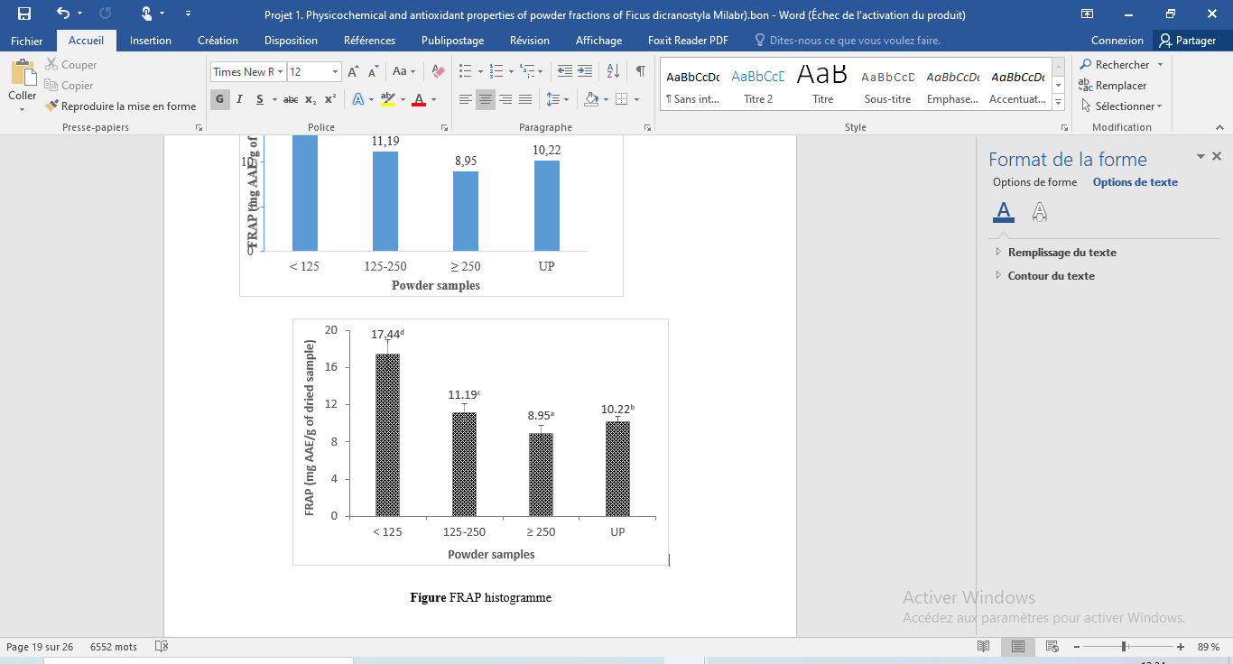

**Figure 3.**Ferric reducing antioxidant power (FRAP) of the powder fractions and unsieved powder from *Ficus dicranostyla* leaves.

**AAE:** ascorbic acid equivalents, **UP:**unsieved powder. Bars with different superscripted letters differ significantly (p < 0.05) according to Duncan’s multiple range test (n = 3).

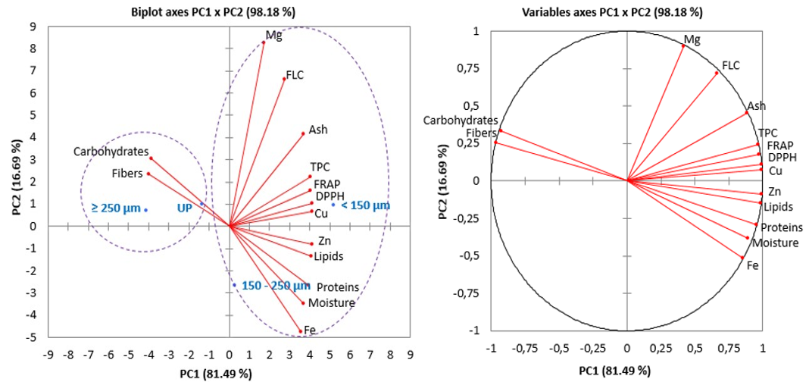

**Figure** **4**. Representation of the variables of *Ficus dicranostyla*powder samples on the principal components **PC1** and **PC2**.

**PC:** principal components, **UP:**unsieved powder, **TPC:** total phenolic content, **FLC:** flavonoid content