Reviewer’s Comments
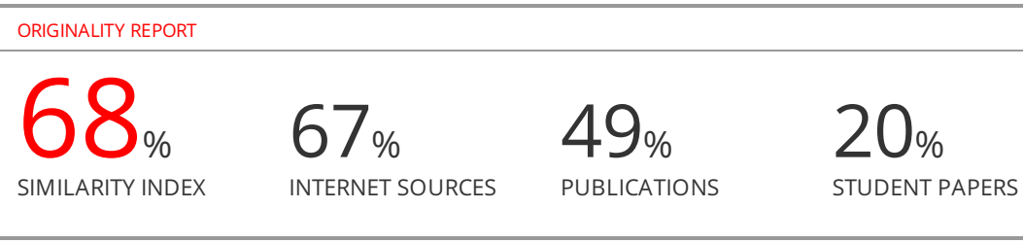
In-Vitro Bioequivalence Study for Marketed Innovator and Three Brands Local Manufacturing Ciprofloxacin Hydrochloride 500mg Tablets in Yemen

Abstract
This study is aimed to evaluate the in vitro bioequivalence of three generic ciprofloxacin 500mg tablets from local manufacturer and marketing in Yemen, with innovator brand using in vitro dissolution study under biowaiver conditions by UV spectrophotometer. Method: Dissolution media were USP buffer solution at pH 1.2 (hydrochloric acid solution), pH 4.5 (acetate buffer solution) and pH 6.8 (phosphate buffer solution). Also, other general quality assessment tests of these tablets like weight variation, hardness, friability, disintegration time and assay test were performed according to proven methods. Results: All brands complied with the official specification for uniformity of weight, friability and disintegration time. Content uniformity of chosen tablets shown that all samples contained over 99% (w/w) of labeled chemical content. The profile dissolution results of all the tablets formulation and the innovator brand were further analyzed with difference factor (f₁) and similarity factor (f₂). Conclusion: These results indicated that the generic Cipro® (C) tablets included in this investigation was bioequivalent with the chosen innovator brand at 0.2N hydrochloric acid solution, pH 1.2 and the other generic brands bioequivalent with the chosen innovator brand at this medium. Also, the results indicated that the three generic ciprofloxacin tablets included in this investigation were bioequivalent with the chosen innovator brand at pH 4.5 and pH 6.8.

Key words: Ciprofloxacin tablet, Biowaiver, Dissolution profile, Difference factor, Similarity factor.

Introduction
The process of dissolution plays a vital role in liberation a drug from its dosage form and making it available for subsequent gastrointestinal absorption. So, dissolution analysis of pharmaceutical solid dosage form is a very important test of product quality and it can be used as a curate method for distinguishing between formulations of the same active ingredient(Bruntion, 1991; Hsu & Ayres, 1989).
Dissolution of a drug from its dosage from is dependent on many factors, which include not only the physicochemical properties of the drug, but also the formulation of the dosage form and the process of manufacturing(Augsburgerx et al., 1983). So, constant dissolution analyses of marketed drug products are essential to ensure availability of quality medicines.
Ciprofloxacin is a synthetic fluoroquinolone derivative with board spectrum activity. It is widely used in the treatment of lower respiratory tract infections, urinary tract infections, soft tissue and skin infections, bacterial diarrhea, joint and bone infections, and in surgical prophylaxis(Mandell & Tillotson, 2002). Ciprofloxacin is considered to be the drug of choice by most of the need to increase supply and also local manufacture of generic products of ciprofloxacin in the market. It is general psychology that the quality of local manufacturing products is considered poor when compared to import generic and innovator products available in the market (Adegbolagun, Olalade, & Osumah, 2007). World Health Organization (WHO) has continuously supported the use of generic drug products aiming to improve the overall health care system (Dunne, Shannon, Dunne, & Cullen, 2013). The generic substitution can be considered when a generic product of an innovator drug contains identical amounts of the same active ingredient in the same does, same dosage and route of administration together with meeting standards for purity, quality, identity and strength(Meredith, 2003).
The local manufacturing generic products are usually much cheaper than its innovator as generic manufacturers do not have similar investment costs for the development of a new drug. In order to substitute the innovator with generics while keeping therapeutic efficacy, dissolution testing can be used as a tool to differentiate between acceptable and unacceptable drug products (Usman, Alam, Suleiman, Awad, & Abudeek, 2014). It can be used as assign for bioequivalence; dissolution testing is a practical and economic approach that can be used when there are limitations for performing in vivo study (Meredith, 2003).
In the present study, in vitro bioequivalence of three local manufacturing generic ciprofloxacin HCl tablets 500mg were investigated in comparison to an innovator product of ciprofloxacin HCl tablet 500mg to justify the quality of local manufacturing substitution of ciprofloxacin generic products in the Yemeni market.
Different reports on comparative dissolution study of ciprofloxacin tablets of different countries have been published (Ngwuluka, Lawal, Olorunfemi, & Ochekpe, 2009) evaluated six brands of ciprofloxacin 500 mg tablet available in Jos, Nigeria and found that only three brands 50% may be used interchangeably with their chosen, innovator brand six. Also, Amit (2010) evaluated six generic ciprofloxacin tablets(Nayak & Pal, 2010), manufactured by different manufacturer in India and reported that all 100% generic ciprofloxacin tablets were bioequivalent with the chosen innovator brand seven. Again Soula (2009) studied ten brands of ciprofloxacin tablet available in Lebanese market and found significant variations among some brands in terms of hardness (Kyriacos et al., 2009), disintegration and found and dissolution eight. Such report is available for ciprofloxacin brands available in Yemen. So, the present work was undertaken to assess the performance of our local products.

Material and Methods
Materials
Ciprofloxacin HCL, working standard (Denk Pharma, Germany) was kindly donated from Shifaco Pharmaceutical Company. Innovator brand (Cipro-IB) and three generic ciprofloxacin 500mg tablet products (Cipro-A, Cipro-B and Cipro-C) were randomly collected and purchased from Community pharmacies in Sana'a, Yemen. The innovator and generic products were purchased from market provided that they have a minimum one year before expiry date. Reagents utilized including Hydrochloric acid, Ortho-phosphoric acid, Sodium acetate, Triethylamine, Acetonitrile, and Sodium hydroxide were of analytical grade (Scharlau, Spain).

Physicochemical Parameters
Tablet dimensions (length and diameter) and hardness were measured using tablet hardness tester (Length, hardness tester TBH 125, Erweka, Germany) using ten tablets form each of the studied products, the average and standard deviation were recorded for the studied innovator and the three generic products.
Weight uniformity test was performing using twenty tablets form each of the studied products, the average weight, the upper and lower limit and standard deviation were recorded for the studied innovator and the three generic products.
Disintegration and friability tests for studied tablets were performed using disintegration tester (Disintegration tester model, Pharma Test, Germany) and tablet friability tester (Friability tester model, Pharma Test, Germany) respectively according to pharmacopeia.
Calibration curve for measuring the accuracy and precision of HPLC instrument was performed by preparing different concentration (0.02, 0.04, 0.06, 0.08 mg/ml) from ciprofloxacin HCl standard material and measuring it by HPLC at 278nm. The measurement was repeated at different time and the average reading (AUC) were plotted vs concentration.
Assay test for drug potency of studied ciprofloxacin tablet products were performed by preparing the mobile phase as the ratio (13ml of acetonitrile and 87ml of a 0.245% w/v solutions of ortho-phosphoric acid and the pH of which has been adjusted to 3.0 with triethanolamine), then standard and the samples for each brand were prepared at the final concentration 0.05% according to the (USP. 2012) and measuring by HPLC (HPLC system, WATERS, USA) at wavelength 278nm.
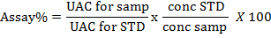

Comparative Dissolution profile
Dissolution test of ciprofloxacin tablets was performed according to USP ciprofloxacin tablet monograph dissolution method for innovator and the three generic products. Dissolution test was carried out using dissolution tester (DT 600, Erweka, Germany) apparatus-II. Operated at 50 rpm. The study was done using three different mediums according to WHO guidance recommended. The first dissolution medium is 900 ml 0.01N HCI (pH 1.2), kept at 37± 0.5°C. Six tablets from each product were withdrawn at 5, 15, 30 min, and the volumes withdrawn, replaced with fresh dissolution medium, samples were then filtered, diluted and measured spectrophotmetricalluy at 276nm (UV-Vis spectrophotometer, SP-3000 PLUS, Optima Tokyo, Japan). Also, the same process was performed using acetate medium 900 ml pH 4.5 and phosphate medium 900ml pH 6.8.

Dissolution profile data analyses
Dissolution comparison methods recommended by FDA (United States Food and Drug Administration) guidance for immediate release solid dosage forms were used in this study (Shah, Tsong, Sathe, & Liu, 1998).
A simple independent approach including difference factor (f₁) and a similarity factor (f₂) were used to compare dissolution profiles between innovator and the three generic products.
The difference factor (f₁) calculates the percent (%) difference between the two curves at each time point and is a measurement of the relative error between the two curves (Guidance, 1997).
f₁= {[ Σ^{n}_{t=1}׀ R_{t} - T_{t}׀]/ [Σ^{n}_{t=1}R_{t}]}*100
Where (n) is the number of time interval points, (R_{t}) is the dissolution value of the innovator at time (t) and (T_{t}) is the dissolution value of the generic product under test at time (t). The similarity factor (f₂) is a logarithmic reciprocal square root transformation of the sum of squared error, it is a measurement or the similarity in the percent (%) dissolution between the two curves (Guidance, 1997).
F₂= 50 * Log {[ 1+ (1/n) Σ^{n}_{t=1} (R_{t} -T_{t})² ]^{-0.5} * 100
Curves can be considered similar when (f₁) values are close to 0, and (f₂) close to 100. (f₁) values from (0-15) and (f₂) values from (50-100) ensure similarity or bioequivalence of the two curves and the performance of the product under test with innovator product (Brand-Williams, Cuvelier, & Berset, 1995).
Statistical analysis

Results
Physicochemical parameters and product label information
Product label information for the innovator and three generic ciprofloxacin marketed products are presented in Table (1). Reviewing the manufacture date and expiry date for the marketed products shows large differences in Labeled expiry date period. The longest expiry date period was 3 years and it belonged to the innovator and all of the generic products.
Table (1): Physical properties for four brands of ciprofloxacin tablets
Brand Name | Code | MF. D | Exp. D | Shape | Taste | Color
CIPRO-DENK 500mg 10 tab | IB | 4/ 2018 | 3 / 2021 | Oblong | Characters | White
CIPROXE  500mg 10 tab | A | 9 / 2018 | 9 /2021 | Oblong | Characters | White
CIPOSAN 500mg 10 tab | B | 3 / 2018 | 3/2021 | Oblong | Characters | White
CIPROFAST 500mg 10 tab | C | 2 / 2018 | 2 /2021 | Oblong | Characters | White
Differences in expiry date period might give an indication that most of the genetic products do not have the same stability achieved by the innovator product. Dimensions, shape. Color and packaging description for studied ciprofloxacin tablet products are products are presented in table (1). The studies products have oblong shape and have close dimensions to the innovator. Color for all product under study were white color. Tablet color might have a positive or negative psychological effect on patients (Cantor, Augsburger, Hoag, & Gerhardt, 2008), the change of color without a reference might has a negative effect on patients. All tested ciprofloxacin tablets were scored. This kind of scoring is usually used to give half dose if needed. The packaging materials of the products under study are transparent packaging material.
Calibration curve
Linearity was demonstrated by analyzing four different concentrations of ciprofloxacin working standard and the average of AUC were recorded for the different conc. table (1). Calibration was constructed by plotting average of AUC vs concentrations figures (1).

Table (2): Show the results of AUC for four different concentrations of ciprofloxacin working standard
Calibration carve
Concentrations µg/ml | 20 | 40 | 60 | 80
Responses  (peaks areas) | 1853742 | 3807075 | 5836893 | 7568032
Responses  (peaks areas) | 1851128 | 3803114 | 5783098 | 7569482
Responses  (peaks areas) | 1849629 | 3804388 | 5792041 | 7617757
Responses  (peaks areas) | 1849902 | 3800762 | 5790875 | 7580746
Responses  (peaks areas) | 1849572 | 3800618 | 5765814 | 7580209
Responses  (peaks areas) | 1870864 | 3805884 | 5786205 | 7573239
Average of AUC | 1854140 | 3803640 | 5792488 | 7581578
SD | 7616 | 2417 | 21655 | 16886
RSD% | 0.41 | 0.0636 | 0.374 | 0.222
Correlation coefficient (R²) = 0.9997
From the figure (1) below represent correlation coefficient (R²) = 0.9997) not more than 1 and not less than 0.9, but R2 between linearity limit (0.9 – 1). This linearity indicates HPLC system which used for measuring different concentration of ciprofloxacin are calibrated and appraises.
Figure 1: Calibration curve of Ciprofloxacin by HPLC
Weight variation, hardness, friability, disintegration, and assay percent of the tested products are presented in Tablet (2) Weights of generic products were close to innovator product.
Table (2): Physicochemical parameters of four brands of ciprofloxacin tablets 500mg
Assay(%) | Disintegration Time(min) | Friability (%) | Hardness  (Kg) | weight variation(mg) | Test name  Brand Cods
99.25% | 1 | 0.07% | 14.4799 | 733.9 | Cipro-IB
100.08% | 1 | 0.18% | 13.8477 | 691.5 | Cipro-A
99.57% | 2 | 0.17% | 15.2957 | 760.03 | Cipro-B
102.08% | 1 | 0.05% | 11.0153 | 682.0 | Cipro-C

Approximately 733.9 mg and all the brands also showed deviation from innovator weight. It gads approximately 51mg lower weight and 27mg higher weight than innovator.
Hardness, friability, and assay results for all studied products were similar to the innovator. Disintegration time results for all studied products were similar to innovator giving approximately 1minute disintegration time of 2 minutes. This 2fold increase in disintegration for brand Cipro-B might have a negative impact on dissolution results for tablets and it might be attributed to using different manufacturing technique like using wet granulation instead of direct compression, using different excipients.
Results of comparative dissolution profile test:
Result of dissolution profile test for four brands of ciprofloxacin 500mg tablet at different pH 1.2, 4.5 and 6.8 are presented in Tablet (3)
Table (3): Results of profile dissolution test for four brands of ciprofloxacin 500mg tablets at pH 1.2, 4.5 and 6.8.
Cipro-C | Cipro-B | Cipro-A | Cipro-IB | Cipro-C | Cipro-B | Cipro-A | Cipro-IB | Cipro-C | Cipro-B | Cipro-A | Cipro-IB
pH 6.8  (Phosphate buffer solution) |  |  |  | pH 4.5  (Acetate buffer solution) |  |  |  | pH 1.2  (Hydrochloric acid solution)
23.5% | 0.136% | 1.03% | 0.3% | 97.13% | 72.16% | 63.22% | 88.66% | 80.77% | 59.9% | 51.12% | 78.7% | 5_{min}
33.79% | 4.8% | 6.87% | 5.49% | 105.14% | 102.19% | 100.34% | 90.12% | 91.003% | 91.99% | 90.06% | 92.45% | 15 _{min}
37.12% | 6.15% | 8.14% | 5.32% | 115% | 102.8% | 100.8% | 95.53% | 101.74% | 98.96% | 99.25% | 97.59% | 30 _{min}
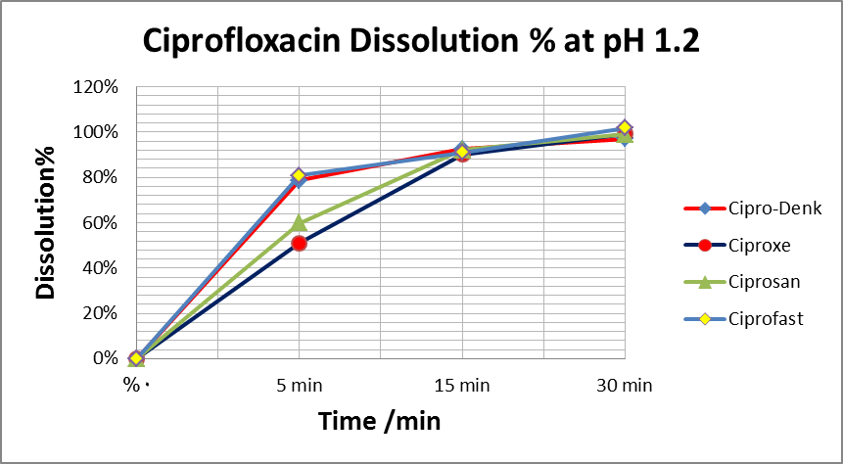
Figure 2: Dissolution profiles of all and the innovative brand ciprofloxacin 500 mg tablets in pH 1.2 (Hydrochloric acid solution).
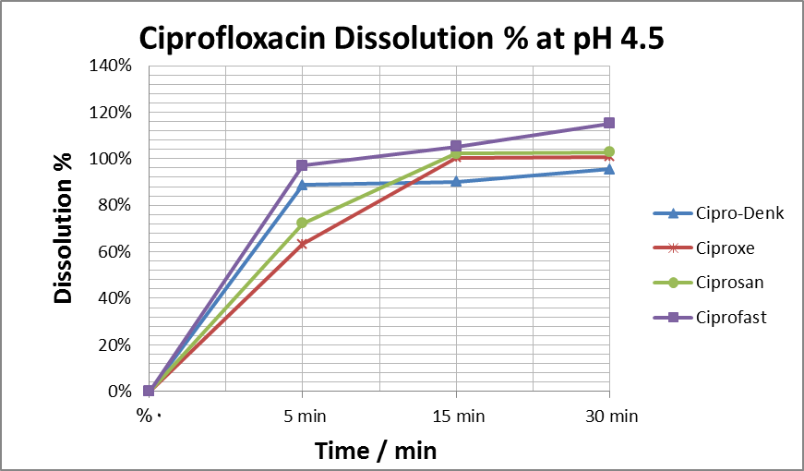
Figure 3: Dissolution profiles of all and the innovative brand ciprofloxacin 500 mg tablets in pH 4.5 (Acetate buffer solution).
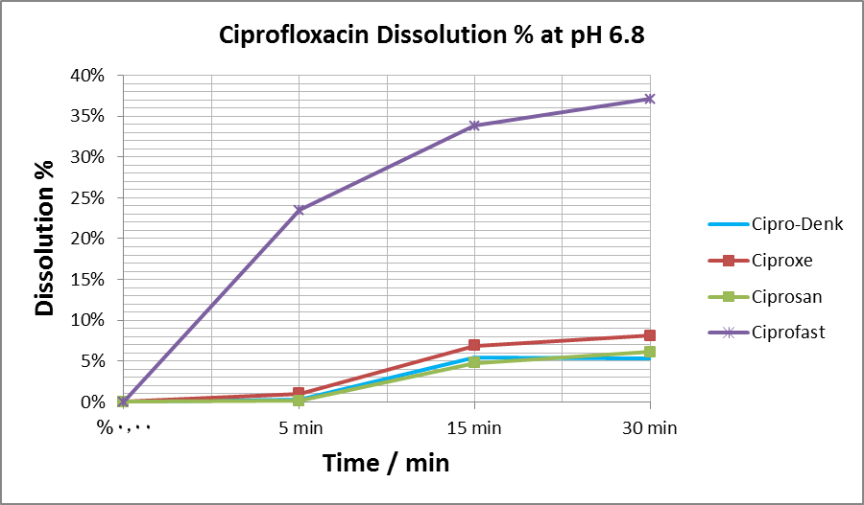
Figure 4: Dissolution profiles of all and the innovative brand ciprofloxacin 500 mg tablets in pH 6.8 (Phosphate buffer solution).
Table 4: The difference factor (f1) and similarity factor (f2) for all generic ciprofloxacin tablets brand in respect to Innovator (Cipro-IB).
PH 6.8 |  | PH 4.5 |  | PH 1.2 |  | Prudects
F1 | F2 | F1 | F2 | F1 | F2 | Prudects
44 | 84 | 15 | 40 | 12 | 40 | Cipro-A
15 | 96 | 13 | 45 | 8 | 48 | Cipro-B
75 | 28 | 16 | 41 | 3 | 77 | Cipro-C

Discussion:
All evaluated ciprofloxacin tablets brands complied with the compendial specifications for identity, weight uniformity, disintegration and assay, as well as the non-compendial test for hardness. The test for identity is necessary to ensure that the product contains the requisite API. The tR of ciprofloxacin HCl in all the samples was 2-2.2 min and closely corresponded to the tR of the ciprofloxacin HCl reference standard (2.02min). The test for weight uniformity serves as a pointer to good manufacturing practice and to assure that the drug content in each unit dose is distributed within a narrow range around the label strength (Polli, 2008).
Hardness is a non-compendial test which assesses the ability of tablets to withstand handling during packaging, transportation and usage without fracturing or chipping. It can also influence other parameters such as friability and disintegration (Minyeto, Njogu, Ndwigah, & Chepkwony, 2015). The harder a tablet, the less friable and the more time it takes to disintegrate. A force of about 4Kg is the minimum requirement for a satisfactory tablet (Oishi, Haque, Dewan, & Islam, 2011). Brand Ciprofast required the least amount of pressure (11 .02Kg) to break as shown in Table3. the disintegration test measures the time required for a tablet to disintegrate into particles when in contact with gastrointestinal fluids, and different formulation factors are known to affect it. There was a wide inter-brand variation in the disintegration time. However, all evaluated brands complied with pharmacopoeia specification which stipulates a disintegration time of not more than 30 min for film coated tablets (Polli, 2008).
There was no direct correlation between tablet hardness and disintegration time. The aim of the assay specification is to assure the presence of the API in requisite amount significant variation in the amount of API could lead to ineffective therapeutic drug levels or overdosing that may cause toxicity (Allen & Ansel, 2013).
Compendial specification require that ciprofloxacin tablets should contain not less than 90.0% and not more than 110.0% of the stated amount ⁽¹²⁾. The highest percentage content was obtained for brand Cipro-denk (99.25%).
Dissolution profile of the innovator and three locale generic products at acidic medium pH 1.2 are presented in figure (3). Generic products (Ciprofast) seems to be very close to innovator (Cipro-denk) in results in all time intervals. The most obvious difference in dissolution is seen at the 5minute time interval, where (ciproxe) generic products showed approximately 26% lower release than innovator, drug release 51.12% on average (Ciprosan) generic products showed 18% lower drug release than innovator, drug 59.9% on average at pH 4.5 most of the generic brands released more that 85% of ciprofloxacin HCI within 30 min. However, all the products including the innovator brand Cipro® had very poor release characteristic at pH 6.8. This observation is consistent with the solubility of ciprofloxacin which exhibits a "U" shaped pH – solubility profile with high solubility at pH values below 5 and above 10, and low solubility near the isoelectric point (pH 7)(Jaman et al., 2015).
Dissolution profile data Analysis ciprofloxacin HCI is classified according to BCS (biopharmaceutical classification) as class III group of drugs. The minimum requirement for accepting ciprofloxacin immediate release tablet dosage forms are specified by USP ciprofloxacin monograph. It states that the amount of not less than 85% (Q) of the labeled amount of ciprofloxacin dissolved in 30 min. All studied products passed this dissolution test limit at acidic medium pH. 1.2 and at acetate butted pH 4.5 but not passed at phosphate buffer pH 6.8.
ciprofloxacin is highly soluble at pH 1.2 and 4.5. So, higher dissolution was obtained in these two media. Ciprofloxacin has limited solubility at pH 6.8 (< 0.02mg/ml) so, 37.17% dissolution is justified in case of phosphate buffer medium (pH 6.8).
According to the FDA guidance for industry, in the dissolution testing of immediate release solid oral dosage forms, the BCS suggests that for class I and in some cases class III drugs 85% dissolution in 0.1 N in HCL in 15 min ensures that the bioavailability comply with requirement of monograph ⁽¹³⁾. The innovator (Ciproxe) and (Ciprosan) are passed the stated limit after 15 minutes of dissolution as the average drug dissolution was higher than 15 minutes of dissolution profiles of the studied innovator and geeric products, a model independent approach of difference factor (f1) and similarity factor (f2) were employed ⁽¹⁴⁾. Similarity factor f2 has been used by FDA and the European medicines evaluation agency (EMEA) to compare the similarity of two or more dissolution profiles. For two dissolution profiles to be considered bioequivalent or similar, difference factor (f1) should be between 0 and 15, while similarity factor (f2) should be between 50 and 100 ⁽¹⁴⁾. The difference factor (f1) and similarity factor (f2) values for the different generic products under Study with respect to innovator (Cipro-Denk) are presented in table (4) at different pH. At pH 1.2 the calculated values of similarity factor (f2) more than 50 and difference factor (f1) values were less than 15 for were studied product (Ciprofast) can be considered to be equivalent to the innovator brand. (Ciproxe and Ciprosan) generic products had a (f2) value of 40 and 48 less than 50 and (f1) value of 12 and 8 less than 15
Because of the value (f1) factor is within the limit (0-15) and the (f2) factor is lower than 50, (Ciproxe and Ciprosan) are considered to be dissimilar and not bioequivalent to innovator. At pH 4.5 the calculated values of similarity factor (f2) were less than 50 for all the three generic brand (Ciproxe, Ciprofast and Ciprofast) and difference factor (f1) values were within the limit (0-15) for studied products (Ciproxe and Ciprosan) and generic product Ciprofast is more than 15. So, all the three generic products are considered to be dissimilar and not bioequivalent to innovator. Similar study carried out in Nigeria, where three (50%) of the six studied ciprofloxacin tablets brands were deemed pharmaceutically nonequivalent to the innovator Cipro brand.
Conclusion:
At pH 6.8, the amount of ciprofloxacin HCl released for all the generic brands and the Innovator brand (IB) was below 85% within 30 min. Therefore, the difference factor f1 and similarity factor f2 are not applicable for the dissolution data obtained factor at pH 6.8 due to low drug release. The low drug release at pH 6.8 even for the IB is expected given the pH- dependent solubility of ciprofloxacin that is lowest at neutral pH.

Conflict of interest
This research has no conflict of interest

Author’s Contribution

Acknowledgements

LIMITATIONS OF THE STUDY

References
Adegbolagun, O., Olalade, O., & Osumah, S. (2007). Comparative evaluation of the biopharmaceutical and chemical equivalence of some commercially available brands of ciprofloxacin hydrochloride tablets. Tropical Journal of Pharmaceutical Research, 6(3), 737-745.
Allen, L., & Ansel, H. C. (2013). Ansel's pharmaceutical dosage forms and drug delivery systems: Lippincott Williams & Wilkins.
Augsburgerx, L. L., Shangraw, R. F., Giannini, R., Shah, V. P., Prasad, V. K., & Brown, D. (1983). Thiazides VIII: Dissolution survey of marketed hydrochlorothiazide tablets. Journal of pharmaceutical sciences, 72(8), 876-881.
Brand-Williams, W., Cuvelier, M.-E., & Berset, C. (1995). Use of a free radical method to evaluate antioxidant activity. LWT-Food science and Technology, 28(1), 25-30.
Bruntion, L. (1991). The pharmacological Basis of Therapeutics. Gilman AG, Ra TW, Nies AS and Taylor P. pergamon press. Singapore, Edition, 8, 926-928.
Cantor, S. L., Augsburger, L. L., Hoag, S. W., & Gerhardt, A. (2008). Pharmaceutical granulation processes, mechanism and the use of binders. Pharmaceutical dosage forms: tablets, 1, 261-302.
Dunne, S., Shannon, B., Dunne, C., & Cullen, W. (2013). A review of the differences and similarities between generic drugs and their originator counterparts, including economic benefits associated with usage of generic medicines, using Ireland as a case study. BMC Pharmacology and Toxicology, 14(1), 1-19.
Guidance, F. (1997). Guidance for industry: Dissolution testing of immediate release solid oral dosage forms. US Department of Health and Human Services. Food and Drug Administration, Center for Drug Evaluation and Research (CDER).
Hsu, H.-Y., & Ayres, J. W. (1989). Chlorpheniramine dissolution and relative urinary excretion from commercial products. Journal of pharmaceutical sciences, 78(10), 844-847.
Jaman, M., Chowdhury, A., Rana, A., Masum, S., Ferdous, T., Rashid, M., & Karim, M. (2015). In vitro evaluation of Ciprofloxacin Hydrochloride. Bangladesh Journal of Scientific and Industrial Research, 50(4), 251-256.
Kyriacos, S. B., Boukarim, C., Safi, W., Mroueh, M., Maroun, A. B., El-Khoury, G., & Shehayeb, R. (2009). In vitro testing of ciprofloxacin formulations and preliminary study on BCS biowaiver.
Mandell, L., & Tillotson, G. (2002). Safety of fluoroquinolones: An update. Canadian Journal of Infectious Diseases, 13(1), 54-61.
Meredith, P. (2003). Bioequivalence and other unresolved issues in generic drug substitution. Clinical therapeutics, 25(11), 2875-2890.
Minyeto, D., Njogu, P., Ndwigah, S., & Chepkwony, H. (2015). Quality and In Vitro Pharmaceutical Equivalence of Ciprofloxacin Tablets Brands in Kenya. East and Central African Journal of Pharmaceutical Sciences, 18(3), 75-85.
Nayak, A. K., & Pal, D. (2010). Comparative in vitro bioequivalence analysis of some ciprofloxacin HCl generic tablets. International Journal of Pharmaceutical Sciences and Research, 1(8), 51.
Ngwuluka, N., Lawal, K., Olorunfemi, P., & Ochekpe, N. (2009). Post-market in vitro bioequivalence study of six brands of ciprofloxacin tablets/caplets in Jos, Nigeria. Scientific Research and Essays, 4(4), 298-305.
Oishi, T. S., Haque, M. A., Dewan, I., & Islam, S. A. (2011). Comparative in vitro dissolution study of some ciprofloxacin generic tablets under biowaiver conditions by RP-HPLC. International Journal of Pharmaceutical Sciences and Research, 2(12), 3129.
Polli, J. E. (2008). In vitro studies are sometimes better than conventional human pharmacokinetic in vivo studies in assessing bioequivalence of immediate-release solid oral dosage forms. The AAPS journal, 10(2), 289-299.
Shah, V. P., Tsong, Y., Sathe, P., & Liu, J.-P. (1998). In vitro dissolution profile comparison—statistics and analysis of the similarity factor, f2. Pharmaceutical research, 15(6), 889-896.
Usman, S., Alam, A., Suleiman, R., Awad, K., & Abudeek, I. (2014). Evaluation of dissolu-tion testing for ciprofloxacin (500 mg) tablets: post market surveillance of different brands available in Ras Al Khaimah (UAE). Int J Biopharm, 5(1), 65-72.

