**Original Research Article**

**Modified Fragment-based Drug Discovery Approach to Identify SARS-CoV-2 Mpro Inhibitors: Molecular Docking, ADMET analysis, and *in-silico*/*in-vitro* toxicity study**

**Abstract**

After theCOVID-19 outbreak, drug repurposing has emerged as an effective and fast approach for combating the SARS-CoV-2 crisis. Thus, comparative molecular docking studies were usedto evaluate the activity of the commerciallyavailable oral antiviral drug simeprevirand its degradation products (compounds 1–5) against the main protease (Mpro)of SARS-CoV-2(PDB ID: 6lu7; resolution: 2.16 Å). Moreover, theADMET and in-silico toxicity properties of the acidic (compounds 1–3) and oxidative (compounds 4 and 5) degradation products of simeprevirwere predicted. Docking studies revealed good binding affinities forcompounds (1–5) against Mpro of SARS-CoV-2, with binding free energies ranging from −6.23 to −7.65 kcal/mol. The acidicdegradant 2 exhibitedthe best affinity and wassuperior to simeprevir and a natural ligand. All compounds were expected to be safe totheCNS. Finally, compounds1, 4, and 5 were expected to possess good human intestinal absorption,whereascompounds 2 and 3 appeared to have moderate intestinal absorption.

**Keywords:**Simeprevir; COVID-19;Structure–activity relationships;Computational chemistry; ADMET; fragment-based drug discovery

# Introduction

The severe acute respiratory syndrome is a result of (SARS-CoV-2), which belongs to the subfamily *Coronavirinae*, family *Coronaviridae*, and affects the respiratory system, causing a severe acute respiratory syndrome.In March of 2020, the WHO proclaimed COVID-19 a worldwide pandemic. It expanded from Wuhan, a crowded city in China, across China, and was then transferred to most other countries of the world 1. As a specific vaccine for COVID-19, either for prophylaxis or treatment to prevent mortality, is lacking, the search for a quick and effective therapeutic protocol for this disease became a prominent challenge worldwide.

In fact, *de novo* drug discovery has long been recognized as a long and costly process,especially in pandemic circumstances, with a total average cost of $2 to $3 billion and taking at least 13–15 years to reach market availability2. During the 1990s, high-throughput screening was introduced as a tool to facilitate and hasten drug discovery 3 however, chemical libraries still need to be prepared through a highly laborious synthetic approach 4. A dramatic change occurred after the evolution of protein crystallography and NMR that gave access to well-characterized protein-ligand complexes, which have guided drug-lead optimization in terms of selectivity and potency 5. Simultaneously, computational methods have been utilized for the calculation of molecular interactions, identification of protein-ligand complexes, and screening of chemical libraries against a molecular target 6.

Based on the successful drugrepurposing stories in the drug market 7,drug repurposing (also called drug repositioning or drug profiling) has been introduced as a useful tool to decrease costs and save time in drug discovery. This approach depends on finding a new indication for an already existing FDA-approved drug 8. In addition to the drug indication, which is available, a full descriptive drug profile, including pharmacokinetics, pharmacodynamics, and toxicological studies, is also necessary; all of this pre-existing drug information saves time and reduces the research efforts in reaching the new drug indication 9.

After the COVID-19 outbreak in December 2019, drug repurposing was chosen as an effective and fast way to manage the SARS-CoV-2 crisis compared with the long cycle of *de novo* drug discovery 10. In addition to drug repurposing, computational methods were of great interest to many researchers,which led to the dawn of “in-silico repurposing,” especially that of pre-existing broad-spectrum antivirals, as this will help shorten the investigation time for any hit compound termed “the drug that will hit the molecular target” to be tested directly in Phase 2 clinical trials. Therefore, by adopting this approach, a new treatment may emerge rapidly and help end this worldwide crisis 11.

Simeprevir is among the pre-existing broad-spectrum antivirals. It is a direct-acting antiviral with a macrocyclic structure (**Fig.1**) that was originally used for the treatment of genotype I hepatitis C (HCV) 12. It is a specific and potent inhibitor of the NS3/4A protease, which is an enzyme that is essential for the life cycle of HCV because viral replication is disrupted by the inhibition of the NS3/4A protease 12. Infact, the mechanism of entry of coronavirusesinto cells occurs via the action of cellular proteases (i.e., human airway trypsin-like protease, cathepsins, and transmembrane protease serine 2 (TMPRSS2)), which split the spike protein of the virus and cause further penetration alterations 13. It has been reported that proteases can be inhibited in SARS-CoV-2 by compounds targeting other viral proteases 14. Moreover, it was reported that simeprevir may be used for the treatment of other viral infections,such as HIV/AIDS15. Therefore, testing simepreviragainst the SARS-CoV-2 protease may be helpful for the treatment of COVID-19.



**Figure 1: Simeprevir and its degradation products**

The principal feature of fragment-based drug discovery (FBDD) is the screening of a small library of low-molecular-weight compounds,followed by the growth of these fragments synthetically, to produce lead compounds. In the present work, we planned to adopt a “reverse fragment-based drug discover approach” for the repurposing of different fragments of an already active drug (simeprevir) via the investigation of its binding to the new target, the reorientation of the fragment in this target, and/or the omission of unnecessary fragments, rather than buildingup a lead compound from promising fragments (standard fragment-based drug design). This approach should be distinguished from the “inverse drug discovery” approach, which identifies proteins via targeting using potent electrophiles. Thus, a set of already characterized fragments/degradants (**Fig.1**) of the antiviral drug simeprevirwas selected to test such an approach virtually.

## Results and Discussion

* 1. **Docking studies**

To explore the target-binding mechanism of Simeprevir and compounds **(1–5)**, they were docked against (Mpro) (PDB ID: 6lu7, resolution: 2.16), the major protease of SARS-CoV-2. A reference molecule was used: the co-crystallized ligand (PRD-002214). With binding free energies ranging from 6.23 to 7.65 kcal/mol, the docked compounds showed excellent binding affinities against Mpro**(Table 1).**

The binding energy of 6.94 kcal/mol was found in the crystalline ligand (PRD-002214). The crystalline ligand had the following binding mode: Mpro's initial pocket was filled by the 2-oxopyrrolidin-3-yl molecule, which formed a hydrogen bond with Phe140. The tert-butyl carbamate moiety also filled Mpro's second pocket, making one hydrogen bond with Me49. The phenyl ring of the phenylalanine molecule also filled the third receptor pocket, producing a hydrophobic contact with His41. Finally, the fourth pocket received the ethyl propionate moiety **(Figs 2, 3, and 4).**

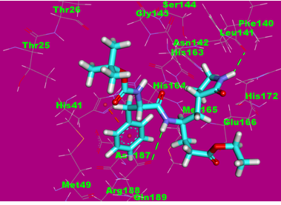

**Fig. 2:** Co-crystallized ligand ([PRD-002214](https://www.rcsb.org/ligand/PRD_002214)) docked into the active site of the COVID-19 main protease, the hydrogen bonds are represented in green dashedlines, and the hydrophobic interactions are represented in orange dashed lines.

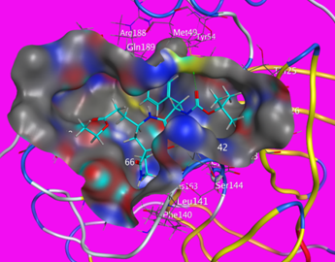

**Fig.3:** Mapping surface showing the co-crystallized ligand ([PRD-002214](https://www.rcsb.org/ligand/PRD_002214)) occupying the active pocket of the COVID-19 main protease.

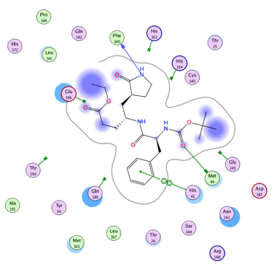

**Fig. 4:** 2D interaction of the co-crystallized ligand ([PRD-002214](https://www.rcsb.org/ligand/PRD_002214)) in the active site of the COVID-19 main protease.

Simeprevir had a binding mechanism that was comparable to that of Mpro's co-crystallized ligand. It had binding energy of about 7.000 kcal/mol. Mpro's initial pocket was filled by the cyclopropanesulfonamide molecule, which formed a single hydrogen bond with Asn142. In addition, the 5-methyl-2,3,3a,6,7,8,9,11a,12,12a,13,14a-dodecahydrocyclopenta [c] is a 5-methyl-2,3,3a,6,7,8,9,11a,12,12a,13,14a-dodecahydrocyclopenta cyclopropa[g] [1,6] The second pocket of Mpro was filled by the diazacyclotetra decine-4,14(1H,5H)-dione moiety, which established a hydrogen connection with Met49. Furthermore, the 7-methoxy-8-methylquinoline molecule was found in the receptor's third pocket, making a hydrophobic contact with Met165. The 4-isopropylthiazole molecule was finally put into the fourth pocket, creating a hydrogen connection with Asn142 **(Figs 5, 6, and 7).**

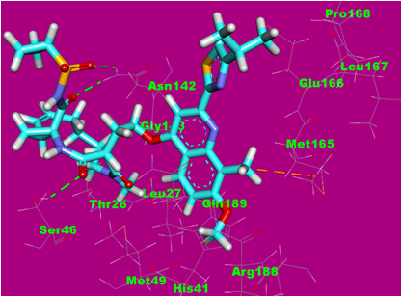

**Fig. 5:** Simeprevir docked into the active site of the COVID-19 main protease, the hydrogen bonds are represented in green dashedlines and the hydrophobic interactions are represented in orange dashed lines.

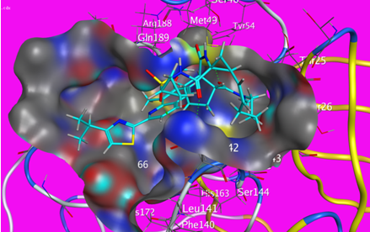

**Fig.6:** Mapping surface showing simeprevir occupying the active pocket of the COVID-19 main protease.

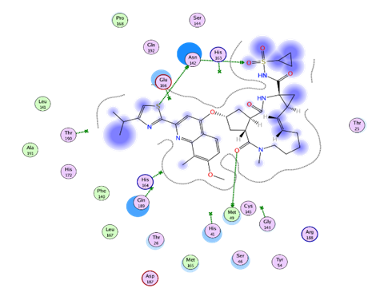

**Fig. 7:** 2D interaction of simeprevir in the active site of the COVID-19 main protease.

In the target-binding site, Compound **1** had a binding mechanism similar to the co-crystallized ligand and simeprevir. It occupied three Mpro pockets and had binding energy of 6.95 kcal/mol. The tetrahydro-1H-cyclopenta[c]furan-1,3(3aH)-dione moiety was found in Mpro's first pocket, where it formed two hydrogen bonds with Gly143 and Gln189. Furthermore, the 7-methoxy-8-methylquinoline moiety filled the receptor's second pocket and formed two hydrophobic contacts with Glu166. In addition, the 4-isopropylthiazole molecule was found in the third pocket, generating two hydrophobic contacts with Pro168 **(Figs 8, 9, and 10).**

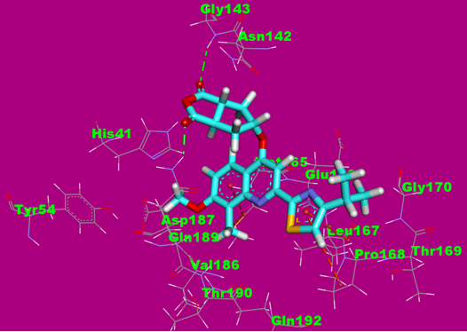

**Fig. 8**: Compound **1** docked into the active site of COVID-19 main protease. The hydrogen bonds are represented in green dashedlines and the hydrophobic interactions are represented in orange dashed lines.

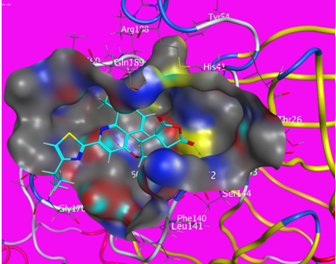

**Fig.9**: Mapping surface showing compound **1** occupying the active pocket of the COVID-19 main protease.

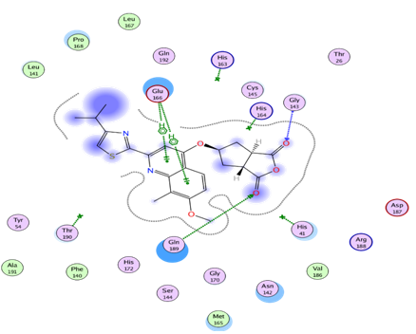

**Fig. 10:** 2D interaction of compound **1** in the active site of the COVID-19 main protease.

In the target-binding site, Compound **2** had a binding mechanism identical to the co-crystallized ligand and simeprevir. It occupied three pockets in Mpro and had the lowest binding energy (7.65 kcal/mol) of all the chemicals studied. 5-methyl-2,3,3a,6,7,8,9,11a,12,12a,13,14a-dodecahydrocyclopenta [c] is a 5-methyl-2,3,3a,6,7,8,9,11a,12,12a,13,14a-dodecahydrocyclo penta [c] is a 5-methyl-2 cyclopropa[g][1,6] The first pocket of Mpro was filled by the diazacyclotetra decine-4,14(1H,5H)-dione moiety, which established a hydrogen connection with Asn142. With Cys145 and His163, it also created two hydrophobic contacts. The 4-isopropylthiazole molecule was introduced into the second pocket, where it formed two hydrophobic contacts with His41 and a hydrogen bond with Thr190. Furthermore, the 7-methoxy-8-methylquinoline molecule was found in the receptor's third pocket, generating a hydrophobic contact with Pro168 **(Figs 11, 12, and 13).**

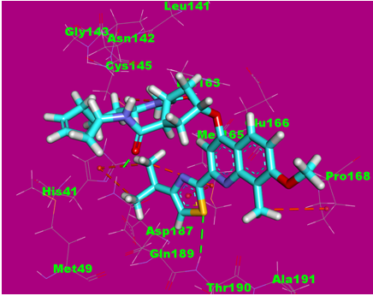

**Fig. 11:** compound **2** docked into the active site of COVID-19 main protease. The hydrogen bonds are represented in green dashedlines and the hydrophobic interactions are represented in orange dashed lines and pi-anionic interaction are presented in blue lines.

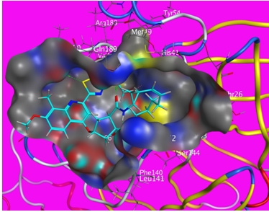

**Fig. 12**: Mapping surface showing compound **2** occupying the active pocket of the COVID-19 main protease.

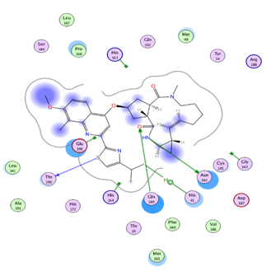

**Fig. 13:** 2D interaction of compound **2** in the active site of the COVID-19 main protease.

Conversely, compounds **3**, **4**, and **5** exhibited a lower binding affinity compared with the **co-crystallized ligand (**[PRD-002214](https://www.rcsb.org/ligand/PRD_002214)), with a free energy of −6.23, −6.44, and −6.32, respectively. In detail, compound **3**formed four hydrogen bonds with Gly143, Gln189, Asn142, and Glu166,whereas compound **4** formed two hydrogen bonds with Met49 and Glu166 and five hydrophobic interactions with Glu166, His 163, and Met165. Regarding compound **5**, it formed one hydrogen bond with Glu166 and six hydrophobic interactions with His163, His41, Met165, and Glu166 (**FigsS1–S9**).

**Table 1**: The docking binding free energies of five compounds, simeprevir and the co-crystallized ligand ([PRD-002214](https://www.rcsb.org/ligand/PRD_002214)) against COVID-19 main protease.

|  |  |
| --- | --- |
| **Compound** | **Binding free energy (kcal/mol)** |
| **Simeprevir** | -7.00 |
| **Co-crystallized ligand (**[PRD-002214](https://www.rcsb.org/ligand/PRD_002214)) | -6.94 |
| **1** | -6.95 |
| **2** | -7.65 |
| **3** | -6.23 |
| **4** | -6.44 |
| **5** | -6.32 |

* + 1. **Fragment-based approach analysis**

the results of the docking study (summarized in **Table 2**) showed that interaction with the fourth pocket of the protease wasnot essential for the activity of the ligand and compounds 1 and 2. Moreover, the establishment of one hydrogen bond in the first pocket was sufficient for good activity, as in the ligand, simeprevir, and compound **2**. Adding one other H-bond in the first pocket yielded a lower activity, as in compound **1**. In contrast, adding two other hydrophobic interactions to the first pocket potentiated the activity, as in compound **2**. However, the tetradecagon macrocycle was not essential, asit could be replaced with a less-complex moiety that was able to form hydrogen bonds and hydrophobic interactions. Moreover, the establishment of only one hydrophobic interaction in the third pocket yielded a better activity,similar to that achieved in the ligand, simeprevir, and compound **2** by the presence of the 7-methoxy-8-methylquinoline moiety. The presence of the 4-isopropylthiazole moiety in the second pocket afforded the essential and only hydrogen bond, as in the ligand, simeprevir, and compound **2**. Furthermore, it formed two other hydrophobic interactions, which seemed to potentiate the activity,as in compound **2**. In conclusion, the 7-methoxy-8-methylquinoline and 4-isopropylthiazole moieties should be retained and be located in the third and second pocket, respectively. The replacement of the tetradecagon macrocycle with a smaller moiety is recommended.

**Table 2: summarized outcomes of docking study**

|  |  |  |
| --- | --- | --- |
| Compound | Interactions with receptor | Chemical moiety (pharmacophore) |
| ligand ([PRD-002214](https://www.rcsb.org/ligand/PRD_002214))  binding energy  -6.95 | hydrogen bond with Phe140 | the 2-oxopyrrolidin-3-yl |
| hydrogen bonding interaction with Met49 | tert-butyl carbamate |
| hydrophobic interaction with His41 | the phenyl ring of phenylalanine |
|  | ethyl propionate |
| Simeprevir  binding energy  -7.00 | hydrogen bond with Asn142 | cyclopropane sulfonamide |
| hydrogen bond with Met49 | 5-methyl-2,3,3a,6,7,8,9,11a,12,12a, 13,14a-dodecahydrocyclopenta [c]cyclopropa[g][1,6]diazacyclotetra decine-4,14(1*H*,5*H*)-dione |
| hydrophobic interaction with Met165 | 7-methoxy-8-methylquinoline |
| hydrogen bonding interaction with Asn142 | 4-isopropylthiazole |
| Compound **1**  binding energy  -6.94 | two hydrogen bonds with Gly143 and Gln189 | The tetrahydro-1H-cyclopenta[c]furan-1,3(3aH)-dione |
| two hydrophobic interactions with Glu166 | 7-methoxy-8-methylquinoline |
| two hydrophobic interactions with Pro168 | 4-isopropylthiazole |
| Compound **2**  binding energy  **-7.65** | hydrogen bond with Asn142  two hydrophobic interactions with Cys145 and His163 | 5-methyl-2,3,3a,6,7,8,9,11a,12,12a,13,14a-dodecahydrocyclopenta [c]cyclopropa[g][1,6]diazacyclotetra decine-4,14(1*H*,5*H*)-dione |
| hydrogen bonding interaction with Thr190  two hydrophobic interactions with His41. | 4-isopropylthiazole |
| hydrophobic interaction with Pro168 | 7-methoxy-8-methylquinoline |

* 1. ***In-silico* ADMET analysis**

Running *in-silico* ADMET studies at the early stages of compound design may reduce the risk of late-stage attrition and direct the screening procedure to choose the most promising ligands.

These experiments could predict properties such as oral absorption, bioavailability, blood–brain barrier (BBB) penetration, excretion, and distribution. These properties provide important information about the dose, dose frequency, route of administration, and safety of the examined drug.

Many descriptors are used in ADMET studies: I aqueous solubility, which predicts each compound's solubility in water at 25°C; ii) BBB penetration, which predicts a molecule's BBB penetration; iii) CYP2D6 binding, which predicts cytochrome P450 2D6 enzyme inhibition; iv) hepatotoxicity, which predicts if the examined compound can cause human hepatotoxicity in dose dependant manner 16.

Discovery studio 4.0 was used to predict ADMET descriptors for all compounds. The predicted descriptors are listed in **Table 3**.

The ADMET aqueous solubility levels of compounds **3** and **4** appeared to be in the good range,whereas compound **5** showed low aqueous solubility. Conversely, compounds **1** and **2** exhibited very low solubility. ADMET BBB penetration studies predicted that the BBB penetration levels of compounds **2** and **3**were very low,whereas compound **4** exhibited low level and compounds **1** and **5** showed medium BBB penetration levels. Accordingly, all compounds were expected to be safe to the CNS.

Intestinal absorption is the percentage of a drug that is absorbed by the gut wall 17. At least 90% of absorption into the bloodstream in humans is needed for a compound to be classified as a well-absorbed compound 18. Moreover, poor absorption was the main reason for numerous compound failures in the clinical phase 19. According to our ADMET studies, compounds **1**, **4**, and **5** were expected to possess good HIA,whereas compounds **2** and **3** appeared to have moderate intestinal absorption.

The hepatotoxicity model predicts the probable organ toxicity of a large variety of structurally varied substances 20. Except for compound **3**, all of the compounds studied were shown to exhibit some amount of hepatotoxicity. *In-vitro* and *in-vivo* research is needed to confirm these preliminary in-silico findings.

The cytochrome P450 2D6 (CYP2D6) model, which uses the 2D chemical structure as an input, predicts CYP2D6 enzyme inhibition. The inhibition of CYP2D6 allows the impact of various medications to be amplified, potentially resulting in hazardous levels. As a result, under drug research and development regulations, a CYP2D6 inhibition trial is a requirement 21. All examined compounds were predicted as non-inhibitors of CYP2D6. Consequently, the examined compounds are not expected to have a toxic effect from this perspective.

The plasma protein binding model predicts a compound's capacity to attach to plasma proteins. This model predicts how likely a substance is to be strongly bound (90 percent binding) to blood carrier proteins 22. Because the bound fraction is temporarily sheltered from metabolism, drug molecule plasma protein binding can have an impact on their efficiency. The unbound fraction, on the other hand, has therapeutic effects when it is isolated 23. All compounds tested here were expected to exhibit >90% binding to plasma proteins,with the exception of compound**4** (**Fig.13**).

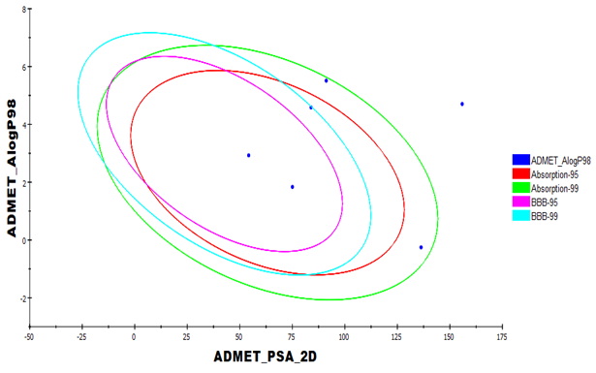

**Fig. 13:** The expected ADMET studies.

**Table 3.** Predicted ADMET for the designed compounds and reference drugs

|  |  |  |  |  |  |  |
| --- | --- | --- | --- | --- | --- | --- |
| **Comp.** | **BBB level a** | **Absorption level b** | **Solubility level c** | **Hepatotoxic prediction d** | **CYP2D6 prediction e** | **PPB prediction f** |
| **1** | 2 | 0 | 1 | TRUE | FALSE | TRUE |
| **2** | 4 | 1 | 1 | TRUE | FALSE | TRUE |
| **3** | 4 | 1 | 3 | FALSE | FALSE | FALSE |
| **4** | 3 | 0 | 3 | TRUE | FALSE | TRUE |
| **5** | 2 | 0 | 2 | TRUE | FALSE | TRUE |

a BBB level, blood brain barrier level, 0 = very high, 1 = high, 2 = medium, 3 = low, 4 = very low.

b Absorption level, 0 = good, 1 = moderate, 2 = poor, 3 = very poor.

c Solubility level, 1 = very low, 2 = low, 3 = good, 4 = optimal.

d Hepatotoxicity probability, TRUE means toxic, FALSE means non-toxic.

e CYP2D6, cytochrome P2D6, TRUE = inhibitor, FALSE = non inhibitor.

f PBB, plasma protein binding, FALSE means less than 90%, TRUE means more than 90%.

* 1. **Physicochemical properties**

The logP values represent the degree of lipophilicity of a chemical compound, whereas the LogD values represent the degree of lipophilicity of a chemical compound taking into account the molecule's ionization states. 24. The fact that these values have risen indicates that the lipophilic nature of the chemical under examination has improved. Compounds **1, 2, 4,** and **5** have different A log P and LogD values, ranging from 1.928 to 5.602. These values may make it simpler for such substances to enter mucosal membranes and the lipophilic capsules of the virus.

Furthermore, the molecular polar surface area (MPSA) is a crucialparameter that affects drug bioavailability; compounds that are passively absorbed and have an MPSA of >140 have a low oral bioavailability25. MPSA (140) levels were found in all of the substances studied. The molecular volume (MV) descriptor also provides information on molecule transport characteristics such as GIT absorption 26. The MV is inversely related to the drug diffusivity. Molecules with a lower MV have a higher diffusivity than those with a higher MV 27. It is noticeable that the tested compounds exhibited low MV values compared with simeprevir (**Table 4)**. The electric dipole moment (µ) represents the electrical effects in drug–receptor interactions 28. The dipole moment values of the substances investigated varied from 3.2791 to 9.11863.

**Table 4:** Physico-chemical properties of the examined compounds.

|  |  |  |  |  |  |  |  |  |
| --- | --- | --- | --- | --- | --- | --- | --- | --- |
| **Comp.** | **ALog P a** | **Log Db** | **Pkac** | **MPSAd** | **MSAe** | **MVf** | **Diploe g** |  |
| **1** | 4.676 | 4.677 | 3.98 4.47 | 115.85 | 437.77 | 354.66 | 3.2791 |  |
| **2** | 5.602 | 5.603 | 3.98 4.47 | 121.89 | 615.58 | 500.77 | 4.07006 |  |
| **3** | -0.253 | -0.149 | 2.5 | 141.26 | 428.6 | 358.77 | 7.21119 |  |
| **4** | 1.928 | 1.928 | - | 108.61 | 355.15 | 270.28 | 6.10701 |  |
| **5** | 3.019 | 3.019 | - | 88.38 | 345.41 | 267.88 | 7.40372 |  |

a Log of the octanol-water partition coefficient.

bThe octanol-water partition coefficient calculated taking into account the ionization states of the molecule.

cThepKa of all ionizable sites.

d Molecular surface area: Calculates the total surface area for each molecule using a 2D approximation.

e Molecular polar surface area: Calculates the polar surface area for each molecule using a 2D approximation.

f Molecular volume: calculates the 3D volume for each molecule using the current 3D coordinates.

g Dipole moment: 3D electronic descriptors that indicates the strength and orientation behavior of a molecule in an electrostatic field.

* 1. **Toxicity studies (*in-silico*/*in-vitro*)**

Our compounds' toxicity was predicted using the Discovery studio software's proven and built models. 29, 30. The ADMET research looked at the toxicity of the chemicals tested on the central nervous system and liver.

The ability to assess a new drug's carcinogenic potential is dependent on its measurement 31. As a result, three in-silico investigations were conducted: I the TOPKAT mouse male FDA none vs carcinogen model, which is an FDA Rodent Carcinogenicity model; and ii) the TOPKAT mouse male FDA none vs carcinogen model, which is an FDA Rodent Carcinogenicity model. The chosen model determines whether or not specific substances are carcinogenic 32. ii) Carcinogenic potency (TD50), which forecasts a chemical's median tumorigenic dose (the dosage needed to cause tumorigenesis in 50% of rats) in a prolonged exposure toxicity test 32. The Carcinogenic Potency Data Base includes the TD50 measure, which has been used previously to evaluate carcinogenic potency (CPDB) 33.iii) In a developmental toxicity potential evaluation, developmental toxicity potential indicates whether a chemical substance is likely to be hazardous. Any reversible or irreversible functional or structural alteration that interferes with and changes homeostasis, proper growth, differentiation, development, or behavior is referred to as developmental toxicity 34, 35.

Three more in-silico studies were conducted to determine the acute and chronic toxicity of the investigated substances. I Maximum tolerated dose (MTD) for rats, which forecasts the greatest dose of a drug that will provide the intended effect without generating undesirable side effects 36, 37,ii) rat oral LD50, which forecasts a chemical's rat oral acute median fatal dosage (LD50) in toxicity tests. 38,iii) The rat chronic least observed adverse effect level (LOAEL), which forecasts a chemical's rat chronic LOAEL 39.

In silico, most chemicals demonstrated relatively little unfavourable effects and toxicity against the evaluated models, as shown in Table 5. With the exception of compound 3, all compounds seemed to be non-carcinogenic in the FDA Rodent Carcinogenicity Model. Compounds 1 and 2 had low TD50 values in the carcinogenic potency TD50 mouse model, but compounds 2, 4, and 5 had high TD50 values. The tested compounds showed MTDs ranging from 0.006 to 0.020 g/kg of body weight in the rat MTD model. Furthermore, in the developmental toxicity potential model, all chemicals were non-toxic. All drugs had modest oral LD50 values in the rat oral LD50 paradigm, ranging from 0.080 to 0.352 mg/kg of body weight/day.Finally, the compounds' LOAELs in the rat chronic LOAEL model varied from 0.005 to 0.023 g/kg of body weight.

**Table 5:** Toxicity properties of our compounds.

|  |  |  |  |  |  |
| --- | --- | --- | --- | --- | --- |
|  | **1** | **2** | **3** | **4** | **5** |
| TOPKAT_mouse_male_  FDA_none_vs_carcinogen model | Non-carcinogen | Non-carcinogen | Carcinogen | Non-carcinogen | Non-carcinogen |
| Carcinogenic Potency TD50 Mouse a | 11.613 | 3.910 | 33.345 | 47.454 | 73.882 |
| Developmental Toxicity Potential | Toxic | Non-Toxic | Non-Toxic | Non-Toxic | Non-Toxic |
| Rat Maximum Tolerated Dose b | 0.018 | 0.006 | 0.012 | 0.020 | 0.013 |
| Rat Oral LD50 b | 0.300 | 0.352 | 0.290 | 0.115 | 0.080 |
| Rat Chronic LOAELb | 0.011 | 0.005 | 0.005 | 0.019 | 0.023 |

a Unit: mg/kg body weight/day.

b Unit: g/kg body weight.

The toxicity of a chemical structure is very crucial for the validation of its use as a drug. Thus, it was of interest to check the toxicity of the tested structures. The SRB assay was used to assess the potential toxicity and/or safety of simeprevirand its degradation products (**1–5**) against a human skin fibroblast (HSF) normal cell line at five different concentrations (0.01, 0.1, 1, 10, and 100 µM) in comparison with a standard drug (doxorubicin, positive control). The SRB assay showed a lack of observed alterations of cell viability, with the exception of compound 3,for which a slight cytotoxicity was noticed,in accordance with the *in-silico* study. These results were also confirmed by the recording of morphological changes via optical microscopy images. Simeprevir and compounds **1–5**were demonstrated to be non-toxic up to 100 µM (IC50> 100 µM) 40.

# Conclusion

# The molecular docking study of the antiviral simeprevirand its degradants 1–5 proved that simeprevir and its degradants 1 and 2 could be added to the protocol of treatment of SARS-COV-2. A docking study revealed the higher binding affinity of simeprevirand compound 2compared with the natural ligand,whereas compound 1 showed equal affinity to the natural ligand. In contrast, compounds 3–5exhibited a lower binding affinity. ADMET and toxicity studies confirmed that compounds 1 and 2 are safe to the CNS, non-toxic, non-carcinogenic, and expected to be orally bioavailable. The approach highlighted in this study could be defined as “reverse FBDD,” in which different fragments of an already active candidate (simeprevir) were inspected, its binding was identified, and reorientation of particular fragments in the active site was performed, to afford the best binding. The removal of unnecessary fragments (e.g., cyclopropane sulfonamide) from already active drug/compounds is recommended, rather than building up compounds from active fragments using the standard “FBDD” approach.

# Experimental

* 1. **Preparation of compounds 1–5**

Compounds **1–5** were prepared and purified as reported previously40.

* 1. ***In-silico* ADMET study**

The ADMET descriptors protocol was implemented using Discovery studio 4.0, to calculate the absorption, distribution, metabolism, excretion, and toxicity of compounds **1–5**. We implemented the CHARMM force field then a small molecule protocol was used to prepare and minimize the compounds 41, 42.

* 1. **Docking studies**

The crystal structure of the target enzyme (SARS-CoV-2 Mpro (PDB ID: 6lu7, resolution: 2.16 Å)) was obtained from the Protein Data Bank (<http://www.pdb.org>). The docking analysis was performed using the Molecular Operating Environment (MOE) 4343[43][43][18][19][19][19][18][18][40]. Compounds **1–5** were tested against Mpro,to estimate their free energies, and binding modes. At the inception, the crystal structure of Mprowas deprived of water,except for one essential chain, for binding. The binding pocket of the protein was defined using the co-crystallized ligand ([PRD-002214](https://www.rcsb.org/ligand/PRD_002214)) as a reference; subsequently, the protein structure was protonated, the hydrogen atoms were hidden, and the energy was minimized 44.

ChemBioDraw Ultra 14.0 was used to draw the structures of compounds **(1–5)** and the co-crystallized ligand and saved in the SDF format. Next, the MOE software was used to open the SDF files, protonate 3D structures, and minimize the energy of the molecules. Low RMSD values were accomplished during the validation process via docking of the co-crystallized ligand solely in the target receptor 42, 45. The default protocol was followed;in each case, we generated 30 docked structures using genetic algorithm searches, followed by the visualization of the output from the MOE software, as visualized using the Discovery studio 4.0 software 41, 46.

* 1. **Physicochemical properties**

Discovery studio 4.0 was used to determine the physicochemical properties of compounds **(1–5)**. At the start, we implemented the CHARMM force field,and thena small molecule protocol was used to prepare and minimize the compounds. The different parameters used here were calculated from the molecular properties ofthe small molecule protocol 44.

* 1. **Cell Culture**

Nawah Scientific Inc. (Mokatam, Cairo, Egypt) supplied the HSF cell line. Cells were maintained in DMEM medium supplemented with 100 mg/mL of streptomycin, 100 U/mL of penicillin, and 10% heat-inactivated fetal bovine serum in a humidified, 5% (v/v) CO2 atmosphere at 37°C 40.

\***Declarations**

**Funding:**Not applicable

**Conflicts of interest/Competing interests:** No conflict.

**Availability of data and material:** Attached supplemental information

**Code availability:**Not applicable

**Authors' contributions:** M.F.E-B: Conceptualization, Methodology, Correspondence, M.A.F: conceptualization, writing—original draft preparation, R, M: data curation, writing-original draft preparation I, A; Methodology, writing-review and editing.

# References

1. Di Gennaro, F.; Pizzol, D.; Marotta, C.; Antunes, M.; Racalbuto, V.; Veronese, N.; Smith, L., Coronavirus Diseases (COVID-19) Current Status and Future Perspectives: A Narrative Review. International Journal of Environmental Research and Public Health 2020,17 (8), 2690.

2. Scannell, J. W.; Blanckley, A.; Boldon, H.; Warrington, B., Diagnosing the decline in pharmaceutical R&D efficiency. Nature reviews. Drug discovery 2012,11 (3), 191-200.

3. Drews, J., Drug discovery: a historical perspective. Science 2000,287 (5460), 1960-1964.

4. Phatak, S. S.; Stephan, C. C.; Cavasotto, C. N., High-throughput and in silico screenings in drug discovery. Expert opinion on drug discovery 2009,4 (9), 947-959.

5. Congreve, M.; Murray, C. W.; Blundell, T. L., Keynote review: Structural biology and drug discovery. Drug discovery today 2005,10 (13), 895-907.

6. Cavasotto, C. N.; Aucar, M. G.; Adler, N. S., Computational chemistry in drug lead discovery and design. International Journal of Quantum Chemistry 2019,119 (2), e25678.

7. Serafin, M. B.; Bottega, A.; Foletto, V. S.; da Rosa, T. F.; Hörner, A.; Hörner, R., Drug repositioning is an alternative for the treatment of coronavirus COVID-19. International Journal of Antimicrobial Agents 2020, 105969.

8. Dhir, N.; Jain, A.; Mahendru, D.; Prakash, A.; Medhi, B., Drug Repurposing and Orphan Disease Therapeutics. 2020.

9. Talevi, A.; Bellera, C. L., Challenges and opportunities with drug repurposing: finding strategies to find alternative uses of therapeutics. Expert Opinion on Drug Discovery 2019,15 (4), 397-401.

10. Sohraby, F.; Bagheri, M.; Aryapour, H., Performing an In Silico Repurposing of Existing Drugs by Combining Virtual Screening and Molecular Dynamics Simulation. Methods in molecular biology (Clifton, N.J.) 2019,1903, 23-43.

11. Senanayake, S. L., Drug repurposing strategies for COVID-19. Future Drug Discovery 2020,2 (2).

12. You, D. M.; Pockros, P. J., Simeprevir for the treatment of chronic hepatitis C. Expert opinion on pharmacotherapy 2013,14 (18), 2581-9.

13. Shereen, M. A.; Khan, S.; Kazmi, A.; Bashir, N.; Siddique, R., COVID-19 infection: Origin, transmission, and characteristics of human coronaviruses. Journal of Advanced Research 2020,24, 91-98.

14. Dai, W.; Zhang, B.; Su, H.; Li, J.; Zhao, Y.; Xie, X.; Jin, Z.; Liu, F.; Li, C.; Li, Y.; Bai, F.; Wang, H.; Cheng, X.; Cen, X.; Hu, S.; Yang, X.; Wang, J.; Liu, X.; Xiao, G.; Jiang, H.; Rao, Z.; Zhang, L.-K.; Xu, Y.; Yang, H.; Liu, H., Structure-based design of antiviral drug candidates targeting the SARS-CoV-2 main protease. Science 2020, eabb4489.

15. Flanagan, S.; Crawford-Jones, A.; Orkin, C., Simeprevir for the treatment of hepatitis C and HIV/hepatitis C co-infection. Expert review of clinical pharmacology 2014,7 (6), 691-704.

16. Van De Waterbeemd, H.; Gifford, E., ADMET in silico modelling: towards prediction paradise? Nature reviews Drug discovery 2003,2 (3), 192-204.

17. Mannhold, R.; Kubinyi, H.; Folkers, G., Pharmacokinetics and metabolism in drug design. John Wiley & Sons: 2012; Vol. 51.

18. Klopman, G.; Stefan, L. R.; Saiakhov, R. D., ADME evaluation: 2. A computer model for the prediction of intestinal absorption in humans. European journal of pharmaceutical sciences 2002,17 (4-5), 253-263.

19. Patel, H.; Dhangar, K.; Sonawane, Y.; Surana, S.; Karpoormath, R.; Thapliyal, N.; Shaikh, M.; Noolvi, M.; Jagtap, R., In search of selective 11β-HSD type 1 inhibitors without nephrotoxicity: An approach to resolve the metabolic syndrome by virtual based screening. Arabian Journal of Chemistry 2015.

20. Hewitt, M.; Przybylak, K., In silico models for hepatotoxicity. In In Silico Methods for Predicting Drug Toxicity, Springer: 2016; pp 201-236.

21. Roy, P. P.; Roy, K., QSAR studies of CYP2D6 inhibitor aryloxypropanolamines using 2D and 3D descriptors. Chemical biology & drug design 2009,73 (4), 442-455.

22. Ghafourian, T.; Amin, Z., QSAR models for the prediction of plasma protein binding. BioImpacts: BI 2013,3 (1), 21.

23. Smith, D. A.; Di, L.; Kerns, E. H., The effect of plasma protein binding on in vivo efficacy: misconceptions in drug discovery. Nature reviews Drug discovery 2010,9 (12), 929-939.

24. Eissa, I. H.; El-Naggar, A. M.; El-Sattar, N. E.; Youssef, A. S., Design and discovery of novel quinoxaline derivatives as dual DNA intercalators and topoisomerase II inhibitors. Anti-Cancer Agents in Medicinal Chemistry (Formerly Current Medicinal Chemistry-Anti-Cancer Agents) 2018,18 (2), 195-209.

25. Utilizing, M. A. H. F. F., OF THE AMERICAN CHEMICAL SOCIETY. J. Am. Chem. Soc 1977,99 (25), 8127-8134.

26. Liang, Y.; Xu, Q.-S.; Li, H.-D.; Cao, D.-S., Support vector machines and their application in chemistry and biotechnology. CRC Press: 2016.

27. Ansel, H. C.; Popovich, N. G.; Allen, L. V., Pharmaceutical dosage forms and drug delivery systems. Williams & Wilkins Baltimore: 1995; Vol. 6.

28. Lien, E. J.; Guo, Z. R.; Li, R. L.; Su, C. T., Use of dipole moment as a parameter in drug‐receptor interaction and quantitative structure‐activity relationship studies. Journal of Pharmaceutical Sciences 1982,71 (6), 641-655.

29. Xia, X.; Maliski, E. G.; Gallant, P.; Rogers, D., Classification of kinase inhibitors using a Bayesian model. Journal of medicinal chemistry 2004,47 (18), 4463-4470.

30. BIOVIA QSAR, ADMET and Predictive Toxicology. https://www.3dsbiovia.com/products/collaborative-science/biovia-discovery-studio/qsar-admet-and-predictive-toxicology.html (accessed May 2020).

31. Heidelberger, C., Chemical carcinogenesis. Annual review of biochemistry 1975,44 (1), 79-121.

32. Venkatapathy, R.; Wang, N. C. Y.; Martin, T. M.; Harten, P. F.; Young, D., Structure–Activity Relationships for Carcinogenic Potential. General, Applied and Systems Toxicology 2009.

33. Thresher, A.; Gosling, J. P.; Williams, R., Generation of TD 50 values for carcinogenicity study data. Toxicology research 2019,8 (5), 696-703.

34. Louisse, J.; Bosgra, S.; Blaauboer, B. J.; Rietjens, I. M.; Verwei, M., Prediction of in vivo developmental toxicity of all-trans-retinoic acid based on in vitro toxicity data and in silico physiologically based kinetic modeling. Archives of toxicology 2015,89 (7), 1135-1148.

35. EPA Guidelines for Developmental Toxicity Risk Assessment. https://www.epa.gov/sites/production/files/2014-11/documents/dev_tox.pdf (accessed May 2020).

36. Goodrnan, G.; Wilson, R., Comparison of the dependence of the TD50 on maximum tolerated dose for mutagens and nonmutagens. Risk Analysis 1992,12 (4), 525-533.

37. Council, N. R., Correlation Between Carcinogenic Potency and the Maximum Tolerated Dose: Implications for Risk Assessment. In Issues in Risk Assessment, National Academies Press (US): 1993.

38. Gonella Diaza, R.; Manganelli, S.; Esposito, A.; Roncaglioni, A.; Manganaro, A.; Benfenati, E., Comparison of in silico tools for evaluating rat oral acute toxicity. SAR and QSAR in Environmental Research 2015,26 (1), 1-27.

39. Venkatapathy, R.; Moudgal, C. J.; Bruce, R. M., Assessment of the oral rat chronic lowest observed adverse effect level model in TOPKAT, a QSAR software package for toxicity prediction. Journal of chemical information and computer sciences 2004,44 (5), 1623-1629.

40. Ahmed, R. M.; Fayed, M. A. A.; El-Behairy, M. F.; Abdallah, I. A., Identification, isolation, structural characterization, in silico toxicity prediction and in vitro cytotoxicity assay of simeprevir acidic and oxidative degradation products. RSC Advances 2020,10 (70), 42816-42826.

41. El-Zahabi, M. A.; Elbendary, E. R.; Bamanie, F. H.; Radwan, M. F.; Ghareib, S. A.; Eissa, I. H., Design, synthesis, molecular modeling and anti-hyperglycemic evaluation of phthalimide-sulfonylurea hybrids as PPARγ and SUR agonists. Bioorganic chemistry 2019,91, 103115.

42. Ibrahim, M. K.; Eissa, I. H.; Alesawy, M. S.; Metwaly, A. M.; Radwan, M. M.; ElSohly, M. A., Design, synthesis, molecular modeling and anti-hyperglycemic evaluation of quinazolin-4 (3H)-one derivatives as potential PPARγ and SUR agonists. Bioorganic & medicinal chemistry 2017,25 (17), 4723-4744.

43. Chemical Computing Group, Molecular Operating Environment (MOE), http://www.chemcomp.com/ (Accessed in May 2017). http://www.chemcomp.com/

44. El-Gamal, K. M.; El-Morsy, A. M.; Saad, A. M.; Eissa, I. H.; Alswah, M., Synthesis, docking, QSAR, ADMET and antimicrobial evaluation of new quinoline-3-carbonitrile derivatives as potential DNA-gyrase inhibitors. Journal of Molecular Structure 2018,1166, 15-33.

45. Elmetwally, S. A.; Saied, K. F.; Eissa, I. H.; Elkaeed, E. B., Design, synthesis and anticancer evaluation of thieno [2, 3-d] pyrimidine derivatives as dual EGFR/HER2 inhibitors and apoptosis inducers. Bioorganic chemistry 2019,88, 102944.

46. Mahdy, H. A.; Ibrahim, M. K.; Metwaly, A. M.; Belal, A.; Mehany, A. B.; El-Gamal, K. M.; El-Sharkawy, A.; Elhendawy, M. A.; Radwan, M. M.; Elsohly, M. A., Design, synthesis, molecular modeling, in vivo studies and anticancer evaluation of quinazolin-4 (3H)-one derivatives as potential VEGFR-2 inhibitors and apoptosis inducers. Bioorganic Chemistry 2020,94, 103422.