**Original Research Article**

**LIPID PROFILE AND IN VITRO ANTIOXIDANT ACTIVITY OF HB CLEANSER®BITTERS IN WISTAR RATS**

**ABSTRACT**

**Background:** HB cleanser**®** bitters is a polyherbal formulation with six medicinal plants as phytoconstituents which is being sold to the public for the treatment of various diseases. Hence, it becomes pertinent to evaluate the likelihood of health issues that may be associated with its consumption so as to provide information to the general public on the biological activity and safety.

**Objectives:**This study was conducted to investigate the lipid profile and in vitro antioxidant activity of HB cleanser**®** bitters inWistar rats.

**Methods:**In vitro antioxidant activity was carried using 2,2-diphenyl-1-picryl-hydrazyl (DPPH) assay, nitric oxide scavenging activity, ferric reducing antioxidant power assay and lipid peroxide scavenging activity. Phytochemical evaluation was done. Twenty-eight male rats were allotted into four groups of seven animals each. Group A received 5 ml/kg normal saline while groups B, C and D were administered with 1 ml/kg, 1.03 ml/kg and 1.29 ml/kg of the bitters based on the manufacturer’s recommendation through the oral route for 28days consecutively.Lipid parameters assayed were total cholesterol, total triglyceride, high density lipoprotein-cholesterol (HDL-C), and low-density lipoprotein-cholesterol (LDL-C).

**Results:**Phytochemical screening indicated the presence of flavonoids and saponins. The antioxidant activity of HB cleanser**®** bitters was dose dependent as it significantly (P<0.05) increased with increase in concentration when compared with ascorbic acid. HB bitters**®**at 1000 µg/ml significantly (P<0.05) inhibited lipid peroxidation (78.21 ± 0.53 %) compared to ascorbic acid (94.43 ± 0.53 %) in-vitro.The bitters at 1.29 ml/kg showed a non-statistically significant (P>0.05) decrease of total cholesterol and total triglyceride (2.32 ± 0.15 mmol/L, 0.92 ± 0.13 mmol /L) with a marked increase in low density lipoprotein-cholesterol (1.32 ± 0.20 mmol/L) compared to control.

**Conclusion:**The findings of this study haverevealed that HB cleanser® bitterspossesses good antioxidant activity and may increase low- density lipoprotein-cholesterol, therefore it should be used with caution.

**Keywords:** HB cleanser bitters; in-vitro; antioxidant; total cholesterol; triglyceride

**INTRODUCTION**

In traditional system of medicine practitioners use barks, leaves, nuts, fruit juices and roots to treat diverse ailments with relative success before the advent of allopathic medicines. This practice gradually waned with the development of synthetic drugs; however, there has been resurgence in the use of herbal medicines all over the world including sub- Saharan Africa1.

Herbal medicines are readily available in health shops hence the increase in their use, either alone or in combination with allopathic medicines1. Herbal bitters are usually poly-herbal liquid preparations which contain bitter herbs. There are other dosage forms, like capsules, tablets and tinctures which have been labelled by their manufacturers as bitters which may be beneficial but not completely harmless2.

HB cleanser® bitters advertisement says it is being used in the treatment of malaria, waist pain, typhoid and infections. Its contents include,*Aloe vera, Acinosarvensis, Moringa oleifera, Chenopodiastrummurale, Cinnamomum aromaticum, Allium sativum.*Aloe vera contains 75 potentially active constituents: vitamins, enzymes, minerals, sugars, lignin, saponins, salicylic acids and amino acids.*Acinosarvensis* (Lamiaceae) known commonly as basil thyme and spring savoury, is a species of plant of the genus Acinos. The scent is faintly reminiscent of thyme, giving it its common name3. *Moringa Oleifera* (Moringaceae) with common names such as moringa, drumstick tree.*Chenopodiastrummurale* (Amaranthaceae) is a species of plant in the amaranth family known by the common names Nettle-leaved Goosefoot, Australian-spinach, salt-green, and sowbane.*Cinnamomum aromaticum* (Lauraceae) is one of several species of Cinnamomum used primarily for their aromatic bark, which is used as a spice.*Allium sativum* (Amaryllidaceae) commonly referred to as Garlic is a species in the onion genus, Allium. Its close relatives include the onion, shallot, leek, chive and Chinese onion3.

However, there is a preponderance of these products claiming to meet majority of the health need of the populace. The use of herbal remedies has also been widely embraced in many developed countries with complementary and alternative medicines (CAMs) now becoming mainstream in the UK and the rest of Europe, as well as in North America and Australia4.

The increase in the sale, use and consumption of herbal medicinal preparations has led to increase in the awareness of public health safety concerns. Quite several of these herbal products are neither registered nor monitored for their efficacy and adverse effects which makes them unacceptable to some group of people5. It is well known that inadequate information on herbal medicines in respect of instructions on dosage administration, contraindications as well as likely interactions with other formulations also have a negative influence on them generally6.

To this end, it has become pertinent, therefore, to assist the public including healthcare professionals with adequate information to facilitate better understanding of the risks associated with the use of these products and to ensure that all medicines are safe and of suitable quality. Herbal bitters to a large extent have served as succour to many health conditions. Therefore, the study aimed to provide among others, information to add to the existing literature onHB cleanser® bittersThis study investigated the lipid profile and in vitro antioxidant activity of HB cleanser® bitters.

.**MATERIALS AND METHODS**

**Purchase of HB Cleanser Bitters****®**

HB cleanser® bitters was purchased from Luckystar branch Office, Mile 3, Port Harcourt, Rivers State, Nigeria. HB cleanser® bitters was bought as liquid formulations and stored at room temperature throughout the period of the experiment.

**Animals Used**

Twenty=eight male albino rats of the Wistar strain were obtained from the Faculty of Pharmaceutical Sciences, University of Port Harcourt, Choba, Rivers State, Nigeria. They were housed in a well-ventilated room in the animal house of the Department of Experimental Pharmacology and Toxicology, Faculty of Pharmaceutical Sciences, University of Port-Harcourt, Rivers State, Nigeria.

**Phytochemical Screening**

Phytochemical screening was conducted on HB cleanser® bitters to determine the phytochemical constituents of its composition. Tests conducted include tests for alkaloid, purine alkaloid,free anthraquinone, combined anthraquinone, steroids/triterpenoids, cardiac glycosides, carbohydrate, tannins, phlobatannin, flavonoids and saponins7.

**In-Vitro Antioxidant Assay**

Total Phenol Determination:

The reaction mixture contained 200 µl of HB cleanser bitters®, 800 µl of freshly prepared diluted FolinCiocalteu reagent and 2 ml of sodium carbonate (7.5%). The final mixture was diluted to 7 ml with deionized water and kept in the dark at ambient conditions for 2h to complete the reaction. The absorbance was measured at 765 nm. Ascorbic acid was used as standard, and the results were expressed as mg/g 8.

Total Flavonoid Content:

This was determined using aluminium chloride (AICI3). A volume of 0.1 ml of the sample was added to 0.3 ml distilled water followed by 0.03 ml of NaNO2 (5%). After 5 min at 25oC, 0.03 ml of AICI3 (10%) was added. After a further 5 min, the reaction mixture was mixed with 0.2 ml of 1 mM NaOH. Finally, the reaction mixture was diluted to 1 ml with water and the absorbance was measured at 510 nm. The results were expressed in mg/100 g8.

2,2-Diphenyl, pieryl-1, hydrazyl (DPPH) Scavenging Activity:

Three millilitres of the HB cleanser bitter® was put in the test tube and 1ml of a methanol solution of DPPH (0.1mm) was added. The mixture was kept in the dark at room temperature for 30 min and absorbance was measured at 517nm against a blank. The same procedure was used for the ascorbic acid was used as standard. The following equation was used to determine the percentage of the radical scavenging activity of the extract.

Scavenging effects (%) = 100 x (A0- As) / A0

Where A0 is the absorbance of the blank and As absorbance of the sample8.

Nitric Oxide Scavenging Activity:

The reaction mixture contained 2ml of sodium nitroprusside (10mm) in 0.5ml phosphate buffer (0.5m; pH 7.4). Various concentrations (12.5,25,50,100,200,400,600,800,1000 µg/ml) of HB cleanser bitters® (0.5ml) was added in a final volume of 3ml. After incubation for 60minutes at 37oC, Griess reagent [α-napthyl-ethylenediamine (0.1%) and sulphanilic acid (1%) in H3PO4 (5%)] was added. The pink chromophore generated during diazotization of nitrite ions with sulphanilamide and subsequent coupling with a-napthylenediamine was measured spectrophotometrically at 540nm. Ascorbic acid was used as a positive control. The scavenging ability (%) of the nitric oxide was calculated using the formula:

Scavenging effects (%) = 100 x (A0- AS) / A0

Where A0 is the absorbance of the blank and Asabsorbance of the sample 8.

Lipid Peroxidation Assay

Anti-Lipid peroxidation assay (TBARS) A modified thiobarbituric acid-reactive species (TBARS) assay9was used to measure the lipid peroxide formed, using egg yolk homogenate as lipid rich medium. Egg homogenate (0.5ml of 10% v/v) and 0.1ml of sample were added to a test tube and made up to 1ml with distilled water. 0.005ml of FeSO4 (0.07M) was added to induce lipid peroxidation and incubated for 30 min. Then 1.5ml of 20% acetic acid (pH adjusted to 3.5 with NaOH) and 1.5ml of 0.8% (w/v) TBA in 1.1%sodium dodecyl sulphate and 0.5ml 20% TCA were added and the resulting mixture was vortexed and then heated at 95oC for 60 minutes. After cooling, 5.0ml of butanol were added to each tube and centrifuged at 3000 rpm for 10 min. The absorbance of the organic upper layer was measured at 532nm.Incubation of lipid peroxidation (%) by the extract was calculated according to [(1-E/C) x 100 where C is the absorbance value of the fully oxidized control and E is (Abs532+TBA – Abs532-TBA)]

Total Antioxidant Activity by Ferric Reducing Antioxidant Power Assay (FRAP):

The fresh FRAP reagent consisted of 500 ml of acetate buffer (300 mM; pH 3.6), 50 mL of 2,4,6 – Tri (2-pyridyl) –s – triazin (TPTZ) (10 mM), and 50 mL of FeC13.6H2O (50 mM). The colorimetric measurement was performed at 593nm and the measurement was monitored up to 12 min on 75 µl of each extract and 2 mL of FRAP reagent 8.

**Experimental Design**

The study used the method described by Nwidu*et al*, 10 and modified by the report of Sadeghi *et al,*11. Twenty-eight male Wistar rats were selected into four groups, each comprising seven male rats.Group A, served as the negative control and received 5ml/kg normal saline once daily for twenty-eight days. Group C, D and E (the test groups) were administered with 1ml/kg, 1.03 ml/kg and 1.29 ml/kg of HB cleanser® bitters respectively, once daily for twenty-eight days.

Assay of Serum Lipid Profile

The last dose of the bitters was administered on the 28th day. After an overnight fast and following diethyl ether anaesthesia, blood samples were collected from the animals. The parameters assayed are total cholesterol, total triglyceride, high density lipoprotein-cholesterol (HDL-C), and low-density lipoprotein-cholesterol (LDL-C) using Randox kit (Randox lab. UK) and following the standard procedures as described by the manufacturers. The LDL-cholesterol was calculated using Friedwald’s equation12,13.

**Statistical Analysis**

All the data obtained were expressed as mean ± SEM. Statistical analysis of data was done using one way analysis data (ANOVA), followed by post-Hoc test with IBMSPSS version 21. The statistical analysis was done to determine the significance between the control group and the treated groups. P-values was considered statistically significant at a value of P<0.05.

**RESULTS**

**Phytochemical Screening**

Phytochemical screening revealed the presence of cardiac glycosides, carbohydrates, saponins and flavonoids. However, phlobatannins, steroids, tannins, purines alkaloids, free anthraquinones and combined anthraquinones were absent.

**In vitro Antioxidant Activity**

There was statistically significant difference (P<0.05) in antioxidant activity of the HB cleanser® bitters for the different antioxidant assay that was conducted.

The total phenolic content, flavonoid content, and antioxidant capacity of the HB cleanser® bitters is as shown in table 1.

**Table 1: Showing the quantification of phytochemical constituents of HB cleanser bitters****®**

|  |  |
| --- | --- |
| Total Phenol (mg/100g) | 44.16 ± 0.67 |
| Total Flavonoid (mg/100g) | 84.92 ± 0.98 |
| Total Antioxidant Capacity (mg/100g) | 77.01 ± 0.50 |

**All values represent** **Mean ±SEM,** **significance=*P<0.05.**

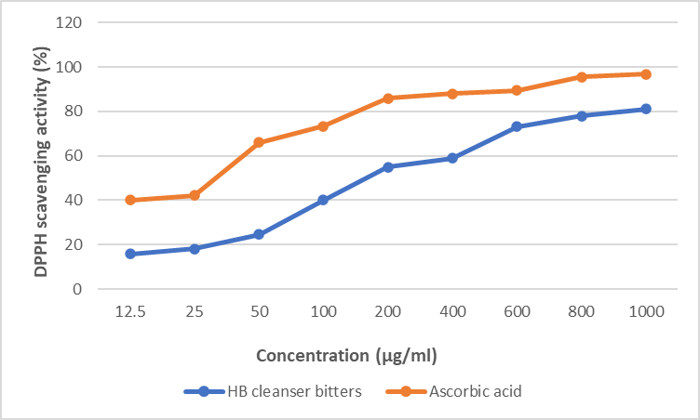

**Figure 1: DPPH scavenging activity (% inhibition) of HB cleanser**® **bitters. Values represent Mean ±SEM, n=3, significance=*P<0.05.**

The DPPH scavenging activity of HB cleanser® bitters increased withincrease in concentration at all the examined concentrationswhen compared to ascorbic acid(Figure 1).

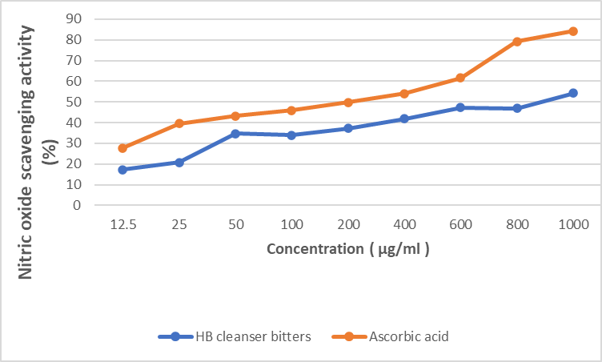

**Figure 2: Nitric oxide scavenging activity (% inhibition) of****HB cleanser**® **bitters. Values represent Mean ±SEM, n=3, significance=*P<0.05.**

The nitric oxide scavenging activity of HB cleanser® bittersshowed an increase as the concentration increases. However, there was a decrease in the percentage inhibition at a concentration of 800 µg/ml when compared with ascorbic acid (Figure 2).

**Figure 3: Ferric reducing power scavenging activity****(% inhibition)of HB cleanser**® **bitters. Values represent Mean ±SEM, n=3, significance=*P<0.05.**

There was a reduction in the ferric reducing power scavenging activity of HB cleanser® bitters at 200 µg/ml while an increase was observed at the other concentration when compared with ascorbic acid (Figure 3).

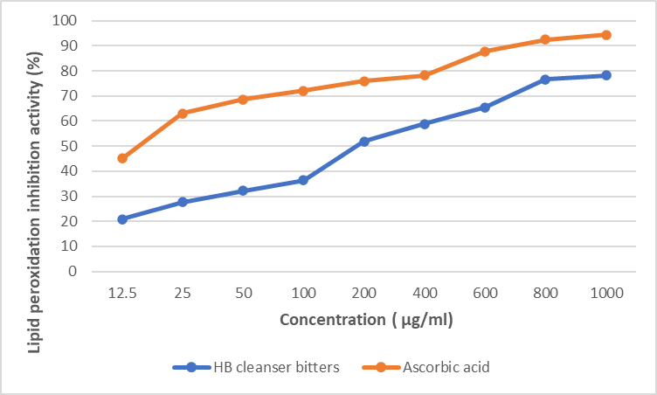

**Figure 4: Lipid peroxidation inhibition activity (% inhibition) of HB cleanser**® **bitters. Values represent Mean ±SEM, n=3, significance=*P<0.05.**

Lipid peroxidation inhibitory activity of HB cleanser® bitters increased with increasing concentrations when compared to ascorbic acid (Figure 4).

**Acute Toxicity**

From the oral acute toxicity test, it was observed that the lethal dose (LD50) of the HB cleanser® bitters is greater than 5000mg/kg since no death was recorded.

**Lipid Profile Assay Result**

There was a statistically significant (P<0.05) difference in total cholesterol and HDL levels at 1 ml/kg of HB cleanser® bitters. The HDL level was also increased at 1 mg/ml, while a reduction in triglycerides level occurred at all the doses while there was a gradual increase in the LDL levels with increase in dose when compared to the control (Table 2).

**Table 2: Evaluation of HB cleanser**® **bitters on lipid parameters.**

|  |  |  |  |  |  |
| --- | --- | --- | --- | --- | --- |
| Group | Dose (ml/kg) | Lipid Parameters (mmol/L) | | |  |
|  |  | TC | TG | HDL | LDL |
| Normal saline | 5 | 2.34 ± 0.17 | 1.04 ± 0.19 | 0.60 ± 0.10 | 1.27 ± 0.15 |
| HB cleanser | 1 | 4.32 ± 1.35 * | 0.90 ± 0.12 | 0.62 ± 0.13 * | 1.29 ± 0.13 |
| HB cleanser | 1.03 | 2.20 ± 0.19 | 0.86 ± 0.18 | 0.44 ± 0.18 | 1.33 ± 0.21 |
| HB cleanser | 1.29 | 2.32 ± 0.15 | 0.92 ± 0.13 | 0.58 ± 0.08 | 1.32 ± 0.20 |

**All values represent Mean±SEM, significance = *P < 0.05 when compared to the control.TC: Totalcholesterol, TG: Total triglyceride, HDL: High density lipoprotein, LDL:** **Low density lipoprotein.**

**DISCUSSION**

The standardization and safety of herbal medicinal preparations have been a major concern for the regulatory and health authorities including the pharmaceutical manufacturing companies14. Herbal preparations have been reported to contain phytoconstituents that imparts antioxidant activities on them15,16. Antioxidants offer protection against the damages caused by free radicals in a biological system17.

Antioxidant activity of plants have been attributed to the presence of phenolics and flavonoids which have redox reaction abilities through which free radicals such as singlet oxygen are scavenged18.

Phytochemical evaluation of HB cleanser® bittersrevealed the presence of cardiac glycosides, carbohydrates, saponins and flavonoids. The total phenolic content of HB cleanser bitters® was44.16 ± 0.67 mg/100g, flavonoids content was 84.92 ± 0.98 mg/100g and antioxidant capacity was 77.01 ± 0.50 mg/100g. The total phenolic content reflects the antioxidant strength of aromatic and medicinal plants. Flavonoids have been known to contribute to antioxidant effects of medicinal substances in physiological systems by scavenging free radicals14,19.Total antioxidant capacity estimates the quantity of free radicals scavenged in eachtest sample20.which serves as an indicator of the antioxidant potential of a medicinal substance17,21.

DPPH assay evaluates the ability of substances to scavenge free radical or donate hydrogen, to evaluate antioxidant activity of substances and estimate the number of antioxidants in biological systems22.In the present study, the DPPH scavenging activity of HB cleanser® bitters increased as the dose increased which was comparable to that of ascorbic acid.The higher the percent (%) inhibition of DPPH the lower the free radical scavenging activity and antioxidant power23.

The IC50 is the concentration of the substrate that causes a 50% reduction in DPPH activity24. The IC50 ofHB cleanser® bitters was 5.06 µg/ml while that of ascorbic acid (standard) was 1.62 µg/ml. The IC50 value is directly proportional to the potency of the sample the lower the IC50 value the more potent the substance or compound25.

Nitric oxide (NO) is obtained from amino acid L-arginine by vascular endothelial cells, phagocytes, and certain cells of the brain. Nitric oxide is a free radical and a weak oxidant due to its unpaired electron and reacts with certain proteins and some free radicals. However, nitric oxide reaction with superoxide radical leads to the formation of an extremely reactive peroxynitrite anion (ONOO−) which may precipitate unwanted toxicity 26.Antioxidants obtained from natural sources such as medicinal plants often compete with nitric oxidefor super oxide oxygen to inhibit the production of peroxynitrite which acts as an oxidant of biomolecules27.

Nitric oxide inhibitory activity of HB cleanser® bitters increased with increase in concentration with an IC50 value of 7.98 µg/ml while that of ascorbic acid was 4.39 µg/ml which is comparable.

Ferric reducing antioxidant activity measures the ability of a substance to donate an electron or hydrogen atom to break the free radical chain28. HB cleanser® bitters showed a good reducing power as it was able to reduce ferric ions (Fe3+) to the ferrous ion (Fe2+) with an IC50 of 1192.67µg/mleven though there was a decrease in reducing abilityat the concentration of 200 µg/ml.

This is in conformity with the report of Adebiyi et al, 29which stated that the scavenging activities of the spices used in their study increased with increasing concentrations and served as a reflection of the increased ability of the test constituents to easily contribute hydrogen atoms to the reactive free radical.

The results of the antioxidant activity assays of HB cleanser® bitters can also be correlated to that of Shorinwa &Shatange30 which reported that the leaves of *Smilax anceps* possessed potent antioxidant activity using similar assay protocols.

Lipid peroxidation leads to oris associated with cell damage while inhibition of peroxidation by antioxidants prevents or protects the cell from damage or destruction.Thus, lipid peroxidation may be considered as a biological marker for cell damage assessment31.Lipid peroxidation might alter the permeability of the cell membrane and influence metabolic processes including ion transport which may lead to increased reactive oxygen species expression32.Lipid peroxidation could also be used an indicator of oxidative stress because of the hydroxyl free radical oxidation of polyunsaturated fats (PUFA) constituents of cell membranes 33.

HB cleanser® bitters exhibited a dose dependent inhibition of lipid peroxidation which increased consistently with increase in concentration.

The findings of the lipid parameters evaluation revealed that the HB cleanser® bitters caused an increase in the low-density lipoprotein-cholesterol (LDL-C) while the total triglyceride, total cholesterol as well as the high-density lipoprotein-cholesterol (HDL-C) level were reduced even though the difference was statistically non-significant (P>0.05). This shows that HB cleanser® bittersrelatively have hypo-cholesterolaemic and hypo-triacylglycerolaemic effects, while decreasing the total cholesterol and total triglyceride even though it decreased HDL-cholesterol and increased LDL-cholesterol levels. This result seems to give credence to the claim by bitters manufacturers that they have hypo-lipidaemic effect. There is evidence that a salient relationship exists between high serum cholesterol levels and the incidence of atherosclerosis and cardiovascular disease 34. The observed hypocholesterolaemic effect of these herbal bitters is therefore a desired positive effect. This is in line with the result of the study carried out by Anionye*et al*, 35on the effects of yoyo bitters on albino rats which revealed the hypochoesterolemic effect of the yoyo bitters and that of Shorinwa &Emenu36which stated that the ethanol extract of Cissus gracillis reduced the concentrations of total cholesterol and triglycerides. This is not to neglect the fact that the study revealed that HB cleanser®bittersincreased the low-density lipoprotein-cholesterol when compared to the control. The observed antioxidant activities and hypocholestromic and hypo-triacylglycerolaemic effects might be attributed to the phenolic and flavonoid constituents of the bitters.

**CONCLUSION**

The study revealed that the antioxidant effect of the HB cleanser bitters® increases with increased concentration. The consumption of HB cleanser bitters® should be done with caution as it was found to increase low density lipoprotein-cholesterol (LDL-C).

**ETHICS APPROVAL**

Ethics approval was obtained from the research ethics committee of the University of Port Harcourt with the approvalnumber UPH/RandD/REC/04 in compliance with international standards.

**CONFLICT OF INTEREST**

Authors hereby declare that no conflict of interest exist.

**AUTHORS CONTRIBUTION**

Author SOA designed and supervised the study while author BVC carried out the study. Both authors drafted the manuscript while author SOA wrote the final manuscript.

**REFERENCES**

1. Showande SJ, Amokeodo OS. Evaluation of the extent and pattern of use of herbal bitters among students in tertiary institution in southwestern Nigeria. Trop J PharmRes 2014; 13 (10):1707-1712. Retrieved on 26/08/19 fromhttp://dx.doi.org/10.4314/tjpr.v13i10.20
2. Cohen PA, Ernst E. Safety of herbal supplements: a guide for cardiologists. Cardiovascular therapeutics 2010: 28 (4): 246-253.
3. Amar S, VasaniR,Saple DG. Aloe vera: a short story. Ind J Dermatol 2008; 53(4):163-166.
4. Ekor M. The growing use of herbal medicines: issues relating to adverse reactions and challenges in monitoring safety. Front Pharmacol 2014; Jan 10; 4:177. doi: 10.3389/fphar.2013.00177. PMID: 24454289; PMCID: PMC3887317.
5. World Health Organization. Programme on Traditional Medicine. (‎2002)‎. WHO traditional medicine strategy 2002-2005. World Health Organization. https://apps.who.int/iris/handle/10665/67163
6. Raynor DK, Dickinson R, Knapp P, Long AF, Nicolson DJ. Buyer beware? Does the information provided with herbal products available over the counter enable safe use? BMC Medicine 2011; 9 (94) :1-8 doi:10.1186/1741-7015-9-94
7. Harborne JB. Phytochemical Methods: A Guide to Modern Techniques

of Plant Analysis. 3rd ed. London, UK: Chapman and Hall; 1998.

1. Moukette BM, Pieme CA, Njimou JA, Biapa CP, Marco B, Ngogang JY. (2015). In-vitro antioxidant properties, free radicals scavenging activities of extracts and polyphenol composition of a non-timber forest product used as spice: *Monodoramyristica.* Biol Res2015; 48 (15):1-17. https://doi.org/10.1186/s40659-015-0003-1
2. Ohkawa H, Ohishi N, Yagi K. Assay for lipid peroxides in animal tissues by thiobarbituric acid reaction. Anal Biochem1979; 95(2):351-358. doi: 10.1016/0003-2697(79)90738-3. PMID: 36810
3. Nwidu LL, Oboma YI, Elmorsy E, Carter GW. (2018). Hepatoprotective effect of hyrdromethanolic leaf extract of *Musangacecropioides* (Urticaceae) on carbon tetrachloride-induced liver injury and oxidative stress. J Taibah Univ Med Sci 2018;13(4):344-354.
4. Sadeghi H, Hosseinzadeh AS, Akbartabar TM, Ghavamzadeh M, JafariBarmak M, Sayahi M et al. Hepatoprotective effect of *Rosa canina* fruit extract against carbon tetrachloride induced hepatotoxicity in rat. Avicenna JPhytomed 2016; 6 (2) :181-188.
5. Friedewald WT, Levy RI, Fredrickson DS. (1972). Estimation of the concentration of low- density lipoprotein cholesterol in plasma, without the use of preparative ultracentrifuge. Clin Chem 1972; 18(6): 499-502.PMID: 4337382.
6. Trinder P.Enzymatic calorimetricdetermination of triglycerides by GOP-PAP Method.Annals ClinBiochem1969; 6:24-https://doi.org/10.1177/000456326900600108
7. World Health Organization. Guidelines for assessing the quality of herbal medicines with references to contaminants and residues. Geneva, Switzerland, 2007;43: 89-93.
8. Wade N. Laetrile at sloan-kettering: a question of ambiguity. Sci 1977; 198(4323):1231-1234. doi: 10.1126/science.198.4323.1231. PMID: 17741690.
9. Loliger J. 1991. The use of antioxidants in food. In:AruomaOI, Halliwell B (Eds.), Free radicals and food additives. London,1991.p: 129-150
10. Marques SS, Magalhães LM, Tóth IV, Segundo MA. Insights on antioxidantassays for biological samples based on the reduction of copper complexesthe importance of analytical conditions. Int J Mol Sci 2014; 15 (7):11387–11402. doi: 10.3390/ijms150711387. PMID: 24968275; PMCID: PMC4139788.
11. Hussain I, Ullah R, Ullah R, Khurram M, Ullah N, Baseer A,*et al*.,Phytochemical analysis of selected medicinal properties, Afri J Biotechnol 2011; 10(38): 7487-7492.
12. Yang WJ, Li DP, Li JK, Li MH, Chen YL, ZhangPZ. Synergistic antioxidant activitiesof eight traditional Chinese herb pairs. Biol.Pharma. Bull 2009; 32(6): 1021–1026.
13. Ghiselli A, Serafini M, Natella F, Scaccini C. Total antioxidant capacity as a tool to assess redox status: critical view and experimental data. Free Radic Biol Med 2000;29 (11):1106–1114.doi: 10.1016/s0891-5849(00)00394-4
14. Pinchuk I, Shoval H, Dotan Y, Lichtenberg D. Evaluation of antioxidants: scope, limitations, and relevance of assays. Chem Phys Lipids 2012;165(6) :638–647.doi: 10.1016/j.chemphyslip.2012.05.003.
15. PrakashA. Antioxidant activity. Med Lab Anal Prog 2001;19(2):1–66.
16. Quian H,Nihorimbere V. Antioxidant power of phytochemicals from Psidium guajava leaf. J ZheijiangUniv Sci 2004; 5(6): 676-683.
17. Molyneux P. The use of the stable free radical diphenylpicrylhydrazyl (DPPH) for estimating antioxidant activity. Songklanakarin J Sci Technol 2004; 26(2): 211-219.
18. Meyer CT, Wooten DJ, Paudel BB, Bauer J, Hardeman KN, Westover D, *et al*. Quantifying Drug Combination Synergy along Potency and Efficacy Axes. Cell Syst 2019; 8(2):97–108.
19. Nagmoti M, Khatri DK,Juvekar PR,Juvekar AR. Antioxidant activity and free radical*-*scavenging potential of Pithecellobium dulce Benth seed extracts. Free Radic Antioxidants 2011;2 (2):37–43.
20. Nimse SB, Pal D. Free radicals, natural antioxidants, and their reaction mechanisms. RSC Adv 2015; 5: 27986–28006.
21. Gordon MH: The mechanism of antioxidant action in vitro. In: Food antioxidants. Edited by Hudson BJ. London: Elsevier Applied Science:1990. p. 1– 18.
22. Adebiyi OE, Olayemi FO, Ning-Hua T, Guang-Zhi Z. In vitro antioxidant activity, total phenolic and flavonoid contents of ethanol extract of stem and leaf of *Grewia carpinifolia*. Beni-Suef Univ. J. Basic Appl Sci 2017; 6 (1)10–14.
23. Shorinwa OA, Shatange DD. Antioxidant and hepatoprotective activity of leaf extract of *Smilax Anceps* Wild. Diabetes Complicat 2022; 6(1): 1-8.
24. Halliwell B, Guttridge JMC. Lipid peroxidation, oxygen radicals, cell damage and antioxidant therapy. Lancet 1984; 1:1396-1398.
25. Catalá A, Díaz M. Editorial: Impact of lipid peroxidation on the physiology and pathophysiology of cell membranes. Front Physiol 2016;22(7):423. doi: 10.3389/fphys.2016.00423. PMID: 27713704; PMCID: PMC5031777.
26. Le NA. Lipoprotein-associated oxidative stress: A new twist to the postprandial hypothesis. Int J Mol Sci 2014; 16 (1):401–419. doi: 10.3390/ijms16010401.
27. Fielding D,MetheronG. Rabbits: The tropical agriculturalist (1st ed.). Macmillan Publishers. London UK, 1991.p.16-17.
28. Anionye JC, Onyeneke EC, Eze GI, Edosa RO, Agu KC, Omorowa EF*et al*.Evaluation of the effects of Yoyo bitters on Albino rats. Int Digital Org Sci Res J applSci 2017; 2(1): 1-24.
29. Shorinwa OA, Emenu GEI. Antidiabetic and anti-hyperlipidaemic effects of the ethanol extract of theleaves and stem of *Cissus gracillis* (Gull et Perr) (Vitaceae). Asian J Pharm Clin Res 2021; 14(12): 54-56.