Reviewer’s Comments
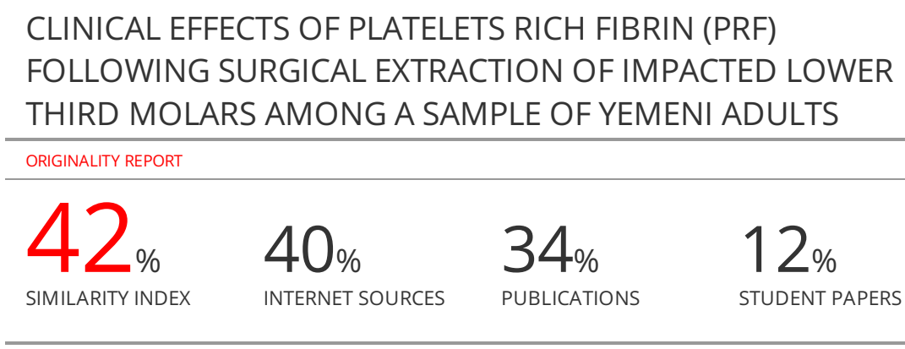
CLINICAL EFFECTS OF PLATELETS RICH FIBRIN (PRF) FOLLOWING SURGICAL EXTRACTION OF IMPACTED LOWER THIRD MOLARS AMONG A SAMPLE OF YEMENI ADULTS

ABSTRACT
Background and aims: Third molar surgery is one of the most frequent procedures in oral and maxillofacial surgery. Pain, trismus, and swelling are the majority symptoms that have an impact on patients' quality of life. Haemorrhage, alveolitis and infections are general complications. Several attempts have been through to decrease the risk of complications and make better patients' quality of life, such as the administration of platelet-rich plasma (PRP) or the administration of platelet-rich fibrin (PRF). The aim of this study is to determine the clinical effects of PRF after surgical extraction of impacted lower third molars among a sample of Yemeni adults by evaluate the effect of PRF on postoperative complications of pain, swelling, and mouth opening and to compare the difference in the healing process between the PRF surgery site and the control site.
Methods: The prospective study consisted of 36 patients who presented for removal of an impacted bilateral mandibular molar. After extraction, plugs were filled with PRF or without PRF in the study (18 patients) and control (18 patients) groups, respectively. Postoperative edema was calculated using a flexible tape measure by estimating the distance between several facial features on the 2nd to the 7th postoperative days. Postoperative pain was assessed using a line-type visual analog scale (VAS) and a verbal scale (VRS); and trismus by caliper scales. Epi-Info version 7.0 was used for data analysis.
Results: There were statistical significant differences between the PRF group and the control group in regard to pain intensity, number of analgesics tablets used and the interincisal distance, as the P value were 0.001, 0.0001 and 0.001 respectively.
Conclusion: The PRF helps in reducing the post-surgical pain, edema and trismus. As well as accelerate healing process after the application to the socket of surgically extracted lower third molar.
Keywords: Edema, Impacted third molar surgery, Pain, Platelet rich fibrin (PRF), Trismus.

INTRODUCTION
Wisdom teeth are most frequently impacted, which is taking into consideration as a pathological condition. The delayed formation of the third molars and the development of the size of the lower jaw meant that there was not enough space for proper eruption. Variations in the physical activity and type of food consumed lead to jaw size reduction ^{1, 2}. In addition, genetic factors should be taken into account^{3, 4}. Lack of adequate gap for the eruption of the third molar is not uncommonly discernible by periorbital inflammation, pain, root resorption of adjacent teeth, and formation of cyst^{2, 5}. The surgery of the third molar is one of the mainly common procedures in maxillofacial and oral surgery. Swelling, pain, and trismus are the most common signs affecting patients' quality of life. In addition, alveolitis, infections, and bleeding are common complications ^{6, 7}. Several attempts have been done to decrease the complications risk and enhance patients' quality of life, such as platelet-rich fibrin (PRF), platelet-rich plasma (PRP) administration ^{8, 9}, laser¹⁰, cryotherapy, and osteotomy or flap designs, and pharmacological treatments¹¹⁻¹⁴. Nevertheless, the precise resolution for pain and edema was not found. PRF thrombolysis, developed by Chouckroun et al.¹⁵, consisting of platelets, leukocytes, cytokines, and circulating dendritic cells (stem cells) secured by a fibrin matrix¹⁵. These elements make PRF a therapeutic biomaterial that allows for optimal healing¹⁶. PRF belongs to the next generation of platelet concentrates destined for simplified preparation without biochemical blood processing ¹⁷. Extraction cavities will heal more quickly and pain will be reduced if autologous platelet concentrate is applied to the area¹⁵. Several studies have shown that PRF accelerates wound healing in periodontal defects, cyst cavities, and paranasal sinuses^{15, 18, 19}. In addition to the benefits of this method in maxillofacial surgery, its preparation and handling are simple, inexpensive and subjective in nature²⁰.
Although previous research has been conducted on dental caries, oral and facial abscesses of odontogenic origin, localized aggressive gingivitis (LAP), periodontitis, bacterial and fungal oral infections, interleukin-1 levels in human gingival sulcus, etc. in Sana’a Yemen^{21–33}, there is no information regarding the clinical effects of PRF after surgical extraction of impacted lower third molars although this is widely used in dental surgery in Yemen. Therefore, this study aimed to determine the clinical effects of PRF after surgical extraction of impacted lower third molars among a sample of Yemeni adults by evaluate the effect of PRF on postoperative complications of pain, swelling, and mouth opening and to compare the difference in the healing process between the PRF surgery site and the control site.
SUBJECTS AND METHODS
Study design: The prospective study was conducted to evaluate the effect of PRF after surgical removal of impacted mandibular third molar.
Study area: This study was carried out in the clinic of maxillofacial surgery department, Faculty of Dentistry, Sana’a University.
Study population and Sample size: The study population included patients which had been referred to the clinic of maxillofacial surgery, Faculty of Dentistry, Sana'a University for extraction of impacted 3rd molars in Sana’a City from December 2021 to June 2022. Sample size was 36 impaction patients; 18 cases and 18 controls. The sample size was determined according to the availability of patients in the time period of the study.
Inclusion criteria: The inclusion criteria including patients with bilateral mandibular impaction, age over 18 years- old, nonsmoker, free from systemic diseases, with good oral hygiene, free of inflammation signs or symptoms.
Exclusion criteria: The study excluded, pregnant and/or lactating women, patients on steroidal anti-inflammatory drugs, patients with systemic diseases that reduce immunity such as diabetes, hypothyroidism, immunosuppressed patients, HIV, severe liver disease, malnutrition, adrenal insufficiency, Cushing's syndrome . The study also excluded patients taking anticoagulant medications and smokers.
Data collection: All patients underwent clinical evaluation and all information was collected in the pooled data sheet (case sheet), which was designed for a systematic recording. The intraoperative distance was measured preoperatively using calipers (Figure 2, 3). Each patient was a fellow from the first to the seventh day of surgery. On these second, third, and seven days, the distance between the cuts was measured and swelling was assessed. Each patient was asked to report a pain score and the number of analgesia tablets taken from the first day of surgery to the seventh day. Each side was extracted on different dates.
Surgical procedure: Under all aseptic techniques, 5 mL of blood was drawn intravenously from the anticubital region of the patient's forearm using a vacutainer needle and transferred into the vacuum tube without anticoagulant and centrifuged at 2,700 rpm for 12 min. The surgical site of the affected third molar was irrigated with normal saline and prepared for the surgical procedure. The inferior alveolar nerve block and the long buccal nerves were treated. A scalpel with a blade No. 15 was used to make an incision for a flap (triangular flap). A complete mucoperiosteal flap was lifted by the periosteal elevator. Then a straight hand piece of suitable speed and torque was used to remove the bone from the occlusal side of the tooth with normal irrigation with abundant saline. Bone gutters and minimal tooth separation were performed to allow removal of the impacted tooth with minimal trauma to the bone. After removal of the impacted tooth, an appropriate debridement was performed. A bone file was used to smooth out any sharp bone edges. The cavity was then cleaned with normal saline. The prepared 1-cm PRF was grasped by forceps and delivered into the socket (Figure 1). The prepared PRF was obtained in the middle of the tube, just between the erythrocytes at the bottom and the cellular plasma at the top. Then, the flap was closed with 3-0 black silk interrupted sutures. The suture was removed on the seventh day after surgery. The patient was only taking Paracetamol 500 mg as an analgesic, without a prescription of antibiotics.
Variables of the study
Inter-incisal distance: The inter-incisal distance was measured before the start of surgery, and on the 2nd day, 4th day and 7th day after surgery, which was reported in centimeter (cm) (Figure 2, 3).

Pain: It was revealed from the patient by answering the questions for the seven post-operative days, each answer had a number as following:
0 = There is no pain.
1= Very mild pain.
2 = Moderate pain with eating.
3 = Severe pain that interferes with sleep.
4 = The pain is intense and persistent in all cases.

Number of analgesic used by the patient: It was revealed from the patient by writing the number of analgesics that was taken for the seven post-operative days in a chart given to the patient.

Swelling: It was examined in the 2nd day, 5th day and 7th day after the surgery, in which each category had a number as following:
‎0 = No swelling.
‎1 = Very slight swelling.
‎2 = Slight swelling.
‎3 = Moderate swelling.
‎4 = Severe swelling.

Statistical method: Data presented using appropriate descriptive statistics (including frequency, mean, standard deviation and P-value). All data statistical analysis was performed by using the Statistical Package for Social Science (SPSS) version 24 and Excel 2010. In which, after data collection, they were recorded and entered to the SPSS for analysis.

Ethical approval: Ethical approval was obtained from the Medical Ethics Committee of the Faculty of Dentistry, Sana’a University that dated November 24- 2021 with official number 2021-27. Each patient in the study signed consent. All data, including patient identification and CBCT images were kept confidential.

RESULT

Thirty-six lower third impactions (18 patients) were evaluated post operatively for this study. Seven of the patients were males 7 (38.9%) and 11 (61.1%) were females. The mean age was 22.8 ± 2.179 years and the age range was from 19 to 28 years old (Table 1) and (Figure 1).

Distribution of pain: There was very mild pain in 14 (77.8%) and moderate pain in 4 (22.2%) with eating in the PRF group. On the other hand, there was moderate pain in 7 (38.9%) with eating and severe pain interfering with sleep in 9 (50%) in the control group. There was a statistically significant difference between the two groups (P = 0.001) (Table 2, Figure 5).

The Linear measurements of inter-incisal distance: The mean preoperative distance in both groups was 4.32 ± 498 mm. There was no statistically significant difference between both groups in the 2nd postoperative day. Unlike the 4th and 7th postoperative days, there was statistically significant difference between both groups (P =0.001). Also, there was no statistically significant difference between both groups in regard to gender (Table 3, Figure 6).

The number of analgesic used by the patient: There was statistically significant difference between both groups in the whole postoperative week in the number of analgesic used (P-value=0.0001). The PRF group did not use any analgesic in the postoperative 5th, 6th and 7th days. Unlike the group without PRF which used analgesics with the means of (1.72 ± 1.487), (1.33± .029) and (1.28 ± 0.958) respectively (Table 4, Figure 7).

Post-operative swelling in both groups: There was statistically significant difference between both groups in second and seventh postoperative day with regard to swelling (P-value = 0.012) (P-value = 0.011) respectively. In contrast to the fifth day, there was no statistically significant difference between both groups with regard to swelling (Table 5, Figure7).

DISCUSSION
There are no published data on the effect of PRF on pain, trismus and swelling in third-molar surgery in Yemen. Also, there is a very limited amount of literature on the effect of PRF on pain and swelling in third molar surgery worldwide. The aim of this study is to investigate the effect of PRF application on postoperative pain and edema after surgical removal of mandibular third molars. The null hypothesis was that postoperative pain and edema with and without postoperative PRF would be equal. The authors measured and compared postoperative pain and edema after surgical removal of mandibular third molars in PRF and non-PRF sockets. PRF is the second generation of platelet concentrates (PRP is the first generation). PRF contains endogenous cytokines and various immune cells; it is a fibrous membrane that adequately covers the wound and can be sutured ³⁴. In the oral and maxillofacial region, PRF has been extensively used in sinus augmentation as the only grafting substance or in mixture with an allograft or xenograft³⁵. PRF clots is also used in the treatment of acute sinus perforations without flap³⁶. Preservation of extraction cavity, intrabony defects, and periodontal troubles are the other indications for the use of intraoral PRF¹⁶.
In the current study PRF usage decreased pain and swelling values significantly in which there was very mild pain in 14 (77.8%) and moderate pain 4 (22.2%) with eating in the PRF group while there was moderate pain ‎in 7 (38.9%)‎ with eating and severe pain ‎that interferes with sleep in 9 (50 %)‎ in the control group (Table 2). Our findings are similar to those reported by Kumar et al. ³⁷ where this study was conducted on 31 patients; this study reported that the use of PRF significantly reduced pain and swelling values ​​on the first control day after surgery. They scored these values ​​using a Type Likert VAS as required by Pasqualini et al. ³⁸. In another study of 20 bilaterally affected third molar surgeries, Singh et al.³⁹ reported that the use of PRF after third molar surgery reduced pain in the first, third, and seventh postoperative days (measured with a Likert-type VAS); However, this result was not statistically significant when compared with the control group. With a large sample in a multicenter study (56 patients, 102 teeth), Özgül et al.⁴⁰ reported that the use of PRF after third molar extraction significantly reduced lateral swelling (including tragus and commissure) on the first and third postoperative day. They reported that there were no statistically significant differences on the seventh day after surgery. They also found no significant differences in vertical swelling, which included lateral canthus measurement and gonion measurement or pain at all, intervals.
In the current study, there was statistically significant difference between both groups in second and seventh postoperative day with regard to swelling (P-value = 0.012) (P-value = 0.011) respectively, in which there was significant decrease in PRF group comparing control group (Table 5).
Our findings differ from those reported by Bilginaylar et al.⁴¹, in the 59 patients studied; the use of PRF significantly reduced pain values ​​on the first, third, and seventh day after surgery, but had no effect on swelling values. Also, our result differs from Kumar et al.³⁷, as there were no significant differences in the swelling values ​​on the first day after surgery. They also determined that there were no statistically significant differences on the third and seventh days after surgery. They stated that a tape measure could be the reason behind the different degrees of swelling. Uyanik et al.⁹, the impacted third molars were extracted bilaterally in 20 patients and reported that the use of PRF in surgery of the impacted third molar significantly relieved pain on days 1, 2, 3, and 7 after surgery (pain was assessed using a Likert-type VAS). However, no significant differences were found regarding swelling, which was assessed by tape measure⁹. Also, regarding swelling after surgery, according to our study, there was a statistically significant difference between the two groups on the second and seventh postoperative day regarding the absence or reduction of swelling (p-value = 0.012) (p-value = 0.011) respectively. Our findings are supported by Ozgul et al.⁴², and Dar et al.⁴³ who found that swelling was less on the PRF sides. In contrast to the fifth day, there was no statistically significant difference between both groups in our study. This result was like that reported by He et al.⁴⁴ with no statistically significant difference between both groups in the first day, but statistically significant difference between both groups in the third day. The positive effect of PRF in swelling can be explained by that, the most important specific activities of platelet-derived growth factor (PDGF) in the PRF include mitogenesis (increase in the cell population on healing cells), angiogenesis (endothelial mitosis into functioning capillaries), and macrophage activation (debridement of the wound site and a second phase source of growth factors for continued repair and bone regeneration). Therefore, a threefold or greater concentration of platelets, as was measured in PRF, can be expected to have a profound effect on swelling reduction by virtue of it swashing away the exudates due to the above-mentioned activities. However, there are some controversies in the literature regarding the effect of PRF in reduction the swelling after surgical extraction. As many authors such as Bilginaylar and Uyanik,⁴¹, Gülşen and Şentürk,⁴⁵ , and Trybek et al.,⁴⁶ who reported no significant differences between the PRF group and control group in the swelling. This dissimilarity may be related to the method of assessment. Some authors assessed by visual assessment as in our study, others by reference point in the face, flexible ruler and others used a tape measure to measure the swelling. Ozgul et al.,⁴² used a 3-D optical scanner for the measurements of facial swelling, which might have given more precise recordings, however the funding of our study did not support such expenses. In addition, our findings are similar to another study of 30 patients; Asutay et al.⁴⁷ reported that there were no significant differences between the PRF and control groups in all periods due to the improvement in pain and swelling values. This study used 3dMD to assess swelling, while a Likert-type VAS was used to assess pain. They reported that all operations took place in a series of two appointments⁴⁷. On the other hand, our findings differ from Gürler et al. study⁴⁸ in which they reported that application of leukocyte PRF (L-PRF) to extraction sockets of impacted third molars in 40 patients was not found to be statistically significant in terms of pain and edema after surgery. They reported that pain is assessed using a VAS-type Likert scale while edema was assessed using a flexible ruler⁴⁸.
With regard to the linear measurements of inter-incisal distance in our study, the mean preoperative distance in both groups was 4.32 ±0.498 mm. There was no statistically significant difference between both groups in the 2nd postoperative day. Unlike the 4th and 7th postoperative days, in which there was statistically significant difference between both groups (P =0.001). There was no statistically significant difference between both groups in regard to gender (P-value=0.001) (Table 3). These findings are similar to studies done by Trybek et al.⁴⁶ and Kumar et al.,⁴⁹, in which the trismus was significantly higher in the control group than in the PRF study group at one, two, and seven days after surgery (P=< 0.05) (P=.040) respectively. However, these results were dissimilar to other authors who have found no statistically significant difference between both groups in regard to trismus^{20, 41}. This dissimilarity may be related to their methods of measurements, as digital caliper reveals more accurate measurements in our study. Other possible factor that may influence this result is the measurements were revealed by non-qualified person (not the operating surgeon).
LIMITATIONS OF THE STUDY

CONCLUSION
The PRF helps in reducing the post-surgical pain, edema and trismus. As well as accelerate healing process after the application to the socket of surgically extracted lower third molar. To obtain more meaningful results, future research should use a larger sample with different evaluation methods for all variables (i.e., pain, trismus and swelling).
ACKNOWLEDGEMENT
The authors would like to acknowledge Sana’a University, Sana’a, and Yemen which supported this work.
Author’s Contribution

CONFLICT OF INTEREST
No conflict of interest associated with this work.
REFRANCESES
1. Mandal, S.; Pahadia, M.; Sahu, S.; Joshi, A.; Suryawanshi, D.; Tiwari, A. Clinical and Imaging Evaluation of Third Molars: A Review. J. Appl. Dent. Med. Sci. 2015, 1, 3–9.

2. Kumar, M.P.; Aysha, S. Angulations of impacted mandibular third molar: A radiographic study in Saveetha dental college. J.Pharm. Sci. Res. 2015, 7, 981–983.

3. Khanal, P.; Dixit, S.; Singh, R.; Dixit, P. Difficulty index in extraction of impacted mandibular third molars and their post-operative complications. Kathmandu Univ. Med. J. 2014, 3, 14–20. https://doi.org/10.3126/jkmc.v3i1.10918

4. Trybek G, Jaroń A, Grzywacz A. Association of Polymorphic and Haplotype Variants of the MSX1 Gene and the Impacted Teeth Phenomenon. Genes (Basel). 2021 Apr 16;12(4):577 https://doi.org/10.3390/genes12040577.

5. Janas A, Stelmach R, Osica P. Atypical dislocation of impacted permanent teeth in children. own experience. Dev Period Med. 2015 Jul-Sep;19(3 Pt 2):383-8. PMID: 26958685.

6. Bui CH, Seldin EB, Dodson TB. Types, frequencies, and risk factors for complications after third molar extraction. J Oral Maxillofac Surg. 2003 Dec;61(12):1379-89. https://doi.org/10.1016/j.joms.2003.04.001.

7. Laureano Filho JR, Maurette PE, Allais M, Cotinho M, Fernandes C. Clinical comparative study of the effectiveness of two dosages of Dexamethasone to control postoperative swelling, trismus and pain after the surgical extraction of mandibular impacted third molars. Med Oral Patol Oral Cir Bucal. 2008 Feb 1;13(2):E129-32. PMID: 18223530.

8. Ogundipe OK, Ugboko VI, Owotade FJ. Can autologous platelet-rich plasma gel enhance healing after surgical extraction of mandibular third molars? J Oral Maxillofac Surg. 2011 Sep;69(9):2305-10. https://doi.org/10.1016/j.joms.2011.02.014.

9. Uyanık LO, Bilginaylar K, Etikan İ. Effects of platelet-rich fibrin and piezosurgery on impacted mandibular third molar surgery outcomes. Head Face Med. 2015 Jul 26;11:25. https://doi.org/10.1186/s13005-015-0081-x..

10. Romeo U, Libotte F, Palaia G, Tenore G, Galanakis A, Annibali S. Is erbium:yttrium-aluminum-garnet laser versus conventional rotary osteotomy better in the postoperative period for lower third molar surgery? Randomized split-mouth clinical study. J Oral Maxillofac Surg. 2015 Feb;73(2):211-8. https://doi.org/10.1016/j.joms.2014.08.013.

11. Laureano Filho JR, de Oliveira e Silva ED, Batista CI, Gouveia FM. The influence of cryotherapy on reduction of swelling, pain and trismus after third-molar extraction: a preliminary study. J Am Dent Assoc. 2005 Jun;136(6):774-8; quiz 807. https://doi.org/10.14219/jada.archive.2005.0261.

12. Olurotimi AO, Gbotolorun OM, Ibikunle AA, Emeka CI, Arotiba GT, Akinwande JA. A comparative clinical evaluation of the effect of preoperative and postoperative antimicrobial therapy on postoperative sequelae after impacted mandibular third molar extraction. J Oral Maxillofac Res. 2014 Jul 1;5(2):e2. https://doi.org/10.5037/jomr.2014.5202.

13. Dolanmaz D, Esen A, Isik K, Candirli C. Effect of 2 flap designs on postoperative pain and swelling after impacted third molar surgery. Oral Surg Oral Med Oral Pathol Oral Radiol. 2013 Oct;116(4):e244-6. https://doi.org/10.1016/j.oooo.2011.11.030.

14. Barone A, Marconcini S, Giacomelli L, Rispoli L, Calvo JL, Covani U. A randomized clinical evaluation of ultrasound bone surgery versus traditional rotary instruments in lower third molar extraction. J Oral Maxillofac Surg. 2010 Feb;68(2):330-6. https://doi.org/10.1016/j.joms.2009.03.053
15. Choukroun J, Adda F, Schoeffler C, Vervelle A. Uneopportunite´ en paroimplantologie: le PRF. Implantodontie. 2001;42:55–62.

16. Choukroun J, Diss A, Simonpieri A, Girard MO, Schoeffler C, Dohan SL, Dohan AJ, Mouhyi J, Dohan DM. Platelet-rich fibrin (PRF): a second-generation platelet concentrate. Part IV: clinical effects on tissue healing. Oral Surg Oral Med Oral Pathol Oral Radiol Endod. 2006 Mar;101(3):e56-60. https://doi.org/10.1016/j.tripleo.2005.07.011.

17. Dohan DM, Choukroun J, Diss A, Dohan SL, Dohan AJ, Mouhyi J, Gogly B. Platelet-rich fibrin (PRF): a second-generation platelet concentrate. Part I: technological concepts and evolution. Oral Surg Oral Med Oral Pathol Oral Radiol Endod. 2006 Mar;101(3):e37-44. https://doi.org/10.1016/j.tripleo.2005.07.008.

18. Aroca S, Keglevich T, Barbieri B, Gera I, Etienne D. Clinical evaluation of a modified coronally advanced flap alone or in combination with a platelet-rich fibrin membrane for the treatment of adjacent multiple gingival recessions: a 6-month study. J Periodontol. 2009 Feb;80(2):244-52. https://doi.org/10.1902/jop.2009.080253.

19. Simonpieri A, Del Corso M, Sammartino G, Dohan Ehrenfest DM. The relevance of Choukroun's platelet-rich fibrin and metronidazole during complex maxillary rehabilitations using bone allograft. Part I: a new grafting protocol. Implant Dent. 2009 Apr;18(2):102-11. https://doi.org/10.1097/ID.0b013e318198cf00.

20- Xiang X, Shi P, Zhang P, Shen J, Kang J. Impact of platelet-rich fibrin on mandibular third molar surgery recovery: a systematic review and meta-analysis. BMC Oral Health. 2019 Jul 25;19(1):163 https://doi.org/10.1186/s12903-019-0824-3.

21. Al Makdad ASM, Al-Haifi AY, Salah MK, Al-ShamahyHA, Al-Falahi TH. Urinary tract infections in post operative patients: prevalence rate, bacterial profile, antibiotic sensitivity and specific risk factors. Universal Journal of Pharmaceutical Research 2020; 5(3):21-26. https://doi.org/10.22270/ujpr.v5i3.329

22. Al-Shami HZ, Al-Haimi MA, Al-dossary OAE, Nasher AAM, Al-Najhi MMA, Al-Shamahy HA, Al-Ankoshy AAM. Patterns of antimicrobial resistance among major bacterial pathogens isolated from clinical samples in two tertiary’s hospitals, in Sana'a, Yemen. Universal Journal of Pharmaceutical Research 2021; 6(5):60-67. https://doi.org/10.22270/ujpr.v6i5.674

23. Abbas AM, Al-Kibsi TAM, Al-Akwa AAY, AL-Haddad KA, Al-Shamahy HA, Al-labani MA. Characterization and antibiotic sensitivity of bacteria in orofacial abscesses of odontogenic origin. Universal J Pharm Res 2020; 5(6):36-42. https://doi.org/10.22270/ujpr.v5i6.510
24. Al-Akwa AA, Zabara A, Al-Shamahy HA. Prevalence of Staphylococcus aureus in dental infections and the occurrence of MRSA in isolates. Universal J Pharm Res 2020; 5( 2):1-6. https://doi.org/10.22270/ujpr.v5i2.384

25. Shogaa Al-Deen SH, Al-Ankoshy AAM, Al-Najhi MMA, Al-Shamahy HA, et al. Porphyromonas gingivalis: biofilm formation, antimicrobial susceptibility of isolates from cases of Localized Aggressive Periodontitis (LAP). Universal J Pharm Res 2021; 6 (4): 1-6. https://doi.org/10.22270/ujpr.v6i4.633.

26. AL-Haddad KA, Ali Al-Najhi MM, Al-Akwa AAY, et al. Antimicrobial susceptibility of Aggregatibacter actinomyce-temcomitans isolated from Localized Aggressive Periodontitis (LAP) Cases. J Dent Ora Heal Ad Re 2007; 103. https://doi.org/10.1111/j.1600-0463.2007.apm_630.x

27. Al-Haddad KA, Al-Najhi MMA, Abbas AKM, Al-Akwa AAY, Al-Shamahy HA, Al-labani MA. Clinical features, age and sex distributions, risk factors and the type of bacteria isolated in periodontitis patients in Sana'a, Yemen. Universal J Pharm Res 2021; 6(1):1-8.https://doi.org/10.22270/ujpr.v6i1.532
28. Alhasani AH, Ishag RA, Al Shamahy HA, et al. Association between the Streptococcus mutans biofilm formation and dental caries experience and antibiotics resistance in adult females. Universal J Pharm Res 2020; 5(6):1-3. https://doi.org/10.22270/ujpr.v5i5.478

29. Al-Safani AA, Al-Shamahy H, Al-Moyed K. Prevalence, antimicrobial susceptibility pattern and risk factors of MRSA isolated from clinical specimens among military patients at 48 medical compound in Sana’a city-Yemen. Universal J Pharm Res 2018; 3(3):40-44. https://doi.org/10.22270/ujpr.v3i3.165

30. Al-Shamahy HA, Abbas AMA, Mahdie Mohammed AM, Alsameai AM. Bacterial and Fungal Oral Infections Among Patients Attending Dental Clinics in Sana’a City-Yemen. On J Dent Oral Health 2018; 1(1): 1-6. https://doi.org/10.33552/OJDOH.2018.01.000504

31. Gylan, E. M. A., B. A. Muharram, A. I. M. Al-Kholani, K. A. AL-Haddad, A. A. Y. Al-Akwa, H. A. Al-Shamahy, M. A. Al-Hamzi, and M. A. Al-labani. “In vitro evaluation of the antimicrobial activity of five herbal extracts against streptococcus mutans”. Universal J Pharm Res 2022; 7(1):1-6. https://doi.org/10.22270/ujpr.v7i1.721.

32. Al-dossary, O. A. I., A. I. M. Al-Kholani, K. A. AL-Haddad, M. M. A. Al-Najhi, H. A. Al-Shamahy, I. A. A. Al-adhami, and K. Aldhorae. “Interleukin-1β levels in the human gingival sulcus: rates and factors affecting its levels in healthy subjects Universal J Pharm Res 2022; 7( 5): 25-30. https://doi.org/10.22270/ujpr.v7i5.838.

33. Al-Hajri, M. M., B. A. Al-Kadasi, M. A. Al-Wesabi, H. M. S. Aldeen, and S. Al-Rai. “Gingival recession in relation to mucogingival deformities and other predisposing factors affect females in lower esthetic zone”. Universal J Pharm Res 2022; 7(5): 50-55. https://doi.org/10.22270/ujpr.v7i5.844.

34. Eshghpour M, Dastmalchi P, Nekooei AH, Nejat A. Effect of platelet-rich fibrin on frequency of alveolar osteitis following mandibular third molar surgery: a double-blinded randomized clinical trial. J Oral Maxillofac Surg. 2014 Aug;72(8):1463-7. https://doi.org/10.1016/j.joms.2014.03.029.

35. Altintas NY, Senel FC, Kayıpmaz S, Taskesen F, Pampu AA. Comparative radiologic analyses of newly formed bone after maxillary sinus augmentation with and without bone grafting. J Oral Maxillofac Surg. 2013 Sep;71(9):1520-30. doi: 10.1016/j.joms.2013.04.036.

36. Gülşen U, Şentürk MF, Mehdiyev İ. Flap-free treatment of an oroantral communication with platelet-rich fibrin. Br J Oral Maxillofac Surg. 2016 Jul;54(6):702-3. doi: 10.1016/j.bjoms.2015.09.037.

37. Kumar N, Prasad K, Ramanujam L, K R, Dexith J, Chauhan A. Evaluation of treatment outcome after impacted mandibular third molar surgery with the use of autologous platelet-rich fibrin: a randomized controlled clinical study. J Oral Maxillofac Surg. 2015 Jun;73(6):1042-9. doi: 10.1016/j.joms.2014.11.013.

38. Pasqualini D, Cocero N, Castella A, Mela L, Bracco P. Primary and secondary closure of the surgical wound after removal of impacted mandibular third molars: a comparative study. Int J Oral Maxillofac Surg. 2005 Jan;34(1):52-7. doi: 10.1016/j.ijom.2004.01.023.

39. Singh A, Kohli M, Gupta N. Platelet rich fibrin: a novel approach for osseous regeneration. J Maxillofac Oral Surg. 2012 Dec;11(4):430-4. doi: 10.1007/s12663-012-0351-0.

40. Alkan A, Kocyigit ID, Atil F. Efficacy of platelet rich fibrin in the reduction of the pain and swelling after impacted third molar surgery: randomized multicenter split-mouth clinical trial. Head Face Med. 2015 Nov 26;11:37. doi: 10.1186/s13005-015-0094-5..

41. Bilginaylar K, Uyanik LO. Evaluation of the effects of platelet-rich fibrin and piezosurgery on outcomes after removal of ımpacted mandibular third molars. Br J Oral Maxillofac Surg. 2016 Jul;54(6):629-33. doi: 10.1016/j.bjoms.2016.03.016.

42. Ozgul O, Senses F, Er N, Tekin U, Tuz HH, Alkan A, Kocyigit ID, Atil F. Efficacy of platelet rich fibrin in the reduction of the pain and swelling after impacted third molar surgery: randomized multicenter split-mouth clinical trial. Head Face Med. 2015 Nov 26;11:37. doi: 10.1186/s13005-015-0094-5.

43. Dar MM, Shah AA, Najar AL, Younis M, Kapoor M, Dar JI. Healing Potential of Platelet Rich Fibrin in Impacted Mandibular Third Molar Extraction Sockets. Ann Maxillofac Surg. 2018 Jul-Dec;8(2):206-213. doi: 10.4103/ams.ams_181_18.

44. He Y, Chen J, Huang Y, Pan Q, Nie M. Local Application of Platelet-Rich Fibrin During Lower Third Molar Extraction Improves Treatment Outcomes. J Oral Maxillofac Surg. 2017 Dec;75(12):2497-2506. doi: 10.1016/j.joms.2017.05.034.

45. Gülşen U, Şentürk MF. Effect of platelet rich fibrin on edema and pain following third molar surgery: a split mouth control study. BMC Oral Health. 2017 Apr 24;17(1):79. doi: 10.1186/s12903-017-0371-8.

46. Trybek G, Rydlińska J, Aniko-Włodarczyk M, Jaroń A. Effect of Platelet-Rich Fibrin Application on Non-Infectious Complications after Surgical Extraction of Impacted Mandibular Third Molars. Int J Environ Res Public Health. 2021 Aug 4;18(16):8249. doi: 10.3390/ijerph18168249.

47. Asutay F, Yolcu Ü, Geçör O, Acar AH, Öztürk SA, Malkoç S. An evaluation of effects of platelet-rich-fibrin on postoperative morbidities after lower third molar surgery. Niger J Clin Pract. DOI: 10.4103/1119-3077.181400, 2016.

48. Gürler G, Delilbaşı Ç, Kaçar İ, Öğüt E. Evaluation of leukocyte-platelet rich fibrin (L-PRF) on postoperative complications following mandibular impacted third molar surgery. Yeditepe Clinical Journal. 2015;1:11–6.

49. Kumar KR, Genmorgan K, Abdul Rahman SM, Rajan MA, Kumar TA, Prasad VS. Role of plasma-rich fibrin in oral surgery. J Pharm Bioallied Sci. 2016 Oct;8(Suppl 1):S36-S38. doi: 10.4103/0975-7406.191963. PMID: 27829743; PMCID: PMC5074036.

RESULTS
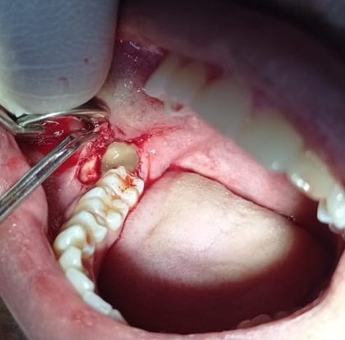

Figure 1: PRF application in the socket

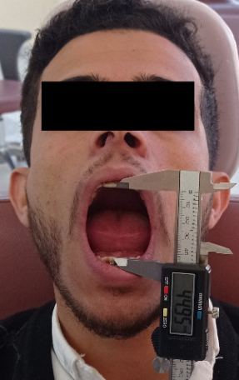

Figure 2: Preoperative inter-incisal distance
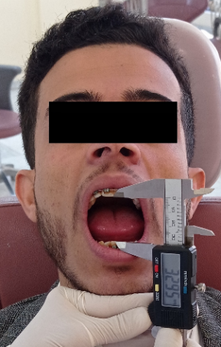

Figure 3: Inter-incisal distance in the 7th day

Table 1 The distribution of patients according to gender and side of operations :

Parameters |  | With PRF  N (%) | Without PRF  N (%)
Gender | Male | 7 (38.9%) | 7 (38.9%)
Gender | Female | 11 (61.1%) | 11 (61.1%)
Gender | Total | 18 (100%) | 18 (100%)
Side | Right | 6 (33.3%) | 12 (66.7%)
Side | Left | 12 (66.7%) | 6 (33.3%)
Side | Total | 18 (100%) | 18 (100%)

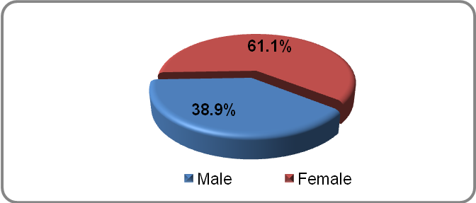
Figure 4 Distribution of data by gender

Table 2 : The mean value of pain in the PRF group and control group
Pain |  |  |  |  | With PRF  N (%) |  |  | Without PRF  N (%) |  | P-value
Very mild pain |  |  |  |  | 14 (77.8%) |  |  | 2 (11.1%) |  | 0.001*
Moderate pain with eating |  |  |  |  | 4 (22.2%) |  |  | 7 (38.9%) |  | 0.051
Severe pain that interferes with sleep |  |  |  |  | 0 (0.0%) |  |  | 9 (50 %) |  | 0.001*
The pain is intense and persistent in all cases |  |  |  |  | 0 (0.0%) |  |  | 0 (0.0%) |  | -
Total |  |  |  |  | 18 (100%) |  |  | 18 (100%)
 | Very mild pain |  | Moderate pain with eating |  |  | Severe pain that interferes with sleep |  |  | The pain is intense and persistent in all cases
 | PRF | Without PRF | PRF | Without PRF |  | PRF | Without PRF |  | PRF |  | Without PRF
1st day | 14 (77.8%) | 2 (11.1%) | 4 (22.2%) | 7 (38.9%) |  | 0 (0.0%) | 9  (50%) |  | 0 (0.0%) |  | 0 (0.0%)
2nd day | 13 (72.2%) | 2 (11.1%) | 4 (22.2%) | 10 (55.6%) |  | 0 (0.0%) | 6 (33.3%) |  | 0 (0.0%) |  | 0 (0.0%)
3rd day | 10 (55.6%) | 1 (5.6%) | 4 (22.2%) | 11 (61.1%) |  | 0 (0.0%) | 5 (27.8%) |  | 0 (0.0%) |  | 0 (0.0%)
4th day | 8 (44.4%) | 3 (9.7%) | 1 (5.6%) | 11 (61.1%) |  | 0 (0.0%) | 3 (11.5%) |  | 0 (0.0%) |  | 0 (0.0%)
5th day | 8 (44.4%) | 5 (27.8%) | 0 (0.0%) | 11 (61.1%) |  | 0 (0.0%) | 1 (5.6%) |  | 0 (0.0%) |  | 0 (0.0%)
6th day | 8 (44.4%) | 9 (29.0%) | 0 (0.0%) | 6 (33.3%) |  | 0 (0.0%) | 1 (5.6%) |  | 0 (0.0%) |  | 0 (0.0%)
7th day | 8 (44.4%) | 9 (29.0%) | 0 (0.0%) | 6 (33.3%) |  | 0 (0.0%) | 1 (5.6%) |  | 0 (0.0%) |  | 0 (0.0%)

P-Value between cases and control (Chi- Square Test)

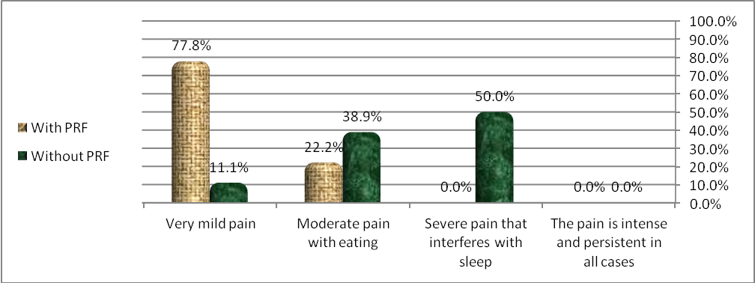
Figure 5: The level of pain in the PRF group and control group

Inter-incisal distance measurement |  |  |  | With PRF |  |  |  | Without PRF |  |  |  | P-Value
 |  |  |  | Mean |  | ±SD |  | Mean |  | ±SD
Preoperative |  |  |  | 4.32 |  | 0.498 |  | 4.32 |  | 0.498 |  | 1.000
‎2nd postoperative ‎day |  |  |  | 3.33 |  | 0.57 |  | 2.89 |  | 0.76 |  | 0.104
4th postoperative day |  |  |  | 3.19 |  | 0.67 |  | 2.28 |  | 0.69 |  | 0.001*
7th postoperative day |  |  |  | 3.53 |  | 0.79 |  | 2.33 |  | 0.95 |  | 0.001*
Inter-incisal distance measurement |  | Preoperative |  |  | 2nd postoperative day |  |  | 4th postoperative day |  |  | 7th postoperative day
 |  | Mean | P-Value |  | Mean |  | P-Value | Mean | P-Value |  | Mean |  | P-Value
With PRF | Male | 4.39  ±0.57 | 0.791 |  | 3.50  ±0.65 |  | 0.451 | 3.14  ±0.69 | 0.860 |  | 3.57  ±0.84 |  | 1.00
With PRF | Female | 4.27  ±0.46 |  |  | 3.23  ±0.57 |  | 0.451 | 3.23  ±0.68 |  |  | 3.50  ±0.806 |  | 1.00
Without PRF | Male | 4.39  ±0.575 | 0.79 |  | 3.29  ±0.76 |  | 0.104 | 2.57  ±0.84 | 0.246 |  | 2.29  ±0.95 |  | 0.930
Without PRF | Female | 4.27  ±0.46 |  |  | 2.64  ±0.67 |  | 0.104 | 2.09  ±0.54 |  |  | 2.36  ±1.00 |  | 0.930
Table 3 :The mean ±SD values of inter-incisal distance of PRF group compare with control group:

P-Value between with PRF group and without PRF group for interincisal distance measurement (Mann-Whitney Test)
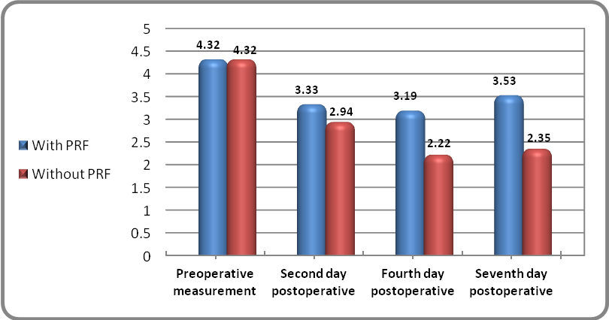

Figure 6: The mean value of inter-incisal distance in the PRF group and without PRF group

Table 4 : The mean value of number of analgesic used by the patient in the PRF group and without PRF group
Number of analgesic used by the patient | With PRF |  | Without PRF |  | P-Value
Number of analgesic used by the patient | Mean | ±SD | Mean | ±SD | P-Value
First day | 2.5 | 1.000 | 4.13 | 1.628 | 0.0001*
Second day | 2.44 | 0.527 | 4.06 | 1.436 | 0.0001*
Third day | 2.33 | 0.516 | 4.08 | 1.084 | 0.0001*
Fourth day | 0 | 0 | 3.50 | 1.243 | 0.0001*
Fifth day | 0 | 0 | 2.73 | 1.104 | 0.0001*
Sixth day | 0 | 0 | 2.09 | 0.701 | 0.0001*
Seventh day | 0 | 0 | 2.10 | 0.738 | 0.0001*
P-Value between with PRF group and without PRF group for number of analgesic used by the patient (Mann-Whitney Test)

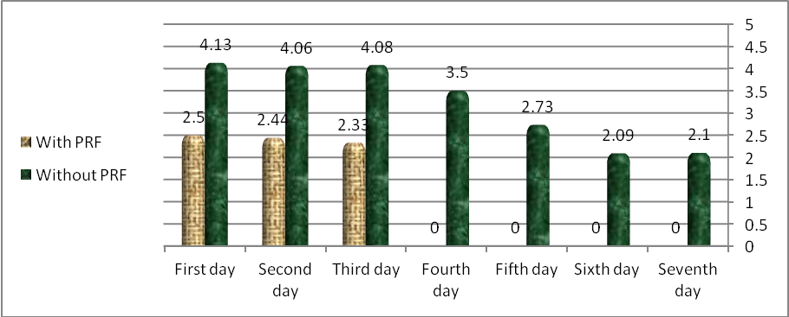
Figure 7: The number of antalgic used in the PRF group and without PRF group

Table 5 : The frequency of swelling in the PRF group and without PRF group

Swelling |  | With PRF  N (%) | Without PRF  N (%) | P-Value
Second day | No swelling | 2 (11.1%) | 1 (5.6%) | 0.248
Second day | Very slight swelling | 2 (11.1%) | 3 (16.7%) | 0.273
Second day | Slight swelling | 2 (11.1%) | 7 (38.9%) | 0.005*
Second day | Moderate swelling | 12 (66.7%) | 7 (38.9%) | 0.012*
Second day | Severe swelling | 0 | 0 | -
Second day | Total | 18 (100%) | 18 (100%)
Fifth day | No swelling | 3 (16.7%) | 1 (5.6%) | 0.083
Fifth day | Very slight swelling | 2 (11.1%) | 1 (5.6%) | 0.248
Fifth day | Slight swelling | 1 (5.5%) | 3 (16.7%) | 0.083
Fifth day | Moderate swelling | 12 (66.7%) | 13 (72.2%) | 0.308
Fifth day | Severe swelling | 0 | 0 | -
Fifth day | Total | 18 (100%) | 18 (100%)
Seventh day | No swelling | 3 (16.7%) | 1 (5.6%) | 0.083
Seventh day | Very slight swelling | 5 (27.8%) | 3 (16.7%) | 0.102
Seventh day | Slight swelling | 3 (16.7%) | 3 (16.7%) | 1.000
Seventh day | Moderate swelling | 6 (33.3%) | 11 (61.1%) | 0.011*
Seventh day | Severe swelling | 1 (5.5%) | 0 | -
Seventh day | Total | 18 (100%) | 18 (100%)

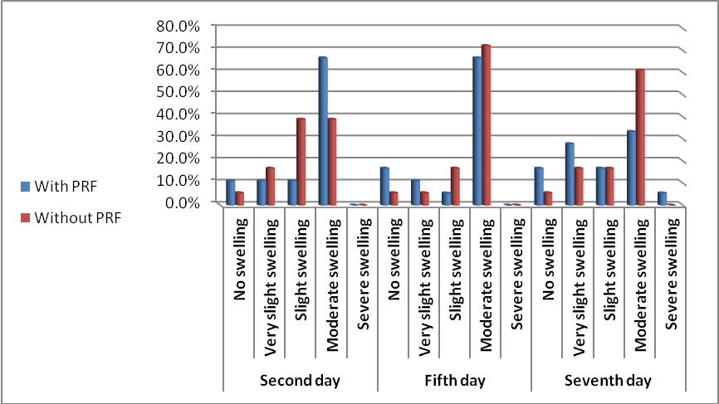

Figure 8: The frequency of swelling in the PRF group and without PRF group

