**Reviewer’s Comments**

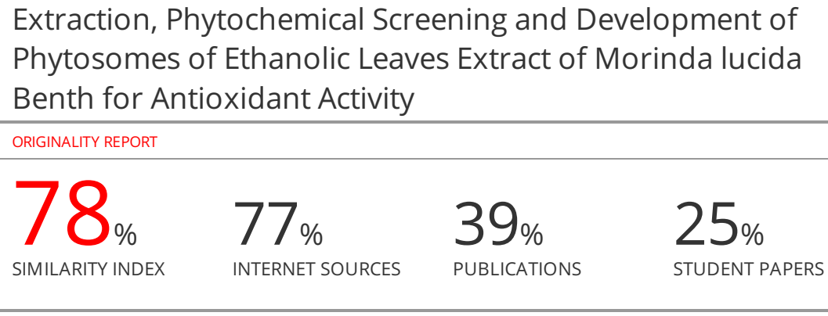**Extraction, Phytochemical Screening and Development of Phytosomes of Ethanolic Leaves Extract of *Morinda lucida*** **Benth for Antioxidant Activity**

**ABSTRACT**

*Morinda lucida* (L) Benth (*M. lucida,* Rubiaceae) is a tropical West African rainforest plant commonly known as Brimstone tree is an evergreen medium-sized trees of the Morinda genus. It is used in traditional medicine in many West African countries for the treatment of various human diseases. In the current days, most of the prevailing diseases and nutritional disorders are treated with natural medicines. The effectiveness of any herbal medication is dependent on the delivery of effective level of the therapeutically active compound. But a severe limitation exists in their bioavailability when administered orally or by topical applications. Phytosomes are recently introduced herbal formulations that are better absorbed and as a result produced better bioavailability and actions than the conventional phyto molecules or botanical extracts. The aim of the present study was to evaluate qualitative and quantitative phytochemical analysis, *in vitro* antioxidant activities, formulation and evaluation of phytosomes of ethanolic leaf extract of *M. lucida.* The phytosome was prepared by the ethanolic extract of plant and phospholipids: cholesterol by simple method. Characterization of phytosome was done by FTIR, entrapment efficiency, particle size and size distribution, optical microscopic study, stability studies and *In vitro* dissolution studies. Phytochemical analysis revealed the presence of alkaloids, glycosides, sterols, phenols, terpenoids, tannins and saponins. The total phenolic and alkaloid content of ethanolic leaves extract of *M. lucida* was found to be 0.721 and 0.464mg/100mg respectively. The *In vitro* antioxidant activity of ethanolic extract of the leaf was assessed against DPPH assay method using standard protocols. Combination of phospholipids and *M. lucida*can result in synergistic effect, synergistic effect measure with free radical scavenging activity use DPPH model. Particle size and entrapment efficiency of optimized batch F10 was founds to be 223.30±0.41nm and76.46±0.61. For the future purpose it can used as a targeting drug delivery system as a liver targeting, brain targeting, cardio protective etc. Novel approach for herbal drug delivery is more prominent than conventional which improves bioavailability of polar extract and also patient compliance.

**Keywords:** *Morinda lucida* (L) Benth*,* Phytosome, Phospholipids, Phytochemical analysis, DPPH assay, Characterization.

**Introduction**

Medicinal plants are used throughout the world in the preventive or curative treatment of several diseases [1]. Despite the progress of modern medicine, which for the most part uses synthetic products and the latest generation techniques, there is an alarming evolution of several chronic diseases including microbial, parasitic, viral infections, cancers, oxidative stress and many more. Nano technologies is important to urgently put in place effective documentation and assessment program to revitalize local health traditions otherwise this great people's health culture will be irretrievably lost. The World Health Organization has estimated the present demand for medicinal plant is approximately US $ 14 billion per year. The demand for medicinal plant based raw material is growing at the rate of 15 to 25% annually and according to an estimate of WHO, the demand for medicinal plant is likely to increase more than US $5trillion in 2050 [2]. Phytosome are more bioavailable as compared to simple herbal extracts owing to their enhanced capacity to cross the lipid rich biomembranes and finally reaching the blood. The lipid-phase substances employed to phytoconstituents, lipid compatible are phospholipids from so, mainly phosphatidylcholine (PC). Phospholipids are complex molecules that are used in all known life forms to make cell membranes. They are cell membrane building blocks, making up the matrix into which fit a large variety of proteins that are enzymes, transport proteins, receptors and other biological energy converters. In humans and other higher animals the phospholipids are also employed. They are miscible both in water and in oil/ lipid environments, and are well absorbed orally. Phospholipids are small lipid molecules in which the glycerol is bonded only to two fatty acids, instead of three as in triglycerides, with the remaining site occupied by a phosphate group [3, 4]. Several researchers have repeatedly shown that medicinal plants contain various biologically active secondary metabolites that exert different pharmacological activities: anti-diabetic, antioxidant, anti-inflammatory, analgesic, antitumor, antipyretic, antiplasmodial, antimicrobial, and antiviral, etc. [1]. *M. lucida* also known as Brimstone tree is an evergreen medium-sized trees of the Morinda genus. Morinda is the most diverse genus classified in the family Rubiaceae. The genus is widely dispersed throughout the tropical and subtropical regions, with over 131 accepted species of flowering trees, shrubs and herbaceous plants [5]. It is widely known as Sagogo or Bondoukou alongua (Ivory Coast), Ewi or Konkroma (Ghana), Atak ake or Ewe amake (Togo) and Oruwo (Nigeria). Secondary metabolite such as anthraquinones, glycosides, alkaloids, terpenoids, iridoids, fatty acids, essential or volatile oils, tannins and flavonoids have been reported in *M. lucida* [6, 7]. The secondary metabolites present in crude extracts, fractions or isolates of Brimstone tree could be responsible for distinct anti-cancer, antidiabetic, antimicrobial, antitrypanosomal, anti-inflammatory, anti-oxidant, antipyretic and anti-plasmodial potencies of different parts of the plant [8]. The aim of present work is develop phytosomes from the extracts of leaves of *M. lucida* so that better antioxidant formulation can be developed.

**Materials and methods**

**Extraction**

***Plant material fattening***

Plant matter from *M. lucida* was crushed up and allowed to air dry at ambient temperature. Soxhlation was used to remove the substance from the shade-dried plants using petroleum ether after it had been coarsely crushed up. The substance was extracted repeatedly until it had been adequately fatted.

***Extraction by soxhlation process***

*M. lucida* powder that has been defatted was thoroughly extracted with ethanol using the soxhlation process. The extract evaporated beyond their boiling points. The dried crude concentrated extract was weighed in order to calculate the extractive yield. When ready for analysis, it was then put into glass vials (6 x 2 cm) and stored in a refrigerator 4°C [9].

**Phytochemical screening**

According to the protocols described, phytochemical screening was done to find any bioactive compounds [10, 11]. By visually seeing a colour change or the production of precipitates following the addition of specific reagents to the solution, the tests were recognized.

***Total phenol measurement***

The Folin Ciocalteu reagent was employed to calculate the total phenolic substance of the extracts. Gallic acid concentration (20-100μg/ml) was produced in CH3OH. 100μg/ml plant extract concentrations were likewise made in CH3OH, and 0.5 ml of every sample was added to the test along with 4 ml of 7.5% sodium carbonate and 2 ml of a 10 fold diluted folin Ciocalteu reagent. After parafilming the tubes, they were keep warmed at RT for 30 minutes with periodic shaking. The absorbance at 765 nm was calculated against CH3OH as a vacant. Gallic acid's conventional regression curve was utilized to calculate the content of phenol overall, and the results were given in milligrammes per gramme (mg/gm) of gallic acid [12].

***Total alkaloids measurement***

Dimethyl sulphoxide (DMSO) was employed to liquefy the plant extract (1 mg), and then 1 ml of 2 N HCl was added and drinkable. This solution was reassigning to a separating funnel, and then 5ml of phosphate buffer and 5ml of bromocresol green solution were included. The mixture was vigorously agitated with 1, 2, 3, and 4ml CHCl3 before being collected in a 10ml volumetric flask and CHCl3 was added to dilute to the volume. Atropine reference standard solutions ranging from 50to250μg/ml were created. The absorbance of the test and standard solutions in relation to the reagent blank at 470 nm was measured using a UV/Vis spectrophotometer. Mg of AE/g of extract was used to express the overall alkaloid content [13].

**DPPH free radical scavenging assay**

DPPH scavenging activity was measured by modified method [14]. DPPH scavenging activity was measured by the spectrophotometer. Stock solution (6 mg in 100ml methanol) was prepared such that 1.5 ml of it in 1.5 ml of methanol gave an initial absorbance. Decrease in the absorbance in presence of sample extract at different concentration (10-100µg/ml) was noted after 15 minutes. 1.5 ml of DPPH solution was taken and volume made till 3 ml with methanol, absorbance was taken immediately at 517 nm for control reading. 1.5 ml of DPPH and 1.5 ml of the test sample of different concentration were put in a series of volumetric flasks and final volume was adjusted to 3 ml with methanol. Three test samples were taken and each processed similarly. Finally the mean was taken. Absorbance at zero time was taken for each concentration. Final decrease in absorbance was noted of DPPH with the sample at different concentration after 15 minutes at 517 nm. The percentage inhibition of free radical DPPH was calculated from the following equation: % inhibition = [(absorbance of control - absorbance of sample)/absorbance of control] × 100%. Though the activity is expressed as 50% inhibitory concentration (IC50), IC50 was calculated based on the percentage of DPPH radicals scavenged. The lower the IC50 value, the higher is the antioxidant activity.

**Formulation development of phytosomes**

**Preparation of phytosomes**

The complex was prepared with phospholipids: Cholesterol and T. chebula in the ratio of 0.5:0.3:1, 1:0.6:1, 1.5:0.9:1, 2:1.2:1 respectively. Weight amount of extract and phospholipids and cholesterol were placed in a 100ml round-bottom flask and 50ml of methanol was added as reaction medium. The mixture was refluxed and the reaction temperature of the complex was controlled to 50°C for 3 h. The resultant clear mixture was evaporated and 20 ml of n-hexane was added to it with stirring. The precipitated was filtered and dried under vacuum to remove the traces amount of solvents. The dried residues were gathered and placed in desiccators overnight and stored at room temperature in an amber colored glass bottle Table 1.

**~~Process variables used for optimization~~**

~~The developed formulation was optimized by selecting following process variables.~~

* ~~Effect of ethanol concentration~~
* ~~Effect of lecithin concentration~~
* ~~Drug concentration~~

**Table 1: Different formulation of phytosomes**

**Optimization of phospholipid and cholesterol**

|  |  |  |  |  |
| --- | --- | --- | --- | --- |
| **Formulation** | **Ratio of Phospholipid and Cholesterol** | **Drug Concentration**  **(%)** | **Alcohol Concentration** | **% Entrapment Efficiency** |
| F1 | 0.5:0.3 | 1 | 50 | 50.15±0.42 |
| F2 | 1.0:0.6 | 1 | 50 | 62.13±0.55 |
| F3 | 1.5:0.9 | 1 | 50 | 75.46±0.22 |
| F4 | 2.0:1.2 | 1 | 50 | 64.22±0.35 |

**\*Average of three determination**

**Optimization of drug concentration**

|  |  |  |  |  |
| --- | --- | --- | --- | --- |
| **Formulation** | **Ratio of Phospholipid and Cholesterol** | **Drug Concentration**  **(%)** | **Alcohol Concentration** | **% Entrapment Efficiency** |
| F5 | 1.5:0.9 | 0.5 | 50 | 64.55±0.13 |
| F6 | 1.5:0.9 | 1.0 | 50 | 64.88±0.64 |
| F7 | 1.5:0.9 | 1.5 | 50 | 54.59±0.46 |
| F8 | 1.5:0.9 | 2.0 | 50 | 62.02±0.57 |

**\*Average of three determination**

**Optimization of alcohol concentration**

|  |  |  |  |  |
| --- | --- | --- | --- | --- |
| **Formulation** | **Ratio of Phospholipid and Cholesterol** | **Drug Concentration**  **(%)** | **Alcohol Concentration** | **% Entrapment Efficiency\*** |
| F9 | 1.5:0.9 | 1.0 | 25 | 64.35±0.53 |
| F10 | 1.5:0.9 | 1.0 | 50 | 76.46±0.61 |
| F11 | 1.5:0.9 | 1.0 | 75 | 62.22±0.57 |
| F12 | 1.5:0.9 | 1.0 | 100 | 57.88±0.84 |

**\*Average of three determination**

**Characterization [15-17]**

**Determination of interaction between *M. lucida* and phospholipids**

Fourier transform infrared spectrophotometer (FT-IR Spectrometer, Bruker alpha) was used to study the interaction between *M. lucida* and phospholipids. The IR spectra of *M. lucida* extract, phospholipids, their complex and physical mixture were obtained by the KBr method.

**Entrapment efficiency**

Phytosome preparation was taken and subjected to centrifugation using cooling centrifuge (Remi) at 12000 rpm for 30min. The clear supernatant was siphoned off carefully to separate the non entrapped quercetin and the absorbance of supernatant for non entrapped *M. lucida* was recorded at λmax 230.0 nm using UV/visible spectrophotometer (Shimadzu 1800). Sediment was treated with 1ml of 0.1 % Triton x 100 to lyse the vesicles and diluted to 100 ml with phosphate buffer saline (7.4) and absorbance taken at 230.0 nm. Amount of gallic acid in supernatant and sediment gave a total amount of *M. lucida* in 1 ml dispersion. The percent entrapment was calculated by following formula.

Amount of drug in sediment

Percent Entrapment = ------------------------------------- X 100

Total amount of drug added

**Particle size and size distribution**

The particle size, size distribution and zeta potential of optimized phytosomes formulation were determined by dynamic light scattering (DLS) using a computerized inspection system (Malvern Zetamaster ZEM 5002, Malvern, UK). The electric potential of the phytosomes, including its Stern layer (zeta potential) was determined by injecting the diluted system into a zeta potential measurement cell.

***In vitro* drug release study**

*In vitro* drug release of the sample was carried out using USP- type II dissolution apparatus (Paddle type). The dissolution medium, 900 ml 0.1N HCl was placed into the dissolution flask maintaining the temperature of 37±0.50C and rpm of 50.Equivalent to 100 mg of phytosomes was placed in each bowl of dissolution apparatus. The apparatus was allowed to run for 10 hours. Sample measuring 5 ml were withdrawn after every 1 hour up to 10 hours using 10ml pipette. The fresh dissolution medium (370C) was replaced every time with the same quantity of the sample. From this take 0.5 ml and dilute up to 10ml and take the absorbance at 230.0 nm using spectroscopy.

**Preparations of ethanolic extract of *M. lucida* phytosomes**

In this study, we prepared the *M. lucida*-phospholipids complex to improve the lipophilic properties of *M. lucida.* We prepared the complex with different quantity ratios of phospholipids and *M. lucida* such as 0.5, 1, 1.5, and 2. The results showed that when the ratio was lower than 1, the stability of the *M. lucida* –phospholipids complex was worse. To get the best complex and use the smallest quantity of phospholipid, we finally prepared a *M. lucida*-phospholipids complex with a 1:1.5:0.9 ratios of ingredients.

**Process variables used for optimization**

Three process variables as concentration of lipid, concentration of drug and concentration of alcohol were used to optimize the best formulation of ethanolic extract of *M. lucida*. *M. lucida* loaded phytosomes and all the formulations were preliminary evaluated for drug entrapment efficiency and particle size.

**Optical microscopic study**

Phytosome was observed under Microscopy, Cippon (Japan). One drop of diluted extract-loaded phytosome suspension was deposited on a glass slide and it was. Excess of solution was drained off with a filter paper and then slide was allowed to dry. The sample was then examined by optical Microscopy.

**Stability studies**

Results of stability studies clearly indicates that optimized batches of phytosomes were stable over the chosen temperature and humidity conditions up to 3 months as were found no significant variation in physical appearance and % drug content.

**Results and discussions**

After completing each consecutive soxhlation extraction process, the crude extracts were focused on a bath of water by totally evaporating the solvents to achieve the real extraction capitulate. Petroleum ether and ethanol were found to produce extracts from plant portions called leaves with yields of 1.45 and 9.229%, respectively. Table 2 shows the results of a qualitative phytochemical analysis of the raw leaves of *M. lucida*. Alkaloids, glycosides, sterols, phenols, terpenoids, tannins and saponins were all detected in ethanolic plant extracts, whereas protein and carbohydrates were detected in petroleum ether extracts. Total phenolic content was calculated as gallic acid equivalent (mg/100mg) using the equation based on the calibration curve: y = 0.032x + 0.004, R2=0.999, where X is the gallic acid equivalent (GA) and Y is the absorbance. Total alkaloid content was calculated as atropine equivalent mg/100mg using the equation based on the calibration curve: y = 0.007x + 0.007, R2=0.999, where X is the Atropine equivalent (AE) and Y is the absorbance. The total phenolic estimation of ethanolic extracts of leaves of *M. lucida* showed the content values of 0.721. The total alkaloids estimation of ethanolic extracts of leaves of *M. lucida* showed the content values of 0.464 mg/100mg Table 3 & Figure 1& 2. There is increasing evidence that indigenous antioxidants may be useful in preventing the deleterious consequences of oxidative stress and there is increasing interest in the protective biochemical functions of natural antioxidants contained in herbs and medicinal plants. Antioxidant activity of ethanolic extract of *M. lucida* is measured by DPPH free radical scavenging activity. The tested plant extracts showed strong antioxidant activity Table 4.From the FTIR data of the extract and phytosome formulation it is clear that functionalities of drug have remained unchanged including intensities of the peak. This suggests that during the process extract and phospholipid-cholesterol has not reacted with the drug to give rise to reactant products. So there is no interaction between them which is in favor to proceed for formulation of phytosomes drug delivery Figure 3 & 4. Entrapment efficiency is an important parameter for characterizing phytosomes. In order to attain optimal encapsulation efficiency, several factors were varied, including the concentration of the lipid, concentration of drug and concentration of alcohol. The entrapment efficiency of all the prepared formulations is shown in Table. The entrapment efficiency of the phytosomes was found in the range of 50.15±0.42to 76.46±0.61%. Particle size of all formulations found within range 223.30±0.41to 336.85±0.83nm. Concentration of lipid has shows significant impact on size of phytosomes. Formulation F10 was found best one which is further evaluated for drug release study, solubility studies and UV spectroscopy. The best formulation of *M. lucida*-phospholipids complex (1.5:0.9) formulation F10 was subjected to structural analysis by drug release study Table 5, 6 & Figure 5. Zeta potential of optimized formulation F10 was found to be -34.50mV Figure 6. *In vitro* dissolution study of F10 indicated that the phytosomes had extended release dissolution pattern. The phytosomes show of 12hr. 98.85 % release Table 7. When the regression coefficient values of were compared, it was observed that ‘r2’ values of Korsmeyer Peppas was maximum i.e. 0.976 hence indicating drug release from formulations was found to follow Korsmeyer Peppas kinetics Table 8, Figure 7-10. The sample was then examined by optical Microscopy Figure 11. Results of stability studies clearly indicates that optimized batches of phytosomes were stable over the chosen temperature and humidity conditions up to 3 months as were found no significant variation in physical appearance and % drug content.

**Table 2: Results of extract phytochemical screening of *M. lucida***

|  |  |  |  |
| --- | --- | --- | --- |
| **S. No.** | **Test** | **Result** | |
| **Petroleum ether Extract** | **Methanolic Extract** |
| **1** | **Flavonoids** | -ve | -ve |
| **2** | **Alkaloids** | -ve | +ve |
| **3** | **Phenolic compounds** | -ve | +ve |
| **4** | **Saponins** | -ve | +ve |
| **5** | **Tannins** | -ve | +ve |
| **6** | **Carbohydrates** | +ve | -ve |
| **7** | **Glycosides** | -ve | +ve |
| **8** | **Sterols** | -ve | +ve |
| **9** | **Terpenoids** | -ve | +ve |
| **10** | **Steroidal compounds** | -ve | -ve |
| **11** | **Protein** | +ve | -ve |

**Table 3: Estimation of total phenolic and alkaloid content of *M. lucida***

|  |  |  |
| --- | --- | --- |
| **S. No.** | **Total phenolic content**  (**mg/ 100 mg of dried extract)** | **Total alkaloid content**  (**mg/ 100 mg of dried extract)** |
| 1. | 0.721 | 0.464 |

**Table 4: % Inhibition of ascorbic acid, extract and phytosomes using DPPH method**

|  |  |  |  |  |
| --- | --- | --- | --- | --- |
| **S. No.** | **Concentration** | **% Inhibition** | | |
| **Ascorbic acid** | **Phytosomes** | **Ethanolic extract** |
| 1 | 10 | 36.77419 | 27.74193 | 24.51612 |
| 2 | 20 | 58.06452 | 36.77419 | 43.87096 |
| 3 | 40 | 64.51613 | 56.12903 | 46.45161 |
| 4 | 60 | 76.77419 | 63.87096 | 47.09677 |
| 5 | 80 | 86.45161 | 83.22580 | 61.93548 |
| 6 | 100 | 36.77419 | 27.74193 | 24.51612 |
| **IC 50** | | **35.44068** | **54.89850** | **73.46154** |

**Table 5: Particle size and entrapment efficiency of drug loaded phytosomes**

|  |  |  |
| --- | --- | --- |
| **Formulation Code** | **Particle size** | **Entrapment Efficiency** |
| **F1** | 243.52±0.43 | 50.15±0.42 |
| **F2** | 237.42±0.31 | 62.13±0.55 |
| **F3** | 278.21±0.40 | 75.46±0.22 |
| **F4** | 303.43±0.34 | 64.22±0.35 |
| **F5** | 336.85±0.83 | 64.55±0.13 |
| **F6** | 283.62±0.64 | 64.88±0.64 |
| **F7** | 293.42±0.40 | 54.59±0.46 |
| **F8** | 276.93±0.30 | 62.02±0.57 |
| **F9** | 268.51±0.21 | 64.35±0.53 |
| **F10** | 223.30±0.41 | 76.46±0.61 |
| **F11** | 290.51±0.22 | 62.22±0.57 |
| **F12** | 289.42±0.11 | 57.88±0.84 |

**Table 6: Composition of best formulation**

|  |  |  |  |
| --- | --- | --- | --- |
| **Formulation Code** | **Lecithin Concentration**  **(%)** | **Drug Concentration**  **(%)** | **Alcohol Concentration** |
| F10 | 1.5:0.9 | 1.0 | 50 |

**Table 7: *In-vitro* drug release data for optimized formulation F10**

|  |  |  |  |  |  |  |
| --- | --- | --- | --- | --- | --- | --- |
| **Time (h)** | **Square Root of Time(h)1/2** | **Log Time** | **Cumulative*% Drug Release** | **Log Cumulative % Drug Release** | **Cumulative % Drug Remaining** | **Log Cumulative % Drug Remaining** |
| 0.5 | 0.707 | -0.301 | 22.25 | 1.347 | 77.75 | 1.891 |
| 1 | 1 | 0 | 39.98 | 1.602 | 60.02 | 1.778 |
| 2 | 1.414 | 0.301 | 46.65 | 1.669 | 53.35 | 1.727 |
| 4 | 2 | 0.602 | 59.95 | 1.778 | 40.05 | 1.603 |
| 6 | 2.449 | 0.778 | 65.58 | 1.817 | 34.42 | 1.537 |
| 8 | 2.828 | 0.903 | 82.23 | 1.915 | 17.77 | 1.250 |
| 12 | 3.464 | 1.079 | 98.85 | 1.995 | 1.15 | 0.061 |

**Table 8: Regression analysis data of optimized formulation F10**

|  |  |  |  |  |
| --- | --- | --- | --- | --- |
| **Batch** | **Zero Order** | **First Order** | **Higuchi** | **Korsmeyer Peppas** |
| **R²** | **R²** | **R²** | **R²** |
| **F10** | 0.947 | 0.856 | 0.963 | 0.976 |

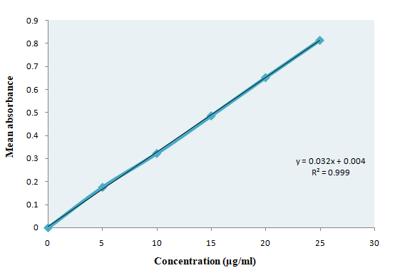

**Figure 1: Graph of estimation of total phenolic content**

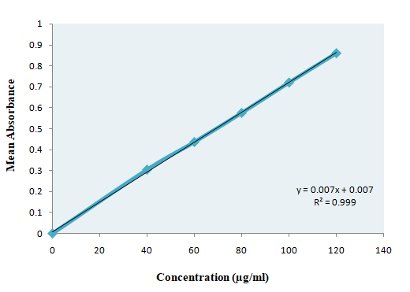

**Figure 2: Graph of estimation of alkaloid content**

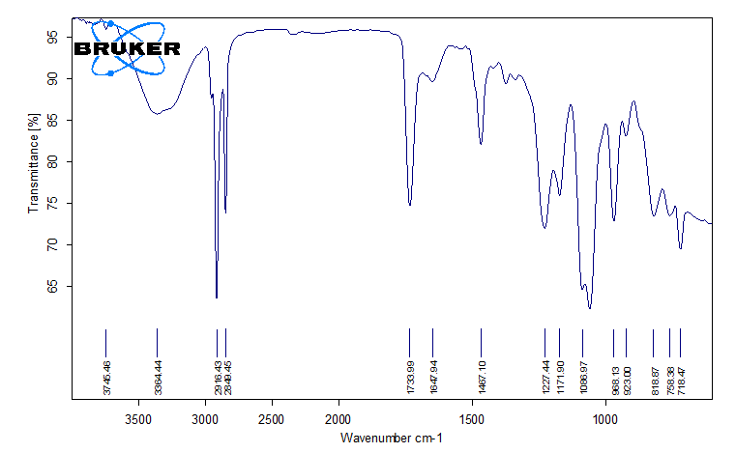

**Figure 3: FT-IR spectrum of ethanolic extract of *M. lucida***

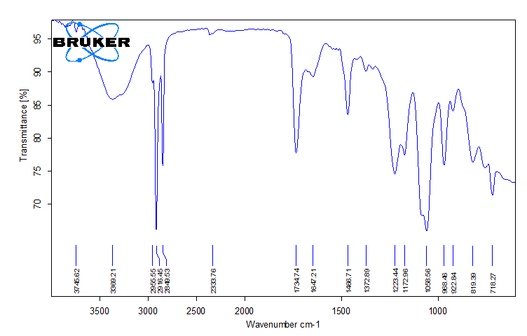

**Figure 4: FT-IR spectrum of ethanolic extract of *M. lucida* loaded phytosomes**

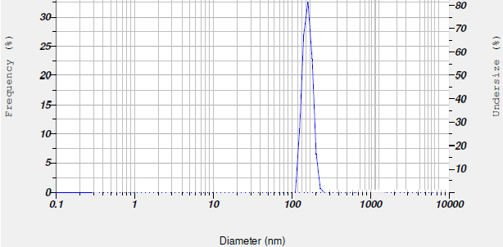

**Figure 5: Particle size of optimized batch F10**

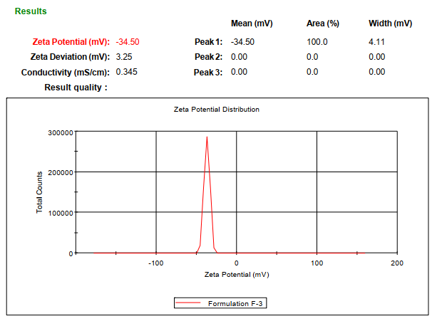

**Figure 6: Zeta potential of optimized batch F10**

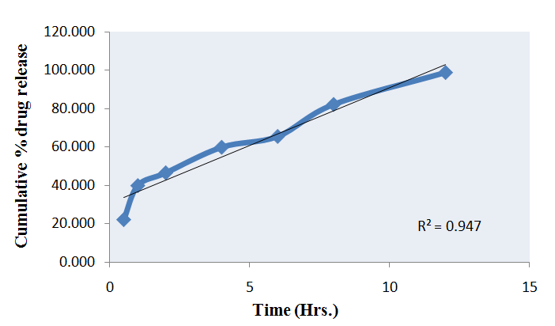

**Figure 7: Cumulative % drug released Vs Time**

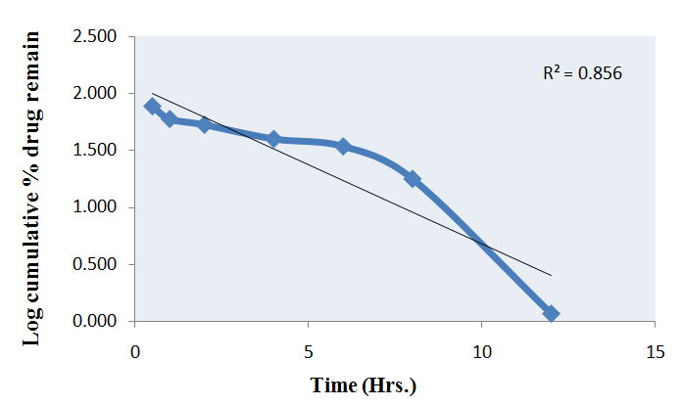

**Figure 8: Log Cumulative % drug remain Vs Time**

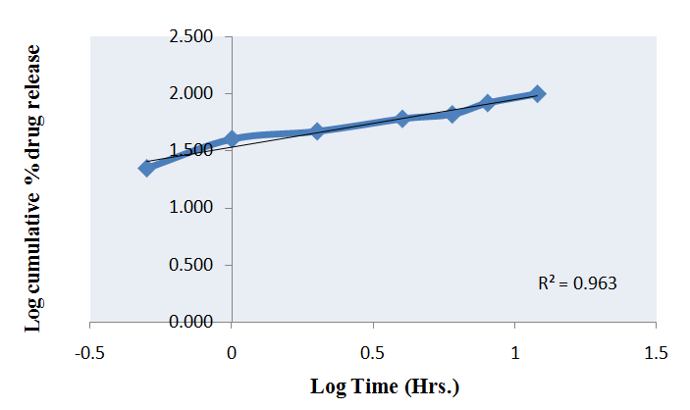

**Figure 9: Cumulative % drug release Vs Root time**

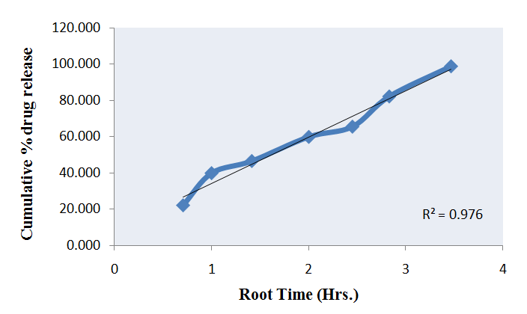

**Figure 10: Log Cumulative % drug release Vs Log time**

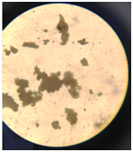

**Figure 11: Optical microscopic study of optimized formulation**

**Conclusion**

From above studies we are concluded that phytosomes has better physical characteristics than that of extract. *In-vitro* studies revealed that phytosomes showed same antioxidant as that of ethanolic extract of leaves of *M. lucida*. The phytochemical investigation gave valuable information about the different phytoconstituents present in the plant, which helps the future investigators concerning the selection of the particular extract for further investigation of isolating the active principle and also gave idea about different phytochemical have been found to possess a wide range of activities. Further research to isolate individual compounds, their *in‑vivo* activities with different mechanism is needed.

**Conflict of interest**

**Author’s Contribution**

**Acknowledgements**

**References**

1. Chokki M, Cudălbeanu M, Zongo C, Dah-Nouvlessounon D, Ghinea IO, Furdui B, Raclea R, Savadogo A, Baba-Moussa L, Avamescu SM, Dinica RM. Exploring antioxidant and enzymes (A-amylase and B-Glucosidase) inhibitory activity of Morinda lucida and Momordica charantia leaves from Benin. Foods. 2020 Apr 4;9(4):434.
2. Blumenthal M., Brusse W.R. and Goldberg A. (1998). The complete German Commission E Monograph. Therapeutic guide to Herbal Medicine. The American Botanical Council, Austin, TX, USA, 16-25.
3. Dubey N.K., Kumar R. and Tripathi P. (2004). Global promotion of herbal medicine, India opportunity, Current Science, 88:335.
4. Mishra Ganesh Prasad, Vyash Lokesh, Survanshi Lakhan and Joshi Hemant M. Preparation and evaluation of phytosomes of Vitex negundo Linn. Novel Science International Journal of Pharmaceutical Science (2012), 1(9-10): 671 -673.
5. Zhang, J., Xin, H., Xu, Y., Shen, Y., He, Y., Bing, L.H., Song, H., Yang, H., Qin, L., Zhang, Q., Du, J., 2018. Morinda officinalis How.–A comprehensive review of traditional uses, phytochemistry and pharmacology. J. Ethnopharmacol. 213, 230–255.
6. Ogunlana, O.E., Ogunlana, O., Farombi, O.E., 2008. Morinda lucida: Antioxidant and +/ reducing activities of crude methanolic stem bark extract. Adv. Natl Appl. Sci. 2, 49–54.
7. Lawal, H., Etatuvie, S.O., Fawehinmi, A.B., 2012. Ethnomedicinal and pharmacological properties of Morinda lucida. J Nat. Prod. 5, 93–99.
8. Oladeji OS, Oluyori AP, Dada AO. Antiplasmodial activity of Morinda lucida Benth. Leaf and bark extracts against Plasmodium berghei infected mice. Saudi Journal of Biological Sciences. 2022 Apr 1;29(4):2475-82.
9. Jain DK, Gupta S, Jain R, Jain N. Anti-inflammatory Activity of 80% Ethanolic Extract of Acorus calamus Linn. Leaves in Albino Rats. Research J. Pharm. and Tech 2010; 3 (3): 882-884.
10. Dutta R, Sharma MK, Khan A, Jha M. Phytochemical and in vitro antioxidant assay of Fumaria officinalis leaf extract. Journal of Advanced Scientific Research. 2020 Aug 10; 11(03):176-82.
11. Gadekar S, Goyal S, Khan A, Jha M. Chemopreventive action of sphaeranthus indicus on dmba-induced skin papillomagenesis in mice. Journal of Advanced Scientific Research. 2020; 11(3):161-167.
12. Pradhan A, Jain P, Pal M, Chauhan M, Jain DK. Qualitative and quantitative determination of phytochemical contents of hydroalcoholic extract of salmalia malabarica. Pharmacologyonline 2019; 1:21-26.
13. Rani D, Kharkwal H, Jha M, Rai N. Assessment of the Total Flavonoid, Phenol, Alkaloid Content and Sun Protection Factor in Grewia abutilifolia Leaf Extract. Journal of Pharmaceutical Research International. 2021; 33(49A): 42-51.
14. Jha M, Ganesh N, Sharma V. In Vitro Evaluation of free radical scavenging activity of Pistia Stratiotes. Asian Pacific J. Tropical Disease. 2010; 2(1):180-4.
15. Sonwani R, Kumar A, Vaishnaw A, Kashyap P, Patel P, Tamboli R, Jain DK, Patel VK. Development and Formulation of Microemulsion for Topical Drug Delivery of Fluconazole. Journal of Pharmaceutical Negative Results. 2022 Nov 26:2257-65.
16. Parkhe G, Jain P, Jain DK. Total phenolic content, total flavonoid & anti-bacterial activity of hydroalcoholic Acacia catechu (LF) willd roots extracts for treatment of mouth ulcer. Pharmacology Online. 2018; 2:227-33.
17. Patel NS, Jain DK, Nagar H, Patel A, Chandel HS. Evaluation of analgesic and antipyretic activity of Tridax procumbens leaves extract. RGUHS J Pharm Sci. 2011; 1(3):226-31.