Reviewer’s Comments
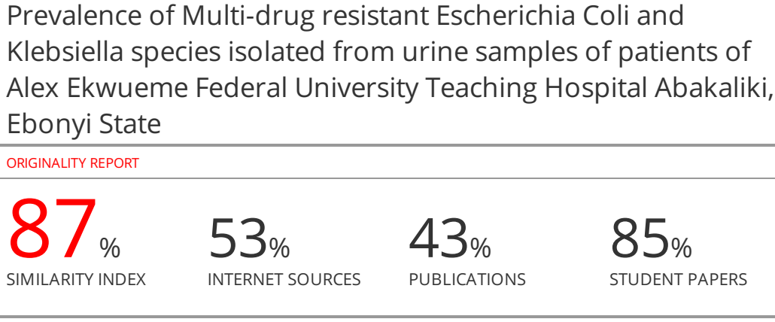Prevalence of Multi-drug resistant Escherichia Coli and Klebsiella species isolated from urine samples of patients of Alex Ekwueme Federal University Teaching Hospital Abakaliki, Ebonyi State

ABSTRACT
Aim and Objective: Morbidity and mortality are attributed to urinary tract infections (UTIs) in the community and hospitals. This study investigated the prevalence of multi-drug resistant isolates of Escherichia coli and Klebsiella species from urine samples of patients visiting Alex Ekwueme Federal University Teaching Hospital Abakaliki (AE-FUTHA), Ebonyi State.
Method: A total of 300 mid-stream urine samples collected in sterile containers were analyzed using standard microbiological and biochemical techniques. Double disc synergy test (DDST) was used for the phynotype screening for extended spectrum beta lactamase (ESBL) production. Susceptibility of ESBL producing bacteria to antibiotics was determined by disc diffusion method. The presence of temoniera (TEM) and sulf-hydryl variable (SHV) beta lactamases genes was determined by polymerase chain reaction (PCR) using specific primers.
Results: A total of 88 isolates of E coli and Klebsiella species were isolated from the urine samples; 29 were E coli and 59 were Klebsiella species. 47 ESBL positive isolates were identified with E. coli, 19 (40%) and Klebsiella, 28 (60%).

E. coli isolated from patients in GOPD, Gynecology and Men Surgical ward were 100% resistant to ofloxacin, ceftazidime, amoxycillin, nitrofurantoin, chloramphenicol and aztreonam while Klebsiella species isolated from Gynaecology ward, Labour ward and Psychiatric ward were 100% resistant to ofloxacin, nitrofurantoin and chloramphenicol. Multiple antibiotics resistance index (MARI) of E. coli and Klebsiella species isolated recorded an average of 0.64 for E. coli and 0.41 for Klebsiella species.The molecular analysis showed that 44.4% of SHV beta lactamase and 65.6% TEM-type β-lactamase genes were present in ESBL producing E. coli while 54.5% of SHV beta lactamase gene and 45.5% TEM-type β-lactamase genes were present in ESBL producing Klebsiella species.
Conlusion: In conclusion, SHV and TEM-type beta lactamase genes are the primary cause of resistance to β-lactam antibiotics in E. Coli and Klebsiella species which has led to an increase in infections caused by organisms harboring the ESBL gene. Nitrofurantoin, ceftazidime, cefalexin, and cefotaxime may be an antibiotic of choice in the treatment of UTIs.
Keywords: Antibiotics, β-lactamase, Escherichia coli, Klebsiella species, Multiple antibiotics resistance, sulf-hydryl variable, temoniera.
INTRODUCTION
Antimicrobial resistance is a worldwide public health emergency that requires urgent global attention¹. Intensive usage of antimicrobials for food animals may cause problems in the treatment of infections by selecting for resistance among bacterial pathogens from animals and humans². Transmission of resistant bacteria from animals to humans may occur via the food chain, environment or by direct interaction with animals and may result in resistant infections³. An increase in resistance to gentamicin has been reported amongst isolates of E. coli associated with UTIs in many parts of Nigeria and other African countries⁴. The advent of fluoroquinolones, the new generation of quinolones antimicrobial agents brought a ray of hope to the treatment of various infections caused by multi-drug resistant bacteria and became the drug of choice for the empiric therapy of most serious life threatening infections⁵. However, the extensive use of these agents in clinical settings has made bacteria to develop resistance to them all over the world⁴. Fluoroquinolones are one of the most widely used drugs in the treatment of UTIs but their frequent use in both community and hospital settings has led to a dramatic rise in resistance amongst E. coli causing UTIs⁶. Quinolones inhibit the DNA replication in E. coli strains by targeting the bacterial DNA gyrase (topoisomerase II) and topoisomerase IV (parC) enzymes but mutations in the specific domains of gyrA, gyrB, parC and parE can cause changes in single amino acid of either gyrase or topoisomerase IV leading to the bacterial resistance to quinolones¹.

Escherichia coli strains are common bacteria that inhabit human gastrointestinal tract, whilst they are often harmless commensals; they can cause multitude of infections such as urinary tract infections (UTIs), meningitis, diarrhoea and septicemia⁵. Their harmless strains can remain commensals as long as they do not acquire genetic elements encoding virulence factors which may eventually result in these diseases¹. The alarming increase in the rate at which these strains acquire antibiotic resistance genes has limited therapeutic options especially for UTIs for which extensive use of antibiotics has been witnessed in both community and hospital settings⁵. Extended Spectrum Beta Lactamases (ESBLs) expression among E. coli strains encodes resistance to oxyimino-cephalosporins and many other important groups of antibiotics, thereby causing impediment to treatment of its infections⁷. Also, the carbapenems which are the last resort in the effective treatment of severe ESBL-producing E. coli infections, have recently witnessed rise in resistance by E. coli strains that produced carbapenem-hydrolyzing enzymes⁴. Aminoglycosides have been an essential component of the antibiotic armory in the treatment of serious life threatening infections and UTIs caused by E. coli, but the increasing wind of antibiotic resistance across the globe has reduced their effectiveness, rendering some members of this class of antimicrobials virtually useless in certain E. coli infections⁷. Zhao et al⁸ in their study, reported that the combined rates of biofilm formation in Uropathogenic E. coli (UPEC) isolates were achieved as 84.6% (95% CI: 72.7-91.9).
Klebsiella is well known to most clinicians as a cause of community-acquired bacterial pneumonia, occurring particularly in chronic alcoholics and showing characteristic radiographic abnormalities due to a severe pyogenic infection which has a high fatality rate if untreated⁹. The vast majority of Klebsiella infections, however, are associated with hospitalization. As opportunistic pathogens, Klebsiella spp. primarily attack immunocompromised individuals who are hospitalized and suffer from severe underlying diseases such as diabetes mellitus or chronic pulmonary obstruction. Nosocomial Klebsiella infections are caused mainly by Klebsiella pneumoniae, the medically most important species of the genus. Nosocomial infections, which are known as hospital-acquired or healthcare-associated infections rank high among important public health problems globally, especially in developing countries⁹. Patients who are admitted into the intensive care unit (ICU) usually have impaired immunity either due to their underlying disease conditions or exposure to invasive procedures which adversely affect their immune mechanisms and therefore at high risk of acquiring nosocomial infections. In addition, they are susceptible to secondary infections such as candidiasis and pseudomembranous colitis arising from destruction of protective microbiota by administration of broad spectrum antimicrobials¹.
Extended spectrum beta lactamase (ESBLs) are plasmid-mediated β-lactamase that are capable of efficiently hydrolyzing penicillin, narrow and broad spectrum cephalosporins and monobactams (Aztreonam), but they do not hydrolyze cephamycin or carbapenems (imipenem, meropenem)¹. β-Lactamase, inhibitors such as clavulanic acid, sulbactam and tazobactam generally inhibit ESBL producing strains¹. ESBL producing isolates are most commonly found in Klebsiella pneumoniae and Escherichia coli ¹. AmpC β-lactamase is primarily chromosomal and plasmid-mediated and are resistant to β-lactamase inhibitors such as clavulanic acid but can hydrolyze cephamycin¹. Carbapenems are one of the antibiotics of last resort for many bacterial infections such as E. coli and K. pneumoniae producing AmpC and extended spectrum β-lactamase but the emergence of carbapenemase which have versatile hydrolytic capacities have the ability to hydrolyze penicillins, cephalosporins, monobactams and carbapenems⁹. The therapeutic intervention of E coli and Klebsiella species acquire antibiotic resistance genes for UTIs and other bacterial infections seem to be limited. Therefore this study was aimed at investigating the prevalence of multidrug resistant isolates of Escherichia coli and Klebsiella species from urine samples of patients visiting Alex Ekwueme Federal University Teaching Hospital Abakaliki, Ebonyi State.

MATERIALS AND METHOD
Media for Bacteriological Screening
The media that were used include Nutrient agar, Nutrient broth, MacConkey agar, and Mueller-Hinton agar (Oxoid, UK). All media was prepared based on manufacturer’s instruction.
Equipment
The equipments used were autoclave, (Searchtech, England), incubator (Newlife England), microscope (Olympus optical Co. Ltd. UK), thermocycler, refrigerator (Gallenkamp Germany), weighing balance (Ohaus, USA), spatula, metre rule.
Reagents and Chemicals
The following reagents and chemicals were used; Lugols iodine, Kovacs reagent, crystal violet, oxidase reagent, methyl-red reagent, normal saline, acetone alcohol, decolourizer, immersion oil, hydrogen peroxide (Hi-Tech Comp India).
Antibiotics disk
The antibiotics used include: ampicillin (10 μg), amoxicillin (30 μg), cefotaxime (30 μg), ceftazidime (30 μg), cefoxitin (30 μg), nitrofurantoin (10 μg, chloramphenicol (10 μg), azetreonam (5 μg), cefepime (25 μg), ertrapenem (10 μg) and ofloxacin (30 μg) (Oxoid Ltd, Basingstoke, United Kingdom).
Determination of sample size
The sample size for this study was determined using Cochran’s sample size formula. The Sample size was calculated based on 95 % confidence interval (CI) at a 0.05 precision; and the following formula (Cochran’s formula) was used to evaluate this: Cochran’s formula; n=Z²pq/e² Where: n = sample size; Z = standard normal deviation at 95 % confidence interval (which was 1.96); p = proportion of target population (prevalence estimated at 50 %; this implies 75/100 = 0.75); q = alternate proportion (1-p), which was calculated as: 1 – 0.5 = 0.5; e = desired level of precision (degree of precision/significance). This was taken as 0.05; Thus, using the sample size determination formular: n=Z²pq/e²; (1.96)² x 0.75(1-0.75) = 291.8 0.05²
An approximate sample size of three hundred (300) was collected randomly and used for this study.
Ethical Clearance
The ethical approval for this study was gotten from the ethical committee of Alex Ekwueme Federal University Teaching Hospital Abakaliki, Ebonyi State.
Sample collection
A total of 300 mid-stream urine samples were collected from the microbiology laboratory unit of the hospital. The collected specimens were transported to Microbiology laboratory unit of Applied microbiology department of Ebonyi State University Abakaliki for bacteriological analysis.
Media Preparation
All the media used include; nutrient agar and broth, MacConkey agar and Mueller-Hinton agar, (Oxoid, UK), were prepared according to manufacturer’s specification.
Isolation and identification of E. coli and Klebsiella species
Each sample was pre-enriched in prepared sterile nutrient broth and incubated at 37ºC for 24 h. After incubation the turbid broth was sub-cultured on MacConkey agar and incubated under aerobic conditions at 37ºC for 24 h. After incubation, the macroscopic characteristics of the colonies were observed and a Gram stain performed following biochemical test.
Gram Staining Reaction
This was carried out using clean grease free slides. A sterile wire loop was used to aseptically pick a colony of each test organisms and was placed on the slides to air dry. The smear was first covered with crystal violet for 30-60 seconds. The stained slides were washed off with tap water. The smear on the slide was covered with lugol‘s iodine for 30 seconds and washed off with clean tap water. The smears were rapidly decolorized with acetone-alcohol and immediately washed with clean tap water. The stained slides were counter stained with safranin for 30 seconds and washed off with clean water. The slides were air-dried and the under surface blotted. Oil immersion was added to the stained slide and examined using X 100 objective.
Motility test (Hanging Drop Method)
Two drops of wet suspension of the test organism was placed on a grease-free coverslip and quickly inverted over a depression grease-free glass slide supported by a ring of petroleum jelly. It was examined under the microscope with X10 and X40 objective lenses. Visible movement of the organism indicated motility, but if absent was interpreted as no motility¹⁰.
Phenotypic Determination of ESBL Production by Double disk synergy test (DDST)
ESBL production in all the E. coli isolates was confirmed phenotypically by the double disc synergy test (DDST) method as was previously described by⁶. Briefly, overnight suspensions of the 2nd and 3rd generation Cephalosporin resistant bacteria was adjusted to 0.5 McFarland turbidity standards and were swabbed aseptically on a solidified MH agar (Oxoid, UK). Antibiotic disks containing amoxicillin acid (10µg) was placed at the center of Mueller-Hinton agar plates and antibiotic disks containing ceftazidime (30 µg) and cefotaxime (30 µg) was placed adjacent to the central disk (amoxicillin acid) at a distance of 15 mm. The plates were incubation at 37ºC for 18- 24 hours; a ≥ 5 mm increase in the inhibition zone diameter for either of the cephalosporins tested in combination with the central disk versus its zone when tested alone confirms ESBL production phenotypically by the DDST method⁶.
Antibiotic susceptibility testing
Antibiotic susceptibility test of ESBL producing isolates of E. coli and Klebsiella species was done by using Kirby-Bauer disc diffusion Method according to Clinical and Laboratory Standards Institute¹¹. Bacteria inoculum equivalent to 0.5 McFarland standard of the isolate was streaked on entire Mueller-Hinton agar plate and was allowed for 5 min pre-diffusion. The following antibiotics: Ofloxacin (30 µg), Ceftazidime (30 µg), Ampicillin (30 µg), Nitrofurantoin (10 µg), Chloramphenicol (10 µg), Cefepime (25 µg), Amoxicillin (10 µg), Cefalexin (30 µg),, Aztreonem (5 µg), Cefotaxime (10 µg),, Ertapenem (10 µg), (Oxoid Ltd, Basingstoke, United Kingdom) was impregnated aseptically on the agar plates and incubated at 37ºC for 24 h. Diameter of zone of inhibition were measured and zone diameter criterion was used to interpret the level of susceptibility to each antibiotic¹¹.
Determination of Multiple Antibiotic Resistance (MAR) index
Multiple antibiotic resistance (MAR) index was determined using the formula MAR=a/b, where a is the number of antibiotics to which test isolate displayed resistance and b is the total number of antibiotics it was subjected to¹².
MOLECULAR STUDIES
Preparation of bacterial stock prior to PCR analysis
Thirteen Isolates namely six (6) ESBL producing E. coli representing each sample source and seven (7) ESBL producing K. Pneumoniae also representing each sample source were selected for screening for the presence of SHV and TEM beta lactamases. Stock cultures of each ESBL producing E. coli and K. pneumoniae isolates were prepared for gene amplification by standard microbiological culturing technique¹⁰. The test E. coli and K .pneumoniae cultures were transferred from stock cultures in the refrigerator and inoculated on double strength nutrient broth (Oxoid, UK). The culture tubes were incubated overnight at 37ºC for resuscitation of the isolates. After incubation, a loopful of the turbid suspension was inoculated on nutrient agar plates and incubates overnight to ascertain purity. The plates were incubated at 37ºC for 18-24 hours. Exactly 8 colonies from the overnight cultures were inoculated in 5 ml peptone water (Oxoid, UK) for molecular studies. This stock culture served as source of bacterial cells and template DNA for further molecular studies.
DNA Extraction using Quick-DNA™ Miniprep Plus Kit (Catalog Nos. D4068 & D4069)
Genomic DNA was extracted using modifications from the Quick-DNA™ Miniprep Plus Kit. The cultured cells were re-suspended in an isotonic buffer prior to use. Up to 200µl of the sample was added to a micro-centrifuge tube and 200 µl of biofluid lysis buffer and 20 µl of Proteinase K was added and mixed thoroughly using a vortex machine for 10-15 seconds. The tube was incubated at 55°C for 10 minutes. Then 1 volume (420 µl) of genomic binding buffer (GBB) was added to the digested sample and mixed thoroughly using a vortex machine for 10-15 seconds. The mixture was transferred to a Zymo-SpinTMIIC-XLR columnin a collection tube and centrifuged at 12,000 x g for 1 minute. After centrifuging, the collection tubes were discarded with the flow through. To the spin column in a new collection tube, 400 µl of DNA pre-wash buffer was added and centrifuged at 12,000 x g for 1 minute. After centrifuging, the collection tubes were emptied. To the spin column, 700µl of g-DNA wash buffer was added and centrifuged at 12,000 x g for 1 minute and the collection tubes were emptied. To the spin column again, 200µl of g-DNA wash buffer was added and centrifuged again for 1 minute at 12,000 x g. After centrifuging, the collection tubes were discarded with the flow through. The spin column was transferred to a clean micro-centrifuge tube and 65 µl of DNA elution buffer was added directly on the matrix and incubated for 5 minutes at room temperature. The mixture was centrifuged at maximum speed for 1 minute to elude the DNA. The eluted DNA was stored at -20°C until it will be further amplified by PCR.
PCR screening for ESBL genes
The detection of different ESBL genes that encode ESBL production in the resistant ESBL producing Escherichia coli and Klebsiella pneumonia isolates was conducted using PCR technique with specific primers as was previously described¹³.
Agarose Gel Electrophoresis of PCR products
For the electrophoresis, 2g of agarose powder was weighed and mixed with 100 ml of 1xTAE in a microwaveable flask. The mixture in a flask was micro waved for 3 minutes until the agarose gel dissolves completely and it was allowed to cool to 50ºC. A 10µl EZ vision DNA stain was added which bound to the PCR product to allow its visualization under the ultraviolet (UV) light. The agarose was poured into a gel tray with the well comb in place and then allowed to solidify under room temperature for 30 minutes. After gelling, the well comb was carefully removed. The loading buffer was added to each of the PCR fragment and then it was placed in the electrophoresis unit. A 1xTAE buffer was used to fill the gel box covering the gel surface. The molecular weight ladder was carefully loaded into the first lane of the gel and the PCR product was carefully loaded into the additional wells of the gel. The gel was run at 80-150V for about 1.5 hrs. After the electrophoresis, the DNA fragment was visualized under UV trans illumination¹⁴
Statistical Analyses
The raw data obtained in the course of the study was presented as mean ± standard deviation in tables and bar charts while relevant data was interpreted using simple descriptive statistics such as minimum, maximum, and one-way analysis of variance (ANOVA) with the aid of IBM Statistical Package for Social Sciences (SPSS) version 22 and Microsoft Excel 2013 software. P < 0.05 was considered to be statistically significant.
RESULTS
Selection of Oligonucleotide primers and amplification conditions for the PCR technique
The specific primers that were used to determine the presence of ESBL resistance genes in this study is shown in Table 1.
Table 1: Oligonucleotide primers and amplification conditions for the PCR technique
Target Gene | Primer sequence | PCR conditions | Amplicon size | Reference
^{bla}TEM | F-5'-ATTCTTGAAGACGAAAGGGC-3'  R-5'-ACGCTCAGTGGAACGAAAAC-3' | Initial denaturation at 94°C x 5mins, followed by 34 cycles of denat. at 94°C x 30 secs  42°C x 30 secs (annealing)  72°C x 5 mins secs(elongation) | 1350 | Saenz et al., 2004
^{bla}SHV | F-5'-CACTCAAGGATGTATTGTG-3'  R-5'-TTAGCGTTGCCAGTGCTCG-3' | Initial denaturation at 94°C x 5mins, followed by 34 cycles of denat. at 94°C x 30 secs  47°C x 30 secs (annealing)  72°C x 5 mins secs(elongation) | 700 | Jouini et al., 2007
Morphology, Microscopy and Biochemical Characteristics of Bacterial Isolates from Urine samples of Patients in Different Wards of AE-FUTHA
Eighty-eight (88) bacteria isolates were identified from three hundred (300) urine samples collected from patients in Alex Ekwueme Federal University Teaching Hospital (AE-FUTHA). The morphological, microscopic and biochemical characteristics of the bacteria isolated is shown in Table 2. It revealed the colour, shape, Gram staining reaction as well as the biochemical reaction test namely Indole, Citrate, Urease, Methyl red, Vogues prokauer.
Table 2: Morphological, Microscopic and Biochemical Characteristics of Bacterial Isolates from Urine samples of Patients in Different Wards of AE-FUTHA
Morphological Characteristics |  | Microscopic Characteristics |  |  |  | Biochemical Tests |  |  |  |  |  | Suspected Organisms
Shape | Colour |  | Gram RXN |  | Motility test | IN | CAT | CIT | UR | VP | MR
Rod | Pink | - |  | + |  | + | + | - | - | - | - |  |  | Escherichia coli
Rod | Pink | - |  | - |  | - | + | + | + | + | - |  |  | Klebsiella pneumoniae
Rod | Green | - |  | + |  | - | + | + | - | NA | NA |  |  | Pseudomonas aeruginosa
KEY: IN = Indole test, CAT = Catalase test, CIT = Citrate test, UR = Urease Test, VP = VogesProskauer test, MR = Methyl Red test, SH = Starch Hydrolysis, Colour = Colour on MacConkey Agar, Gram RXN = Gram staining reaction, - =Negative, + =positive, NA = Not applicable
Distribution of Bacteria from Urine samples of Patients in Different Wards in AE-FUTHA
The frequency of bacteria isolated from different wards in AE-FUTHA is shown in Table 3. It revealed that Female medical ward had the highest E. coli frequency of 7 (24 %), while the least was isolated in Labour ward, Male medical, Orthopedic and Male surgical wards all with a frequency of 1 (3 %). Klebsiella pneumoniae was isolated most from Female medical ward with a frequency of 30 (59 %), while the least was isolated from Psychiatric ward with a frequency of 1 (2 %). The result of extended spectrum beta lactamase detection is shown in Table 4. It revealed that, of the 88 bacteria isolated from 300 urine samples screened for presence of ESBL, 47 ESBL positive bacteria was gotten in which 19 (40 %) were E. coli, while Klebsiella pneumoniae had the highest number of ESBL positives with a frequency of 28 (60 %).
Table 3: Frequency of Isolation of E. coli and Klebsiella species and Distribution of Extended Spectrum Beta-lactamase Producing E. coli and Klebsiella species from Urine Samples of Patients in Different Wards in AE-FUTHA
S/N | Ward | No. (%) of E. coli Isolated | ESBL positive  E. coli | No. (%) of Klebsiella sp. Isolated | ESBL positive  Klebsiella
1 | GOPD | 4 (14) | 2 (10) | 2 (3) | 2 (7)
2 | A&E | 4 (14) | 3(15) | 10 (18) | 2 (7)
3 | Female Medical | 7 (24) | 7 (40) | 30 (49) | 17(63)
4 | Gynaecology | 3 (11) | 3 (15) | 3 (5) | 3 (10)
5 | Male Medical | 1 (3) | - | - | -
6 | Male Surgical | 1 (3) | - | - | -
7 | Orthopaedic | 1 (3) | - | - | -
8 | Female Surgical | 2 (7) | 2 (10) | 10 (18) | 3 (10)
9 | Labour | 2 (7) | 2 (10) | 3 (5) | 1 (3)
10 | Psychiatric | 4 (14) | - | 1 (2) | -
 | Total | 29 (33) | 19 (66) | 59 (67) | 28 (47)
KEY: GOPD = General Outpatient Department, A & E = Accident & Emergency. - =Nil
Antibiotic Susceptibility Pattern of ESBL Producing E. coli and Klebsiella pneumoniae Isolated from Urine Samples of Patients in Different Wards in AE-FUTHA
The antibiotic susceptibility pattern of E. coli and Klebsiella pneumoniae isolated from urine samples of patient in different wards in AE-FUTHA is shown in Table 4 and 5. It revealed that, E. coli isolated from patients in GOPD, Gynaecology and Men Surgical ward were 100 % resistant to different antibiotics used which includes ofloxacin, ceftazidime, amoxicillin, nitrofurantoin, chloramphenicol and aztreonam (Table 4). Meanwhile, Klebsiella pneumoniae isolated from Gynecology ward, Labour ward and Psychiatric ward were 100 % resistant to ofloxacin, nitrofurantoin and chloramphenicol (Table 5).
Table 4: Antibiotic Susceptibility Pattern of ESBL producing E. coli Isolated from Urine samples of patients in Different Wards in AE-FUTHA
 | GOPD  (n = 4) | A&E  (n = 4) | FM  (n = 7) | GYN  (n = 3) | MM  (n = 1) | MS  (n =1) | OTH  (n = 1) | FS  (n = 2) | LAB  (n = 2) | PSY  (n = 4)
Antibiotic (µg) | R (%) | R (%) | R (%) | R (%) | R (%) | R(%) | R (%) | R(%) | R(%) | R(%)
OFX (30) | 100 | 50 | 71 | 100 | 100 | 100 | 0 | 100 | 100 | 100
CAZ (30) | 100 | 25 | 14 | 100 | 100 | 100 | 0 | 100 | 100 | 0
AM (30) | 100 | 50 | 57 | 100 | 100 | 100 | 0 | 50 | 100 | 0
F (10) | 50 | 25 | 57 | 100 | 100 | 100 | 0 | 100 | 100 | 100
C (10) | 50 | 50 | 71 | 100 | 0 | 100 | 100 | 50 | 100 | 100
FEP (25) | 25 | 25 | 100 | 100 | 100 | 100 | 100 | 50 | 100 | 100
AMC (10) | 100 | 50 | 28 | 66.3 | 100 | 100 | 0 | 50 | 100 | 100
CN (30) | 100 | 50 | 42 | 66.3 | 0 | 0 | 100 | 50 | 0 | 0
ATM (5) | 100 | 50 | 42 | 100 | 100 | 100 | 100 | 50 | 50 | 0
CTX (10) | 100 | 50 | 85 | 33.3 | 100 | 100 | 100 | 50 | 50 | 0
ETP (10) | 0 | 0 | 0 | 0 | 0 | 0 | 0 | 0 | 0 | 0
Key: OFX = Ofloxacin, CAZ = Ceftazidime, AM =Ampicilli, F = Nitrofurantoin, C= Chloramphenicol, FEP = Cefepime, AMC = Amoxycillin, CN = Cefalexin, ATM = Aztreonem, CTX =Cefotaxime, ETP- Ertapenem, n = Number tested, R (%) = Percentage resistance.
Table 5: Antibiotic Susceptibility Pattern of ESBL Producing Klebsiella spp. Isolated from Urine Samples of Patients in Different Wards in AE-FUTHA
 | GOPD  (n = 2) | A&E  (n = 10) | FM  (n = 30) | GYN  (n = 3) | FS  (n = 10) | LAB  (n = 3) | PSY  (n = 1)
Antibiotic (µg) | R (%) | R (%) | R (%) | R (%) | R (%) | R (%) | R (%)
OFX (30) | 100 | 80 | 90 | 100 | 40 | 100 | 100
CAZ (30) | 100 | 100 | 100 | 100 | 40 | 33.3 | 100
AM (30) | 100 | 100 | 100 | 100 | 60 | 33.3 | 100
F (10) | 50 | 60 | 87 | 100 | 40 | 100 | 100
C (10) | 50 | 60 | 90 | 100 | 100 | 100 | 100
FEP (25) | 100 | 60 | 90 | 100 | 20 | 66.3 | 0
AMC (10) | 100 | 100 | 100 | 66.3 | 100 | 100 | 0
CN (30) | 50 | 40 | 77 | 0 | 20 | 0 | 0
ATM (5) | 100 | 80 | 100 | 100 | 80 | 33.3 | 0
CTX (10) | 50 | 80 | 100 | 100 | 40 | 33.3 | 0
ETP (10) | 0 | 0 | 0 | 0 | 0 | 0 | 0
Key: OFX = Ofloxacin, CAZ = Ceftazidime, AM =Ampicilli, F = Nitrofurantoin, C= Chloramphenicol, FEP = Cefepime, AMC = Amoxycillin, CN = Cefalexin, ATM = Aztreonem, CTX =Cefotaxime, ETP- Ertapenem, n = Number tested, R (%) = Percentage resistance.
Multiple Antibiotic Resistance Index (MARI) of ESBL producing E. coli and Klebsiella pneumoniae Isolated from Urine Samples of Patients in AE-FUTHA
Table 6 showed the results of multiple antibiotics resistance index (MARI) of E. coli and Klebsiella pneumoniae isolated from different hospital wards in AE-FUTHA. It recorded an average MARI of 0.64 for E. coli and 0.41 for Klebsiella specie.
Table 6: Multiple Antibiotic Resistance Index (MARI) of ESBL-producing E. coli Isolated from Different Hospital Wards
S/N | Ward | MARI of ESBL E. coli | MARI of ESBL Klebsiella sp.
1 | GOPD | 0.8 | 0.7
2 | A&E | 0.4 | 0.7
3 | Female Medical | 0.5 | 0.8
4 | Gynaecology | 0.8 | 0.9
5 | Male Medical | 0.8 | -
6 | Male Surgical | 0.9 | -
7 | Orthopaedic | 0.5 | -
8 | Female Surgical | 0.6 | -
9 | Labour | 0.7 | 0.5
10 | Psychiatric | 0.5 | 0.5
 | AVERAGE MARI | 0.64 | 0.41

Molecular Analysis
The gene image of SHV amplifications of SHV beta lactamases is shown in Plate 1. Isolates 1-6 represent E. coli from GOPD, A&E, Female Medical, Gynecology, Female Surgical and Labor wards. Isolates 1, 2, 3 and 6 (44.4 %) were positive for SHV among ESBL producing E. coli while isolate 4 is negative. Isolates 7-13 from GOPD, A&E, Female Medical, Gynecology, Female Surgical, Labor and Psychiatric wards are ESBL producing K. pneumoniae and all were positive for SHV except isolate 8.
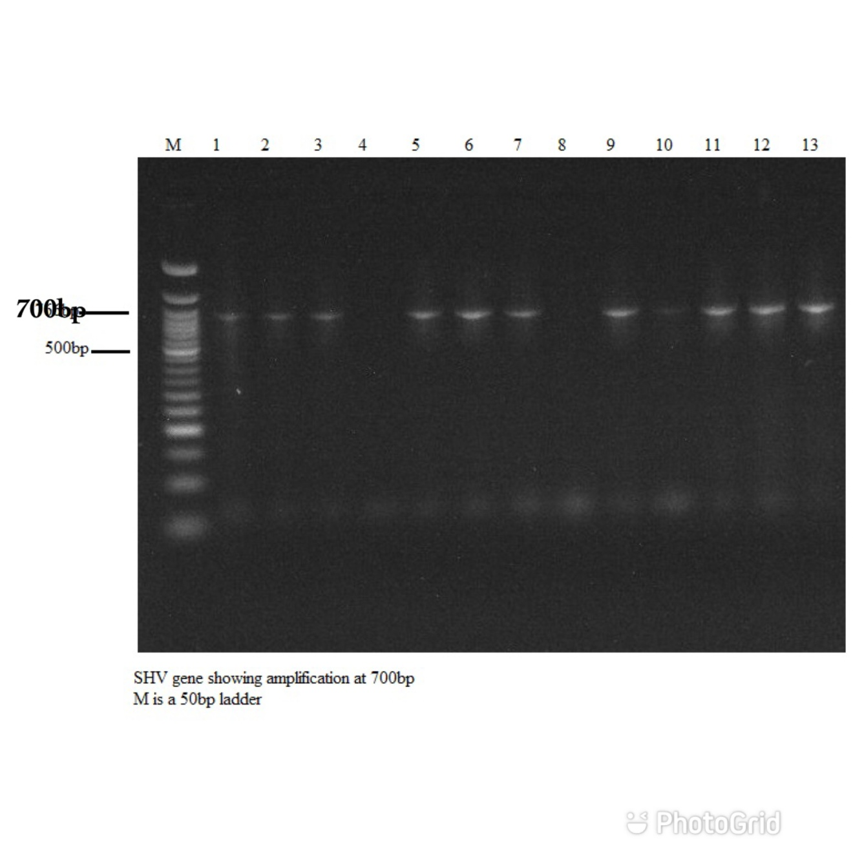
Plate 2 shows the gene amplifications of TEM beta lactamases. Isolates 1-6 represent E. coli from GOPD, A&E, Female Medical, Gynecology, Female Surgical and Labor wards. Isolates 1,2,3,5 and 6 (65.6 %) were positive for TEM among ESBL producing E. coliwhile isolate 4 was negative. Isolates 7-13 are ESBL producing K. pneumoniae and all were positive for TEM except isolates12 and 13 from GOPD, A&E, Female Medical, Gynecology, Female Surgical, Labor and Psychiatric wards.
Plate 1: SHV gene showing amplification at 700bp (M is a 50bp ladder)

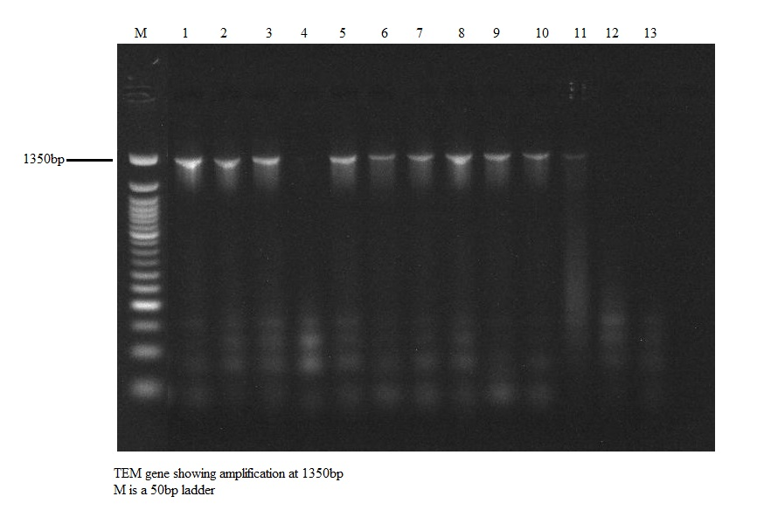
Plate 2: TEM gene showing amplification at 1350bp (M is a 50bp ladder)

Table 7: Percentage occurrence of amplified genes through PCR
S/N | Molecular Gene | E. coli  (% occurrence) | Klebsiella  (% occurrence)
1 | SHV | 4 (44.4) | 6 (54.5)
2 | TEM | 5 (65.6) | 5 (45.5)
 | Total | 9 (100) | 11 (100)

DISCUSSION
Antimicrobial resistance is now recognized as an increasingly global problem, especially Gram-negative bacteria¹⁴. Increasing resistance to broad spectrum cephalosporins amongst E. coli and Klebsiella species predominantly due to the production of ESBLs, reported from different countries^{15, 16}.
In this study the ESBLs producing MDR pathogen E. coli and Klebsiella species were 40 % and 60 % respectively. Many other reports from different countries and regions showed different prevalence rates of ESBLs producing Entrobacteriaceae causing urinary tract infections. K. pneumoniae and E. coli are the most common ESBL-positive species, but all Enterobacteriaceae can harbor plasmid-mediated ESBL genes^{14,16}. This finding is a little bit higher than those obtained from the studies done by¹⁶ from Egypt and Blair¹⁵ in Saudi Arabia, where ESBL were produced by 40.9 and 40.3% E. coli and Klebsiella species respectively. Innes et al¹⁷ reported that out of 100 patients studied, E. coli was the most dominant with a prevalence of 10%. The prevalence was high among females (11.5%) compared with males (8.3%) and among the age group of ≤17 years. Escherichia coli isolates were highly susceptible to cefotaxime/clavulanic acid (100%) and nitrofurantoin (70%) but showed high resistance to cefuroxime (100%), ceftazidime (100%), nalidixic acid (90%), and ciprofloxacin (90%). Another study carried out in India⁴ showed that ESBL was positive in 42% and Anago et al. (2015) detected ESBL production in 48.3%, as determined by the double disc synergy test, which was much higher than that obtained by Anago¹⁸ from Nigeria in which ESBL production was only 20.8%. The result of this study is much less than Rossolini¹⁹, in India, where it was observed that ESBL production was 71.5% and 82.3 % of the Gram-negative bacilli (E. coli and Klebsiella species).
Identifying ESBL producing organisms is a major challenge in clinical settings and, due to the selective pressure caused by heavy use of expanded-spectrum cephalosporins, lapses in effective infection control measures and affinity of these enzymes for different substrates, outbreaks are increasing¹⁹. The prevalence of ESBL producing Enterobacteriaceae varies greatly among country and among the hospitals within the country. Less than 1% to greater than 70% ESBLs producers is reported worldwide. Isolates 47 (53 %) from the 88 isolates of E. coli and Klebsiella spp were confirmed ESBL producers phenotypically. Hassuna et al²⁰ reported that Uropathogens were found in 400 urine samples (68.6%) out of which 134 E. coli isolates were identified. Among the examined uropathogenic E. coli (UPEC), 80 (59.7%) were recognized as ESBL-producers. Greater than half of the ESBL-producers were multi-drug resistant (MDR) (62%) and all of them were susceptible to meropenem.
In this study, a higher prevalence of ESBL production was observed in E. coli than K. pneumoniae. These are in agreement with the study of Anago¹⁸, however, contrary to the findings of other study of ¹². Out of 29 E. coli isolates, 19 (66 %) were ESBL producers. This is in accord with the other studies of ^{18,19}, however, the studies of ¹² are in variance with this study. Likewise, of 59 Klebsiella spp. isolates, 28 (47 %) were ESBL producers. This accords with other studies¹⁹, however, discords with ^{12,18}. Asukwo et al²¹ reported that 283 (29.5%) had positive cultures from the samples analyzed and E coli and Klebsiella pneumonia were the most frequently isolated organisms.
This study showed that all isolates were susceptible to carbapenems which are the most common alternative drugs used for treatment of ESBL producing bacteria. Similar results were observed in the study done by Anago et al¹⁸ who revealed that, more than 89% of the ESBL producers were susceptible to imipenem and meropenem. However, the use of alternative drug which is very broad spectrum and expensive drug as first line for treatment of ESBL-positive bacteria will significantly increases cost of treatment and will contribute to carbapenem resistance in another organism^{12,19}. Resistance to additional classes of antibiotics rather than beta lactams has been noted among ESBLs producing E. coli and Klebsiella species which pose a therapeutic challenge¹⁸.
Molecular characterization of β-lactamase gene would be crucial for a reliable epidemiological analysis of antimicrobial resistance¹⁸. From different studies, it was observed that the predominant of ESBL gene was diverse. Ugwu et al²² reported that Out of the 58 ESBL screened positive E. coli, 35 were confirmed positive with PCR. The predominant ESBL gene was blaTEM while blaSPM was the most prevalent among MBL genes. Earlier reports mentioned that the most prevalent type of ESBL genes is SHV, TEM, and CTX-M. During the past decade, TEM and SHV types were reported to be the most common types of β-lactamase genes, but recently, CTX-M type has been widespread worldwide compared to TEM and SHV genotypes¹⁹. CTX-M was predominant in many regions; several reports were made from Iran (74%)¹⁹, Morocco, North Africa (70%)¹⁹, and India (93.7%)¹⁸. However, the present study showed that TEM-type β-lactamase gene (65.6 %) was the predominant ESBL gene in uropathogenic E. coli which corroborated with the reports of several other previous studies^{12,19}. TEM-type β-lactamase gene was the predominant in Italy (45.4%), Portugal (40.9%)¹², and Turkey (72.7%)²³. Our study also corroborates with another study from India, where TEM was predominant followed by SHV in E. coli and Klebsiella pneumonia from UTI¹⁸. Ajani et al²⁴ in their study reported that UTIs were confirmed in 14.5% (29/200) participants. Of the pathogens isolated, Escherichia coli was predominant 30.6% (11/36).
CONCLUSION
In conclusion, ESBL-producing E. coli and Klebsiella species is a rising problem and the dissemination occurs over the whole country. The predominant gene type was TEM, but SHV gene was also increasing. SHV and TEM-type beta lactamase genes are the primary cause of resistance to β-lactams in E. coli and Klebsiella species which has led to an increase in urinary tract infections and poses a major challenge for the management of ESBL infections. Ertapenem, nitrofurantoin, ceftazidime, cefalexin, and cefotaxime constitute the reasonable treatment option for UTI as based on state of findings. Since dissemination of MDR and ESBL-producing E. coli and Klebsiella species isolates decreases the treatment options and increases the hospital cost, it is necessary to be updated with the prevailing resistant pattern of any locality which will help in appropriate antimicrobial therapy.
AUTHOR’S CONTRIBUTION
This study was done through the combine efforts of the authors. Authors OHC and IIR designed the study, managed the literature searches and performed the statistical analyses. Authors IA, OHC and IIR wrote the first draft of the manuscript and authors IIR, IA and OHC read and approved the final manuscript.
ACKNOWLEDGEMENTS

CONFLICT OF INTEREST
Authors declare that that no conflict of interest exist.
REFERENCES

- Laxminarayan RDA, Wattal C, Zaidi AK, Wertheim HF Sumpradit N. Antibiotic resistance, the need for global solutions. The Lancet Infectious diseases 2013; 13(12): 57–98.
- Ibrahim Y, Sani Y, Saleh Q, Saleh A, Hakeem G. Phenotypic detection of extended-spectrum beta-lactamase and carbapenemase co-producing clinical isolates from two tertiary hospitals in Kano, northwest Nigeria. Ethiopian Journal of Health Science 2017; 27: 3–10.
- De Kraker MDP, Grundmann H. BURDEN study group. Mortality and hospital stay associated with resistant Staphylococcus aureus and Escherichia coli bacteria: estimating the burden of antibiotic resistance in Europe. PLoS medicine 2011; 2: 11-17.
- Muhammad MH, Swedan S. Molecular and phenotypic characterization of carbapenem resistance and extended spectrum beta-lactamases among urinary Escherichia coli isolates. International Journal of Science and Technology 2015; 5(9): 21-29.
- Röderova M, Halova D, Papousek I, Dolejska M, Masarikova M, Hanulik V. Characteristics of Quinolone Resistance in Escherichia coli Isolates from Humans, Animals, and the Environment in the Czech Republic. Front Microbiology 2017; 7: 21-47.
- Iroha IR, Esimone CO, Neumann S, Marlinghaus L, Korte M, Szabados F. First description of Escherichia coli producing CTX-M-15-extended spectrum beta lactamase (ESBL) in out-patients from south eastern Nigeria. Annals of Clinical Microbiology of Antimicrobials 2012; 11: 19-23
- McLaughlin M, Advincula MR, Malczynski M, Qi C, Bolon M, Scheetz MH. Correlations of antibiotic use and carbapenem resistance in enterobacteriaceae. Antimicrobial Agents Chemotherapy 2013; 57(10): 5131-3
- Zhao B, Chao N, Ran G, Yuyan W, Li Y, Jinsong W, Ting L, Jianqing L, Qisheng Z, Wei X, Youhua X, Xiaoyue W, Zhenghong Y, Junbo L, Rong Z, Xinhua L. Recapitulation of SARS-CoV-2 infection and cholangiocyte damage with human liver ductal organoids. Protein & Cell 2020; 11:771–775.
- Rothe C, Schlaich C, Thompson S. Healthcareassociated infections in sub-Saharan Africa. Journal of Hospital Infections 2013; 85 (4): 257-267.
- Cheesbrough M. Tropical health technology. Medical laboratory manual for tropical countries 2004; 7: 35-45.
- Clinical and Laboratory Standards Institute (CLSI). Methods for dilution of antimicrobial susceptibility tests for bacteria that grow aerobically. Approved standard 2015; 10: 7-10.
- Dia ML, Ngom B, Diagne R, Ka R, Lo S, Cisse MF . Molecular detection of CTX-M-15- type β-lactamases in Escherichia coli strains from Senegal. New microbes and New Infection 2016; 9: 45-46.
- Savelkoul PH, Aarts HJ, de Haas J, Dijkshoorn L Duim B. Amplified-fragment length polymorphism analysis: the state of an art. Journal of Clinical Microbiology 1999; 37: 3083–3091
- Mukonzo JK, Namuwenge PM, Okure G, Mwesige B, Namusisi OK, Mukanga D. Over-the-counter sub-optimal dispensing of antibiotics in Uganda. Journal of multidisciplinary healthcare 2013; 6:303–10.
- Blair JMA, Mark A, Webber MA, Baylay AJ, Ogbolu DO, Piddock LJV. Molecular mechanisms of antibiotic resistance. Nature Reviews Microbiology 2015; 13 (1): 42-51.
- Brink AJ. Epidemiology of carbapenem-resistant Gram-negative infections globally. Current Opinions on Infectious Disease 2019; 32: 609–616.
- Innes GK, Randad PR, Korinek A, Davis M.F, Price LB, So AD, Heaney CD. External Societal Costs of Antimicrobial Resistance in Humans Attributable to Antimicrobial Use in Livestock. Annual Review of Public Health 2020; 41 (1): 141–157.
- Anago E, Ayi-Fanou L, Akpovi CD, Hounkpe WB, Tchibozo MA, Bankole HS. Antibiotic resistance and genotype of beta-lactamase producing Escherichia coli in nosocomial infections in Cotonou, Benin. Annals of Clinical Microbiology and Antimicrobials 2015; 14: 5-17
- Rossolini GM. Extensively drug-resistant carbapenemase-producing Enterobacteriaceae: An emerging challenge for clinicians and healthcare systems. Journal of Internal Medicine 2015; 277: 528–531.
- Hassuna NA, Ahmed SK, Eman MF, Adel MH, Medhat A. Molecular characterization of Extended-spectrum β lactamase- producing E. coli recovered from community-acquired urinary tract infections in Upper Egypt. Scientific Reports, 2020: 10(2772).
- Asuquo SE, Kadija MT, Kathryn EM, Donaldson FC, Mesoma AI, Kelechi PC et al., Youth engagement in HIV prevention intervention research in sub-Saharan Africa: a scoping review. Journal of International AIDS Society, 2021: 24(2):e25666.
- Ugwu MC, Shariff M, Nnajide CM, Beri K, Okezie UM, Iroha R, Esimone CO. Phenotypic and Molecular Characterization of β-Lactamases among Enterobacterial Uropathogens in Southeastern Nigeria. Canadian Journal of Infectious Diseases and Medical Microbiology. 2020:1-9.
- Bush K. Alarming β-lactamase-mediated Resistance in Multidrug-resistant Enterobacteriaceae. Curr.Opin.Microbiol 2012; 13(5):58–64.
- Testimony JO, Oluwafolajimi AA, Iyanuoluwa JF, David OB, Judith UO, Olusola AO et al. Infectious disease outbreak preparedness and response in Nigeria: history, limitations and recommendations for global health policy and practice. AIMS Public Health, 2020; 22;7(4):736-757.

