**Reviewer’s Comments**

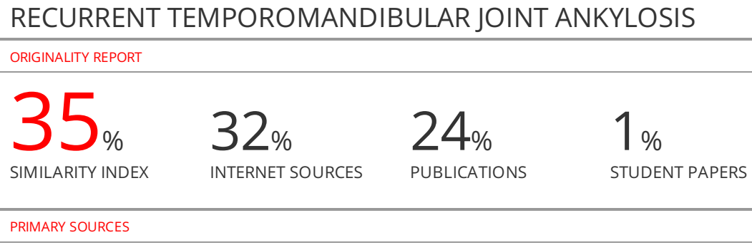

**RECURRENT TEMPOROMANDIBULAR JOINT ANKYLOSIS**

**ABSTRACT:**

**Background and aims:** Recurrence of ankylosis is one of the most common complication following surgery especially during gap arthroplasty without interposition material. The aim of this study was to compare of three different methods in prevent of recurrent temporomandibular joint ankylosis.

**Methods:** Fifteen patients with age ranged between 2-22 years were collected from those attending the outpatient clinic of Oral and Maxillofacial Surgery Department, Al-Kuwait Hospital, Sana’a University. In this study all patients that have temporomandibular joint ankylosis were included. Diagnosis of temporomandibular joint ankylosis through history, clinical and radiographic examinations. All patients were divided into three group according type of treatment.

**Results:** No signs of infection in or around the incision. In group I: three cases of recurrence ankylosis were happened, while one case was dislodging of cartilage from harvested rib in group II. However, in group III, there were no complication observed after the end period of follow-up.

**Conclusion:** The temporalis fascia as interpositional material is an effective method to prevent recurrence of temporomandibular joint ankylosis and produce good esthetic and function results.

**Keywords:** interpositional material, reankylosis, TMJ ankylosis.

**INTRODUCTION:**

The primary goals of managing temporomandibular joint ankylosis are to re-establish joint function, prevent re-ankylosis and restoration of mouth opening**1,2**.Recurrence of ankylosis is one of the most common complication following surgery especially during gap arthroplasty without interposition material**3**.Children with ankylosis were found to be more prone to recurrence compared with adults**4**.

According to Hegab**5** After creation of gap between two raw bony surfaces the osseous particles and bone dust created during the surgery are implanted, albeit unintentionally, into surrounding soft tissues. In addition, postoperative hematoma rich in the “Wandering histiocytes” or inductor cells which activate perivascular connective tissue cells to differentiate into specialized osteoprogenitor cells or chondroprogenitor cells. The progenitor cells start to form bone or cartilage that is subsequently mineralized into mature bone. Where bone induction took place, a pool of responsive cells surrounded by abundant capillaries and advancing fronts of osteoblasts were also present**6**. In association of the contributing factors of close approximation of the articular components, and decreased joint mobility resulting from the action of the atrophied muscles lead to re-ankylosis**5**.

Growing period, physical exercises, severity of the ankylosis. amount of ankylotic mass removed, wound infection, and a foreign body reaction represent the etiological factors causingreankylosis of temporomandibular joint**7,8**.

Treatment of TMJ ankylosis has been a major challenge for surgeons due to difficult techniques and high rate of recurrence. A variety of surgical techniques including condylectomy, gap arthroplasty, interpositional arthroplasty, mandibular distraction osteogenesis, and joint reconstruction with bone grafts or joint prosthesis. However, no method has been accepted as a unique surgical intervention**9,10,11**.

The aim of this study was to compare of three different methods in prevent of recurrent temporomandibular joint ankylosis.

**MATERIALS AND METHODS:**

Fifteen patients with age ranged between 2-22 years were collected from those attending the outpatient clinic of Oral and Maxillofacial Surgery Department, Al-kawait Hospital, Sana’a University, Yemen. In this study all patients that have temporomandibular joint ankylosis were included in period from March 2017 to April 2020. Diagnosis of the temporomandibular joint ankylosis was achieved through history, clinical and radiographic examinations by computerized tomography

we're explaining to all of the participants and their parents and informed consent was taken from their parents before the scheduled surgery. This study was approved by the Sana'a University, Faculty of Dentistry prior to the study under number of 5/ 2-3-2017. Patients were divided into three groups according to type of surgical procedure. Group I: patients treated by gap arthroplasty alone. Group II: patients treated by gap arthroplasty and costochondral graft. Group III: patients treated by gap arthroplasty temporalis fascia as interpositional material. Each of all groups was consisted of 5 patients, scheduled for preauricular incision and gap arthroplasty was done for all groups. The wound healing was followed up clinically twice a week for two weeks and radiographically at intervals of two weeks and six months using CT. Instruct patients to aggressive exercise immediately after surgical procedure and follow-up every three months until the end of the two years. All surgical procedures were performed under general anesthesia using nasoendotracheal intubation or retrograde intubationor tracheostomy. The operative field was scrubbed and draped to isolate surgical site in routine way. The preauricular approach was done for all groups to removal ankylotic mass to create a gap more than 10mm by using surgical burrs, chisel and mallet and coronoctomy in the ipsilateral sideto enable patients to achieve mouth opening more than 35mm (Fig.2).

In group I: after removal of ankylotic mass and coronectomy of ipsilateral side the interincisal opening increased than copious irrigation and suturing in layers.

In group II: after removal of ankylotic mass, the costochondral graft harvested from the 6th rib approximately 6 cm of bone with cartilage. The patient should be placed in intermaxillary fixation, then the retromandibular approach was done in the ipsilateral side to facilitate the fixation of rib into its position. (Fig.3). Finally, copious irrigation and suturing to cover all incision in layers.

In group III: after removal of ankylotic mass, Al-khayat and Bramley incision was done to exposure the temporalis fascia. Then fascia was harvested and secured between the gap created by suturing to the adjacent tissues (Fig.4).

Finally, in all groups, Copious irrigation, the wound was closed in layers and a pressure dressing applied. physiotherapy was started immediately after the operation and it was advised to continue for at least two years. Patients were encouraged to be discharged from the hospital on the seventh postoperative day after removal of skin sutures.

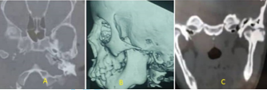

**Fig.1: Showing left condylar reankylosis. A: Axial view, B: 3D, & C: Coronal view.**

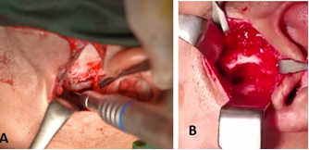

**Figure 2. A: Removal of ankylotic mass by osteotomy cut, & B. a gap more than 10mm.**

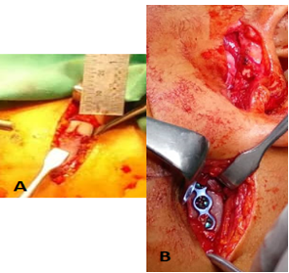

**Fig.3: A: harvested of 6th rib & B: fixation with miniplate and screw.**

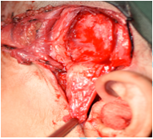

**Fig.4: harvested of temporalis fascia into gap between fossa and mandible.**

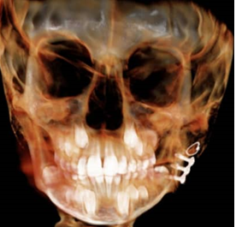

**Fig.5: Showing the fixation of dislodge cartilage by wire.**

**Statistical analysis**

**RESULTS:**

This study was carried out on 15 patients. Details of age, gender and surgical procedure are distributions in table (1). Trauma was the main etiological factor for ankylosis in all patients. While the etiological factor of recurrence was unknown.

According to type of surgical procedure, the patients were divided into three groups. In all patients, the surgical wounds healed calmly, and the patients showed no signs of complications such as facial paresis, infection, hematoma, and others after surgery. All patients underwent rigorous physiotherapy exercises immediately after the operation.

Satisfactory results achieved was 35 mm interincisal opening in all cases intraoperatively. These results were stable after the first year. However, in the final of the second year confirmed the results with no recurrence of ankylosis except three cases in group I, the maximum mouth opening was less than 10 mm. While, in group II, one case had dislodged of cartilage from harvested rib, and then fixed with stainless steel wire (fig.5).

**Table No. (1): summarizes the age, sex, and surgical procedure.**

|  |  |  |  |  |  |  |  |  |
| --- | --- | --- | --- | --- | --- | --- | --- | --- |
| **Age** | **Sex** | | | | | **Surgical procedure** | | |
|  | Male | ~~Percentage~~ | Female | ~~Percentage~~ | Total | Gap arthroplasty | Gap arthroplasty and costochondral graft | Gap arthroplasty and temporalis fascia |
| 2-5 | 3 | 20% | 1 | 6.67% | 26.67% | 2 | 1 | 1 |
| 6-12 | 5 | 33.33% | 3 | 20% | 53.33% | 2 | 3 | 3 |
| 13-22 | 2 | 13.33% | 1 | 6.67% | 20% | 1 | 1 | 1 |

**DISCUSSION:**

Recurrence of temporomandibular ankylosis is the most common complication that happened after surgical management of ankylosis. This was in accordance with Chossegros et al.,**12**. However, this was in opposition to Liu et al.,**13** , proposed that the facial nerve injury is the most common complication.

There are many etiological factors that play role in recurrent temporomandibular joint ankylosis. The radical removal of the TMJ bone is essential to avoid recurrence**14**. On the other hand, the prevent recurrence of temporomandibular joint depend on type of interpositional material and early physiotherapty**12**.

Moreover, some conditions such as multiple TMJ operation, severe heterotopic ossification, and fibrosis of soft tissue increase the risk of reankylosis**15**. In heterotopic ossification, pluripotent cells are induced to differentiate into fibroblasts, chondroblasts, and osteoblasts. This leads to reankylosis of the articulation with an increase in pain and progressive limited mouth opening**16**.

In our study, intensive physiotherapy started immediately after the operation and continued for 2 years with parents instructed to follow up every three months to prevent recurrence. This agreement with Mishra et al.,**17** who reported early physiotherapy after surgery, strict follow-up is necessary to prevent adhesions after surgery.

Gap arthroplasty is reported with high rate of recurrence, and mouth deviation is the result of this operation**18**. This study recorded three cases have reankylosis with gap arthroplasty alone.

In the current study, thecostochondral graft is the most widely accepted autogenously technique especially in children which provides growth potential, biological compatibility, a cartilaginous articulating surface and decrease the incidence of reankylosis. However, lack of parental acceptance and consent on harvesting a rib graft had precluded that option. This agreed withMacIntosh**19**and Sharma et al.,**20** However, it was contradicting the study of Balaji**21**who reported care should be taken to ensure proper postoperative functional therapy and to examine the role of cartilage thickness on future growth in young patients.

Unfortunately, in this study there was one case in group II presented with dislodge of cartilage from harvested rib, and as stated by Baek&Song**22** and Mishra et al.,**10**many complication are occlusion changes with time, possibility of cartilage separated, infection and reankylosis has been reported in 5-39%.

In the present study, the temporalis fascia are autologous nature; therefore least immunoreactive, proximity to the joint, enabling excellent mobility and coverage of the arthroplasty gap, minimal donor site morbidity both cosmetically and functionally, minimal damage to the temporal branch of the facial nerve, good resilience and blood supply, hollowing in the temporal region is not evident, minimal intraoperative blood loss, low degree of friction, good positional stability and prevent recurrent ankylosis.This agreed with those of Bajpai & Saikrishna**23** and Suday et al.,**24**

**LIMITATIONS OF THE STUDY**

**CONCLUSION:**

There are many methods can be used to prevent recurrent reankylosis of temporomandibular joint depend on removal of large amount of ankylotic mass, early aggressive and longer time of physiotherapy and place of interpositional material. The temporalis fascia as interpositional material is an effective method to prevent recurrence of temporomandibular joint ankylosis, produce good esthetic, function results and to avoid complication which occurs with costochondral graft.

**ACKNOWLEDGEMENTS:**

The authors would like to acknowledge all staff of al kuwait hospital which helps and supports this work.

**AUTHORS' CONTRIBUTIONS:**

This work under supervision, Dr. Sam A. Da'er. Assistant professor of oral and Maxillofacial Surgery, Faculty of Dentistry, Sana'a university. Other authors work as teamwork with Dr. Sam in preform the surgical procedure, and analyzed the data, wrote the manuscript, and reviewed it.

**CONFLICT OF INTEREST**:

The authors declare that they have no conflict of interest associated with this work.

**REFERENCES:**

1. Katsnelson A, Markiewicz MR, Keith DA, Dodson TB. Operative management of temporomandibular joint ankylosis: a systematic review and meta-analysis. Journal of oral and maxillofacial surgery. 2012;70(3):531-6.

.https://pubmed.ncbi.nlm.nih.gov/22209104/

2. Chen S, He Y, An J-g, Zhang Y. Recurrence-related factors of temporomandibular joint ankylosis: a 10-year experience. Journal of Oral and Maxillofacial Surgery. 2019;77(12):2512-21.

.https://pubmed.ncbi.nlm.nih.gov/31348873/.

3. Elgazzar R, Abdelhady A, Saad K, et al. Treatment modalities of TMJ ankylosis: experience in Delta Nile, Egypt. International journal of oral and maxillofacial surgery. 2010;39(4):333-42.

.https://pubmed.ncbi.nlm.nih.gov/20149597/

4. Das U, Keerthi R, Ashwin D, et al. Ankylosis of temporomandibular joint in children. Journal of Indian Society of Pedodontics and Preventive Dentistry. 2009;27(2):116

.https://pubmed.ncbi.nlm.nih.gov/19736506/.

5. Hegab A. Pathogenesis of ankylosis and re-ankylosis: The story. J Dent Health Oral Disord Ther. 2015;2(5):00063.

.https://www.researchgate.net/publication/279419311_Pathogenesis_of_Ankylosis_and_Re-Ankylosis_The_Story

6. Bossche LV, Vanderstraeten G. Heterotopic ossification: a review. J Rehabil Med. 2005;37(3):129-36.

.https://pubmed.ncbi.nlm.nih.gov/16040468/

7. Kaban LB, Perrott DH, Fisher K. A protocol for management of temporomandibular joint ankylosis. Journal of oral and maxillofacial surgery. 1990;48(11):1145-51.

.https://pubmed.ncbi.nlm.nih.gov/2213309/

8. Bello SA, Olokun BA, Olaitan AA, Ajike SO. Aetiology and presentation of ankylosis of the temporomandibular joint: report of 23 cases from Abuja, Nigeria. British Journal of Oral and Maxillofacial Surgery. 2012;50(1):80-4.

.https://pubmed.ncbi.nlm.nih.gov/21255886/

9. Qudah MA, Qudeimat MA, Al-Maaita J. Treatment of TMJ ankylosis in Jordanian children–a comparison of two surgical techniques. Journal of Cranio-Maxillofacial Surgery. 2005;33(1):30-6.

.https://pubmed.ncbi.nlm.nih.gov/15694147/

10. Mishra P, Kshirsagar R, Warade P, et al. Costochondral Graft in Surgical Treatment of TMJ Ankylosis.

.https://www.medicalandresearch.com/journals/view_article/875

11. Upadya VH, Bhat HK, Rao BS, Reddy SG. Classification and surgical management of temporomandibular joint ankylosis: a review. Journal of the Korean Association of Oral and Maxillofacial Surgeons. 2021;47(4):239-48.

.https://pubmed.ncbi.nlm.nih.gov/34462381/

12. Chossegros C, Guyot L, Cheynet F, Blanc J, Cannoni P. Full-thickness skin graft interposition after temporomandibular joint ankylosis surgery: A study of 31 cases. International journal of oral and maxillofacial surgery. 1999;28(5):330-4.

.https://pubmed.ncbi.nlm.nih.gov/10535529/

13. Liu F, Giannakopoulos H, Quinn PD, Granquist EJ. Retrospective study of facial nerve function following temporomandibular joint arthroplasty using the endaural approach. Craniomaxillofacial Trauma & Reconstruction. 2015;8(2):88-93.

.https://pubmed.ncbi.nlm.nih.gov/26000077/

14. Raveh J, Vuillemin T, L drach K, Sutter F. Temporomandibular joint ankylosis: surgical treatment and long-term results. Journal of oral and maxillofacial surgery. 1989;47(9):900-6.

.https://pubmed.ncbi.nlm.nih.gov/2547919/

15. Egemen O, Ozkaya O, Filinte GT, Uscetin I, Akan M. Two-stage total prosthetic reconstruction of temporomandibular joint in severe and recurrent ankylosis. Journal of Craniofacial Surgery. 2012;23(5):e520-e4.

.https://pubmed.ncbi.nlm.nih.gov/22976729/

16. Singh V, Dhingra R, Sharma B, Bhagol A, Kumar P. Retrospective analysis of use of buccal fat pad as an interpositional graft in temporomandibular joint ankylosis: preliminary study. Journal of oral and maxillofacial surgery. 2011;69(10):2530-6.

.https://pubmed.ncbi.nlm.nih.gov/21664741/

17. Mishra S, Tripathy R, Sabhlok S, Roy R. Management of adult unilateral TMJ ankylosis with temporalis muscle and fascia flap: Review of 51 Cases. Int J Head and Neck Surg. 2012;3(3):133-36.

.https://www.semanticscholar.org/paper/Management-of-Adult-Unilateral-TMJ-Ankylosis-with-Mishra-Tripathy/d72101e5d60ab990961a8e70c0a8a993fb1d1438

18. Zhi K, Ren W, Zhou H, et al. Management of temporomandibular joint ankylosis: 11 years' clinical experience. Oral Surgery, Oral Medicine, Oral Pathology, Oral Radiology, and Endodontology. 2009;108(5):687-92.

.https://pubmed.ncbi.nlm.nih.gov/19782622/

19. MacIntosh RB. The use of autogenous tissues for temporomandibular joint reconstruction. Journal of oral and maxillofacial surgery. 2000;58(1):63-9.

.https://pubmed.ncbi.nlm.nih.gov/10632167/

20. Sharma H, Chowdhury S, Navaneetham A, Upadhyay S, Alam S. Costochondral graft as interpositional material for TMJ ankylosis in children: a clinical study. Journal of maxillofacial and oral surgery. 2015;14(3):565-72.

.https://pubmed.ncbi.nlm.nih.gov/26225045/

21. Balaji S, Balaji P. Overgrowth of costochondral graft in temporomandibular joint ankylosis reconstruction: a retrospective study. Indian Journal of Dental Research. 2017;28(2):169.

.https://pubmed.ncbi.nlm.nih.gov/2861 1327/

22. Baek R-M, Song Y-T. Overgrowth of a costochondral graft in reconstruction of the temporomandibular joint. Scandinavian journal of plastic and reconstructive surgery and hand surgery. 2006;40(3):179-85.

.https://pubmed.ncbi.nlm.nih.gov/16687339/

23. Bajpai H, Saikrishna D. The versatility of temporalis myofascial flap in maxillo-facial reconstruction: a clinical study. Journal of maxillofacial and oral surgery. 2011;10(1):25-31.

.https://www.ncbi.nlm.nih.gov/pmc/articles/PMC3177505/

24. Rajurkar SG, Makwana R, Ranadive P, et al. Use of temporalis fascia flap in the treatment of temporomandibular joint ankylosis: A clinical audit of 5 years. Contemporary clinical dentistry. 2017;8(3):347.

.https://pubmed.ncbi.nlm.nih.gov/29042715/