**Original Research Article**

**AMOXICILLIN – ANTACIDS *IN VITRO* INTERACTION STUDY BY SPECTROPHOTOMETRIC METHOD AND INVESTIGATION OF ANTIMICROBIAL ACTIVITY OF AMOXICILLIN WITH ANTACIDS.**

**ABSTRACT**

**Background:** An interaction between a drug and any other element that inhibits the drug from working as intended is known as a drug interaction. Usually, an interaction can change how the drug is absorbed, distributed, metabolized, and eliminated by the body.

**Objective:** This study is aimed to evaluate the in-vitro complexation nature and strength of complex which may be formed due to interaction between Amoxicillin and Magnesium hydroxide, Mg(OH)₂ (Antacid-1), Amoxicillin and Calcium carbonate, CaCO₃ (Antacid-2) and investigation of antimicrobial study of Amoxicillin.

**Methodology:** This research work ensures that there was a possible interaction between the Amoxicillin and Mg(OH)₂ (Antacid-1) and CaCO₃ (Antacid-2) which was confirmed by the Job’s plot method.In order to investigate the number of Mg(OH)₂ (Antacid-1) and CaCO₃ (Antacid-2) involved in the complexation with Amoxicillin complexes was demonstrated by exploiting various spectrophotometric methods. The ultraviolet studies of these complexes were carried out and compared. The microbial sensitivity test is important to know whether there is any change in the effectivity of Amoxicillin after the interaction with antacid.

**Findings:**The study confirms that there is a possible interaction between Amoxicillin and Mg(OH)₂ (Antacid-1) and CaCO₃ (Antacid-2) which is confirmed by job’s plot method. The absorbance of Amoxicillin is quite different from the absorbance of Amoxicillin – Mg(OH)₂ (Antacid-1) and Amoxicillin- CaCO₃ (Antacid-2). The intensity of the peak of Amoxicillin changes remarkably Amoxicillin forms a strong 1:1 complex with Mg(OH)₂ (Antacid-1), and CaCO₃ (Antacid-2) as ‘^’ shaped curves in Jobs plot. These curves may indicate strong kinetics of complexation between Amoxicillin with Mg(OH)₂ (Antacid-1) and CaCO₃ (Antacid-2). By Antimicrobial investigation against gram positive bacteria, it was confirmed that the zone of inhibition of Amoxicillin with Mg(OH)₂ (Antacid-1) and CaCO₃ (Antacid-2) reduced from 15 mm, 11 mm and 9 mm respectively.AndAmoxicillin with Mg(OH)₂ and CaCO₃ did not exhibit any detectable antibacterial action when tested against gram negative bacteria.

**Conclusions:** Due to interaction of both amoxicillin with antacids, it is shown that the standard absorbanceof amoxicillin is quite different from the absorbance of drug-antacidand the antimicrobial activity is also reduced.

***Keywords-*** *Amoxicillin, Antacid, Interaction, Job’s Plot, Antimicrobial Activity.*

1. **Introduction**

Drug interaction is when a drug interacts with another substance, such as another drug or a specific type of food, causing an interaction that may result in a change in the effectiveness of one or both drugs, an adverse reaction, or a brand-new side effect that is not present with either drug alone and may be severe enough to affect the clinical outcome. The term "object drug" refers to the medication whose activity is impacted by such an interaction.A medication interaction may have beneficial or adverse consequences and occasionally it may even be harmful [1]. Drug-drug interactions, drug-food and beverage interactions, drug-laboratory test interactions, drug interactions caused by a patient's disease state, and even environmental chemicals and smoking habits of the individual can affect the physiological parameters that define a particular drug are examples of very common drug interactions. Simultaneously administered drugs that affect one another's efficacy or safety profile are considered to be interacting drugs[2]. The several physiological processes, including medication absorption, distribution, metabolism, and elimination, can frequently be changed by interactions. Less is said about drug interactions brought on by distribution changes than about other causes. It is argued that there is interaction when the effects of one drug are balanced off by the presence of additional drugs, drinks, foods, and ambient chemicals. When a multimodality treatment might cause an unanticipated change in the patient's condition, this would be described as an interaction of possible clinical significance.It is common to take antacid preparations along with other drugs. The chemistry and physical characteristics of an antacid preparation determine whether antacid-drug interactions are possible [3]. Free aluminum, magnesium, calcium, and other ions administered through the stomach may have an impact on the pharmacokinetics of drugs as well as gastrointestinal function. Antacid-drug interactions may manifest as a result of modifications in gastrointestinal motility or variations in the pH of the stomach and urine.Drug bioavailability is however reduced as a result of direct adsorption [4][5]. Human drug interaction studies are typically conducted on healthy volunteers; hence, extrapolating conclusions from these clinical settings may not necessarily be reliable. However, the most recent research suggests that some members of the cephalosporin, quinolone, and non-steroidal anti-inflammatory drug (NSAID) families of medications do interact seriously with antacids. Ketoconazole, tetracycline, quinidine, and oral glucocorticoids are more drugs that can have strange interactions. In the case of a patient with sepsis, heart illness or inflammatory disorders, these interactions are particularly important.There are other effects as well, such as toxicity, an unexpected rise in pharmacological activity, and positive ones, such as chemical or physical interactions that are additive and potentiating (planned) or antagonistic (unintended). There is still much to learn, despite the fact that the study of drug interaction processes has made significant progress in recent years. As a result, many of the mechanism concepts that are relevant today will be improved, leading to a more accurate representation of the situation. Additionally, it should be remembered that multiple mechanisms may operate simultaneously in some drug-drug interactions.In order to treat type II diabetes in animals, new insulin lookalike zinc (II) complexes with various coordination structures and a blood glucose reducing action were discovered [6].A stabilizing constant, also known as a formation or binding constant, governs how a complex forms in solution. It is a measurement of how strongly the chemicals interacting to generate the complex interact with one another. There are two primary types of complexes: supramolecular compounds like host-guest complexes and complexes of anions, and compounds created when a metal ion combines with a ligand. Calculating the concentration of the complexes in solution requires knowledge of the stability constants [7]. Applications in chemistry, biology, and medicine are numerous. The ligands must not always be a metal and a ligand but can be any species which form a complex. Infectious organisms like bacteria and protozoa are killed (bactericidal) or have their growth inhibited (bacteriostatic) by chemical substances known as antibiotics.The beta lactams, which are divided into penicillins, cephalosporins, carbapenems, and monobactams are the oldest class of antibiotics still used in medicine. All but one of these substances have outstanding safety profiles. Antacids and multivitamin formulations are the most frequently co-administered medications with antibiotics because it is well known that extended antibiotic therapy produces anemia, stomach discomfort, or acidity.Amoxicillin kills bacteria by blocking the development of their cell walls as a beta-lactam antibiotic that is a member of the popular aminopenicillin antibiotic class. All beta lactam antibiotics possess the same molecular structure, the beta-lactam ring, which accounts for their shared characteristics. Penicillin-like drugs have a long history in medicine and are still widely

|  |  |  |
| --- | --- | --- |
| Serial No | Name | Source |
| 1 | Amoxicillin | Gift samples from alvion laboratories ltd. |
| 2 | Magnesium hydroxide (Antacid-1) | Merck Itd, Mumbai, India. |
| 3 | Calcium carbonate (Antacid-2) | Merck Itd, Mumbai, India. |
| 4 | Disodium hydrogen phosphate | Dept. of pharmacy, USTC, Foy’s lake, Chittagong. |
| 5 | Sodium di-hydrogen phosphate | Dept. of pharmacy, USTC, Foy’s lake, Chittagong. |
| 6 | Phosphate buffer | Dept. of pharmacy, USTC, Foy’s lake, Chittagong. |

used today.

1. **MATERIALS AND METHODS**

**Chemical and reagents**

All of the chemicals utilized in this project were of the analytical grade and were organized for optimal storage. About an hour before collecting the data, the experimental mixtures and solutions were made in standard volumetric flasks.

**Instruments and equipments**

|  |  |  |
| --- | --- | --- |
| Name | Model | Source |
| Electronic balance | AL-204 | Mettler toleddo, Switzerland. |
| pH meter | PH-211 | Hanna, Romania |
| UV spectrophotometer | T80 | PG instrument Itd, England. |
| Pipette |  | Fischer scientific, Germany. |

***Preparation of stock solution***

Amoxicillin, 0.36541 gram in 100 ml of demineralized water in a 100 ml volumetric flask was used to prepare 100 ml of a1 $×$ 10⁻² stock solution. By using buffer solution, the stock solution was diluted to the necessary strength.

***Preparation of antacid solutions***

Antacid-1, Magnesium hydroxide, Mg(OH)₂ (0.05853 gm) and Antaciod-2, Calcium carbonate, CaCO₃ (0.10009 gm) were precisely weighed and introduced with the use of funnels in 100 ml volumetric flasks separately, dissolved in demineralized water and made up to the required concentration using the same solvent. The final solutions had a concentration of 0.01M after being further ten times diluted in the same solvent as the initial solutions.

***Preparation of buffer solution***

To make buffer solution 5.05 gm of Disodium hydrogen phosphate was dissolved in demineralized water with 0.848 gm of Sodium di hydrogen phosphate. The pH was then raised to 7.4 and the volume was increased to 250 ml using the same solution.

***Preparation of standard curve of Amoxicillin***

The concentration of 1×10⁻ $⁵$ M Amoxicillin stock solution was measured at pH 7.4 and applied in various amounts to ten test tubes to produce the following concentrations:1×10⁻ $⁵$ M : 9×10⁻⁵ M, 8×10⁻⁵ M, 7×10⁻⁵ M, 6×10⁻⁵ M, 5×10⁻⁵ M, 4×10⁻⁵ M, 3×10⁻⁵ M, 2×10⁻⁵ M, 1×10⁻⁵ M [8].

The solutions were appropriately combined after that. Using a UV spectrophotometer, the absorbance values of the solutions were calculated at 256 nm. The reference sample's control was a phosphate buffer solution with a pH of 7.4. Plotting the absorbance readings against the corresponding concentrations led to the creation of the standard curve.

**Disc diffusion method**

By dissolving measured amounts of the test samples in calculated volumes of solvents, a solution of the test samples with a defined concentration (3 µg/ml) is created. The test compounds are then impregnated into dried, sterile, 6mm diameter filter paper discs using a micropipette. Standard antibiotic discs and blank discs (impregnated with solvent) are used as positive and negative controls. Discs containing the test material are placed on nutrient agar medium uniformly seeded with the test microorganism.For maximum diffusion, these plates are then held at a low temperature (4◦C) for 24 hours. Dried discs absorb the surrounding media's moisture during this time, after which the test components dissolve and diffuse out of the sample disc. The physical law that governs the diffusion of molecules through agar gel is what causes the diffusion to happen. There is consequently a progressive alteration in the test substance concentrations in the medium around the disc. The plates are then kept at 37°C for 24 hours to promote the organism's maximum growth. A clear, definite zone of inhibition will be visible encircling the medium if the test materials have any antibacterial activity since it will hinder the growth of the microorganisms.The diameter of the inhibition zone, reported in millimeters, is used to calculate the test agent's antimicrobial activity. The experiment is run multiple times and the average of the readings is needed.

**Determination of antimicrobial activity by the Zone of inhibition**

The ability of the test agents to suppress the development of microbes around the discs, which results in a distinct zone of inhibition, serves as an indicator of their antimicrobial efficacy. Using a clear millimeter scale, the diameter of the zone of inhibition was measured after incubation to determine the test materials' antibacterial properties [9].

1. **RESULTS AND DISCUSSIONS**

The absorbance of Amoxicillin increases with increasing concentration in accordance with Beer Lambert's law, as shown in the following figure.

Plotting the absorbance value against the respective concentrations produced the standard curve.

**Standard curve of Amoxicillin**

|  |  |
| --- | --- |
| Mx10-5 | Absorbance |
| 1 | 0.495 |
| 2 | 0.498 |
| 3 | 0.508 |
| 4 | 0.510 |
| 5 | 0.523 |
| 6 | 0.540 |
| 7 | 0.531 |
| 8 | 0.533 |
| 9 | 0.541 |

**Absorbance of Amoxicillin**

According to Beer-Lambert's law, we can see from the preceding figure that Amoxicillin's absorbance rises as concentration increases.

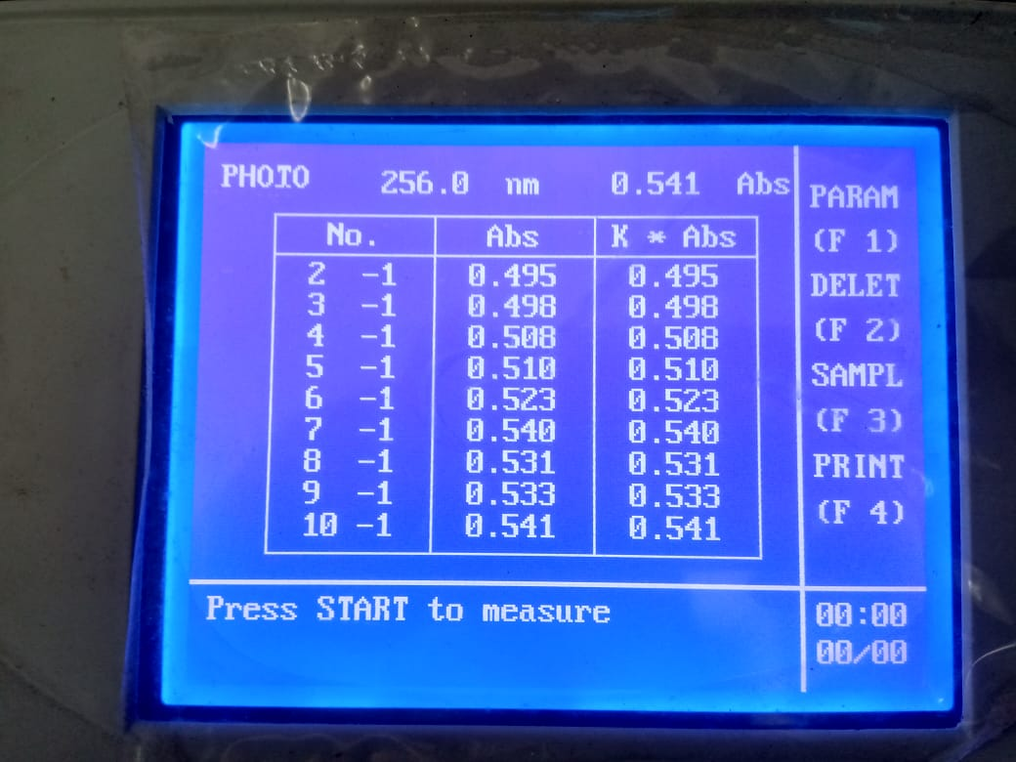

|  |  |
| --- | --- |
| Wavelength | Absorbance |
| 200 | 1.132 |
| 205 | 1.295 |
| 210 | 1.423 |
| 215 | 1.488 |
| 220 | 1.076 |
| 225 | 0.575 |
| 230 | 0.319 |
| 235 | 0.244 |
| 240 | 0.155 |
| 245 | 0.085 |
| 250 | 0.033 |
| 255 | -0.004 |

Figure: Determination of absorbance of Amoxicillin by UV spectrophotometer.

Absorbance of Amoxicillin at different wavelength

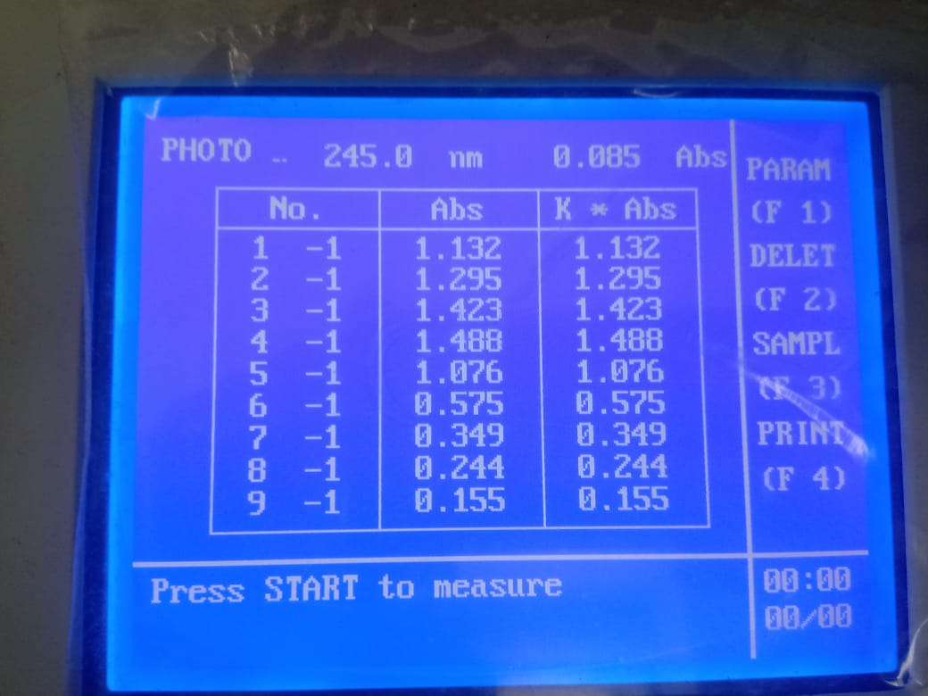

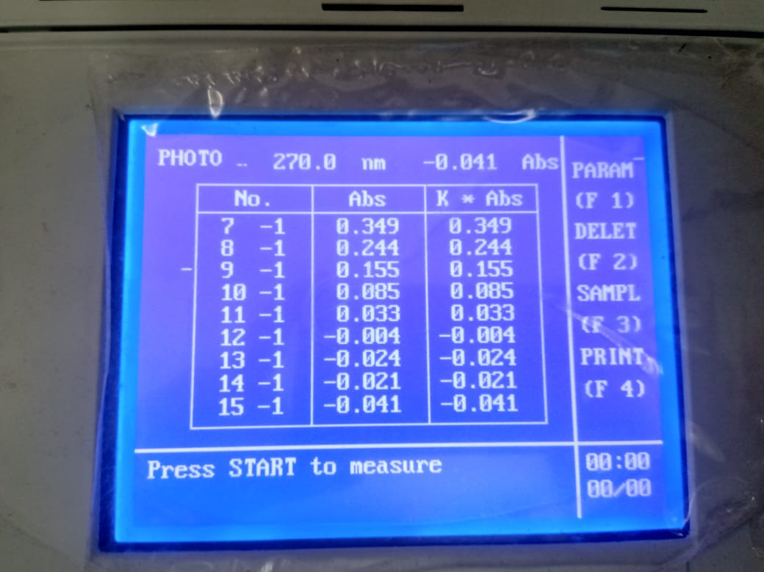

Figure: Determination of absorbance of Amoxicillin at different wavelength by UV spectrophotometer.

**SPECTRAL STUDIES OF INTERACTION OF AMOXICILLIN WITH ANTACIDS**

**Spectral analysis of Amoxicillin with Magnesium hydroxide, Mg(OH)₂ (Antacid-1)**

|  |  |
| --- | --- |
| Wavelength/nm | Absorbance of Amoxicillin + Mg(OH)₂ |
| 200 | 1.303 |
| 205 | 1.474 |
| 210 | 1.613 |
| 215 | 1.705 |
| 220 | 1.600 |
| 225 | 1.322 |
| 230 | 1.137 |
| 235 | 1.039 |
| 240 | 0.951 |
| 245 | 0.879 |
| 250 | 0.824 |
| 255 | 0.781 |
| 260 | 0.749 |
| 265 | 0.740 |
| 270 | 0.695 |
| 275 | 0.666 |
| 280 | 0.637 |
| 285 | 0.606 |
| 290 | 0.581 |
| 295 | 0.554 |
| 300 | -0.955 |

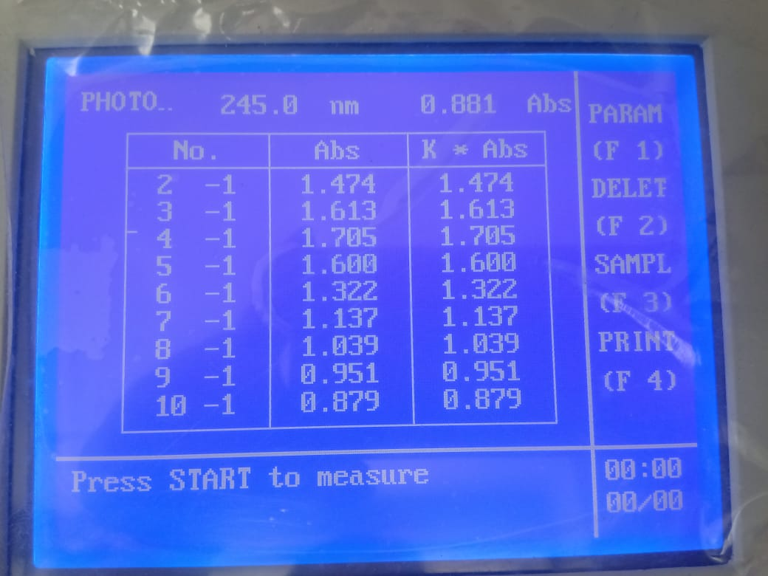

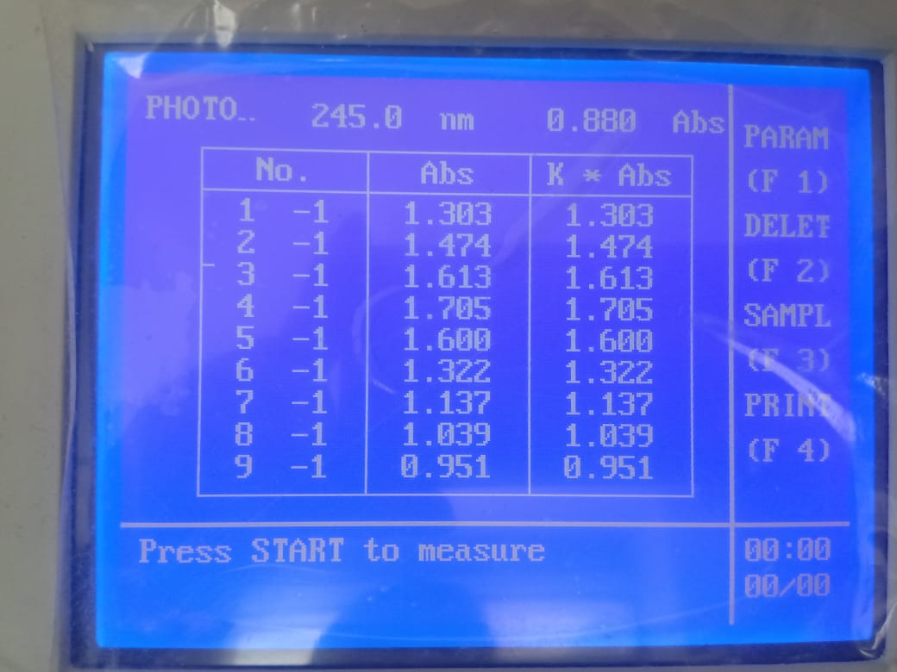

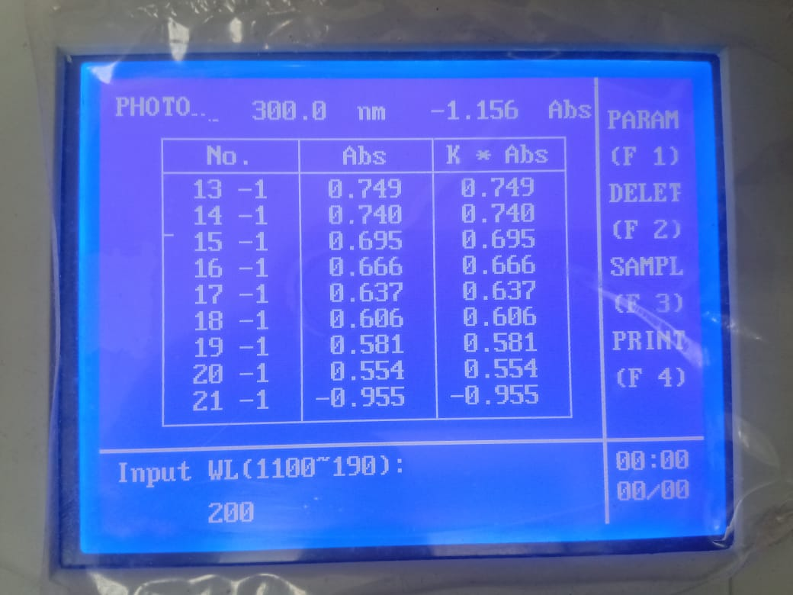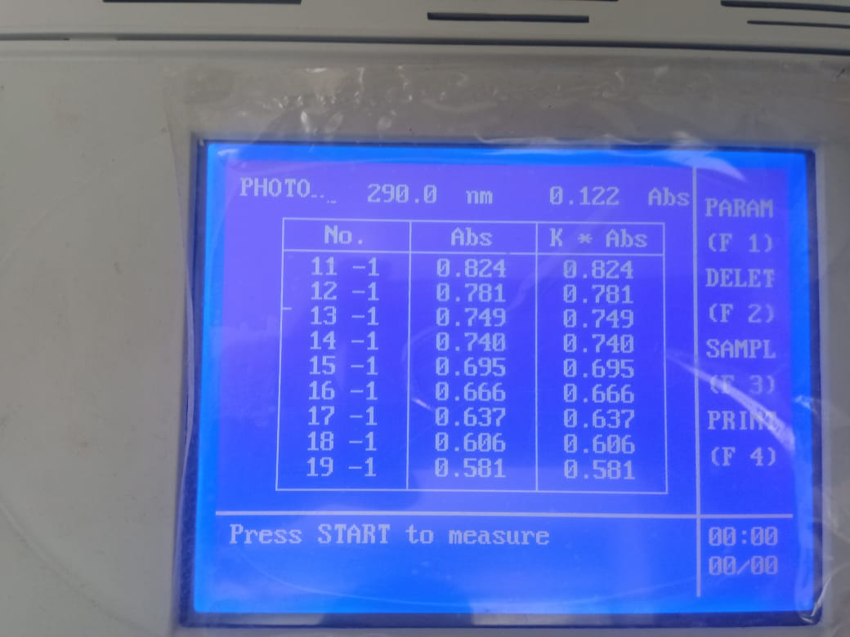

|  |  |
| --- | --- |
| Wavelength/nm | Absorbance of Amoxicillin + CaCO₃ |
| 200 | 0.680 |
| 205 | 0.830 |
| 210 | 0.957 |
| 215 | 1.038 |
| 220 | 0.977 |
| 225 | 0.841 |
| 230 | 0.732 |
| 235 | 0.680 |
| 240 | 0.641 |
| 245 | 0.615 |
| 250 | 0.594 |
| 255 | 0.569 |
| 260 | 0.550 |
| 265 | 0.535 |
| 270 | 0.497 |
| 275 | 0.467 |
| 280 | 0.443 |
| 285 | 0.422 |
| 290 | 0.405 |
| 295 | 0.393 |
| 300 | -0.096 |

Figure: Spectral analysis of Amoxicillin with Mg(OH)₂ determination by UV spectrophotometer.

Spectral analysis of Amoxicillin with calcium carbonate, CaCO₃ (Antacid-2)

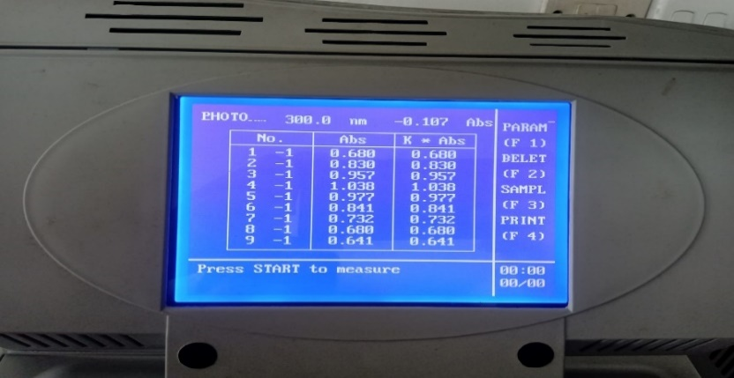

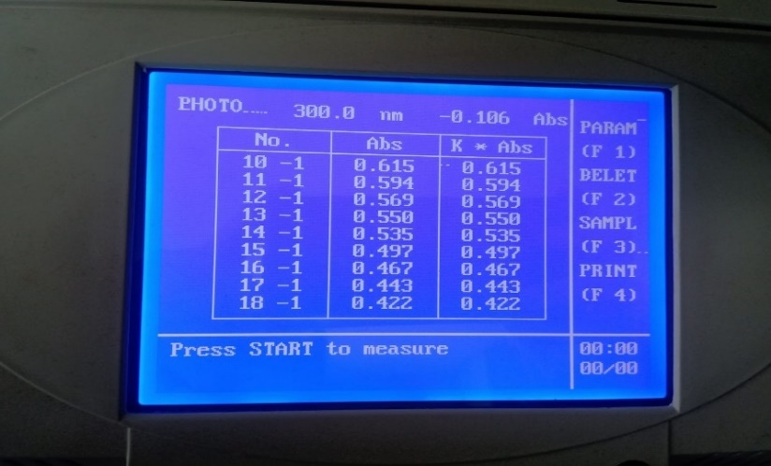

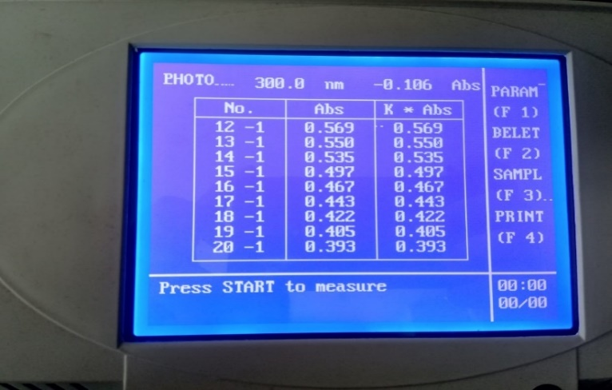

**Figure: Spectral analysis of Amoxicillin with CaCO₃ determination by UV spectrophotometer.**

EFFECT OF ANTACIDS ON AMOXICILLIN BY JOB’S METHOD OF CONTINUOUS VARIATION

By using Job's method of continuous variation, the molar ratios of the complexes of amoxicillin with antacids were estimated. The reported absorbance values were measured at 256 nm with a range of Amoxicillin concentrations (1×10 ̄ ⁵ to 9×10 ̄ ⁵M) and antacids. The absorbance difference against the drug's mole fraction was plotted to produce the Job's plots at pH 7.4, which are shown in the following table:

**Values of job plot of Amoxicillin and Mg(OH)₂**

*Figure: Absorbance difference of Amoxicillin with Magnesium hydroxide, Mg(OH)₂.*

|  |  |  |  |  |  |
| --- | --- | --- | --- | --- | --- |
| **Concentration of Amoxicillin**  **M×10 ̄ ⁵** | **Absorbance of Amoxicillin**  **A** | **Concentration of Mg(OH)₂**  **M×10 ̄ ⁵** | **Absorbance of Mg(OH)₂**  **B** | **Absorbance of mixture**  **C** | **Absorbance difference**  **D=(A+B)-C** |
| 1 | 0.495 | 9 | 0.675 | 0.705 | 0.465 |
| 2 | 0.498 | 8 | 0.685 | 0.711 | 0.472 |
| 3 | 0.508 | 7 | 0.673 | 0.692 | 0.489 |
| 4 | 0.510 | 6 | 0.673 | 0.688 | 0.495 |
| 5 | 0.523 | 5 | 0.680 | 0.700 | 0.503 |
| 6 | 0.540 | 4 | 0.681 | 0.724 | 0.497 |
| 7 | 0.531 | 3 | 0.685 | 0.755 | 0.461 |
| 8 | 0.533 | 2 | 0.692 | 0.747 | 0.478 |
| 9 | 0.541 | 1 | 0.694 | 0.751 | 0.484 |

The given figure demonstrates how Amoxicillin and Magnesium hydroxide mix to form potent 1:1 complexes, which are represented by the‘^’ shaped curve.

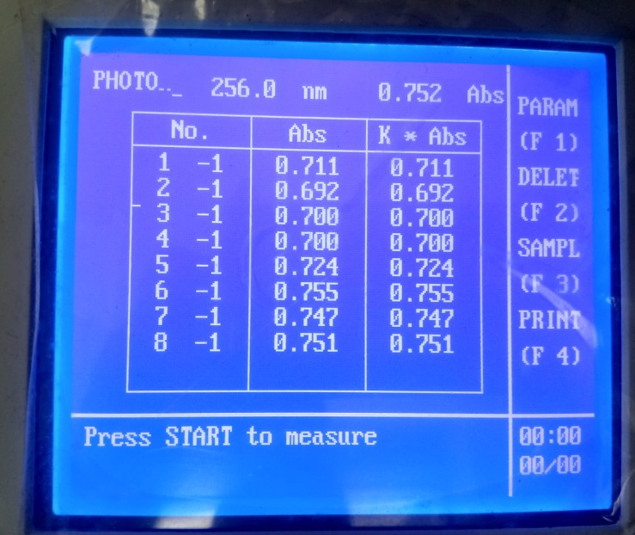

Figure: Determination ofabsorbance of mixture of Amoxicillin and Mg(OH)₂ by UV spectrophotometer.

|  |  |  |  |  |  |
| --- | --- | --- | --- | --- | --- |
| **Concentration of amoxicillin M×10 ̄ ⁵** | **Absorbance of Amoxicillin**  **A** | **Concentration of CaCO₃**  **M×10 ̄ ⁵** | **Absorbance of CaCO₃**  **B** | **Absorbance of mixture**  **C** | **Absorbance difference**  **D=(A+B)-C** |
| 1 | 0.495 | 9 | 0.778 | 0.807 | 0.466 |
| 2 | 0.498 | 8 | 0.785 | 0.790 | 0.493 |
| 3 | 0.508 | 7 | 0.804 | 0.817 | 0.495 |
| 4 | 0.510 | 6 | 0.813 | 0.804 | 0.519 |
| 5 | 0.523 | 5 | 0.840 | 0.806 | 0.557 |
| 6 | 0.540 | 4 | 0.835 | 0.839 | 0.536 |
| 7 | 0.531 | 3 | 0.822 | 0.865 | 0.488 |
| 8 | 0.533 | 2 | 0.841 | 0.891 | 0.483 |
| 9 | 0.541 | 1 | 0.862 | 0.849 | 0.554 |

Values of job plot of Amoxicillin and CaCO₃

*Figure: Absorbance difference of Amoxicillin with Calcium carbonate, CaCO₃.*

From the above image, we can see that amoxicillin and calcium carbonate combine to produce powerful 1:1 complexes, which are shown as ‘^’shaped curve.

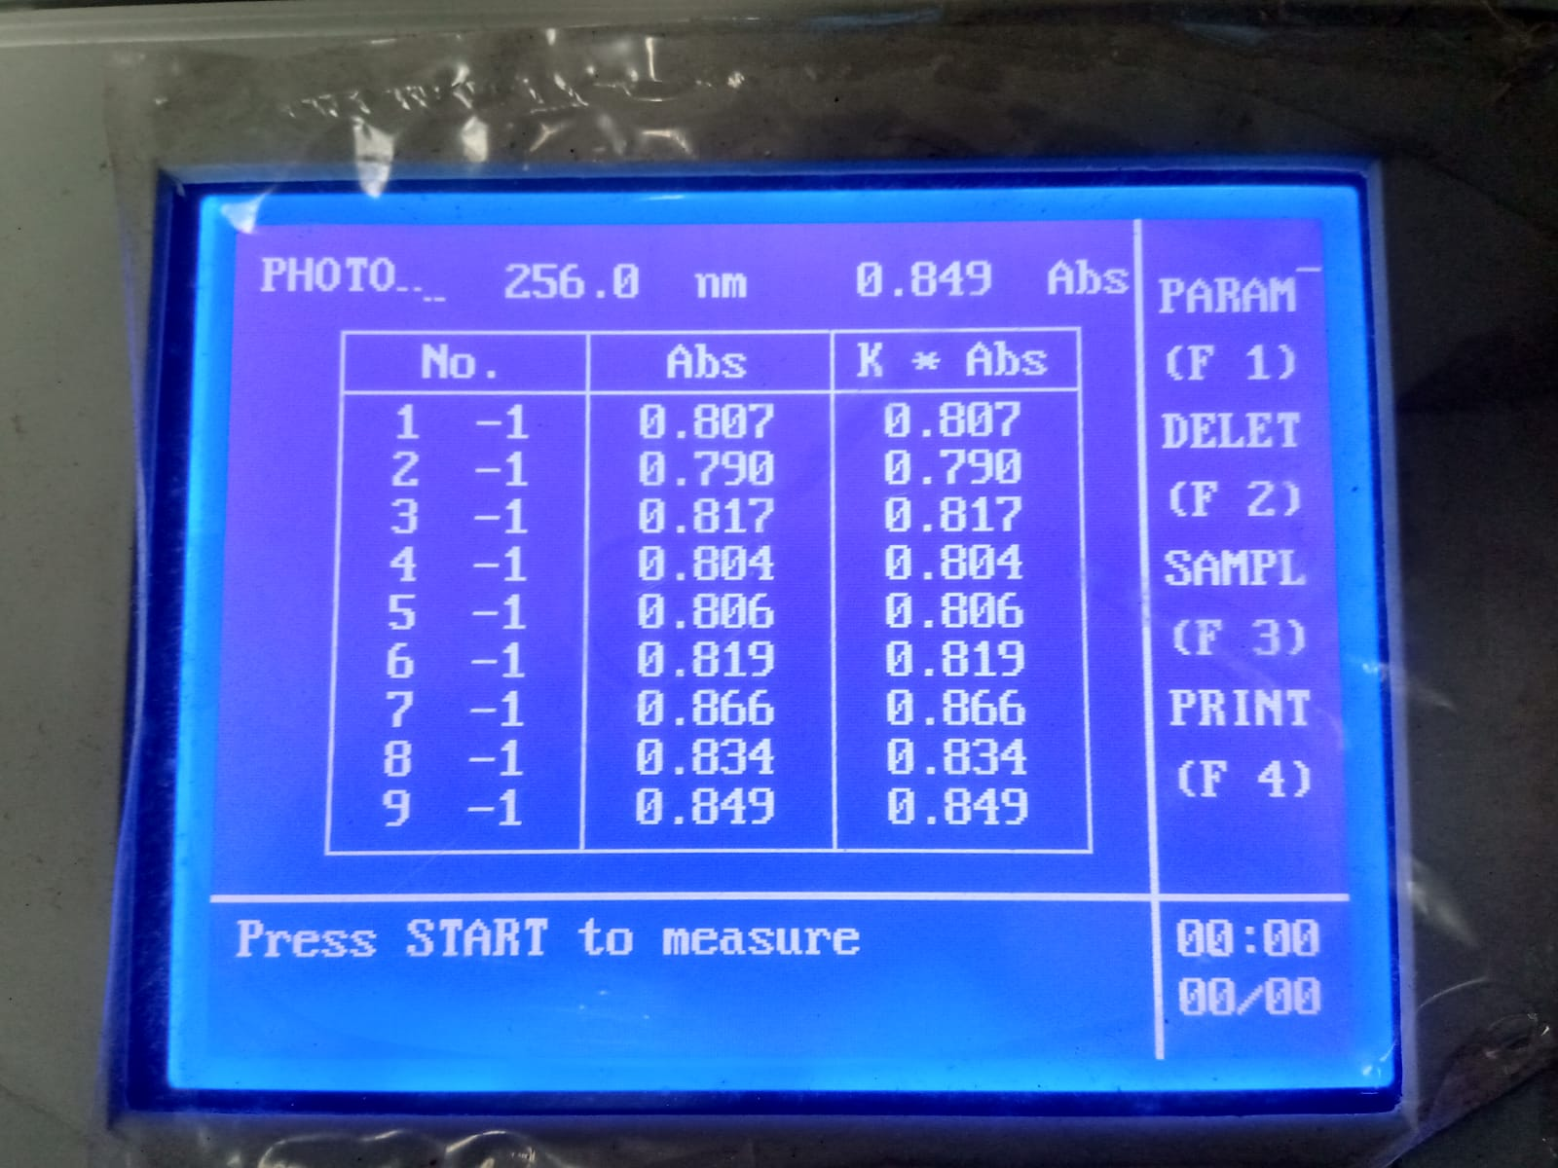

Figure: Determination of absorbance of mixture of Amoxicillin and CaCO₃ by UV spectrophotometer.

COMBINED ABSORBANCE DIFFERENCE OF DRUG WITH DIFFERENT ANTACID

|  |  |
| --- | --- |
| Amoxicillin + Mg(OH)₂ | Amoxicillin + CaCO₃ |
| 0.465 | 0.466 |
| 0.472 | 0.493 |
| 0.489 | 0.495 |
| 0.495 | 0.519 |
| 0.503 | 0.557 |
| 0.497 | 0.536 |
| 0.461 | 0.488 |
| 0.478 | 0.483 |
| 0.484 | 0.554 |

|  |  |  |
| --- | --- | --- |
| **Amoxicillin** | **Amoxicillin+Mg(OH)₂** | **Amoxicillin+CaCO₃** |
| 0.495 | 0.465 | 0.466 |
| 0.498 | 0.472 | 0.493 |
| 0.508 | 0.489 | 0.495 |
| 0.510 | 0.495 | 0.519 |
| 0.523 | 0.503 | 0.557 |
| 0.540 | 0.497 | 0.536 |
| 0.531 | 0.461 | 0.488 |
| 0.533 | 0.478 | 0.483 |
| 0.541 | 0.484 | 0.554 |

***Figure: Combined absorbance difference of drug with different antacid.***

The figure above displays how the absorbance difference between Amoxicillin and Mg(OH)₂ and Amoxicillin and CaCO₃ are dissimilar from one another.

|  |  |  |
| --- | --- | --- |
| Bacteria used | Standard disk ( zone of inhibition/mm) | Sample disk ( zone of inhibition) |
| *Staphylococcus aureus* | 16 mm | Amoxicillin |
| 15 mm |
| *Staphylococcus aureus* | 16 mm | Amoxicillin+ Mg(OH)2 |
| 11 mm |
| *Staphylococcus aureus* | 16mm | Amoxicillin+ CaCO₃ |
| 9mm |

**ABSORBANCE OF DRUG AND COMBINED ABSORBANCE DIFFERENCE OF DRUG WITH DIFFERENT ANTACIDS**

*Figure: Combined absorbance of drug with different antacid.*

The illustration above demonstrates how Amoxicillin absorbance varies from Amoxicillin absorbances when combined with Mg(OH)₂ and CaCO₃.

ANTIMICROBIAL STUDY

*Staphylococcus aureus* was used to test the test samples. *Staphylococcus aureus* was tested against the common amoxicillin disk as well. Table 1 displays the results of the antibacterial activity, assessed as the diameter of the zone of inhibition in mm.

**ACTIVITY AGAINST GRAM POSITIVE BACTERIA**

|  |  |  |
| --- | --- | --- |
| Bacteria used | Standard disk ( zone of inhibition/mm) | Sample disk ( zone of inhibition) |
| *Escherichia coli* | 6 mm | Amoxicillin |
| 6 mm |
| *Escherichia coli* | 6 mm | Amoxicillin+ Mg(OH)2 |
| 6 mm |
| *Escherichia coli* | 6mm | Amoxicillin+ CaCO₃ |
| 6mm |

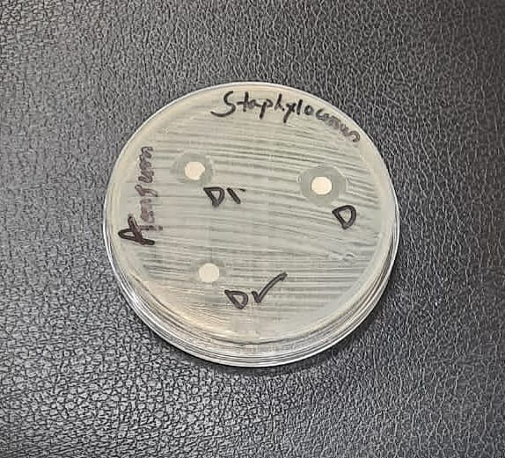

Figure: Amoxicillin was tested for antimicrobial sensitivity against *Staphylococcus aureus* after interacting with a Mg(OH)₂ solution and a CaCO₃ solution, respectively.

Here, D= Antibiotic solution (AMOXICILLIN).

D₁=Antacid solution-1…………..Mg(OH)2

D₂= Antacid solution-2……………CaCO₃.

ACTIVITY AGAINST GRAM NEGATIVE BACTERIA

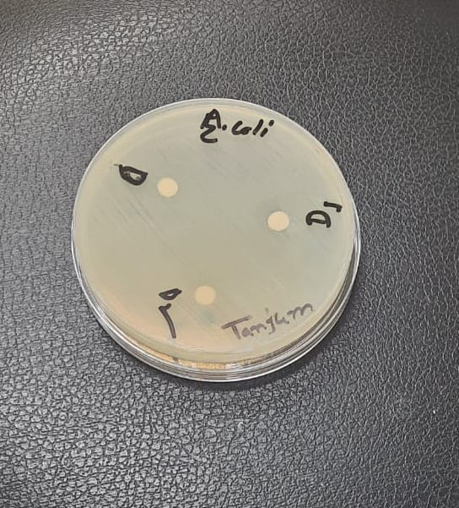

**Figure: Following interactions with Mg(OH)₂ and CaCO₃ solutions, Amoxicillin was tested for antimicrobial sensitivity against *Escherichia coli* respectively.**

Here, D= Antibiotic solution (AMOXICILLIN).

D₁=Antacid solution-1…………..Mg(OH)2

D₂= Antacid solution-2……………CaCO₃.

**Conclusion**

Penicillin-type medications were a significant advance in medicine at the time and are still in use today. Although Amoxicillin is a reliable and inexpensive antibiotic, not all infections respond well to it. It is a potent broad-spectrum antibiotic that works well for treating bacterial infections in general and pediatric bacterial pneumonia in particular. Antacids are simple compounds that, when consumed, react with stomach acid and reduce the acidity of the stomach's contents. They are mostly used to treat hyperchlorhydria and peptic ulcer. Antacids that contain calcium or magnesium are more widely used by consumers than H2-antagonists or proton pump inhibitors. Mg(OH)₂ is used to treat indigestion, heartburn, and other symptoms brought on by having too much stomach acid. It is an antacid that lessens the stomach's acid production. Many commercial antacid formulas contain calcium, either as carbonate or chloride. Patients with osteoporosis or other bone-related illnesses frequently take calcium carbonate tablets or supplements as part of their treatment regimens. Present work describesAmoxicillin, a significant antibiotic medication, interacts with Magnesium hydroxide and Calcium carbonate at a pH of 7.4 using a range of physical techniques, including spectrum behavior analysis and Job's method of continuous variation.According to spectral analysis, amoxicillin exhibits a distinct peak at 256 nm. When Amoxicillinis treated in a 1:1 ratio with Magnesium hydroxide and Calcium carbonate, the strength of the peak varies noticeably (absorbance decreases), altering the absorption properties due to the interaction but not altering the compound's position.An agent must undergo antimicrobial screening to determine its range of activity against different kinds of pathogenic organisms. Numerous methods exist for determining an organism's sensitivity to antimicrobial compounds in vitro, however the disk diffusion method, which uses various concentrations of the agents absorbed on filter paper disks, is generally accepted for the initial assessment of antimicrobial activity [10].Amoxicillin produces potent 1:1 complexes at pH 7.4 with magnesium hydroxide and calcium carbonate, which are represented as‘^’shaped curves.Antimicrobial testing against gram positive bacteria revealed that it was confirmed that the zone of inhibition of Amoxicillin with Mg(OH)₂ (Antacid-1) and CaCO₃ (Antacid-2) lowered from 15 mm, 11 mm and 9 mm respectively. And also the activity against gram negative bacteria, Amoxicillin with Mg(OH)₂ and CaCO₃ donot show any recordable antimicrobial effect. We are aware that the drug's availability corresponds to its quantity or concentration. It aids in the research of choosing the most effective dosage type for treatment. Furthermore, it is crucial to modify the effective dose and dose ranges.

**References**

[1] Chou TC. Theoretical basis, experimental design and computerized simulation of synergism and antagonism in drug combination studies. Pharmacological reviews.2006 Sep 1;58(3):621-81.

[2] M.N. Prichard and C. Shipman, “ A three-dimensional model to analyze drug-drug interactions.” Antiviral Research, vol `14, issue 4-5, pp, 181-205, 1990.

[3] Aronson, J. K. (2004), Drug interactions—information, education, and the *British NationalFormulary*. British Journal of Clinical Pharmacology, 57: 371–372.[cited 1 october 2017] Available at: <http://onlinelibrary.wiley.com/doi/10.1111/j.1365-2125.2004.02125.x/full>

[4] E.Bergogne, N Lambert, J.L Rouvillosis, (1973) ‘Antibacterial activity and clinical effectiveness of cephradine’ International journal of experiment and clinical chemotherapy, vol 18, p 191-204.

[5] MD K, A. MD E, M. MD R. Principles of Clinically Important Drug Interactions. *Journal of Clinical Psychopharmacology* [Internet]. 1991 [cited 2 October 2017];Volume 11(3):ppg 198-202. Available from: <http://journals.lww.com/psychopharmacology/citation/1991/06000/principles_of_clinically_important_drug.9.as>

[6] S.M. Moazzem hossen, Md. Raihan Sarkar, Md. Shohidul Islam, Abanti barua, Mohammad Kamal Hossain, Mohammad Kamal Hossain, Md. Sahamir Hossain (2012) “In vitro interaction study of cephradine with different essential mineral salts and its influence on antimicrobial activity (MIC) of cephradine” International journal of pharmaceutical and life sciences, vol 1, pp 220-230.

[7] Van Loosdrecht MC, LyKlema J, Norde W, Zehnder AJ. *Influence of interfaces on microbial activity.* Microbiological reviews. 1990 Mar 1;54 (1):75-87.

[8] MD. Shohidul Islam and Nobina Akter, “In-vitro interaction of cefpodoximeproxeti with different essential metals, antacids and investigation of antimicrobial activity”. International Research Journal of Pharmacy and Medical Sciences (IRJPMS) 2 (1): 70-75.

[9] MD. Shohidul Islam and Pinkey Ghose, “Ceftriaxone with Antacid and Metal Complexation and Investigation of Antimicrobial Activity, In-vitro demonstration”. International Research Journal of Pharmacy and Medical Sciences (IRJPMS) ISSN (Online): 2581-3277.

[10] Jinnat Begam Tumpa and Md Shahidul Islam, “Antibiotic with essential metals complexation and interaction, An In-vitro study by Spectrophotometric method”. American Journal of Biomedical Science and Research, [www.biomedgrid.com](http://www.biomedgrid.com), ISSN: 2642-1747.