**Original Research Article**

**Anti-dyslipidaemia and Cardio-protective Effects of Nigerian Bitter Honey in Streptozotocin Induced Diabetic Rats**

**ABSTRACT**

**Background and Aim:**Chronic hyperglycemia, oxidative stress, and dyslipidemia usually predispose to cardiac aberrations. Certain honey samples have been reported to worsen glycemic control or proven to be cardiotoxic. The study sought to elucidate the roles of Nigerian bitter honey in experimental diabetes.

**Experimental Procedures:**Diabetes was induced in adult female Wistar rats (90 – 110g) by intraperitoneal administration ofstreptozotocin (65 mg/kg body weight). Rats were randomly allocated into six groups (n= 8). Bitter honey(50 mg/kg)and metformin (100 mg/kg)were orally administered daily for 28 days. On day 29, animals were sacrificed and blood samples were obtained via cardiac puncture. Lipid profile and lipid peroxidation analysis were carried out using standard methods. Atherogenic, coronary, and cardiovascular risk indexes were calculated. Heart, pancreas, and lung tissues were harvested and subjected to histopathological assessment. Data were expressed as mean ± standard error of mean and analyzed using ANOVA, at p < 0.05 level of significance.

**Result and Discussion:**Bitter honey treatment in the diabetic animals significantly (p < 0.05) reduced hyperglycemia,triglyceride, total cholesterol, low-density lipoprotein, malondialdehyde, and cardiovascular risk levels. Correspondingly, HDL and reduced glutathione levels were significantly (p < 0.05) higher. Bitter honey preserved the histoarchitectural integrity of the cardiomyocytes and lungs tissue.

**Conclusion:**The bitter honey is a highly remarkable repository of naturally occurring bioactive compounds that can potentially modulate downstream biochemical pathways of hyperglycemia, dyslipidemia and lipid peroxidation. The bitter honey may therefore be a promising new source of anti-diabetic and cardio protective nutraceuticals.

**Key Words:** Diabetes, Bitter Honey, Dyslipidemia, Metformin, Cardiovascular risk.

**INTRODUCTION**

Dyslipidemia is a long-term pathological consequence of type 1 diabetes mellitus (T1DM) and an independent risk dynamic of type 2 diabetes mellitus (T2DM).1Incidences of TIDM are a function of insulin deficiency, thereby plummeting glucose accessibility and utilization, subjecting the blood to the pathologically relevant pattern of lipid parameters.2 Invariably, hyperglycemia-induced dyslipidemia is originated. In contrast, induction of T2DM is preceded by a buildup of circulating free fatty acids to a concentration that is high enough to precipitate insulin insensitivity.3 In fact, a high-fat diet has been used to induce experimental models of T2DM, a model of hyperlipidemia-induced hyperglycemia.4 In a country analysis of Africa and the Middle East Cardiovascular Epidemiological (ACE) study conducted in Nigeria, the prevalence of dyslipidemia was found to be 68%.5Progression of dyslipidemia in any type of diabetes mellitus can spawn a chain of redox reactions which may extort endogenous antioxidant defense mechanisms.6Except an ideal intervention is ensured, the structural and functional integrity of the vasculature will always be at risk of oxidative attack from metabolic by-products of lipid peroxidation.7Consequently, progressive oxidative attack to membrane lipid molecules may deteriorate the functional integrity of the endothelial vasculature.8In return, the complex cascade mechanism can be an underlying predisposing factor for the development of atherogenic plaques9.Sadly, this can further deteriorate to coronary and cardiovascular complications.10

Natural supplements are well reputed for modulating distinct pathways of disease initiation and progression.11Honey is a natural medium for conserving plant – based bioactive compounds.Distinctively, the sensory properties and medicinal significance of honey varies widely from one geo-botanical origin to the other. Due to the heterogeneity of distinctive bioactive compounds in honey, it therefore represents a grand mix of high profiled phytoconstituents that may potentially interact with multiple indices of disease initiation and progression. Notwithstanding honey is a highly reputed nutritional supplement, especially for its prophylactic and curative efficacy. With adequate knowledge of the indigenous plants constituting its primary geo-botanical source, honey can function to alleviate or modulate many of the symptoms associated with changes in both physiologic and pathologic states.12 Therefore, honey can alter the course of various diseases. Depending on the plant basis of its bioactivity, honey supplementation in the diabetic state may likely be a double-edged sword, aside being of no effect at all. For instance, auniflora bitter (mad) honey from Turkey was reported to be cardiotoxic.13,14,15 However, it is not known whether all bitter honeys can predispose to cardiac aberrations irrespective of their botanical source. Also, supplementation with an Egyptian honey has been reported to increase glycosylated hemoglobin among diabetic subjects.16These scientific findings are generating confusions and controversies concerning the suitability of honey as an ideal functional food for diabetics.17Besides, the scientific basis behind the wide variations in the therapeutic value of honey is poorly explored.

In our previous study18, we have earlier reported the botanical markers, phytochemical, proximate and elemental compositions of the bitter honey used for this study. Also, the protective effect of the bitter honey on animal models of hepatic and renal damage has been documented.19Meanwhile, some of its plant precursors are reputed as having hypolipidemic and cardioprotective properties. Yet, there is a paucity of data concerning the reproducibility of these nutritional benefits in a bitter honey sample cultivated from those medicinal plants. Therefore, this study sought to explore the roles of a Nigerian bitter honey on indices of hyperglycemia, hyperlipidemia and cardiovascular dysfunctions in animal models of diabetes.

**MATERIALS AND METHODS**

***Sourcing of Bitter Honey and other Materials***

Bitter Honey (BH) was sourced from Community Lifestyle Improvement Project (CLIP) farm (CRBN: 0953750) into an airtight container. The farm is located at Modakeke (7° 27' 19.6704'' North and 4° 32' 39.8112'' East) South-Western Nigeria. The BH was freshly diluted with distilled water before each administration.Streptozotocin was obtained from Sigma – Aldrich (MO, USA), while other reagents or kits were obtained from either British Drug House (Poole, England) or Randox laboratory (Aldren, USA).

***Animal Use and Care***

Female rats (90 – 110 g) of Wistar strain were acquired from the animal house of Faculty of Pharmacy, Obafemi Awolowo University (OAU), Ile-Ife. The animals were kept in well-ventilated plastic rat cages (Mediwise animal cage, 430 × 270 × 15 mm) and a 12-h day/night cycle was maintained. The animals were given standard laboratory pellet (grower’s mash) and water*ad libitum*. Ethical approval for the study was obtained from Osun State Health Research Ethics Committee (OSHREC) with clearance number OSHREC/PRS/569T/158. All animals received humane care in accordance with the principle of Laboratory Animal care of the National Society of Medical Research and Guide for the care and use of Laboratory Animals of the National Academy of Sciences (National Institutes of Health Publication no. 80-23).19

***Induction of Diabetes***

Diabetes Mellitus (DM) was induced by a single intraperitoneal (i.p) administration of 65 mg/kg body weight of STZ. Before this, the rats were fasted overnight for about 14 hours. The development of hyperglycemia was confirmed after 72 hour (using blood obtained from the tail vein). Animals with fasting blood glucose levels ≥ 250 mg/dL were considered diabetic.

***Experimental Design***

Rats were randomly allocated into treatment groups (n = 8) as follows: Group A (non-diabetic control) and group C (diabetic control) were administered 2 ml/kg distilled water daily for 28 days. Group B (non-diabetic BH-supplement) and group D (diabetic BH) were administered 50 ml/kg BH daily for 28 days. To examine BH ability to prevent induction of diabetes, Group E rats were pretreated with 50 ml/kg BH for 28 days, followed by administration of single dose of STZ (65 mg/kg). Group F (diabetic Metformin) rats were administered 100 mg/kg metformin daily for 28 days. All dosage administrations were done orally.A dose of 50 mg/kg body weight of 20% BH was chosen based on the report ofÖztaşan*et al.,* 2005. 20 Fasting blood glucose (FBG) concentration (mg/dL) was determined at baseline (using blood obtained from tail vein) and then on weekly basis using a portable Accu-Chek glucometer (Roche, Germany).

***Sample collection and preparation***

Fasting blood glucose was determined on weekly basis using the tail blood sample.Following the last treatment on day 28, rats were fasted overnight (14 hours), and FBG was determined.For the pretreatment group, FBG was also measured weekly until the 28th day and then 72 hours post STZ administration. Rats were theneuthanized under mild diethyl ether in a tightly covered glass jar. Blood samples were collected by cardiac puncture into sample bottles without anticoagulant. The blood samples were allowed to clot at room temperature for about 45 minutes, centrifuged at 1500 × g for 10 minutes, and the supernatants (sera) were collected and stored at -200 C until required for analysis.

***Lipid profile analysis***

Total cholesterol (TC), triglyceride (TG), and high-density lipoprotein (HDL) were determined enzymatically using assay kits (Randox laboratory, Aldren, USA) in line with the manufacturer’s protocols. Low-density lipoprotein (LDL), and very-low-density lipoprotein (VLDL)were estimated using Friedwald equation. 21

***2.7Estimation of Atherogenic index, Coronary risk index, and Cardiovascular risk index***

The atherogenic index (AI), coronary risk index (CRI), and cardiovascular risk index (CVRI) were determined using the equations below as earlier described. 21

***Lipidperoxidation assay***

Glutathione (GSH) and malondialdehyde (MDA) were measured by standard methods as earlier described.22

***Histopathological Analysis***

The heart, pancreas and lungs were excised, weighed, and fixed in 10% formal saline and processed routinely for paraffin embedding. Micro sections (5µ) of the tissues were obtained with a rotatory microtome and processed using Haematoxylin and Eosin (H & E) staining technique.Not less than three specimen per sample were processed and slides were viewed under a light microscope with photomicrographs taken with a Leica DM750 Camera Microscope (× 400), as earlierdescribed.23

***Statistical Analyses***

Quantitative data were presented as mean ± standard error of mean (SEM) and analyzed using one-way analysis of variance (ANOVA) on GraphPad prism (version 8.0). Post hoc analysis was carried out using Student Neuman – Keuls test and p < 0.05 was considered significant.

**RESULTS**

***Effect of Bitter Honey on Blood Glucose***

As shown in Table 1, significant differences in fasting blood glucose levels were observed when the experimental groups were compared (p<0.05). Treatment with 50 mg/kg b.w.of 20% BH significantly lowered blood glucose level (242.83 ± 0.87 mg/dL)when compared with the diabetic control (DC) group (337.08 ± 1.34 mg/dL). Also, FBG was significantly higher in the pre-treatment group (191.3 ± 1.04mg/dL) relative to the non-diabetic group (62.73 ± 6.13 mg/dL). Meanwhile, metformin (124.2 ± 0.53) treatment also achieved significant reduction in the FBG.

***Effect of Bitter Honey on Dyslipidaemia***

The effect of bitter honey supplementation on lipid profile parameters are shown in Table 1. Triglyceride level was significantly lower (p<0.05) among the BH supplemented (BH_s), BH treated (BH_t) and BH pre-treated (BH_p) groups relative to the diabetic control (DC) and metformin-treated groups. Total cholesterol was significantly lower (p<0.05) in the bitter honey treated group compared with the diabetic untreated group. High density lipoprotein cholesterol level was significantly higher (p<0.05) in BH treated (BH_t) and BH pre-treated (BH_p)and BH-supplemented (BH_s) groups compared with diabetic control (DC) and metformin treated groups. In addition, LDL-C and VLDL-C were significantly low (p<0.05) in bitter honey treated (BH_t) group relative to both diabetic control (DC)and the metformin-treated groups.

***Effect of Bitter Honey on Lipid Peroxidation***

Inter-group comparison of concentrations of reduced glutathione (GSH) and malondialdehyde (MDA) revealed significant differences among the various groups. The Diabetic control (DC) group showed significantly lower (P<0.05) concentrations of GSH and a corresponding increase in MDA compared with other groups. Similar to the non – diabetic group, the BH_s, BH_t, BH_p and metformin treated groups had a significantly (p<0.05)increased concentration of GSH and a corresponding low MDA level in relation with the diabetic control (DC) groups.

***Effects of Bitter Honey on Cardiovascular, Coronary and Atherogenic risk Index***

As shown in Figure 1,the diabetic control group presented with significantly elevated cardiovascular risk index (CVRI), coronary risk index (CRI), and atherogenic index (AI). Whereas, the BH – supplemented (BH_s), BH-treated (BH_t), BH - pretreated (BH_p) and metformin treatment groups had significantly lower (p< 0.05) CVRI, CRI and AI relative to the diabetic control (DC) group.

***Histological Assessment of Heart, Pancreas and Lungs***

The diabetic untreated and metformin treated rats had distorted cardiac tissues, unlike the bitter honey treated rat which had a well preserved cardiac histoarchitectureSection shows that the bitter honey treated group (D) had a well - preserved myocardia histoarchitecture similar to the non-diabetic group. Whereas the diabetic untreated and metformin treated groups had cardiac muscles which presented with mild infiltrations of inflammatory cells (arrow head) as well as perivascular inflammatory cells infiltration (circle)(Plate 1). There was no pathological observation in the lung tissue of all the experimental groups (Plate 2). There was no morphological distinction in the pancreatic tissue sections (Plate 3) of all the experiment animals.

**Table 1: Effect of Bitter Honey on Blood Glucose, Lipid Profile and Markers of Oxidative Stress**

|  |  |  |  |  |  |  |  |  |
| --- | --- | --- | --- | --- | --- | --- | --- | --- |
| **Group** | **FBG (mg/dl)** | **TG**  **(mmol/L)** | **TC**  **(mmol/L)** | **HDL – C**  **(mmol/L)** | **LDL – C**  **(mmol/L)** | **VLDL – C**  **(mmol/L)** | **GSH**  **(µmol/L)** | **MDA**  **(µmol/L)** |
| ND | 62.73 ± 0.59* | 0.75 ± 0.50 | 5.02 ± 0.05 | 2.89 ± 0.19 | 2.28 ± 0.24 | 0.15 ± 0.01 | 0.23 ± 0.01* | 3.14 ± 0.58* |
| BH_s | 63.68 ± 0.70 | 1.14 ± 0.02§* | 5.01 ± 0.16* | 7.10 ± 0.18‡ | 1.86 ± 0.17* | 0.23 ± 0.005* | 0.44 ± 0.02* | 3.89 ± 0.57 *.20 * |
| DC | 337.08 ± 1.34§ | 2.53 ± 0.02 | 8.17 ± 0.04 | 1.13 ± 0.14 | 7.55 ± 0.13 | 0.51 ± 0.004 | 0.04 ± 0.007 | 8.48 ± 0.54 |
| BH_t | 242.83 ± 0.87§* | 1.09 ± 0.03§* | 5.47 ± 0.10* | 3.42 ± 0.22‡ | 2.27 ± 0.21* | 0.22 ± 0.006* | 0.41 ± 0.01* | 4.47 ± 0.20* |
| BH_p | 191.3 ± 1.04§* | 1.14 ± 0.08§* | 5.33 ± 0.13* | 5.41 ± 0.27‡ | 0.15 ± 0.27* | 0.23 ± 0.016* | 0.38 ± 0.01* | 5.14 ± 0.15* |
| Metformin | 124.2 ± 0.53§* | 1.79 ± 0.04§* | 6.09 ± 0.15* | 1.41 ± 0.14‡ | 5.04 ± 0.17* | 0.36 ± 0.007* | 0.33 ± 0.01* | 3.83 ± 0.41* |

ND, Non-diabetic control;BH_t, Bitter Honey treated; DC, Diabetic control; BH_s, BH Supplemented; BH_p, BH Pre-treatment; TG, Triglyceride; TC, Total Cholesterol; HDL-C, High Density Lipoprotein Cholesterol; LDL-C, Low Density Lipoprotein Cholesterol; VLDL-C, Very Low-Density Lipoprotein Cholesterol; GSH, Glutathione; MDA, Malondialdehyde; FBG, Fasting blood glucose (24 hour after last treatment).

Results were presented as mean ± SEM.

* Values are significantly lower (p < 0.05) compared to diabetic control.

‡ Values are significantly higher (p < 0.05) compared to diabetic control.

§ Values are statistically significant (p < 0.05) compared to non - diabetic control.



**Figure 1: Effect of bitter honey on a cardiovascular risk, coronary risk, and atherogenic index**. BH, Bitter Honey. Value is significantly higher ( * p<0.05) than non – diabetic control, BH supplemented, BH treated, BH pretreated and Metformin treated groups.

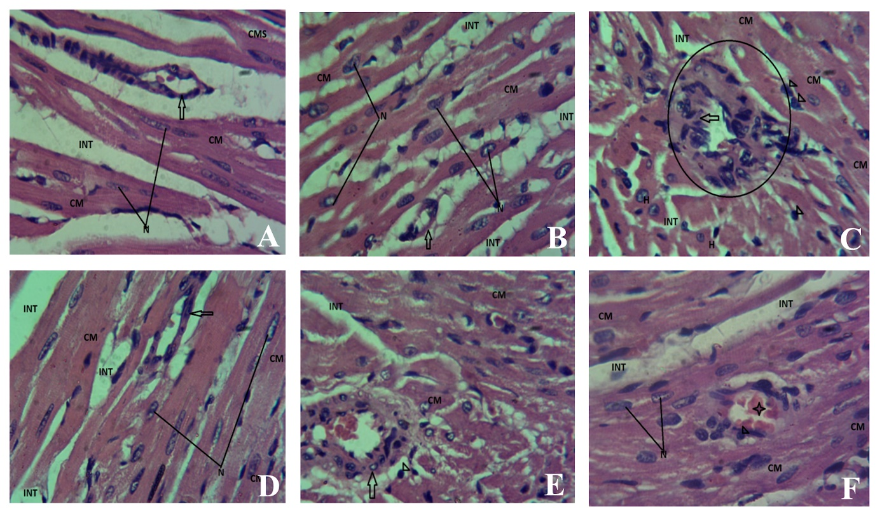

**Plate 1: Representative light photomicrograph of the heart** (× 400).

Abbreviation: Cardiac muscle (CM), Nucleus (N), Interstitium (INT). The Bitter honey pretreated (E) and metformin-treated (F) groups had cardiac tissue disorganization similar to the diabetic untreated group (C). Stain:Haematoxylin and Eosin stain.

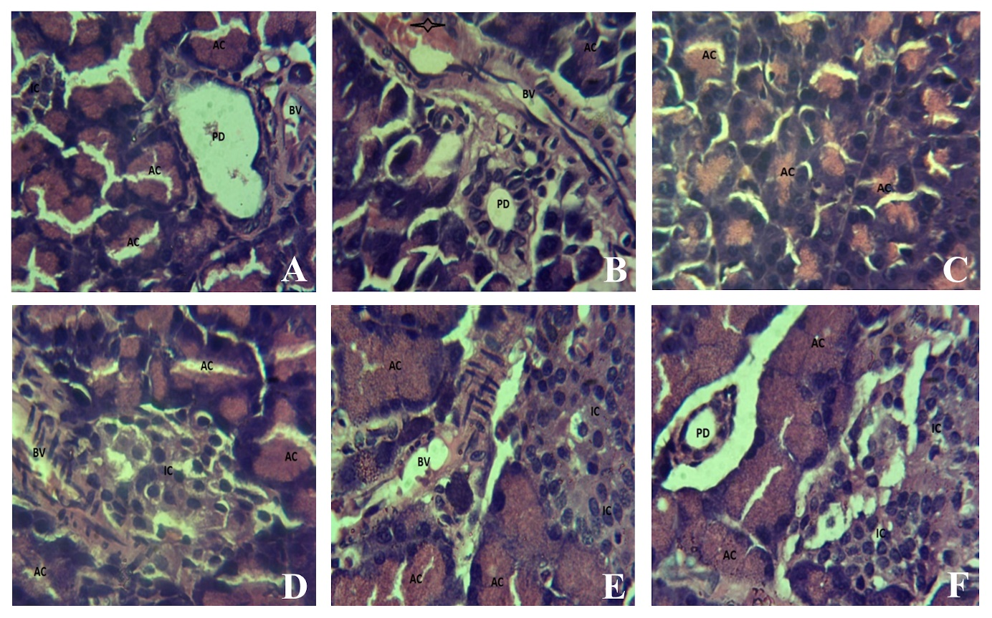

**Plate 2: Representative light photomicrograph of the pancreas** (× 400). The section shows the pancreatic tissue composed of the endocrine unit made up of the islet cells (IC) and the exocrine unit made up of the acinar cells. Branches of the Pancreatic Ducts (PD) and blood vessels (BV) appear normal across all groups. Their cells types and distribution appeared unremarkable.

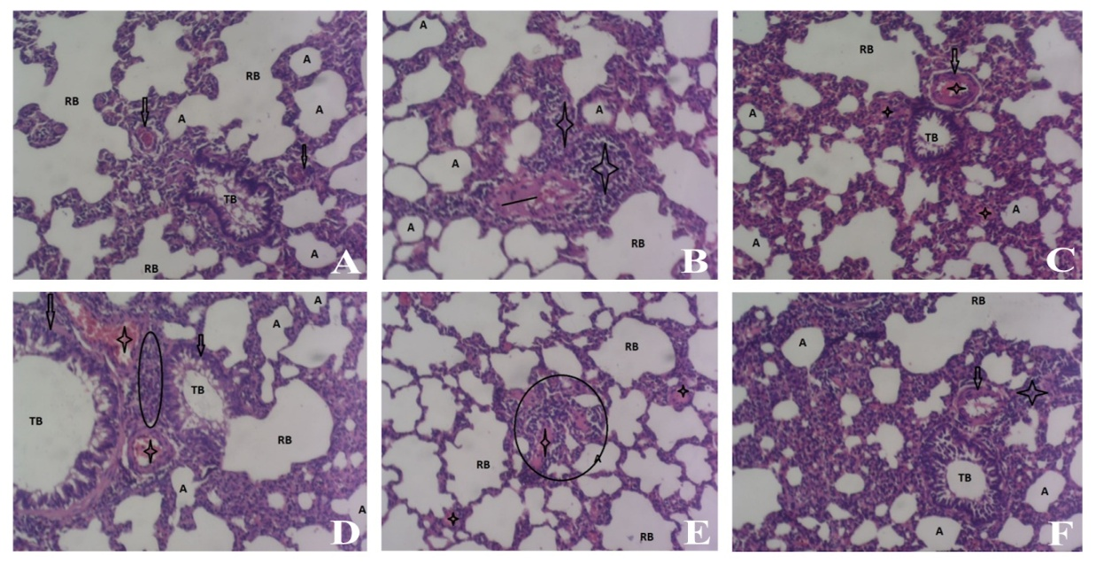

**Plate 3: Representative light photomicrograph of the lungs** (x 400).

Abbreviation: Alveoli (A); Terminal Bronchi (TB) and Respiratory bronchi (RB).

**DISCUSSION**

Dyslipidemia is a life - threatening metabolic condition with numerous etiologies. Independently, dyslipidemia is often implicated as a key player in several downstream metabolic pathways pertaining to metabolic syndrome. Essentially, dyslipidemia can precipitate progressive redox imbalance and a build - up of atherosclerotic plaques in the endothelial vasculature,thereby eliciting a compromised histoarchitecture of the blood vessels. 24 Furthermore, dyslipidemia may alsoimpair insulin receptor signaling in such a way as to perturb the cellular uptake of glucose, typical of type II diabetes mellitus.25 In the present study, experimental diabetes mellitus was chemically induced by streptozotocin in Wistar rats. To this effect, using standard biochemical and histological methods, a Nigerian bitter honey (BH) variety was screened for its potential pharmacological properties againstclassic diabetes symptoms viz a vizhyperglycemia, oxidative stress, and cardiac tissue abberations, atherogenicity, cardiovascular and coronary indices.

Data obtained from the study showed supplementation with bitter honey among group II animals did not cause a spike in blood glucose level. This suggests an antiglycemic potential of the bitter honey.Meanwhile, treatment of diabetic rats with BH (50 mg/kg BW of 20% BH) for 28 days significantly (p <0.05) reduced blood glucose level. Similar to our findings, certain honey varieties indigenous to forest zones at Oyo,26 and Delta27 states of Nigeria were reported to significantly curtail hyperglycemia within three weeks, and eightweeks respectively.In our previous study, we elucidated the botanical characteristics of the bitter honey.18Surprisingly, some of the plant precursors of the bitter honey are reputed for their glucose – lowering efficacies in experimental diabetes. Notably, plant precursors such as*Elaeisguinensis*, *Irvingiagabonensis*,*Chromolaena odorata*may possibly be the hypoglycemic determinants of the bitter honey. In addition, our previous investigation showed that the bitter honey is a potent inhibitor of pancreatic alpha – amylase enzyme.28 Distinctively, this suggests that the BH variety is a repository of important bioactive compounds which can potentially modulate specific cellular membrane mechanisms that enhances glucose clearance from the blood. Taken together, these suggests that the normoglycemic property of the bitter honey may have been elicited through multiple dimensions such as theregulation of postprandial hyperglycemia, enhanced facilitated diffusion or improved secondary active transport of glucose into the cell.

Contrary to our findings, it is worrisome that certain honey varieties from different plant precursors are reputed for worsening indices of diabetes mellitus. Typically, the outcome of a non – randomized clinical trial involving diabetic volunteers showed that intervention with Egyptian clover honey for 8 weeks and 1 year respectively, resulted in elevated glycosylated hemoglobin 16 and worsened dyslipidemia.29Unlike these findings, certain honey varieties from Indonesia 30 and Australia,31could not curtail hyperglycemia following 4 and 5 weeks of treatment respectively. The inconsistent empirical data concerning the anti-diabetic significance of honey can be attributed to the wide variations in the botanical characteristics of each honey variety.The inability of these honey samples to significantly curtail hyperglycemia may likely indicate the absence of bioactive compounds which can potentially modulate downstream biochemical pathways of glucose uptake or utilization.This shows that in as much as their native plant precursors are not the same, the inherent bioactive constituents in a honey sample may likely be quantitatively and qualitatively divergent, hence, a possible variation in their corresponding pharmacological propensities.

In the present study, STZ administration did not elicit any morphological distortion to the pancreatic islet histoarchitecture. The resultant development of dyslipidemia suggests that a non - insulin-dependent diabetes mellitus was likely induced by STZ in which case pancreatic β – cell damage was not necessarily implicated. Previous reports on the use of STZ as a diabetogenic agent are quite controversial. Apart from factors such as dosage of STZ, sex,32 Age,33 and breed 34 of experimental animals, the nutritional status of the experimental animal have also been implicated 35 as a key determinant of the type of diabetes STZ will likely induce.

Importantly, there is increasing empirical data concerning the metabolic roles of dietary fat quality and quantity in STZ induced diabetes.36 Under a metabolic condition whereby circulating free fatty acid (FFA) is relatively high in the blood, STZ administration may potentially predispose to insulin resistance 37 and consequently hyperglycemia without any adverse effect on the cellular integrity of the pancreatic islets.38

Nevertheless, dyslipidemia is a very common feature of STZ induced diabetes. Similar metabolic derangements were reproduced in this study. Abnormal lipid profile parameters were observed among the diabetic untreated rats. In tandem with the observations of some previous authors, BH supplementation normalized dyslipidemia despite not curtailing hyperglycemia. Notwithstanding, an atherogenic index value above 0.24 is strongly associated with an elevated risk of cardiovascular diseases.[32] Bitter honey supplementation significantly (p < 0.05) reduced atherogenic index, coronary and cardiovascular risk indexes. A similar result was obtained for Nigerian honey cultivated at a forest zone in Ebonyi state.39 Even when supplemented on a long-term basis, certain honey varieties remained beneficial in the diabetic state. For instance, data obtained in a clinical trial experiment conducted among type 2 diabetic subjects showed that honey supplementation for 4 months caused a significant reduction of glycated hemoglobin while also curtailing dyslipidemia.40Also, supplementation with Egyptian clover honey for 6 years was reported to curtail hypertension and stroke despite not ameliorating hyperglycemia and dyslipidemia. 41 In our previous study where we characterized the botanical origin of the bitter honey, some of its plant precursors were observed for their roles in modulating molecular pathways of dyslipidemia. These include *Irvingia gabonensis*,42*Moraceae*,43Asteracea,44*Combretaceae*,45*Blighia Sapida*,46 and *Chromolaena odorata*,47, 48e.t.c. Infact, there exist an hypolipidemic patent from *Irvingiagabonensis*.49 Since the BH was a multifloral blossom honey, it is therefore possible that the significant hypolipidemic bioactivity of the BH may have been contributed by native plants with such inherent health benefit. The combinations of such plants which constitute the geobotanical origin may therefore likely be the hypolipidemic determinants of the bitter honey.

Diabetes mellitus is an oxidative stress-related disease. Unrestricted lipid peroxidation in the endothelial vasculature can promote life - long pathological consequences on vital organs including the heart, and brain. In this study, lipid peroxidation (LPO) was more pronounced among the diabetic untreated animals, as depicted by a significantly high level of MDA and a corresponding significant (p < 0.05) reduction in glutathione (GSH) level. Notably, bitter honey treatment, unlike metformin, significantly (p < 0.05) restored the endogenous defense mechanism, GSH, against the deleterious effect of LPO. The prophylactic effect of BH against hyperglycemia-induced peroxidation of lipid molecules was equally significant among the BH pretreatment group. Interestingly, amelioration of hyperglycemia-induced oxidation of LDL has been proposed to be one of the anti - atherosclerotic mechanisms inherent in honey.50 The varied antioxidant efficacy of honey owing to its native plant precursors is currently being explored for the management of micro and macrovascular complications diseases.

Moreover, the histopathological assessment of cardiac tissues showed that the diabetic untreated group had a distorted cardiac histoarchitecture. A similar degenerative condition of the cardiac tissue was found among the metformin-treated group. However, cardiac tissue integrity was well preserved among the bitter honey-treated diabetic group, but not among the metformin-treated group. This shows that the Nigerian bitter honey used for this study contains essential cardioprotective bioactive compounds which are deficient in the standard drug metformin.The cardio - protective mechanism of the bitter honey may have been elicited by sustaining a metabolic crossfire in resistance to hyperglycemia induced oxidative attack to the endothelial vasculature and cardiac tissue compartments.Interestingly, appreciable and moderate amounts of flavonoid, cardiac glycoside, phenols and steroids have been reported to be present in the bitter honey used for this study.18Consequently, the cardio - protective efficacy may have been elicited by these inherent phytochemicals. Since plant based steroids are known to confer anti inflammation similar to glucocorticoids,50 the steroid content of the bitter honey may likely contribute to its anti-inflammatory effects. Moreover, the component sodium and potassium may have also contributed to the cardioprotective property of the bitter honey, as diabetes related hyponatremia51 and hypokalemia52are widely common.

At the dose administered, the Nigeria bitter honey used for this study did not elicit any form of toxicity to the pancreas, lungs or cardiac tissues. Unlike the uniflora bitter honey native to the black sea region of Turkey, the Nigerian bitter honey indigenous to Modakeke (7° 27' 19.6704'' North and 4° 32' 39.8112'' East) is not mad. Unfortunately, the expression of cardiotoxic grayanotoxin in Turkish bitter honey is a distinguishing feature that is peculiar to its rhododendron plant source. By implication,none of the indigenous plant constituting the botanical origin of the bitter honey used for this study is likely to synthesizecardio toxic- grayanotoxin. This shows that the variation in the botanical source of any honey is a key determinant of its nutrient quality and quantity, as well as its corresponding therapeutic significance. The cardioprotective property of our bitter honey unlike Turkish bitter honey affirms that honeys from different floral origin are not exactly alike in terms of bioactive mechanisms and corresponding pharmacological significance. Due to the indigenous plant source of their bioactive markers, each honey sample is biochemically and therapeutically distinct. Furthermore, this suggests that the potential pharmacological value of a particular honey sample may be exclusively homologous to the vegetal basis of its bioactive mechanisms. This will clarify the controversy concerning the wide variation in the pharmacological significance of honey, especially with respect to its antidiabetic properties.

**LIMITATIONS OF THE STUDY**

This study is limited to animal experimentation only and may not be directly translated to humans without further investigation. It is also limited by resources to unravel the mechanism(s) of the reported effects at cellular and molecular levels.

**CONCLUSION**

Data obtained from this study suggest that the botanical source of the bitter honey may likely have been dominated by native plants which synthesize a relatively higher amount of hypoglycemic, hypolipidemic or cardioprotective bioactive compounds. These properties suggest that the BH used for this study in combination with standard hypoglycemic agents may likely produce better treatment outcomes in the management of diabetes, dyslipidemia, and associated vascular complications. Further study is needed to evaluate the long term effect of the bitter honey treatment at varying doses, and also to characterize the actual bioactive compounds eliciting the therapeutic response.

**ACKNOWLEDGEMENT**

None

**AUTHOR’S CONTRIBUTION**

**OBA, AAI, and MOD:** Conceptualization and Project Administration. **MOD and AAI**: Validation, Method development, and Resource sourcing. **OBA, DAA, OLO, OOA, AOA, BOO, and OMO**: Performed the experiments**. OBA, AAI, OLO, OOA, OMO, and MOD**: Data analysis. **OBA**: Write initial draft of the manuscript. **OBA, DAA, OLO, OOA, AOA, BOO, OMO, AAI, and MOD:**Reviewed and edited the manuscript, and approved the final submission.

**FUNDING**

This research did not receive any specific grant from funding agencies in the public, commercial, or not-for-profit sectors.

**DECLARATION OF CONFLICT OF INTEREST**

The Authors declare no conflict of interest

**ABBREVIATIONS**

AI, Atherogenic Index; BH, Bitter Honey; CLIP, Community Lifestyle Improvement Project; CRI, Coronary Risk Index; CVRI, Cardiovascular Risk index; DM, Diabetes Mellitus; FBG, Fasting Blood Glucose; FFA, Free Fatty Acid; GSH, Glutathione; HDL, High Density Lipoprotein; LDL, Low Density Lipoprotein; LPO, Lipid Peroxidation; MDA,Malondialdehyde; STZ, Streptozotocin; T1DM, Type one diabetes mellitus; T2DM, Type two diabetes mellitus; TC, Total Cholesterol; TG, Triglyceride; VLDL, Very Low Density Lipoprotein.

**REFERENCES**

1. Tangvarasittichai S. Oxidative stress, insulin resistance, dyslipidemia and type 2 diabetes mellitus. World J of Diab. 2015;6(3):456. doi:<https://doi.org/10.4239/wjd.v6.i3.456>
2. Zhu X, Yu L, Zhou H, et al. Atherogenic index of plasma is a novel and better biomarker associated with obesity: a population-based cross-sectional study in China. Lip in Health and Dis. 2018;17(1). doi:<https://doi.org/10.1186/s12944-018-0686-8>
3. Bhowmik B, Siddiquee T, Mujumder A, et al. Serum Lipid Profile and Its Association with Diabetes and Prediabetes in a Rural Bangladeshi Population. International Journal of Env Resh and Public Health. 2018;15(9):1944. doi:<https://doi.org/10.3390/ijerph15091944>
4. Magalhães DAD, Kume WT, Correia FS, et al. High-fat diet and streptozotocin in the induction of type 2 diabetes mellitus: a new proposal. Anais da Aca Brasileira de Ciências. 2019;91(1). doi:<https://doi.org/10.1590/0001-3765201920180314>
5. Onyemelukwe GC, Ogunfowokan O, Mbakwem A, et al. Cardiovascular risk factors in adult general out-patient clinics in Nigeria: a country analysis of the Africa and Middle East Cardiovascular Epidemiological (ACE) study. Afr Health Sci. 2018;17(4):1070. doi:<https://doi.org/10.4314/ahs.v17i4.15>
6. Ito F, Sono Y, Ito T. Measurement and Clinical Significance of Lipid Peroxidation as a Biomarker of Oxidative Stress: Oxidative Stress in Diabetes, Atherosclerosis, and Chronic Inflammation. Antioxidants. 2019;8(3):72. doi:<https://doi.org/10.3390/antiox8030072>
7. Opreh OP, Adeoye BO, Giebel H, Fam SL, Adeoye AD, Saliu OA. Distribution of Diabetes Co-Morbidities and Treatment Outcome of Hypertension at a Tertiary Lifestyle Medical Centre in Ile-Ife, Osun State, Nigeria: A 5 –Year Retrospective Study. Eur J. Pharm. Med. Res. 2022;9(8):21-27.
8. Trimbake S, Chikhalikar P, Pratinidhi S. Comparative Analysis of Atherogenic Index of Plasma and Body Mass Index in Type II Diabetes Mellitus Patients. European J. Biomed and Pharm Sci. 2018;5(8):256-261.
9. Bo MS, Cheah WL, Lwin S, Moe Nwe T, Win TT, Aung M. Understanding the Relationship between Atherogenic Index of Plasma and Cardiovascular Disease Risk Factors among Staff of a University in Malaysia. J of Nutr and Metab. 2018;2018:1-6. doi:<https://doi.org/10.1155/2018/7027624>
10. Tijani SA, Akin – Akanbi BF, Adeoye BO. Differential roles of tannin – rich extract of chasmantheradependens in modulating piroxicam induced electrolyte imbalance in rats. EJPMR 2022;9(8):474-482.
11. Ahmad RS, Hussain MB, Saeed F, Waheed M, Tufail T. Phytochemistry, metabolism, and ethnomedical scenario of honey: A concurrent review. Int J of Food Prop. 2017;20(sup1):S254-S269. doi:<https://doi.org/10.1080/10942912.2017.1295257>
12. Yaylaci S, Kocayigit I, Aydin E, et al. Clinical and laboratory findings in mad honey poisoning: A single center experience. Nig J of Clin Pract. 2014;17(5):589. doi:<https://doi.org/10.4103/1119-3077.141424>
13. Tatli O. The Black Sea’s poison; Mad Honey. J of Anal Res Clin Medicine. 2017;5(1):1-3. doi:<https://doi.org/10.15171/jarcm.2017.001>
14. Cakici O. Mad Honey: Is It Useful or Dangerous. Immun Res J. 2017;1(1):5.
15. Bahrami M, Ataie-Jafari A, Hosseini S, Forouzanfar MH, Rahmani M, Pajouhi M. Effects of natural honey consumption in diabetic patients: an 8-week randomized clinical trial. Int J of Food Sci and Nutr. 2008;60(7):1-9. doi:<https://doi.org/10.1080/09637480801990389>
16. Erejuwa OO. Effect of honey in diabetes mellitus: matters arising. Journal of Diabetes &MetabcDisord. 2014;13(1):23. doi:<https://doi.org/10.1186/2251-6581-13-23>
17. Adeoye BO, Iyanda AA, Daniyan MO, Adeoye AD, Oyerinde AM, Olatinwo GO. Botanical and Bioactive Markers of Nigerian Bitter Honey. Trop J of Nat prod Res. 2022;6(11). doi:<https://doi.org/10.26538/tjnpr/v6i11.17>
18. Adeoye BO, Iyanda AA, Daniyan MO, et al. Ameliorative effects of Nigerian bitter honey on streptozotocin induced hepatorenal damage in Wistar rats. J of Krishna Ins of Med Sci Univ. 2022;11(1):65-76.
19. Öztaşan N, Altinkaynak K, Akcay F, Göçer F, Dane S. Effects of mad honey on blood glucose and lipid levels in rats with streptozocin-induced diabetes. Turkish J of Vet and Anim Sci. 2005;29(1093-1096.).
20. Erejuwa O, Nwobodo N, Akpan J, et al. Nigerian Honey Ameliorates Hyperglycemia and Dyslipidemia in Alloxan-Induced Diabetic Rats. Nutrients. 2016;8(3):95. doi:<https://doi.org/10.3390/nu8030095>
21. Adeoye AD, Ayoka OA, Akano OP, et al. Neuroprotective Effects of Garcinia kola ethanolic seed Extract on Haloperidol-Induced Catalepsy in Mice. Trop Journof Nat Prod Res. 2022;6(2):281-286.
22. Adetunji OA, Adetunji OA, Adeoye BO, Adetunji IT, Nwobi NL, Adeoye AD. Ethanol and Benzene Induced Toxicity In Wistar Rats: Ameliorative Effects Of Extra-Virgin Olive Oil On Haematological Indices And Spleen Damage. EJPMR. 2022;9(8):523-531.
23. Mancini, G. J., Hegele, R. A., Leiter, L. A., & Diabetes Canada Clinical Practice Guidelines Expert Committee. (2018). Dyslipidemia. Canadian J of diab., 42, S178-S185.
24. Bahiru, E., Hsiao, R., Phillipson, D., & Watson, K. E. (2021). Mechanisms and treatment of dyslipidemia in diabetes. Curr Card Reps, 23, 1-6.
25. Adesoji F, Oluwakemi A. Differential effect of honey on selected variables in alloxan-induced and fructose- induced diabetic rats. Afric J of Biomed Res. 2010;11(2). doi:<https://doi.org/10.4314/ajbr.v11i2.50706>
26. Asuquo A, Obia O, Chuemere A. Prolonged Effect of Niger Delta Honey on Blood Glucose and Haematological Parameters in Alloxan Induced Diabetic Rats. Int Jour of Biochem Res & Rev. 2018;21(4):1-10. doi:<https://doi.org/10.9734/ijbcrr/2018/41584>
27. Adeoye B.O, Iyanda A.A, Oyerinde A.M, Oyeleke I.O, Fadeyi B.O. Inhibitory effects of Nigerian sweet and bitter honey on pancreatic alpha amylase activity. Nig J of Nutr Sci. 2022; 43(2): 27-32
28. Abdulrhman MA. Honey as a Sole Treatment of Type 2 Diabetes Mellitus. Endocr&MetabSyndr. 2016;05(02). doi:<https://doi.org/10.4172/2161-1017.1000232>
29. Al-Aamri ZM, Ali BH. Does honey have any salutary effect against streptozotocin - induced diabetes in rats? Jour of Diab &MetabDisord. 2017;16(1). doi:<https://doi.org/10.1186/s40200-016-0278-y>
30. Sahlan M, Rahmawati O, Pratami DK, Raffiudin R, Mukti RR, Hermasyah H. The Effects of stingless bee (Tetragonulabiroi) honey on streptozotocin-induced diabetes mellitus in rats. Saudi J of Biol Sci. 2020;27(8):2025-2030. doi:<https://doi.org/10.1016/j.sjbs.2019.11.039>
31. Xiang X, Wang Z, Zhu Y, Bian L, Yang Y. [Dosage of streptozocin in inducing rat model of type 2 diabetes mellitus]. J of HygResh. 2010;39(2):2138-2142.
32. Arulmozhi DK, Veeranjaneyulu A, Bodhankar SL. Neonatal streptozotocin-induced rat model of Type 2 diabetes mellitus: A glance. Ind J of Pharm. 2004;36(4). <https://tspace.library.utoronto.ca/handle/1807/2873>
33. Wu J, Yan LJ. Streptozotocin-induced type 1 diabetes in rodents as a model for studying mitochondrial mechanisms of diabetic β cell glucotoxicity. Diabetes, Metabolic Syndrome and Obes: Targ and Ther. 2015;2(8):181-188. doi:<https://doi.org/10.2147/dmso.s82272>
34. Zhuo J, Zeng Q, Cai D, et al. Evaluation of type 2 diabetic mellitus animal models via interactions between insulin and mitogen‑activated protein kinase signaling pathways induced by a high fat and sugar diet and streptozotocin. Mol Med Rep. 2018;17(4). doi:<https://doi.org/10.3892/mmr.2018.8504>
35. El-Sayed M, Al-Massarani S, El Gamal A, El-Shaibany A, Al-Mahbashi HM. Mechanism of antidiabetic effects of PlicosepalusAcaciae flower in streptozotocin-induced type 2 diabetic rats, as complementary and alternative therapy. BMC Complem Med and Ther. 2020;20(1). doi:<https://doi.org/10.1186/s12906-020-03087-z>
36. Gheibi S, Kashfi K, Ghasemi A. A practical guide for induction of type-2 diabetes in rat: Incorporating a high-fat diet and streptozotocin. Biomed & Pharm. 2017;95:605-613. doi:<https://doi.org/10.1016/j.biopha.2017.08.098>
37. Udogadi NS, Onyenibe NS. Ameliorative Potentials Of Cyperus Esculentus Oil On Type 2 Diabetes Induced By High Fat Diet And Low Dose Streptozotocin In Male Wistar Rats. Int Jour of Diab Res. 2019;2(1):33-39. doi:<https://doi.org/10.17554/ijdr.v2i1.2494>
38. Lee MJ, Park JT, Han SH, et al. The atherogenic index of plasma and the risk of mortality in incident dialysis patients: Results from a nationwide prospective cohort in Korea.Shimosawa T, ed. PLOS ONE. 2017;12(5):e0177499. doi:<https://doi.org/10.1371/journal.pone.0177499>
39. Enginyurt O, Cakir L, Karatas A, et al. The role of pure honey in the treatment of diabetes mellitus. Biomedical Research. 2017;28(7).
40. Abdulrhman MM, El-Hefnawy MH, Aly RH, et al. Metabolic effects of honey in type 1 diabetes mellitus: a randomized crossover pilot study. J. of Med Food. 2013;16(1):66-72. doi:<https://doi.org/10.1089/jmf.2012.0108>
41. Okpashi VE, Ofoelo LI, OFC N, N A. Assessment of Lipid Profile Indices of Alloxan-Induced Diabetic Rats Using Irvingiagabonensis Seeds Extracts. Transl Biomed. 2017;08(04). doi:<https://doi.org/10.21767/2172-0479.100128>
42. Mikailu S, Abo K. Saudi Journal of Medical and Pharmaceutical Sciences Antidiabetic Activity of the Leaves of Ficus sur Forssk (Moraceae) on Alloxan Induced Diabetic Rats. Saudi J. of Med and Pharm Sci. 2018;4(1b). doi:<https://doi.org/10.36348/sjmps.2018.v04i01.020>
43. Agbafor K, Godwill E, Ude C, Obiudu I. The Effect of Aqueous Leaf Extract of Ageratum Conyzoides on Blood Glucose, Creatinine and Calcium Ion Levels in Albino Rats. J. Pharm, Chem and Biol Sci. 2015;3(3):408-415.
44. Sulyman AO, Akolade JO, Sabiu S, et al. Antidiabetic efficacies of methanolic and ethyl acetate extracts of Aristolochiaringens (Vahl) roots: in vivo comparative studies. Comp Clin Path. 2019;28(5):1267-1274. doi:<https://doi.org/10.1007/s00580-019-02912-3>
45. Ojo OA, Ojo AB, Ajiboye BO, Imiere OD, Oyinloye BE. Antihyperlipidemic Activities and Hematological Properties of Ethanol Extract of BlighiaSapida Koenig Bark in Alloxan-Induced Diabetic Rats. Serb J of Exp and Cli Res. 2020;21(1):11-17. doi:<https://doi.org/10.2478/sjecr-2018-0042>
46. Uhegbu F, Imo C, Onwuegbuchulam C. Lipid lowering, hypoglycemic and antioxidant activities of Chromolaena odorata (L) and Ageratum conyzoides (L) ethanolic leaf extracts in albino rats. J. of Med Plants Studies. 2016;4(2):155-159.
47. Omonije OO, Saidu AN, Muhammad HL. Antioxidant and Hypolipidemic Effects of Methanolic Root Extract of Chromolaena odorata in Alloxan-induced Diabetic Rats. Iran J. of Toxicol 2020;14(2):63-70. doi:<https://doi.org/10.32598/ijt.14.2.612>
48. Nguyen H, Panyoyai N, Kasapis S, Pang E, Mantri N. Honey and Its Role in Relieving Multiple Facets of Atherosclerosis. Nutrients. 2019;11(1):167. doi:<https://doi.org/10.3390/nu11010167>
49. Ajibola A. Novel Insights into the Health Importance of Natural Honey. MJMS. 2015;22(5):7-22.
50. Morsy MA, Patel SS, El-Sheikh AAK, et al. Computational and Biological Comparisons of Plant Steroids as Modulators of Inflammation through Interacting with Glucocorticoid Receptor. Med of Inflamm. 2019;2019:1-9. doi:<https://doi.org/10.1155/2019/3041438>
51. Pliquett, R. U., Schlump, K., Wienke, A., Bartling, B., Noutsias, M., Tamm, A., &Girndt, M. (2020). Diabetes prevalence and outcomes in hospitalized cardiorenal-syndrome patients with and without hyponatremia. BMC nephr, 21, 1-9.
52. Coregliano-Ring, L., Goia-Nishide, K., & Rangel, É. B. (2022). Hypokalemia in diabetes mellitus setting. Medicina, 58(3), 431.