Original Research Article

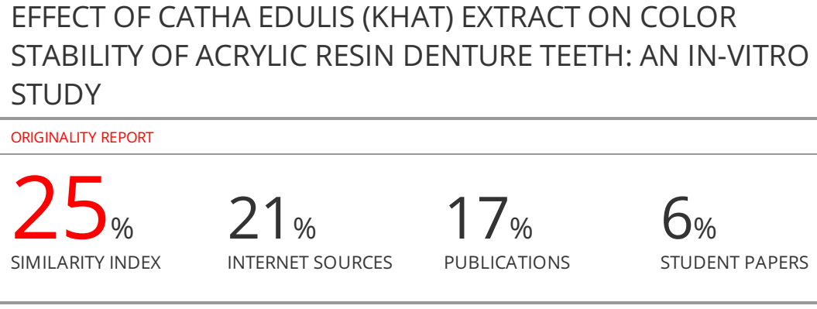 EFFECT OF CATHA EDULIS (KHAT) EXTRACT ON COLOR STABILITY OF ACRYLIC RESIN DENTURE TEETH: AN IN-VITRO STUDY

ABSTRACT
Background and aim: Color stability of long-term denture teeth for patients is a significant criterion in the selection of the types of denture teeth material to be used as one of the main concerns in treatment. Discoloration of denture teeth may result in patient dissatisfaction and an additional expense for their replacement. In Yemen, khat (Catha edulis) chewing habit may affect the color of acrylic denture teeth. Therefore, there is a need for data for long-term clinical success of removable Prosthodontics. The aim of this study was to assess the effect of khat extract on color stability of reinforced acrylic resin denture teeth.
Materials and Methods: Experimental design carried to 3 brands of reinforced acrylic resin teeth from three manufacturers, Vitapan, FX-Anterior and Shanghai-SND were evaluated 40 specimens (maxillary central incisors) of each brand were selected systematically and grouped into A, B and C respectively. All the specimens were stored in distilled water (DW) at 37 °C for 24 hours after which baseline color measurements were recorded by a colorimeter. Then the 40 specimens of each brand were randomly divided into 2 subgroups of 20 specimens each. The first subgroup was stored in distilled water (DW) as the control group. The second subgroup was stored in the khat homogenate (KH) as the study group. All the specimens were immersed for 24 hours daily and kept in an incubator at 37 °C for 30 days. The KH was changed every 24 hours. Colorimeter was used for color change testing of each specimen after 10, 20 and 30 days on CIE L* a* b*. Then the collected data was analyzed using SPSS version 23.
Results: The results of this study shows that there was a significant effect of KH on acrylic teeth (p value < 0.001). Also, a significant interaction between the three brands acrylic teeth and KH was found (p < 0.05). The effect of time on acrylic teeth color stability was statistically significant (p < 0.05). The brands teeth specimens at 10, 20 and 30 days in KH revealed more significantly color change than DW (p <0.05). The color changes ΔE* values Vitapin, FX-Anterior and Shanghai–SND (mean ΔE* 30 days of 3.1, 3.3 and 3.7 respectively, (p < 0.001).
Conclusions: The khat homogenate (KH) causes discoloration on the 3 brands of reinforced acrylic teeth and the discoloration increases with the passage of time. The change of discoloration is acceptable clinically except in SND teeth. Vitapin teeth has more color stable compared to FX teeth and SND teeth. There is an effect of KH at 10, 20 and 30 days within the same brand and between brands for V, FX and SND.
Keywords: acrylic denture teeth, Color stability, discoloration of denture teeth, khat (Catha edulis), Yemen

INTRODUCTION
Color is very important in the aesthetic characterization and personalization of a smile. Cosmetic treatment has been one of the most requested dental treatments which come right after pain treatments. Therefore, color stability is an important marker for the clinical success of Prosthodontics. The etiologies of staining of artificial teeth are multifactorial wear, lack of patient care, influence of textural characteristics, exposure to stains, and time are factors that contribute to internal and external staining¹. Also, in removable dentures, the dentures are an important part of the overall aesthetic outcome. In maintaining aesthetic effects, the color stability of dental prosthesis materials is one of the key factors. Therefore, color stability is an important factor affecting the longevity of dentures². Several brands of artificial teeth are commercially available and differ in material like vacuum-sintered porcelain, conventional acrylic resin, and modified resin. Acrylic resin teeth are widely used in oral rehabilitation since they have advantages over porcelain, such as greater fracture resistance, better absorption of masticatory forces, higher flexural impact strength and easier occlusal adjustment, and they also present higher bond strength to denture base acrylic resin³. However, they present low resistance to abrasion and increased susceptibility to color change and biofilm formation¹, which can lead to occlusion unbalance and aesthetic problems and thus have a shorter durability period and service life¹.
Khat plant is an evergreen shrub and cultivated as small tree or a bush. The shrub can grow to reach 6 meters of height approximately with leathery leaves and glossy with brownish green color⁴. Khat (also known as Qat, kat, and Miraa) is the common name for an evergreen plant (Catha edulis), that belongs to the Celastraceae family, endemic to southwest of Arabia and eastern Africa. Millions of Yemenis and East Africans as well as immigrants to the western countries habitually chew the fresh khat leaves and twigs. Khat has many different compounds (alkaloids, terpenoids, flavonoids, sterols, glycosides, tannins, amino acids, minerals and vitamins) the major alkaloids found in fresh plant khat are Phenylalkylamines and cathedulins and they are structurally related to amphetamine⁵ . Khat chewing produces stimulating amphetamine-like effects⁵. Based on available information on the association of khat with several reported health and socioeconomic problems affecting consumers and their families in a number of African, Asian, European and North American countries, the WHO Expert Committee on Standards for Pharmaceutical Preparations has recommended the following: khat should be considered as a controlled drug⁶. There is increasing evidence of the negative effects of khat on oral and dental diseases including: white lesions, mucosal pigmentation, periodontal disease, tooth loss, stomatitis, and xerostomia⁷⁻¹³.
The frequent chewing of khat as a daily habit is the most common habit by Yemeni population, therefore; there is a need to evaluate the effect of chewing khat on the color stability of acrylic resin teeth for long-term clinical success of removable Prosthodontics.
MATERIALS AND METHODS
Study Design: The study design was an in-vitro observational (experimental) study, which carried out in the Laboratory of General Police Hospital, Sana'a City- Yemen. In this study, 120 samples were used to assess and measure the effect of homogeneous khat extract mixture (KH) on color changes of acrylic resin denture teeth.
Simulation Period of the Study: This study was of 30 days (24h per day or 720^{h}) as immersion period of Specimens (teeth) in KH would correspond to 6 months continuously of clinical exposure of khat chewing process. Thus, the mean time is 4 hours minimum per day of the Yemeni people who often chew khat from 4-10^{h} per day. Thus, 10 days (240^{h}) of storage in KH correspond to 2 months of their daily consumption. 20 days (480^{h}) of storage correspond to 4 months and 30 days (720^{h}) of storage correspond to 6 months of consumption.

Sample Size: The sample size was one hundred and twenty (120) acrylic teeth selected and divided into three groups, n = (3 × 40 = 120).

Materials: Maxillary (right and left) central incisor denture teeth in Vita shade A1 were selected from three different manufacturers for reinforced acrylic resin denture teeth: Vitapan, FX-Anterior and Shanghai-SND. Maxillary central incisors were used as ready-made of reinforced acrylic molds (block) for each teeth brand used as specimens in this study. Also, because the maxillary central incisor has a near flat facial surface and has a similar size and shape (uniform surface). The flat face (middle labial) surface of a maxillary central incisor tooth was chosen to measure the degree of discoloration and to ensure that color was properly measured; it was taken from the same spot in the tooth each time as suggested by Gregorius et al.¹. Using a colorimeter (TECHKON-SpectroDens). The size of the specimen (tooth) was large to ensure a more flat surface. Square tooth moulds were selected. The specimens used were selected from shade A1 Vita shade, to exhibit the staining effect more distinctly as suggested by Bayindir et al.¹⁴. All teeth specimens were examined visually and carefully selected to be free of any defect manufacturer or storing such as porosity and visible fissures, surface irregularities, surface roughness and swelling interface caused by water uptake. The specimens have a very smooth surface with a shiny appearance, especially on the testing side (facial). All the teeth specimens have intact surfaces according to the manufacturer’s specifications. All the specimens were stored in a controlled dry environment until the execution of the experiment.

Methodology:

Grouping of the Test Specimens: Three brands of reinforced acrylic resin denture teeth (single shade A1) from three manufacturers were evaluated (grouped as A, B and C respectively). The forty specimens (40 maxillary central incisors) of each brand were selected systematically and randomly divided into two equal subgroups (20 specimens). The first subgroup was stored in distilled water (DW) as the control group, and the second subgroup was stored in khat homogenate (KH) as the staining media or the study group. So, group A (Vitapan-Vita) was divided into A1 and A2, group B (FX-Anterior Yamahachi) was divided into B1 and B2, and group C (Shanghai-SND New Dental) was divided into C1 and C2. The alphabets indicate the main group and numbers indicate the subgroup. Figure 2 illustrates the distribution specimens on groups and containers.
Each specimen was coded with a number by a waterproof pen on the non-testing surface (palatal). So, specimens of each subgroup were coded 1 to 20 to avoid any confusion and ensure color measurement for each specimen. The same sample continues with the same code number during periods of the color measurement on 10, 20 and 30 days as shown in Table 2.

Experimental Procedures of the Acrylic Teeth Specimens: All 120 specimens were rinsed with distilled water for 1 minute to remove any debris before immersion. Then each group of teeth specimens was stored (immersed) in distilled water (water bath) at 37 °C for 24 hours, in three plastic containers. The initial color measurement (T0) after 24 hours in distilled water, baseline color measurements were taken for each specimen before immersion in KH, using a colorimeter. Before pouring the staining media into containers, six plastic containers, coded with a waterproof pen, were used to store 120 specimens of the teeth. Each container was used to store 20 of the specimens as in Figure 5.
Each incisor tooth sample was fixed vertically on the floor of the container in the cervical region of each tooth and remains facing tooth exposed to avoid tooth to tooth contact. A carding wax was used to fix the specimen to be later removed easily.
After immersion of the specimens in the respective containers containing the storage staining media. Study group specimens was immersed in the KH and control group specimens was immersed in DW, then all containers were closed and kept in the incubator at 37 °C and stored in dark place to simulate oral conditions. The specimens were immersed in KH and DW 24h a day for 30 days at 37 °C as suggested in several vitro studies¹⁻⁶. To prevent air entrapment around the specimens and reduce the (settling) precipitation of particles in solutions, solutions were shaken every 6 hours for one minute.
KH was freshened once every day in each of the three study subgroups during testing period to ensure the activity of crude khat extract and to mimic the process of daily chewing in the vivo. Overall, KH and DW in all containers were replaced and freshened once after 24^{h} daily to prevent sedimentation. In addition, the specimens were washed with distilled water and dried with absorbent paper before the new immersion. KH has the same concentration (1g/1ml) and the same amount (33.33g) in the subgroup containers (A2, B2, C2) until the end of the trial period of 30 days.
To investigate color change of specimens after immersion, the color measurements were repeated after 10 days (T1), 20 days (T2) and 30 days (T3) as suggested by Singh and Aggarwal¹⁵ as the Figure 8. After each session of color measurements that was recorded in Excel spreadsheet.

Preparation of Khat Extract: Fresh Hamdani khat was used for homogeneous khat extract mixture preparation (KH). The fresh leaves and twigs of khat were cleaned with running water, air-dried, and packed in plastic bags and transported to the Lab as in Figure 6. Homogeneous khat extract mixture (KH) was prepared by adding 100 grams of fresh minced khat which has been extracted with 100 ml distilled water (W/V) at a ratio of 1:1. The khat homogenate (KH) was then mixed with 2gm of NaOH until; its pH becomes similar to the pH of saliva and the oral cavity, as suggested by Al Moaleem et al., ⁶. Afterward, it was shaken at 160 rpm, in the shaking machine for 10 minutes at room temperature, which helps to speed up mixing. Khat homogenate (KH) was daily prepared and distributed and equally divided into 3 containers (A2, B2, C2) and the same concentration (1g/mL) in the containers for the 30 days as in Figure 5. The specimens were washed with distilled water and dried with absorbent paper before the new immersion.

Colorimeter Readings: Color measurement was conducted before and after immersion. Before immersing each group of denture teeth into the KH, they were stored in distilled water at 37 °C for 24 hours. After 24 hours of immersion, the color of each tooth (T0) was measured in daylight with a colorimeter (TECHKON SpectroDens).
The color of each tooth was measured in daylight with a colorimeter on a black background in order to simulate the absence of light in the mouth as suggested by Colombo et al.,¹⁶.
Color measurements were repeated after 10 days (T1), 20 days (T2) and 30 days (T3) of immersion in either the staining media (KH) or in the control solution (DW). Before each measurement session, the colorimeter was calibrated according to the manufacturer’s recommendation by using the supplied white calibration standard A. Each specimen was measured twice, and then the average value was calculated and recorded. This value was considered the average color ΔE*. Color changes were characterized using the Commission International d’Eclairage L*a*b* color space (CIE L*a*b*).

Calculation of Color Changes
The color change in the different CIE L* a* b* axes (∆L*, ∆a*, ∆b*).The total color change (∆E*) was calculated for each specimen at a specific time interval of 10,20, and 30 days, relative to its baseline color using the color difference formula: ∆E* = [(∆L*)2 + (∆ a*)2 + (∆b*)2] 1/2 where ∆E* represents the color difference and ∆L*, ∆a*, ∆b* represent the changes in lightness, changes in the red-green coordinate, and changes in the yellow-blue coordinate respectively. Therefore, total color differences were expressed by the formula: E* ＝ [(L) 2 + (a) 2 + (b) 2]1/2, where L, a and b is different in L*, a* and b* values before (T0) and after immersion at each time interval (T1, T2 and T3). After each session of color measurements, the data stored in an excel spreadsheet. To link the amount of color change (∆E*) recorded by the colorimeter to a clinical environment, the data (∆E*) were converted to national bureau of standards units (NBS units) using the equation: NBS unit ＝ ∆E* × 0.92, where important remarks of color differences are represented in NBS units as table 3.3 shows.
Data Analysis: All data were entered into an excel spreadsheet using Excel 13 computer software. Total color changes (∆E*) is the difference between the two colors (baseline and after immersion at 10, 20 and 30 days. All the intervals were calculated using a calculator for calculate Delta-E (Cie76 algorithm). http://colormine.org/delta-e-calculator. Mann-whitny test was used to compare the quantitative data with abnormal distribution at 10 day or 20 days or 30 days on the two materials. Kurskal-wallis test was used to compare the quantitative data with abnormal distribution at 10 days or 20 days or 30 days on the three materials. Frinedman test was used to compare the quantitative data with abnormal distribution at 10 days or 20 days or 30 days on the three materials. One-way Anova test was used to compare the quantitative data with normal distribution at three times on three materials.
RESULTS
The National Bureau of Standards System (NBS) units are calculated to assess the color differences caused by immersion time and/or solution type. A total color change expressed by an ∆E* value is converted to the NBS unit using the equation, NBS unit ＝ ∆E* × 0.92, to link the color change with clinical environment in terms of NBS units, as shown in table 3. So, there is slight change in all of ∆E 10 days for three brands (Vitapan acrylic teeth, FX-Anterior acrylic teeth and Shanghai-SND acrylic teeth) after immersion in KH (mean ∆E 10 days of 0.9, 1.2 and 1.5 respectively) which is clinically acceptable, and trace change (extremely slight change) in all of ∆E 10 days for three brands (groups) after immersion in distilled water (mean ∆E 10 days of 0.3, 0.4 and 0.5 respectively), which is clinically acceptable.
Table 4 shows that there are differences in the mean and standard deviation of the total color changes (∆E*) for the Vitapan acrylic teeth, FX-Anterior acrylic teeth and Shanghai-SND acrylic teeth over 10 days, 20 days and 30 days after immersion in khat homogenate (KH) as a study group and distilled water (DW) as a control group. The second immersion period, days 20, shows a gradual increase in the total color change relative to days 10 (Noticeable change) for all three companies (Vitapan acrylic teeth, FX-Anterior acrylic teeth and Shanghai-SND acrylic teeth) after immersion in KH (mean ∆E 20 days of 1.9, 2.2 and 2.5 respectively) which is clinically acceptable, and slight change in of ∆E 20 days for two companies after immersion in distilled water except trace change in Vitapan acrylic teeth (mean ∆E 20 days of 0.6, 0.7 and 0.9 respectively), which is clinically acceptable (Table 4). The third immersion period, days 30, shows appreciable color changes (marked change) for two companies (FX-Anterior acrylic teeth and Shanghai-SND acrylic teeth) after immersion in KH except noticeable change in Vitapan acrylic teeth (mean ∆E 30 days of 3.1, 3.3 and 3.7 respectively), which is clinically acceptable except Shanghai-SND acrylic teeth more than 3.3 which is clinically unacceptable, and showed slight color changes in of ∆E 30 days for three companies after immersion in distilled water ( mean ∆E 30 days of 0.9, 1.1 and 1.3 respectively), which is clinically acceptable (Table 4). The color change is smaller in the 10 days but increased by prolongation of immersion time. The greatest color change occurs at 30 days and was the highest in shanghai-SND acrylic teeth followed by FX-Anterior acrylic teeth and Vitapan acrylic teeth in KH (mean ∆E of 3.1, 3.3 and 3.7 with a standard deviation of 0.41, 0.68 and 0.86 respectively), as shown in table 4 and figure 9.
Table 5 shows a comparison of the mean change in ΔE values within the teeth study group and control group when immersed in KH and DW at 10, 20 and 30 days. There is statistically significance difference in color within Vitapan, FX-Anterior and Shanghai-SND to different immersion periods at 10, 20 and 30 days either control group or study group with p value (0.001). The color change is at 10, 20 and 30 days either in control group or in the study group increased by prolongation of immersion time but more increased in the study group (KH). The greatest color change occurs at 30 days within one group of denture teeth either in the control group or in the study group and the highest is in Shanghai-SND teeth followed by FX-Anterior teeth and Vitapan teeth in KH (median ∆E 30 days of 3.4, 3.1 and 2.9 respectively) and in DW (mean ∆E 30 days of 1.3, 1.1 and 0.9 respectively) (Table 5). The statistical difference in color is explained by Post Hoc analysis between 10 days and 20 or 10 and 30 days within the three groups. The color change is at 10, 20 and 30 days either in the control group or in the study group, increased by prolongation of immersion time, but more increased in the study group (KH ) (Table 5). Bonferroni test statistical analysis (Table 5) indicates mean difference of the total color change in acrylic denture teeth is statistically significant differences (P < 0.05) affected by either KH or DW. The different immersion periods at (10 days to 20 days) and (10 days to 30 days) and (20 days to 30 days) affect the color stability of acrylic teeth as revealed by a pair-wise comparison.
Table 6.shows the comparison of mean change in ΔE values between the three brands (3 groups). There is statistically significant difference between Vitapan, FX-Anterior and Shanghai-SND at ΔE 10, 20 and 30 days either control group or study group where p value was (0.001). The statistical difference in color is explained by Post Hoc analysis between Shanghai-SND and Vitapan, Shanghai-SND and FX-Anterior, statistical difference in color change between Vitapan, FX-Anterior and Shanghai-SND at ΔE 10, 20 and 30 days either control group or study group where p value is (0.001). Bonferroni test statistical analysis (Table 7) indicates mean difference of the color change between the three brands denture teeth (3 groups) with the same immersion period at ΔE 10, 20 and 30 days is (P < 0.05) significantly affected by either KH or DW and denture teeth manufacturer, excepted between FX-Anterior and Shanghai-SND at ΔE 20 days and 30 days is not significant (P > 0.05) (mean difference of 0.3 and 0.2 respectively) affected by either KH and denture teeth manufacturer. The type of denture teeth materials affects the color stability at each immersion period and in each Staining media, as revealed by a pair-wise comparison) (Table 7). Table 8 shows comparison of mean color change in values between study group and control group in the same group at the same 10, 20 and 30 days when immersed in distilled water (DW) and Khat Homogenate (KH). There are statistically significant differences between the mean of E* for control group and study group in all groups where p value is < 0.05 level. Khat Homogenate (KH) causes the largest changes in ΔE than distilled water for Vitapan acrylic teeth, FX-Anterior acrylic teeth and Shanghai-SND acrylic teeth at ΔE 10, 20 and 30 days.
DISCUSSION
The values of the three brands of reinforced acrylic teeth tested (Vitapin, FX-Anterior and Shanghai-SND), when immersed in KH for 30 days (720^{h}) were (a mean ∆E value of 3.1, 3.3 and 3.7 respectively), meaning that the color change in the Vitapin teeth was a noticeable (perceivable change) whereas the color change in FX-Anterior and Shanghai-SND was an appreciable (marked change). Overall, the behavior of all tested teeth immersed in KH for 30 days could be considered clinically unacceptable and in disagreement with NBS and the ΔE* of 3.0 is clinically acceptable. In addition, this study coincides with the values (ΔE* 3.1 and 3.3) obtained for Vitapin teeth and FX-Anterior teeth respectively would be clinically acceptable, except for the values of Shanghai-SND teeth (ΔE* 3.7) which could be considered clinically unacceptable compared to other studies^{17,18} which concluded that ΔE* values of ≥ 1 to ≤ 3.3 can be detected by the eyes and are clinically acceptable. The effect of KH on the color of tested teeth was evident in all teeth to different degrees. The ∆E* values were slightly higher, as shown in Table 4, with mean ∆E values of 30 days of 3.1, 3.3 and 3.7 for Vitapin, FX-Anterior and Shanghai-SND, respectively. This result agrees with the finding of Al-Anesi et al. ¹⁹ Who stated that color change due to exposure to khat solution is very superficial and can be easily removed by teeth brushing and occurs due to deep absorption of stains and thus cleaning is more difficult. Also, there was a possibility that the mix of KH with NaOH might have generated an acidic pH solution, weakening the surface integrity of the teeth and creating good conditions for discoloration. Since, khat contains carotene, iron and tin, which are the chemical sources of chromospheres (colored agents); the tendency for that khat to cause staining restoration, among the chronic users is no doubt ¹⁹. On the other hand, crude khat has tannin and some amount of fluoride, which may be the cause of staining⁴.
The current study revealed in table 5 there was a statistically significant difference in the effect of KH on Vitapin teeth and FX-Anterior teeth and Shanghai-SND teeth in different immersion periods of 10, 20 and 30 days. The result explained that the increase in color changes with time where p ≤ 0.05. This result was accompanied with a study that was carried out by Mousavi et al.,²⁰ who mentioned that there was statistically significance about the effect of tea, cola and coffee on the reinforced acrylic teeth which, p ≤ 0.05 in three weeks and six weeks but disagrees with periods of one week, six weeks for tea where p > 0.05.
The current study in Table 6 explained that there was a statistically significant difference in color changes that was explained by Post Hoc analysis between the three brands in the effect of KH on Vitapin teeth and FX-Anterior teeth and Shanghai-SND teeth in the same immersion period. When comparison was made among the denture tooth materials, the Vitapin teeth have less color changes than FX-Anterior teeth and Shanghai-SND teeth in KH and can be presented in the following decreasing order: Vitapin teeth (most stable) > FX-Anterior teeth > Shanghai-SND teeth at 10, 20 and 30 days were statistically significance difference between the three groups p ≤ 0.05. This result was in agreement with the study carried out by Koksal and Dikbas,²¹ who mentioned that there was a statistically significant difference of p ≤ 0.05 between the three brands of reinforced acrylic teeth after one day and one month of immersion in tea, coffee and coke solution. It could be due to different absorption properties of materials, different polarity, and different hydrophilic nature and different manufactures of the brands acrylic teeth. The present study showed in Table 8 that pair-wise comparisons of the average total color change between two solutions of homogenization of khat (KH) as a study group and distilled water (DW) as a control group for the same acrylic denture teeth tested in each over a period of 10, 20, and 30 days, Vitapin teeth, FX anterior teeth, and Shanghai-SND teeth had significant differences (P < 0.05) affecting color stability in solution type. The reaction of the solution factor type is significant in each time period. This result was also similar to the study by Koksal and Dikbas²¹.
The current study explains the color change in distilled water as a control group with three brands of acrylic teeth’s mean was ∆E 30 days of 0.9, 1.1 and 1.3 for Vitapin, FX-Anterior and Shanghai-SND, respectively, having imperceptible least color changes with values of ∆E* less than 1.3. Generally, in this study, after 30 days distilled water as a control demonstrated the least effect on the color stability and small color change occurred in all teeth tested. This result was in agreement with those obtained by Moon et al.,² and Gregorius et al.,¹, may be due to the thermal effect of the immersion temperature related to intrinsic factors which include loss of fillers and matrix, which might happen following a period of storage in water or saliva and/or due to acrylic polymers absorb water²².
LIMITATIONS OF THE STUDY

CONCLUSION
The khat homogenate (KH) causes discoloration on the 3 brands of reinforced acrylic teeth and the discoloration increases with the passage of time. The change of discoloration is acceptable clinically except in SND teeth. Vitapin teeth has more color stable compared to FX teeth and SND teeth. There is an effect of KH at 10, 20 and 30 days within the same brand and between brands for V, FX and SND.
ACKNOWLEDGMENTS
The authors thank the Faculty of Dentistry, Sana'a University, Sana'a, and Yemen for their generous support. CONFLICT OF INTEREST
No conflict of interest associated with this work.
AUTHOR’S CONTRIBUTIONS
This research is part of a master's degree in the Prosthodontics Department, Faculty of Dentistry, Sana’a University, Yemen, first author Badea Saeed Abdu Mohammed , who conducted the lab. Tests and other authors contributed to data analysis, drafting and review of the paper, and gave final approval to the research.
REFERENCES
1. Gregorius WC, Kattadiyil MT, Goodacre CJ, Roggenkamp CL, Powers JM, Paravina RD. Effects of ageing and staining on color of acrylic resin denture teeth. J Dent. 2012;;40 (l 2):e47-54. doi: 10.1016/j.jdent.2012.09.009. Epub 2012 Sep 21. PMID: 23007129.
2. Moon A, Powers JM, Kiat-Amnuay S. Color stability of denture teeth and acrylic base resin subjected daily to various consumer cleansers. J Esthet Restor Dent. 2014; 26(4):247-55. doi: 10.1111/jerd.12109. Epub 2014 Jun 30. PMID: 24980803; PMCID: PMC4138258.
3. Neppelenbroek KH, Kuroishi E, Hotta J, Marques VR, Moffa EB, Soares S, Urban VM. Surface properties of multilayered, acrylic resin artificial teeth after immersion in staining beverages. J Appl Oral Sci. 2015 Jul-Aug;23(4):376-82. doi: 10.1590/1678-775720150054. PMID: 26398509; PMCID: PMC4560497.
4.Gashawa, A. and Getachew, T. 'The chemistry of khat and adverse effect of khat chewing', American Scientific Research Journal for Engineering, Technology, and Sciences (ASRJETS) 2014; 9 (1):35-46.
5. Wabe NT. Chemistry, pharmacology, and toxicology of khat (catha edulis forsk): a review. Addict Health. 2011; 3(3-4):137-49. PMID: 24494129; PMCID: PMC3905534.
6. Moaleem MMA, AlSanosy R, Ahmari NMA, Shariff M, Alshadidi AA, Alhazmi HA, Khalid A. Effects of Khat on Surface Roughness and Color of Feldspathic and Zirconia Porcelain Materials under Simulated Oral Cavity Conditions. Medicina (Kaunas). 2020; 56(5):234. doi: 10.3390/medicina56050234. PMID: 32414190; PMCID: PMC7279326.
7. AL-Haddad, K. A., M. M. A. Al-Najhi, A.-K. M. Abbas, A. A. Y. Al-Akwa, H. A. Al-Shamahy, and M. A. Al-labani. “Clinical features, age and sex distributions, risk factors and the type of bacteria isolated in periodontitis patients in sana’a, Yemen”. Universal J Pharm Res vol. 6, no. 1, Mar. 2021, doi:10.22270/ujpr.v6i1.532.
8. Zabara AQMQ, Al-Kholani AIM, Al-Shamahy HA, et al. Resolution of factors and pattern of permanent dental extraction in selected dental clinics in Sana’a city, Yemen. Universal J Pharm Res 2022; 7 (4):1-8. https://doi.org/10.22270/ujpr.v7i4.813
9. Al-Khorasani, M. A. M., A. M. Al-Kebsi, M. S. Al-Hammadi, A. H. Y. Al-hamzi, N. F. Al-Sanabani, K. A. AL-Haddad, M. M. A. Al-Najhi, H. A. Al-Shamahy, and T. A. M. Al-Kibsi. “Prevalence of signs of temporomandibular disorders in healthy asymptomatic completely edentulous individuals and the effect of denture on temporomandibular disorders”. Universal J Pharm Res, vol. 8, no. 1, Mar. 2023, doi:10.22270/ujpr.v8i1.894.
10. Al-Shami, I. Z., Y. A. S. Alrubaidi, K. A. AL-Haddad, M. M. A. Al-Najhi, H. A. Al-Shamahy, T. A. M. Al-Kibsi, and A. I. M. Al-Kholani. “Effect of removable dentures on colonization of aerobic bacteria in the oral cavity and antibiotic pattern of the common isolated bacteria”. Universal J Pharm Res vol. 7, no. 6, Jan. 2023, doi:10.22270/ujpr.v7i6.862.
11. Alhasani, A. H., R. A. Ishag, A. A. Y. Al-Akwa, H. A. Al-Shamahy, and M. A. A. Al-labani. “Association between the streptococcus mutans biofilm formation and dental caries experience and antibiotics resistance in adult females”. Universal J Pharm Res, vol. 5, no. 6, Jan. 2021, doi:10.22270/ujpr.v5i6.507.
12. Abbas, A.-K. M., T. A. M. Al-Kibsi, A. A. Y. Al-Akwa, K. A. AL-Haddad, H. A. Al-Shamahy, and M. A. Al-labani. “Characterization and antibiotic sensitivity of bacteria in orofacial abscesses of odontogenic origin”. Universal J Pharm Res vol. 5, no. 6, Jan. 2021, doi:10.22270/ujpr.v5i6.510.
13. Halboub E, Dhaifullah E, Abdulhuq M. Khat chewing and smoking effect on oral mucosa: a clinical study. Acta Medica (Hradec Kralove). 2009;52(4):155-8. doi: 10.14712/18059694.2016.122. PMID: 20369709.
14. Bayindir F, Kürklü D, Yanikoğlu ND. The effect of staining solutions on the color stability of provisional prosthodontic materials. J Dent. 2012;40 Suppl 2:e41-6. doi: 10.1016/j.jdent.2012.07.014. Epub 2012 Jul 27. PMID: 22842201.
15. Singh SV, Aggarwal P. Effect of tea, coffee and turmeric solutions on the colour of denture base acrylic resin: an in vitro study. J Indian Prosthodont Soc. 2012;12(3):149-53. doi: 10.1007/s13191-012-0122-0. Epub 2012 May 27. PMID: 23997464; PMCID: PMC3416941.
16. Colombo M, Cavallo M, Miegge M, Dagna A, Beltrami R, Chiesa M, Poggio C. Color stability of CAD/CAM Zirconia ceramics following exposure to acidic and staining drinks. J Clin Exp Dent. 2017;9(11):e1297-e1303. doi: 10.4317/jced.54404. PMID: 29302281; PMCID: PMC5741842.
17. Ghazal M, Albashaireh ZS, Kern M. Wear resistance of nanofilled composite resin and feldspathic ceramic artificial teeth. J Prosthet Dent. 2008 Dec;100(6):441-8. doi: 10.1016/S0022-3913(08)60262-0. PMID: 19033028.
18. Maciel LC, Silva CFB, de Jesus RH, Concílio LRDS, Kano SC, Xible AA. Influence of polishing systems on roughness and color change of two dental ceramics. J Adv Prosthodont. 2019; 11(4):215-222. doi: 10.4047/jap.2019.11.4.215. Epub 2019 Aug 27. PMID: 31497269; PMCID: PMC6718845.
19.Al-Anesi WA, Madfa AA, Dubais MA and Albahari AA. Effects of Khat Extract and Other Staining Media on Color Change of Composite Resins Subjected to Various Polishing Methods. Oral Biol Dent. 2019; 7:1. http://dx.doi.org/10.7243/2053-5775-7-1
20.Mousavi S, Narimani S, Hekmatfar S. and Jafari K. 'Colour stability of various types of acrylic teeth exposed to coffee, tea and cola', Journal of dental biomaterials 2016; 3 (4):335. PMID: 28959762; PMCID: PMC5608047.
21. Koksal T, Dikbas I. Color stability of different denture teeth materials against various staining agents. Dent Mater J. 2008;27(1):139-44. doi: 10.4012/dmj.27.139. PMID: 18309623.
22. Mathias P, Costa L, Saraiva LO, Rossi TA, Cavalcanti AN, da Rocha Nogueira-Filho G. Morphologic texture characterization allied to cigarette smoke increase pigmentation in composite resin restorations. J Esthet Restor Dent. 2010;22(4):252-9. doi: 10.1111/j.1708-8240.2010.00347.x. PMID: 20690954.

.

Table 1: The Study Sample of Denture Teeth Materials.
No. of Samples | Section | Color | Size | Manufacturer | Code | Trade Name | Type of Materials | N
40 | Maxillary Central Incisors | A1 | large | Vita Zahnfabrik-Germany | V | Vitapan | Reinforced acrylic | 1
40 | Maxillary Central Incisors | A1 | large | Yamahachi Dental – Japan | FX | FX – Anterior | Reinforced acrylic | 2
40 | Maxillary Central Incisors | A1 | large | Shanghai New Dental – China | SND | Shanghai –SND | Reinforced acrylic | 3

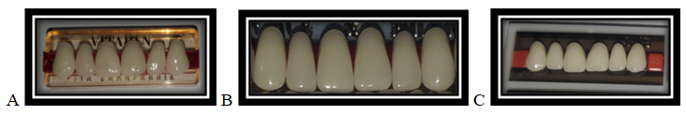

Fig.1:A=Vitapan acrylic teeth; B=FX-Anterior acrylic teeth & C=Shanghai-SND acrylic teeth

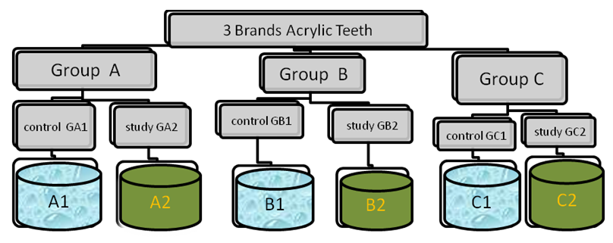

Figure 2: Distribution of Specimens in Groups and Containers.

Table 2: Codes of the Main Group, Subgroups and Specimens of the Acrylic Teeth
Group | Material | Subgroup | Staining media | Experimental codes | specimens coded
A | V | A1 | DW | A1 | 1 to 20
A | V | A2 | KH | A2 | 1 to 20
B | FX | B1 | DW | B1 | 1 to 20
B | FX | B2 | KH | B2 | 1 to 20
C | SND | C1 | DW | C1 | 1 to 20
C | SND | C2 | KH | C2 | 1 to 20

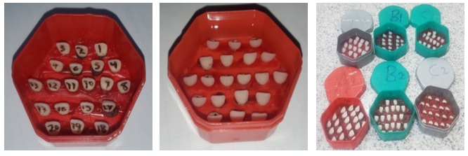

Figure 4: Teeth specimens in the containers before pouring khat homogenate and distilled water. Containers and specimens are coded by waterproof pen and specimens are fixed vertically on the floor of the container by carding wax.

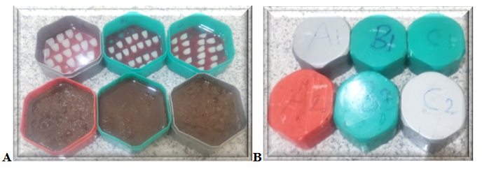Figure 5:Teeth Specimens in the Containers after Pouring Khat Homogenate and Distilled Water

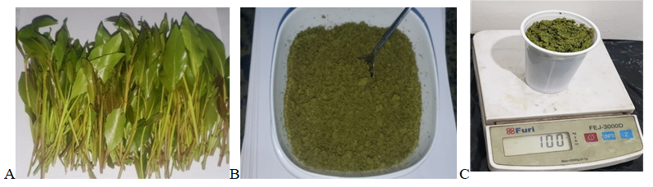Figure 6: (A) Fresh Khat (Catha Edulis Plant) Ready to be Chewed. (B) Khat Extract Used in the Study. (C) Electronic Scale used to Measure Minced Khat Extract.
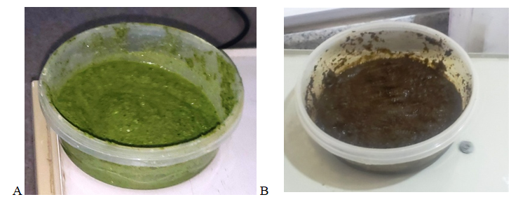

Figure 7: (A) Khat Homogenate (KH) and (B) KH Mixed With NaOH

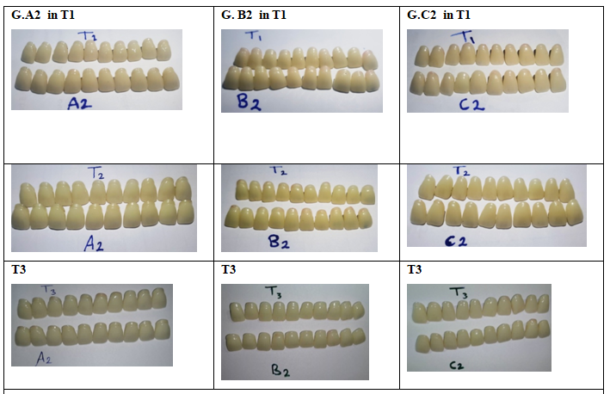

Table 3: National Bureau of Standards System of Expressing Color Difference
NBS unit | Critical remarks of color differences
0.0－0.5 | Trace: | Extremely slight change
0.5－1.5 | Slight: | Slight change
1.5－3.0 | Noticeable: | Perceivable change
3.0－6.0 | Appreciable: | Marked change
6.0－12.0 | Much: | Extremely marked change
12.0 or more | Very much: | Change to other color
Figure 8: Teeth Specimens (Vitapan = G. A2 ; FX-Anterior = G.B2 and Shangha-SND. =G.C2) After 10, 20 and 30 Days Immersion in khat Homogenate.

Table 4: Color Differences of the Acrylic Teeth After 10, 20 and 30 Days
Type of Teeth | Group | Sub-G  ( n = 20 ) | Staining media | Time | Mean ∆E* | S.D | NBS unit
Vitapan | A | A1  Control | DW | ΔE10days | 0.3 | 0.05 | (0.2) Trace
 |  |  |  | ΔE20days | 0.6 | 0.09 | (0.5) Trace
 |  |  |  | ΔE30days | 0.9 | 0.05 | (0.8) slight change
Vitapan | A | A2  Study | KH | ΔE10days | 0.9 | 0.11 | (0.8) slight change
 |  |  |  | ΔE20days | 1.9 | 0.18 | (1.7) Noticeable
 |  |  |  | ΔE30days | 3.1 | 0.41 | (2.8) Noticeable
FX-Anterior | B | B1  Control | DW | ΔE10days | 0.4 | 0.04 | (0.3) Trace
 |  |  |  | ΔE20days | 0.7 | 0.12 | (0.6) slight change
 |  |  |  | ΔE30days | 1.1 | 0.13 | (1.0) slight change
FX-Anterior | B | B2  Study | KH | ΔE10days | 1.2 | 0.26 | (1.1) slight change
 |  |  |  | ΔE20days | 2.2 | 0.31 | (2.0) Noticeable
 |  |  |  | ΔE30days | 3.3 | 0.68 | (3.0) Appreciable
Shanghai-  SND | C | C1  Control | DW | ΔE10days | 0.5 | 0.05 | (0.5) Trace
 |  |  |  | ΔE20days | 0.9 | 0.07 | (0.8) slight change
 |  |  |  | ΔE30days | 1.3 | 0.13 | (1.1) Slight change
Shanghai-  SND | C | C2  Study | KH | ΔE10days | 1.5 | 0.36 | (1.3) Slight change
 |  |  |  | ΔE20days | 2.5 | 0.66 | (2.3) Noticeable
 |  |  |  | ΔE30days | 3.7 | 0.86 | (3.4) Appreciable
DW = Distilled Water ; KH = Khat Homogenate; ∆E10, ∆E20 and ∆E30 = the magnitude of color difference of the samples after 10 days, 20 days, and 30 days, respectively ; ∆E* = Total color change value; SD = Standard Deviation ; NBS unit = National Bureau of Standards unit = ∆E* × 0.92 ; Sub G = Subgroup; n = number of simples.

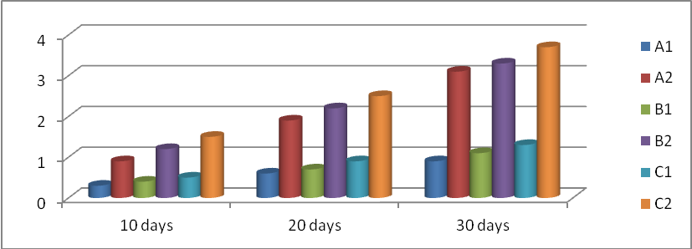

Figure 9: Mean Color Changes (∆E* values) of Acrylic Teeth after 10, 20 and 30 days of Immersion in khat Homogenate as a Study Group and the Distilled Water as a Control Group.

Table 5: Comparison Within One Group of Acrylic Teeth to Different Immersion Periods
Type of Teeth | Time | N | Control Groups  ( Distilled Water ) |  | Study Groups  ( Khat Homogenate )
Type of Teeth | Time | N | Mean ± SD | P | Median (Rang) | P
Vitapan | ΔE10 days | 20 | 0.3 ± 0.04 | 0.001* | 0.95 (0.83 - 1.25) | 0.001**
Vitapan | ΔE20 days | 20 | 0.6 ± 0.09 | 0.001* | 1.9 (1.7 - 2.4) | 0.001**
Vitapan | ΔE30 days | 20 | 0.9 ± 0.05 | 0.001* | 2.9 (2.7 - 3.9) | 0.001**
FX-Anterior | ΔE10 days | 20 | 0.4 ± 0.04 | 0.001* | 1.1 (0.9 - 1.8) | 0.001**
FX-Anterior | ΔE20 days | 20 | 0.7 ± 0.1 | 0.001* | 2.1 (1.9 - 3.2) | 0.001**
FX-Anterior | ΔE30 days | 20 | 1.1 ± 0.1 | 0.001* | 3.1 (2.3 - 4.6) | 0.001**
Shanghai- SND | ΔE10 days | 20 | 0.5 ± 0.05 | 0.001* | 1.3 (1.1 - 2.5) | 0.001**
Shanghai- SND | ΔE20 days | 20 | 0.9 ± 0.07 | 0.001* | 2.2 (1.8 - 4.1) | 0.001**
Shanghai- SND | ΔE30 days | 20 | 1.3 ± 0.1 | 0.001* | 3.4 (2.7 - 5.1) | 0.001**
* = one way Anova Test; ** = Friedman test; P = Probability value ≤ 0.5 = Significance

Table 5.1: Multiple Comparisons By Bonferroni (Post Hoc) Test.
Type of Teeth | Time |  | Control Groups  ( Distilled Water ) |  | Study Groups  ( Khat Homogenate )
Type of Teeth |  |  | Mean Difference | P | Mean Difference | P
Vitapan | 10-20 |  | -0.31 | 0.001 | -0.95 | 0.001
Vitapan | 10-30 |  | -0.59 | 0.001 | -2.09 | 0.001
Vitapan | 20-30 |  | -0.28 | 0.001 | -1.14 | 0.001
FX-Anterior | 10-20 |  | -0.33 | 0.001 | -1.08 | 0.001
FX-Anterior | 10-30 |  | -0.67 | 0.001 | -2.17 | 0.001
FX-Anterior | 20-30 |  | -0.34 | 0.001 | -1.09 | 0.001
Shanghai- SND | 10-20 |  | -0.39 | 0.001 | -1.02 | 0.001
Shanghai- SND | 10-30 |  | -0.76 | 0.001 | -2.25 | 0.001
Shanghai- SND | 20-30 |  | -0.37 | 0.001 | -1.22 | 0.001
Time = or days; P = Probability value ≤ 0.5 = Significance

Table 6: Comparison Between the Three Groups in the Same Immersion Period
Groups | Time | N | Control Groups  ( Distilled Water ) |  | Study Groups  ( Khat Homogenate )
Groups | Time | N | Mean ± SD | P | Median (Rang) | P
A - B - C | ΔE10 days | 60 | 0.3±0.04 | 0.001* | 0.9(0.8- 1.3) | 0.001**
A - B - C | ΔE10 days | 60 | 0.4±0.04 | 0.001* | 1.1 (0.9 – 1.8) | 0.001**
A - B - C | ΔE10 days | 60 | 0.5 ±0.05 | 0.001* | 1.3 (1.1 – 2.5) | 0.001**
A - B - C | ΔE20 days | 60 | 0.6±0.09 | 0.001* | 1.9 (1.7 – 2.4) | 0.001**
A - B - C | ΔE20 days | 60 | 0.7±0.1 | 0.001* | 2.1 (1.9 – 3.2) | 0.001**
A - B - C | ΔE20 days | 60 | 0.9±0.07 | 0.001* | 2.2 (1.8– 4.1) | 0.001**
A - B - C | ΔE30 days | 60 | 0.9±0.05 | 0.001* | 2.9 (2.7 – 3.9) | 0.02**
A - B - C | ΔE30 days | 60 | 1.1±0.1 | 0.001* | 3.1 (2.3 – 4.6) | 0.02**
A - B - C | ΔE30 days | 60 | 1.3±0.1 | 0.001* | 3.4 (2.7 – 5.1) | 0.02**
A = Teeth (Vitapan); B =Teeth (FX-Anterior); C = Teeth (Shanghai-SND); N = number of samples; * = One Way Anova test; ** = Kurskal Wallis test ; P = Probability value P ≤ 0.5 = Significance.

Table 7: Multiple Comparisons By Bonferroni ( Post Hoc ) Test
Groups | Time | Control groups  ( Distilled Water ) |  | Study Groups  ( Khat Homogenate )
Groups | Time | Mean Difference | P | Mean Difference | P
A-B | ΔE10 days | -.10 | 0.001 | -2.6 | 0.009
A-C | ΔE10 days | -.19 | 0.001 | -5.2 | 0.001
B-C | ΔE10 days | -.09 | 0.001 | -3.7 | 0.001
A-B | ΔE20 days | -.13 | 0.001 | -3.8 | 0.001
A-C | ΔE20 days | -.28 | 0.001 | -3.6 | 0.001
B-C | ΔE20 days | -.19 | 0.001 | -1.03 | 0.3
A-B | ΔE30 days | -.19 | 0.001 | -1.7 | 0.09
A-C | ΔE30 days | -.37 | 0.001 | -2.7 | 0.008
B-C | ΔE30 days | -.18 | 0.001 | -1.4 | 0.2
A = Teeth (Vitapan); B = Teeth (FX-Anterior); C =Teeth (Shanghai-SND); P = Probability value P ≤ 0.05 = Significance

Table 8: Comparison Between the Control and the Study for the Same Group at the Same Immersion Period
T | N | Group A |  |  | Group B |  |  | Group C
T | N | S.G | Median  ( Rang ) | P | S.G | Median  ( Rang ) | Sig. | S.G | Median  ( Rang ) | P
10 | 40 | A2 | 0.95(0.8-1.2) | 0.001* | B2 | 1.1 (0.9-1.8) | 0.001* | C2 | 1.3(1.1-2.5) | 0.001*
10 | 40 | A1 | 0.3(0.2-0.4) | 0.001* | B1 | 0.4 (0.3-0.5) | 0.001* | C1 | 0.5(0.4-0.6) | 0.001*
20 | 40 | A2 | 1.9(1.7-2.4) | 0.001* | B2 | 2.1(1.9-3.2) | 0.001* | C2 | 2.2(1.8-4.1) | 0.001*
20 | 40 | A1 | 0.6(0.4-0.8) | 0.001* | B1 | 0.7(0.5-0.9) | 0.001* | C1 | 0.9(0.8-1.1) | 0.001*
30 | 40 | A2 | 2.9(2.7-3.2) | 0.001* | B2 | 3.1 (2.3-4.6) | 0.001* | C2 | 3.4(2.7-5.1) | 0.001*
30 | 40 | A1 | 0.9(0.8-1.0) | 0.001* | B1 | 1.0 (0.9-1.3) | 0.001* | C1 | 1.3(1.0-1.5) | 0.001*
T = Time or days; N = Number of sample; S.G = Subgroups; A2 = Study Group (khat); A1= Control Group ( distal water); P = Probability value ≤ 0.5 = Significance ; * = Mann-whitney test

