**Reviewer’s Comments**

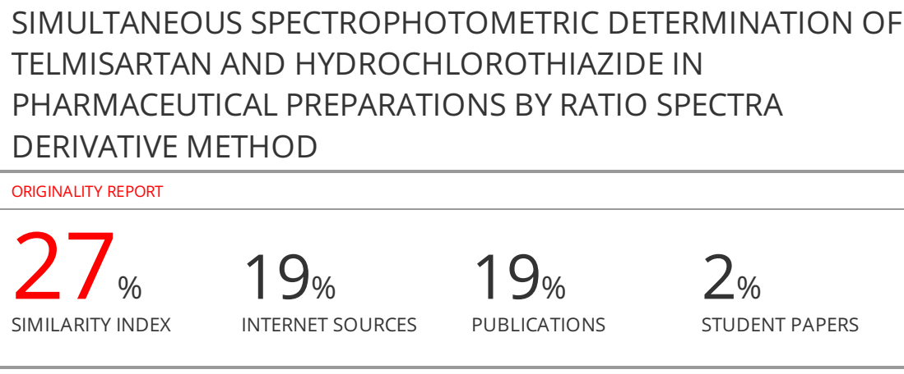

**SIMULTANEOUS SPECTROPHOTOMETRIC DETERMINATION OF TELMISARTAN AND HYDROCHLOROTHIAZIDE IN PHARMACEUTICAL PREPARATIONS BY RATIO SPECTRA DERIVATIVE METHOD**

**ABSTRACT**

**Background**: As it is known, antihypertensive drugs are frequently used for the treatment of individuals with high blood pressure all over the world. ~~The aim of this study is~~ to precisely determine the active substances of telmisartan and hydrochlorothiazide, which are commercially sold as high blood pressure drugs in the market, and to use the ratio spectrum method for this purpose.

**Method**:First of all, solutions of the active ingredients of the drugs studied in the method were prepared in various concentrations. Subsequently, mixtures were prepared in accordance with the commercial drug sample, their spectra were taken by spectrophotometric method, and the spectrum ratio method was successfully applied to these data sets.

**Results**:When the results of the applied method were examined, it was found that the results were consistent.

**Conclusion**:The applied method can be used in the field of drug development.

**Keywords**: Ratio Spectra, Derivative Spectrophotometry, Telmisartan, Active Substances.

**INTRODUCTION**

It is aimed to increase ~~the~~ efficiency by obtaining synergistic effects with the use of diuretic mixtures. Since it contains a low dose and increases the activity of hypertension is an advantage, various mixtures of thiazides and diuretics are often used in drug mixtures. Combination of telmisartan (TEL) with hydrochlorothiazide (HCT) is used synergistic anti-hypertensive effects. Various methods including HPLC1-4, spectrophotometry5-8, LC-MS9, spectrofluorimetry10, and TLC 10-11for TEL and HCTanalysis have been reported.

As a result of the studies conducted by Salinas and his colleagues, the researchers have developed a new method for the analysis of mixtures that give consecutive spectra with each other. This method is based on the use of the ratio spectra, which are also often used today. The method is short, the concentrations of the active components can be easily calculated by determining the minimum or maximum points at the points corresponding to the selected wavelengths. Berzas Nevado et al.12-13 and Dinç and Onur14-15 have determined the active compounds in drugs by applying this method in recent years.

In this research, the ratio spectra derivative method was applied to a drug formulation containing TEL and HCT, which are quite difficult to determine by classical UV methods due to their absorbance in very close places. In this method, similar to the method applied by Salinas described above, analytical signals were measured at wavelengths corresponding to the highest and lowest points in the first derivative values of the ratio spectra, and linear regression equations were obtained for both drug active ingredients.

**MATERIALS AND METHODS**

**Apparatus**

All measurements were made with the UV 1700 PHARMASPEC SHIMADZU spectrophotometer. Absorbance measurements were performed under room temperature conditions with a pair of matching quartz cuvettes. The data groups taken in a computer environment were converted into graphs with Excel and performed following the operations.

**Chemical and reagents**

TEL and HCT and dosage forms (Telvis Plus® which contains 80 mg TEL and 12.5 mg HCT) were provided by Neutec Pharma International (Turkey). Methanol (Merck) used as a solvent has a chromatographic purity degree. All the chemicals used in the study were used in analytical purity.

**Analysis of tablet**

The commercial sample containing the active ingredients of the drug was weighed and at least ten tablets were crushed into powder in a mortar. Then, it was transferred to a balloon and the solution, which was sonicated with the solvent for at least 25 minutes to ensure the required dissolution, was completed to the volume to be used with the same solvent. It was observed that there were insoluble parts, these parts were filtered and washed with solvent and the solutions were combined.

**~~RESULTS AND DISCUSSION~~**

Ratio spectra were obtained as a result of dividing each of the spectra of the active ingredient of TEL pharmaceuticals obtained in different concentrations to the HCT spectrum in a certain concentration(see Fig.1a).The first derivative of these spectra (1DD) was traced with the interval of Δ λ = 1 nm using the scaling factor (SF) =/10 (see Fig. 1b).As can be seen from Figure 1b, the ratio spectra obtained have a maximum at 290 nm and a minimum at 257 nm, and we found that both these points are suitable for TEL determination in a TEL+HCT mixture.In the experiments of the commercial product, 257 nm was selected from these values for the determination of this active ingredient. The reason for this is the lower RSD value and higher recovery average at the selected wavelength, as can be seen ~~from~~ Table 1. In addition, the regression equations and correlation coefficients drawn at the two wavelengths studied in the ratio spectra are shown in ~~Figures 2a and 2b~~. As can be easily seen, the correlation coefficient at the selected 257 nm is closer to one and the slope is smaller. This situation is in perfect harmony with the low RSD values mentioned in table 1.The ratio spectra of the HCT standards at increasing concentrations were obtained by dividing each of the obtained spectra by the TEL spectrum at a certain concentration (see Fig.3a).The first derivative of these spectra (1DD) was traced with the interval of Δ λ = 1 nm using the scaling factor (SF) =/10 (see Fig. 3b).As can be seen from Figure 3b, the ratio spectra obtained have a maximum at 280 nm and a minimum at 264 nm, and we found that two of them are suitable for the determination of HCT in the HCT+TELmixture.In addition, the regression equations and correlation coefficients drawn at the two wavelengths studied in the ratio spectra are shown in Figures 4a and 4b.

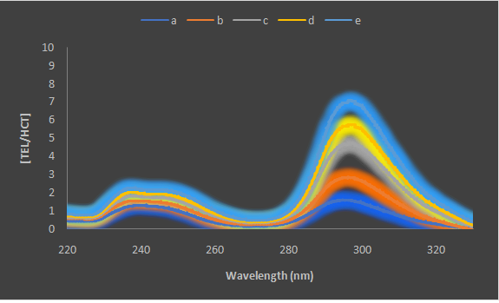 (a)

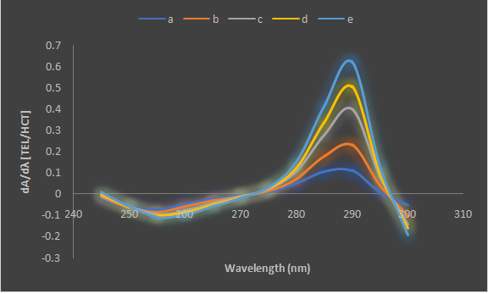 (b)

**Figure 1:**Ratio spectra (a) and first derivative of the ratio spectra (b) of a) 2 ppm b) 4 ppm c) 6 ppm d) 8 ppm and e) 10 ppm solution of TEL in methanol when 8 ppm solutionof HCT in methanol used as divisor.

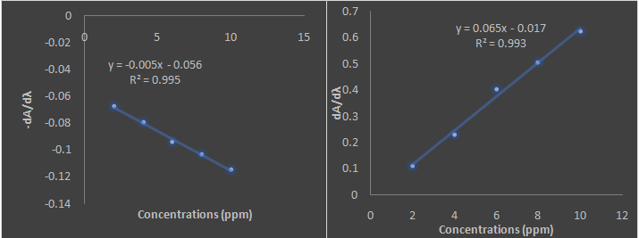

(a)(b)

**Figure 2**: First derivative calibration plot of TEL at 257 nm in methanol solvent (a) and 290 nm in methanol solvent.

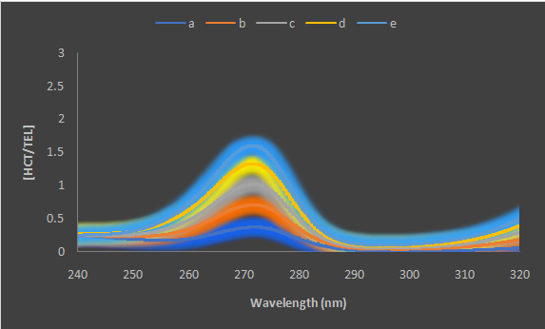 (a)

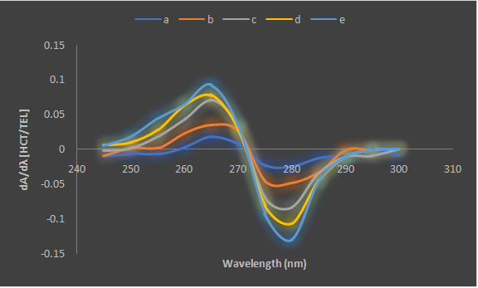

(b)

**Figure 3**: Ratio spectra (a) and first derivative of the ratio spectra (b) of a) 3 ppm b) 6 ppm c) 9 ppm d) 12 ppm and e) 15 ppm HCT in methanol when 25 ppm solution of TEL in methanol used as a divisor.

The signals observed at the measured wavelengths are proportional to the concentration of drug active substances. For the reasons we mentioned above for Telmisartan, 264 nm was also selected for Hydrochlorothiazide and successful results were obtained.The calibration graphs of our drug active substances in our study were calculated from the signals measured in the absence of each other at the wavelengths mentioned above.

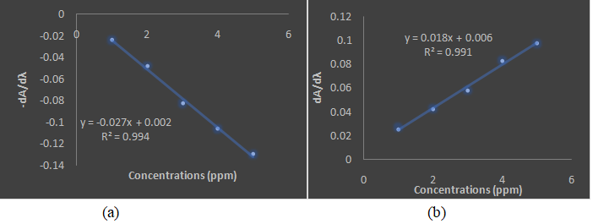

**Figure 4**: First derivative calibration plot of HCT at 264 nm in methanol solvent (a) and 280 nm in methanol solvent.

**Table 1** Recovery results for TEL and HCT in synthetic mixtures by ratio spectra first derivative method

|  |  |  |  |  |  |  |
| --- | --- | --- | --- | --- | --- | --- |
| Mixture | Added(ppm) | TEL recovery (%) | | Added | HCT recovery (%) | |
| 257 290 264 280 | | | | | | |
| 1 | 2 | 101.0 | 101.5 | 7 | 100.6 | 100.2 |
| 2 | 4 | 100.0 | 100.2 | 7 | 101.2 | 102.5 |
| 3 | 6 | 100.2 | 102.6 | 7 | 98.8 | 99.2 |
| 4 | 8 | 101.4 | 99.3 | 7 | 98.6 | 100.4 |
| 5 | 10 | 100.2 | 96.4 | 7 | 101.4 | 96.8 |
| 6 | 5 | 100.1 | 98.8 | 3 | 99.6 | 100.4 |
| 7 | 5 | 99.8 | 102.4 | 6 | 100.8 | 98.2 |
| 8 | 5 | 101.4 | 102.6 | 9 | 99.6 | 98.8 |
| 9 | 5 | 100.6 | 99.2 | 12 | 98.8 | 102.4 |
| 10 | 5 | 99.9 | 102.4 | 15 | 101.0 | 101.4 |
|  | $$\overline{x}$$ | 100.46 | 100.54 | $$\overline{x}$$ | 100.04 | 100.03 |
|  | RSD* | 0.61 | 2,11 | RSD | 1.08 | 1.82 |

RSD* Relative standard deviation

The average recoveries and relative standard deviations calculated for the synthetic mixtures we prepared in the laboratory for the applied method are quite satisfactory, as shown in Table 1. In this type of studies, the divisor concentration is one of the main parameters. The 25 ppm TEL and 8 ppm HCT concentrations were considered suitable for determining the TEL and HCT, respectively, as the divisors of the standard spectra.

Finally, the application of the method was tested on a commercial sample. The cumulative results are shown in Table 2.

**Table 2** Application of the ratio spectra first derivative method to tablets containing telmisartan and hydrochlorothiazide together and statistical evaluation of the results

|  |  |  |  |  |
| --- | --- | --- | --- | --- |
| Number of experiments | The amount of TEL in the tablet (mg/tablet) | Found (mg/tablet) | The amount of HCT in the tablet (mg/tablet) | Found  (mg/tablet) |
| 1 | 80.00 | 80.12 | 12.50 | 12.49 |
| 2 | 80.00 | 79.94 | 12.50 | 12.50 |
| 3 | 80.00 | 80.02 | 12.50 | 12.50 |
| 4 | 80.00 | 79.98 | 12.50 | 12.50 |
| Average value80.0.21 Average value 12.50  Standarddeviation0.07 Standarddeviation0.03  Confidence interval80.02± 0.08 Confidence interval 12.5± 0.02 | | | | |

**LIMITATIONS OF THE STUDY**

**CONCLUSION**

It has been shown that the ratio spectrum method we proposed for quantitative measurement of TEL and HCT prepared synthetically in the laboratory environment gives repeatable and accurate results without any pretreatment. It has been concluded that the proposed method can be applied routinely in drug development laboratories.

**CONFLICT OF INTEREST**

There is no conflict of interest.

**AUTHOR’S CONTRIBUTION**

The authors continued to work by acting jointly at each stage of the study.

**ACKNOWLEDGEMENTS**

We would like to thank SüleymanDemirel University Institute of Natural Sciences for enabling such a study to be carried out.

**REFERENCES**

1. Tiris G, Mehmandoust M, Lotfy HM, Erk N, Joo SW, Dragoi EN, Vasseghian Y. Simultaneous determination of hydrochlorothiazide, amlodipine, and telmisartan with spectrophotometric and HPLC green chemistry applications. Chemosphere. 2022; 303: 135074. *https:// doi.org/ 10.1016/ j.chemosphere.2022.135074*

2. Salama I. Simultaneous HPLC–UV analysis of telmisartanand hydrochlorothiazide in human plasma. Bulletin of Faculty of Pharmacy, Cairo University. 2011; 49: 19-24*. https://doi.org /10.1016/ j.bfopcu.2011.07.005.*

3. Mukhopadhyay S, Kadam K, Sawant L, Nachane D, Pandita N. Simultaneous determination of related substances of telmisartan and hydrochlorothiazide in tablet dosage form by using reversed phase high performance liquid chromatographic method, Journal of Pharmacy and Bioallied Sciences July-September 2011; 3(3): 375-383. *DOI:10.4103/0975-7406.84441*.

4. Bhat LR, Godge RK, Vora AT, Damle MC. Validated RP‐HPLC Method for SimultaneousDetermination of Telmisartan andHydrochlorothiazide in Pharmaceutical Formulation. Journal of Liquid Chromatography & RelatedTechnologies, 2007; 30(20): 3059-3067, *DOI: 10.1080/10826070701632774.*

5. Patıl KR, Shınde DB. Stability-indicating LC method for the simultaneous determination of telmisartan and hydrochlorothiazide in dosage form. J. Chil. Chem. Soc. 2012; 57(1): 1017 -1021. [*http://dx.doi.org/10.4067/S0717-97072012000100014*](http://dx.doi.org/10.4067/S0717-97072012000100014)*.*

6. Beliz K, Dinç E, Baleanu D. Chemometric Methods for the Simultaneous Spectrophotometric Determination of Telmisartan and Hydrochlorothiazide in the Commercial Pharmaceuticals.REV. CHIM. 2009;60(6): 544-550.

7. Lakshmi KS, Lakshmi S. Design and Optimization of a Chemometric-Assisted Spectrophotometric Determination of Telmisartan and Hydrochlorothiazide in Pharmaceutical Dosage Form. *J Young Pharm. 2010;2(1): 85-89. DOI:*[*10.4103/0975-1483.62224*](https://doi.org/10.4103%2F0975-1483.62224)*.*

8. Gangola R, Singh N, Gaurav A, Maithani M, Singh R. Spectrophotometric simultaneous determination hydrochlorothiazide and telmisartan in combined dosage form by dual wavelength method. PharmacieGlobale (IJCP). 2011; 2(04): 1-4.

9. Tingting Y, Hao LA, Lili D, Yingjie G,Weisong Y, Fawcett JP, Dan Z, Yimin C, Jingkai G. Liquid chromatographic–tandem mass spectrometric methodfor the simultaneous quantitation of telmisartan and hydrochlorothiazidein human plasma, Journal of Pharmaceutical and Biomedical Analysis 48 (2008) 1225–1229. *DOI: 10.1016/j.jpba.2008.08.021.*

10. Lories IB, Samah SA, Laila AF, Heba HR. Application of first-derivative, ratio derivative spectrophotometry, TLC-densitometry and spectrofluorimetry for the simultaneous determination of telmisartan and hydrochlorothiazide in pharmaceutical dosage forms and plasma, Il Farmaco. 2005; 60: 859–867. *DOI: 10.1016/j.farmac.2005.06.009.*

11. Shah NJ, Suhagıa BN, Shah RR, Shah PB. Development and Validation of a HPTLC Method for the Simultaneous Estimation of Telmisartan andHydrochlorothiazide in Tablet Dosage Form, Indian Journal of Pharmaceutical Sciences. 2007; 202-205.*DOI: 10.4103/0250-474X.33150.*

12. Berzas NJJ, Lemus GJM, Castenada PG**.** Spectra ratioderivative spectrophotometricdetermination of sulphaquinoxaline pyrimethamine inveterinary formulation. J. Pharm. Biomed. Anal. 1993; 11: 601-607.

13. Berzas NJJ, Rodrigeuez FJ, Moreno PML. Determination ofsulphamethizole in the presence of nitrofurantoine by derivative spectrophotometry andratio spectra derivative. Talanta,1991; 38: 1261-1264.

14. Dinç E. Onur F. Application of the ratio spectra derivative spectrophotometric andVierordt's's method to quantitative analysis of paracetamol and metamizol in apharmaceutical formulation. Sci.Pharm., 1999; *67*: 57 – 68.

15. Dinç E, Onur F.Application of derivative and ratio derivative spectrophotometryfor determination of pseudoephedrine and acrivastine. Anal.Lett. 1997; 30(6): 1179-1191.