**Research Article**

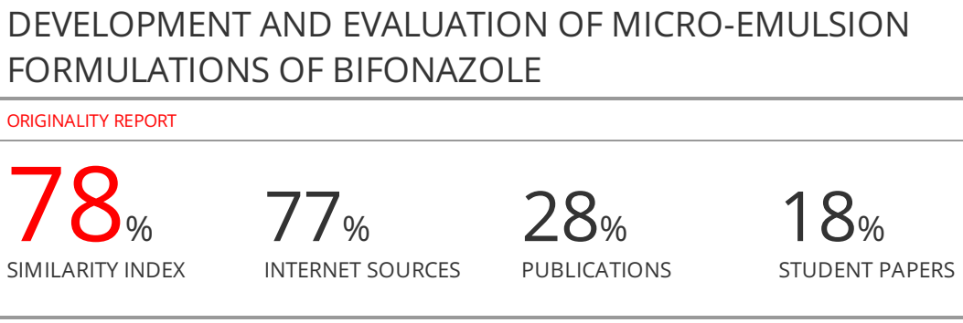**DEVELOPMENT AND EVALUATION OF MICRO-EMULSION FORMULATIONS OF BIFONAZOLE**

**ABSTRACT:**

The purpose of this study was to develop microemulsion-based hydrogel formulation for topical delivery of bifonazole with an objective to increase the solubility of the drug.

Total 5 micro emulsion formulations were developed using water titration method. Capmul Pg-12 (oil). Tween-80**:** (surfactant) and Propylene glycol (co-surfactant) were used in different ratio based on the emulsification efficiency. Prepared formulations were evaluated on different parameters liketransmittance (%), pH, refractive index, viscosity, drug content, solubility, and *in-vitro* release study Franz diffusion cell. Ternary phase diagram was prepared using oil (Capmul Pg-12), surfactant (Tween 80), co-surfactant (Propylene glycol) in different ratio

Based on the drug solubility and emulsification efficiency**,** oil (Capmul Pg-12), Tween-80**:** (surfactant) and Propylene glycol (co-surfactant) were used for the formulations development. The % transmission was found to be in the range of 98.47 ±0.09 to 99.2 ± 0.08%, the pH value was found to be in the range of 3.34 ± 0.08 to 4.02 ± 0.09, refractive index in the range of 1.3418±0.016 to 1.3818 ± 0.004, drug content was found to be in the range of 98.47± 0.08 to 99.62 ± 0.02%, viscosity was found to be in the range of 65.23±2.1 to 71.56±5.77% . It was seen that after 4 hours of diffusion, the drug released from the formulation ME5 faster and more than that of the other ratios i.e., 91.2±0.06%. It was observed that drug release was governed by the diffusion process.

On the basis of different evaluation parameters microemulsion formulations of batch ME5 were found to be the best.Present study concludes successful delivery of Bifonazole by the means of microemulsion formulations

**Keywords:** microemulsions, surfactant, Bifonazole, co-surfactant, oil.

**INTRODUCTION:**

Topical preparations are used for the localized effects at the site of their application by virtue of drug penetration into the underlying layers of skin or mucous membranes. The main advantage of topical delivery system is that it has ability to deliver drugs more selectively to a specific site (local action). It provides utilization of drugs with short biological half-life, narrow therapeutic window to increase the duration of action.[[2](https://www.ncbi.nlm.nih.gov/pmc/articles/PMC3555009/#ref2)]

Approximately 40% of new chemical entities exhibit poor aqueous solubility and presents major challenge to modern drug delivery systems which leads to poor absorption, poor bioavailability, and lack of dose proportionality. However, in many instances, oral administration is unsuitable when the drug undergoes significant degradation in the gastrointestinal tract or is metabolized to a high degree via the first pass effect in the liver. These disadvantages intensified the search for an alternative drug delivery in the form of microemulsion-based formulations for topical delivery.

A microemulsion is considered to be a thermodynamically or kinetically stable liquid  
dispersion of an oil phase and a water phase, in combination with a surfactant. The dispersed phase typically comprises small particles or droplets, with a size range of 5 nm-200 nm, and has very low oil/water interfacial tension1,2. Because the droplet size is less than 25% of the wavelength of visible light, microemulsions are transparent.

ME are clear systems of with a droplets diameter>500 nm3. Due to small droplets size, they may serve an excellent carrier for drugs having poor water solubility. Aqueous phase consists of salt(s), and/or other ingredients, while oil consists of hydrocarbons and olefins. There is need of high shear in the preparation of emulsions, but for ME, there is no need of high shear, they simply formulated by the mixing of different ingredients4.O/W microemulsion tends to increase solubility by changing in its dispersed phase and improve oral bioavailability by the means of increase in rate of absorption and its wettability5-8.

Bifonazole is azole antifungal agent belonging to broad spectrum category; it is used for the treatment of skin infections like tinea, Athlete's foot, and ringworm of the body. It is used topically in the form of gel for the treatment of Athlete's foot, but it has shown very low absorption (0.6% of an applied dose). Moreover the half life of bifonazole is only 1-2 h. So, for the sustain delivery of bifonazole, and to increase the duration of action, microemulsion-based formulations are developed in this study.

**MATERIALS AND METHODS:**

Bifonazole was obtained from Genvio Pharma Ltd, Octanol , Castor Oil, Soyabean Oil, Linseed oil, Span 80, Tween 80 were obtained from Essential Drugs Company Ltd, Bangladesh. Other ingredients used were of analytical grade.

**Selection of the oil phase**

Selection of the oil phase was based upon the maximum solubility of the drug. Different oils including castor oil, Capmul Pg-12, soyabean oil, Kollisolv GTA, MCT were taken for solubility studies. Based on the solubility Capmul Pg-12 was selected as the oil phase10.

**Selection of surfactants and co surfactant**

Solubility of Bifonazole was checked in different surfactants and co surfactants. Emulsification efficiency of surfactants and co-surfactants to check their ability to emulsify selected oil.

To determine the emulsification ability, equal amount of surfactant was mixed with drug and after proper dilution, it was monitored for transmittance at 638 nm using UV-Vis spectrophotometer. The ease of formation of emulsion was monitored by the number inversions of volumetric flask required to produce uniform emulsion. Similarly co surfactant were selected based on their ability to form stable and clear micro emulsion at a minimum concentration11.

**Solubility analysis**

About 10 gm of oil was accurately weighed in 25 ml glass beaker and 100 mg of Bifonazole was added into it, followed by stirring on magnetic stirrer at moderate speed to dissolve the drug. When drug was dissolved completely another 10 mg Bifonazole of was added and stirring was continued. Addition of drug was continued until the saturated solution is obtained. Finally, the total amount of drug consumed was determined by using UV-spectrophotometer at 250 nm. In the similar way solubility of Bifonazole was checked in different surfactants and co-surfactants12.

**Construction of Pseudo-Ternary Phase Diagrams**

The pseudo-ternary phase diagrams were constructed using water titration method to  
determine the microemulsion area and to detect the possibility of making microemulsions  
with different possible compositions of oil, surfactant/co-surfactant and water respectively. The ratios of surfactant to co-surfactants were selected to be 1:1, 2:1 and 3:1 with fixed 5 % oil amount. These mixtures (S/CoS) were mixed with the oil phase to give the weight ratios of 9:1, 8:2, 7:3, 6:4, 5:5, 4:6, 3:7, 2:8 and 1:9. Water was added drop by drop and stirred using a magnetic stirrer at constant temperature until a homogeneous dispersion or solution was obtained. After each addition, the system was examined for the physical appearance. The end point of the titration was the point where the solution becomes transparent or translucent. The amount of the aqueous phase required to make the mixture turbid was noted.[25-26] The percentages of the various incorporated pseudo phases were estimated, and the same procedure was followed for the other S/CoS ratios. All the ratios of S/Co gives dotted area in pseudo ternary phase diagram13-16.

**Preparation of drug loaded microemulsion**

Formulations were developed using water titration method. Predetermined amounts of Bifonazole (100) mg was dissolved in the required quantity of Capmul Pg-12 (oil). Tween-80**:** (surfactant) and Propylene glycol (co-surfactant) were added to the above mixture in different ratio. Distilled water was added gradually with continuous stirring, which resulted in the formulation of a transparent and homogenous microemulsion17.

**Characterization of microemulsion formulations**

**Percentage Transmittance**

Transparency of microemulsion formulations was determined by measuring percentage transmittance through U.V. Spectrophotometer at 638 nm with distilled water taken as blank and three replicates were performed for each sample18.

**pH determination**

The apparent pH of all microemulsion formulations was determined at 25°C by immersing the electrode directly into the microemulsion formulations using a digital pH meter19.

**Refractive index**

Refractive indices of the prepared microemulsion formulations were determined at 25°C by Abbe’s refractometer by placing one drop of micro emulsion on the slide20.

**Viscosity measurement**

Micro emulsions are generally low viscosity systems. The viscosity of the prepared micro emulsion was measured at 25°C at 60 rpm by LV spindle no. 63 using a Brookfield viscometer21.  
**Determination of Drug Content in the Bifonazole micro emulsion formulations**

The drug content of the microemulsion formulations was determined by dissolving 1 ml (equivalent to 10 mg drug) of the formulation in 10 ml of methanol. After suitable dilutions with methanol, absorbance was determined using the UV spectrophotometer keeping blank micro emulsion as control at wavelength 250 nm and three replicates were performed for each sample22.  
**Drug solubility study:** Bifonazole was added in excess to the optimized microemulsion  
formulation as well as each individual ingredient of the formulation. After continuous  
stirring for 4 hours at room temperature, samples were withdrawn and centrifuged for 10 minutes. The amount of drug soluble in optimized formulation as well as each  
individual ingredient of the formulation was calculated by subtracting the drug in the  
sediment from the total amount of drug added. The solubility of drug in microemulsion was  
compared with respect to its individual ingredients23.

***In-vitro* drug release:** The diffusion study was carried out on a modified Franz diffusion cell of  
volume 20ml. The receptor compartment was filled with 20 ml of Phosphate buffer (pH 7.4). The  
donor compartment was fixed with cellophane membrane (Cut Off weight = 1000 Da) contains  
Bifonazole microemulsion formulation (equivalent to 5 mg of drug) and plain drug solution separately. At predetermined time intervals samples were withdrawn from receptor compartment and analyzed for drug content by UV Spectrophotometer at 250 nm24.

**Drug release kinetic data analysis:**

Release data was evaluated through PCP disso software for the kinetic models. First, and Peppas and Korsmeyer model were studied25,26.

**Stability study**

Based on different evaluation parameters microemulsion formulations of batch ME5 was used for stability testing.. The formulations were air tight packed and kept for three months on 40°C and 75% RH. The samples were observed by UV spectrophotometer at 250 nm for the absorbance. By the means of the calibration curve the amount of the drug was estimated27.

**Statistical analysis**

The data obtained for different formulations was analyzed by one way analysis of variance (ANOVA).

**Table 1: Solubility of Bifonazole.**

|  |  |  |  |  |  |
| --- | --- | --- | --- | --- | --- |
| **Oils** | **Solubility** | **Surfactant** | **Solubility (mg/ml)** | **Cosurfactant** | **Solubility (mg/ml)** |
| Castor Oil | 1.23±0.35 | Span 80 | 12.45±0.31 | PEG 200 | 19.64±0.08 |
| Soyabean Oil | 0.46±0.04 | Tween 80 | 14.43±0.87 | PEG 400 | 8.65±0.41 |
| Peanut oil | 0.594±0.81 | Labrasol | 13.63±0.41 | Propylene glycol | 26.77±0.35 |
| Capmul Pg-12 | 16.563±0.08 | Tween-60 | 13.55±0.31 | Iso propyl alcohol | 0.86±0.54 |
| Linseed oil | 1.4453±0.0121 |  |  |  |  |
| Cottonseed oil | 0.759±0.0048 |  |  |  |  |

**Table 2: Emulsification efficiency (selected oil and surfactant).**

|  |  |  |
| --- | --- | --- |
| **Surfactant** | **% Transmittance** | **HLB Value** |
| Tween-80 | 88.147±0.0251 | 14 |
| Labrasol | 76.251±0.0228 | 13 |
| Tween-60 | 85.167±0.0182 | 13.9 |

**Table 3: Emulsification efficiency (selected surfactant and cosurfactant).**

|  |  |  |
| --- | --- | --- |
| **Co surfactant** | **% Transmittance** | **HLB Value** |
| PEG 200 | 72.141±0.0148 | 5-6 |
| PEG 400 | 73.132±0.0151 | 8-9 |
| Propylene glycol | 79.253±0.0241 | 11.6 |

**Table 4: Compostion of ternary phase diagrams (quantity in ml).**

|  |  |  |  |  |  |  |  |
| --- | --- | --- | --- | --- | --- | --- | --- |
| **Oil: SA/CoSA** | **Capmul Pg-12**  **(Oil)** | **Tween-80:Propylene glycol**  **(Surfactant:Cosurfactant)** | | | | | |
| **1:1** | | **2:1** | | **3:1** | |
| 1:9 | 1 | 4.5 | 4.5 | 6.0 | 3.0 | 6.7 | 2.3 |
| 2:8 | 2 | 4.0 | 4.0 | 5.3 | 2.7 | 6.0 | 2.0 |
| 3:7 | 3 | 3.5 | 3.5 | 4.6 | 2.3 | 5.3 | 1.7 |
| 4:6 | 4 | 3.0 | 3.0 | 4.0 | 2.0 | 4.5 | 1.5 |
| 5:5 | 5 | 2.5 | 2.5 | 3.3 | 1.7 | 3.8 | 1.2 |
| 6:4 | 6 | 2.0 | 2.0 | 2.6 | 1.3 | 3.0 | 1.0 |
| 7:3 | 7 | 1.5 | 1.5 | 2.0 | 1.0 | 2.3 | 0.7 |
| 8:2 | 8 | 1.0 | 1.0 | 1.3 | 0.7 | 1.5 | 0.5 |
| 9:1 | 9 | 0.5 | 0.5 | 0.7 | 0.3 | 0.7 | 0.3 |

(Bifonazole=100 mg)

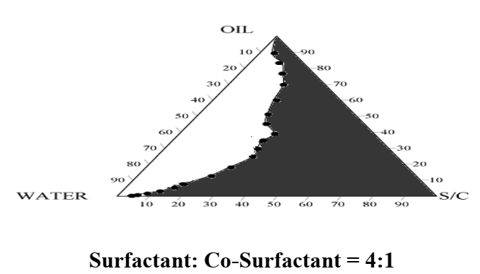

**Figure 1: Pseudo ternary phase diagram for 1:1.**

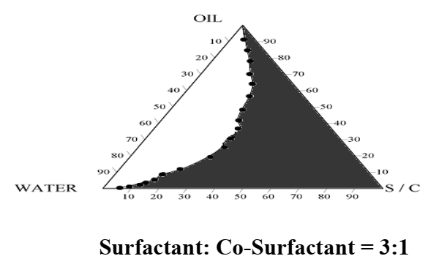

**Figure 2: Pseudo ternary phase diagram for 2:1.**

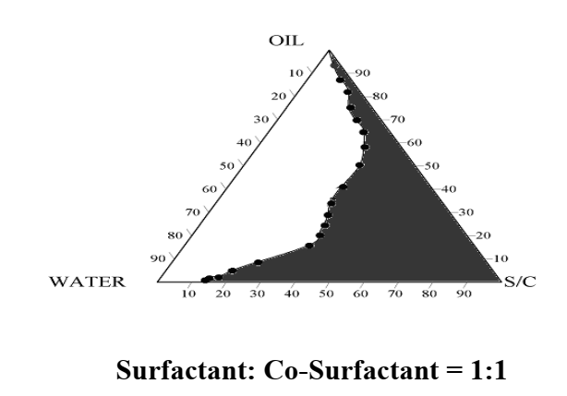

**Figure 3: Pseudo ternary phase diagram for 3:1.**

**Table 5: Composition of batches for Bifonazole micro emulsion.**

|  |  |  |  |  |
| --- | --- | --- | --- | --- |
| **Code** | **Smix ratio** | **% w/w composition** | | |
| **% Oil** | **Smix** | **% Water** |
| ME1 | 1:1 | 35 | 65 | 5 |
| ME2 | 1:2 | 60 | 35 | 5 |
| ME3 | 1:3 | 35 | 60 | 10 |
| ME4 | 2:1 | 50 | 40 | 10 |
| ME5 | 3:1 | 40 | 55 | 5 |

**Table 6: Evaluation parameters of prepared ME Terbinafine formulations.**

|  |  |  |  |  |  |  |
| --- | --- | --- | --- | --- | --- | --- |
| **Batch** | **Transmittance (%)** | **pH** | **Refractive index** | **Viscosity (cp)** | **Drug content (%)** | **Solubility mg/ml** |
| ME1 | 99.4 ± 0.12 | 3.73 ± 0.08 | 1.3648±0.007 | 64.23±0.12 | 98.37± 0.08 | 26.47±0.07 |
| ME2 | 99.37 ± 0.31 | 3.75 ± 0.12 | 1.3420 ± 0.008 | 66.46±0.14 | 99.52 ± 0.04 | 27.77±0.18 |
| ME3 | 99.42 ± 0.23 | 3.82 ± 0.07 | 1.3718 ± 0.004 | 70.56±0.77 | 99.61 ± 0.03 | 28.67±0.09 |
| ME4 | 98.57 ±0.09 | 3.44 ± 0.08 | 1.3720 ± 0.008 | 68.43±0.34 | 99.32 ± 0.06 | 25.87±0.09 |
| ME5 | 99.63 ± 0.03 | 4.12 ± 0.09 | 1.3518±0.016 | 66.36±0.74 | 98.23 ± 0.08 | 31.87±0.07 |

**Figure 4: *In vitro* study of prepared Bifonazole micro emulsion formulations.**

**Table 8: Different release models for Bifonazole micro emulsion formulations.**

|  |  |  |
| --- | --- | --- |
| **Batch** | **Kinetic model** | **Parameters** |
| ME1 | Peppas and Korsmeyer | R = 0.955, K1 = 4.334, n = 0.780 |
| ME2 | Peppas and Korsmeyer | R = 0.984, K1 = 3.247, n = 0.864 |
| ME3 | First order | R = 0.972, K1 = 5.81, n = 0.770 |
| ME4 | Peppas and Korsmeyer | R = 0.954, K1= -0.070 |
| ME5 | Peppas and Korsmeyer | R = 0.983, K1 = 6.712, n = 0.762 |

**Figure 5: Stability studies of microemulsion formulations of batch ME5 at different temperature**

**RESULTS and Discussion:**

Solubility ofBifonazole was checked in different oil to select the oil for the preparation of microemulsion formulation. On the basis of solubility Capmul Pg-12 was selected as the oil and on the basis of emulsification efficiency and solubility Tween 80 was selected as the surfactant and Propylene glycol as the co-surfactant.

Given Bifonazole sample has shown maximum absorption (λmax) at 250 nm. FTIR spectroscopy was used to detect any kind of interaction between Bifonazole and used oil (Capmul Pg-12), surfactant (Tween 80), co-surfactant (Propylene glycol). No change in peak was found, that indicate compatibility between them.

Ternary phase diagram was prepared using oil (Capmul Pg-12), surfactant (Tween 80), co-surfactant (Propylene glycol) in different ratio to identify the micro emulsion existing zone from which appropriate concentration ranges of components of micro emulsion can be obtained. The ternary phase diagrams of all the ratios are shown in Figure 6 to Figure 8. Formation of micro emulsion systems (the shaded area) was observed at room temperature. Phase behavior investigations of this system demonstrated the suitable approach to determine the water phase, oil phase, surfactant concentration, and co surfactant concentration with which the transparent, one-phase, low-viscous micro emulsion system was formed.

Total five formulations were developed to enhance the solubility of the Bifonazole. Prepared formulations were further studied for different parameters including percent transmittance, drug content, pH determination, refractive index, viscosity, drug release.

The percent transmission carried out on UV spectrophotometer at 638 nm was found to be in the  
range of 98.47 ±0.09 to 99.2 ± 0.08%for all which confirms good transparent nature of formulations.

For the micro emulsion formulations, the pH value was found to be in the range of 3.34 ± 0.08 to 4.02 ± 0.09.

The refractive index for the micro emulsion formulations was found to be in the range of 1.3418±0.016 to 1.3818 ± 0.004.

The drug content was found to be in the range of 98.47± 0.08 to 99.62 ± 0.02% in the micro emulsion formulations.

The Viscosity was found to be in the range of 65.23±2.1 to 71.56±5.77% in the micro emulsion formulations. The viscosity of the micro emulsion increased with increasing concentration of the surfactant.It was seen that after 4 hours of diffusion, the drug released from the formulation ME5 faster and more than that of the other ratios i.e., 91.2±0.06%.

In present study PCP disso Version 2 software was used in for the estimation of release pattern.Models for the release kinetic profile are shown in Table 8. *In-vitro* release data were plotted in 2 different models i.e. first, and Korsemeyer peppas. It was observed that release was governed by the diffusion process.

Stability studies indicated that the preparation was stable at room temperature over the period of 3 months. The results are shown in Table 8.

**CONCLUSION:-**

ME are clear systems of with a droplets diameter>500 nm1. Due to small droplets size, they may serve an excellent carrier for drugs having poor water solubility. Aqueous phase consists of salt(s), and/or other ingredients, while oil consist of hydrocarbons and olefins. There is need of high shear in the preparation of emulsions, but for ME, there is no need of high shear, they simply formulated by the mixing of different ingredients.

Present study concludes successful delivery of Bifonazole by the means of micro emulsion formulations.

**Author’s Contribution**

**Acknowledgements**

**REFERENCES:**

1. Kreilgaard M, Pedersen EJ, Jaroszewski JW. NMRcharacterization and transdermal drug delivery potential ofmicroemulsion systems. J Control Release 69, 421–433.
2. Obanewa OA, Oyeniran OT. Development and estimation of anti-inflammatory activity of topical etoricoxib emulgel by carrageenan induced paw oedema method. Universal Journal of Pharmaceutical Research 2019;4(3): 22-26.
3. Paliwal S, Kaur G, Arya KKR. Formulation and characterization of topical nano emulgel of terbinafine. Universal Journal of Pharmaceutical Research 2018; 3(6): 28-34.
4. Gasco MR, Gallarate M., Pattarino F, 1991: In *vitro*permeation of azelaic acid from viscosized microemulsions. Int. J.Pharm. 69, 193–196.
5. Osama Umar, Kapil Kumar, Aparna Joshi, Dipti Khairiya, Deepak Teotia, Ikram. A comprehensive review on microemulsions: a potential novel drug delivery system. Int J Indig Herbs Drugs 2022; 7(3): 56-61.
6. Trotta M. Influence of phase transformation on indomethacinrelease from microemulsions. J Control. Release 60, 399–405.
7. ALGIN YAPAR E, BESKAN U, KARAVANA SY. A recent overview of locally administered topical otic dosage forms. Universal Journal of Pharmaceutical Research 2019; 4(4): 39-42.
8. Alvarez-Figueroa, M.J., Blanco-Méndez, J: Transdermal delivery ofmethotrexate: iontophoretic delivery from hydrogels and passivedelivery from microemulsions. Int. J. Pharm 2015, 57–65.
9. Lackner TE, Clissold SP. Bifonazole. A review of its antimicrobial activity and therapeutic use in superficial mycoses. Drugs. 1989;38:204–25.
10. *Trösken ER, Fischer K, Völkel W, Lutz WK (February 2006). "Inhibition of human CYP19 by azoles used as antifungal agents and aromatase inhibitors, using a new LC-MS/MS method for the analysis of estradiol product formation". Toxicology.* ***219*** *(1–3): 33–40.* [*doi*](https://en.wikipedia.org/wiki/Doi_(identifier))*:*[*10.1016/j.tox.2005.10.020*](https://doi.org/10.1016%2Fj.tox.2005.10.020)
11. Madani S, Barilla D, Cramer J, Wang Y, Paul C: Effect of terbinafine on the pharmacokinetics and pharmacodynamics of desipramine in healthy volunteers identified as cytochrome P450 2D6 (CYP2D6) extensive metabolizers. J Clin Pharmacol. 2002 Nov;42(11):1211-8.
12. Yan, J; Wang, X; Chen, S (August 2014). "Systematic review of severe acute liver injury caused by terbinafine". International Journal of Clinical Pharmacy. 36 (4): 679–83.
13. Acharya S. P., Moulik, S. K. Sanyal, Mishra, B. K. and Puri, P. M:Physicochemical Investigations of Microemulsification of CoconutOil and Water Using Polyoxyethylene 2-Cetyl Ether (Brij 52) andIsopropanol or Ethanol, Journal of Colloid and Interface Science245 , 163–170.
14. Gurleen Kaur, Alfisha Saifi, Kapil Kumar , Deepak Teotia. Development  
    and Evaluation of Micro Emulsion Formulations of Nebivolol for Solubility Enhancement, Journal of Drug Delivery and Therapeutics. 2021; 11(5):84-  
    89.
15. Ghosh, P.K., Murthy, R.S.R: Microemulsions: A Potential DrugDelivery System, C. Drug. Del., 2006, 3; 167-180.
16. Carlfors, J.,Blute, I. , Schmidt, V: Lidocaine in microemulsion — adermal delivery system, J. Disp. Sci. Technol. 12, 467–482.
17. Edenta C, Ezeaku IN, Zainab A, John DF. Development and evaluation of nanoemulsion formulations for improved oral delivery of carvedilol. Universal Journal of Pharmaceutical Research 2017; 2(1): 5-10.
18. Attwood, D., Mallon, C., Taylor, C.J: Phase studies of oil-in waterphospholipid microemulsions, Int. J. Pharm. 84, R5–R8.
19. Ojha A, Madhav NVS, Tyagi S, Basnet V, Parveen H. An exhaustive statistic on current mucoadhesive intravaginal drug delivery methodologies. Universal Journal of Pharmaceutical Research. 2017; 2(6): 76-84.
20. Shinoda, K., Araki, M., Sadaghiani, A., Khan, A., Lindman, B:Lecithin-Based Microemulsions: Phase Behaviour and MicroStructure, J. Phys. Chem. 95, 989–93.
21. Angelo, M.D., Fioretto, D., Onori, G., Palmieri, L., Santucvelocity,A: Dynamics of water-containing sodium bis(2-ethylhexyl)sulfosuccinate (AOT) reverse micelles: a high frequencydielectric study, Phys. Rev. E 54, 993–996.
22. Türkmen A, Esentürk-Güzel İ, Kara BA. Innovative drug delivery systems for infectious diseases of the skin. Universal Journal of Pharmaceutical Research 2022; 7(4):68-76.
23. Tungadi R , Jusuf H. Formulation and characterization of Astaxanthin Self Nano Emulsifying Drug Delivery System (SNEDDS). Universal Journal of Pharmaceutical Research 2022; 7(3):8-11.
24. Bhargava, H.N., Narurkar, A., Lieb, L. M: Using microemulsions fordrug delivery, Pharm. Tech. 11, 46–52.
25. Lawrence, M.J: Surfactant systems: microemulsions and vesiclesas vehicles for drug delivery, Eur. J. Drug Metab. Pharmacokinet.3, 257-269.
26. Dingwoke John Emeka Francis, Felix Sunday Yusuf. Development and evaluation of nanosponges loaded extended release tablets of lansoprazole. Universal Journal of Pharmaceutical Research 2019; 4(1): 24-28.
27. Sunday OS. Colon-targeted drug delivery systems: design, trends and approaches. Universal Journal of Pharmaceutical Research 2017; 2(4): 46-50.