**Reviewer’s Comments**

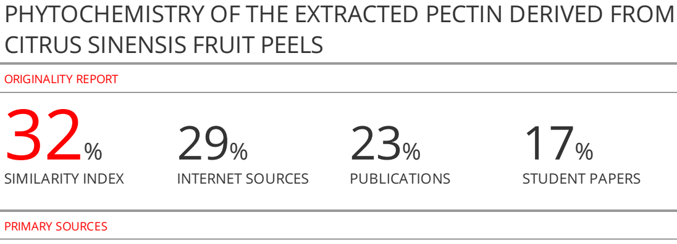

**PHYTOCHEMISTRY OF THE EXTRACTED PECTIN DERIVED FROM *CITRUS SINENSIS* FRUIT PEELS**

**ABSTRACT**

Pectin is a natural polysaccharide commonly extracted from citrus peels under mild acidic conditions. It is a promising multifunctional pharmaceutical excipient and has been investigated for its use in oral solid dosage forms.The research work was aimed at the extraction and characterization of the extracted pectin from *Citrus sinensis* fruit peels. The pectin was obtained using acidified waterbased extraction in Soxhlet apparatus. To characterize the extracted pectin, phytochemical screening was carried out and micromeritics properties, flow behavior, viscosity and swelling index were calculated. Using acidified waterbased extraction method, 8.00% yield of pectin was obtained. The result revealed that the extracted *Citrus sinensis* fruit peel pectin exhibited good flow properties (angle of repose 29 ± 02), 2.03 % w/w total ash and -0.70% loss on drying. The pH was found to be 3.5, and this showed that this can be used in oral dosage form without any irritation. Extracted pectin was soluble in warm water, methanol and hydrochloric acid. It formed lumps in cold water and insoluble in some organic solvents like ethanol, acetone and alkali.The estimated molecular weight was 1.44 x 105. Results of evaluated parameters showed that *Citrus sinensis* peel derived pectin can be used as pharmaceutical excipient to prepare solid oral dosage form like tablets and powder for oral suspension

**Key words**: *Citrus sinensis,*Pectin, Extraction, Characterization, Pharmaceutical excipient, Powder for oral suspension

**INTRODUCTION**

Pectin, a multifunctional constituent of cell wall is a high value functional food ingredient. It is produced commercially as a white to light brown powder, mainly extracted from citrus fruits. Pectin is a linear chain of α-(1,4)-D-galacturonic acid that forms the pectin-backbone [1].Extracted pectin from *Citrus sinensis*fruit peels being a natural polysaccharide has some advantages over semi-synthetic and synthetic polysaccharides which may include; low toxicity, biodegradable, biocompatibility, cheap and readily availability.Pectin are mainly used as gelling agents, but, can also act as thickener, water binder and stabilizer [2,3]. Its gelling activity which is the most important attribute of pectin as a pharmaceutical excipient, is influenced by the content of methoxy groups. Low methoxyl pectin (< 50% esterified) form thermos reversible gels in the presence of calcium ions and at low pH (3.0–4.5) whereas high methoxylpectins rapidly form thermally irreversible gels in the presence of sufficient (for example, 65% by weight) sugars such as sucrose and at low pH (< 3.5); the lower the methoxyl content, the slower the set” [4, 5]. The study was designed to extract the pectin from *Citrus sinensis* fruit peels, to ~~study~~ the physicochemical characteristics and to ~~study~~ its micromeritics properties as a pharmaceutical excipient. Different parameters such as particle size analysis, bulk density, tapped density, true density, angle of repose, Carr’sindex, bulkiness and the determination of the viscosity and swelling index of *Citrus sinensis* fruit peels pectin were investigated. The extracted pectin from *Citrus sinensis* has gelling properties that makes it a good binder and stabilizer for tablets and suspensions respectively[6].

**MATERIALS AND METHODS**

**Sample collection/preparation**

*Citrus sinensis* fruits were purchased fromObla orchard, Ajobe, Otukpo LGA, Benue State as *Citrus sinensis* fruits. This *Citrus sinensi*s fruits were authenticated/identified by Prof. G.E Omakhua, Department of forestry and wild life management, Faculty of Agriculture, University of Port Harcourt as *Citrus sinensis* (L). Osbck. Family Rutaceae, with herbarium number UPHRO477 and the specimen preserved in the University herbarium for future references. The peels were carefully removed and washed. They were dried under shade for 14 days,then, furtherdried in an oven at 30–40ºC until constant weight was obtained. The dried fruit peels were cut into pieces and powdered in electric grater. The powdered peel was further passed through sieve # 20 and stored in air tight container.

**Extraction of pectin involved two steps**

**Step1: Extraction of Pectin**

The pectin was extracted under reflux using water acidified with hydrochloric acid to pH 2.2. The temperatureof extraction media was maintained at 120ºCand duration of extraction was about 60 min. The extractor consisted of a Whatmann, cellulose thimble with 33 mm internal diameter and 80 mm external length. The drypowdered*Citrussinensis*fruit peel was taken in soxhlet and reflux was continued for 60 min. [4, 5].

**Step2: Isolation of Pectin**

The hot acid extract was pressed in cheese cloth bag and the concentrated juice was cooled to 4ºC. Pectin was precipitated by 2:1 (v/v)alcohol-juice treatment, followed by continuous stirring for 15 min. The mixture was further allowed to stand for 2 h for better pectin precipitation. Floating pectin coagulate was filtered through cheesecloth, washed with alcohol (95%) and pressed. Thepressed pectin was further dried to constant weight at 35–45ºC in hot air oven. Hard pectin cake was ground and sieved through sieve # 20, stored in desiccator for further use [4,5].

**Physico-chemical analysis of the extracted pectin**

**Test for carbohydrate**

Molisch’s test

500 mg of the extracted pectin was dissolved in purified water and made up to 50 mL and the resulting 1%w/v extracted pectin-solvent system was subjected to the test. Two drops of α-naphthol solution were added to 2 mL of the extracted pectin-solvent system. Concentrated sulfuric acid was added in drops to the inclined test tube containing the 1%w/v extracted pectin- solvent system and the color change was observed and recorded. The determination was done in triplicate.

**Test for protein**

Million’s test

A few drops of million’s reagent were added to 2 ml of the extracted pectin-solvent system, and observed. The precipitate formed was observed and recorded. This determination was done in triplicate, and all the readings were taken

**Tests for alkaloids**

Dragendorff’s test

A few drops of Dragendorff’s reagent (Bismuth and potassium iodide) were added to about 2 mL of the extracted pectin-solvent system, and the color change was observed and recorded. Triplicate determinations were made and all the results were taken.

Wagner’s test

A few drops of Wagner’s reagent (solution of sodium and potassium iodide)were added to about 2 mL of the extracted pectin-solvent system, and the color change observed was recorded. This determination was carried out in triplicate.

Hager’s test

A few drops of Hager’s reagent (saturated picric acid solution) were added to about 2 ml of the extracted pectin-solvent system and the color change was observed and recorded. This determination was carried out in triplicate.

**Test for saponins**

Frothing test

About 2 mL of the 1%w/v extracted pectin-solvent system was added to 2 mL of freshly prepared distilled water in a test tube and the mixture was vigorously shaken and the test tube was observed for a while and the observation was recorded. This determination was carried out in triplicate.

**Test for flavonoids**

Ammonium test

About 2 mL of the extracted pectin-solvent system was added to 2 mL of dilute ammonia solution, then few drops of concentrated sulfuric acid were added, and the observations were recorded. The determination was carried out in triplicate.

Aluminum chloride test

Few drops of 1%w/valuminum chloride solution were added to about 2 mL of the extracted pectin-solvent system and observed. The determination was carried out in triplicate.

**Test for tannins**

Ferric chloride test

Two drops of 0.1 % w/v ferric chloride solution were added to about 2 mL of the extracted pectin-solvent system and the observation was recorded. The determination was carried out in triplicate[7].

**Determination of ash values of *Citrus senensis* fruit peels**

Total ash

Three clean and dry nickel crucibles were placed in a furnace for about 15min at 35 0C, then kept in a desiccator for about one hour to cool. The crucibles were then weighed and tagged, W0. A 2 g of the drug material was weighed and transferred into each nickel crucible W1. These were gently heated and gradually increased until all the drug materials were charred and the carbon vapourised and the residue was free from carbon and the ash was white. The crucibles were removed with the help of a long fork, allowed to cool in a desiccator and reweighed (W2). Percentage ash content was determined by the formula;

Total ash= $\frac{W2-W0}{W1} ×100$ Eqn. 1

Where W2 is the weight of crucible and sample after incineration W0 is the weight of empty crucible, and W1 is the initial weight of the drug before incineration. This determination was carried out in triplicates and all the results were taken.

Water soluble ash

A 25 mL of purified water was added to the total ash and boiled for 5 min. This mixture was filtered using ash less filter paper (Whatmann’s No1) of known weight (W0). After washing the residue with hot water and the filter paper was dried in an oven at 105 0C until a constant weight (W2) was obtained. The percentage water soluble ash was determined using the formula:

Weight of residue = W2 – W0

Water soluble= Eqn. 2

Where W0 is the weight of an empty crucible, W1 is the weight of drug material before incineration, and W2 is the weight of crucible and the ash.

These determinations were carried out in triplicates and the mean taken [8]

**Organoleptic evaluation of the extracted pectin**

The organoleptic properties of the extracted pectin powder like the color, odor, taste, shape and texture were investigated and recorded. These were done in triplicates and the observations were recorded.

**Moisture absorption/hysteresis of the extracted pectin**

This was carried out under different relative humidities of52 % RH (potassium nitrate), 75 % RH (Sodium chloride), 84 % RH (potassium chloride), 96 % RH (potassium sulfate). These salts were dissolved in some freshly distilled water until saturated and left for seven days. The empty containers were weighed, W0, then 0.5 g of the extracted pectin was weighed into various already weighed containers and then reweighed, W1. These containers with the extracted pectin W1 were left in the different desiccators of different relative humidity for 72 h. After 72 h each container and its content was re-weighed as the final weight W2.

Where the extract weight is W1 – W0, Change in weight of extract is W2 – W1

%Moistureabsorption= $\frac{W2-W1}{W1-W0} ×100$ Eqn.3

These determinations were done in triplicates and all the results were recorded.

**Swelling Index of the extracted pectin**

1 g of the extracted pectin was accurately weighed and transferred into a 50 mL graduated measuring cylinder and tapped to obtain the tapped volume, vt. Then, a dispersion of the powdered pectin extract was made in 40 mL of distilled water and thoroughly agitated. The volume was made to 50 mL with more distilled water and allowed to stand undisturbed for 24 h on a flat surface and the volume of the sediment formed, vs noted. Triplicate determinations were done, and the swelling index for the extracted pectin was calculated as a percentage using the formula in equation 4

$S.I =\frac{Vs-Vt}{Vt} ×100$ Eqn.4

Where vs is the volume of sediments, vtis the trapped volume. [9].

**pH determination of the extracted pectin**

A 1 g of the powdered extracted pectin was dispersed and made up to 50mL in distilled water with vigorous shaking for 3 min and allowed to settle to make 2 % w/v of the extracted pectin-solvent system. The pH was determined using a pH meter (Hanna® USA). Triplicate determinations were made and the results recorded [10].

**Solubility of the extracted pectin**

Distilled water was added drop wise to a 0.5 g portion of the extracted pectin until submerged, then vigorously agitated, visually observed and the observations were recorded. The same procedure was repeated using methanol, acetone, alkali, and 0.1 N HCl solution. The determinations were carried out in triplicates [11].

**Relative viscosity of the extracted pectin-solvent system**

4%w/v Stock dispersion of the extracted pectin-solvent system was prepared by weighing and dissolving 2 g in distilled water and the volume made up to 50 mL. Serial dilutions of the dispersion were made using distilled water to produce; 0.05, 0.125, 0.5, 1.0, 1.5, 2.0, and 2.5 % w/v respectively.

Using the U-tube viscometer, (PSL, England), the average time of flow of the different serial dilutions of the dispersion were determined at room temperature. Also the mean flow time for purified water was also determined.

Then using the formula in equation 5 below, the viscosity was determined for both the extracted pectin-solvent system and purified water. The equation was used to calculate the viscosities of the pectin extract dispersion at different concentrations. All the determinations were done in triplicate.

Relative viscosity n = kÞt Equation 5

Where n is viscosity of the solvent, Þ is the density of the solvent, K is the viscosity constant for the solvent, t is the time of flow of the extracted pectin [12].

**Intrinsic viscosity of the extracted pectin-solvent system dispersion**

In the determination of intrinsic viscosity, the least concentration of the dispersion which is the concentration closest to that of the solvent was used, and in this case 0.05 %W/V.

Nrel = t/t0,Equation 6

Where t and t0 are the time of flow for the pectin extract-solvent system and distilled water respectively.

Then, using Bill Meyer’s equation, the intrinsic viscosity, Nint could be calculated;

Ñint= Eqn.7

Where Nrelis the relative viscosity, C is the concentration of the extracted pectin-solvent system, andNintis the intrinsic viscosity.

**Estimation of the molecular weight of the extracted pectin**

Mark and Houwink in 1938 and 1940 respectively independently connected the intrinsic viscosity with molecular weight.

[Nint] = kMa Equation 8

Where, M is the molecular weight, k and a, the Mark–Houwink constants respectively were determined experimentally by measuring the intrinsic viscosity of several pectin polymer samples for which the molecular weight has been determined by an independent method; osmotic pressure or light scattering [13].

**Loss on drying**

1 g of hydrogel powder was weighed accurately in a tared glass stoppered bottle and was dried in a hot air oven at 105°C and the weight was checked at intervals of 1 h, until a constant weight was obtained. The percentage of weight lost by the powder was calculated [5, 6].

% Loss on Drying; LOD = $\frac{W3-W2}{W2-W1} ×100$ Eqn. 9

Where, W1 the weight of empty container, W2 the weight of empty container + moist material, W3 the weight of container + dry material.

**True density**

Among various methods available for the determination of true density, liquid displacement method was used in the present study andn-hexane was selected as the liquid for displacement, because, pectin is insoluble and heavy in n- hexane. This method has been used by several authors [5, 10, 11].

The non-solvent liquid used is n-hexane. The empty dry 25 mL pycnometer (Mettler, Germany) was weighed and recorded as W1. A 0.5 g of the extracted pectin was accurately weighed and poured into a 25 mL pycnometer and the pycnometer and its content weighed and recorded as W2.The extracted pectin was discharged and the pycnometer was filled with n- hexane and covered. The spills were cleansed and the liquid and the pycnometer were weighed and recorded as W3. The pycnometer was emptied and 0.5 g the extracted pectin was weighed and poured, then, the remaining space was filled with n-hexane, weighed and recorded as W4.These determinationswere carried out in triplicate.

Density of sample = $\frac{W2-W1}{\left(W3-W1\right)-(W4-W2} ×0.6606$ Eqn.10

Where 0.6606 is the relative density of n-hexane.

**Flow characteristics of the extracted pectin were determined by;**

**Angle of repose and the flow rate**

The angles of repose of the extracted pectin was determined using the static method with some modifications. A 13.5 cm long plastic pipe opened at both ends with internal diameter of 4 cm wasplaced on a paper on a flat surface and 50 g of the extracted pectin was poured from the upper end. The pipe was lifted up to discharge the extracted pectin powder to form a heap of height, h and the edge of the powder heap was carefully marked without distortion to estimate its diameter. The time it took the extracted pectin powder to flow through the long plastic pipe was also recorded.

These determinations were carried out in triplicate and the mean taken. The angle of repose was calculated using the formula in equation 11,

Ø= tan-1 (2h/d) Equation 11

Where h is the height of the granule heap, d is the diameter of the heap and Ø is angle of repose.

**Flow rate**

The flow rate of the granule was calculated using the formula;

Flow rate = $\frac{Mass of granules (g)}{Time of flow (min)}$ Equation12

**Bulk density**

A 20 g quantity powder of the extracted pectin was weighed and transferred into a clean and dry 25 mL glass measuring cylinder and placed on a smooth flat surface. The volume occupied by the granules was noted. The determination was done in triplicate and the densities calculated according to the formula in equation 13.

Bulk density = $\frac{Mass of granules (g)}{Bulk volume (mL)}$ Eqn.13

**Tapped density**

A 20 g quantity the extracted pectin powder wasaccuratelyweighed using digital electronic weighing balance and then transferred into a clean and dry 25 mL measuring cylinder placed on a flat smooth surface. The measuring cylinder was tapped on the smooth-flat surface from a height of about 4cm until a constant volume was obtained. Triplicate determinations were made and the readings taken, and the densities were calculated using the formula;

Tapped density = $\frac{Mass of granules (g)}{Tapped volume (mL)}$ Eqn.14

**Melting point determination of the extracted pectin powder**

The open capillary method using Stuart melting point apparatus (Bibby Scientific Ltd, UK) was used to determine the melting point of the extracted pectin powder at room temperature. Small quantity of the extracted pectin powder was packed into a sample capillary tube. The capillary tube containing the extracted pectin powder was inserted into the melting point apparatus and the temperature over which the powder melts (°C) in the tube was recorded as the melting point. This determination was done in triplicate [15].

**Scanning electron microscopy (SEM)**

The elucidation of morphologic characters of the extracted pectin powder was carried out using scanning electron microscopy. A 5 mg of the powdered extract was dispersed in distilled water and smeared on a microscope slide using a glass rod. The mixture was covered with a cover slip and viewed using a polarized photomicroscope (Hind Weltzlar Germany), attached with a motic image analyzer which is an automated imaging system at a magnification of X100. The particles were sized in the motic image analyzer and the image of the particles was also captured, and the morphology of the extracted pectin was assessed by the scanning electron microscope as micrograph of the sample [5]

**Fourier transform infrared (FTIR)**

The power in the machine, (Agilent Technology Cary 630 FTIR, California) was turned on and allowed to warm for about 15 min. then, the computer, PC attached to the system was also turned on and double clicked on Micro-lab. PC window icon, waited until the computer opened. The sampling operation was initiated by starting and selecting the appropriate method; absorbance or transmittance, but, transmittance was selected. The crystal was properly cleansed with organic solvent and checked against collecting background. 15 mg was taken, closed and pressed to make a pellet on top of the crystal and the alignment of sample was checked. All the samples were appropriately coded for identification, then, the machine was set for sampling. After sampling, the ‘peak’ was picked and selected for labeling. The peaks were printed as spectra [5]

**Powder x-ray diffraction (PXRD) of the extracted pectin**

The x-ray diffraction patterns of the extracted pectin was obtained by x-ray diffraction analysis of the powder at room temperature using a PanalyticalXpert Pro Diffractometer (PANalytical J B Eindhoven, Netherlands).The measurement conditions were as follow; the target metals Cu, Kα filter, voltage 40 kV, current 40 mA. The analysis were performed at 2-theta range of 5-80 º,150 mg of the sample was placed on the sample holder and leveled to prevent particle orientations during sample analysis. The diffractogram of the sample was recorded as a print [16].

**Results and Discussion**

Yield of the pectin extracted from *Citrus sinensis* fruit peel

An alcoholic extraction of *Citrus sinensis* fruit peels was carried out in acidic medium and pectin extract was obtained. The percentage yield was 8 %W/W as shown in Table 1. This confirms earlier report, though, lower value as earlier report ranges from 12-14 % [16]. This may be due to the differences in the working temperatures. For their work, the temperature was 95 ºC and the period of extraction was 105 min., and the pH used was 1.5. Whereas, in this case the working temperature, extraction period and pH were 120 ºC, 45 min. and the pH 2.2 respectively. The higher temperature of 120 ºC may had resulted in the degradation of the extracted pectin. The shorter period of extraction could had resulted in lower yield as well as the higher pH. For maximum extract pectin yield; the pH should be lower than 2, the extraction period must be long enough, about 2 h and the temperature should be lower than 100 º C. This agrees with the earlier findings [17, 18]. The yield also decreases with increase in fruit maturation [19].

**Phytochemical evaluation of the extracted pectin**

The constituents of the extracted pectin were evaluated and presence of carbohydrate, protein, alkaloids, and mucilage were detected as shown in Table 1. Ash values that designate the degree of purity and/or adulteration of a drug substance was evaluated. The values obtained for total ash, water insoluble ash, and water soluble ash were 3.68, 1.65, and 2.03 % respectively. These low values of ash signified that the extracted pectin was pure [20]. The phytochemical constituents of the extracted pectin is in accordance with the reported findings of *Citrus sinensis* peels [21]. Also the ash values determined is in agreement with the earlier reported values that ranges from 2 to 6 % [22].

Table 1: Physicochemical characteristics of the extracted pectin

|  |  |
| --- | --- |
| Parameter Result | |
| Percentage yield (%) | 8.0 |
| Loss on drying (%) | 0.70 |
| Carbohydrate | + |
| Protein | + |
| Alkaloids | + |
| Mucilage | + |
| Gum | + |
| Saponins | - |
| Flavonoids | - |
| Tannins | - |
| Total ash | 3.68 ±0.17 |
| Acid insoluble (%) | 2.43 ± 0.00 |
| Water insoluble (%) | 1.65 ± 0.01 |
| Water insoluble (%) | 2.03 ± 0.00 |
| Surface tension (dynes/cm2) | 35.20± 0.15 |

KEY: + Presence, - Absence.

**Organoleptic properties**

Organoleptic evaluations are sensory characterization that helps in the identification of a crude drug material and/ or excipient. Organoleptic evaluation of *Citrus sinensis* alcoholic pectin extract was carried out using sensory organs to evaluate the texture, color, odor, and taste of the extracted pectin [23]. The result revealed that it was a rough and irregular, brownish and odorless amorphous powderwith orange juice taste, amorphous powder as shown in Table 2. This is in agreement with earlier reports on extracted pectin [24].

**Moisture absorption capacity**

Moisture absorption capacity of a material gives an idea on its ability to absorb and retain moisture, thus, aids dosage formulators on choice of packaging materials and storage conditions. The extracted pectin had different moisture absorption capacity depending on the relative humidity; at 54, 75, 84, and 96 % RH, the moisture absorption capacity were determined to be 20, 08, 20, and 24 % respectively. This result indicated that the extracted pectin was most stable at 75 % RH as it absorbed the least quantity of moisture at this relative humidity as shown in Table 2. The implication of the findings is that hygroscopic and/or deliquescent drugs should not be formulated into dosage form using pectin extract as an excipient; a binder, a suspending agent, and/or carrier. However, if used in such formulations, the medicament must be packaged in air-tight containers [25].

**Swelling index**

Swelling index is the volume (in mL)taken up by the swelling of 1 g of test material under specified conditions. Swelling index of a material dictates the fragmentation of the granules during dissolution, release of drugs from its dosage form and subsequent absorption of the medicament. The swelling index for the extracted pectin determined was 2.30 ± 0.01 as shown in Table 2. This means that the extracted pectin retains about twice as much water of the trapped volume of its dry powder. This is an indication that if any of these excipients were to be used in the formulation of granules and/or tablets are likely to act as a good dis- integrant thereby releasing the active pharmaceutical ingredients readily for dissolution and subsequent absorption [14].

**PH determination of the extracted pectin**

The pH of a formulation to a greater extent determines the point of release/dissolution of its medicament and subsequent absorption. For oral dosage forms, the release of the drug depends on the pH of the gastrointestinal tractthrough which the dosage form passes. The pH of the extracted pectin -solvent system determined was 3.50 ± 0.2 as shown in Table 2 which is near the value for pH of the stomach. It makes it safe and comfortable for the patient and good for oral formulations [10].

**Solubility tests for the extracted pectin**

The solubility of a drug material and/or excipient is one of the criteria for its oral formulation as the solubility of a dosage form has a direct link with its dissolution and subsequent absorption. The extracted pectin was insoluble, formed lumps in cold water but, it was well dispersed in hot water. It was insoluble in alkali, acetone, ethanol, but, soluble in methanol and hydrochloric acid. This result is shown in Table 2 [24].

**Relative viscosity and intrinsic viscosity**

Suspending agents are thickeners and viscosity enhancers. The relative and intrinsic viscosity determined for the extracted pectin were 3.73 and 33.45 cP for 0.05 %w/v dispersion respectively. The viscosity at room temperature was approximately 0.91cP (BP, 2012). The viscosity of the extracted pectin being higher than that of water has the tendency of increasing the viscosity of the suspension when reconstituted. These determinations were made at a concentration of 0.05 %w/v, but, the concentration of the extracted pectin at which suspending activity could be achieved was 3.0 %w/w. This indicates that at this higher concentration, there would be better viscosity enhancement. However, at this higher concentration, the extracted pectin-solvent system is non-Newtonian (dilatant) which expands on agitation (Aulton, 2018). These results are shown in Table 2.

**Estimated molecular weight of the extracted pectin.**

The extracted pectin is a polymer consisting of many monomer units joined together. This makes it to be of high molecular weight. The calculated estimated molecularweight was 1.44 x 105 g/mol. as shown in Table 2.This estimated molecular weight obtained from this work is within the range of 5.0 x104 – 1.8 x105 g/mol. reported by previous workers[26, 27]. Thus, on addition of the extracted pectin to the dispersion medium will certainly increase the viscosity of the dispersion medium and/or vehicle, thereby making it a good suspending agent.

Table 2: Physico-chemical evaluation of the extracted pectin.

|  |  |
| --- | --- |
| Parameter | Extracted pectin |
| Color | Brown |
| Odor | Odorless |
| Taste | Orange fruit juice. |
| Texture | Rough, irregular |
| 52 % RH | 20 ± 0.01 |
| 75 % RH | 08 ± 0.00 |
| 84 % RH | 20 ± 0.00 |
| 96 % RH | 24 ± 0.00 |
| Swelling index (%) | 2.30 ± 0.01 |
| pH | 3.5 ± 0.2 |
| Solubility; |  |
| In cold water | Insoluble/ lumps. |
| In hot water | Suspension/gel. |
| Acetone | 1nsoluble |
| Ethanol | Insoluble |
| Alkali | Insoluble |
| Methanol | Soluble |
| Dil. HCl | Soluble |
| Relative viscosity (cP) 0.05 %w/v | 3.73 |
| Intrinsic viscosity (cP) 0.05 %w/v | 33.45 |
| Estimated molecular weight (g/mol) | 1.44 x105 |

**Flow properties of the extracted pectin**

Micromeritics study data of pectin for bulk density and bulkiness, true density, total porosity, powder flow behavior is shown in Table 3. The bulkiness value indicated that powder is ‘heavy’ in nature. Pectin exhibited good flow characteristics.

**Angle of repose**

The angle of repose for the extracted pectin is shown in Table 3 and its angle of repose calculated range was 29.00 ± 0.02. Though, there was a significant difference (p<0.05). This indicates a good flow into the final container, the extracted pectin powder will not stick together, and could also produce good tablets with minimal tablet weight variation [28].

**Bulk and Tapped density**

The bulk and tapped densities of the extracted pectin powder evaluated are shown in Table 3. The bulk densities were consistently less than the tapped densities of the extracted pectin powder which indicates reduction of powder volume on tapping. The bulk density calculated was 0.35±0.01 and that of tapped density was 0.42±0.00 g/mL for the extracted pectin.There was no significant difference in the bulk densities (p<0.05). It was also similar in the tapped densities.

**Hausner’s quotient and Carr’s index**

The Hausner’s quotient of the extracted pectin powder was 1.20 ± 0.00 and Carr’s index was 15.00 ± 0.01 % as shown in Table 3. These are good flow indices which means the extracted pectin are loose as powders in their final pack/containers or tableting. Good flow-ability is desirable in proper die filling and production of tablets with very limited tablet weight variation [28]

**Flow rate of the extracted pectin powder**

The calculated flow rate of the extracted pectin is shown in Table 3 and it was 5.46 ± 0.01 g/min. which is a good flow property while filling the final containers and would begood for preparation of good powder for suspension and tablets with good physical properties; weight and content uniformity, hardness and friability. Though a significant difference (p<0.05)

**Particle density**

The determined particle density was 1.57 ± 0.01 as shown in Table 3. This is the density of the particulate solid or powder that make up the powder devoid of air or fluid or space [29, 30].

**Melting point determination of the extracted pectin**

The melting point for the pectin powder determined is shown in Table 3. The melting point was 1510C. This makes the extracted pectin to be stable and maintain its solid powder form at temperatures below this 151 °C. This result falls within the reports of previous workers; 150-154 ºC [31]. The melting point of the extracted pectin is high, therefore, caution should be taken in case of melting point depression when combined with the active pharmaceutical ingredients so that the melting point of the product will not be lower than those of the components excessively; excipients and active pharmaceutical ingredients [32].

Table 3: Micromeritics properties of the extracted pectin powder

|  |  |
| --- | --- |
| Parameter Result | |
| Bulk density (g/mL) | 0.35 ± 0.01 |
| Tapped density (g/mL) | 0.42 ± 0.00 |
| Angle of repose (0) | 30 ± 0.04 |
| Flow rate (g/sec) | 5.46 ± 0.01 |
| Carr’s (%) | 15 ± 0.01 |
| Hausner’s quotient | 1.2 ± 0.00 |
| Particle density (g/mL) | 1.57± 0.01 |
| Melting point | 151 ± 0.33 |

**Scanning electron microscopy (SEM) of the extracted pectin**

The micrograph of the extractedpectin from *Citrus sinensis* fruit peels depicted the particle structure and geometric variations of the obtained bio-based material’s surface morphology, showing a rough and uneven aspect containing some fibers within the mixture. Also, the polysaccharide particles’ size and shape are different. The particles vary in shapes appearing as uneven pores, smooth, and highly irregular. Therefore, it is obvious that the presence of different polymers in the film affected the shape of the particles. This rough and uneven appearance may be due to drying process under shade. This result is in agreement with earlier reports [33].

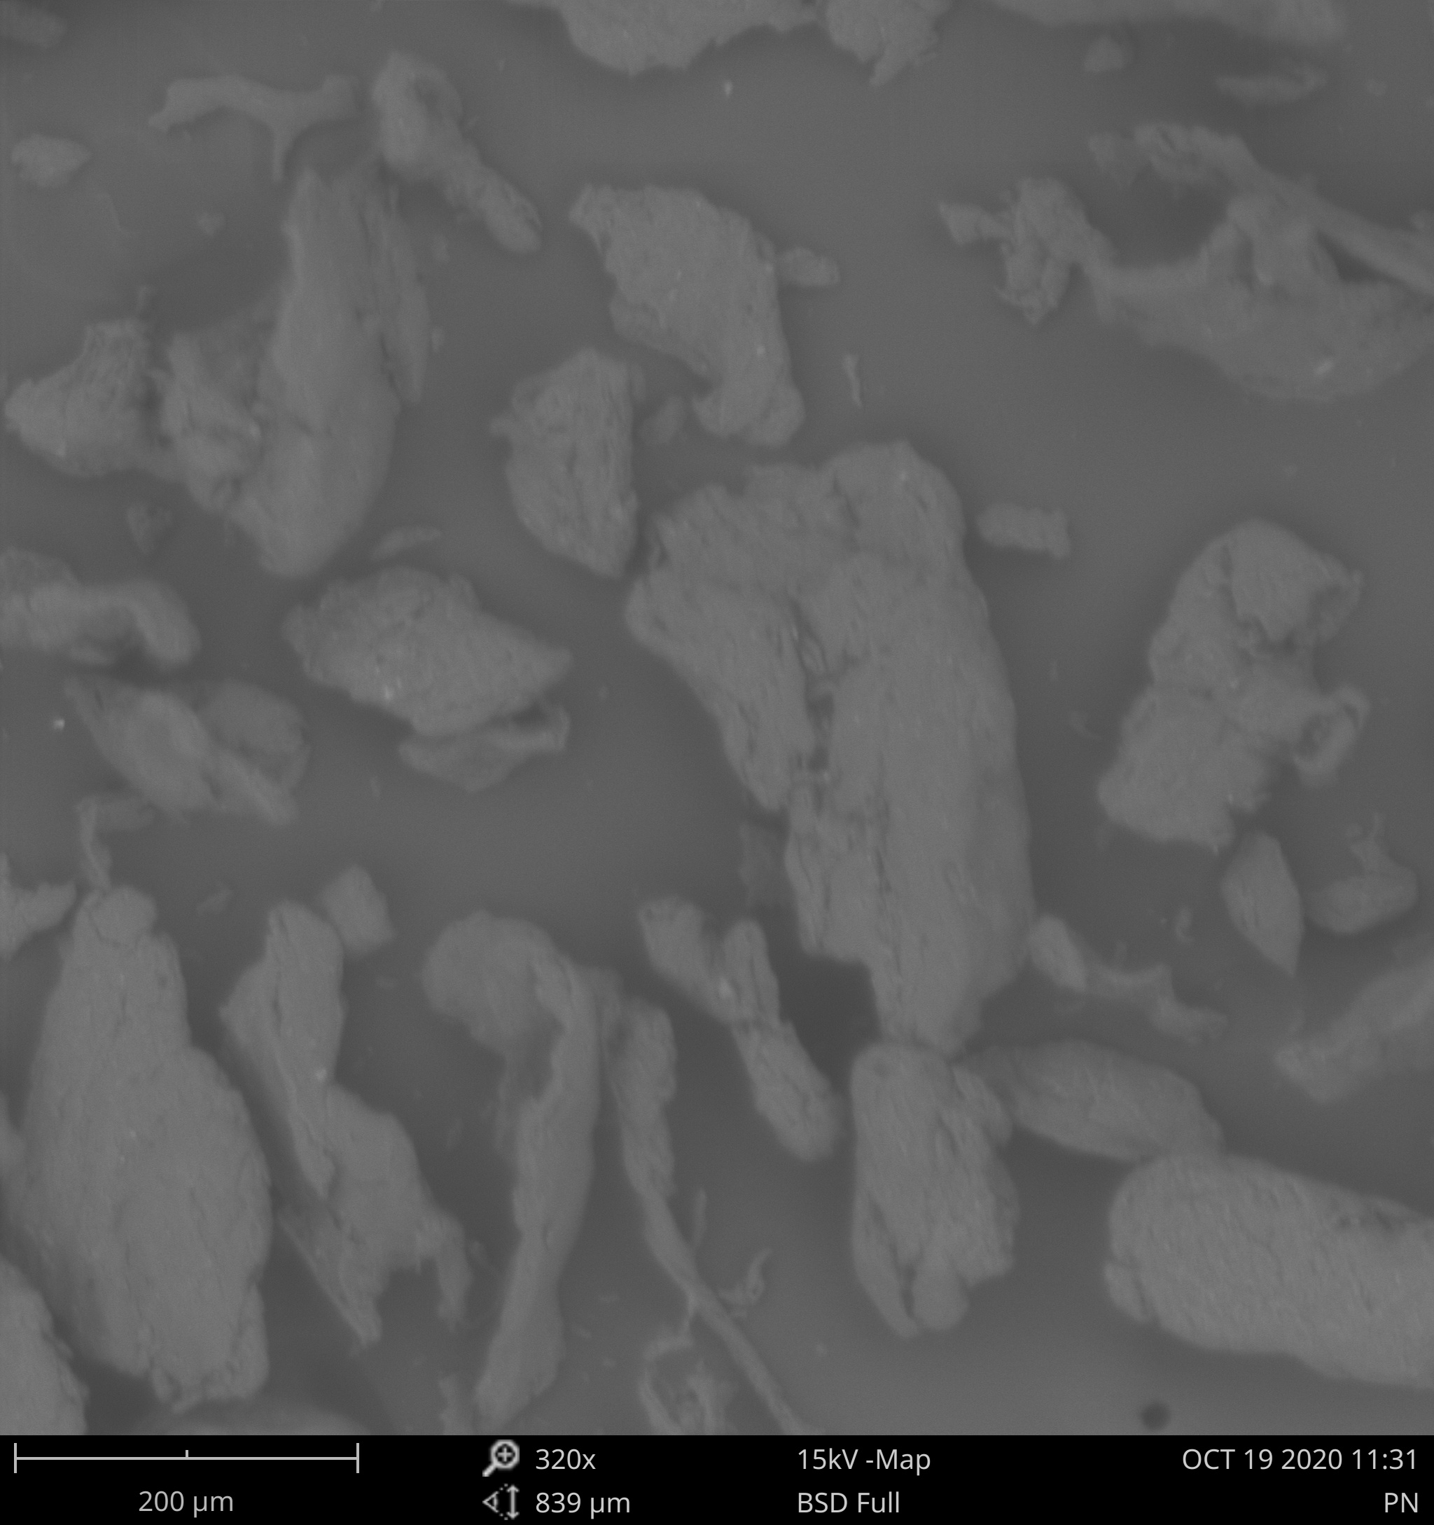Fig. 1: Micrograph of pectin

**Fourier transform infrared (FTIR) for the extracted pectin**

FTIR spectroscopy is an analytical technique used to identify organic, polymeric, and in some cases inorganic materials. The FTIR analytical technique uses infrared light to scan test samples and observe chemical changes. The resulting signal or the detector presents a spectrum which could be used as a great tool for chemical identification in the analytical process. A change in the characteristic pattern of absorption bands clearly indicates a change in the composition of the material or the presence of contamination. If by visual inspection, the problems are identified, then origin could be determined by FTIR micro analysis.The extracted pectin is made up of carboxylic and alcoholic hydroxyl groups. From the spectrum of the extracted pectin, the following peaks were deduced;1025 cm-1 for C = O, 1237.5 cm-1 for OH, 1319 – 1420 cm-1 for – OH - , 1638 cm-1 for C = C, 1990 – 2109 cm-1 for aromatic combination bands, 2818.5 cm-1 for methyl C-H and 3287.5 cm-1 for polymeric OH stretch as shown in Fig 2 [34]

Since the peak are more than 5 each for the extracted pectin shows that they are complex molecules [35]. Each molecule or chemical structure will produce a unique spectral finger print of the sample, making FTIR analysis a great tool for chemical identification and/or contamination detection [36].

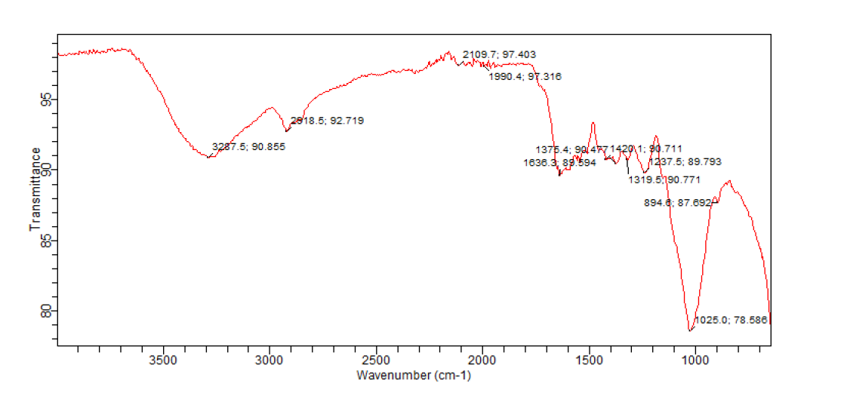

Fig 2: FTIR of the extracted pectin.

**X-Ray diffraction for pectin powder**

X-ray diffraction for powder is the evaluation of its crystal structure of the crystalline materials. It also reveals the chemical composition of the sample to be analyzed. It can distinguish the major, minor and trace compounds present in a sample. X-ray diffraction analysis includes the mineral name of the substance, chemical formula, crystalline system and reference pattern number from the International Centre for Diffraction Data, ICDD international database. Viewing the x-ray diffractogram of the extracted pectin from *Citrus sinensis*fruit peels shows a broad humped peak at 2Ø degree that is about 15, 19.5, 20, and 27 ° which reveals the amorphous nature of the extracted pectin powder as shown in Fig 3[37, 33]. The chemical composition include graphite 0.708, quartz 0.876, Brushite 1.169, Hydrophilite 0.708, pyrochlore 0.916, lime 1.121, calcite 1.195, calcium silver Aluminum silicate hydrate 3.088 [38].

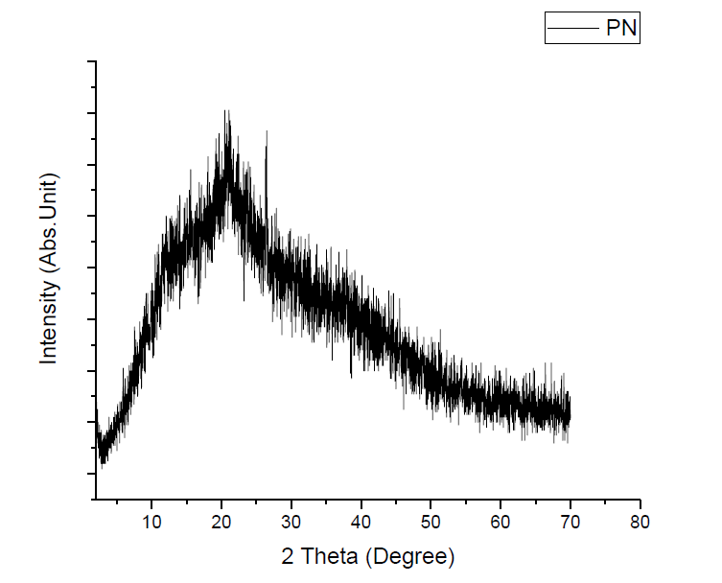

**LIMITATIONS OF THE STUDY**

**CONCLUSION**

The percentage yield of the extracted pectin from *Citrus sinensis* fruit peels was 8 %w/w as was reported by previous workers [16]. The phytochemical constituents of the extracted pectin include, but, not limited to carbohydrate, proteins, alkaloids, mucilage and gum [21] and the ash value of 2-4 % as earlier reported [22]. The result for the organoleptic properties revealed rough, irregular, brownish and odorless amorphous powder with orange juice taste [24]. The least moisture absorption of the extracted pectin occurred at 75 % RH and so had its highest stability at this humidity. The determined swelling index for the extracted pectin was 2.03 ±0.01 thereby making it a good delivery system [14]. The estimated molecular weight of the extracted pectin was 1.44 x 105g/mol. which is in agreement with previous workers report of 5.0 x104 – 1.8 x105 g/mol. [26, 27]

**Acknowledgements.**

The authors wish to sincerely appreciate the contributions of the Chief Executive Officers of Emzor Pharmaceutical Company, Lagos and SABHEIK Pharmacy, Port Harcourt, Rivers State for their sample donations.

The authors’ appreciation also goes to Dr. Nwachukwu and Mr. Bekweri of Department of Pharmaceutics and Pharmaceutical Technology, University of Port Harcourt, and Mr. Amadi of Pharmaceutics and Industrial Pharmacy Department, Madoona university, Elele. Rivers state for their technical assistance.

**Author’s Contribution**

**Conflict of interest**: Nil

**REFERENCES**

1) Knox J. P., Mikkelsen J. D., Willats W. G. T (2006). Pectin: new insights into an old polymer are starting to gel. Food Science and Technology, 17, 97–104.

2)Pilnik W., Kravtchenko T. P., Voragen A. G. C (1992). Analytical comparision of three industrial pectin preparations. Carbohydrate Polymer, 18, 17–25.

3) ScholsH. A., Voragen A. G. J (1996). Complex Pectins: Structure Elucidation Using Enzymes, Pectins and Pectinases. 1st ed. Else-vier Science B.V.: Amsterdam.

4) Malviya R., Srivastava P., Bansal M., Sharma P. K (2010) Mango Peel Pectin as Superdisintegrating Agents. Journal of Scientific and Industrial Research. 69, 688–690.

5) Malviya R (2011). Extraction and characterization of selected mucilage as a pharmaceutical excipients. Polim. Med. 41, 3.

6) Ogaji, I. J., and Hoag S. W. (2011). Effect of Grewia Gum as a suspending Agent in Ibuprofen pediatric formulation AAPS Pharm. Sci. Tech; 12(2): pp 507-513

7) Edeoga, H. O., Okwu, D. E., Mbaeble.( July, 2005). Phytochemical constituents of some Nigerian Medicinal plants. African Journal of Biotechnology 4(7) pp685-688

8) USP 28, N.F 23 United States Pharmacopoeia and National Formulary, 2005; the United States Pharmacopoeia convention, Rock ville, 2005.

9) Bowen FE, Vadino WA. (1984). A simple method of differentiating starches. Drug Dev Ind Pharm; 10;505-511. Accessed on 15 March 2018.

10) British Pharmacopoeia, vol. ii. (2012). Her majesty Stationary office, University press, Cambridge, London, A326-327, A478-479

11) Nwachukwu, N., and Ofoefule, SI. (2020) Effects of drying powder methods on the powder and compaction properties of microcrystalline cellulose derived from *Gossyiumherbaceum*. Braz. J Pharm Sci. 2020; 56: e18660.pp 3. Accessed on 10 September 2022

12) Nwachukwu, N.,andUbieko, E. A. (2020) In vitro quality assessment of ten brands of metronidazole benzoate suspensions marketed in Warri, Nigeria.

13) Masuelli, M.(2011). Osmotic study of pectin. Effect of temperature on the hydrodynamic properties. International Journal of Biological Macromolecules; 48: 286-291.

14) Jone, T.M., and, Pipel, N. (1996). The flow properties of granular Magnesia. J Pharm. Pharmacol;18: pp 81-93.

15) Kuntworbe, N., Acqual, F. A, Johnson, R., Ofori – Kwakye, K. (2018). Comparism of the physicochemical properties and in vivo bioavailability of generic and innovator artemether + lumefautrine tablets in Kumasi, Ghana. J Pharm pharmacogn Res. 6 (3) 167 – 178

16) Fakayode AO., Abobi KE. (2018). Optimisation of oil and pectin extraction from Citrus sinensis peels. A response surface approach. J Anal. Sci and Technol. 9(20): pp 1-16.

17)Mollea, C., Chiampo, F., Conti, R. (2008). Extraction and Characterisation of pectin from cocoa husks: A preliminary study. Science Direct Food Chemistry journal: pp1353-1356.

18) Pagan, J., Ibarz, A., Pagan, A., Babosa-Canovas, G.V. (2001). Extraction and Characterisationof pectin from stored peach pomace. Food Research International Journal; 34 (7): pp 605-612.

19) Phaviphu, K. (2018). Characterisation of pectin extracted from banana peels of different varieties. Korea Agricultural Science Digital Library

20) Swamy P., Mulla S. K. (2010). Preliminary pharmacognostical and phytochemical Evaluation of portulacaquadrifida Linn: Intl J. Pharm Tech Res. 2010, 2(3): pp 1699-1702

21) Chede PS. (2013). Phytochemical analysis of *Citrus sinensis* peel. Intl J Pharm Bio Sci.; 4(1): (B); pp 339-343.

22) Ceylan C., Bayraktar O., Atci E., Sarafi S. (2017). Extraction and Characterisation of pectin from fresh globe artichoke and can.ned artichoke waste. J Food Gida (2017) 42(5):568-576

23) Shulammithi, R., Sharnya M., Tejaswini R., Kiranmi, M. (2016). Standardization and quality evaluation of herbal drugs. IOSR Journal of pharmacy and Biological sciences (IOSR-JPBS) : 11(5): pp 89-100

24)Malviya R., Kulkarni G. (2012). Extraction and Characterisation of mango peel pectin as pharmaceutical excipient. Polim Med, 42(3-4): pp185-190.

25) Amidon, G. E., Houghton, M. E. (1995).The effect of moisture on the mechanical and powder flow properties of microcrystalline cellulose pharm Res, 12: pp 923-929

23) Aulton, M. E., Taylor K. M. G. Aulton’s pharmaceutics: The Design and manufacture of medicines (5thed); 2018: Pp. 440-445.

26) Sayah, M. Y., Chabir, R., Benyahia, H., RodiKandri, Y., QuazzaniChahdi F., Errachidi F., Touzani, H., *et al* (2016). Yield, Esterification Degree and Molecular weight Evaluation of pectins Isolated from orange and grape fruit peels under different conditions. PloS ONE 11(9) e0161751.https:// doi.org/101371/jounral.pone .0161751License. CC BY 4.0. Accessed 11 November 2022

27) Sinhar VR., Kumria R. (2001). Polysaccharides in colon-specific drug delivery. Intl. J Pharmaceutics : 224 (1-2):19-38.

28) The United States Pharmacopoeia. The United States Pharmacopoeial convention, Rockville, USA, 2009. Pp 358, 688-689.

29) Odeku, A. O. (2013).Potentials of Tropical Starches as pharmaceutical excipients. A review of starch starke, 65: pp 89-106.

30) Kunle O. O (2002). Review pharmaceutical grade starch and some of its potential sources in Nigeria. Journal of Phytomedicine and Therapeutics: 7(1 and 2): pp 1-17.

31) Athmaselvi KA, Kumar C, Balasabramanian M., Roy I. (2014). Thermal, Structural, and Physical properties of freeze-dried Tropical food powder. Journal of Food Processing vol. 2014 Article ID 524705, 10 pages. https.//dx. Doi.org/10.1155/524705. Accessed 15 October, 2022.

32)Feghe Q. (2018). In Accelerated Predictive Stability

33) Palanisamy C. P., Kanakasabapathy D., Tom Ashafa, A. O (2018). In vitro Antioxidant potential of Eucleacrispa (Thub) Leaf Extracts. Pharmacogn. Research; 10:296-300.

34)Baum A., Dominiak M., Vidal Melgosa S., William GT., Karen MS., Hansen PW., Meyer AS., Jorn DM. (2017). Prediction of Pectin Yield and Quality by FTIR and Carbohydrate Microarray Analysis; Food Bioprocess Technol 10, 143-154 (2017). https:// doi.org/10.1007/s11947-016-1802-2. Accessed on 18 August, 2021.

35) Asep N., Rosi O., Rish, R. (2019). How to read and interpret FTIR spectroscope of organic material. Indonesian Journal of Science and Technology. 4(1) 97-118.

36) Usman, U., Mohammed, G., Abdulkar, N., and Abdullahi, M. (2014) Ethno-botanical study of medicinal plants used for the treatment of malaria in Nupe land and North central Nigeria. Global Journal of Research on Medicinal plants and Indigenous medicine 3(4):112-126.

37) AbdelHamid EM., Moawad A., Hassan H., Ragaa M., Abd EL-Kader, Farid M., Hamed M., Essan N., and Rady A. (2022). Production and characterization of pectin by Acid Extraction Method from orange peels using Response Surface Method (RSM). Intl Journal of Industry and Sustainable Development, 3(1). Accessed 1st August, 2022. Pp 36-43.

38) Sindar, R.A., Rubila, S.,Juyabalan, R.,Rengaanathan T. V. A review on pectin: Chemistry due to general properties of pectin and its pharmaceutical uses. 1(12) 2012.