**Reviewer’s Comments**

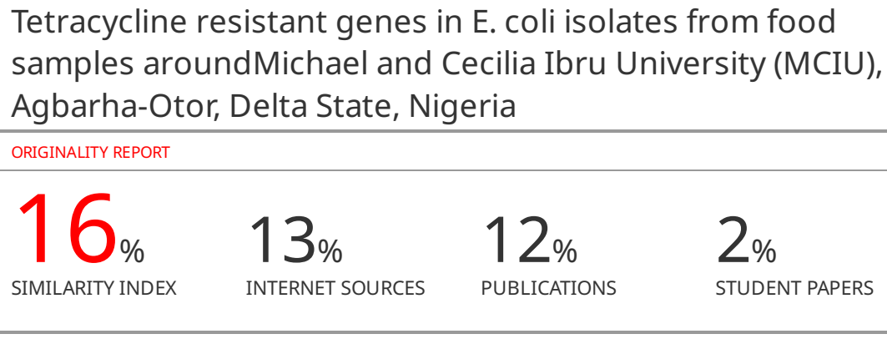

**Tetracycline resistant genes in *E. coli* isolates from food samples around Michael and Cecilia Ibru University (MCIU), Agbarha-Otor, Delta State, Nigeria**

**ABSTRACT**

**Background:** The impacts of antibiotic resistance on human health, environmental sustainability, and food safety are becoming a growing global concern. The spread of antibiotic-resistant genes throughout bacterial populations is one of the major factors causing this dangerous trend. The genes that give resistance to tetracycline, a popular antibiotic used in both human and veterinary medicine, are among the most worrisome antibiotic-resistant genes. Tetracycline treatment, a crucial weapon in the fight against bacterial infections, could be compromised by this resistance.

**Aim:** The assessment was conducted to determine the prevalence and spread of tetracycline - resistant genes within *E. coli* strains present in food samples obtained from local food vendors in and around Michael and Cecilia Ibru University, Agbarha-Otor.

**Methods:** Ten food vendors that the University population (especially students) patronize on a regular basis in Agbarha-Otor were selected for the study. Then, food samples were obtained from 6 out of 10 selected food vendors. A total sample size of 100 respondents were administered questionnaires. Four food types were collected from the six selected vendors leading to total food sample size of 28. About 25grams of food samples were homogenized with 225 ml of buffered peptone water (BPW) in an electric blender (Vitamix 5200 model). The homogenates were then subjected to pre-enrichment culture for 6 hours. Eosin Methylene Blue (EMB) agar was subsequently used as the culture media. About 0.5 ml aliquots of the inoculum were taken to extract DNA by the modified Boiling Lysis Method. Polymerase Chain Reaction (PCR) was performed using a thermocycler (Applied Biosystems, USA) for the detection of *tet*A gene in *E. coli* isolates using specific primers (*tet*A-F CGCCTTTCCTTTGGGTTCTCTATATC; *tet*A-R CAGCCCACCGAGCACAGG; Size = 182 base pairs). Thereafter, gel electrophoresis was done at 200 volts for 15 minutes and studied under UV light Gel Documentation System (Cleaver Scientific, UK). Statistical analysis was conducted using Chi-square tests to identify significant differences (p<0.05) in resistance patterns among the food categories.

**Results:** Tetracycline resistant gene (*tet*A) was investigated among 18 of 28 cultured samples which had *E. coli* growth indicating 64% prevalence. Electrophoresis results indicated the presence of *tet*A gene in 11 out of the 18 *E. coli* positive samples as the prevalence of *tet*A gene was 61%. The results suggested high prevalence of *tet*A induced tetracycline resistance in *E. coli* isolates as there was significant association between the presence of *tet*A gene and *E. coli*contamination in food vendor at MCIU (p<0.05). Lane 2,4,5,6,7 and 10, showed bands at 182 bp confirming the isolate contained *tet*A gene. Lane 5 showed additional bands at 780 bp which indicated possible superficial polymorphism of the *tet*A gene in isolates. The presence of bands at 182 bp confirmed the presence of the gene, and the presence of additional bands at 780 bp in Lane 5 suggested potential genetic variation in the *tet*A gene.

**Conclusion:** The study contributes to the broader understanding of antibiotic resistance patterns, gene prevalence, and genetic variations in bacterial isolates, with particular reference to *E. coli*. It underscores the need for continued surveillance and research into antimicrobial resistance, particularly in environments where *E. coli* contamination is of concern, such as food vendor settings.

**Keywords:** antibiotic resistance, tetracycline-resistant genes, *E. coli* strains, MCIU

**Introduction**

Antibiotic resistance is a growing global concern that has profound implications for public health, environmental sustainability, and food safety1. One of the key contributors to this alarming trend is the emergence and dissemination of antibiotic-resistant genes within bacterial populations. Among the most concerning antibiotic-resistant genes are those conferring resistance to tetracycline, a commonly used antibiotic in both human and veterinary medicine. This resistance has the potential to compromise the effectiveness of tetracycline treatment, a vital tool in combating bacterial infections2.

*Escherichia coli (E. coli*) is a ubiquitous bacterium found in various environments, including the intestines of humans and animals3. It is a well known fact that *E. coli* mainly exists in the human and animal gastrointestinal tract, despite its occurrence in the natural environment, especially in soil, water and plants4. The bacterium is renowned for its significant role in foodborne illnesses and has been widely studied due to its rapid reproduction and adaptability. As a result, *E. coli* serves as a valuable indicator of antibiotic resistance patterns in different ecosystems, including those related to food.

Tetracyclines are popular gram-negative and gram-positive bacteria-fighting antibiotics with a broad spectrum of activity. These medications interfere with protein synthesis and prevent aminoacyl-tRNA from binding to the 30s ribosomal subunit, which prevents the growth of susceptible bacteria5. Tetracyclines have many benefits, including being widely available, affordable, and having few adverse effects. As a result, these antibiotics are increasingly used to treat infections in both humans and animals. Tetracycline-resistant bacteria have now emerged as a result, limiting the usage of these drugs6.

Genes that are resistant to tetracycline are typically encoded as plasmids and transposons, and they are passed from one cell to another. But in other isolates, the necessary genes can also be identified in the chromosome7. Through the acquisition of tet genes, efflux pumps, ribosome protection, and enzymatic deactivation are the basic mechanisms of tetracycline resistance. The resistance to antibiotics is also influenced by mutations7. The *tet*A, *tet*B, *tet*C, *tet*D, and *tet*G genes code for efflux pumps, which are related to the tet genes that are most frequently found in gram-negative bacteria8. In essence, tetracycline resistance can be used to assess the genes responsible for antibiotic resistance.

Since food samples serve as potential reservoirs of antibiotic-resistant bacteria and genes due to their direct association with human consumption, the transmission of tetracycline resistance genes among *E. coli* strains isolated from food samples is of particular concern, as contaminated food products can serve as a vehicle for the dissemination of antibiotic-resistant bacteria into the human population9. The acquisition and dissemination of tetracycline resistance genes in *E. coli* isolates from food samples pose a potential threat to food safety and human health10. Therefore, by understanding the genetic basis and prevalence of tetracycline resistance in *E. coli* isolates from food sources is crucial for elucidating the dynamics of antibiotic resistance transmission and devising effective strategies to mitigate its impact. However, it was on the basis of the foregoing that the current study was conducted with the aim of assessing the prevalence and spread of tetracycline - resistant genes within *E. coli* strains present in food samples obtained from local food vendors within and around the Michael and Cecilia Ibru University (MCIU) campus at Agbarha-Otor, Ughelli, Delta State, Nigeria.

**Materials and Methods**

**Sample Collection and Processing**

Food samples were collected from different food vendors within and around the Michael and Cecilia Ibru University campus. A total of 10 vendors were selected, but samples were obtained from 6 out of the 10 vendors based on the frequency of patronage by the university populace, particularly the students. Semi structured questionnaires were distributed to a total sample size of 100 respondents. The privacy and anonymity of the food vendors and consumers were maintained throughout the study. Using appropriate hygiene procedures, 4 different food types were collected from the 6 selected vendors resulting in 28 total food sample size. The collected food samples were put in separate, sterile ziplocked bags and taken to the laboratory for examination within 2 hours after collection. In the laboratory, samples were weighed and approximately 25g of samples were homogenized with 225 ml of buffered peptone water (BPW) in an electric blender (Vitamix 5200 model). The homogenates were then subjected to pre-enrichment culture for 6 hours.

**Sample Culture and *E. coli* Isolation**

Eosin Methylene Blue (EMB) agar was used as the culture media and was prepared according to manufacturer’s instructions. About 15ml of the prepared, sterilized and cooled media were then poured into sterile petri dishes and allowed to solidify. Using a sterile pipette, 1ml of sample homogenate was inoculated then into media. The plates were then inverted and incubated at 44oC for 18 hours. To confirm the presence of *E. coli,* plates were checked for colonies with blue -black bull’s eye with or without greenish- metallic sheen after 18 hours. Thereafter, a colony counter was used to count the number of typical *E. coli* colonies on each plate

**DNA Extraction**

To extract DNA from isolates, a loopful of one typical colony per plate was re-inoculated in 5ml of buffered peptone water for 16 hours at 37oC. About 0.5 ml aliquots of the inoculum were taken to extract DNA by the modified Boiling Lysis Method11. About 1 ml sterile water was then added to the aliquots. Thereafter, they were vortexed and centrifuged at 12000 rpm for 3 minutes to sediment, while the supernatant was discarded. Sediments were further washed twice with 1 ml and 500 μL sterile water respectively vortexed and centrifuged as above. Then, sediments were resuspended in 500 μL sterile water and incubated at 95oC for 15 minutes in a dry heating block. After incubation, the mixture was freeze shocked for 10 minutes at -20oC and then centrifuged for 3 minutes at 12000 rpm. About 200 μL of supernatant was then transferred into a fresh eppendorf tube to be use as a DNA template. DNA was quantified to ensure that templates were pure and of high yield (>20ng) using Nanodrop 1000 Spectrophotometer (Thermoscientific, USA).

**Polymerase Chain Reaction (PCR)**

Detection of *tet*A gene in *E. coli* isolates was done using conventional PCR. Specific primers were used in order to identify the *tet*A gene (*tet*A-F CGCCTTTCCTTTGGGTTCTCTATATC; *tet*A-R CAGCCCACCGAGCACAGG; Size = 182 bp). Amplification was done in a 30 μl reaction mixture comprising 15μl of 1x GoTaq Green master mix, 0.6 μl each of forward (*tet*A-F) and reverse (*tet*A-R) primers, 12.8 μl nuclease free water and 2μl of template DNA. The PCR reaction was performed using a thermocycler (Applied Biosystems, USA) under the following program conditions: one cycle of initial denaturation at 94 °C for 5 min and 35 cycles for the other steps including a denaturation step at 94 °C for 30 s, annealing of primers at 55 °C for 30 s, and an extension step at 72°C for 30 s, followed by one cycle of final extension at 72 °C for 5 min. The amplification was confirmed through visualization on 1.5% agarose gel stained with 5μl Safeview dye. Gel Electrophoresis was done at 200 volts for 15 minutes and studied under UV light Gel Documentation System (Cleaver Scientific, UK).

**Data Analysis**

The prevalence of tetracycline-resistant *E. coli* isolates and the distribution of different tetracycline resistance genes across different food types were determined. Statistical analysis was conducted using Chi-square tests to identify significant differences (p<0.05) in resistance patterns among food categories.

**Results**

**Table 1:** Socio-demographics and Food Consumption Habits

|  |  |  |  |
| --- | --- | --- | --- |
| **Variables** | | **Frequency (%)** | **~~Percentage (%)~~** |
| **Gender** | Male | 45 (45.5) | ~~45.5~~ |
| Female | 54 | 54.5 |
| **Age** | 16-20 | 54 | 54.5 |
| 21-25 | 23 | 23.2 |
| 25-30 | 11 | 11.1 |
| 31-35 | 5 | 5.1 |
| 36-40 | 4 | 4.0 |
| 41-45 | 1 | 1.0 |
| 46-50 | 1 | 1.0 |
| **Designation at MCIU** | Student | 75 | 75.8 |
| Academic Staff | 8 | 8.1 |
| Non-Academic Staff | 12 | 12.1 |
| Others | 4 | 4.0 |
| **Duration at MCIU** | < 1 year | 36 | 36.4 |
| 1- <2 years | 19 | 19.2 |
| 2- < 3 years | 15 | 15.2 |
| 3 - <4 years | 13 | 13.1 |
| 4- <5 years | 7 | 7.1 |
| > 5 years | 9 | 9.1 |
| **Primary Source of Food** | Home made meals | 34 | 34.3 |
| MCIU Cafeteria vendors | 47 | 47.5 |
| off-campus food vendors | 18 | 18.2 |
| **Frequency of patronage (off-campus food Vendors)** | once daily | 11 | 61.1 |
| more than once daily | 4 | 22.2 |
| once a week | 3 | 16.7 |
| **Frequency of patronage (MCIU cafeteria food Vendors)** | once daily | 30 | 63.8 |
| more than once daily | 14 | 29.8 |
| once a week | 2 | 4.3 |

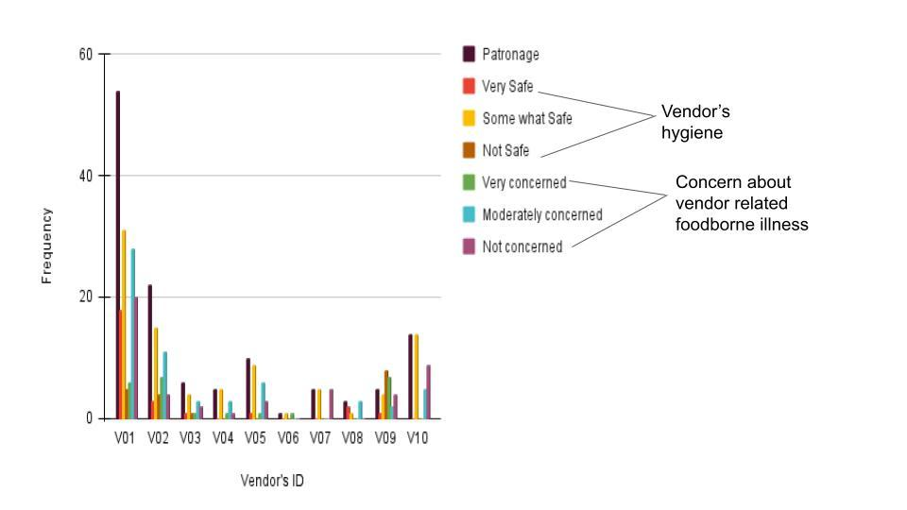

**Figure 1.** Frequency distribution of vendor’s patronage and participants’ perception of vendor’s hygiene/ food safety.

**Table 2:**Traveller’sdiarrhea history among participants with respect to gender

|  |  |  |  |
| --- | --- | --- | --- |
| X2 =1.343  P-value = 0.246 | **Traveller’s Diarrhea history** | |  |
| **Gender** | **No N(%)** | **Yes N(%)** | **Grand Total N(%)** |
| Female | 35 (64.8) | 19 (35.2) | **54** |
| Male | 24 (53.3) | 21 (46.7) | **45** |
| **Grand Total** | **59** | **40** | **99** |

*No significant association between gender and history of traveller’s diarrhea.

**Table 3.**Traveller’sdiarrhea history among participants with respect to Age

|  |  |  |  |
| --- | --- | --- | --- |
| X2 = 2.79  P-value = 0.59 | Traveller’sdiarrhea history | |  |
| Age Group | No N(%) | Yes N(%) | **Grand Total N(%)** |
| 16-20 | 36 (66.7) | 18 (33.3) | **54 (54.5)** |
| 21-25 | 12(52.2) | 11(47.8) | **23 (23.2)** |
| 25-30 | 5(45.5) | 6(54.5) | **11 (11.1)** |
| 31-35 | 3(60.0) | 2(40.0) | **5 (5.1)** |
| 36-40 | 2(50.0) | 2(50.0) | **4(4.0)** |
| 41-45 | 0 (0) | 1(100.0) | **1 (1.0)** |
| 46-50 | 1 (100.0) | 0(0) | **1(1.0)** |
| **Grand Total** | **59(59.6)** | **40(40.4)** | **99** |

*No significant association between age and traveller’s diarrhea history

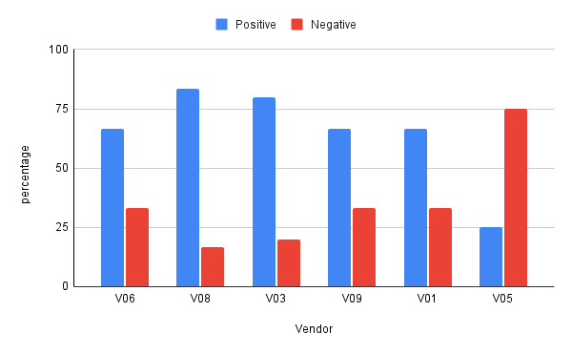

**Figure 2.** Prevalence of *E.coli* contamination in food samples from different food vendors

*Vendor 8 (VO8) had the highest prevalence (83.3 %) of *E.coli* contamination, while Vendor 5 (VO5) had the least food contamination

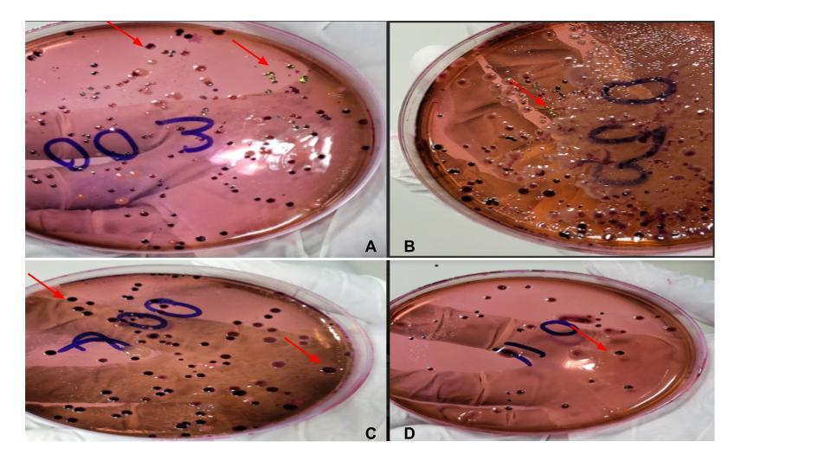

FIG 3: *E.coli* growth on EMB agar as seen in cultured food samples.

*A-B = colonies with blue-black eye with presence and absence of greenish metallic sheen

*C-D = colonies with blue-black eye with the absence of greenish metallic sheen.

*Red arrowspoints to a few *E.coli* colonies

*18 of the 28 cultured samples had *E. coli* growth indicating 64% prevalence suggesting heavy food contamination in MCIU

**Table 6**. Correlation between participant’s perception of vendors’ hygiene/ food safety and prevalence of *E.coli* in the food samples

|  |  |  |  |
| --- | --- | --- | --- |
| N=6  P-value < 0.05 | | ***E.coli* Isolation** | |
| Positive  r (p-value) | Negative  r (p- value) |
| **Vendor’s Hygiene** | Very Safe | 0.37 (0.47) | 0.29 (0.58) |
| Somewhat Safe | 0.16 (0.76) | 0.50 (0.31) |
| Not Safe | -0.08 (0.88) | -0.14 (0.79) |
| **Food Safety** | Very concerned | -0.13 (0.81) | 0.00 (0.00) |
| Moderately concerned | 0.28 (0.59) | 0.43 (0.39) |
| Not concerned | 0.2 (0.70) | 0.36 (0.48) |

*No significant correlation between people's perception of vendor's hygiene and food safety in relation to actual prevalence of food contamination. This implies that in general, people’s perception of a vendor’s hygiene and safety is not reliable to determine or correctly predict if a vendor's food is safe or unsafe.

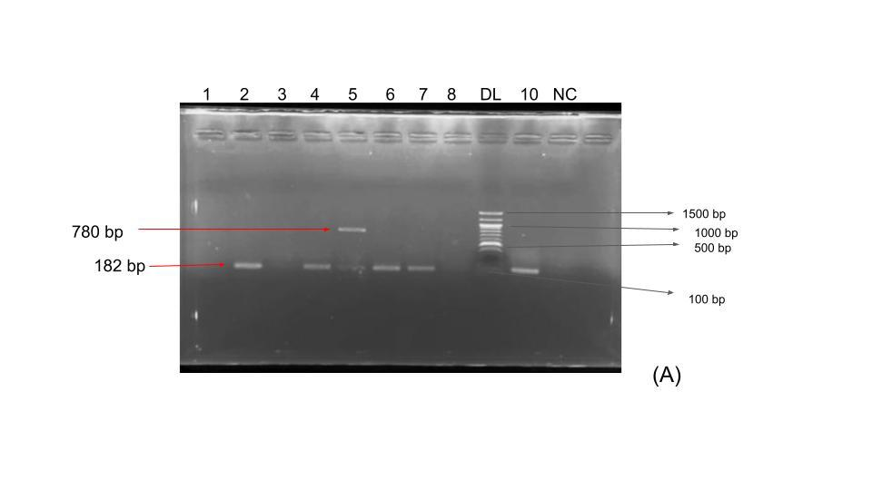

**Figure4.**Electrophoresis results for detecting the *tet*A gene.

*Lane 2,4,5,6,7 and 10 shows bands at 182bp confirming isolate contains *tet*A gene.

*Lane 5 shows additional bands at 780 bp indicating possible superficial polymorphism of the *tet*A gene in isolates.

*DL = DNA Ladder

*NC = Negative Control

\**tet*A gene present in 11 of 18 *E.coli* positive samples. The61% prevalence of *tet*A gene suggest high prevalence of *tet*Ainduced tetracycline resistance in *E.coli* isolates.

*There was significant association between the presence of *tet*Agene and *E.coli* contamination in food vended at MCIU (p=0.0016)

**Discussion**

Table 1 showed the socio-demographics and food consumption preferences of the individuals surveyed at MCIU. It was observed that slightly more females participated in the study than males. The majority of participants fall within the 16-20 age group, with the frequency decreasing as the age increases. Most participants are students, followed by a smaller percentage of academic and non-academic staff. The highest frequency of participants falls within the <1 year duration category, and the frequency decreases as the duration increases. The majority of participants rely on MCIU Cafeteria vendors for their primary source of food. However, a significant portion of those who use off-campus food vendors do so occasionally, once daily which is also the case with the majority of individuals that patronize MCIU cafeteria food vendors.

Figure 2 showed how respondents perceive different vendors' hygiene and their concerns about foodborne illnesses. Vendor 1 has the highest patronage, while Vendor 6 has the lowest patronage. Though, a significant number of respondents perceive the vendor's hygiene as "somewhat safe," and the majority have a moderate level of concern about foodborne illnesses. In general, all vendors are considered to be somewhat safer than very safe in terms of hygiene. More people are very concerned about contracting food borne illness from Vendor 9 compared to other vendors.

In table 2, data about the occurrence of traveller's diarrhea among participants categorized by gender were presented. The Chi-squared (X2) test was used to determine the relationship between gender and traveller's diarrhea history. The p-value associated with the test is 0.246, which indicates that there was no statistical significance of the relationship between gender and traveller's diarrhea at p>0.05. From the results, 35 out of 54 females did not have traveller's diarrhea (64.8%), while 19 out of 54 females had traveller's diarrhea (35.2%). Similarly, for males, 24 out of 45 males did not have traveller's diarrhea (53.3%), while 21 out of 45 males had traveller's diarrhea (46.7%).

Table 3 presents data on the occurrence of traveller's diarrhea among participants categorised by age groups. Similar to table 2, a Chi-squared (X2) test was conducted to explore the relationship between age and traveller's diarrhea history. The p-value associated with the test was 0.59, indicating no statistical significance (p>0.05) of the relationship between age and traveller's diarrhea. From the result, 36 out of 54 participants in the 16-20 age group did not have traveller's diarrhea (66.7%), while 18 out of 54 participants in the 16-20 age group had traveller's diarrhea (33.3%).

Figure 2 and Appendix 2 provide information on the prevalence of *E. coli* in cultured food samples obtained from various food vendors. *E. coli* as a bacterium is commonly associated with foodborne illnesses. From the results, in Sample 1 (Vendor V06, Fried Rice), the detection of *E. coli* in the Fried Rice sample is concerning, suggesting possible contamination during food preparation, handling, or storage. The presence of 15 *E. coli* colonies indicates the potential for microbial growth, which could lead to foodborne illnesses if consumed. In Sample 3 (Coconut Rice), the detection of a substantial *E. coli* colony count (97 colonies) in Coconut Rice raises serious food safety concerns. Such a high count indicates a significant level of bacterial contamination, potentially resulting from poor hygiene practices during food processing or storage. Sample 5 (Melon Soup) showed positive test for *E. coli* with 31 colonies suggesting contamination, though the colony count is comparatively lower. Nevertheless, even a moderate count implies a risk of foodborne illness if the contaminated food is consumed. For Sample 6 (Pasta), the positive result for *E. coli* in Pasta further underscores the potential contamination of various food types. With 36 colonies, there is a concern for bacterial growth, necessitating a closer look at the handling and preparation practices. In Sample 7 (Beans Porridge), the alarming observation of over 100 *E. coli* colonies indicate a significant health risk. Such a high colony count could be attributed to inadequate cooking or unhygienic conditions during food preparation, warranting immediate attention. However, the detection of 9 *E. coli* colonies in Beef (sample 9) indicates a moderate level of contamination. While the colony count is not as high as in some other samples, the presence of any *E. coli* suggests lapses in food safety practices. In essence, food samples gotten from Vendor 8 had the highest prevalence of *E. coli* contamination amongst food vendors with a prevalence of 83.3% while food Samples from vendor 5 were the least contaminated. This finding with particular reference to Vendor 8, raises significant concerns about the hygiene and food safety practices employed by this vendor. Such a high prevalence indicates that a substantial portion of the food samples collected from this vendor tested positive for *E. coli*, posing a considerable risk to consumers. The source of contamination could be traced back to various factors, including improper handling of ingredients, inadequate cooking or storage temperatures, cross-contamination, or unsanitary food preparation environments. In contrast, food samples from Vendor 5 were identified as having the lowest level of *E. coli* contamination. The implication is that this vendor's food samples exhibited a significantly lower incidence of *E. coli*. This outcome suggests that Vendor 5 may be implementing more effective food safety measures, adhering to proper hygiene practices and maintaining a cleaner food preparation environment compared to other vendors

Moreover, the overall result outlined the prevalence of *E. coli* in cultured food samples obtained from diverse food vendors, revealing a concerning spectrum of contamination across various food types. Notably, samples including Coconut Rice, Beans Porridge, and Fried Beef exhibited notably high *E. coli* colony counts, suggestive of potential health risks. Conversely, Jollof Rice and certain other samples tested negative, indicating a lack of *E. coli* presence. Therefore, these results underscore the importance of stringent food safety practices and vendor oversight to mitigate the potential for foodborne illnesses arising from microbial contamination in the food supply chain.

However, the information provided in figure 3 focuses on the growth of *E. coli* bacteria on Eosin Methylene Blue (EMB) agar, a commonly used culture medium that facilitates the differentiation of bacterial species based on their ability to ferment lactose and produce acid. The description given in the context of the figure outlines the appearance of *E. coli* colonies on the EMB agar in various scenarios. The observation of colonies with blue-black eye and greenish metallic sheen (A-B) implied that the colonies of *E. coli* on the EMB agar exhibit a distinct visual appearance that is characterized by a blue-black central area, often referred to as a "blue-black eye," which indicates the presence of acid production due to lactose fermentation12. Additionally, the colonies showed a greenish metallic sheen around the central area. This metallic sheen is a characteristic feature of *E. coli* growth on EMB agar, indicating strong acid production. The greenish metallic sheen is the result of the ability of *E. coli* to produce copious amounts of acid during lactose fermentation13. The colonies with blue-black eye and absence of greenish metallic sheen (C-D) describes *E. coli* colonies on the EMB agar that exhibit a similar blue-black eye in the central area, suggesting lactose fermentation and acid production. However, in this case, there is an absence of the greenish metallic sheen around the colonies. The absence of the metallic sheen might indicate a different level of acid production compared to the colonies with the metallic sheen. The presence of the red arrow points to specific *E. coli* colonies within the culture. This visual indicator helps to draw attention to the location of *E. coli* growth on the agar plate. Overall, 18 of 28 samples cultured had *E. coli* growth indicating 64% prevalence. That suggest heavy food contamination in MCIU.

Figure 4 presents the results of an electrophoresis experiment aimed at detecting the presence of the *tet*A gene in *E. coli* isolates. The figure displays distinct bands in different lanes, each of which provides valuable information about the genetic composition of the isolates. With the use of electrophoresis as a laboratory technique, DNA fragments are separated based on their size and charge14. Lane 2, 4, 5, 6, 7, and 10 exhibit bands at 182 base pairs (bp), confirming the presence of the *tet*A gene in the respective isolates. The *tet*A gene is associated with antibiotic resistance, often found in bacteria that have developed resistance to tetracycline antibiotics1. Notably, in Lane 5, there are additional bands observed at 780 bp. This suggests the possibility of a superficial polymorphism (genetic variation) of the *tet*A gene in the isolate represented by Lane 5. Polymorphism implies that there may be genetic differences in this isolate's *tet*A gene that result in slightly different fragment sizes, potentially due to mutations or other genetic variations15.Depending on the sample type, tetracycline resistance levels vary. The findings of this investigation, which indicated that the tetracycline-resistant isolates had *tet*A genes as the most prevalent tetracycline-resistant gene (61%) are consistent with earlier findings1,15. The majority of *E. coli* strains identified from urine, stool, poultry, and soil include the *tet*A gene in particular16. Tetracycline determinants other than *tet*A genes were thought to occur less frequently in the environment17. This hypothesis seemed to have been supported by researchers whose studies showed that *tet*A occurred more frequently than other tet determinants18.

The presence of bands at 182 bp in multiple lanes indicates the successful detection of the *tet*A gene in these isolates. This suggests that these isolates carry the genetic information associated with tetracycline resistance, which is of clinical and public health importance. However, the presence of additional bands at 780 bp in Lane 5 suggests genetic variation or polymorphism in the *tet*A gene of that particular isolate. This could have implications for the behaviour of the antibiotic resistance conferred by the *tet*A gene in that specific isolate.

Figure 4 provides a visual representation of electrophoresis results for detecting the *tet*A gene in *E. coli* isolates. The presence of bands at 182 bp confirms the presence of the gene, and the presence of additional bands at 780 bp in Lane 5 suggests potential genetic variation in the *tet*A gene. These findings contribute to the overall understanding of antibiotic resistance mechanisms and genetic diversity in bacterial isolates, with particular reference to *E. coli.*

Overall, the present study agrees with the findings that showed 86.9% resistance to tetracycline as prevalence of *E. coli* and resistance patterns of the isolated bacteria did not signiﬁcantly differ based on samples source19. A report indicating 66.7–76.1% *E. coli* contamination of poultry meat relates to the findings of the current study on meat samples obtained from vendor 820. Another similar findingshowed that thirty seven out of 50 (74%) examined samples of ready to eat foods had *E. coli* contamination21. The result is clearly in line with the present study that showed 64% contamination of food samples with *E. coli.* On the other hand, 80.7% high level of resistance in *E. coli* to tetracycline antibiotics as against 61% occurrence observed in the present study was detected5. Furthermore, 81.3% tetracycline-resistant isolates that were positive for the *tet*A genewere detected in similarity with the current study22. Although, we can assume that in an environment under higher selection pressure of tetracycline antibiotics, the *tet*A gene will predominate because numerous authors have previously confirmed that the overuse and misuse of antibiotics in veterinary medicine plays a significant role in the development of bacterial resistance22. Additionally, it has been noted that the *tet*A gene is one of the most prevalent genes causing tetracycline resistance.

**Limitations of the study**

**Conclusion**

Foods vended in Michael and Cecilia Ibru University, Agbarha-Otor, had unsatisfactory levels of contamination with *E. coli.* Unhygienic practice may reveal the risk factors associated with contamination of food. This research will contribute to our understanding of the dissemination of tetracycline resistance in food borne bacteria, potentially informing strategies to mitigate the spread of antibiotic resistance and improve food safety standards. The investigation into the tetracycline-resistant gene of *E. coli* isolates from food samples has provided valuable insights into the prevalence and mechanisms of antibiotic resistance within our food supply. However, through meticulous analysis, the understanding of the factors contributing to the dissemination of this resistant gene and its potential implications for public health can be deepened further.Moreover, the study underscores the urgency for proactive measures and research in mitigating the challenges posed by antibiotic resistance, with the ultimate goal of ensuring the overall wellbeing of all.

**Authors Contributions**

The authors were all involved in the entire research process.

**Conflict of Interest**

The authors declared no conflict of interest.

**References**

1. Jahantigh, M., Samadi, K., Dizaji, R. E., & Salari, S. Antimicrobial resistance and prevalence of tetracycline resistance genes in Escherichia coli isolated from lesions of colibacillosis in broiler chickens in Sistan, Iran. BMC Veterinary Research 2020; 16(1): 1-6.
2. Ferri, M., Ranucci, E., Romagnoli, P., & Giaccone, V. Antimicrobial resistance: A global emerging threat to public health systems. Critical Reviews in Food Science and Nutrition, 2017; 57(13): 2857-2876.
3. Galindo-Méndez, M. Antimicrobial resistance in Escherichia coli. *E. Coli Infections-Importance of Early Diagnosis and Efficient Treatment* 2020; 1-20.
4. Al-Bahry, S., Al-Sharji, N., Yaish, M., Al-Musharaﬁ, S. and Mahmoud, I. “Diversity of tetracycline resistant genes in Escherichia coli from human and environmental sources,” The Open Biotechnology Journal, 2016; 10(1): pp.289–300
5. Doubra, O. P., Kome, O. & Obakpororo, E. A. Tetracycline-Resistant Genes in Escherichia coliform Clinical and Non clinical Sources in Rivers State, Nigeria. *International Journal of Microbiology*2022; 1-5
6. Urumova, V. Investigations on tetracycline resistance in commensal Escherichia coli isolates from swine. Bulgarian J Vet Med 2016; 19(3): 179-88.
7. Roberts, M. C.Tetracyclines: mode of action and their bacterial mechanisms of resistance. Bacterial Resistance to Antibiotics–From Molecules to Man 2019; 101-124.
8. Markley, J. L. & Wencewicz, T. A. (2018). Tetracycline-inactivating enzymes. Frontiers in Microbiology 2018; 9:1058.
9. O'Flaherty, E., Solimini, A. G., Pantanella, F., De Giusti, M., & Cummins, E. (2019). Human exposure to antibiotic resistant-Escherichia coli through irrigated lettuce. Environment International 2019; 122: 270-280.
10. Li, J., Tai, C., Deng, Z., & Zhong, W. Identification and assessment of antibiotic resistance genes in Lactobacillus isolated from traditional dairy products. Food Control 2017; 77:24-30.
11. Zhu, K., Jin, H., He, Z., Zhu, Q., & Wang, B. A continuous method for the large-scale extraction of plasmid DNA by modified boiling lysis. Nature Protocols 2006;1(6): 3088-3093.
12. Obioha, P. I., Ouoba, L. I. I., Anyogu, A., Awamaria, B., Atchia, S., Ojimelukwe, P. C., & Ghoddusi, H. B. Identification and characterisation of the lactic acid bacteria associated with the traditional fermentation of dairy fermented product. Brazilian Journal of Microbiology 2021; 52: 869-881.
13. Basavaraju, M., & Gunashree, B. S. Escherichia coli: An Overview of Main Characteristics. *Escherichia coli*. 2022
14. Hert, D. G., Fredlake, C. P., & Barron, A. E. Advantages and limitations of next-generation sequencing technologies: a comparison of electrophoresis and non-electrophoresis methods. Electrophoresis 2018; 29(23): 4618-4626.
15. Enyew, M., Feyissa, T., Carlsson, A. S., Tesfaye, K., Hammenhag, C., & Geleta, M. Genetic diversity and population structure of sorghum [*Sorghum bicolor* (L.) Moench] accessions as revealed by single nucleotide polymorphism markers. Frontiers in Plant Science 2022; 12: 799482.
16. Moller, T. S., Overgaard, M., Nielsen, S. S., Bortolaia, V., Sommer, M. O., Guardabassi, L., & Olsen, J. E. Relation between tetR and tetA expression in tetracycline resistant Escherichia coli. BMC Microbiology 2016; 16(1): 1-8.
17. Perewari, D. O., Otokunefor, K., & Agbagwa, O. E. Research Article Tetracycline-Resistant Genes in *Escherichia coli*from Clinical and Nonclinical Sources in Rivers State, Nigeria 2022
18. Olowe, O. A., Idris, O. J., & Taiwo, S. S. Prevalence of tet genes mediating tetracycline resistance in Escherichia coli clinical isolates in Osun State, Nigeria. European Journal of Microbiology and Immunology 2013; 3(2): 135-140.
19. Alam, G. S., Hassan, M. M., Ahaduzzaman, M., Nath, C., Dutta, P., Khanom, H. & Cobbold, R. Molecular Detection of Tetracycline-Resistant Genes in Multi-Drug-Resistant Escherichia coli Isolated from Broiler Meat in Bangladesh. Antibiotics 2023; 12(2): 418.
20. Parvin, M. S., Talukder, S., Ali, M. Y., Chowdhury, E. H., Rahman, M. T., & Islam, M. T. Antimicrobial resistance pattern of *Escherichia coli* isolated from frozen chicken meat in Bangladesh. Pathogens 2020; 9: 420.
21. Gozde, E., & Emek, D. Escherichia coli and food safety. *IntechOpen,* London, UK 2019
22. Skocková, A., Cupáková, S., Karpísková, R., & Janstová, B. (2012). Detection of tetracycline resistance genes in Escherichia coli from raw cow's milk. The Journal of Microbiology, Biotechnology and Food Sciences 2012;1:777.

**Appendix**

**Appendix 1.** Vendor’s patronage distribution, Perception of vendor’s hygiene and food safety

|  |  |  |  |  |  |  |  |
| --- | --- | --- | --- | --- | --- | --- | --- |
|  | | **Perception of Vendor's hygiene** | | | **Food borne illness concern** | | |
| **Vendor ID** | Patronage N(%) | Very Safe  N | Somewhat Safe  N | Not Safe  N | Very concerned  N | Moderately concerned  N | Not concerned  N |
| V01 | 54 (40.6) | 18 | 31 | 5 | 6 | 28 | 20 |
| V02 | 22 (16.5) | 3 | 15 | 4 | 7 | 11 | 4 |
| V03 | 6 (4.5) | 1 | 4 | 1 | 1 | 3 | 2 |
| V04 | 5 (3.8) | 0 | 5 | 0 | 1 | 3 | 1 |
| V05 | 10 (7.5) | 1 | 9 | 0 | 1 | 6 | 3 |
| V06 | 1 (0.8) | 0 | 1 | 0 | 1 | 0 | 0 |
| V07 | 5 (3.8) | 0 | 5 | 0 | 0 | 0 | 5 |
| V08 | 3 (2.3) | 2 | 1 | 0 | 0 | 3 | 0 |
| V09 | 5 (3.8) | 1 | 4 | 8 | 7 | 2 | 4 |
| V10 | 14 (10.5) | 0 | 14 | 0 | 0 | 5 | 9 |

**Appendix 2:** Prevalence o*f E. coli* in cultured food samples gotten from food vendors

|  |  |  |  |  |
| --- | --- | --- | --- | --- |
| **Sample ID** | **Vendor** | **Food Type** | **Culture test for *E. coli*** | **Number of *E. coli* colonies seen** |
| 1 | V06 | Fried Rice | Positive | 15 |
| 2 | Jollof Rice | Negative | 0 |
| 3 | Coconut Rice | Positive | 97 |
| 4 | V08 | Stew | Negative | 0 |
| 5 | Melon soup | Positive | 31 |
| 6 | Pasta | Positive | 36 |
| 7 | Beans porridge | Positive | >100 |
| 8 | Fufu | Positive | 40 |
| 9 | Beef | Positive | 9 |
| 10 | V03 | Beans porridge | Negative | 0 |
| 11 | White Rice | Positive | 8 |
| 12 | Pasta | Positive | 100 |
| 13 | Melon soup | Positive | 13 |
| 14 | Fried Rice | Positive | 9 |
| 15 | V09 | Banga soup | Positive | 4 |
| 16 | White Rice | Positive | 5 |
| 17 | Stew | Negative | 0 |
| 19 | V01 | Banga | Negative | 0 |
| 20 | Beans | Positive | 45 |
| 21 | Melon soup | Positive | 6 |
| 22 | Pasta | Positive | 15 |
| 23 | Moimoi (Beans pudding) | Negative | 0 |
| 24 | Jollof Rice | Positive | 7 |
| 25 | V05 | Fried Beef | Positive | 90 |
| 26 | Fufu | Negative | 0 |
| 27 | Beans porridge | Negative | 0 |
| 28 | Banga soup | Negative | 0 |