**Reviewer’s Comments**

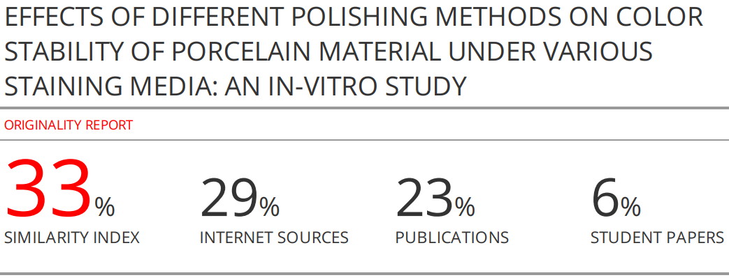

**EFFECTS OF DIFFERENT POLISHING METHODS ON COLOR STABILITY OF PORCELAIN MATERIAL UNDER VARIOUS STAINING MEDIA: AN IN-VITRO STUDY**

**ABSTRACT**

**Background and aim:** The rapid rate of development of new resin-based materials coincided with the increase in demand for cosmetic dentistry. Therefore, an ongoing study is needed to determine the effect of different polishing methods on the color stability of feldspathic porcelain surfaces exposed to four staining solutions at different time intervals in order to determine the most appropriate polishing method, which results in to better color stability for long periods and this was the goal of this study.

**Material and methods:** This in-vitro study included 80 disc-shaped feldspathic porcelain specimens (10 mm diameter and 2 mm thickness) which were self-fabricated, All the specimens were auto glazed to close any pores, then randomly divided into 4 equal groups of 20 specimens (1 control group and 3 experimental groups). Specimens of the unpolished group (control group) underwent a removal of their glaze layer, another group was untreated (auto glazed), whereas the other two groups were prepared based on two polishing systems (over-glazed and polished). Specimens of each group (n=20) were divided into 4 groups (n=5) to be immersed in 4 staining solutions (distilled water as a control group, prepared khat extract, prepared red tea, Delsi soft drink). The color measurement of each specimen was assessed before immersion and after 1, 7 and 14 days of immersion. Then data were analyzed using SPSS v 28 computed program.

**Results:** There were statistically significant differences in the color change when the studied porcelain groups interact with time (p<0.05). The interaction between unpolished porcelain surfaces and khat extract or red tea showed significant higher increase in color change over time (p<0.05), whereas their interaction with Pepsi or distilled water showed no significant differences (p>0.05). The interaction between polished porcelain surfaces and khat extract showed significant higher increase in color change over time (p<0.05), whereas their interactions with other stains showed no significant differences (p>0.05). The interaction between over glazed or auto glazed porcelain surfaces and each stain showed no significant differences over time (p>0.05).

**Conclusion:** Time plays an important role in the discoloration of feldspathic porcelain. Khat has the highest staining ability followed by red tea; however, Pepsi has the lowest staining ability due to the lack of colorant. Over glazed and auto glazed groups showed better prolonged color stability of porcelain surfaces than the polished group; however, the polishing method can be an effective and more preferable alternative as it has acceptable ∆E values and is free from the limitations of glazing methods.

**Keywords:** polishing methods, color stability, porcelain material, staining media, time.

**INTRODUCTION**

The need for cosmetic dentistry is rising, and new materials for restorative purposes are being developed at a rapid rate. Different methods can be used to cure unsightly teeth caused by hypoplasia, fluorosis, fractures, caries, and defects in shape, form, or color. These strategies include preventative, conservative, and esthetic methods such porcelain or composite laminate veneering, surface coating, esthetic contouring, and bleaching1. Because of its various benefits, including biocompatibility, durability, long-life survival, and good aesthetic capabilities with long-term follow-up, dental porcelain has grown to be a very important material in Prosthodontics. This substance exhibits the same degree of translucency, color brightness, and intensity as healthy, unstained teeth2. Several materials, including feldspathic porcelain, glass-based ceramics, and zirconia-based ceramics, have been used to make ceramic prostheses as a result of ongoing advancements. In addition, for many years, the feldspathic metal-ceramic prosthesis has been widely used as a restorative material in the aesthetic zone due to its clinical longevity and the accepted aesthetics of restoration 3. Due to its superior mechanical qualities and great biocompatibility compared to other dental ceramic materials, zircon-based ceramic is currently one of the most widely utilized materials in modern dental practice to construct porcelain prosthesis4-6. Porcelain restorations may get discolored for inherent or extrinsic reasons. The modification of the resin matrix itself, as well as oxidation or hydrolysis in the resin matrix, are intrinsic causes of discoloration. However, stains caused by the adsorption or absorption of colorants owing of pollution from numerous external sources are one of the extrinsic factors1.

Dental ceramics' resistance to deterioration in the oral environment is directly related to their high surface polishing, subcritical crack propagation, and chemical inertness of their material atoms. Dental restorations with a rough surface lose their biomechanical and aesthetic value, making them more susceptible to aging. A dental restoration with a rough surface not only encourages the retention of more plaque and harms the opposing dentition through abrasion, but it is also weakened by the presence of surface imperfections, which can lead to material failure7. To reduce the wear damage that the porcelain surface may cause on enamel in dental applications, porcelain with a smooth surface is preferred. Additionally, the porcelain restoration's surface should have a feel and appearance similar to that of a real tooth1, 7.

Effective finishing and polishing of dental restorations provide three benefits of dental care: oral health, function, and esthetics. Many finishing and polishing methods have been developed and evaluated with various types of porcelain materials in order to obtain a smoother surface and eliminate any potential discoloration. Moreover, porcelain materials are not yet able to guarantee unanimously excellent results in their color stability due to their exposure to various beverages and habits that vary from one country to another, indicating that this issue is still controversial1,3,7. Therefore, the effect of polishing methods on color stability of porcelain materials under different beverages or with different habits needs more investigation particularly in Yemen wherein one of the most commonly widespread habits is khat chewing which is practiced by many male and female patients with porcelain fixed prostheses. Consequently, this study aimed to determine the effect of different polishing methods (polish, unpolished, auto glaze, and over glaze) on the color stability of feldspathic porcelain surfaces exposed to four staining solutions.

**MATERIALS AND METHODS**

**Study Design**

This in-vitro study was conducted in the Faculty of Dentistry, Sana’a University, Yemen between May 2021 and March 2022. It included 80 disc-shaped feldspathic porcelain specimens in order to assess the effect of four staining media on the color changes of different polishing methods (polish, unpolished, auto glaze, and over glaze) at different time intervals.

**Sample Preparation and Fabrication**

Eighty disc-shaped feldspathic porcelain specimens (10 mm diameter and 2 mm thickness) were self-fabricated using a 5 ml (5 cc) disposable medical syringe (Jiangsu Caina Medical Co., Ltd, China) after removing the rubber stopper along with the covered part of the plunger using a sharp scalpel in order to get a smooth surface8.

Dentin body porcelain shade A2 was dispensed on a glass slab and mixed with a modeling liquid using a ceramic spatula until the mixture obtained was of a working consistency according manufacture instruction. Any excess moisture was absorbed with a tissue by placing it at one end of the mass. The mixed mass was not dried completely while absorption of excess water. The mixed porcelain was carried out in small increments and condensed over the plunger by a sable brush. To condense the powder, the medical syringe was given gentle vibrations with the serrated handle of the instrument. Tissue paper was again used to absorb excess water before adding the next increment.

The dentin porcelain was condensed till the rim of the outer tube, and any excess porcelain material was removed using a ceramic spatula and smoothened. A glass plate was used to verify whether the surface was flush with the rim of the outer tube, and porcelain was added when needed. The specimens’ size was controlled through observing the gradual numbers on the syringe. Then, the thumb screw was rotated to raise the specimen, and the specimen was carefully transferred from the disposable syringe to the Saggar tray by lifting with the mixing spatula. The specimens were fired in a furnace (Programat P80, Ivoclar-Vivadent, Schaan, Liechtenstein) according to the manufacturer recommended firing cycle directions (approximately 920-960 ̊C)9. After firing and cooling, specimens were taken out.

The specimens were finished using medium-grit diamond rotary cutting burs (SE 30-Piece Set of Assorted Diamond Burrs, 240 Grit - 8230DD24, China) on both sides with a slow-speed hand piece (W&H MF-PERFECTA, 9975-E, United States) rotating at approximately 10,000 rpm with water cooling to remove surface irregularities10. Only one side of the specimens was adopted for reading; therefore, a mark/notch was made on the other side11,12.

Thickness was measured using a manual dental gauge caliper and any specimens thicker than 2 mm or with surface irregularities, visible cracks or porosities were excluded and replaced with new specimens with accurate measurements. After that, the tested specimens were auto glazed to close any pores, then they were equally divided into 4 groups for surface treatment, including 1 control group (unpolished) and 3 experimental groups (auto glazed, over glazed and polished) (n=20).

**Surface Treatment of Samples**

Specimens of the auto glazed group were not submitted to any other type of surface treatment. However, other groups’ specimens’ surfaces were treated as follows. Specimens of the unpolished group (control group underwent a removal of their glaze layer using the medium-grit diamond rotary cutting burs with the slow-speed hand piece rotating at approximately 10,000 rpm with water cooling to stimulate to stimulate chair side adjustment. For the over glazed group specimens, an over glaze material (Super porcelain EX-3, Kuraray Noritake Dental Inc., Japan) was mixed with a glaze liquid material (ES Liquid, Kuraray Noritake Dental Inc., Japan) and was applied on the surface of the specimens using a ceramic brush according to the manufacturer’s instructions. After the application, the specimens were placed in a firing oven. The starting temperature was 600 ̊C and increased 50 ̊C/min after reaching 930 ̊C. The specimens were held at this temperature for 1 minute. For specimens of the polished group, the surface finishing and polishing were performed using a diamond polishing system for porcelain (Diasynt Plus, Diapol, EVE Emst, Vetter GmbH, Germany) in a sequence of decreasing abrasiveness with intermittent movements as suggested by the manufacturer. This ceramic polishing kit contains grinding and polishing in one set (i.e., Diasynt is used for reducing and Diapol for the final high shine). This started with a green polishing bur for grinding and shaping at a speed of 8000-12000 rpm. A blue coarse polishing bur was then used for smoothening, followed by a pink medium polishing bur for pre-polishing, then a white fine polishing bur for the high shine polishing at a speed of 7000-12000rpm. This procedure was performed using a low straight hand piece according to the manufacture instructions. Grinding and finishing processes were performed for 15s. for each step. The sequential polishing of every sample was done with polishing burs at one direction at constant speed and at moderate pressure under water coolant according to the manufacturer instructions.

After finishing and polishing the feldspathic porcelain specimens, they were numbered from 1-80 within their specific polishing groups (n=20) and stored into 80 glass test tubes of 7 mL in distilled water for 24 hours at 37 °C. The specimens’ preparation and finishing were carried out by the same operator to reduce variability.

**Preparation of Staining Solutions**

The staining solutions include two ready solutions which are distilled water and Delsi soft drink (Delsi Rumman) as well as two prepared solutions which are red tea and khat extract. The red tea solution was prepared by immersing two prefabricated tea bags of 2g into 300 ml boiled distilled water for 10 min according to manufacturer’s recommendations. Khat the soft fresh leaves and twigs were cleaned, washed by water, and then blended.

**Preparation for Color Measurement**

After numbering and storing the study sample (80 specimens) into 80 glass test tubes, each group specimens (n=20) were divided equally into 4 subgroups (n=5). Specimens of each group of the polishing method (n=20) were arranged in a way that every 5 tubes were placed in a column in an order of 1, 2, 3, 4 to be immersed in the 4 types of staining media respectively. They were kept arranged in an incubator at 37 °C. The solution of all staining media was daily refreshed for 14 days to maintain the effect of solution and avoid bacterial or yeast contamination and stirred 3 times a day for 10 minutes using a shaker.

**Standardization of Color Measurement**

Color measurement was standardized through allocating an identical position (i.e., center of the specimen) by fabricating a mold using a Vinyl Polysiloxane (addition silicone) (Durosil L; CentraDent, Munchen, Germany). The fabricated mold was used for firmly holding each specimen for taking color measurements. The mold was fabricated by a putty impression which was made around the tip of the device and over the specimen with a window of 4 mm dimeter in the center to standardize the extent of color measurement, and the borders of the window were well-shaped and precise. Therefore, the measurement was repeated approximately at the same point of the specimen every time.

**Color Measurement**

The color measurement was taken before immersion (baseline) and after immersion (1, 7 and 14 days) by VITA Easy shade V Spectrophotometer (SN: H57517, VITA Zahanfabrik H. Rauter GmbH & Co. KG, Germany) according to the CIE-Lab (International Commission on Illumination (Commission Internationale de L'éclairage) L*, a* and b* parameters). L* represents value (ranges from (100) white to (0) black), a* refers to chromaticity in red and green axis (+a red/ -a green) and b* refers to chromaticity in yellow and blue axis (+b yellow /-b blue). The following CIE (Commission Internationale de L'éclairage) formula was used to determine the total color difference before and after immersion in staining solutions by trained operator:

ΔE = [(ΔL*) 2 + (Δa*) 2 + (Δb*) 2] ½

Before each measurement time period (before immersion, and after 1, 7 and 14 days of immersion), the spectrophotometer was calibrated according to the manufacturer’s instructions.

After 24 hours of storage in distilled water at 37 °C, the specimens were rinsed under running distilled water for 30 seconds dried with absorbent papers and air-dried for 30 minutes at room temperature. Then specimens were arranged according to their groups for measuring their color values of L*, a*, and b* (CIE system) parameters before the subsequent immersion. In each assessment time interval, three readings were taken in the same position from one side of the specimen at the same daily time with the same light. Readings were also taken against a gray background to mimic the absence of the light in the mouth and minimize the effect of external light. The mean value and standard deviation (SD) were calculated. All steps of color measurement were done by one researcher.

**Statistical Analysis**

The mean color changes ΔE* of feldspathic porcelain specimens of all the study groups were recorded and then compared before and after immersion. Microsoft Excel 19 software was used to input the data, which were analyzed using Statistical Package for Social Science (SPSS) version 28.0 (SPSS Inc., Chicago IL, USA). Repeated measures ANOVA test followed by post hoc Tukey test were conducted to detect any significant difference between and within the groups at p < 0.05.

**RESULTS**

**Effect of time on color change (ΔE)**

Repeated measures ANOVA test was used to evaluate the effect of time on color change and whether there are significant differences in the color change when the studied porcelain group interacts with time. Table 1 shows that the main effect of time is statistically significant, Wilks’ Lambda = 0.639, F = 21.162, p<0.001. This effect, therefore, is qualified by a significant time × group interaction, Wilks’ Lambda = .515, F=9.850, p<.001. This indicates that the time has an impact on the color change and that there are significant differences in the color change when the studied group interacts with time. It also implies that delta score differences are significant among groups according the three occasions.

Table 1. Repeated measures ANOVA test evaluate the effect of time on color change

|  |  |  |  |  |  |
| --- | --- | --- | --- | --- | --- |
| **Effect** | | **Value** | **F** | **P** | **Partial Eta Squared** |
| Time | Pillai's Trace | .361 | 21.162 | <.001 | .361 |
| Wilks' Lambda | .639 | 21.162 | <.001 | .361 |
| Hotelling's Trace | .564 | 21.162 | <.001 | .361 |
| Roy's Largest Root | .564 | 21.162 | <.001 | .361 |
| Time * Porcelain group | Pillai's Trace | .495 | 8.332 | <.001 | .247 |
| Wilks' Lambda | .515 | 9.850 | <.001 | .283 |
| Hotelling's Trace | .925 | 11.403 | <.001 | .316 |
| Roy's Largest Root | .904 | 22.900 | <.001 | .475 |

**Interaction effect between time, stain type and studied porcelain group on the color stability of feldspathic porcelain surfaces**

Post hoc Tukey test was run to highlight significant difference of delta scores according the interaction between stain type, time and studied porcelain group as shown in Table 2. In the unpolished porcelain group, the results revealed that the interaction between time and khat or tea showed a significant increase in delta scores from time 1 (one day) to time 3 (two weeks) (p<0.001). Besides, the interaction between time and Pepsi showed a significant increase in delta scores from time 1 (one day) to time 3 (two weeks) (p=0.005); however, no significant difference was shown between time 2 and time 3 (p>0.05). Moreover, the interaction between time and distilled water showed no significant differences between each time and the subsequent one (p>0.05). These findings indicate that when interacted with unpolished porcelain surfaces, khat and tea stains showed the highest color change over time followed by Pepsi. In the polished porcelain groups, the results revealed that the interaction between time and khat showed a significant increase in delta scores between time 1 (one day) and time 3 (two weeks) (p<0.001) and between time 2 (one week) and time 3 (two weeks) (p=0.008). Besides, the interaction between time and other stains showed no significant differences between each time and the other (p>0.05). These findings indicate that when interacted with polished porcelain surfaces, khat stain showed the highest color change over time. In the other porcelain groups (i.e., over glazed and auto glazed), the results revealed that the interaction between time and any stain type showed no significant differences across the three-time intervals (p>0.001), indicating the effectiveness of over glaze and auto glaze polishing methods.

Table 2. Difference of delta scores according the interaction between stain type, time and studied porcelain group

| **Porcelain group** | **Stain type** | **(I) time** | **(J) time** | **Mean Difference (I-J)** | **Std. Error** | **Sig.** | **95% Confidence Interval for Difference** | |
| --- | --- | --- | --- | --- | --- | --- | --- | --- |
| **Lower Bound** | **Upper Bound** |
| Unpolished | Distilled water | 1 | 2 | -.646- | .356 | .074 | -1.357- | .064 |
| 3 | -1.040-* | .407 | .013 | -1.853- | -.226- |
| 2 | 1 | .646 | .356 | .074 | -.064- | 1.357 |
| 3 | -.393- | .317 | .219 | -1.026- | .240 |
| 3 | 1 | 1.040* | .407 | .013 | .226 | 1.853 |
| 2 | .393 | .317 | .219 | -.240- | 1.026 |
| Khat | 1 | 2 | -4.773-* | .356 | <.001 | -5.484- | -4.063- |
| 3 | -8.091-* | .407 | <.001 | -8.904- | -7.277- |
| 2 | 1 | 4.773* | .356 | <.001 | 4.063 | 5.484 |
| 3 | -3.318-* | .317 | <.001 | -3.951- | -2.684- |
| 3 | 1 | 8.091* | .407 | <.001 | 7.277 | 8.904 |
| 2 | 3.318* | .317 | <.001 | 2.684 | 3.951 |
| Tea | 1 | 2 | -3.805-* | .356 | <.001 | -4.516- | -3.095- |
| 3 | -6.832-* | .407 | <.001 | -7.645- | -6.018- |
| 2 | 1 | 3.805* | .356 | <.001 | 3.095 | 4.516 |
| 3 | -3.026-* | .317 | <.001 | -3.659- | -2.393- |
| 3 | 1 | 6.832* | .407 | <.001 | 6.018 | 7.645 |
| 2 | 3.026* | .317 | <.001 | 2.393 | 3.659 |
| Pepsi | 1 | 2 | -.764-* | .356 | .035 | -1.474- | -.053- |
| 3 | -1.187-* | .407 | .005 | -2.001- | -.374- |
| 2 | 1 | .764* | .356 | .035 | .053 | 1.474 |
| 3 | -.424- | .317 | .186 | -1.057- | .210 |
| 3 | 1 | 1.187* | .407 | .005 | .374 | 2.001 |
| 2 | .424 | .317 | .186 | -.210- | 1.057 |
| Polished | Distilled water | 1 | 2 | .080 | .356 | .823 | -.630- | .790 |
| 3 | -.117- | .407 | .775 | -.930- | .697 |
| 2 | 1 | -.080- | .356 | .823 | -.790- | .630 |
| 3 | -.197- | .317 | .537 | -.830- | .437 |
| 3 | 1 | .117 | .407 | .775 | -.697- | .930 |
| 2 | .197 | .317 | .537 | -.437- | .830 |
| Khat | 1 | 2 | -.667- | .356 | .065 | -1.377- | .043 |
| 3 | -1.535-* | .407 | <.001 | -2.349- | -.722- |
| 2 | 1 | .667 | .356 | .065 | -.043- | 1.377 |
| 3 | -.868-* | .317 | .008 | -1.502- | -.235- |
| 3 | 1 | 1.535* | .407 | <.001 | .722 | 2.349 |
| 2 | .868* | .317 | .008 | .235 | 1.502 |
| Tea | 1 | 2 | -.103- | .356 | .773 | -.814- | .607 |
| 3 | -.679- | .407 | .100 | -1.492- | .135 |
| 2 | 1 | .103 | .356 | .773 | -.607- | .814 |
| 3 | -.575- | .317 | .074 | -1.209- | .058 |
| 3 | 1 | .679 | .407 | .100 | -.135- | 1.492 |
| 2 | .575 | .317 | .074 | -.058- | 1.209 |
| Pepsi | 1 | 2 | -.068- | .356 | .848 | -.779- | .642 |
| 3 | .023 | .407 | .956 | -.791- | .836 |
| 2 | 1 | .068 | .356 | .848 | -.642- | .779 |
| 3 | .091 | .317 | .775 | -.542- | .724 |
| 3 | 1 | -.023- | .407 | .956 | -.836- | .791 |
| 2 | -.091- | .317 | .775 | -.724- | .542 |
| Over glazed | Distilled water | 1 | 2 | -.031- | .356 | .931 | -.741- | .679 |
| 3 | -.397- | .407 | .333 | -1.210- | .416 |
| 2 | 1 | .031 | .356 | .931 | -.679- | .741 |
| 3 | -.366- | .317 | .253 | -.999- | .267 |
| 3 | 1 | .397 | .407 | .333 | -.416- | 1.210 |
| 2 | .366 | .317 | .253 | -.267- | .999 |
| Khat | 1 | 2 | -.187- | .356 | .600 | -.898- | .523 |
| 3 | -.159- | .407 | .698 | -.972- | .655 |
| 2 | 1 | .187 | .356 | .600 | -.523- | .898 |
| 3 | .029 | .317 | .928 | -.604- | .662 |
| 3 | 1 | .159 | .407 | .698 | -.655- | .972 |
| 2 | -.029- | .317 | .928 | -.662- | .604 |
| Tea | 1 | 2 | .103 | .356 | .772 | -.607- | .814 |
| 3 | -.181- | .407 | .658 | -.995- | .632 |
| 2 | 1 | -.103- | .356 | .772 | -.814- | .607 |
| 3 | -.284- | .317 | .373 | -.918- | .349 |
| 3 | 1 | .181 | .407 | .658 | -.632- | .995 |
| 2 | .284 | .317 | .373 | -.349- | .918 |
| Pepsi | 1 | 2 | -.250- | .356 | .484 | -.961- | .460 |
| 3 | -.146- | .407 | .721 | -.960- | .667 |
| 2 | 1 | .250 | .356 | .484 | -.460- | .961 |
| 3 | .104 | .317 | .744 | -.529- | .737 |
| 3 | 1 | .146 | .407 | .721 | -.667- | .960 |
| 2 | -.104- | .317 | .744 | -.737- | .529 |
| Auto glazed | Distilled water | 1 | 2 | -.029- | .356 | .936 | -.739- | .682 |
| 3 | -.090- | .407 | .825 | -.904- | .723 |
| 2 | 1 | .029 | .356 | .936 | -.682- | .739 |
| 3 | -.062- | .317 | .847 | -.695- | .572 |
| 3 | 1 | .090 | .407 | .825 | -.723- | .904 |
| 2 | .062 | .317 | .847 | -.572- | .695 |
| Khat | 1 | 2 | .040 | .356 | .911 | -.670- | .750 |
| 3 | -.459- | .407 | .263 | -1.273- | .354 |
| 2 | 1 | -.040- | .356 | .911 | -.750- | .670 |
| 3 | -.499- | .317 | .120 | -1.133- | .134 |
| 3 | 1 | .459 | .407 | .263 | -.354- | 1.273 |
| 2 | .499 | .317 | .120 | -.134- | 1.133 |
| Tea | 1 | 2 | .308 | .356 | .390 | -.402- | 1.018 |
| 3 | -.284- | .407 | .489 | -1.097- | .530 |
| 2 | 1 | -.308- | .356 | .390 | -1.018- | .402 |
| 3 | -.591- | .317 | .067 | -1.225- | .042 |
| 3 | 1 | .284 | .407 | .489 | -.530- | 1.097 |
| 2 | .591 | .317 | .067 | -.042- | 1.225 |
| Pepsi | 1 | 2 | .091 | .356 | .799 | -.620- | .801 |
| 3 | -.267- | .407 | .514 | -1.080- | .546 |
| 2 | 1 | -.091- | .356 | .799 | -.801- | .620 |
| 3 | -.358- | .317 | .263 | -.991- | .275 |
| 3 | 1 | .267 | .407 | .514 | -.546- | 1.080 |
| 2 | .358 | .317 | .263 | -.275- | .991 |

Time 1: After 24 hours, Time 2: After 1 week, Time 3: After 2 weeks.

This is further suggested by examining the profile plot of the means (Figures 1), indicating that the delta score increases in unit when the time increases in one day.

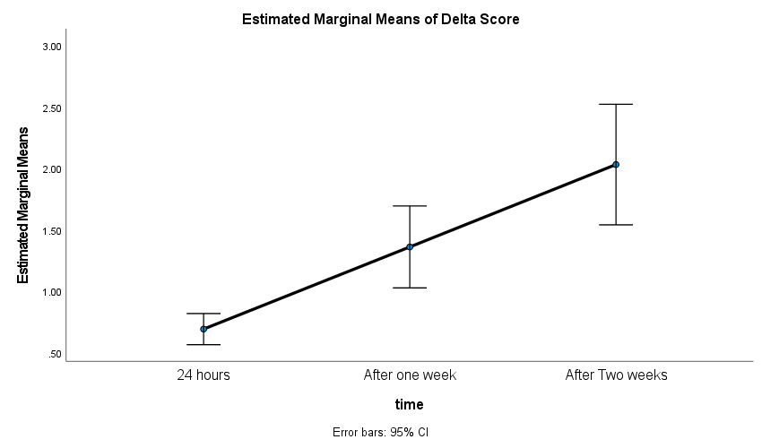

Figure 1. Profile plot of delta score means over the three-time intervals

Figure 2 shows the delta score change over time according to the type of stain. It is noticed that the delta score in tea and khat stains increased significantly over time. However, the delta score in distilled water and Pepsi did not increase over time.

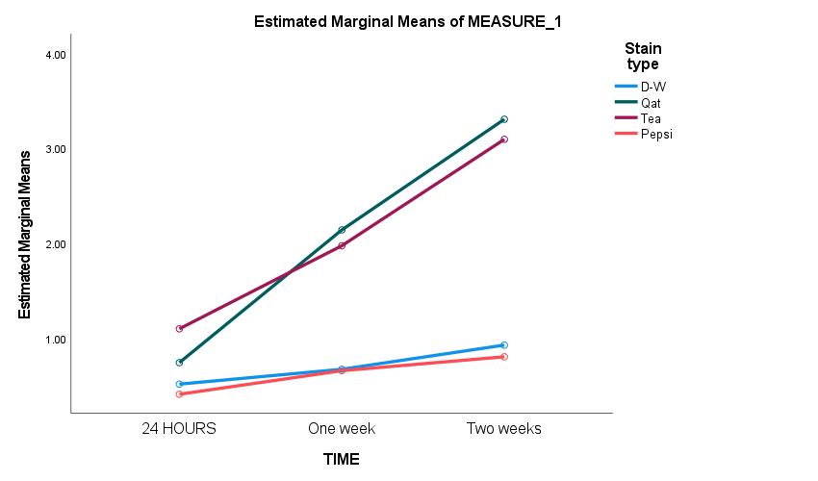

Figure 2. Delta score change over time according to the type of stain

Figure 3 shows the delta score change over time according to the porcelain group. It is noticed that the delta score in the unpolished group increased significantly over time. On the other hand, the delta score in polished, over glazed and auto glazed groups did not increase over time; however, after two weeks the over glazed group showed the lowest color change followed by the auto glazed then the polished group.

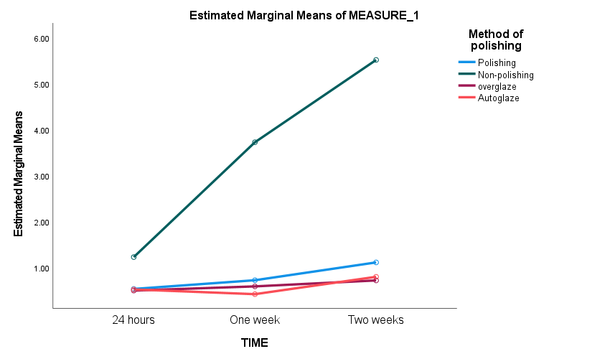

Figure 3. Delta score change over time according to the porcelain group

**DISCUSSION**

The present study investigated the differences in delta scores of the tested feldspathic porcelains due to the type of stain. Regardless of the polishing system, results elucidated that the khat stain demonstrated the highest color change followed by tea, while Pepsi demonstrated the lowest color change followed by distilled water. This result is similar to that of Al-Anesi *et al*.13 and Al-Shami14 who concluded that khat extract induced the highest level of discoloration, and khat extract and tea revealed significantly more color changes than Pepsi (p<0.05). It is also similar to that of Al Moaleem *et al*. 12 who evidently reported the effect of khat stain on the color stability as well as that of khat modifies teeth enamel surfaces, causing beverage collections on surfaces and color changes of teeth after a period of time. Moreover, Al-Alimi *et al.*15 concluded that natural teeth become discolored because of the acidic and mechanical effect of khat stain on teeth surfaces. Additionally, it is in line with that of Al-Akhali16 who concluded that khat extract medium has a highly staining ability. Furthermore, it was in agreement with Yarom *et al*. 17 who found that staining of teeth was in 91.2% of khat chewers, while in the control group no teeth staining was found; however, their study was conducted in vivo on natural teeth. This could be attributed to the fact that the crude khat has tannins and some amount of fluoride which may be the causative agent of staining18. Khat chewing is considered one of the most common habits in Yemen which affect the color of composite restorations. Therefore, there are several factors associated with khat chewing which more adversely affect the discoloration of composite and ceramic restorations, including drinking Pepsi, energy beverages, grape juice and ginger. Moreover, pesticides on khat leaves may play a vital role in oral problems, including gingivitis, periodontitis, ulcers and discoloration degree of teeth or restorations14. Besides, khat solution was found to cause severe discoloration especially at the site of khat inside the oral cavity and depend on the time of consuming14. The discoloration affects the teeth without the loss of enamel luster, and the stain associated with teeth is caused by the presence of chromospheres (colored agents), which arise from two chemical sources: organic compounds (i.e., Carotene) and inorganic transition metal ions (i.e., iron and tin)19. These associated factors of khat chewing could increase the discoloration of porcelain surfaces. Of the test stains in this study, khat is the most usable stain by the Yemeni population, and most khat chewers from teenagers, adolescents and the elderly have discolored teeth (dark-yellowish to dark).

The present study showed that tea also revealed significantly more color changes than Pepsi and distilled water. This result is similar to that of Gross and Moser20 who evaluated colorimetric measurements on four composite resins before and after controlled immersion treatments and found that specimens of the same material when immersed in a tea solution with different surface polishing methods showed greater differences in color changes than when immersed in control and coffee solutions. In this study, red tea was the most frequently used by Yemenis at afternoon and especially after lunch and all groups from all ages drink it and has discolored teeth (yellow-brown color). Tannic acid and stains in tea is the reason for significant restoration color change21. It is one of different subgroups of phenol compounds, which cause unwanted yellowish color of teeth21. Moreover, it is in line with that of Ghahramanloo *et al.*22 who evaluated the effect of tea, cola, orange juice, and distilled water on the color stability of a porcelain (Vita VMK 95) after 30 days of immersion. They concluded that ΔE of all the materials was changed after immersion in all the staining solutions during the experimental process and tea caused most significant color change.

The present study also showed small color change of the tested feldspathic porcelains immersed in distilled water. This could be attributed to the direct relevance of ceramics' staining susceptibility to the degree of water sorption Their ability to absorb water can also absorb fluid with pigments, thus acting as a vehicle for stain penetration into the bulk of the material23.

The present study showed that Delsi as a soft drink demonstrated the lowest color change, which could be attributed to the fact that soft drinks have weak colorants called caramels14. This result is also confirmed by previous studies, which showed Coca Cola had the lowest pH and damaged composite resin material surfaces; however, it did not produce as much discoloration as tea and coffee, presumably due to the lack of colorant. In addition, soft drinks cause ceramic roughness and that cola abrades several ceramics and this erosion can result in a tribochemical corrosion mechanism24. Moreover, the most common factor that causes dental erosion is acidic beverages, including carbonated drinks (Pepsi). In addition, it is known there is an effect of acidic solution on the surface roughness of ceramic material14.

According to the study results, the null hypothesis which states that “there are no significant differences of various polishing methods in the color stability of feldspathic porcelains under various staining media for different durations (1, 7, 14 days)” was rejected. This can be discussed as follows. The interaction between unpolished porcelain surfaces and khat extract or tea showed significant higher increase in color change over time, whereas their interaction with Pepsi or distilled water showed no significant difference. The interaction between polished porcelain surfaces and khat extract showed significant higher increase in color change over time, whereas their interactions with other stains showed no significant difference. The interaction between over glazed or auto glazed porcelain surfaces and any stain showed no significant differences across the three-time intervals (p>0.001), indicating the effectiveness of over glaze and auto glaze polishing methods. Most of the studies suggest that there is no total stain free ceramic; however, there is wide diversity in their color stability and surface characteristics observed with different oral conditions. Of all the esthetic restorative materials known to mankind, ceramics have been proven to be the most natural in appearance, texture, color, reflectance, and translucency so much so that distinguishing them from the natural teeth at times may be impossible3. On the basis of these findings, the stain ability of porcelain materials was related to the porcelain type, firing temperature, manufacturing technique, glazing, surface roughness, and type of staining agent9. In general, the colorant which is in contact with restoration surfaces for long time leads to more discoloration14. This was also supported by Özdaş *et al*. 25 who observed that all materials showed significant color change after all period of immersion time in various beverages (*p* < 0.01).

**LIMITATION OF THE STUDY**

Methodological limitations are inherent to all in vitro study as it may not be an actual reproduction of what may happen in the oral cavity, because the materials in the oral environment are displayed to different endogenous and exogenous conditions that may adjust the outcome of the material and complexity of the intraoral such as the influence of saliva, food, temperature changes, pH changes were not considered. The data must be interpreted cautiously when extrapolating to clinical settings. Therefore, an in-vivo study is suggested to take these factors into consideration. The specimen surfaces were flat, whereas clinical feldspathic porcelain restorations have an irregular shape with convex and concave surfaces. Furthermore, the colonization of bacteria on specimen surfaces should be investigated for possible differences in the kinetic cell growth and the hardness of bacterial plaque. In addition, daily brushing of restoration by patients was not simulated during the immersion period and the complementary effects of brushing; micro-surface roughness and other habits were not considered in this study.

**CONCLUSIONS**

In light of the findings, it can be concluded that the unpolished feldspathic porcelain surfaces showed significantly higher ∆E than the polished, over glazed and auto glazed feldspathic porcelain surfaces. Moreover, over glazed and auto glazed groups showed better prolonged color stability of porcelain surfaces than the polished group; however, these three finishing methods showed acceptable ∆E values (∆E < 1) with no significant differences over time. Due to the limitations of over glaze and auto glaze after functioning or after reglazing of adjusted porcelain surfaces, the polishing method can be an effective and more preferable alternative as it has acceptable ∆E values and it is free from such limitations of glazing methods. Time plays an important role in discoloration since the color change increases with time.

**Conflict of interest**

**Author’s Contribution**

**Acknowledgements**

**REFERENCES**

1.Güler AU, Güler E, Yücel AC, Ertaş E. Effects of polishing procedures on color stability of composite resins. J Appl Oral Sci. 2009 Mar-Apr;17(2):108-12. https://doi.org/10.1590/s1678-77572009000200007. PMID: 19274395; PMCID: PMC4327586.

**2 .** Sakaguchi R L, Pfeifer C S, Sakaguchi R L, Powers J M, Braga R R, Denry I, Lm Muenchinger K L. Craig materiais dentários restauradores 2012; Rio de Janeiro: Elsevier.

3. Singh K, Suvarna S, Agnihotri Y, Sahoo S, Kumar P. Color stability of aesthetic restorative materials after exposure to commonly consumed beverages: A systematic review of literature. European Journal of Prosthodontics 2014;  2(1), 15-22. https://doi.org/[10.4103/2347-4610.122989](http://dx.doi.org/10.4103/2347-4610.122989)

**4** . Arena A, Prete F, Rambaldi E, Bignozzi MC, Monaco C, Di Fiore A, Chevalier J. Nanostructured Zirconia-Based Ceramics and Composites in Dentistry: A State-of-the-Art Review. Nanomaterials (Basel). 2019 Sep 29;9(10):1393. https://doi.org/10.3390/nano9101393. PMID: 31569589; PMCID: PMC6836160.

5. Haralur SB, Raqe S Alqahtani N, Alhassan Mujayri F. Effect of Hydrothermal Aging and Beverages on Color Stability of Lithium Disilicate and Zirconia Based Ceramics. Medicina (Kaunas). 2019 Nov 19;55(11):749. https://doi.org/10.3390/medicina55110749. PMID: 31752316; PMCID: PMC6915526.

**6.** Abu-Obaid A, AlMawash A, Alyabis N, Alzaaqi N. An in vitro evaluation of the effect of polishing on the stainability of different CAD/CAM ceramic materials. Saudi Dent J. 2020 Mar;32(3):135-141. https://doi.org/10.1016/j.sdentj.2019.08.005. Epub 2019 Aug 28. PMID: 32180670; PMCID: PMC7063477.

**7.**  Oliveira-Junior OB, Buso L, Fujiy FH, Lombardo GH, Campos F, Sarmento HR, Souza RO. Influence of polishing procedures on the surface roughness of dental ceramics made by different techniques. Gen Dent. 2013 Jan-Feb;61(1):e4-8. Erratum in: Gen Dent. 2013 Mar-Apr;61(2):75. PMID: 23302371.

**8.** Reddy N R, Padmaja B I, Devi G, Priya G K, Bindu G H, Babu N S. The effect of commonly consumed beverages on colour stability and surface roughness of two metal ceramic materials: An in-vitro study. Journal of Dr. NTR University of Health Sciences 2018; 7(1), 31-38 https://doi.org/[10.4103/JDRNTRUHS.JDRNTRUHS_93_17](http://dx.doi.org/10.4103/JDRNTRUHS.JDRNTRUHS_93_17)

**9.**  Sarikaya I, Güler A U. Effects of different surface treatments on the color stability of various dental porcelains. Journal of Dental Sciences 2011; 6(2), 65-71. <https://doi.org/10.1016/j.jds.2011.03.001>

**10****.**  Sanal FA, Kurt M. Could Microwave Glazing Be Considered as an Alternative to Conventional Surface Finishing Methods of Ceramic Materials in Terms of Color Stability? Int J Prosthodont. 2020 May/Jun;33(3):328-332. https://doi.org/10.11607/ijp.6412. PMID: 32320187.

11. Maciel LC, Silva CFB, de Jesus RH, Concílio LRDS, Kano SC, Xible AA. Influence of polishing systems on roughness and color change of two dental ceramics. J Adv Prosthodont. 2019 Aug;11(4):215-222. https://doi.org/10.4047/jap.2019.11.4.215. Epub 2019 Aug 27. PMID: 31497269; PMCID: PMC6718845.

12. Al-Moaleem M M, Homeida H E, Dafalla O M, Alamir O H, Dahas Z A, Alqasemi W I, Al-Sanabani F A. Evaluation of color changes and surface topography of different feldspathic ceramic materials after Khat, Catha edulis extract immersion. Biosci. Biotechnol. Res. Commun 2020; 13, 160-168.

**13.** Al Anesi W A M M. Effects of different polishing methods on color stability of resin composites under various staining media: An in-vitro study (Master thesis). University of Science and Technology 2019; Sana’a.

**14.** Al-Shami A M A. Effect of different immersion media on the color stability of nano and microhybrid composites (Master thesis). Sana’a University 22020; Yemen.

15. Al-Alimi K R, Razak A A A, Saub R. Salivary caries parameters: Comparative study among Yemeni khat chewers and nonchewers. Journal of Dental Sciences 2014; 9(4), 328-331.

**16.** Al-Akhali A A M. Effect of khat extract on color stability of provisional restorations fabricated by CAD/CAM milling, 3D printing and manually in various times. An in vitro comparative study (Master thesis) 2022; Sana’a University, Yemen.

17. Yarom N, Epstein J, Levi H, Porat D, Kaufman E, Gorsky M. Oral manifestations of habitual khat chewing: a case-control study. Oral Surg Oral Med Oral Pathol Oral Radiol Endod. 2010 Jun;109(6):e60-6. doi: 10.1016/j.tripleo.2010.02.022. Erratum in: Oral Surg Oral Med Oral Pathol Oral Radiol Endod. 2013 May;115(5):702. PMID: 20451834.

18. Gashawa A, Getachew T. The Chemistry of Khat and Adverse Effect of Khat Chewing. American Scientific Research Journal for Engineering, Technology, and Sciences2014; 9(1), 35–46. Retrieved from <https://asrjetsjournal.org/index.php/American_Scientific_Journal/article/view/633>

19. Hailu K, Lawoyin D O, Woods D, Bailey J R. Khat chewing and dental staining 2006. Retrieved from https://www.priory.com/den/khateeth.htm

**20.** Gross M D, Moser J B. A colorimetric study of coffee and tea staining of four composite resins. Journal of Oral Rehabilitation 1977; 4(4), 311-322.  <https://doi.org/10.1111/j.1365-2842.1977.tb00997.x>

**21.** AlSheikh R. Color stability of Lucirin-photo-activated resin composite after immersion in different staining solutions: a spectrophotometric study. Clin Cosmet Investig Dent. 2019 Sep 5;11:297-311. https://doi.org/10.2147/CCIDE.S216011. PMID: 31564988; PMCID: PMC6733397.

22. Ghahramanloo A, Madani AS, Sohrabi K, Sabzevari S. An evaluation of color stability of reinforced composite resin compared with dental porcelain in commonly consumed beverages. J Calif Dent Assoc. 2008 Sep;36(9):673-80. PMID: 18856169.

**23.** Aldamaty M F, Haggag K M, Othman H I. Effect of Simulated Gastric Acid on Optical Properties of Different Monolithic Ceramics. Al-Azhar Journal of Dental Science 2021; 24(1), 1-9. https://doi.org/[10.21608/ajdsm.2020.34011.1071](https://dx.doi.org/10.21608/ajdsm.2020.34011.1071)

24. El Sharkawy A, Shalaby M M. Effect of different surface finishing procedures on the color and translucency of two CAD/CAM monolithic glass ceramics. Egyptian Dental Journal 2020; 66(1), 517-530. https://doi.org/[10.21608/EDJ.2020.79127](https://doi.org/10.21608/edj.2020.79127)

25. Özdaş DÖ, Kazak M, Çilingir A, Subaşı MG, Tiryaki M, Günal Ş. Color Stability of Composites After Short-term Oral Simulation: An *in vitro* Study. Open Dent J. 2016 Aug 31;10:431-437. https://doi.org/10.2174/1874210601610010431. PMID: 27733871; PMCID: PMC5040758.