**Reviewer’s Comments**

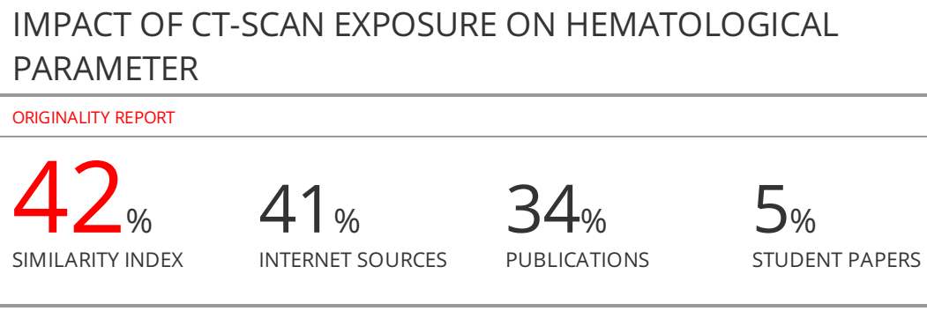

**IMPACT OF CT-SCAN EXPOSURE ON HEMATOLOGICAL PARAMETER**

**ABSTRACT:**

CT scan is more used in diagnosis; however this examen delivered a low dose estimated approximately to 5 mGy. In this study, we analyze the impact of CT scan exposure on hematological parameters for Congo-Brazzaville patients.

Blood samples have been obtained from 61 patients including 23 young patients (<17 years). Blood sample was obtained before and 24h after CT-scan exposure from three different hospitals Congo-Brazzaville. 30 healthy donors have been included as a control. Hematological parameters have been analyzed using R software.

Significant decrease of red blood and hemoglobin were observed after 24 h of CT scan exposure for all patients (p=0.0002 and p=0.0004 respectively). Significant increase of white blood and granulocyte were observed only in adult patients (p=0.0057 and p=0.011respectively). Significant correlation was observed between the abdominal-Pleven (AP) CT-scan and the variation of white blood and granulocytes. Interestingly, decrease of lymphocytes was observed in adult patients and lymphocyte increase was detected in young patients.

We demonstrate for the first time the variation of hematological parameters after exposure to very low doses such as CT-Scan doses. These variations could reflect inflammatory reactions. Additional analysis can be performed for the validation of these data using a large cohorte.

**Key words:** CT-Scan, hematological parameters, low dose exposure, young patients

**INTRODUCTION**

The introduction of ionizing radiation in medical field has revolutionized not only the detection of diseases but also the therapeutic management of patients3. CT scan is the most used radiological exams in diagnosis allowing a higher precision in the detection of the diseases14 Nevertheless, CT-scan delivered a low dose of ionizing radiation, approximately 5 mGy. Epidemiological studies and physiscsdosimetry are generated sufficient knowledge concerning the absorbed dose after CT scan and the risks associated to these exposures in general population and specially in children6. In case of accidental exposure with higher doses, three exams are recommended: hematological exams, cytogenetic investigations and biochemistry analysis. A large literature concerns these three pillars of biological dosimetry after higher dose exposure is very well established. However, the impact of a very low dose exposure such as CT scan still debated and significantly controversy7. The impact of low dose exposure in hematological parameters has not been performed until now5In this study, hematological parameters have been investigated in children and adults before and after 24h after CT-Scan exposure. We demonstrated for the first time the decrease of hemoglobin and reed blood in children and adults after CT-scan. In adult, a significant increase of white blood and granulocyte were observed. All these data demonstrate clearly that CT scan exposure induced a inflammatory reactions.

**MATERIALS AND METHODS**

**Material**

**Patients:**

We studied 61 patients who were exposed to CT scan for diagnosis in three different hospital centers (Mfilou; Blanche Gomes etTalangai). They were 27 males and 34 females with a men age of 29 (range 7-70 years) (Table 1-A).

**Methods**

None of these patients had been exposed to ionizing irradiation. 30 healthy donors with mean age 26 (range 8-55 years) (Table 1-B) and 1 M/F ratio have been used as a control.

Blood samples were obtained before CT-scan and 24 hours after. For healthy donors, similar sample protocols have been performed. Hematological parameters have been analyzed using diagnosis protocols. All patients and healthy donors gave their informed consent. This study was performed in accordance with local ethical rules (N° 398/MESRSIT/IRSSA-CERSSA).

**Table 1-A:** Distribution of patients by age

|  |  |  |
| --- | --- | --- |
| Age group | Workforce (%) | Percentage in % |
| 7 – 19 | 20 (21.74) | 21,74 |
| 20 – 33 | 25 | 27,17 |
| 34 – 46 | 08 | 8,7 |
| 46 – 59 | 14 | 15,22 |
| 60 – 72 | 03 | 0,02 |
| Total | **92** | **100%** |

**Table 1-B:** Distribution of healthy donors by age

|  |  |  |
| --- | --- | --- |
| N° | ages of healthy donors | Workforce |
| 1 | 8 | 02 |
| 2 | 9 | 01 |
| 3 | 10 | 02 |
| 4 | 12 | 01 |
| 5 | 16 | 03 |
| 6 | 17 | 01 |
| 7 | 20 | 03 |
| 8 | 21 | 01 |
| 9 | 23 | 02 |
| 10 | 24 | 02 |
| 11 | 26 | 01 |
| 12 | 30 | 02 |
| 13 | 32 | 01 |
| 14 | 33 | 01 |
| 15 | 37 | 01 |
| 16 | 39 | 01 |
| 17 | 42 | 01 |
| 17 | 45 | 01 |
| 18 | 50 | 01 |
| 19 | 55 | 02 |
|  | **Total** | **30** |

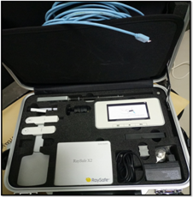

Let m be the average age of our sample.

**m $=\frac{8x2+9+2x10+12+3x16+17+3x20+21+23x2+24x2+26+60+32+33+37+39+42+45+50+110}{30}=25,7$**

Our sample of healthy donors has an average age of 26 years.

**CT scan exposure:**

Patients have been exposed to three kind of CT-scan (Siemens and Neusoft ) in the helical mode with or without contrast medium(OMNIPAQUETM, IOHEXOL). The dose can be quantified by two dosimetric quantities: computed tomography dose index (CTDI, in Gy) and dose length product (DPLin Gy cm). In addition, the sensible dosimeter (RAYSAFE, X2 /Ref.82310106, SWEDEN, SN 283777, calibrated 2021-07-2022) was placed next to the patient to collect the absorbed doses by the skin patient (Figure 1).

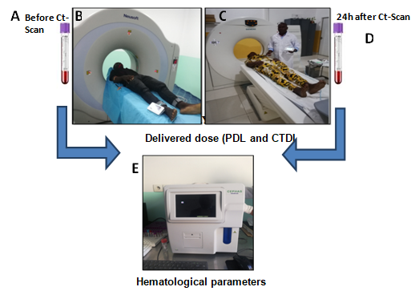

Three types of CT scans have been performed according to their availability in different hospitals: Cerebral, Thoraco-Abdominal (TA), Thoraco-Abdominal-Pelvienne(TAP).

**Hematological parameter analysis:**

The blood study was performed by the Blood Count technique (CBC) using EDTA-K3 tubes then passed to the automated machine. From this homogenate, 2 to 5µL are sucked in and then passed to the analyser, before the scan. The examination was repeated 24 hours later to confirm the changes in the haematological parameters of the blood cells. The haematology machine was used to count the number of blood elements (red blood cells or erythrocytes, white blood cells or leukocytes, platelets or thrombocytes). The automated system was used to analyse the blood collected from the patients, allowing the detection of abnormalities of the three blood lines.

Analyses performed by the automaton for the collection of hematologicalparameters: red blood cells or erythrocytes, white blood cells or leukocytes, platelets or thrombocytes.

**Statistical analysis:**

All statistical tests are done with R v4.3.0, the non-parametric Wilcoxon rank sum test (equivalent to the Mann-Whitney test) is from the ggpubr v0.6.0 library.

**RESULTS AND DISCUSSION**

**Repartition of the delivered dose by CT-scan:**

The DPL and CTDI delivered by CT-Scan are showed in figure 2. No significant difference was observed between the calculated dose with or without contrast compound. However, significant difference for the delivered doses was observed between the type of CT scan (Figure2A). The pediatric patients received a reduced dose compared to adult patients (Figure 2B).

**Comparison avec ICRP**

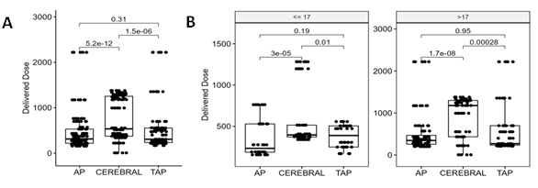

**Variation haematological parameter after CT scan**

Figure 3 shows the variation of haematological parameters in patients 24h after CT-Scan exposure compared to control population sampled in the same conditions. Significant decrease of red blood and hemoglobin were observed in all patients compared to controls (p=0.00028 and p=0.00042 respectively).

Nevertheless, significant increase of white blood and granulocyte were observed in patients compared to controls (p=0.029 and p=0.0071 respectively). In addition, no significant difference was observed in the level of lymphocytes between patients and controls. However a higher inter-individual variation has been observed (Figure 3).

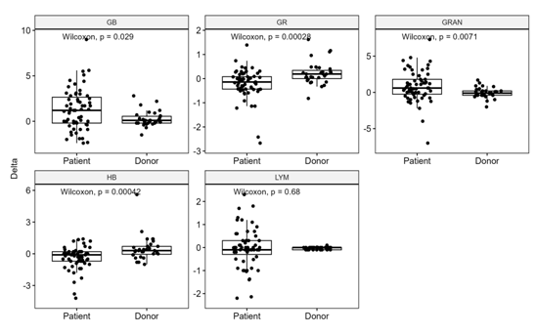

Next, we have analyzed the impact of the type of CT-Scan for these hematological exams.

Figure 4 shows the correlation between the type of CT-scan and the variation of hematological parameters. Significant decrease of red blood and hemoglobin were observed after different type of CT-Scan. Similar correlation was obtained regarding the increases of granulocytes and all type of CT-Scan. However, only significant correlation was obtained between AP CT Scan and white blood.

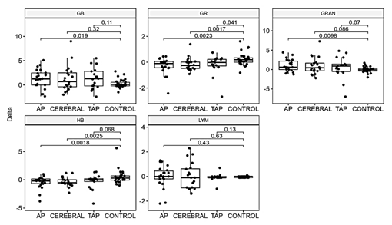

**Variation of hematological parameter age depends:**

Regarding the higher inter-individual variation, we have analyzed the variation of hematologic parameters in young patients (<17years) and adult patients (>17 years).

Figure 5 shows the impact of CT scan on the hematological parameters for these two groups.

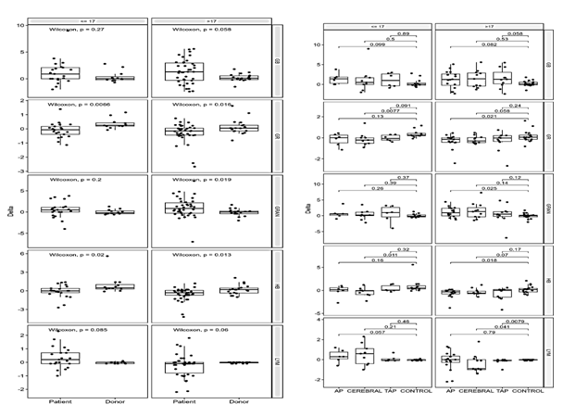We confirmed the significant decrease of red blood and hemoglobin for young and adult patients. Nevertheless, significant increases of white blood and granulocyte were observed only in adult patients. Concerning the variation of lymphocytes, we observed the different variation between young and adult patients. Increases of lymphocyte counts were detected in young patients and decreases in adult patients.

Next, we have analyzedthe impact of age and type of CT-Scan on hematological parameters.

Significant difference was observed between the variation of white blood, granulocyte and hemoglobin and the AP CT-Scan in adult patients. For young patients, only white blood was correlated to TAP CT Scan. Concerning the lymphocytes variation, the significant correlation was observed between CEREBRAL CT-scan for adult and APCT scan for young patients. Long-term exposure to low doses of ionizing radiation can have adverse effects on human cells and tissues of volunteer patients, particularly on peripheral blood cell counts ([Mykyta Sokolov](https://sciprofiles.com/profile/50470) and Ronald Neumann 2016).New to the research is the examination of hematological effects and susceptibility in people exposed to low-dose ionizing radiation, particularly in patients and controls in Congo-Brazzaville.Thus, this study recruited patients and controls, all volunteers, exposed to ionizing radiation which generally consists of X-rays.The sampling method is based on a survey of patients and control subjects, all volunteers and exposed to radiation.in the Mfilou, Branche Gomes and Talangai hospital centers in Congo-Brazzaville, in which we obtained 61 patients and 31 controls. Indeed, ionizing radiation has well-documented effects on blood cells and these effects are generally assumed to contribute to the hematopoietic syndrome (HS), observed in patients and case/control subjects, following exposure to body radiation.(TBI)2.Exposure to low doses of IR is a fact of life in some workplaces. Radiological accidents, while unfortunate at the minimum and devastating at the worst, will undoubtedly continue to occur. Fortunately, most radiation exposures involve low doses (<1 Gy) and therefore have no immediate fatal effects. However, the long-term effects of low-dose exposures may be real and should be seriously considered16.Based on the magnitude of the decrease and the time required to show a significant decrease in blood cell count after irradiation, white blood cells appeared to be the most sensitive to X-ray irradiation among the cell types assessed18.The damage caused by IR leads to a significant reduction in the number of blood cells in a dose-dependent manner, which can be considered as a potential health risk during exposure. Previously, Rozgaj et al reported that long-term exposure to low doses of ionizing radiation can affect cells and tissues and lead to low blood counts soon after irradiation and recovery within weeks. The decrease in the number of leukocytes confirms the results observed in the blood formula11.Seed et al reported that IR is one of the cytotoxic agents that particularly damage cell renewal systems.

They also demonstrated that lymphocytes and neutrophil granulocytes uniformly showed an early decrease in the first days corresponding to cumulative radiation doses13.A proliferating cell system requires an intact cell type, the stem cell, and early progenitor cells to maintain cell replication and system homeostasis.Following irradiation, whether acute or chronic, all cells can be affected, stem cells and early progenitor cells being among the most radiosensitive.At relatively low doses or dose rates, hundreds of stem and progenitor cell clones can emerge bearing individual damage, as one would expect from a "damaged cell".number of cell clones supplying a wide variety of proliferating cells and possibly the abnormal cell populations9.Given the remarkable degree of heterogeneity in cell type, proliferative capacity andthe state of the cell cycle in the bone marrow, the hypothesis that subpopulations of stem cells (or other cell types in the marrow microenvironment) are selectively resistant to radiation damage has been proposedand tested by4.In the present study, the significant reduction in the number of white blood cells was detected 24 h (one day) after irradiation at all dose levels compared to the control group and the number of white blood cells began to be affected at thedose of 0.3 Gy. There is an increase in magnitude with increasing dose. This result was comparable to that of 17who detect a statistically significant reduction in leukocyte count 24 h (one day) after irradiation for patients at all doses except the 0.25 Gy group.

Hematopoietic stem cell (HSC) damage is the leading cause of death after accidental or intentional exposure to moderate or high doses of ionizing radiation.Radiation exposure can damage hematopoietic stem cells and generate several types of free radicals in living cells.These free radicals/reactive oxygen species (ROS) can cause apoptosis of hematopoietic cells, decreasing the cells ability to proliferate.This is very likely to happen because the hematopoietic system is one of the most radiosensitive systems.This system also provides blood clots for whole blood vessels1.Figure 3 indicates that levels of red blood cells and hemoglobin were significantly lower in radiation-exposed patients than in controls, while levels of white blood cells and granulocytes were significantly higher in radiation-exposed patients.radiation than in controls (P <0.05). A previous study by17 stated that levels of red blood cells and lymphocytes were higher in patients exposed to radiation.

The possible reason is that the hematological parameters of radiation-exposed patients, with the exception of red blood cells and monocytes, are more sensitive and easily changed due to radiation exposure.For example, although mature platelets are less sensitive to ionizing radiation, stem cells are very radiosensitive.This results in lower platelet counts in patients than in case/control subjects.The platelet count generally decreases 5 to 10 days after exposure to a mild or moderate IR dose. The duration of thrombocytopenia is directly correlated with the dose of IR and the utilization of platelets at sites of active bleeding (due to non-haematologicalsequelae of IR exposure such as gastrointestinal lesions, trauma, etc8. According to a study sent, there was a post-irradiation reduction effect on the number of platelets, especially at 0.5 Gy, but this reduction is not statistically significant compared to the control On the other hand, on the 1st and 2nd day of irradiation, the number of platelets has no obvious change compared to the control for the other doses used. recovery takes place at the same time with a net decrease in the number by increasing the radiation dose. The red blood cell is not a very radiosensitive cell, so picking it is not a reflection of cell radiation damage on the scan. However, it is a suitable candidate for monitoring the effect of radiation for many reasons. First, it is a representative sample of whole-body exposure, since it circulates throughout the body, second, its accessibility and ease of separation to obtain cells with intact membranes15.Previous reports have shown significant differences in red blood cell count and hemoglobin in patients17found that the differences between the results, following patient exposure to low dose rate and high dose rate radiation for peripheral hematopoietic cell counts, were not statistically significant.In the current study, it was found that red blood cells increased with gradually increasing IR dose until it reached 0.5 Gy and then began to decrease until itreaches the maximum at 1 Gy. Thus, the maximum value of the RBC number was reached at the dose of 0.5 Gy 3 hours after irradiation.Then, the number of red blood cells decreases exponentially with increasing time.On the contrary12 reported that the total red blood cell count showed a significant decrease (p < 0.001) throughout the experiment at all radiation dose levels.

In addition, radiation exposure significantly (p < 0.001) reduced the number of normoblasts in the bone marrow and the number of red blood cells, hemoglobin (Hb), hematocrit (Hct) and blood glucose level, erythropoietin (EPO) in the blood, but increased the myeloid to erythroid ratio. Therefore, the data reported are results obtained at radiation doses of 1 and 2 Gy. Red blood cell, hematocrit and hemoglobin levels remained within 10% of those of irradiated case/control donors throughoutthe observation period. Fortunately, red blood cell count (RBC) and hematocrit values remained stable after radiation exposure2.

**Limitations of the study**

**CONCLUSION**

Hematopoietic cells are highly susceptible to radiation damage, even at relatively low exposure levels, and understanding the temporal appearance of each symptom with gradually increasing radiation doses is invaluable to understanding the animal model. The study reported the effect of low-dose ionizing radiation on certain blood components in patients in Congo-Brazzaville. The platelet count shows that there is a slow linear dependence increase in the rate of recovery up to the dose of 0.4 Gy and a steep linear dependence increase in the rate of degradation up to the dose of 0. 3 Gy. Both processes are carried out at the same time with a sharp decrease in the number by increasing the radiation dose. Irradiation of red blood cells indicates that the maximum value of the number of red blood cells occurs at the dose of 0.5 Gy 24 hours after irradiation. This duration and dose are recommended for maximum effect on red blood cell count. The study concluded that IR causes a significant reduction in blood cell count in a dose-dependent manner, which can be considered a potential health risk during radiation exposure. Further studies are recommended to establish other risks of IR that may affect patients in radiation fields.

**COMPETING INTERESTS** The authors declare that they have no competing interests.

**AUTHORS CONTRIBUTIONS** All the authors’ participle in writing, giving feedback on this manuscript, have read and approved the final manuscript.

**ACKNONLEDGEMENTS** The authors sincerely thank all the actors of the laboratories involved in the success of this work. We also thank Radhja M’KACHER, for their technical assistance.

**REFERENCES**

1-[Azin Samimi](https://onlinelibrary.wiley.com/authored-by/Samimi/Azin), [Heybatullah Kalantari](https://onlinelibrary.wiley.com/authored-by/Kalantari/Heybatullah) [Marzieh, Zeinvand Lorestani](https://onlinelibrary.wiley.com/authored-by/Lorestani/Marzieh+Zeinvand), [Reza Shirzad](https://onlinelibrary.wiley.com/authored-by/Shirzad/Reza), [Najmaldin Saki](https://onlinelibrary.wiley.com/authored-by/Saki/Najmaldin). Oxidative stress in normal hematopoietic stem cells and leukemia [APMIS](https://onlinelibrary.wiley.com/journal/16000463) , [V 126-4](https://onlinelibrary.wiley.com/toc/16000463/2018/126/4) p. 284-294 [https://doi. 2018. org/10.1111/apm.12822](https://doi.org/10.1111/apm.12822)

2-[Billings PC, Romero-Weaver AL,  Kennedy AR.](http://refhub.elsevier.com/S1687-8507(16)00004-2/sref1)  [Effect of gender on the radiation sensitivity of murine blood](http://refhub.elsevier.com/S1687-8507(16)00004-2/sref1) [cells. *Gravitational and Space Research,* 2014. *2*(1), 25](http://refhub.elsevier.com/S1687-8507(16)00004-2/sref1)e[31](http://refhub.elsevier.com/S1687-8507(16)00004-2/sref1).

# 3-Gomes Marin, José Flávio Theranostics in Nuclear Medicine: Emerging and Re-emerging Integrated Imaging and Therapies in the Era of Precision Oncology. [RadioGraphics](https://pubs.rsna.org/journal/radiographics) [Vol. 40, No. 6](https://pubs.rsna.org/toc/radiographics/40/6) 2020, 2020, https://doi.org / 10.1148/rg.2020200021

4-[Grande T, Varas F,  Bueren JA. Residual damage of](http://refhub.elsevier.com/S1687-8507(16)00004-2/sref5) [lymphohematopoietic repopulating cells after irradiation of](http://refhub.elsevier.com/S1687-8507(16)00004-2/sref5) [mice at different stages of development. *Experimental*](http://refhub.elsevier.com/S1687-8507(16)00004-2/sref5)[*Hematology,* *2000, 28*(1), 87](http://refhub.elsevier.com/S1687-8507(16)00004-2/sref5)e[95](http://refhub.elsevier.com/S1687-8507(16)00004-2/sref5).

5-Imen Ghorbel,  Maktouf, Sameh  Disruption of erythrocyte antioxidant defense system, hematological parameters, induction of pro-inflammatory cytokines and DNA damage in liver of co-exposed rats to aluminium and acrylamide. [Chemico-Biological Interactions](https://www.sciencedirect.com/journal/chemico-biological-interactions). [236](https://www.sciencedirect.com/journal/chemico-biological-interactions/vol/236/suppl/C), 2015.  Pages 31-40

6-[John M. Boone](https://pubs.rsna.org/author/Boone%2C+John+M), [William R. Hendee](https://pubs.rsna.org/author/Hendee%2C+William+R), [Michael F. McNitt-Gray](https://pubs.rsna.org/author/McNitt-Gray%2C+Michael+F). [Radiation Exposure from CT Scans: How to Close Our Knowledge Gaps, Monitor and Safeguard Exposure Proceedings and Recommendations of the Radiation Dose Summit, Sponsored by NIBIB, February 24–25, 2011](https://pubs.rsna.org/doi/full/10.1148/radiol.12112201) (2012. [Radiology](https://pubs.rsna.org/journal/radiology)[Vol. 265, No. 2](https://pubs.rsna.org/toc/radiology/265/2). <https://doi.org/10.1148/radiol.12112201>

7-Ki Moon Seong, Songwon Seo, Dalnim Lee, Min-Jeong Kim, Seung-Sook Lee, Sunhoo Park, Young Woo Jin.. Is the Linear No-Threshold Dose-Response Paradigm Still Necessary for the Assessment of Health Effects of Low Dose Radiation? Korean Medical Science 31(Suppl1): S10-S23. <https://doi.org/10.3346/jkms.2016.31.S1.S10>

8-[Krigsfeld GS, Sanzari JK,  Kennedy, AR. The effects](http://refhub.elsevier.com/S1687-8507(16)00004-2/sref10) [of proton radiation on the prothrombin  and  partial](http://refhub.elsevier.com/S1687-8507(16)00004-2/sref10) [thromboplastin times of irradiated ferrets. *International Journal*](http://refhub.elsevier.com/S1687-8507(16)00004-2/sref10)[*of Radiation Biology, 88*(4), 2012. 327](http://refhub.elsevier.com/S1687-8507(16)00004-2/sref10)e[334](http://refhub.elsevier.com/S1687-8507(16)00004-2/sref10).

9-[Kutkov V, Buglova F, McKenna T,  Severe](http://refhub.elsevier.com/S1687-8507(16)00004-2/sref11) [deterministic effects of external exposure and intake of](http://refhub.elsevier.com/S1687-8507(16)00004-2/sref11) [radioactive material: basis for emergency response criteria.](http://refhub.elsevier.com/S1687-8507(16)00004-2/sref11) [Journal of Radiological Protection, 31(2), 2011. 237](http://refhub.elsevier.com/S1687-8507(16)00004-2/sref11)e[253](http://refhub.elsevier.com/S1687-8507(16)00004-2/sref11).

10-[Mykyta Sokolov](https://sciprofiles.com/profile/50470)  and Ronald Neumann...  Global Gene Expression Alterations as a Crucial Constituent of Human Cell Response to Low Doses of Ionizing Radiation Exposure. *Int. J. Mol. 17*(1), 55; 2016 [https://doi.org/10.3390/ijms 17010055](https://doi.org/10.3390/ijms%2017010055)

11-[Rozgaj R, Kasuba V, Sentija K,  Prlic I. Radiation-](http://refhub.elsevier.com/S1687-8507(16)00004-2/sref19) [induced chromosomal aberrations and hematological](http://refhub.elsevier.com/S1687-8507(16)00004-2/sref19) [alterations in hospital workers. *Occupational Medicine, 1999.49*(6),](http://refhub.elsevier.com/S1687-8507(16)00004-2/sref19) [353](http://refhub.elsevier.com/S1687-8507(16)00004-2/sref19)e[360](http://refhub.elsevier.com/S1687-8507(16)00004-2/sref19).

12-[Sanzari JK, Cengel KA, Wan XS, Rusek A,  Kennedy AR.](http://refhub.elsevier.com/S1687-8507(16)00004-2/sref20) [Acute hematological effects in mice exposed to the](http://refhub.elsevier.com/S1687-8507(16)00004-2/sref20) [expected doses, dose-rates, and energies of solar particle](http://refhub.elsevier.com/S1687-8507(16)00004-2/sref20) [event-like proton radiation. *Life Sciences in Space Research*](http://refhub.elsevier.com/S1687-8507(16)00004-2/sref20)[*(Amst)., 2014,  2*, 86](http://refhub.elsevier.com/S1687-8507(16)00004-2/sref20)e[91](http://refhub.elsevier.com/S1687-8507(16)00004-2/sref20).

13-[Seed TM, Fritz TE, Tolle DV,  Jackson WE.](http://refhub.elsevier.com/S1687-8507(16)00004-2/sref23)  [Hematopoietic responses under protracted exposures  to  low](http://refhub.elsevier.com/S1687-8507(16)00004-2/sref23) [daily dose gamma irradiation. *Advances in Space Research, 2002.30*(4),](http://refhub.elsevier.com/S1687-8507(16)00004-2/sref23) [945](http://refhub.elsevier.com/S1687-8507(16)00004-2/sref23)e[955](http://refhub.elsevier.com/S1687-8507(16)00004-2/sref23).

14-[Seung Soo Lee](https://pubmed.ncbi.nlm.nih.gov/?term=Lee%20SS%5BAuthor%5D) and [Seong Ho Park](https://pubmed.ncbi.nlm.nih.gov/?term=Park%20SH%5BAuthor%5D). Radiologic evaluation of nonalcoholic fatty liver disease [World J Gastroenterol.](https://www.ncbi.nlm.nih.gov/pmc/articles/PMC4064084/) 2014 20(23): 7392–7402. doi: [10.3748/wjg.v20.i23.7392](https://doi.org/10.3748%2Fwjg.v20.i23.7392)

15-Shishkina LN, Kushnireva EV, Smotriaeva MA. A new approach to assessment of biological consequences of exposure to low-dose radiation. Radiatsionnaia Biologiia, Radioecologiia, 2004 44(3):289-295

16-[Tucker JD. 2008. Low-dose ionizing radiation and chromosome](http://refhub.elsevier.com/S1687-8507(16)00004-2/sref29) [translocations: a review of  the  major  consideration  for](http://refhub.elsevier.com/S1687-8507(16)00004-2/sref29) [human biological dosimetry. *Mutation Research, 659*(3),](http://refhub.elsevier.com/S1687-8507(16)00004-2/sref29) [211](http://refhub.elsevier.com/S1687-8507(16)00004-2/sref29)e[220](http://refhub.elsevier.com/S1687-8507(16)00004-2/sref29).

17-Wirth Elżbieta -Dzięciołowska, Jadwiga Karaszewska, Kazimiera Pyśniak, Małgorzata Smolińska, Marta Gajewska. Selected peripheral blood cell parameters in twelve inbred strains of laboratory mice. Animal Science Papers and Reports no. 1, 2009.  69-77