**Reviewer’s Comments**

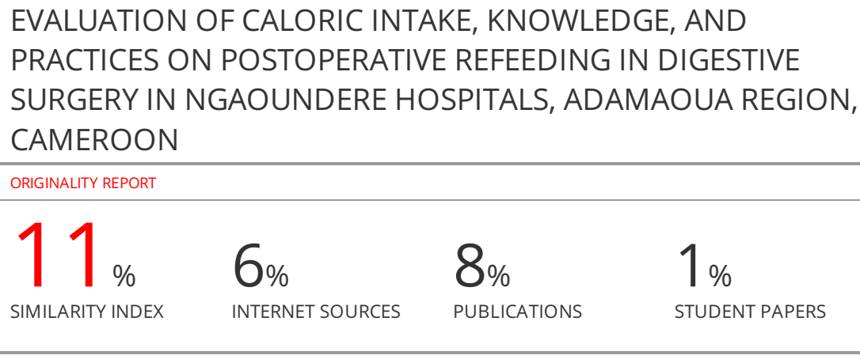

**EVALUATION OF CALORIC INTAKE, KNOWLEDGE, AND PRACTICES ON POSTOPERATIVE REFEEDING IN DIGESTIVE SURGERY IN NGAOUNDERE HOSPITALS, ADAMAOUA REGION, CAMEROON**

**ABSTRACT**

Insufficient caloric intake among postoperative digestive surgery patients, linked to a lack of knowledge and practices regarding their re-feeding, is a frequent health problem in developing countries. The aim of this study was to assess the caloric intake of postoperative digestive surgery patients, as well as the knowledge and practices related to their refeeding in two hospitals in the city of Ngaoundere. This was an observational, analytical, cross-sectional, prospective cohort study over ~~a~~ 5 months ~~period~~ from June to November 2022, focusing on the patients, the diets of post-digestive surgery patients, their nurses, and the operating theatre nursing staff. Caloric targets were defined as those with mean intakes above 15 kcal/kg/day at day-3 and 25 kcal/kg/day at discharge. The Kruskal-Wallis test was used to investigate daily variations in means for each macronutrient, the difference being significant at p<0.05. A total of 134 patients, 240 caretakers, 20 nursing staff, and 614 dieters (meals) were included in the study. Males were more represented, with rates of 82.1%, 56.7%, and 75% for patients, nurses, and staff respectively. 25.4% of day-3 caloric targets and 24.6% of discharge caloric targets were met. Lack of information and practice on the composition of a porridge, food frequency score, feeding chronology, and lack of nursing practice on the part of operating room nursing staff, were the main reasons observed. The dietary balance in postoperative digestive surgery patients and the practices of re-feeding are deficient in the 2 hospitals in the town of Ngaoundere, suggesting an in-depth study of the dietary consequences they may have, such as undernutrition.

**Keywords**:Undernutrition, knowledge and practices, refeeding, postoperative, digestive surgery, Ngaoundere hospitals

**INTRODUCTION**

Insufficient caloric and/or protein intake in relation to the body's needs is a heavy burden in developing countries**1**. It is all the more marked in healthcare settings, with 15% to 60% of hospitalized patients suffering from it depending on the type of admission**2**. In surgical wards, the figures are even higher, with 40-50% of patients affected, due to increased caloric requirements caused by increased catabolism and anorexia, the intensity and duration of which are proportional to the severity of the surgical procedure **3,4**. In Cameroon, very few or no studies have addressed the problem of calculating caloric intake in surgical inpatients. The persistence of this deficiency in caloric intake is associated with other exogenous factors responsible for undernutrition, some of which are linked to the patient's comorbidities, such as extreme age, cancers, sepsis, chronic digestive pathologies, HIV... and factors linked to carcinological treatments, corticosteroid therapy exceeding one month and the polymedication**5** in postoperative patients: hence the need to carry out an assessment of caloric intake in the latter. The poor exploration of the dietary sector among postoperative digestive surgery patients in the Cameroonian context is the reason that prompted us to conduct the present study with the aim of assessing the caloric intakes of postoperative digestive surgery patients, as well as knowledge and practices on the refeeding of postoperative digestive surgery patients in two hospitals in the city of Ngaoundere located in the Adamawa region.

**MATERIALS AND METHODS**

We collected: 134 patients, 100 from « Clinique La Patience de Ngaoundéré » and 34 from Ngaoundere Regional Hospital; 255 patients attendants, 15 of whom were lost to follow-up. Of the remaining 240 attendants, 174 were from « Clinique La Patience de Ngaoundéré » and 66 from Ngaoundere Regional Hospital of 20 post-operative attendants (none lost to follow-up), including 6 from « Clinique La Patience de Ngaoundéré » and 14 from Ngaoundere Regional Hospital; 650 meals, of which 36 could not be characterized. Of the 614 meals, 454 came from « Clinique La Patience de Ngaoundéré » and 160 from Ngaoundere Regional Hospital. 4 representative soups were analyzed.

**Type, period, and setting of study**

We carried out a cross-sectional, observational, analytical, and prospective cohort study. It was carried out in the « Clinique La Patience de Ngaoundéré » and Ngaoundere Regional Hospital in the city of Ngaoundere in the Region of Adamawa Cameroon for a period of five (5) months, from June to November 2022.

**Study population**

The study population consisted of postoperative patients in the post-surgical care departments of the selected hospitals, their meals, patient caretakers, and the nursing staff working in the surgical department.

**Selection Criteria**

**Inclusion criteria :** Included in our study were all patients who had undergone emergency or scheduled digestive surgery during the study period, and who had given their consent, all the patient caretakerswho spent less than 24 hours at the patient's bedside, who had spent at least 24 hours at the bedside and who had given their consent, all nursing staff in the surgical department had given their consent, and all enteral and parenteral meals were included. Not included in our study werepatients who had undergone digestive surgery but died, patients who were malnourished prior to surgery,nursing staff who were lost to follow-up, and enteral and parenteral meals consumed by patients but which could not be characterized during their stay, and all liquid meals that were not representative of the dosing phase.

**Data Collection**

The sampling of patients,patient caretakers, nursing staff, and meals was based on exhaustive, non-probabilistic, and consecutive recruitment. The data were selected among patients who had undergone emergency or scheduled digestive surgery, all the patient caretakerswho spent less than 24 hours at the patient's bedside, and all nursing staff in the surgical department. Signed informed consent was obtained from each participant at recruitment. Before analysis, data collection was anonymized to protect the privacy of participants. A structured questionnaire was set up to collect the following information:

* Demographic characteristics like age, sex, profession, education level, matrimonial status, religion, patient caretakers;
* Assessment of nutritional intake goals and debts of enteral and parenteral patients.

The methodological approach used to assess the nutritional intake targets and debts of enteral and parenteral patients was divided into 4 phases: the characterization phase, the sampling and preservation phase, the dosing phase, and the macronutrient and calorie calculation phase.

1. Meal characterization phase. 7 elements are used to characterize a meal: The Food Diversity Score (FDS) per day is low when consumption is ≤ 2 food groups, medium when consumption is between 3 and 4 food groups, and high when consumption is ≥ 5 food groups. According to the 7 major food families **6**: Meat, fish, and eggs family; Dairy products family; Starchy foods and cereals family; Fruit and vegetable family; Fats family; Sugars and sweetened products family; Beverages family. Record the meal code: structure-patient-day-meal. Food Frequency Score (FFS) per day: Low (1 time - 3 times), normal (4-6 times), high (more than 6 times/day)**7,8**. Food typology from the first day consumed, to identify the types of food consumed: water diet, soup, compote, solid, and solute. Consistency of meal if liquid: liquid, fluid, and thick. Routes of administration per day until discharge: oral, enteral, parenteral. Amount of food consumed per meal, per day.
2. The sampling and preservation phase.We sampled liquid foods, mainly 4 soups (corn porridge, soy, apple poisons, and apple meat). Solid foods, solutes, and labeled liquids were not sampled, as the macronutrient and calorie contents laid down by the FAO were already known from the labels. Samples were kept in the freezer for future analysis, and labeled with the meal code.
3. The dosing phase.Water content was determined by differential weighing before and after oven drying at 130°C to constant mass**9**. Lipid content was determined by the Soxhlet extraction method using hexane as solvent**10**. Total protein content was determined by the Kjeldahl method**11**. Ash content was obtained by incineration in a muffle furnace (Nabertherm®) at 550°C for 4h**12**. Total carbohydrate content was determined by the difference method**13** according to formula (**1**).

$Total Carbohydrate content (\%) = 100 - [Water content (\%) + Protein content (\%) + Lipid content (\%) + Ash content (\%)]$**(1)**

1. The macronutrient and calorie calculation phase. Following the determination of macronutrient contents, the energy value of the dishes was calculated using the coefficients of Atwater and Benedict**14** according to formula (**2**).

$Energyvalue (Kcal/100g) = Carbohydratecontent (\%) × 4 (Kcal) + Proteincontent (\%) × 4 (Kcal) + Fatcontent (\%) × 9 (Kcal)$**(2)**

* Caloric content and macronutrients of operated patients’ mean calorie and macronutrient levels at day-3 and discharge. First, we add up the contents of daily meals. Second, we'll take the average on Day-3 and at discharge for each patient. Third, we'll compare with the energy-carbohydrate-lipid-protein targets on Day-3 at 15kcal/kg/day-2.25g/kg/day-0.5g/kg/day-0.5g/kg/day and at discharge at 25kcal/kg/day-3.75g/kg/day-0.8g/kg/day-1.2g/kg/day (for those who did more than a week) if ≥ then achieved. And finally, for debts or boluses, make the difference between the average on Day-3 or at discharge with the target limits established**15**.
* Nutritional goals, caloric and macronutrient balance. The energy intake considered was that of the average of three successive days. Normal energy and protein requirements were 35 kcal/kg/day and 20% of energy intake, respectively. Patients with an energy intake below the requirement of more than 200 kcal had a low energy intake. Those whose energy intake was above the requirement of more than 200 kcal had a high energy intake. Patients with a protein intake below the requirement of more than 10 g had a low protein intake. Those whose protein intake exceeded the requirement by more than 10 g had a high protein intake. Water intake was calculated as the sum of drinking water, water in liquid food, and infused fluids. Water requirements were 1 mL for 1 kcal, oras many kilocalories as mL of water. Patients with a fluid intake below the requirement of more than 500 mL had a low fluid intake. Those whose fluid intake exceeded the requirement by more than 500 mL had a high fluid intake. Outside the defined limits, energy, protein, or water intake was considered normal**4**.
* Knowledge and practices of health care staff and patient caretakers on post-digestive surgery refeeding. We used 4 questionnaires based on Virginia Henderson's 14 needs and dietary recommendations after digestive surgery**7,16**. Questionnaire 1 concerns the reception of information by the patient attendant from the nurse on the refeeding of a postoperative patient; Questionnaire 2 looks at the nurse's practice in relation to the information received; Questionnaire 3 looks at the nursing staff's knowledge of post-op nutrition in digestive surgery  Questionnaire 4 looks at nursing practices with regard to feeding and hydration needs.

All the procedures of the study were approved by authorization of the Department of Biomedical Sciences of the Faculty of Sciences of the University of Ngaoundere, Ngaoundere Regional Hospital and « Clinique La Patience », and authorization was obtained from the Regional Delegation of the Ministry of Health to recruit participants for this study.

**Ethical considerations**

The experimental procedures used in this study were approved by the Ethics Committee of the Department of Biomedical Sciences of the Faculty of Sciences of the University of Ngaoundere, by the Institutional Review Boardof Ngaoundere Regional Hospital and « Clinique La Patience de Ngaoundéré ».

**Statistical analysis**

The Sphinx Plus.V5 software allowed us to establish the survey questionnaire forms; Microsoft Excel 2016 to collect answers, calculate caloric and macronutrient contents, and establish graphs; finally, the XLSAT 2016 software allowed us to make statistical analyses such as statistical description (by numbers and frequencies for qualitative variables, means, standard deviations and extremes for quantitative ones); Kruskal Wallis test to compare the means Values of p < 0.05 were considered statistically significant.

**RESULTS AND DISCUSSION**

**Demographic characteristics**

Our study was carried out on 134 patients, 240 nurses, and 20 patient caretakers. The predominant sex was male, or 82.09%, 56.71%, and 75% for patient caretakers, and nursing staff respectively. This may be explained by the fact that, during our study period, the majority (for patients) of pathologies encountered were strangulated and non-strangulated hernias (29.85%), the latter affecting men more than women. Our results are superior to the study conducted by Adébayo et al.,**4** in Benin, who found 57.78% male predominance. Among patients, the most represented age bracket was [18-70] years, either 73.35% (105); the majority 62.68% (84) were married and 65.67% (88) were Muslims. Among patients caretakers, the majority were [18-28] years old, or 30.83% (74). The majority were farmers (34.17%, 82), undereducated (34.17%, 82), married (60%, 144), and Muslim (60.42%, 145). Among operating theater staff, the majority were aged [28-38], either 35% (7) or 50% (10) were nurses (**Table 1**).

**Assessment of nutritional intake goals and debts of enteral and parenteral patients**

**Nutritional characterization and diet dosage**

Figure (**1A**) showed that the most consumed food group was soup at 52.28% (apple, fish, meat, soy porridge, and corn porridge) with 25.26%, which is normal since this is the recommended food form for postoperative patients.

Figure (**1B**) showed that the majority of patients had a low Food Diversity Score because they consumed less than 2 food groups (78.37%). This is due to the fact that the most consumed soup was corn porridge (46.15%).

Of the 4 soups measured, maize porridge had a high carbohydrate content (82.07g/100g DM), but the lowest energy content (395.91 kcal/100g DM), with low protein (5.75g/100g DM) and lipid (4.96g/100g DM) contents. This is due to the fact that no other protein or lipid elements were added to its composition (**Figure 1C**).

Patients consumed an average of 7.089 kcal/kg/day of calories containing 1.26g/kg/day of mostly carbohydrates; 0.21g/kg/day of protein and 0.13g/kg/day of fat. This was far from the study done by Clara**16** which found an average calorie intake of 18.5+/- 9.6 kcal/kg/day. this is explained by the fact that the most consumed soup which was Corn Boil, has a low energy intake (395.91kcal) and a low Food Diversity Score.

**Caloric content and macronutrients of operated patients**

Of 134 patients surveyed, carbohydrates were the most consumed macronutrient with a peak on day 12 of 3.17 g/kg/day followed by day 3 of 2.55 g/kg/day for 59 and 132 patients with 12 and 3 days of hospitalization respectively (**Figure 2A**). The caloric peak was 19.45 g/kg/day on day 12 followed by 15.37 g/kg/day on day 3 for 59 and 132 patients with 12 and 3 days of hospitalization, respectively (**Figure 2B**). The Kruskal-Wallis test shows us that the means for each macronutrient varied very significantly by day p<0.0001.

Of 134 patients surveyed, carbohydrates were the most consumed macronutrient, with a peak on day-12 of 3.17 g/kg/day followed by day-3 of 2.55g/kg/day for 59 and 132 patients respectively, who had been hospitalized for 12 and 3 days (**Figure 2A**). Peak caloric intake was 19.45 g/kg/day on day 12, followed by 15.37g/kg/day on day 3, for 59 and 132 patients respectively with 12 and 3 days of hospitalization (**Figure 2B**). The Kruskal-Wallis test showed us that the means for each macronutrient varied very significantly by day p <0.0001. Patients consumed an average of 7.089 kcal/kg/day of calories, containing 1.26g/kg/day of main carbohydrates, 0.21g/kg/day of protein, and 0.13g/kg/day of fat. This was a far cry from Clara's 2014 study, which found an average calorie intake of 18.5+/- 9.6kcal/kg/day. This can be explained by the fact that the most widely consumed soup was Corn Porridge, which has a low energy intake (395.91kcal) and a low Food Diversity Score.

The majority of patients had not reached their caloric-carbohydrate-lipid-protein goal at day-3, which was 15kcal/kg/day-2.25g/kg/day-0.5g/kg/day-0.5g/kg/day. Thus, only 24.63%; 30.60%; 11.94%; 14.93% respectively for caloric, carbohydrate, lipid, and protein objectives were reached. Also, the majority of patients had not reached their caloric-carbohydrate-lipid-protein objective at discharge, which was set at 25kcal/kg/day-3.75g/kg/day-0.8g/kg/day-1.2g/kg/day. Thus, only 25.37%; 29.10%; 11.19%; 14.96% for caloric, carbohydrate, lipid, and protein targets respectively were achieved. This would be a departure from the 2014 Clara**16**study in France which found 53% at day-3 and 54.5% at discharge of patients who achieved their caloric goal. This is because the patients had a very low average caloric intake. Thus, patients who did not reach their caloric goals on day-3 or at discharge had an average of 12.36 kcal/kg/day as a caloric debt on day-3 and were discharged with an average caloric debt of 17.61 kcal/kg/day which is very high.

**Mean calorie and macronutrient levels on day-3 and discharge**

On average 8.22 [0-41.92] Kcal/kg/day were consumed on day-3 and 10.9 [0.81-56.26] Kcal/kg/day at discharge. All post-op patients were grade I and II patients, as daily intake over 7 days was < 60% (**Table 2**).

**Nutritional goals**

The majority of patients had not reached their caloric-carbohydrate-lipid-protein goals set at 15kcal/kg/day-2.25g/kg/day-0.5g/kg/day-0.5g/kg/day for day-3 respectively and at 25kcal/kg/day-3.75g/kg/day-0.8g/kg/day-1.2g/kg/day respectively for discharge. Thus only 25.37%; 29.10%; 11.19%; 20.90% respectively for caloric, carbohydrate, lipid, and protein goals at day-3 (**Figure 3A**) and 24.63%; 30.60%; 11.94%; 19.90% respectively for caloric, carbohydrate, lipid, and protein goals at discharge (**Figure 3B**) were achieved. These results are in line with those of Clara, who worked on the evaluation of nutritional management in the surgical intensive care units at the **Centre Hospitalier Universitaire de Nancy** in 2014 in Benin.

**Caloric and macronutrient balance**

Patients who did not reach their caloric goals on day-3 or at discharge had an average caloric debt of 12.36 kcal/kg/day on day-3 and were discharged with an average caloric debt of 17.61 kcal/kg/day (**Table 3**).

**Knowledge and practices of health care staff and patient caretakers on post-digestive surgery refeeding**

The nurses were more informed about the beginning of the feeding (100%), the type of food (95.83%), and had good practices (97.91% of the nurses waited for the gas to be released and 91.66% gave the best type of food to the patients). On the other hand, regarding the other parameters such as the composition of a slurry, the Food Frequency Score, and the chronology of feeding, the caretaker was not sufficiently informed about it and therefore had non-conforming practices. These data correlated very well with staff knowledge and practice, as the higher the rate of staff knowledge and practice, the higher the rate of staff information and practice. For the aspect of knowledge and practices of the personnel with regard to the needs of feeding and hydration expressed by the patient, the majority of the personnel had knowledge of it, or 15/20 for the most minimal knowledge or the evaluation of the ingesta, but on the other hand, the practices left something to be desired, or 0/20 of the person who always calculated the BMI and the caloric needs of the patients, and 2/20 of the person who drew up the nursing care plans (**Table 4**).

Lack of information and practices of the nurses on the composition of porridge, the Food Frequency Score, the chronology of feeding, and the lack of practices of the operating room staff on the nursing care plans, the evaluation of the BMI, and the calculation of the caloric intake of the patients were mostly observed. This can be explained by the fact that the majority of under-educated people at the bedside are not able to remember the instructions given by the staff. For the staff, the presence of non-nursing staff within the operating team is not equipped with knowledge of the nursing care plan but is considered as such. And also the laziness developed by some nursing staff in the past years.

**LIMITATIONS OF THE STUDY**

**CONCLUSION**

The patients were mostly male, aged between [18-70] years, married, and of the Muslim religion. The majority of the meals consumed by the patients were of the soup group, in this case, corn porridge, which is not very diversified in terms of Food Diversity Score and has a low energy and protein content, unlike fish soup or other diets. This is the reason why the majority of patients did not reach their carbohydrate, lipid, and protein caloric objectives on day-3 and at discharge and left the ward with more caloric debts than boluses. Also, there was a lack of information and practices of the nurses on the constitution of porridge, the Food Frequency Score, the chronology of feeding, and the lack of practices of the personnel in function in the operating room on the nursing care plan, the evaluation of the body mass index and the calculation of the caloric intake of the patients.

**ACKNOWLEDGEMENTS**

The authors would like to thank the University of Ngaoundere (Cameroon) for its infrastructural support. The authors would also like to thank members of LABBAN (Laboratory of Biophysics, Food Biochemistry and Nutrition of ENSAI, University of Ngaoundere, Cameroon) and Professor Nguimbou Richard Marcel, Head of the Department of Food Science and Nutrition at the University of Ngaoundere, Cameroon.

**CONFLICT OF INTEREST**

No conflict of interest is associated with this work.

**AUTHOR’S CONTRIBUTION**

Nguimbou Richard Marcel,Tsague Marthe Valentine, Sineche Ngunte Raoul: Methodology; Sineche Ngunte Raoul, Modjo Gabriel Archange, Nguimbou Richard Marcel: Analysis and interpretation of data; Sineche Ngunte Raoul, Tsague Marthe Valentine, Ngadjui Ngodjoum Donald Roger: Manuscript writing; Nguimbou Richard Marcel, Ngaha Damndja Wilfred Critical revision; Sineche Ngunte Raoul, Nguimbou Richard Marcel: Statistical analysis; Ze Minkande Jacqueline: Study supervision

**REFERENCES**

1.Correia, M. et Waitzberg, D., 2003. The impact of malnutrition on morbidity, mortality, length of hospital stay and costs evaluated through a multivariate model analysis. *clinical nutrition,* 22(3), 235-239. https://doi.org/10.1016/S0261-5614(02)00215-7

2. Elsa, C., 2016. Dénutrition de l’adulte hospitalisé : évaluation et conséquences*,* [Thèse de doctora]*,* Faculté de médecine de l'université Paris Diderot, 114

3. Shpata, V. et al., 2014. Malnutrition at the time of surgery affects negatively the clinical outcome of critically Ill patients with gastrointestinal cancer.. *Medical Archives,* 68(4), 263-267. <https://doi.org/10.5455%2Fmedarh.2014.68.263-267>

4. Adébayo, C., Adrien, M., Albert, C., Gaspard, D., Séraphin, A., Francis, M., Delphin, K., 2018. Fréquence et déterminants de la dénutrition post-opératoire en chirurgie viscérale au Centre National Hospitalier et Universitaire Koutoucou Hubert Maga, Cotonou. *Pan African Medical journal,* 29(1), 1-10. https://10.11604/pamj.2018.29.19.10805

5. Chambrier, C. et Sztark, F., 2012. Recommandations de bonnes pratiques cliniques sur la nutrition périopératoire. Actualisation 2010 de la conférence de consensus de 1994 sur la « Nutrition artificielle périopératoire en chirurgie programmée de l’adulte ». *Journal de chirurgie viscérale,* 149(5), 369‑380. https://doi.org/10.1016/j.jchirv.2012.04.009

6. Richard, N., 2019. Chimie des aliments et de l'environnement*,* [Cour de chimie des aliments], Departement des Sciences Biomédicale de l'Université de Ngaoundere, Cameroun

7. Mathieu, j., 2007. Alimentation et chirurgie digestive. *Médecine et nutrition,* 43(3), pp. 128-131.https://www.medecine nutrition.org/

8. Gilbert, Z., Stéphane, S. et H, X., 2012. Conséquences nutritionnelles de la chirurgie digestive. *Nutrition clinique et métabolisme,* 26, 5-13. https://doi.org/10.1016/j.nupar.2011.12.005

9. Association Française de Normalisation (AFNOR). 2000. Détermination de la teneur en eau, méthode pratique. Céréales, Légumineuses, Produits Dérivés NF V 03-707

10. ISO (*International Standardization Organization*). 1998., Détermination de la teneur en matière grasse selon la méthode d’extraction par Soxhlet, ISO 659

11. Association Française de Normalisation (AFNOR). Directives générales pour le dosage de l'azote avec minéralisation selon la méthode de Kjedahl. Produits Agricoles Alimentaires, NF V 03-050, 1970.

12. ISO (*International Standardization Organization*). 2007. Dosage du taux de cendre par incinération à 550°C. céréales, légumineuses et produits dérivés, ISO 2171

13. Egan H, Kirk RS and PR Sawyer Chemical Analyses of Food (8th edition). Churchill. Livingstone: London-UK, 591p, 1981.

14. Atwater WO and FG Benedict Experiments on the metabolism of matter and energy in the human body. US Department of Agriculture. Washington, D.C., Bulletin 69, 112p, 1899.

15. Clara, J., 2014. Evaluation de la prise en charge nutritionnelle dans les services de réanimation chirurgicale du Centre Hospitalier Universitaire de Nancy, [Thèse de doctora]*,* Faculté de pharmacie de l'université de Lorraine, 8. https://hal.univ-lorraine.fr/hal-01770864/document

16. Paget, S., Adam, F., Courtois-Dubresson, C. et Bon, C., 2018. Le modele de Virginia Henderson. https://www.ifsidijon.info/v2/

**Table 1:** Demographic characteristics of postoperative patients, operating room staff, and patient caretakers

|  |  |  |  |  |  |  |  |
| --- | --- | --- | --- | --- | --- | --- | --- |
| **Variables** | | **Effective (N)** | | | **Frequency (%)** | | |
| **Patients (N=134)** | | | | | | | |
| **Structure** | |  | | |  | | |
|  | CPN | 100 | | | 74.63 | | |
|  | HRN | 34 | | | 25.37 | | |
| **Gender** | |  | | |  | | |
|  | Male | 110 | | | 82.09 | | |
|  | Female | 24 | | | 17.91 | | |
| **Age range (year)** | |  | | |  | | |
|  | <18 | 19 | | | 14.18 | | |
|  | [18-70] | 105 | | | 78.36 | | |
|  | >70 | 10 | | | 7.46 | | |
| **Age(year)** | |  | | |  | | |
|  | Mean, SD | | **36 +/- 17.78** | | | |  |
| **Religion** | |  | | |  | | |
|  | Animist | 5 | | | 3.731 | | |
|  | Christian | 41 | | | 30.59 | | |
|  | Muslim | 88 | | | 65.67 | | |
| **Matrimonial status** | |  | | |  | | |
|  | Single | 50 | | | 37.31 | | |
|  | Married | 84 | | | 62.68 | | |
| **Patient caretakers (N=240)** | | | | | | | |
| **Structure** | |  | | |  | | |
|  | PCN | 153 | | | 63.75 | | |
|  | RHN | 87 | | | 36.25 | | |
| **Gender** | |  | | |  | | |
|  | Male | 139 | | | 57.92 | | |
|  | Female | 101 | | | 42.08 | | |
| **Sex ratio** | |  | | |  | | |
|  | M /F | **1.3** | | | | | |
| **Age range (year)** | |  | | |  | | |
|  | ˂18 | 4 | | | 1.67 | | |
|  | [18-28[ | 74 | | | 30.83 | | |
|  | [28-38[ | 50 | | | 20.83 | | |
|  | [38-48[ | 57 | | | 23,75 | | |
|  | ≥48 | 55 | | | 22,92 | | |
| **Age (year)** | |  | | |  | | |
|  | Mean, SD | **40 +/-13.73** | | | |  | |
| **Profession** | |  | | |  | | |
|  | Farmer | 82 | | | 34.17 | | |
|  | Frame | 16 | | | 6.67 | | |
|  | Retailer | 72 | | | 30.00 | | |
|  | Teacher | 10 | | | 4.17 | | |
|  | Student | 8 | | | 3.33 | | |
|  | Housewife | 44 | | | 18.33 | | |
|  | Retired | 8 | | | 3.33 | | |
| **Education level** | |  | | |  | | |
|  | Undereducated | 82 | | | 34.17 | | |
|  | Primary | 43 | | | 17.92 | | |
|  | Secondary | 60 | | | 25.00 | | |
|  | Upper | 55 | | | 22.92 | | |
| **Matrimonial status** | |  | | |  | | |
|  | Single | 46 | | | 19.17 | | |
|  | Divorced | 38 | | | 15.83 | | |
|  | Married | 144 | | | 60.00 | | |
|  | Widower | 12 | | | 5.00 | | |
| **Religion** | |  | | |  | | |
|  | Christian | 95 | | | 39.58 | | |
|  | Muslim | 145 | | | 60.42 | | |
| **Staff working in the operating room (N=20)** | | | | | | | |
| **Structure** | |  | | |  | | |
|  | PCN | 6 | | | 30 | | |
|  | RHN | 14 | | | 70 | | |
| **Gender** | |  | | |  | | |
|  | Female | 5 | | | 25 | | |
|  | Male | 15 | | | 75 | | |
| **Age range (year)** | |  | | |  | | |
|  | [18-28[ | 6 | | | 30 | | |
|  | [28-38[ | 7 | | | 35 | | |
|  | [38-48[ | 5 | | | 25 | | |
|  | ≥48 | 2 | | | 10 | | |
| **Age(year)** | |  | | |  | | |
|  | Mean, SD |  | | **33 +/- 10.89** | | | |
| **Grade of the staff** | |  | | |  | | |
|  | Nursing Assistant | 4 | | | 20 | | |
|  | Nurses | 10 | | | 50 | | |
|  | Trainee | 6 | | | 30 | | |
| *N: Numbers; SD: standard deviation; PCN: La Patience Clinic in Ngaoundere ; RHN: Regional Hospital of Ngaoundere* | | | | | | | |

**Table 2:** Summary of average calorie and macronutrient contents on day-3 and at discharge

|  |  |  |  |  |
| --- | --- | --- | --- | --- |
|  | Minimum | Maximum | Mean | SD |
| Mean Carbohydrate on day-3 (g/kg/day) | 0 | 8.04 | 1.50 | 1.93 |
| Mean Fat on Day-3 (g/kg/day) | 0 | 0.99 | 0,14 | 0.24 |
| Mean Protein on Day-3 (g/kg/day) | 0 | 1.23 | 0.23 | 0.35 |
| Mean Energy Values on day-3 (kcal/kg/day) | 0 | 41.92 | 8.22 | 10.76 |
| Mean Carbohydrate at discharge (g/kg/day) | 0.17 | 8.04 | 1.91 | 1.91 |
| Mean Lipids at discharge (g/kg/day) | 0.008 | 1.87 | 0.21 | 0.29 |
| Mean Protein at discharge (g/kg/day) | 0.01 | 4.07 | 0.32 | 0.49 |
| Mean Energy Values at discharge (kcal/kg/day) | 0.81 | 56.26 | 10.90 | 11.41 |

*SD:Standard Deviation*

**Table 3:** Mean caloric and macronutrient debts and boluses on day-3 and at discharge

|  |  |  |  |  |
| --- | --- | --- | --- | --- |
|  | **Mean [min ; max]** | | | |
|  | **Day-3** | | **output** | |
|  | **Debts** | **bolus** | **Debts** | **bolus** |
| Carbohydrate (g/kg/day) | -1.84 [-2.25 ; -0.01] | 1.91 [0.06; 5.7] | -2.65 [-3.37 ; -0.05] | 1.82 [0.06; 5.79] |
| Lipid (g/kg/day) | -0.43 [-0.50 ; -0.11] | 0.21 [0.01; 0.49] | -0.58 [-0.79 ; -0.07] | 0.33 [0.02; 1.38] |
| Protein (g/kg/day) | -0.40 [-0.50 ; -0.01] | 0.46 [0.09; 0,74] | -0.85 [-1.19 ; -0.08] | 0.57 [0.10; 3.57] |
| Caloric (kcal/kg/day) | -12.36 [-15 ; -1.12] | 9.66 [2.65; 26.93] | -17.61 [-24.19; -0.95] | 11.52[1.32 ; 41,27] |

**min** : minimum **; max :** maximum

**Table 4:** Knowledge and practices of staff and patient caretakers

|  |  |  |  |  |  |  |
| --- | --- | --- | --- | --- | --- | --- |
|  | **Variables** | **Patient care (N=240)** | | **Staff (N=20)** | | |
|  | **Information** | **Practices** | **Knowledges** | **Practices** | |
| **On re-feeding** | | | | | |
|  | Start feeding (after gas emission) | 240 | 235 | 20 | 20 | |
| Type of food and consistency (soup, compote... liquid/semi-liquid) | 230 | 220 | 20 | 20 | |
| Composition of a soup mix (corn, sugar, peanuts, soya...) | 10 | 5 | 10 | 10 | |
| Feeding chronology (water diet, real 1, real 2, normo caloric without residues) | 45 | 19 | 12 | 6 | |
| FFS (at least 4 times per day) | 20 | 9 | 6 | 3 | |
| Hygiene rules (wash hands, utensils, use bottled water) | 59 | 240 | 20 | 10 | |
| **On the need for nutrition and hydration** | | | | | |
|  | Care plan with regard to feeding and hydration needs | / | / | 20 | 2 | |
| Evaluation of ingesta and excreta (diuresis, stools, quantity of food ingested) | / | / | 15 | 11 | |
| BMI Assessment | / | / | 20 | 2 | |
| Energy requirements | / | / | 16 | 0 | |
| Counseling on re-feeding | / | / | 20 | 20 | |

*BMI: Body Mass Index; FFS: Food Frequency Score; p-value ˂0.05 chi² test*

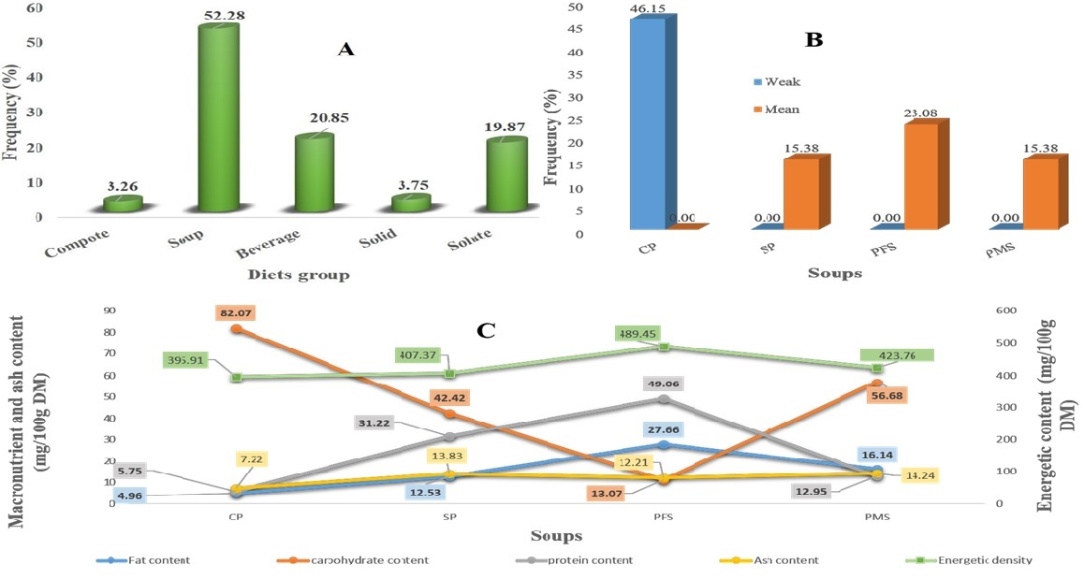

**Figure 1**: Distribution of diet groups consumed by patients (A), SDA of most consumed diet (B) Average energy content of soups (C)

***CP****: corn porridge;* ***SP****: soy porridge;* ***PFS****: porridge fish soup;* ***PMS****: porridge meat soup;* ***FDS****: Food Diversity Score;* ***DM****: dry matter.*

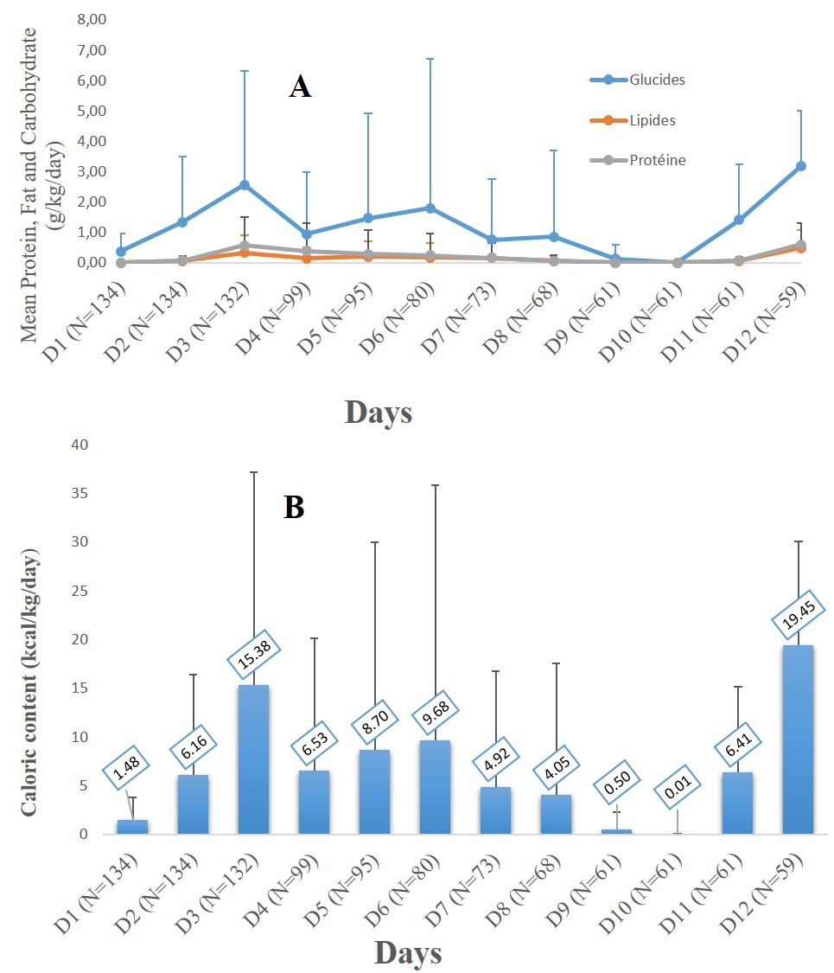

**Figure 2** :Average daily macronutrient (**A**) and caloric (**B**) content of dishes per kg according to hospitalization days and number of patients remaining per day

*D : day*

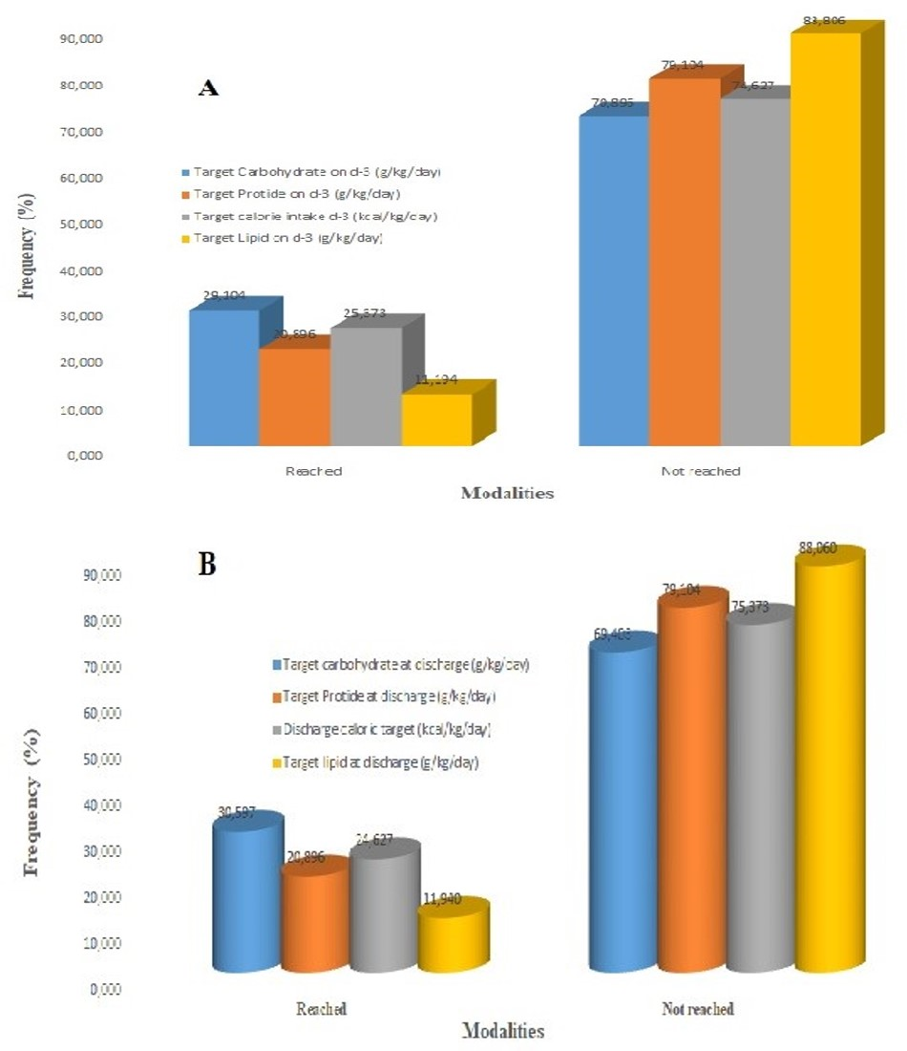

**Figure 3**: Distribution of patients according to the achievement of caloric and macronutrient targets on D-3 (**A**) and at discharge (**B**)