**Reviewer’s Comments**

**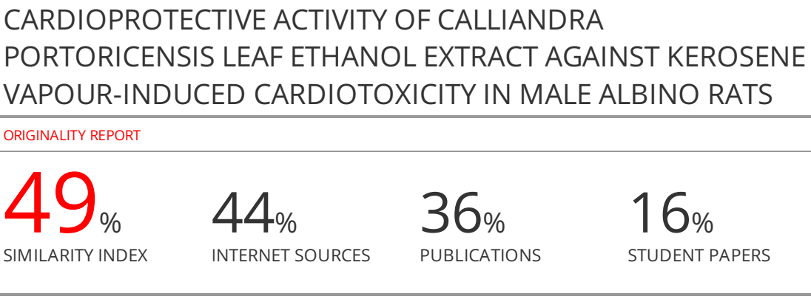**

**CARDIOPROTECTIVE ACTIVITY OF *CALLIANDRA PORTORICENSIS* LEAF ETHANOL EXTRACT AGAINST KEROSENE VAPOUR-INDUCED CARDIOTOXICITY IN MALE ALBINO RATS**

**ABSTRACT**

*Calliandraportoricensis*plant is attracting global-interest due to its broadly reported phytomedical application.This study investigated the cardioprotective activity of *Calliandraportoricensis* leaf ethanol extract (CPLEE) on kerosene vapour–induced cardiotoxic male albino rats. Twenty-five male albino rats (120 – 150 g) were grouped into five groups (n=5). Group 1 received distilled water (normal control), while CPLEE constituted doses of 25 and 50 mg/kg b.wt*p.o* were administered once daily for the last 4 weeks to animals in groups 4 and 5 respectively. Group 2 received kerosene vapour1.0 mL/kg b. wt by inhalation for 4 weeks to induce toxicity, while group 3 received vitamin C 200 mg/kg*p.o*. Serum and cardiac samples were collected and used for the biochemical analyses. Qualitative phytochemical analysis ofCPLEE revealed the presence of different phytochemicalsincluding flavonoids, tannin, saponin, alkaloids, cardiac-glycosides,. CPLEE caused a significant reduction (p<0.05) in the serum levels of ALT, AST, ALP and LDH in the treated kerosene vapour groups in contrast to the untreated kerosene vapour induced cardiotoxic group. CPLEE showed potentials to mop-up **free radicals** generated by kerosene, by significantly reducing (p<0.05) lipid peroxidative-product (malondialdehyde, MDA) levels and increasing antioxidant activities of superoxide dismutase, catalase and reduced glutathione (GSH) in dose dependent manner in the treated kerosene vapour groups compared to the untreated kerosene vapor-induced cardiotoxic group. The findings suggests that the CPLEE have the capacity to improving cardiac functions at safe doses possibly due to its abundant phytochemicals and antioxidants that offers protections against kerosene vapour-induced oxidative-damage.

*Keywords: Calliandraportoricensis;* antioxidant defence system; MDA; *Phytochemicals;*kerosene vapouroxidative-damage**.**

**Introduction**

Kerosene also called kerosine, paraffin, paraffin oil, fuel oil no. 1, lamp oil is a low-viscous combustible hydrocarbon liquid with a density of 0.78-0.81 g/cm3 that is obtained by fractionally distilling petroleum between 150 and 275°C (300 and 525°F). It is made up of hydrocarbon molecules, with 9-16 carbon atoms1.

Both domestic and commercial airplanes use it extensively as fuel. Kerosene or other liquid fuels are still used for lighting in an estimated 500 million residences worldwide, amounting to an annual consumption of 7.6 billion liters2. It dissolves in petroleum-based solvents but not in water. Household kerosene lighting was much less common in the first half of the 20th century as electricity and the availability of gas fuels grew, especially in wealthy nations. Kerosene is still widely used for cooking and lighting in underdeveloped nations in Africa, Asia, and Latin America. This is because where solid fuels—biomass (wood, agricultural residues, and animal dung) and coal—are major household energy sources, often burned indoors without chimneys or smoke hoods. Exposures to combustion products from solid fuels have been associated with a range of health effects, including lung cancer, chronic obstructive pulmonary disease (COPD), low birth weight, cataracts, pneumonia, and tuberculosis3.

Kerosene poisoning is mostly caused by inhalation (aspiration) following consumption. Kerosene can be ingested or inhaled using commercial items like paints and insecticides, occupational exposure (such as in the petrochemical and aviation industries), accidental discharge (such as during traffic accidents), and drug usage.As long as the product is utilized in accordance with recognized safety procedures, the acute health hazards connected with handling and using kerosene are minimal4. Chemical pneumonitis, arrhythmias and ventricular fibrillation caused by increased myocardial sensitivity to endogenous catecholamines, narcolepsy, cataplexy, and confusion, central nervous system depression, as well as symptoms of pulmonary inflammation like coughing and dyspnea, are the main risks associated with kerosene4-6.

Globally, cardiovascular diseases (CVDs) are the main cause of death. According to estimates, 17.9 million deaths worldwide in 2019 were attributable to CVDs, or 32% of all fatalities. Heart attack and stroke deaths accounted for 85% of these fatalities. The majority(over 75%) of CVD fatalities occur in low- and middle-income nations. In 2019, noncommunicable illnesses caused 17 million premature deaths (before the age of 70), and 38% of those fatalities were attributable to CVDs7. It is now known that environmental pollution contributes significantly to CVD causes, although air pollution is not considered a risk factor in the standard evaluation of CVD. At least 39% of the causes and risk factors for CVD are still mostly unknown8-10. Traditional risk factors do not seem to account for all of the causes of cardiovascular disease in Nigeria, Africa, or the rest of the world. Studies linking environmental contaminants, such as petroleum products, with cardiovascular disease are on the rise11. The potential impact of environmental toxins on the rising prevalence, morbidity, and death of CVD must be properly evaluated.

The modern pharmacological therapy used for the treatment of arrhythmias and ventricular fibrillation, or cardiovascular diseases are believed to be effective but not devoid of unfavorable side effects that cause patient noncompliance. Thus, the increased interest in plants and herbs having reputed antioxidant effects.Calliandra is a genus of perennial flowering plants in the family Fabaceae and the subfamily Mimosoidae12,13. *Calliandraportoricensis* is a woody shrub that grows to about 6m in height. The leaves are small, bi-pinnate in structure, while the flowers are pinkish. The fruits are in the form of pods of about 10cm in length12-14. *Calliandra portoricensis* (Jacq.) Benth is native to tropical and subtropical regions of the Americas, including Mexico and Panama, and other tropical regions of Africa such as Nigeria15. The common name for *Calliandraportoricensis* is Corpse Slinger. In the Yoruba language it is called "Tude”. The parts commonly used in traditional medicine are the leaves and roots.

The plant is used in Nigerian folk medicine as a laxative, abortifacient, anticonvulsant, antipyretic, analgesic, anthelmintic, and treatment for snake bites16,17. There appears to have been little, if any, systematic research on the exposure implications and risks of household kerosene in causing cellular damage via oxidative stress and how plants/herbs can mitigate oxidative damage. The present study evaluated the cardioprotective effects of *Calliandraportoricensis* leaf ethanol extract on kerosene vapour induced cardiotoxicity in male albino rats.

**MATERIALSANDMETHODS**

**Chemicals**

Trichloroacetic acid (TCA), 1-chloro-2, 4-dinitrobenzene (CDNB), 5-5-dithiobis-2-nitrobenzoic acid (DTNB), Dinitrophenylhydrazine (DNPH), **hydrogen peroxide** and thiobarbituric acid (TBA) were purchased from Sigma (St Louis, MO, USA). All chemicals and reagents used in the present study were of analytical grade and were obtained from Sigma Chemical Company, Saint Louis, USA.

**Collection of the Plant materials**

The leaves of *Calliandraportoricensis* were collected from the medicinal plant garden of the National Centre for Genetic Resources and Biotechnology (NACGRAB), Ibadan and was authenticated at the Botany Department, University of Ibadan, Ibadan, and assigned voucher number UIH-22843. The freshly harvested, leaves were washed, air-dried and pulverized using local grinding machine into fine particles and then extracted as described by Siemuri*et al.*18.

**Extraction of the Plant**

Plant extraction Briefly 200 g of the pulverized plant sample were cold macerated in 1.5 L 90% ethanol (w/v) and kept at 25oC for 72hours with occasional stirring. The mixture was filtered with muslin cloth and then with Whatman No.1 filter paper. The filtrate was then dried in a vacuum rotary evaporator (B-491; BUCHI, Rotavapor R-210, Switzerland) in a water bath at 40°C until a semi-solid paste was obtained. This was then stored in airtight container in a refrigerator until needed for analysis.

**Petroleum sample**

Kerosene used for this study was obtained from Debistol petrol filling station, Ibadan Nigeria and was stored in clean containers in our laboratory until needed for use.

**Experimentalanimals**

Twenty-five (25) adults male Wistar rats weighing 120–150 g were procured from College of Veterinary Medicine, Federal University of Agriculture Abeokuta (FUNAAB), and randomly selected into five (5) groups (n = 5). The animals were maintained under standard laboratory conditions (relative humidity 50 ± 15%,30±2oC and12 h light–dark cycle photoperiods) and fed with standard pellet diet and water *ad libitum*, and acclimatized for 2 weeks prior to the experiment. All animal experiments were performed in compliance with the institutional ethics committee regulations and guidelines on animal welfare of our Institution and according to the Guide for the care and use of laboratory animals19.

**Induction of cardiotoxicity**

A modified nose-inhalation exposure method was used as previously described by (Azeez *et al.*20; Uboh*et al.*21). Briefly, the cages housing the animals were placed in respective exposure chambers with calibrated beakers of 1000 cm3 containing 500 cm3 of kerosene. The kerosene was allowed to evaporate freely within the respective exposure chambers at ambient humidity and temperature, and the animals were exposed to vapors (1.0 ± 0.08 cm3/min/kg/m3/day) generated from direct evaporation of the petroleum products. The animals were exposed for ten minutes daily. At the end of the exposure, the animals were transferred to a kerosene-free section of the animal house. The initial and final volumes of kerosene in the beaker before and after exposure were respectively recorded. The differences in volume per day were used as the estimate relative concentrations of the vapors used.The rats were kept in the exposure chambers saturated with the kerosene vapors. All treatment sessions lasted for four weeks. Cardiotoxicity was induced via inhalation of 1.0 mL/kg kerosene vapour for 4 weeks in all animal groups, except the normal control group. After the cardiotoxicity induction, the animals were co-treated through oral administration of *Calliandraportoricensis* ethanol leaf extract (CPELE) and standard vitamin C. The oral administration was done via cannula during the duration of the experiment.

**Experimental design**

The methods of Azeez *et al.*20 and Uboh*et al.*21were used. Twenty-five Albino rats were divided into 5 groups of 5 animals each. All animal groups received kerosene vapour 1.0 mL/kg b. wt by inhalation for 4 weeks to induce toxicity (hepatotoxicity, nephrotoxicity, pulmonotoxicty, neurotoxicity, cardiotoxicity) except Group I which served as normal control. Group 2 served as negative control while Groups 4 and 5 were orally administered CPLEE 25 and 50 mg/kg b. w., and group 3 the positive control group were orally administered standard vitamin C 200 mg/kg b. w., p. o. respectively from 3rd week till the 4th week. On the 29th day, blood was collected by puncturing retro-orbital plexus under light ether anesthesia. Further the heart and other organs were excised and used for biochemical estimations.

**Blood collection**

Whole blood sample was drawn by retro-orbital venipuncture technique using a microcapillary tube by pressing the thumb behind the angle of the jaw resulting in the engorgement of retro-orbital plexus22,23. The blood was then collected into plain vials and held for 30 min at room temperature to allow clotting. The blood sample was centrifuged at 3000 rpm for 10 min at 4°C to obtain clear serum. The serum was transferred into separate tubes without disturbing blood clots and stored at −4°C.

**Preparation of tissue homogenates**

After 4 weeks of the experiment, the rats were fasted overnight and sacrificed by cervical dislocation. The tissues (liver, heart and kidney) were rinsed in 1.15% KCl saline solutions and blotted dry with a paper towel. The tissues were then weighed and homogenized in potassium phosphate buffer (10 mM, pH 7.4). A 10% tissue homogenate was prepared by homogenizing 0.5 g tissue in 4.5 mL homogenizing buffer. The homogenate was centrifuged at 10,000 *g* for 15 min at 4°C. The supernatant was collected for the biochemical estimation of oxidative stress biomarkers antioxidants *in vivo*.

**Biochemical Estimations**

Serum was utilized for the estimation of various bio-chemical parameters namely AST, ALT, ALP and serum total bilirubin. The tissue homogenate supernatant wasused for the biochemical estimation of oxidative stress biomarkers antioxidants *in vivo*.

**Determination of oxidative stress/antioxidant markers**

Lipid peroxidation was assayed by measuring the formation of thiobarbituric acid reactive substances (TBARS) (expressed as MDA equivalents) described by the method of Ohkawa e*t al.*24. The malondialdehyde (MDA) level was calculated from the absorbance according to the method of Adam-Vizi and Seregi,25.Superoxide dismutase activity was determined as described by Misra and Fridovich,26, catalase activity was determined by means of H2O2 as substrate. The results were expressed in μmoles H2O2 consumed/ min.27,28, reduced glutathione was determined according to method described by Ellman29.

**Determination of cardiac biomarkers in kerosene-induced cardiotoxic male wistar rats**

Alanine aminotransferase30, Aspartate aminotransferase30, alkaline phosphatase31and lactate dehydrogenase32,33were determined in the serum using commercial kits.

**Statistical Analysis**

Data were expressed as Mean ± standard deviation statistically using one-way analysis of variance (ANOVA)with tukey’s multiple comparison test. Acceptable value of p<0.05 was statistically significant. The Graph pad prism 6 software version 6 was used for this analysis.

**RESULTS**

The phytochemicals responsible for the biological activities of the *Calliandraportoricensis* ethanol leaf extract was screened. The results are presented in Table 1. It was discovered that the extracts contained essential phytochemicals such as saponin, flavonoids and steroids.

**Table1:** Phytochemical screening of *Calliandraportoricensis* leaf ethanol extract.

|  |  |
| --- | --- |
| **Phytochemicals** | **Ethanol Extract** |
| Alkaloids | + |
| Anthraquinones | + |
| Cardiac glycosides | + |
| Flavonoids | + |
| Phenols | + |
| Reducing sugars | - |
| Saponins | + |
| Steroids | + |
| Tannins | + |
| Terpenoid | + |

+ve = present; –ve = absent

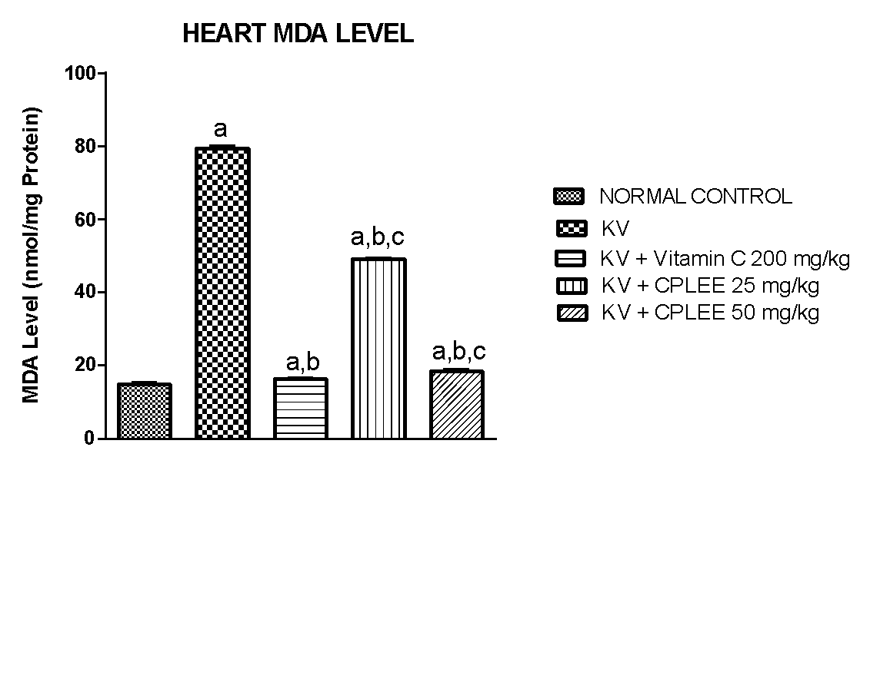

**Figure 1:** The effects of *Calliandraportoricensis* leaf ethanol extract (CPLEE) on lipid peroxidation (MDA) levels in heart of male albino rats exposed to kerosene vapour for 4 weeks. CPLEE protected heart tissue as indicated by the maintenance of comparable levels to the control. Different letters indicate significant differences between groups (p < 0.05). Values are means ±SD (n = 5)

Letter a: indicate significant difference compared to normal control.

Letter b: indicate significant difference compared to kerosene vapour (KV) control.

Letter c: indicate significant difference compared to standard vitamin C control.

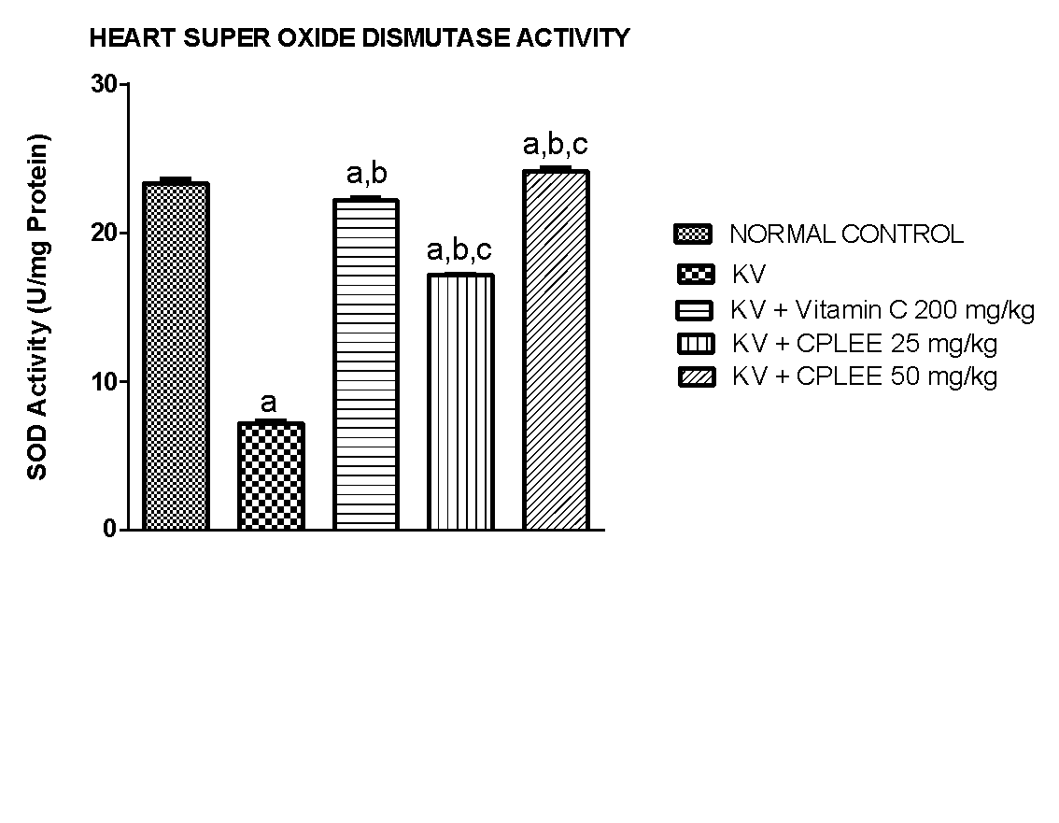

**Figure 2:** The effects of *Calliandraportoricensis* leaf ethanol extract (CPLEE) on superoxide dismutase (SOD) activity in heart of male albino rats exposed to kerosene vapour for 4 weeks. CPLEE protected heart tissue as indicated by the maintenance of comparable activities to the control. Different letters indicate significant differences between groups (p < 0.05). Values are means ±SD (n = 5)

Letter a: indicate significant difference compared to normal control.

Letter b: indicate significant difference compared to kerosene vapour (KV) control.

Letter c: indicate significant difference compared to standard vitamin C control.

**Figure 3:** The effects of *Calliandraportoricensis* leaf ethanol extract (CPLEE) on catalase (CAT) activity in heart of male albino rats exposed to kerosene vapour for 4 weeks. CPLEE protected heart tissue as indicated by the maintenance of comparable activities to the control. Different letters indicate significant differences between groups (p < 0.05). Values are means ±SD (n = 5)

Letter a: indicate significant difference compared to normal control.

Letter b: indicate significant difference compared to kerosene vapour (KV) control.

Letter c: indicate significant difference compared to standard vitamin C control.

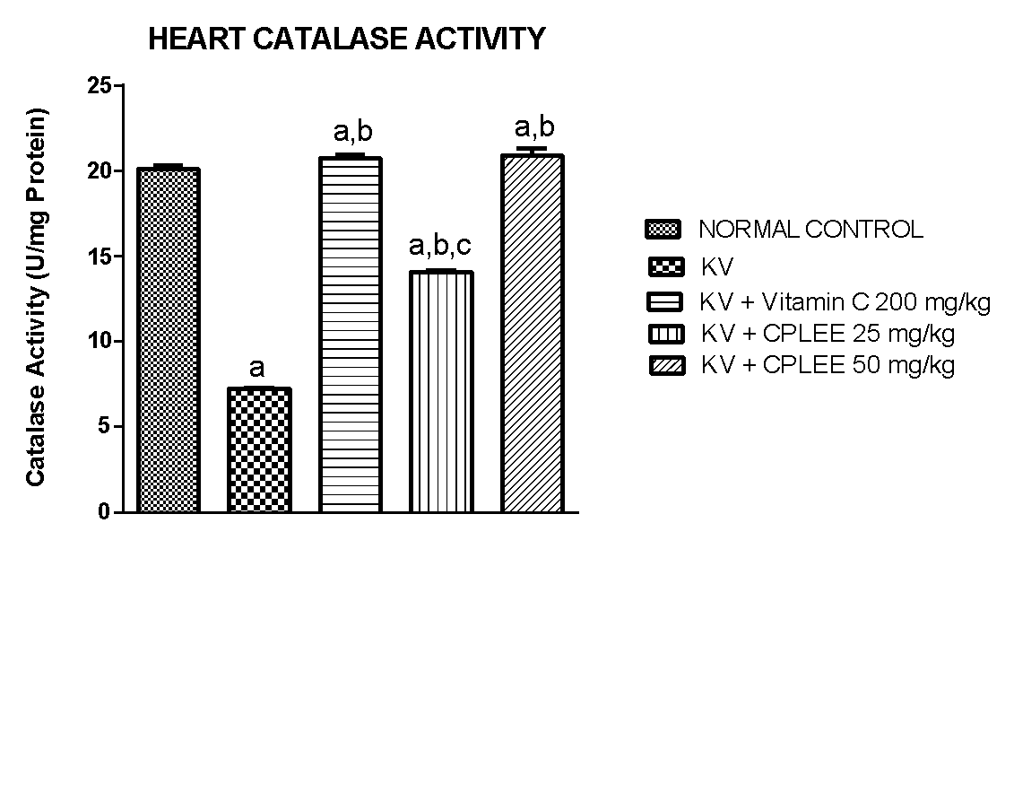

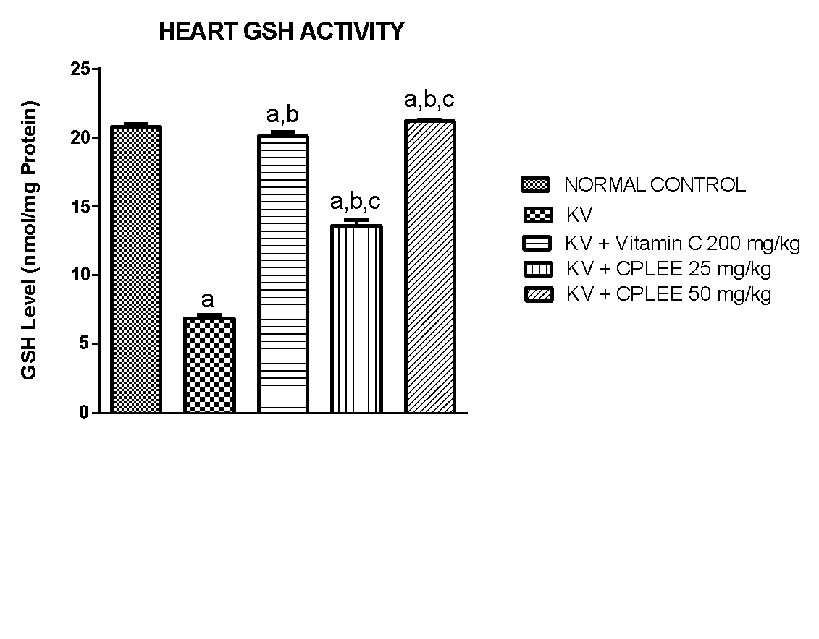

**Figure 4:** The effects of *Calliandraportoricensis* leaf ethanol extract (CPLEE) on glutathione (GSH) levels in heart of male albino rats exposed to kerosene vapour for 4 weeks. CPLEE protected heart tissue as indicated by the maintenance of comparable levels to the control. Different letters indicate significant differences between groups (p < 0.05). Values are means ± SD (n = 5)

Letter a: indicate significant difference compared to normal control.

Letter b: indicate significant difference compared to kerosene vapour (KV) control.

Letter c: indicate significant difference compared to standard vitamin C control.

**Table 2:** Effect of oral administration of *Calliandraportoricensis* leaf ethanol extract on serum liver marker enzymes in male albino rats, exposed to kerosene for 4weeks.

|  |  |  |  |  |  |
| --- | --- | --- | --- | --- | --- |
|  | **ALT IU/L** | **AST IU/L** | **ALP IU/L** | **LDH IU/L** | **TB mg/dl** |
| **Control** | 51.92 ± 2.81 | 94.74 ± 2.54 | 69.88 ± 2.74 | 315.29 ± 4.97 | 0.86 ± 0.02 |
| **KV** | 178.07 ± 2.23 a | 251.09 ± 3.71 a | 225.03 ± 3.01 a | 802.78 ± 5.95 a | 3.05 ± 0.05 a |
| **KV + Vitamin C 200 mg/kg** | 67.78 ± 1.26a,b | 96.61 ± 1.06a,b | 73.81 ± 2.76a,b | 319.89 ± 2.85a,b | 0.67 ± 0.04b |
| **KV + CPLEE 25 mg/kg** | 105.17±3.77a,b,c | 199.71±4.65a,b,c | 203.41 ± 3.43a,b,c | 517.17± 4.76a,b,c | 1.41 ± 0.01a,b,c |
| **KV + CPLEE 50 mg/kg** | 71.21 ± 2.75a,b | 125.79±3.74a,b,c | 111.68 ± 2.13a,b,c | 299.63 ± 3.54a,b | 0.74 ± 0.01b |

CPLEE protected liver, lungs, heart tissue as indicated by the maintenance of comparable activities to the control. Different letters indicate significant differences between groups (p < 0.05). Values are means ±SD (n = 5)

Superscript Letter a: indicate significant difference compared to normal control.

Superscript Letter b: indicate significant difference compared to MSG control.

Superscript Letter c: indicate significant difference compared to standard vitamin C control.

CPLEE = *Calliandraportoricensis* leaves ethanol extracts; bw = body weight; Aspartate aminotransferase (AST); Alanine aminotransferase (ALT); Alkaline phosphatase (ALP); Lactate dehydrogenase (LDH); Total bilirubin (TB).

**DISCUSSION**

Due to the valuable natural antioxidants they contain, phytochemicals from medicinal plants have demonstrated therapeutic potential. They are viewed as possibly safe medications. According to research by Rice-Evans 34, almost 70% of the population relies on traditional medical practices and folklore.It was discovered that the of *Calliandraportoricensis* ethanol extracts contained essential phytochemicals such as saponin, flavonoids, steroids, tannins, alkaloids, cardiac glycosides, anthraquinones, phenols, terpenoids, and with no presence of reducing sugars. The phytochemicals compounds helped in suppressing the deleterious effect caused by the exposure of the hearts, livers and lungs of the albino rats to kerosene. This study clearly shows that CPLEE leaves ethanolic extracts contain a broad variety of medicinal bioactive phytochemicals that have antioxidant properties and cardioprotective activities. *Calliandraportoricensis* is considered as a potent source of unique natural products for development of medicines or drugs against various harmful diseases including cardiovascular disease.

Kerosene is a vital component of human life because of their industrial and home needs35. However, clinical and experimental investigations suggest that kerosene exposure is a risk factor for cardiac disorders, possibly by producing reactive oxygen species.The generation of reactive oxygen species by uncoupling the cytochrome P450 electron transport systems and other electron transport systems can be mediated by kerosene. Reactive oxygen species induce membrane damage through lipid peroxidation, of membrane lipids especially the polyunsaturated fatty acids36. The initial reaction generates a second radical, which can further react with a second macromolecule, generating chain reaction and causing cellular abnormalities. In the present study, CPLEE significantly inhibit or reduce Malondialdehyde (MDA) levels in male albino rats exposed to kerosene fumes in dose dependent comparable to the normal control group and the Vitamin C treated group (Figure 1). However, the untreated kerosene group had significant (p < 0.05) high level of MDA (Figure 1). This is in agreement with the work of Patrick-Iwuanyanwu*et al.*46 who evaluated the Hepatotoxic and Nephrotoxic Effects of Kerosene and Petrol-Contaminated Diets in Wistar Albino Rats manner. MDA is an important index marker of lipid peroxidation. These results indicated that CPLEE can prevent cellular abnormalities caused by ROS by breaking down the chain reactions responsible for lipid peroxidation. Thus, CPLEE is a good source of natural antioxidants and may be used to treat several diseases including cardiovascular diseases caused by free radicals owing to its numerous phytoconstituents.

Oxidative stress is an imbalance between oxidants (ROS) and antioxidants in favour of the former. ROS can damage biomolecules—proteins, lipids and DNA, thus altering the structures and functions of the cell, tissue and organs. As evident from this study exposure to kerosene led to oxidative damage of the cardiac tissue, evident by the significant rise in cardiac MDA level, and significant reduction in superoxide dismutase (SOD), catalase (CAT), and glutathione (GSH) activities in the untreated kerosene group (Figures 1 – 4). CPLEE caused a significant reduction in MDA levels and a significant increase in SOD, CAT, and GSH in a dose dependent fashion comparable to the normal control group and the positive control vitamin C group (Figures 1 – 4). This agrees with the study of Azeez *et al.*37 who reported the prooxidant effect of hydrocarbons. The results of this study thus suggest that oxidative stress is a principal mode of action of kerosene-induced cardiac dysfunction. While the observed CPLEE potentials could be attributed to the antioxidant properties of the phytochemicals. Antioxidant enzymes are essential in the effort to counteract oxidative stress caused by toxicants when the supply of other antioxidant compounds is depleted. These enzymes, which remove peroxides, and superoxide radicals include SOD, catalase and GSH and are very crucial in oxidative stress to deal with free radicals causing several disturbances14. Therefore, intake of *C. portoricensis* leaf ethanol extracts could boost the antioxidant system and reduce lipid peroxidation of the heart in kerosene exposure. *C. portoricensis* is a potential herbal plant that is good for use as a natural medicine due to the redox active phenolic compounds that may act as reductants, hydrogen donors or singlet oxygen quenchers.

In the current study, aspartate aminotransferase (AST), alanine aminotransferase (ALT), alkaline phosphatase (ALP) and lactate dehydrogenase (LDH), activities were increased significantly (p< 0.05) in the kerosene exposed rats. This elevation could be an indication of cellular leakage and failure of functional integrity of liver and cardiac cell membranes in which membrane fluidity is lost resulting probably from free radicals generated in response to the effect of the kerosene exposure which could lead to the leakage of these enzymes to the cytosol or escape from parenchyma cells into the blood stream where their presence can be detected in the serum. The leakage of these enzymes is usually attributed to the compromised integrity of the plasma membrane following the kerosene exposure (Table 2). AST is one of the cardiac biomarkers as well as liver. Besides liver, it is also found in other organs such as heart, muscle, brain, lungs and kidney. These enzymes were described by Teschke38, as sensitive indicators of liver cell injury as well as cardiac injury. Elevated activity of such enzymes (AST, ALT and ALP) in serum reflects its increase rate of entrance into the serum from damaged cardiac tissues and liver cells47. Also, elevated level of ALT could be associated to leakages from damaged cells, due to increased permeability of the hepatocellular membrane, or due to necrosis, indicating organ dysfunction48. Increased serum alkaline phosphatase has been negatively correlated with endothelial dependent vasodilation in hypertensive individuals39,40. The increase in the ALP enzyme activity was also reported to promote arterial calcification in human and experimental animals hence, ALP could be used as a reliable marker for cardiac injury41.

However, in this study, *C. portoricensis* leaf ethanol extracts showed serious depletion in the levels of serum cardiac and liver marker enzymes in rats exposed to kerosene. The treated groups showed (Table 2) a significant reduction in serum ALT, AST, ALP and LDH levels in dose dependent manner compared with the control and the vitamin C treated group. This could be due to the presence of the phytochemicals such as flavonoids saponin tannins that function as antioxidants in mopping free radicals generated by the kerosene xenobiotic and preventing membrane lipid peroxidation thus restoring membrane integrity. The result obtained from the current study correlates with the activity of AST was significantly higher in male and female rats exposed to kerosene and petrol-contaminated diets when compared to the control. Increase activity of AST has also been reported in CCI4-induced toxicity in rats42. This increase may be due to the abnormal dynamic properties of cellular membranes following exposure to hydrocarbon fractions present in kerosene.

Lactate dehydrogenase (LDH), a cytosolic enzyme catalyses the reversible conversion of pyruvate to lactate as part of the Cori cycle in all mammalian cells43. upon cellular injury, LDH is released into the bloodstream resulting in increased lactate dehydrogenase activitywhich has been suggested to be a marker reflecting alteration in organ/cardiac metabolism associated withxenobiotic/kerosene related tissue complications44,45. the ability of CPLEE to decrease the activities of Lactate dehydrogenase in the serum of rats may indicate its cardioprotective potentials.

**LIMITATIONS OF THE STUDY**

**CONCLUSION**

The results obtained from the study shows clearly that the ethanol extract of *Calliandraportoricensis*leaf carries a series of medicinally important bioactive phytochemicals and plays a significant role in mitigating the effect of kerosene inhaled by albino rats due to its antioxidant properties by reducing the Lipid peroxidation (MSD) products while the antioxidant enzymes such as Super peroxide dimutase, catalase and glutathione had significant effects (p < 0.05) in the heart in a dose-dependent manner. Likewise, treatment of kerosene-exposed rats with higher concentrations of*Calliandraportoricensis* leaves ethanolic extracts and vitamin C could boost the antioxidant defense system and lower the levels of serum cardiac and liver marker enzymes such as ALT, ALP, AST, LDH when it was orally administered in 25mg/kg and 50mg/kg dose to rats exposed to kerosene vapor.

**AUTHOR’S CONTRIBUTIONS**

All authors have worked equally for this work.

**ACKNOWLEDGMENTS**

The authors appreciate the Southwestern University Nigeria for providing laboratory support for this investigation.

**CONFLICT OF INTEREST**

No conflict of interest associated with this work.

**FUNDING SOURCES**

This research did not receive any specific grant from funding agencies in the public, commercial, or not-for-profit sectors.

**References**

1. Collins C. "Implementing Phytoremediation of Petroleum Hydrocarbons". Methods in Biotechnology. Humana Press. 2007; 23 (23): 99–108. doi:10.1007/978-1-59745-098-0\_8. ISBN 978-1-58829-541-5.
2. Mills E. The specter of fuel-based lighting. Science. 2005; 308: 1263–64. [PubMed: 15919979]
3. Fullerton DG, Bruce N, Gordon SB. Indoor air pollution from biomass fuel smoke is a major health concern in the developing world. Trans R Soc Trop Med Hyg. 2008; 102:843–51.
4. World Health Organization (2016). Burning opportunity: clean household energy for health, sustainable development, and wellbeing of women and children. Geneva, Switzerland. p. 49. Archived from the original on 24 November 2017.
5. Bebarta V, DeWitt C. Miscellaneous hydrocarbon solvents. *Clin Occup Environ Med* 2004; 4: 455-79.
6. National Poisons Information Service (NPIS). 2003. Kerosene. TOXBASE®.
7. World Health Organization (WHO). Global health risks: mortality and burden of disease attributable to selected major risks. Geneva: World Health Organization; 2021.
8. Collins DR, Tompson AC, Onakpoya IJ, Roberts N, Ward AM, Heneghan CJ. Global cardiovascular risk assessment in the primary prevention of cardiovascular disease in adults: systematic review of systematic reviews. BMJ open. 2017; 7:e013650.
9. Gersh BJ, Sliwa K, Mayosi BM, Yusuf S. Novel therapeutic concepts: the epidemic of cardiovascular disease in the developing world: global implications. Eur Heart J. 2010; 31:642-648.
10. World Health Organization. Global health risks: mortality and burden of disease attributable to selected major risks. Geneva: World Health Organization; 2009.
11. Anakwue RC, Anakwue AC. Cardiovascular disease risk profiling in Africa: environmental pollutants are not on the agenda Cardiovasc Toxicol. 2014; 14:193-207.
12. SiemuriOE, OgaJF, Ijachi-Sam k O. Lethal dose and histopathological studies of the acute and sub-acute effects of *Calliandraportoricensis* root bark methanol extract on the vital organs of adult male albino rats. *UJPR*. 2022; 7(1): 21-26.
13. Souza ER, Lima AVF, Santos FAR, DeQueiroz LP. Three new species of Calliandra in section Monticola (Leguminosae, Mimosoideae) from Chapada Diamantina, Bahia, Brazil. Phytotaxa. 2014; 164(2):104-114.
14. Siemuri EO, Akintunde JK, Anuoluwapo JS. Effects of sub-acute methanol extract treatment of *Calliandraportoricensis*root bark on antioxidant defence capacity in an experimental rat model. *J. Basic Clin. Physiol. Pharmacol.* 2015; 26(4): 375–382.
15. Orishadipe AT, Okogun JI, Mishelia E. Gas chromatography- mass spectrometry analysis of the hexane extract of *Calliandraportoricensis* and its antimicrobial activity. Afr J Pure Appl Chem 2010;4:131–4.
16. Akah, A. P. and Nwaiwu, I. J. (1988). Anticonvulsant activity of the root and stem of *Calliandraportoricensis*. Journal of Ethnopharmacology. 22: 205-210.
17. Onyeama HP, Ebong PE, Etang MU, Igile GO, Ibekwe HA, Atangwho IJ. Effects of *Calliandraportoricensis*extracts on the haematologicalindices of Wistar rats challenged with venom of Echisocellatus. J Appl Pharmaceut Sci. 2012; 02(06):140-144
18. Siemuri EO, Akintunde JK, Bello IJ, Dairo KP. Assessment of cytotoxic effects of methanol extract of *Calliandraportorecensis*using brine shrimp (*artemia salina*) Lethality bioassay. *G.J.B.B*. 2012; 1 (2): 257-260.
19. National Research Council (NRC). 2011. Guide for the care and use of laboratory animals: Eight Edition. Washington, DC: The National Academy Press. 2011.
20. Azeez OM, Akhigbe RE, Anigbogu CN, Ige SF, Saka WA. Variability in cardiovascular functions and baroreflex sensitivity following inhalation of petroleum hydrocarbons. J Cardiovasc Dis Res. 2012; 3:99–103.
21. Uboh FE, Akpanabiatu MI, Eteng MU, Ebong PE, Umoh IB. Toxicological effects of exposure to gasoline vapours in male and female rats. Internet J Toxicol. 2008; 4:59–63.
22. Sorg DA, Buckner B. A simple method of obtaining venous blood from smalllaboratory animals. Proc. Soc. Exp. Biol. Med. 1964; 115: 1131–113.
23. Van HH, Baumans V, Brandt CJ, Boere HA, Hesp AP, van Lith HA, Schurink M, Beynen AC. Blood sampling from the retro-orbital plexus, the saphaenous vein and the tail vein in rats: comparative effects on selected behavioural and blood variables. *Laboratory Animals* 2001; 35(2): 131-9.
24. Ohkawa M, Ohisi N, Yagi K. Assay for lipid peroxides in animal tissue by thiobarbituric acid reaction. *Analytical Biochem*istry 1979; 95: 351-358.
25. Adam-Vizi V, Seregi M. Receptor dependent stimulatory effect of noradrenaline on Na+/K+ ATPase in rat brain homogenate: role of lipid peroxidation. Biochem. Pharmacol. 1982; 32: 2231–2236.
26. Misra HP, Fridovich I. The role of superoxide anion in the auto-oxida­tion of epinephrine and a simple assay of superoxide dismutase. *Journal of biochemical and molecular toxicology*1989; 2417: 3170–5.
27. Sinha AK. Colorimetric assay of catalase. Anal. Biochem. 1972; 47 (2): 389 – 394.
28. Mahmoud HH. New Method for assessment of serum catalase activity. Indian Journal of Science and Technology. 2016; 9(4): 1-5.
29. Ellman GL. Tissue sulphydryl groups. *Arch of Biochemistry and Biophys*ics 1959; 82: 70-7.
30. Reitman S, Frankel S. “A colorimetric method for the determination of serum glutamic oxalacetic and glutamic pyruvic transaminases,” *American Journal of Clinical Pathology* vol. 1957; 28 (1):56–63.
31. kochmar JF, Moss DW. 1976. Fundamentals of Clinical Chemistry. N. W. Tietz (ed). P. 604, W . B. sauders and Company, Philadelphia, P. A
32. Tientz N. 1976. Fundamentals of Clinical chemistry. WB Saunders. 1976.
33. King J. 1965. “The dehydrogenase of oxidoreductase-lactate dehydrogenase,” in *Practical Clinical Enzymology* J. C. King, Ed., pp. 83–93, Van Nostrand, London, UK. 1965.
34. Rice-Evans C. Flavonoids and isoflavones: absorption, metabolism and bioactivity. *Free Rad Biol Med* 2004; 36:827 – 8.
35. Ovuru SS, Berepubo NA, Nodu MB. Biochemical blood parameters in semi‑adult rabbits experimentally fed crude oil contaminated diets. *Afr J Biotechnol*. 2004; 3: 343‑5.
36. Md. Mahbubur R, [Md. Badrul I.](https://bmcresnotes.biomedcentral.com/articles/10.1186/s13104-015-1618-6#auth-Md__Badrul-Islam), [Mohitosh B](https://bmcresnotes.biomedcentral.com/articles/10.1186/s13104-015-1618-6#auth-Mohitosh-Biswas). [. Khurshid, A](https://bmcresnotes.biomedcentral.com/articles/10.1186/s13104-015-1618-6#auth-A__H__M_-Khurshid_Alam).2015. *In vitro* antioxidant and free radical scavenging activity of different partsA. H. M of *Tabebuia pallida* growing in Bangladesh.*BMC Res Notes*. 2015; 8:621.
37. Azeez OM, Akhigbe RE, Anigbogu CN. Oxidative status in rat kidney exposed to petroleum hydrocarbons. Journal of Natural Science, Biology and Medicine. 2013; 4 (1): 149 – 154.
38. Teschke R. Hepatotoxicity by drugs and dietary supplements: Safety perspectives on clinical and regulatory issues. *Ann. Hepatol*. 2009; 8: 184-195.
39. Perticone F, Perticone M, Maio R, Sciacqua A, Andreucci M, Tripepi G, Corrao S, Mallamaci F, Sesti G, Zoccali C. Serum alkaline phosphatase negatively affects endothelium-dependent vasodilation in naive hypertensive patients. *Hypertension.* 2015; 66(4): 874-880.
40. Kumar G, Dey SK, Kundu S. Functional implications of vascular endothelium in regulation of endothelial nitric oxide synthesis to control blood pressure and cardiac functions. *Life Sciences* 2020; 259: 118377.
41. Schutte R, Huisman HW, Malan L, van Rooyen JM, Smith W, Glyn MCP, Mels CMC, Fourie CMT, Malan NT, Schutte AE. Alkaline phosphatase and arterial structure and function in hypertensive African men: The SABPA study. *International Journal of Cardiology*. 2013; 167(5): 1995-2001.
42. Ikechukwu UR, Sangodare RSA, Muhammad KH, Lilian AC. Effect of methanol extract of *Abrusprecatorius*leaves on male Wistar Albino rats induced liver damage using carbon tetrachloride (CCl4). *Journal of Biological Sciences.* 2015; 15:116-123.
43. Kumar P, Nagarajan A, Uchil P. Analysis of cell viability by the lactate dehydrogenase assay. Cold Spring Harb Protocol 2018 (6).
44. Liaw CC, Wang CH, Huang JS, Kiu MC, Chen JS, Chang HK. Serum lactate dehydrogenase level in patients with nasopharyngeal carcinoma. *Acta Oncologica.* 1997; 36(2): 159-164.
45. Papies B, Frille J, Günther KH, Wagenknecht C. Isoenzyme (lactate dehydrogenase, aspartate aminotransferase) and dipeptidyl peptidase IV activity changes in blood plasma likely indicative of organ involvement due to arterial hypertension. *Cor et vasa.* 1991; 33(3): 218-226.
46. **Patrick-Iwuanyanwu**[KC](http://ascidatabase.com/author.php?author=K.C.&last=Patrick-Iwuanyanwu" \t "_blank" \o "Click to find out more papers by K.C. Patrick-Iwuanyanwu)**, Onyemaenu**[CC](http://ascidatabase.com/author.php?author=C.C.&last=Onyemaenu" \t "_blank" \o "Click to find out more papers by C.C. Onyemaenu)**, Wegwu**[MO,](http://ascidatabase.com/author.php?author=M.O.&last=Wegwu" \t "_blank" \o "Click to find out more papers by M.O. Wegwu)**Ayalogu**[EO.](http://ascidatabase.com/author.php?author=E.O.&last=Ayalogu" \t "_blank" \o "Click to find out more papers by E.O. Ayalogu) Hepatotoxic and nephrotoxic effects of kerosene and petrol-contaminated diets in Wistar Albino Rats.*Research Journal of Environmental Toxicology.* 2011; 5 (1): 49-57.
47. EzejinduD, Chinweife KC, Uloneme GC.The effect of *Rauwolfia vomitoria* extract on liver enzymes of potassium induced hepatotoxicity in adult Wistar rats.International Journal of Biomedical and Advance Research 2013; 4(12):909.
48. McIntyre MB. Endothelial function in hypertension. *Hypertension*.1999; 539-545.