**CASE STUDY**

**PENETRATING CRANIUM INJURY BYA CONCRETE NAIL: CASE STUDY**

**Abstract**

The article describes a case study, demonstrating the infliction of a single blind penetrating «gunshot» wound to the head with a concrete nail fired from apowder-actuated fastening tool. Forensic examination of the injury caused by atypical projectiles when fired from atypical firearms can be a difficult task. The results of a thorough autopsy examination of the body and the ante-/post-mortem discovery of atypical projectiles (or other foreign objects) in the victim’s bodyare theprerequisitefor correct interpretation of the injury morphological features.

**Keywords:**atypical projectile; atypical firearms; powder-actuated fastening tool; gunshot wound; cranium

**1. Introduction**

Penetrating head injuries caused by atypical projectiles can beencounteredboth in clinical and forensic pathology practice. Commonly, difficulties in penetrating head injury forensic diagnosis arise whenatypical or homemade firearms loaded with atypical ammunition (instead of standard bullets orpellets) was used. The literature describes the use of steel balls, the so-called«chaff» (chopped fragments of steel wire or lead plates), small metal fasteners (rivets, nuts, washers, screws, bolts, nails), salt, fine gravel and sand, match heads, peas, grains, and fine-cut corn stems instead of standard buck shot [1-3].

The gunpowder propellant effect (the principle on which gunshot works) is used in construction and production fastening tools –powder-actuated tools (PAT), which allow direct bonding of various solid materials (low-carbon steel, reinforced concrete, concrete, bricks, wood). This technology is based on the controlled ignition and combustion of solid fine chemical fuel - the propellant charge of a mounting (construction, industrial) cartridge, similar to how a firearm works.

ThePATis loaded with specially designedfastening cartridges with a powder charge, structurally similar to blank ammunition for firearms, and concrete nails as fastening tools.

Theconcrete nailwasstructurally composed of a wide flattened round cap, a cylindrical rod with a conically pointed end and a round flat metal gasket located at the pointed end of the rod that can be displaced when attaching. According to Russian technic specificationsTU 14-4-1731-92, the concrete nailsare commercially produced with the following dimensional parameters (rod width/length, cap width, gasketwidth): 3.7x30 mm, 3.7x35 mm, and 3.7x40 mm, 8 mm, 10 mm; 4.5x30 mm, 4.5x35 mm, 4.5x40 mm, 4.5x50 mm, 4.5x60 mm, 10 mm, 12 mm [4].

The damage caused by concrete nailswhen fired from the PATcan be both accidental and intentional.

**2. Case Presentation**

The following case from the expert practice demonstrates the morphological features of a single blind penetrating gunshot wound to the head with an atypical metal projectile, which was a concrete nail 4,5x60 mm in size. Acranium with a perforating wound in the occipital bone and a spike-like protrusion of a foreign body in the frontal area on the left side was presented for forensic examination.

From the squama of frontal bone above the middle third of the upper edge of the left orbital socket, a conical end of the metal foreign body protruded from the skull cavity to the outside 9 mm in length; its sharp endwas oriented anteriorly, to the left and upwards (Figure 1). In the center of squama occipitalis, 26 mm from the apex of the external occipital tubercle, a perforating fracture of an oval shape measuring 16x15 mm was discovered (Figure 2).

From the outer surface of the cranium, the edges of the perforating fracture are relatively even, withoutcompact bonechipping (Figure 3a). There was an arc-shaped fissure4-6 mm along the left half of the upper edge of the fracture. The fracture beveled from outside to inside. Inside the cranium cavity, the edges of the fracture had a prominent annular chipping, up to 3 mm wide (Figure 3b).

In the frontal cranial fossa, a part of a metal foreign body with corroded surface was found.It was 32 mm long, and it was stuck in the squama of frontal bone (Figure 4a). Its axis was oriented posteriorly, from bottom to top and from right to left. The inner end of the foreign body (Figure 4b) was located in the area of the “cock’s comb” and the perforated plate of the ethmoidal bone. Under this part of the foreign body a splintered fracture with a bone defect, covering the area of 38x35 mm was found. From the right edge of the defect, 4 linear fissures up to 42 mm extended to the small wing of the sphenoid bone and to the squama of the frontal bone.

A foreign body was extracted from the squama of frontal bone. It was a metal concrete nail 59.4 mm long (Figure 4c). The cap was flattened, round, 10 mm in width, the gasket is flat, round, 12 mm in width. The nail’s rod was cylindrical, its cross section was round, 4.5 mmin diameter. The end of the nail’s rod was conical, with a round cross section, 2 mm in width at the tip, in its middle third - 3.5 mm. The parameters of the foreign body clearly attribute it to a fastening element - a concrete nail 4.5x60 mm in size (according to TU 14-4-1731-92 [4]).

After the extraction of the concrete nail, a perforated splintered fracture was revealed in the squama of frontal bone. On the cranium outer surface, it is round and limited by regular edge withoutcompact bone chipping, with about 4,5 mm in size (Figure 5a). From the inside, in the wall of the frontal sinus, there was a defect of an irregular polygonal shape, measuring about 15x18 mm (Figure 5b).

**3. Discussion**

The described above morphological features of theperforated fracture of squama of frontal bonesuggest the local fracture pattern as a result of shearing deformation caused by the contact (impact) force of a solid blunt object with a limited contact surface and having sufficient kinetic energy (speed) forpenetrating action. Morphologically similar perforated fractures of the flat skull bones are verified as gunshot input bullet injuries [1-3, 5, 6].

The perforated-fragmented nature of the exit fracture is due to the anatomical structure of the squama of frontal bone of the local contact (impact) area (frontal sinus, brow arc), by an atypicalnature of the projectile that initially had low travelling speed and had furtherreduction in kinetic energy (speed) after penetrating and passing through the first tough barrier (squama occipitalis), it is quite safe to assume, that the reduction of the projectile speed can be attributed to the structural features of the PAT from which the shot was fired, its distance and head position at the time of injury (for example, close contact with the frontal region of the head into a hard surface (concrete/brick wall, cement/wooden floor).

**4. Conclusion**

In this case, the discovery of an atypical projectile made it possible to correctly interpret the number, the nature and the features of the revealed injuries on the cranium, defining them as a single blind penetrating gunshot wound to the head with a concrete nail. The condition of this object did not allow to determine the vitality of injury, neither to detect additional factors of the shot.

**Funding**

None.

**Conflict of Interest**

The authors declare that they have no competing interests.

**References**

1. Popov V. L., Shigeev V. B., Kuznecov L. E. Sudebno-medicinskajaballistika [Forensic ballistics]. St.Peterburg: Gippokrat.2002. 656 p. (Russian).

2. Molchanov V. I., Popov V. L., Kalmykov K. N. Ognestrel’nyepovrezhdenijaiihsudebno-medicinskajaekspertiza [Gunshotinjuries and their forensic medical examination]. Leningrad: Medicina, 1990. 272 p. (Russian).

3. Gusencov A. O., Kashinskij M. Ju., Kuhar’kovJu. V. Sudebnajamedicinaisudebnajapsihiatrija [Forensic Medicine andForensic Psychiatry]. Minsk: Akademija MVD. 2021. 581 p. (Russian).

4. Djubeli-gvozdi s nasazhennymishajbami s cinkovympokrytiem [Dowel-nails with mounted washers, zinc-coated].Available from: vikmetiz.ru/category/djubel-gvozd/. (accessed 17.01.2022). (Russian).

5. Shadymov A. B. Osobennostisudebno-medicinskojjekspertizyognestrel’nyhpulevyhpovrezhdenijmozgovogocherepa[Features of forensic medical examination of gunshot bullet injuries of the brain skull]. Sudebno-medicinskijekspert. 2000.No 1. P. 14-19. (Russian).

6. Dubrovin I. A. Sudebno-medicinskajaocenkaognestrel’nyhperelomovploskihkostej [Forensic medical evaluation ofgunshot fractures of flat bones]. Germanija: LAP LAMBERT Acad. Publ. 2017. 220 p. (Russian).

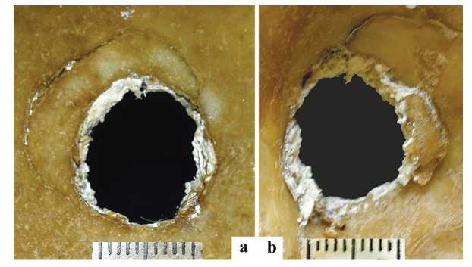

Figure 3. Perforatingfractureinthecenterofsquamaoccipitalis, outersurfaceview ofthecranium (a) andfromthe inside (b)

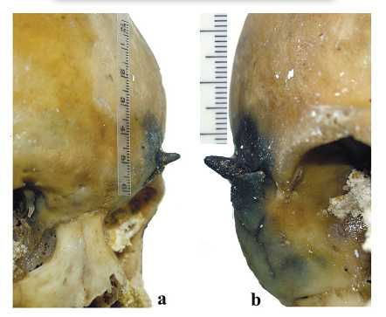

Figure 1. Ametalforeignbodyofaconicalshapeisprotrudingfromthesquama of frontal bone. Rightsideview (a) andleftsideview (b)

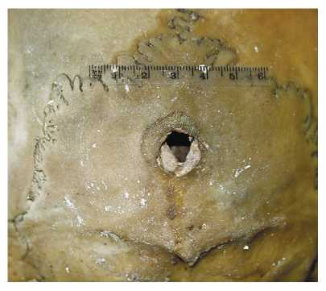

Figure2. Aperforatingwouldinthecenterofsquamaoccipitalis

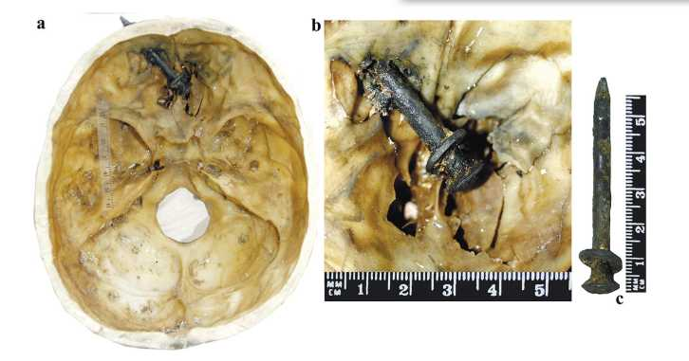

*Figure 4.Ametalforeignobjectstuckinsidesquamaof frontal bone, discoveredaftercraniumcavity dissection (a, b) a concrete nail4,5х60 mm in size (c)*

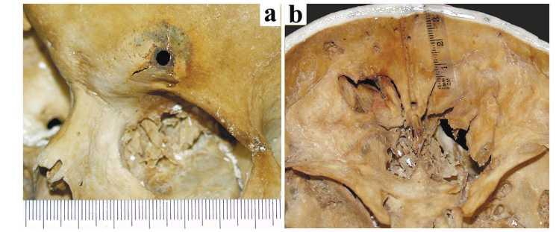

Figure 5. Perforated-fragmentedfractureofsquamaofthefrontalbonefromtheleftside, craniumoutersurfaceview (a) andinsidethecavity.

About authors