**REVIEW ARTICLE**

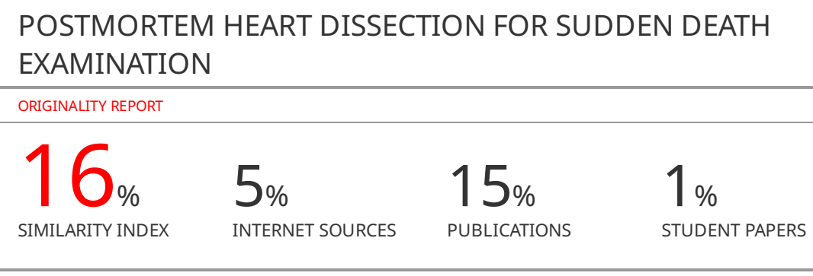

**POSTMORTEM HEART DISSECTION FOR SUDDEN DEATH EXAMINATION**

**Abstract**. The article describes the postmortem heart examination technique during a forensic autopsy of adults. The heart examination technique is based on the recommendations of scientific societies of pathologists, publications on autopsy techniques used in recent decades. The achievements of morphologists of the second half of the 20th century are also taken into account. The postmortem heart examination technique provides an examination of the coronary vessels, as well as myocardium and heart valves.

The possibilities for examination of the elements of the conductive system is also represented. The following method ensures preservation of topographic relationships of morphological structures within the heart and possibility of its re-examination. The postmortem heart examination includes the following stages: examination of the coronary arteries, the making of three transverse incisions from the apex to the middle of the ventricles, “blood flow” incisions taking into account the localization of the main nodes of the conducting system, as well as the peculiarities of the examination of the heart valves.

**Keywords**: heart dissection; sudden death; forensic autopsy

**Introduction**

Heart examination in a case of sudden death may play the decisive role in the forensic death investigation. A thorough heart examination does take some time at the dissecting table. Occasionally, it is advised to fix or decalcify the coronary arteries first and then return to their examination the next day. A formalistic approach when a pathologist, believing that he/she performs methodically correct “blood flow” incisions is unacceptable and what he does actually is conducting the study on hit-and-miss basis, and for histological examination he takes random samples from different parts of the heart. The purpose of heart examination is to identify gross abnormalities and pathological changes that are important for determining the cause of death to further confirm the suspected condition during histological examination, otherwise, we have to perform a systematic and standardized examination that will allow detecting pathological changes that are macroscopically not expressed during histological examination. The effectiveness of histological heart examination highly depends on the relevance of the selected myocardial fragments. Furthermore, it is highly preferable to examine the heart while preserving relationship within its internal structure, thus preserving the ability to make full re-examination.

In anatomic pathology and forensic medicine, various methods of heart dissection have been developed.The “blood-flow” dissection method of Shor G.V. and Abrikosov A.I. (1939) is considered classic [1]. The first stage of this method involves opening the heart cavities and muscles, and the second involves the examination of arteries. As a result, the investigation of the coronary artery system begins after the disruption of their anatomical connections. Additionally, the method makes it difficult to assess focal changes in the myocardium.

Dementieva N. M. in 1959 justified the importance of examining the coronary arteries before opening the cavities of the heart [2]. Avtandilov G. G. in 1962 proposed a methodology for a comprehensive heart and aorta examination along with coronary arteries. Subsequently, this technique was supplemented by measuring the inflow and outflow tracts and separate weighing the heart sections with the calculation of the "ventricular index" and "cardiac index" [3]. In 1953, Lev M. proposed a cardiotomy technique with the preservation of the atrioventricular node [5]. Sinev A.F. et al. proposed a method of opening the heart by filling the coronary channel with X-ray contrast mediumand conducting detailed morphometry of the whole heart, which is especially important in the study and diagnosis of complex forms of congenital cardiac defects [6].

While preparing this publication, we summarized different heart dissection approaches in the forensic autopsy, while also taking into account the established world practice and the level of contemporary knowledge about the possible causes of sudden death of young adults. We were based on the 2017 guidelines of the Association for the European Cardiovascular Pathology [7], scientific societies of pathologists and publications on autopsy techniques of recent decades [4, 8-10].

Overall, the heart study consists of 11 stages.

1. External examination and measurement of the heart.

2. Examination of coronary arteries.

3. 3-4 cross-sections through heart ventricles from an apex to the level of the middle of ventricles.

4. Opening of the right atrium using a horizontal section from the lower vena cava to the top of appendage.

5. Opening of the right ventricle by incision through the conditional midline of back wall, parallel to an interventricular septum.

6. Opening the right ventricle outflow tractby incision anteriorly to the anterior papillary muscle of the tricuspid valve.

7. Opening the left atrium by horizontal incision between the right and left pulmonary veins and continuing it tothe top of appendage.

8. Opening the left ventricle bya lateralincision between anterior and posterior papillary muscles.

9. Opening the left outflow tractby incision immediately posteriorly to the anterior papillary muscle, up to the aortal valve, and then through a commissure between the right and left coronary cuspsof the aortal valve.

10. Heart weigh-in.

11. Sampling for histological examination.

Heart dissection technique. Before the dissection, the heart should be separated from the rest of the organ complex. For this purpose, the pulmonary trunk and the aorta are transected at a distance about 3 cm from the valves, the superior vena cava is transected 2 cm higher of the right atrial appendage crest (this allows to preservesinus node area for a research), the inferior vena cava is transected near a diaphragm (Figs. 1, 2).

The heart dimensions are measured. Length is measured from the aorta basis to the apex or from heart cross to the apexwhile the width is measured between the side surfaces of the heart on level of the basis of ventricles in the largest cross size, thickness - in the largest antero-posterior size of heart. After external inspection and measurement of the heart, the examination moves on to the coronary arteries. It is important to examine not just the main trunks of coronary arteries (the right coronal artery, the descending and circumflex branch of the left coronal artery), but also their major branches. It generally starts with the main trunkof the right coronal artery in the right coronarysulcus. The major branches of the right coronal artery on the anteriorsurface of heart are located in front from acute edge of the heart or on the edge itself. On the back surface of the heart, the incisionsare made on sulcus transversus in the direction from right to left. In case of right coronary artery dominance, the larger branches of the right coronal artery are located at the acute and obtuse edgeof the heart and in the area of a posterior longitudinal sulcus. If the heart hasco-dominant coronary circulation, there will be major branches of the right coronary artery to the right of longitudinal sulcus, whileon the left, there should bemajor branches of the left coronal artery (circumflex branch). And finally, if the heart has LCA dominance, the main trunk of the right artery gets interrupted either immediately behind the acute edge of the heart, or in itsarea. In this case, the posterior interventricular artery (the descending branch) is located to the right of a posterior longitudinal sulcus, while larger branches of the left circumflex coronary artery are located in the area of a longitudinal sulcus at the obtuse edge of the heart . Major trunks examination on the posterior surface of the heart provides the chance to establish the variant of coronary circulation and to determine hemodynamic abnormalities in any given artery and it’s relation to the cause of death. On the heart anterior surface, the circumflexcoronary artery is found in the left coronal sulcus. In case of RCA dominance, the circumflex branch is not always present in this area, slantwise going down immediately from the siteof division of the left coronary artery into the main branches. In this case, the main trunk of the circumflex coronary artery with larger branches lies on an anterior wall of the left ventricle. The descending branch of the left coronary artery (anterior interventricular artery) passes on a anterior longitudinal sulcus. The diagonal branch arises from the corner created by branches of the circumflex and descending trunks.

Another method to examine the coronary arteries involves separationof the left coronary artery (Fig. 3) along with its larger branches, which are the left circumflex artery and the anterior interventricular artery, as well as separation of the right coronary artery (Fig. 4) with its larger branch — the posterior interventricular artery. Isolated arteries are examined through transverse incisions either immediately after isolation or after formalin fixation. It isworth noting that the study after formalin fixation is technically more convenient and makes it easier to detect hemorrhages inside atherosclerotic plaques as well as thrombosis. In the case of atherosclerosis with pronounced calcinosis, it is advisable to first decalcify the isolated blood vessels.

During this study, the pathologistis trying to assess the presence or absence of abnormalities of the coronary arteries, in particular, their abnormal departure, course, presence of aneurysms, stenosis, including those caused by atherosclerosis. Special attention is paid to the presence of thrombosis in the coronary arteries. In the case of discovered atherosclerotic lesion, the degree of lumen narrowing and the prevalence of atherosclerotic lesion as a percentage of the total area of the coronary vessels are estimated.

When the examination of the blood vessels has done, the heart is positioned on a sectional table with the frontal surface upwards. The pathologist makes 3-4 transverse incisions, starting from the apex to the middle level of the ventricles which corresponds to the apex of the papillary muscles (Fig. 5). This provides full-scale visualization of the myocardium of the right and left ventricles and the interventricular septum, as well as full-thickness sampling of the myocardium for histological examination. The remainder of right and left ventricles in the basal half of the heart is dissected in the direction of flow of blood.

The right atrium is opened using surgical scissors from the vena cava inferior to the apex of the right atrial appendage (Fig. 6). The mentioned incision ensures the preservation of the superior vena cava and makes it easy to find the area of the sinus node.

The sinus node (Keith—Flack node, sinoatrial node) is located subendocardiallyin the right atrium wall lateral to the opening of the superior vena cava between the opening of the superior vena cava and the right atrial appendage in the crista terminalis.

In the right atrium, the septum, condition of the foramen ovale, the coronary sinus, and the atrial appendageare examined.

Right ventricle is opened along posterior wall. The knife is placed at a distance of 2–3 cm from the interventricular septum, parallel to it. Then the lengthof tricuspid valve’s ring is measured and state of valve cuspsand the structure of tendon threads are examined. The thickness of the right ventricle is measured in the area of the posterior wall at the level of the middle of the ventricle.

The atrioventricular node (Aschoff—Tawara node, AV node) is located under the endocardium in the posterior part of the atrial septum and to the right, ahead of the coronary sinus ostium, immediately above the attachment septal cusp of the tricuspid valve. The AV node is located in the anterior corner of the Koch triangle, the anterior-superior border of which is the Todar’s tendon (a fibrous fascicle passing at the base of the inferior vena cava valve); the lower border is the attachment line of the septal cusp of the tricuspid valve; upper-posterior border is the ostium of the venous sinus (Fig. 7). Then the right ventricle outflow tract is opened. For this purpose, the incision is madethrough anterior wall of right ventricle. The scalpelshould be placed anteriorly from anterior papillary muscle. After that, the outflow tract, the pulmonary artery valve and pulmonary artery itself are examined.

The size of the right ventricle outflow tract, the degree of fat deposits on anterior wall of right ventricle and anatomical features of interventricular septum are accessed. A special attention is paid to the membranous part of the interventricular septum as the area of the most frequent congenital interventricular septum defects localization. The left atrium is opened between the right and left pulmonary veins continuing incision to theappendage apex paying special attention to the presence or absence of blood clots in the appendage, as well as the condition of the atrial septum. Then the left ventricle is opened. The blade should face lateral wall of the left ventricle, incision is made between anterior and posterior papillary muscles. Mitral valve ring length is measured. Left ventricle thickness is measured at the level of lateral wall middle. The left ventricle out flow tract is opened. In case of sudden death of young adults, it is important to examine the ostia of the coronary arteries before crossing the aortic valves to exclude the deviation of the arteries at an acute angle, as well as the abnormal position of the coronary arteries ostia.

Before opening the left ventricle outflow tract, it is advised to examine the aortic valve and position the heart with the anterior-septal wall of the left ventricle lying on the table. The scalpel should be placed directly behind anterior (anterolateral) papillary muscle and incision is made through anterior wall. Only half of the outflow tract is opening yet. Then the heart is laid on a table with its base and the incision is continued to the aortic valve (Fig. 8).

While sectioning the aorta at the valve level, damage to the pulmonary artery and the appendage of the left atrium should be avoided.Scissors are used to cut between right and left coronary cuspsof the aortic valve. The described incision allows you to fully examine the aortic valve and the coronary ostia. The coronary ostia are normally locatedin the middle part of the corresponding sinus of Valsalva and below the sinotubular junction. The clinical importance of such anomalies as the presence of a single coronary ostium, the location of the coronary ostiaatimpropersinus,and their vertical and/or horizontal displacement.

At this stage, the heart is weighed whole, and then the myocardium of both ventricles is weighed separately without valvular complexes and epicardial fat. Heart weight is compared to normal values, which depend on the body length and age of the person. Ventricular heart index is calculated to assess hypertrophy type.

For histological examination, grosslyaltered and unchanged areas of the myocardium of both ventricles are taken, along with papillary muscles of the left ventricle, valvular endocardium and heart vessels, a sinoatrial node with a feeding artery. A fragment of the anterior wall from the right ventricle outflow tract area is taken. Transmural sections of each of the left ventricle walls in the middle third are samples. Fragments of the interventricular septum are sampled from its upper third to takethe endocardium of both ventricles, which is necessary for the conductive pathwaysevaluation. The endocardium of a valve is sampled with a fragment of the fibrous ring along with adjacent anatomical regions. The coronary arteries shouldbe sampled for histological examination even in the absence of visual changes to exclude fibromuscular dysplasia .

The described technique is quite universal and provides a full-scale examination of the coronary vessels, myocardium and valves, as well as the elements of the conducting system of the heart, if necessary. It is worth noting that after such dissection, it is relatively easy to restore the anatomical relations of the heart structure and perform reexamination if needed. "The classic" examination of the heart “along the blood flow” does not allow a comprehensive examination of neither coronary vessels, nor the heart muscle. Serial transverse sections to the rings of the atrioventricular valves of the heart, instead of the middle of the ventricles, have a risk losing the area of the atrioventricular node.

**Conclusion**

**Limitations of the study**

**Conflict of interest**

**Author’s Contribution**

**Acknowledgements**

**References**

1. Solokhin A.A, Solokhin Yu.A. Guide to Forensic Autopsy. Moscow, RMAPO, 1997

2. Dement'eva N.M. On Methods of Investigation of Heart and Its Arteries. Sudebno-Meditsinskaya Ekspertiza – Forensic Medicine, 1961, no. 4, pp.15-22.

3. Avtandilov G.G., Tyukov A.I. Unified Methods of HeartDissection and Assessment of Atherosclerotic Vascular Changes. Sudebno-Meditsinskaya Ekspertiza – Forensic Medicine, 1972, no. 1, pp.6-8.

4. Letkovskaya T. A., Yudina O. A., Smolenskii A. Z.Method of Morphological Evaluation of the Explanted Heart : Instruction for Use No 052-0615 : approved by the Ministry of Health of the Republic of Belarus on June 18, 2015, Minsk, 2015.

5. Lev M. Autopsy Diagnosis of Congenitally Malformed Hearts. Springfield, Thomas, 1953.

6. Sinev A.F., Krymskii L.D.Surgical anatomy of the cardiac conduction system, Moscow, Meditsina Publ., 1985.

7. Basso C, Aguilera B, Banner J, Cohle S, d'Amati G, de Gouveia RH et al. Association for European Cardiovascular Pathology. Guidelines for autopsy investigation of sudden cardiac death: 2017 update from the Association for European Cardiovascular Pathology. Virchows Arch. 2017, no. 471(6), pp.691-705.

8. Yang, K.-M., Lee, S.-Y., Kim, Y.-S., Seo, J.-S., Lee, Y.S. and Seo, J.-W. Guidelines for Forensic Assessment of Natural Unexpected Cardiovascular Death. Basic and Applied Pathology, 2008, no. 1, pp. 155-163.

9. Cardiovascular Pathology (Fourth Edition). Academic Press,2016.

10. Duncanson E.R, Mackey-Bojack S.M. Adult Heart Dissection Technique. Academic Forensic Pathology. 2011, no.1, pp. 148-155.

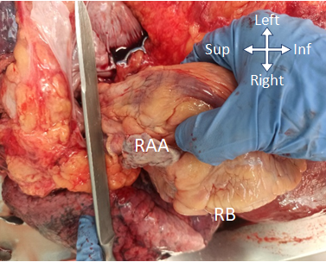

Fig. 1. The transection of the pulmonary trunk. RAA - right atrial appendage; RB - right border of the heart

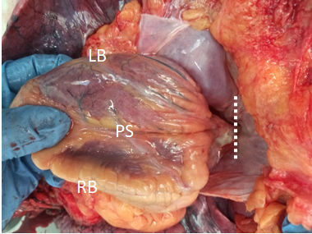

Fig. 2. The transection of the vena cava inferior at the diaphragm (dotted line). LB - left border of heart; RB - right border of the heart; PS - posterior surface of the heart

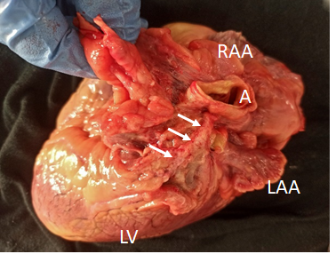

Fig. 3. Dissectionof the left coronary artery (arrows). A - aorta; RAA - right atrial appendage; LAA- left atrial appendage; LV - left ventricle

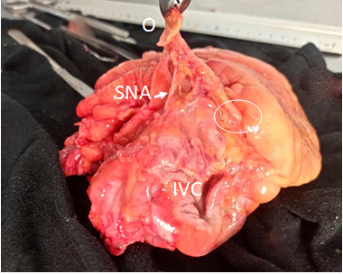

Fig. 4. Dissectionof the right coronary artery with its ostium. O — the ostium of the right coronary artery; IVC — inferior vena cava; SNA - sinus node artery; the circleindicates the place where the artery crosses the right border of the heart

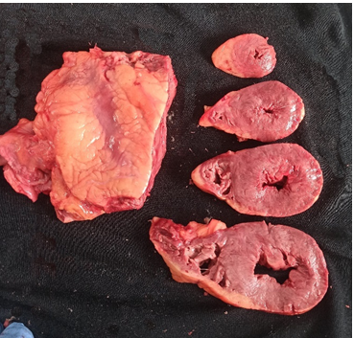

Fig. 5. Transversal sections of the heart

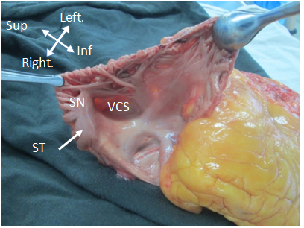

Fig. 6. The left atrium is opened along the line, connecting the opening of the vena cava inferior and the apex of the appendage. VCS - opening of the vena cavasuperior; ST– sulcus terminalis; SN - sinus node area

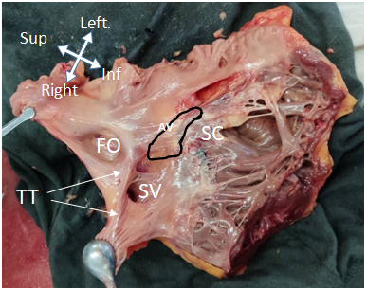

Fig. 7. Right atrium and right ventricle cavities. FO–foramen ovale; TT- tendon of Todaro; SV- opening of the sinus venosus; SC– septal cusp of tricuspid valve; AV - atrioventricular node area (Koch triangle)

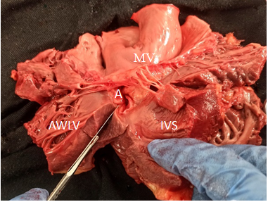

Fig. 8. Opening of the left ventricular outflow tract, the second stage. Incision between the left and right valves of the semilunar valve. A - aorta; AWLV - anterior wall of the left ventricle; IVS - interventricular septum;MV - mitral valve

ПСЛЖ

МЖП

МК