**Reviewer’s Comments**

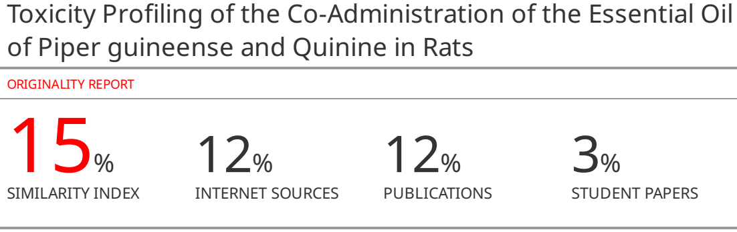

**Toxicity Profiling of the Co-Administration of the Essential Oil of *Piper guineense* and Quinine in Rats**

**ABSTRACT**

***Background***: The co-administration of medicinal plantproducts with orthodox drugs is not uncommon with a view to enhancing efficacy and improvingtreatment outcomes. However, reports indicated that such combinations may also enhance associated toxic effects. We recentlyreported that thoughthe co-administration of essential oil of*P. guineense*((EOPG) and Quinine has potentialto improve treatment outcomes in experimental cerebral malaria, the observed deaths associated with higher co-administered dosesnecessitated the need for further toxicological evaluation.

***Method*:** Rats were randomly divided into 12 groups (n=10), consisting of control, quinine, EOPG (12.5, 25, 50, 100, and 150 mg/kg), and their respective Quinine combinations. Control received vehicle (5% Tween 80 in distilled water), Quinine was given at a dose of 20 mg/kg stat, then 10 mg/kg twice daily for the next two days, while other groups were treated once daily for 3 days. All doses were administered intraperitoneally and rats were assessed for weights and novelty-inducedbehaviors(NIB). On day 4, rats were randomly sub-grouped into Treated and non-dosing Recovery (n=5) and sacrificed on day 4 and 18 respectively. Blood and organ samples were processed for hematological, biochemical, and histopathological evaluation.

***Results*:**In this study, analysis of our results showed that co-administration of EOPG and Quinine, revealed varying degrees of significant alteration in body and organ weights, rearing, grooming, and locomotion, as well as biochemical, hematological, and histopathological indices.

**Conclusion:** We propose that the earlier reported death associated with the co-administration of EOPG with Quinine in experimental cerebral malarial may be associated with increased toxicity on the liver and risk of heart-related diseases. This study concludes that despite the beneficial effects of EOPG/Quinine co-administration at lower doses, caution is advised.

**Keywords:** Essential oil; *Piper guineense*; Toxicity; Hematology; Biochemical; Histology

# 

# INTRODUCTION

Plants contribute a crucial part to the world of medicine1–3. Its use in medicine is as old as the existence of mankind2,3. The knowledge of plant use in medicine emanated from man’s interaction with his environment, and this early knowledge came from instinct and experience mostly without any scientific basis3. About 80% of the population in developing countries rely on plants as sources ofprimary health care because of cultural beliefs and the absence of modern health facilities. Also, about 11% of the 252 drugs considered “basic and essential” were mainly of plant origin2.

Crude drugs of natural or biological origin are used to describe plant parts or whole plants with medicinal properties. Both plant-based drugs and plant-derived drugs are of enormous importance in treating different diseases and infections1,2. Recent research shows that medicinal plants play a great role, not just in the treatment of diseases, but also in prevention2,4. Plants owe their relevance in medicine to the presence of certain phytochemicals or bioactive ingredients in them, which can be isolated and/or synthesized for use in orthodox medicine. Common examples are quinine, morphine, codeine, vincristine, aspirin, digitalis, etc5,6. Some of these plant phytochemicals may need to be structurally optimized into new drugs for better efficacy for use in modern medicine. Thus, plants remain the most abundant natural primary sources of active drugs and are of immeasurable benefit to medicine.

Despite breakthroughs in modern medicine, there are still many diseases and infections for which suitable drugs are yet to be found. Emerging resistance cases with synthetic drugs have fueled great exploration into the use of medicinal plants and the development of more potent drugs5–7. A major approach to these emerging problems is the complementary usage of both orthodox medicine and herbal medicine in the management of diseases and infections8,9. Herbal medicines are normally mixtures of several complex and diverse phytochemicals, and available reports have indicated that they may sometimes be associated with very toxic phytochemicals present alongside the active principles responsible for their pharmacological effects10,11. The multi-component nature of herbal medicines increases the tendency to interact with orthodox drugs12. Such interactions can be very toxic at the pharmacokinetics or pharmacodynamics level; hence the combination of herbal medicine and orthodox medicine need to be carefully assessed for possible toxicity12.

*Piper guineense* Schum & Thonn (Piperaceae), is among the commonly used plants in many households within the West African region, where the fruits and leaves havebeen used as condiments to flavor food in both domestic and commercial cuisines13,14. The nutritive values of the plant are associated with its spicy taste, high fiber, and mineral content, with traces of protein, carbohydrate, andessential vitamins15,16. Several scientifically validated pharmacological uses have been attributed to various parts of the plant, including antinociceptive, anti-inflammatory, antioxidant, antihyperglycemic, anti-plasmodial, analgesic,anticonvulsant, muscle relaxant, sedative, and antipsychotic activities13,14,17–20. Recently, wereported the antimalarial and neuroprotective effects of the essential oil of *P. guineense* in experimental cerebral malaria21. While our report showed thatthe combination of the essential oil of the dried fruit of *P. guineense* and Quinine has the potential to improve treatment outcomes in mouse models of cerebral malaria,the administration of the combination at doses greater than 6.25 mg/kg caused deaths in tested animals within 24 hours of commencement of treatment, necessitating the need for further evaluation of the toxicity profile of the combination.In this study, we report that indeed the co-administration of Quinine and EOPG, especially at higher doses, significantly altered weight, biochemical, hematological, and histopathological indices, and increasedthe risk to heart-relatedproblems.

# MATERIALS AND METHODS

# Materials for the Study

The following materials were used: plastic animal cages, feed and water containers, dissecting set and board, syringes and needles, disposable gloves, EDTAK3 anduniversal sample bottles, animal observation cage, cotton wool, tissue papers, microscope, and glass wares. Also used are Tween 80, Quinine, formalin, and distilled water. All the chemicals and reagents were of analytical grade.

# Processing of Collected Plant Materials

The sourcing, preparation, and processing of the dried fruits of *Piper guineense* by hydro-distillation to obtain essential oil were as earlier reported21. The Avoucher specimen (FPI 2312) was earlierdeposited in the Pharmacy herbarium, Obafemi Awolowo University (OAU), Ile-Ife. The oil was prepared in 5% Tween 80 shortly before administration.

# Humane Care of Experimental Rats

Healthy adult rats of both sexes and weights ranging from 130-150g were obtained from the Department of Pharmacology Animal HouseFacility, Faculty of Pharmacy, OAU, Ile-Ife, Nigeria. The rats were kept in standard plastic cages with free access to feeds and water *ad libitum*.Proper hygienic conditions were maintained through constant cleaning and changing of cage beddings. The rats were maintained and cared for according to the international guidelines22,23, and in line with approved protocols by the Animal Health Research and Ethic Committee of the Institute of Public Health, OAU, Ile-Ife, Nigeria, with ethical clearance number IPH/OAU/12/1782.

# Pilot Study

The determination of the median lethal dose (LD50) was carried out using a modification of Lorke’smethod24as earlier described21. A preliminary assessment was carried out using the proposed highest dose of 150 mg/kg, and its combination with Quinine, to determine the humane endpoint criteria22,25,26.

# Experimental Setup and Dosage Administration

Administration was carried out via the intraperitoneal route for 3 days. Rats were randomly allocated into twelve groups consisting of 10 rats each (two controls and ten test groups). Group 1is the negative control in which 1 ml/kg 5% Tween 80 was administered. Group 2 isthe positive control and was given Quinine standard regimen (20 mg/kg stat, followed by 10 mg/kg twice daily for the next two days). Groups 3-7 were administered 12.5, 25, 50, 100, and 150mg/kg doses of the essential oil respectively. Groups 8 – 12 were co-administered with the above-graded doses of the essential oil and Quinine standard regimen. After the last administration, surviving animals were randomly divided into two sub-groups – Treated and Recovery. The treatedsub-group was sacrificed 24 hours after the last administration, while the Recovery sub-group was sacrificed after 14 daysof a non-dosing recovery period.

# Novelty Induced Behaviour Observation

Novelty-induced behaviour of each animal which includes grooming, rearing, and locomotion; wasassessed daily before administration using standard procedures20,27. For the recovery set, observational assessments were continued every other day of the 14 days of the non-dosing recovery period.

# Weights and Weight Ratio Determination

The body weight of each animal was assessed dailyand prior to sacrifice for both Treated and Recovery sub-groups. Relative body weights were calculated as the percentage of daily weights relative to the weight on day 0. Also, relative organ weights were calculated as the percentage of organ weight relative to the body weighton the day of sacrifice. The organ-brain weight ratio is the ratio of organ weights relative to the weight of the brain in each animal.

# Sample Collection

Animals were sacrificed via cervical dislocation. Blood was collected by cardiac puncture into K3 EDTA sample tubes for hematological and biochemical analysis. The brain, liver, and kidney were harvestedand weighed. Randomly selected livers were prepared for homogenization and biochemical assessment. Other livers and kidneys were preserved in 10% formalin for histopathological assessment.

# Assessment of Hematological Indices

The hematological indices, including red blood cell (RBC), white blood cell (WBC), hemoglobin concentration (HBC), packed cell volume (PCV) or hematocrit, as well as mean corpuscular volume (MCV), mean corpuscular hemoglobin (MCH), and mean corpuscular hemoglobin concentration (MCHC), were auto-determined using auto-analyzer as earlier reported 28,29.

# Evaluation of Plasma and Liver Homogenate Biochemical Indices

The K3 EDTA blood samples were subjected to centrifugation at 3000rpm for 5 minutesto obtain the plasma. The liverhomogenate was prepared as earlier described30. Quantitative assessment of biochemical parameters including aspartate aminotransferase (AST) and alanine aminotransferase (ALT)31,cholesterol (CHOL), triglycerides (TRIG), high-density lipoprotein (HDL), and low-density lipoprotein (LDL)were conducted using standard laboratory kits (Randox Laboratories Limited, Crumlin, County Antrim, BT294QY, United Kingdom) in line with manufacturer’s protocols.

# Histopathological Examination

The tissuespecimen was prepared on slides mounted in DPX (Distrene Plasticizer and Xylene) with a cover slip using standard histology protocols as earlier reported28,29,32. The staining was carefully reviewed under the microscope, andphotomicrographs were taken with a LEICA DM750 microscope connected with a digital camera (LEICA ICC 50) and a desktop computer at x400 magnification.

# Statistical Analysis

Quantitative data were expressed as Mean ± Standard error of the mean (Mean ± SEM) and analyzedusing one-way analysis of variance (ANOVA) and/or pairwise comparison with Student’s T-Test. Data were considered significant at p < 0.05.

# RESULTS

# Effect on the Body Weight and Organ–Weight Ratio

Results for relative weight change are given in Figure 1A. Decreases in weights as compared to the starting weights were observed in all the Treated and Recovery sub-groups, except with Q/25 and Q/100. The changes in relative weights were significant with EOPG-12.5, EOPG-150, Q/25, and Q/150 for the Treated, and Q/25, Q/100 and Q/150 for the Recovery when compared to Control and/or Quinine (Figure 1A). While there were slight improvements in weights following the non-dosing recovery period, such were not significantly different from the Treated, suggesting persistent nature of toxicity.

The results of organ – body weight and organ–brain weight ratios are shown in Table 1. In Treated sub-groups, the brain-body weight ratio did not show any significant changes except the observed significant reduction at Q/150 when compared with Control. However, following the recovery period, more significant changes were observed with increases with Q/12.5, and Q/150, and reduction with EOPG-12.5 and Q/100. These increases were also significantly higher than their respective Treated sub-groups, suggesting potential for persistent toxicity. On the other hand, the liver/body weight ratio revealed a more pronounced toxic effects, with significant increases in all EOPG and Q/EOPG combination doses when compared with Control and Quinine, except with EOPG-12.5, and Q/12.5, suggesting that the toxic effects are dose dependent and lies more with the higher dose. This is consistent with our earlier published work where combination of lower doses of EOPG with Quinine showed improved antiplasmodial and neuroprotective effects21. Following recovery, the new liver/body weight ratio showed that the effects appear completely reversed when compared to respective Treated sub-groups, though, there were still significant changes at EOPG-150 and higher doses of the combination when compared with recovery Control and/or Quinine.

The observed effects on kidney/body, liver/brain, and kidney/brain ratios were similar to the effects on liver/body weight ratio (Table 1). However, contrary to the liver/body ratio, both the Treated and Recovery sub-groups for kidney/body, liver/brain, and kidney/brain ratios maintained similar significant changes. But, while changes in Treated appears dose dose-dependentincreases in ratios, the recovery wasnot dose-dependent with some showing significant reduction. In general, the Recovery sub-groups showed significant reduction in these weight ratios when compared with their corresponding Treated group, suggesting a potential for reversal of toxic effects following withdrawalor cessation of administration.

# Analysis of Novelty-Induced Behavioural Observations

The results for rearing, grooming, and locomotion are as presented in Figure 1 (B – D). In Treated, all sub-groups showed significant decrease in rearing activities when compared to Control and Quinine. Following the recovery period, the significant decreases were maintained in all except EOPG-25 and Q/150, which were not significant, and Q/50, which showed significantly higher rearing activities. For grooming and locomotion activities, the animals showed significant decreases in activities when compared to Control and Quinine. However, similar to rearing, Q/50 showed a significantly higher locomotion activity following recovery. The majorly significant reduction in rearing, grooming, and locomotion activities for treatment and recovery period, suggestsa form of persistent toxic effects.

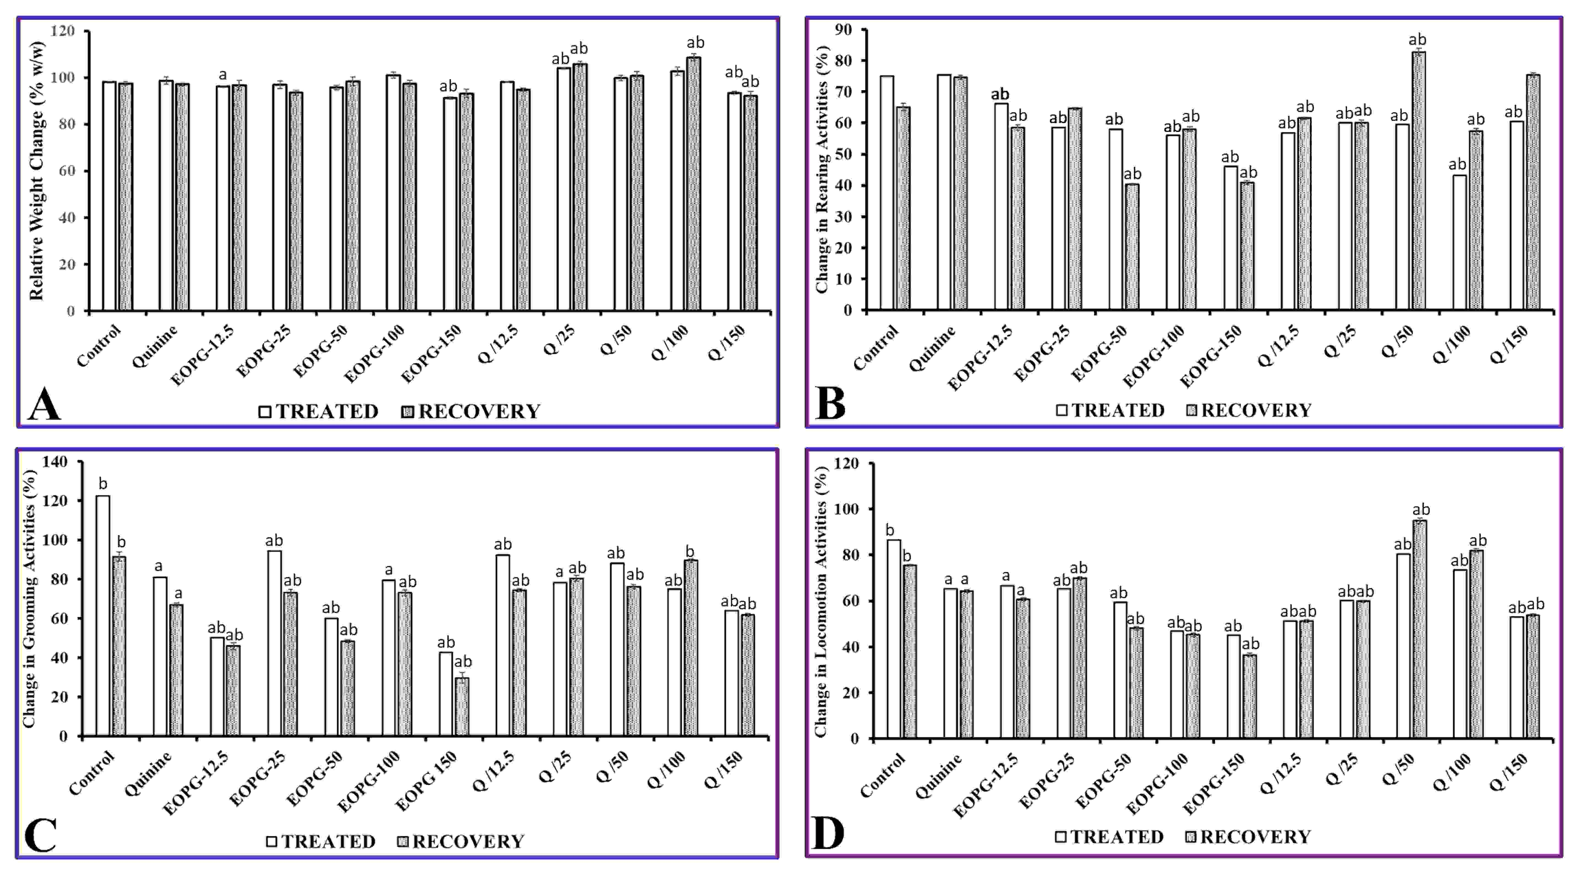

**Figure 1: Relative change in weight, rearing, grooming, and locomotion in rats following co-administration of Quinine with EOPG.** EOPG is essential oil of Piper guineense;EOPG-12.5 – EOPG-150 are range of doses (12.5, 25, 50, 100, and 150 mg/kg) of EOPG; Their corresponding combination are indicated as Q/12.5, Q/25, Q/50, Q/100, and Q/150 where Q is Quinine. Control is 5% Tween 80. aand bindicate significant difference when compared to Control and Quinine (p < 0.05) respectively. Images wereprepared using Microsoft Excel &PowerPoint and GIMP 2.10.1433.

Table 1: Organ weight ratios following Co-administration of EOPG and Quinine

|  |  |  |  |  |  |
| --- | --- | --- | --- | --- | --- |
|  | **BRAIN/BODY** | **LIVER/BODY** | **KIDNEY/BODY** | **LIVER / BRAIN** | **KIDNEY/BRAIN** |
| **TREATED** | | | | |
| **Control** | 0.0119 ± 0.0001 | 0.0324 ± 0.0011 | 0.0066 ± 0.0004 | 2.7580 ± 0.0689 | 0.5570 ± 0.0238 |
| **Quinine** | 0.0113 ± 0.0003 | 0.0335 ± 0.0013 | 0.0072 ± 0.0003 | 2.9800 ± 0.0445 | 0.6418 ± 0.0138 |
| **EOPG-12.5** | 0.0123 ± 0.0005 | 0.0395 ± 0.0023 | 0.0084 ± 0.0001ab | 3.2132 ± 0.1039a | 0.6840 ± 0.0251a |
| **EOPG-25** | 0.0112 ± 0.0002 | 0.0426 ± 0.0022a | 0.0083 ± 0.0002a | 3.9041 ± 0.0845ab | 0.7503 ± 0.0062ab |
| **EOPG-50** | 0.0119 ± 0.0007 | 0.0460 ± 0.0018ab | 0.0080 ± 0.0002a | 3.9267 ± 0.0972ab | 0.6771 ± 0.0329 |
| **EOPG-100** | 0.0117 ± 0.0004 | 0.0542 ± 0.0013ab | 0.0094 ± 0.0001ab | 4.7082 ± 0.1071ab | 0.8121 ± 0.0322ab |
| **EOPG 150** | 0.0126 ± 0.0004 | 0.0525 ± 0.0027ab | 0.0096 ± 0.0002ab | 4.3291 ± 0.0651ab | 0.7735 ± 0.0263ab |
| **Q /12.5** | 0.0123 ± 0.0004 | 0.0355 ± 0.0004 | 0.0070 ± 0.0005 | 3.8863 ± 0.1238ab | 0.5718 ± 0.0128b |
| **Q /25** | 0.0116 ± 0.0006 | 0.0478 ± 0.0027ab | 0.0072 ± 0.0003 | 4.1355 ± 0.1154ab | 0.6191 ± 0.0246 |
| **Q /50** | 0.0125 ± 0.0002 | 0.0467 ± 0.0003ab | 0.0087 ± 0.0001ab | 3.7499 ± 0.0512ab | 0.7026 ± 0.0114a |
| **Q /100** | 0.0116 ± 0.0005 | 0.0490 ± 0.0010ab | 0.0092 ± 0.0002ab | 4.2570 ± 0.0891ab | 0.8036 ± 0.0113ab |
| **Q /150** | 0.0108 ± 0.0002a | 0.0507 ± 0.0037ab | 0.0099 ± 0.0004ab | 4.6820 ± 0.0811ab | 0.9165 ± 0.0261ab |
|  | **RECOVERY** | | | | |
| **Control** | 0.0122 ± 0.0001 | 0.0368 ± 0.0004b* | 0.0075 ± 0.0004 | 3.0249 ± 0.0069b* | 0.6158 ± 0.0032b* |
| **Quinine** | 0.0127 ± 0.0004* | 0.0345 ± 0.0001a | 0.0084 ± 0.0004 | 2.7341 ± 0.0164a* | 0.6657 ± 0.0018a |
| **EOPG-12.5** | 0.0111 ± 0.0001ab | 0.0352 ± 0.0006 | 0.0077 ± 0.0004 | 3.2266 ± 0.0307ab | 0.6994 ± 0.0047ab |
| **EOPG-25** | 0.0114 ± 0.0007 | 0.0365 ± 0.0011* | 0.0076 ± 0.0001* | 3.2166 ± 0.0251ab* | 0.6693 ± 0.0042ab* |
| **EOPG-50** | 0.0102 ± 0.0008 | 0.0376 ± 0.0012* | 0.0072 ± 0.0004 | 3.7173 ± 0.0191ab | 0.7223 ± 0.0052ab* |
| **EOPG-100** | 0.0123 ± 0.0001 | 0.0350 ± 0.0008* | 0.0073 ± 0.0005* | 2.8728 ± 0.0166ab* | 0.5926 ± 0.0021ab* |
| **EOPG 150** | 0.0112 ± 0.0005 | 0.0383 ± 0.0007b* | 0.0078 ± 0.0003* | 3.4237 ± 0.0193ab* | 0.6915 ± 0.0023ab* |
| **Q /12.5** | 0.0134 ± 0.0003a* | 0.0353 ± 0.0013 | 0.0075 ± 0.0001 | 2.6283 ± 0.0118ab* | 0.5587 ± 0.0050ab |
| **Q /25** | 0.0117 ± 0.0004 | 0.0367 ± 0.0012* | 0.0065 ± 0.0003b | 3.1377 ± 0.0092ab* | 0.5573 ± 0.0022ab* |
| **Q /50** | 0.0129 ± 0.0004 | 0.0378 ± 0.0002b* | 0.0070 ± 0.0005* | 3.9435 ± 0.0428ab* | 0.5402 ± 0.0027ab* |
| **Q /100** | 0.0113 ± 0.0001a | 0.0333 ± 0.0006a* | 0.0079 ± 0.0004* | 2.9430 ± 0.0207ab* | 0.6935 ± 0.0029ab* |
| **Q /150** | 0.0148 ± 0.0002ab* | 0.0377 ± 0.0003b* | 0.0085 ± 0.0004 | 2.5728 ± 0.0148ab* | 0.5733 ± 0.0015ab* |

*, aandbindicate significant different when compared to respective Treated sub-group, Control, and Quinine (p < 0.05) respectively.

Control*:* 5%v/v Tween 80; Quinine*:* Standard; EOPG*;* Essential oil of *Piper guineense*. 12.5 to 150 are mg/kg body weights *EOPG* doses, and Q/12.5 – Q/150 are their corresponding combinations with Quinine.

# Effect on Haematological Indices

The analysis of blood indices (Table 2) showed varying degreesof significant changes when compared with Control and/or Quinine. While red blood cells (RBC), white blood cells (WBC), hematocrits or packed cell volume (PCV), and hemoglobin concentration (HBC) showed mostly dose-dependent decreases in values, mean corpuscular volume (MCV), mean corpuscular hemoglobin (MCH), and mean corpuscular hemoglobin concentration (MCHC) were mostly significantly increased when compared to Control and Quinine. The observed dose-dependent reduction in RBC, PCV, and HBC, as well as the corresponding significant increases in MCV, MCH, and MCHC, suggest potential toxic effects on the blood cells, which may be unconnected with any extraneous infections as indicated by reduced WBC.The situation is similar following the recovery period, and though there were signs of reversal with RBC, WBC, PCV, and HBC, the dose-dependent significant increases in MCV, MCH and MCHC, which were also significantly higher than the respective Treated sub-groups, may be an indication of persistent toxicity.

# Biochemical Result Analysis

The results of biochemical assessment of aspartate aminotransferase (AST), alanine aminotransferase (ALT), cholesterol (CHOL), triglycerides (TRIG), high-density lipoprotein (HDL), low-density lipoprotein (LDL), and protein levels using liver homogenates and plasma are presented in Tables 3 and 4, and supplementary Tables 1 and 2 (Tables S1 and S2). The results from the analysis of the liver biochemical indices (Table 3 and Table S2) showed dose-dependent significant reduction in liver proteins with EOPG alone, and varying degree of significant reduction with Quinine/EOPG combination when compared with Control and Quinine.The recovery showed similar pattern, except for a significant reduction in values when compared with the treated groups, indicating potential for reversal of toxic effects. The significant dose-dependent increases in CHOL/HDL, TRIG/HDL and LDL/HDL ratios, and in non-HDL (the bad lipids), which were especially higher with higher doses of EOPG alone and in all combinations, is an indication of increased potential risk of heart problems. However, while these lipid ratios showed a good sign of recovery, recovery from AST/ALT alteration may take longer time, suggesting a potential for persistent toxic effects.

Furthermore, the results from the plasma biochemical evaluation (Table 4 and Table S2) were similar to that of the liver homogenate, with some variations. Using EOPG alone, a dose-dependent increases in values were observed with non-HDL, and AST/ALT, CHOL/HDL, and LDL/HDL ratios, as well as dose-dependent decreases in TRIG/HDL ratio. On the other hands, with the combination of Quinine with EOPG, dose-dependent increases were seen with AST/ALT, CHOL/HDL, TRIG/HDL, and non-HDL, while LDL/HDL showed a dose-dependent decrease. Unlike in the liver homogenate, LDL/HDL was not associated with increasedvalues in all tested groups, but instead TRIG/HDL, which was low in liver samples. In any case, significantly higher values of AST/ALT, CHOL/HDL, TRIG/HDL, and non-HDL are clear indicationsof toxicity, especially an increased risk of heart disease. However, similar to liver samples, there were signs of potential recovery, as seen with a significant reduction in values when compared with the Treated group. Howeverthe rate of reduction appears quite slow, confirming high potential for persistent toxicity.

# 

Table 2: Effects of Co-administration of EOPG and Quinine on Hematological Indices

|  |  |  |  |  |  |  |  |
| --- | --- | --- | --- | --- | --- | --- | --- |
|  | **RBC x 106 (cell/µL)** | **WBC x 103 (cells/µL)** | **PCV**  **(%)** | **HBC**  **(g/dl)** | **MCV**  **(fl/cell)** | **MCH (pg/cell)** | **MCHC**  **(g/dl)** |
| **TREATED** | | | | | | |
| **Control** | 11.80 ± 0.18 | 6.57 ± 0.38 | 41.00 ± 0.21 | 14.26 ± 0.66 | 34.92 ± 0.82 | 12.22 ± 0.19 | 34.95 ± 0.24 |
| **Quinine** | 10.47 ± 0.53 | 5.86 ± 0.15 | 38.00 ± 1.15 | 13.56 ± 1.08 | 36.48 ± 0.21 | 12.92 ± 0.50 | 35.68 ± 0.70 |
| **EOPG-12.5** | 8.55 ± 0.58a | 5.81 ± 0.16 | 41.33 ± 1.20 | 13.28 ± 1.04 | 48.70 ± 1.02ab | 15.52 ± 0.49ab | 32.16 ± 0.58ab |
| **EOPG-25** | 12.05 ± 1.00 | 5.85 ± 0.29 | 32.00 ± 1.53a | 14.30 ± 0.38 | 26.76 ± 1.48ab | 12.02 ± 0.25 | 44.82 ± 1.45ab |
| **EOPG-50** | 9.00 ± 1.38 | 5.30 ± 0.37 | 27.33 ± 1.20ab | 13.01 ± 1.17 | 31.51 ± 0.77b | 14.92 ± 0.19ab | 47.40 ± 1.29ab |
| **EOPG-100** | 9.20 ± 0.90 | 5.42 ± 0.11 | 36.00 ± 0.65a | 13.21 ± 0.86 | 39.35 ± 0.18ab | 14.79 ± 0.25a | 37.36 ± 0.77 |
| **EOPG 150** | 6.72 ± 0.31ab | 4.89 ± 0.12ab | 29.33 ± 1.33ab | 10.83 ± 0.47a | 43.93 ± 1.34ab | 16.19 ± 0.14ab | 37.17 ± 0.11a |
| **Q /12.5** | 5.67 ± 0.68ab | 5.40 ± 0.14 | 40.00 ± 1.15 | 13.56 ± 0.56 | 43.58 ± 1.05ab | 23.78 ± 0.19ab | 34.05 ± 0.32 |
| **Q /25** | 7.47 ± 0.53ab | 5.01 ± 0.67 | 31.33 ± 0.71ab | 12.86 ± 0.62 | 41.93 ± 1.37ab | 17.28 ± 0.26ab | 41.05 ± 1.06ab |
| **Q /50** | 7.10 ± 0.37a | 5.41 ± 0.54 | 38.67 ± 0.67 | 12.16 ± 0.97 | 42.61 ± 0.64ab | 13.49 ± 0.36 | 31.48 ± 0.71ab |
| **Q /100** | 6.68 ± 0.35ab | 4.81 ± 0.44 | 26.50 ± 0.50ab | 10.43 ± 0.47a | 39.53 ± 0.12ab | 15.55 ± 0.40ab | 39.31 ± 0.36ab |
| **Q /150** | 5.25 ± 0.82 | 4.25 ± 0.18ab | 39.33 ± 0.33a | 12.04 ± 0.39 | 42.60 ± 1.06ab | 13.18 ± 0.46 | 30.89 ± 0.79ab |
|  | **RECOVERY** | | | | | | |
| **Control** | 11.28 ± 0.53 | 6.18 ± 0.17 | 46.67 ± 0.08b* | 13.87 ± 0.18 | 41.47 ± 0.28b* | 12.36 ± 0.14b | 29.78 ± 0.67* |
| **Quinine** | 12.23 ± 0.49 | 6.31 ± 0.19 | 42.33 ± 0.09a* | 13.16 ± 0.28 | 34.78 ± 0.16a | 10.79 ± 0.13a* | 31.12 ± 1.09* |
| **EOPG-12.5** | 11.50 ± 0.24* | 6.15 ± 0.16 | 43.67 ± 0.08ab | 12.81 ± 0.29 | 38.99 ± 0.80b* | 11.36 ± 0.12a* | 29.36 ± 0.92 |
| **EOPG-25** | 9.69 ± 0.19b | 5.95 ± 0.18 | 47.00 ± 0.10b* | 15.24 ± 0.41b | 47.01 ± 0.24ab* | 16.00 ± 0.35ab* | 34.25 ± 0.31a* |
| **EOPG-50** | 11.25 ± 0.39 | 5.55 ± 0.13 | 43.50 ± 0.50a* | 12.22 ± 0.46 | 38.78 ± 0.81b* | 10.98 ± 0.16a* | 28.27 ± 1.08* |
| **EOPG-100** | 8.93 ± 0.41b | 5.40 ± 0.12ab | 40.00 ± 0.20ab* | 13.37 ± 0.28 | 45.39 ± 0.38ab* | 15.30 ± 0.21ab | 33.56 ± 1.02 |
| **EOPG 150** | 8.54 ± 0.01ab* | 6.39 ± 0.24* | 43.50 ± 0.50a* | 15.58 ± 0.31ab* | 50.94 ± 1.02ab* | 18.24 ± 0.32ab* | 35.91 ± 0.39ab |
| **Q /12.5** | 8.97 ± 0.03ab* | 6.31 ± 0.28* | 43.67 ± 0.96 | 13.37 ± 0.17 | 50.20 ± 1.40ab* | 15.29 ± 0.23ab* | 30.58 ± 0.65* |
| **Q /25** | 8.20 ± 0.06ab | 6.37 ± 0.09 | 37.67 ± 0.33ab* | 13.30 ± 0.42 | 45.95 ± 0.08ab* | 16.22 ± 0.17ab* | 35.30 ± 0.17ab* |
| **Q /50** | 9.51 ± 0.24b | 5.28 ± 0.18ab | 39.00 ± 0.30ab | 15.03 ± 0.32b* | 42.39 ± 1.18b | 16.41 ± 0.11ab | 38.63 ± 0.13ab* |
| **Q /100** | 9.31 ± 0.44b* | 6.68 ± 0.22* | 45.67 ± 0.28b* | 15.73 ± 0.28ab* | 49.06 ± 0.57ab* | 17.03 ± 0.13ab* | 34.72 ± 0.22a* |
| **Q /150** | 8.17 ± 0.22ab | 5.12 ± 0.17ab* | 41.00 ± 0.10ab | 15.45 ± 0.15ab* | 49.58 ± 1.08ab* | 19.22 ± 1.06ab* | 39.03 ± 0.17ab* |

*, aandbindicate significant differenceswhen compared to respective Treated sub-group, Control, and Quinine (p < 0.05) respectively.

Control*:* 5%v/v Tween 80; Quinine*:* Standard; EOPG*;* Essential oil of *Piper guineense*. 12.5 to 150 are mg/kg body weights *EOPG* doses, and Q/12.5 – Q/150 are their corresponding combinations with Quinine.

Table 3: Effects of Co-administration of EOPG and Quinine on Liver Biochemical Indices

|  |  |  |  |  |  |  |
| --- | --- | --- | --- | --- | --- | --- |
|  | **PROTEIN** | **AST/ALT** | **CHOL/HDL** | **LDL/HDL** | **TRIG/HDL** | **non-HDL** |
| **TREATED** | | | | | |
| Control | 1.37 ± 0.01b | 0.76 ± 0.06 | 1.95 ± 0.02b | 0.45 ± 0.02b | 1.03 ± 0.05b | 2.09 ± 0.06b |
| Quinine | 1.68 ± 0.04a | 0.85 ± 0.03 | 2.44 ± 0.08a | 1.14 ± 0.06a | 0.65 ± 0.07a | 3.07 ± 0.10a |
| EOPG-12.5 | 1.21 ± 0.02ab | 4.24 ± 0.06ab | 2.00 ± 0.04b | 0.46 ± 0.00b | 0.47 ± 0.02a | 3.28 ± 0.05a |
| EOPG-25 | 1.11 ± 0.03ab | 7.32 ± 0.03ab | 1.70 ± 0.01ab | 0.55 ± 0.00ab | 0.47 ± 0.01a | 5.25 ± 0.09ab |
| EOPG-50 | 1.03 ± 0.02ab | 10.52 ± 0.06ab | 1.68 ± 0.05ab | 0.84 ± 0.04ab | 0.23 ± 0.01ab | 4.50 ± 0.32ab |
| EOPG-100 | 0.87 ± 0.01ab | 8.38 ± 0.07ab | 2.48 ± 0.07a | 1.08 ± 0.01a | 0.26 ± 0.01ab | 9.48 ± 0.50ab |
| EOPG 150 | 0.75 ± 0.02ab | 3.79 ± 0.01ab | 2.70 ± 0.04ab | 1.08 ± 0.00a | 0.16 ± 0.01ab | 7.84 ± 0.23ab |
| Q /12.5 | 0.91 ± 0.02ab | 5.16 ± 0.02ab | 2.18 ± 0.04a | 0.58 ± 0.00ab | 1.80 ± 0.03ab | 2.99 ± 0.17a |
| Q /25 | 1.28 ± 0.05b | 4.94 ± 0.16ab | 2.19 ± 0.07 | 0.77 ± 0.03ab | 1.32 ± 0.01ab | 5.41 ± 0.35ab |
| Q /50 | 1.08 ± 0.02ab | 3.31 ± 0.03ab | 4.56 ± 0.10ab | 3.04 ± 0.10ab | 1.15 ± 0.05b | 7.72 ± 0.07ab |
| Q /100 | 1.23 ± 0.04b | 3.12 ± 0.03ab | 4.64 ± 0.03ab | 3.42 ± 0.02b | 0.49 ± 0.02a | 8.01 ± 0.08ab |
| Q /150 | 1.03 ± 0.05ab | 2.13 ± 0.04ab | 5.53 ± 0.07a | 4.39 ± 0.04a | 0.45 ± 0.01a | 8.11 ± 0.15ab |
|  | **RECOVERY** | | | | | |
| Control | 1.55 ± 0.03a | 0.98 ± 0.04 | 1.62 ± 0.11b | 0.43 ± 0.04b | 0.74 ± 0.03b | 1.86 ± 0.29 |
| Quinine | 1.01 ± 0.09b | 0.99 ± 0.02 | 2.17 ± 0.06a | 0.80 ± 0.04a | 1.29 ± 0.08a | 2.51 ± 0.13 |
| EOPG-12.5 | 1.02 ± 0.03a | 3.64 ± 0.06ab* | 3.06 ± 0.09ab* | 1.49 ± 0.01ab* | 0.97 ± 0.02ab* | 6.73 ± 0.30ab* |
| EOPG-25 | 0.79 ± 0.02a | 4.04 ± 0.16ab* | 1.61 ± 0.05b | 0.21 ± 0.01ab* | 0.34 ± 0.00ab* | 4.65 ± 0.39ab* |
| EOPG-50 | 0.80 ± 0.03a | 7.10 ± 0.30ab* | 1.42 ± 0.04b | 0.26 ± 0.01ab* | 0.26 ± 0.01ab | 2.45 ± 0.21* |
| EOPG-100 | 0.86 ± 0.03a | 5.42 ± 0.17ab* | 3.29 ± 0.08ab* | 1.95 ± 0.03ab* | 0.27 ± 0.00ab | 5.73 ± 0.27ab* |
| EOPG 150 | 0.91 ± 0.05a | 2.66 ± 0.12ab* | 1.20 ± 0.02ab* | 0.29 ± 0.01b* | 0.08 ± 0.00ab* | 2.05 ± 0.25* |
| Q /12.5 | 1.17 ± 0.03a | 3.36 ± 0.06ab* | 2.62 ± 0.06ab* | 1.18 ± 0.02ab* | 1.29 ± 0.04a* | 5.88 ± 0.31ab* |
| Q /25 | 1.05 ± 0.03a | 2.82 ± 0.09ab* | 2.25 ± 0.12a | 0.86 ± 0.09a | 0.89 ± 0.07b* | 5.72 ± 0.16ab |
| Q /50 | 1.09 ± 0.10a | 2.68 ± 0.05ab* | 2.21 ± 0.03a* | 0.68 ± 0.03a* | 1.00 ± 0.01ab* | 4.21 ± 0.06ab* |
| Q /100 | 1.13 ± 0.04a | 2.20 ± 0.05ab* | 1.79 ± 0.08b | 0.52 ± 0.02b* | 0.49 ± 0.02ab | 2.50 ± 0.12 |
| Q /150 | 1.18 ± 0.03a | 2.22 ± 0.06ab | 2.04 ± 0.01a* | 0.88 ± 0.01a* | 0.40 ± 0.01ab | 3.46 ± 0.06ab* |

*, aandbindicate significant different when compared to respective Treated sub-group, Control, and Quinine (p < 0.05) respectively.

Control*:* 5%v/v Tween 80; Quinine*:* Standard; EOPG*;* Essential oil of *Piper guineense*. 12.5 to 150 are mg/kg body weights *EOPG* doses, and Q/12.5 – Q/150 are their corresponding combinations with Quinine.

Table 4: Effects of Co-administration of EOPG and Quinine on Plasma Biochemical Indices

|  |  |  |  |  |  |  |
| --- | --- | --- | --- | --- | --- | --- |
|  | **PROTEIN** | **AST/ALT** | **CHOL/HDL** | **LDL/HDL** | **TRIG/HDL** | **non-HDL** |
| **TREATED** | | | | | |
| **Control** | 0.76 ± 0.02b | 1.53 ± 0.07b | 1.91 ± 0.01b | 0.88 ± 0.06b | 0.40 ± 0.01b | 1.61 ± 0.13b |
| **Quinine** | 0.94 ± 0.04a | 4.84 ± 0.05a | 3.12 ± 0.02a | 1.83 ± 0.05a | 0.53 ± 0.02a | 4.90 ± 0.08a |
| **EOPG-12.5** | 1.88 ± 0.02ab | 3.32 ± 0.02ab | 2.06 ± 0.05b | 0.15 ± 0.01ab | 2.09 ± 0.03ab | 2.80 ± 0.09ab |
| **EOPG-25** | 1.19 ± 0.03ab | 2.99 ± 0.08ab | 2.21 ± 0.06ab | 0.65 ± 0.02ab | 1.24 ± 0.02ab | 4.76 ± 0.02a |
| **EOPG-50** | 1.35 ± 0.07ab | 3.08 ± 0.05ab | 2.33 ± 0.05ab | 1.14 ± 0.02ab | 1.16 ± 0.02ab | 5.56 ± 0.13ab |
| **EOPG-100** | 1.92 ± 0.06ab | 2.97 ± 0.03ab | 2.88 ± 0.01ab | 1.78 ± 0.06a | 0.32 ± 0.01ab | 7.60 ± 0.14ab |
| **EOPG 150** | 1.75 ± 0.02ab | 3.03 ± 0.04ab | 3.16 ± 0.03a | 2.01 ± 0.02a | 0.29 ± 0.01ab | 8.74 ± 0.09ab |
| **Q /12.5** | 0.59 ± 0.01b | 4.11 ± 0.02ab | 2.95 ± 0.01ab | 1.85 ± 0.05a | 0.75 ± 0.03ab | 2.78 ± 0.01ab |
| **Q /25** | 0.67 ± 0.03b | 4.65 ± 0.04a | 2.89 ± 0.08a | 1.50 ± 0.05ab | 1.67 ± 0.04ab | 2.98 ± 0.03ab |
| **Q /50** | 0.68 ± 0.01b | 4.90 ± 0.01a | 3.13 ± 0.02a | 1.53 ± 0.03ab | 3.88 ± 0.03ab | 3.24 ± 0.01ab |
| **Q /100** | 0.78 ± 0.01b | 4.64 ± 0.02ab | 3.94 ± 0.08ab | 1.37 ± 0.00ab | 4.74 ± 0.04ab | 3.91 ± 0.03ab |
| **Q /150** | 0.88 ± 0.03 | 5.23 ± 0.01ab | 4.16 ± 0.05a | 1.19 ± 0.03ab | 5.69 ± 0.01ab | 4.23 ± 0.06ab |
|  | **RECOVERY** | | | | | |
| **Control** | 0.90 ± 0.01 | 2.63 ± 0.01b | 4.08 ± 0.02b | 2.40 ± 0.01b | 1.35 ± 0.04b | 2.41 ± 0.04b |
| **Quinine** | 0.85 ± 0.02 | 4.80 ± 0.04a | 1.09 ± 0.01a | 0.20 ± 0.01a | 0.27 ± 0.01a | 0.39 ± 0.03a |
| **EOPG-12.5** | 1.48 ± 0.02ab | 2.60 ± 0.02b | 1.54 ± 0.06ab | 0.12 ± 0.01ab | 1.68 ± 0.07ab | 1.57 ± 0.15ab |
| **EOPG-25** | 1.53 ± 0.03ab | 3.13 ± 0.02ab | 1.97 ± 0.02ab | 0.58 ± 0.01ab | 0.95 ± 0.01ab | 5.37 ± 0.15ab |
| **EOPG-50** | 1.69 ± 0.03ab | 3.66 ± 0.03ab | 2.10 ± 0.05ab | 0.91 ± 0.02ab | 0.79 ± 0.00ab | 6.14 ± 0.04ab |
| **EOPG-100** | 1.70 ± 0.00ab | 3.44 ± 0.03ab | 2.16 ± 0.03ab | 1.60 ± 0.03ab | 0.58 ± 0.00ab | 7.17 ± 0.17ab |
| **EOPG 150** | 1.85 ± 0.02ab | 3.55 ± 0.04ab | 2.72 ± 0.07ab | 1.71 ± 0.02ab | 0.35 ± 0.01ab | 8.74 ± 0.09ab |
| **Q /12.5** | 0.80 ± 0.02a | 3.73 ± 0.03ab | 1.81 ± 0.03ab | 1.52 ± 0.03ab | 0.92 ± 0.04ab | 2.71 ± 0.07ab |
| **Q /25** | 0.86 ± 0.03 | 3.74 ± 0.06ab | 2.60 ± 0.03ab | 0.50 ± 0.05ab | 0.97 ± 0.04ab | 3.23 ± 0.10ab |
| **Q /50** | 0.89 ± 0.06 | 3.49 ± 0.02ab | 2.67 ± 0.02ab | 0.94 ± 0.03ab | 2.44 ± 0.01ab | 3.35 ± 0.19ab |
| **Q /100** | 0.95 ± 0.04 | 3.42 ± 0.03ab | 2.79 ± 0.03ab | 0.94 ± 0.06ab | 2.61 ± 0.03ab | 3.85 ± 0.05ab |
| **Q /150** | 1.03 ± 0.03ab | 3.22 ± 0.04ab | 2.86 ± 0.05ab | 0.71 ± 0.02ab | 3.54 ± 0.06ab | 4.83 ± 0.21ab |

*, aandbindicate significant differenceswhen compared to respective Treated sub-group, Control, and Quinine (p < 0.05) respectively.

Control*:* 5%v/v Tween 80; Quinine*:* Standard; EOPG*;* Essential oil of *Piper guineense*. 12.5 to 150 are mg/kg body weights *EOPG* doses, and Q/12.5 – Q/150 are their corresponding combinations with Quinine.

# Histology Result

The histological assessment of the kidney in the Treated sub-groups (Figure 2) revealed that all the sub-groups show normal histoarchitecture with well-delineatedglomeruli, proximal convoluted tubules, and distal convoluted tubules, except Q/150 which shows some signs of necrosis, and EOPG-12.5, EOPG-50 and Quinine which show signs of distorted proximal and distal convoluted tubules when compared with the other groups. The followingperiod of non-dosing recovery, all the Recovery sub-groups showed and/or maintained near-to-normal histoarchitecture with well-delineatedglomeruli, proximal convoluted tubules, and the distal convoluted tubules, except Q/25 where the distal convoluted tubules are not well represented. This suggests potential for reversal of kidney toxicity(Figure 3).

In addition, the assessment of liver histology in Treated sub-groups (Figure 4) revealed that EOPG-25 and EOPG-150 showed some aberrations in the histoarchitecture of the hepatocytes when compared with the other groups. Treated sub-groups Q/12.5, Q/25, and Q/100 showed signs of necrosis and distortion of the hepatocytes with dilated sinusoids when compared with the others (Figure 4). Thus, the result showed that EOPG alone or in combination with Quinine has the potential to induceliver toxicity. Following the period of recovery, all the Recovery sub-groups showed normal hepatocytes (Figure 5). However, Quinine showed deposition of plaques, while Q/100 and Q/150 showed dilated sinusoid and deposition of brownish plaques respectively (Figure 5), suggesting a form of persistent liver toxicity at higher dosesof EOPG combination with Quinine.

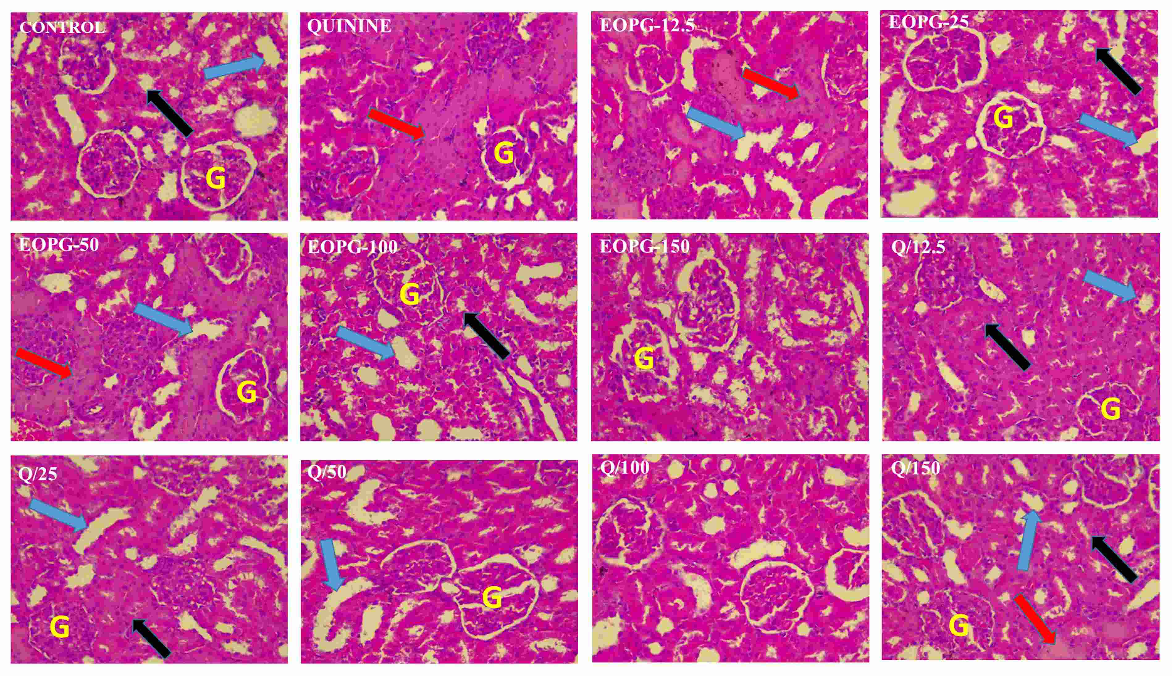

**Figure 2: Photomicrographs of Rat’s Kidney following Co-Administration of EOPG and Quinine:** Glomeruli (G), proximal convoluted tubules (blue arrows), and the distal convoluted tubules (black arrows). Red arrows indicate signs of necrosis and/or distorted proximal and distal convoluted tubules. CONTROL: 5%v/v Tween 80; QUNINE: Standard; EOPG; Essential oil of Piper guineense. 12.5 to 150 are mg/kg body weights EOPG doses, and Q/12.5 – Q/150 are their corresponding combinations with Quinine.Staining was done using H & E and magnification was x400. Images were prepared using Microsoft PowerPoint and GIMP 2.10.1433.

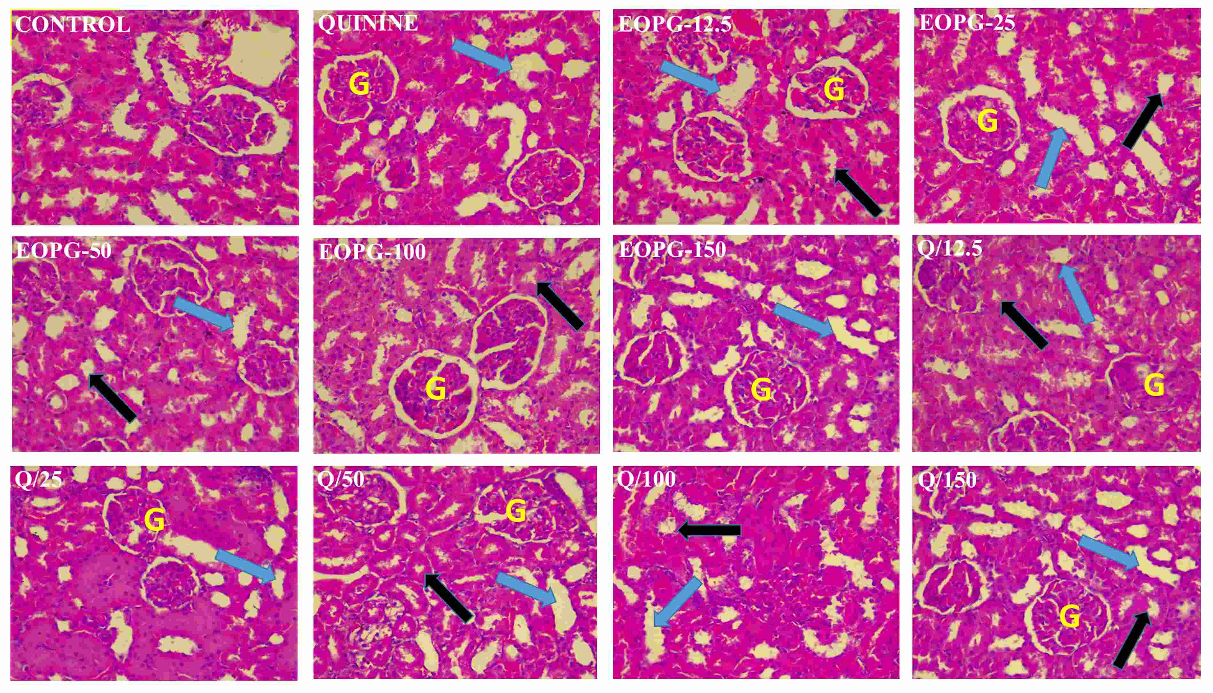

**Figure 3: Photomicrographs of Rat’sKidney following non-dosing recovery period:** Glomeruli (G), proximal convoluted tubules (blue arrows), and the distal convoluted tubules (black arrows). CONTROL: 5%v/v Tween 80; QUNINE: Standard; EOPG; Essential oil of Piper guineense. 12.5 to 150 are mg/kg body weights EOPG doses, and Q/12.5 – Q/150 are their corresponding combinations with Quinine. Staining was done using H & E and magnification was x400. Images were prepared using Microsoft PowerPoint and GIMP 2.10.1433.

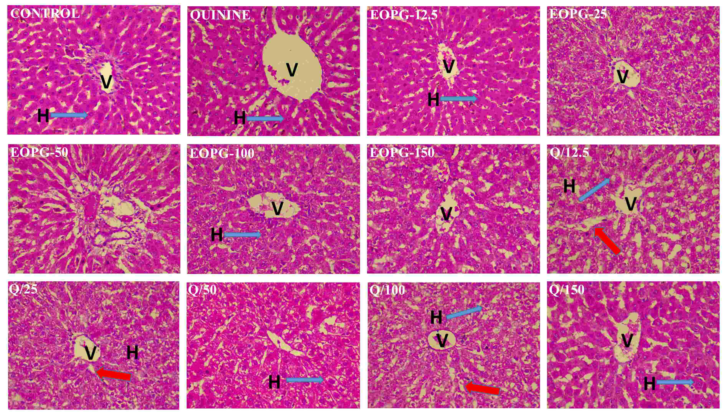

**Figure 4:Photomicrographs of Rat’sLiver following Co-Administration of EOPG and Quinine.**H:Hepatocytes; V:Central vein; dilated sinusoid (red arrows); CONTROL: 5%v/v Tween 80; QUNINE: Standard; EOPG: Essential oil of Piper guineense. 12.5 to 150 are mg/kg body weights EOPG doses and Q/12.5 – Q/150 are their corresponding combinations with Quinine. Staining was done using H & E and magnification was x400.Images were prepared using Microsoft PowerPoint and GIMP 2.10.1433.

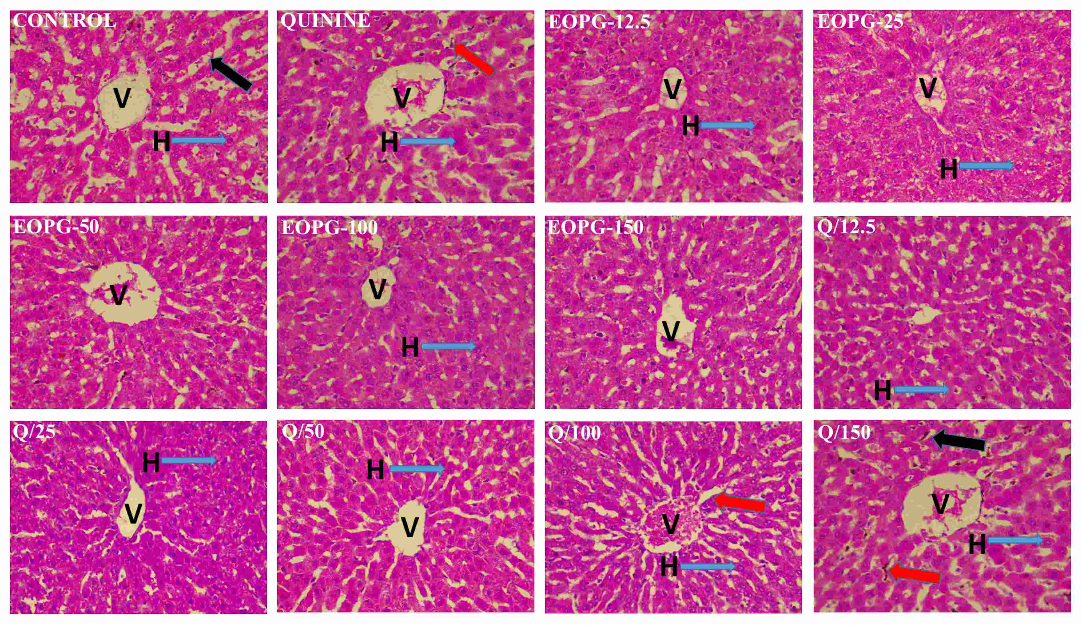

**Figure 5: Photomicrographs of Rat’sLiver following non-dosing recovery period.**H:Hepatocytes; V:Central vein; CONTROL: 5%v/v Tween 80; QUNINE: Standard; EOPG: Essential oil of Piper guineense. 12.5 to 150 are mg/kg body weights EOPG doses, and Q/12.5 – Q/150 are their corresponding combinations with Quinine. Dilated sinusoid and deposition of brownish plaques are shown with red and black arrows respectively. Staining was done using H & E and magnification was x400.Images were prepared using Microsoft PowerPoint and GIMP 2.10.1433.

# DISCUSSION

Toxicology involvesan observational and data-gathering phase and the use of those data to predict likely outcomes upon exposure to human populations34,35. This is very vital, especially in the use of herbal medicines, which is as old as human civilization3,10. Plants are useful not only in the treatment and management of many disease conditions but also in the discovery of potential bioactive molecules5–7. However, alongside the beneficial components present in plants are also some toxic secondary metabolites produced as natural defense mechanisms11. With over 80% of the world’s population still depending on the use of medicinal plants for their primary healthcare needs, there the growing concerns about the potential toxicity associated with the use of these medicinal plants, and thus, the need to establish their safety36. Also, the conscious or unconscious co-administration of orthodox medicine with medicinal plantproducts is not uncommon, and though some beneficial effects of such combination have been reported8,12,37,38, concerns about their safety remain. We have earlier reported that the combination of the essential oil of the dried fruit of *P. guineense* and Quinine has the potential to improve treatment outcomes in mouse models of cerebral malaria. However, the observed deaths associated with the co-administration of the EOPG and Quinine at doses greater than 6.25 mg/kg EOPG within 24 hours of the commencement of treatment21, necessitated the need for further toxicological evaluation.

Body and organ weights are useful parameters in assessing the toxicity of substances which can be revealed through an increase or decrease in weight39,40. Weight reduction has been associated with consequent depression of cellular metabolism and growth or cell death, and a dose capable of causing a 10% decrease in body weight, is considered a toxic dose39,40. While the observed mostly reduction in weights in the Tested and Recovery sub-groups (Figure 1A) may not be significant when compared with starting weights of the animals, the significant changes in relative weights at EOPG-12.5, EOPG-150, Q/25, and Q/150 for Treated set, and Q/25, Q/100 and Q/150 for Recovery, and lack of significant different between Treated and Recovery sub-groups(Figure 1) demonstrated that the toxic effects of EOPG and its combination with Quinine on weights may be persistent.

Organ weight analysis is a useful endpoint in determining organ toxicity39,41–43. An increase in liver weight,which may be in the form ofhepatocellular hypertrophy (increase in size) or hyperplasia of organelles (increase in number), is majorly indicative of toxicity29,44.Our results showed a more persistent toxic effect on the liver compared to the kidney, and though alteration in organ/body and organ/brain ratios remains significant when compared with Control and Quinine, the kidney stands a better chance of faster recovery (Table 1). This may not be unexpected since the liver has greater exposure to tested substances than any other body organ. The histology results (Figures 2 – 5) also confirmed these observations and clearly showed that liver toxicity is more persistent. Furthermore, itconfirmed that toxicity to the kidneys may be more associated with EOPG or Quinine alone rather than with their respective combination, suggesting that the Q/EOPG co-administration may have potential kidney protective roles at EOPG doses less than 150 mg/kg (Figures 2 - 5). Histological examination is a golden standard for evaluating treatment-related pathological changes in tissues and organs. This complements chemical pathological data with morphological pathological findings and gives a piece of more holistic information on toxicity. Our current histological findings pointed to the fact that the use of EOPG alone or with quinine may precipitate organ damage. Hence, there is a need to exercise caution in the long-term use of the oil.

In addition, the biochemical analysis of liver homogenate and plasma further confirmed that the liver is adversely affected by the test substances (Tables 3 and 4). The biochemical assessment is a fundamental tool in evaluating not just the extent and severity of organ damage but also the type of organ damage29,45,46. Liver biomarkers in the biochemical assessment include aspartate aminotransferase (AST), alanine aminotransferase (ALT), Alkaline phosphatase (ALP),etc. ALP is located in the cytoplasm and is released into circulation after cellular damage. ALT is found in the cytoplasm, liver, kidney, heart, and muscle but its highest concentration is in the liver47. ALT is a more specific indicator of liver damage as AST elevations may be caused by damage to other organs45,47. Elevation of the level of these enzymes provide an indication of cellular damage, leakages, and loss of functional integrity of the hepatic cell membrane45,47,48. Elevation in the cholesterol and triglyceride levels of the liver, due to their accumulation within the hepatocytes can result insteatosis and primary lipotoxicity49. With significant increases in proteins, AST, ALT, cholesterol (CHOL), triglyceride (TRIG), low-density lipoproteins (LDL), non-HDL (high-density lipoprotein) and the correspondingly higher ratios of AST/ALT, CHOL/HDL, TRIG/HDL, and LDL/HDL, in both Treated and Recovery sub-groups, our results confirmed the superior and persistent assaults on the liver. However, in general, even though AST/ALT ratios are significantly higher with EOPG alone, the significantly lower values of CHOL/HDL, TRIG/HDL, and LDL/HDL ratios when compared with corresponding Q/EOPG combination, suggest that the risk of heart problems is less likely with EOPG alone, and more likely with the combination. This may explain the reason for the 100% deaths following EOPG/Quinine co-administration in parasitized mice as reported in our previous study21.Such toxic effects may also be exacerbated by the load of the malaria parasite. Furthermore, novelty-induced behavior (NIB) change is a sensitive endpoint in assessing how animals react to changes in their internal or external environment. Reduction in NIB may be a result of neuro-suppressant activity or physiological changes causing weakness. In this study, the observed majorly significant, and yet persistent reduction in rearing, grooming, and locomotion activities confirmed the neuro-behavioural activities of EOPG as earlier reported20,21.

Meanwhile, the assessment of hematological parameters can be used to determine the extent of the toxic effects of xenobiotics, including plant extracts, on the blood. Blood components are diagnostic in nature and can be used for predicting human toxicity29,50.White blood cells are the first line of cellular defense that fight off infectious agents and respond to any inflammation or tissue injury, and their elevation may indicate induction of immune response by the test substance51. Red blood indices such asmean corpuscular volume (MCV), mean corpuscular hemoglobin (MCH), and mean corpuscular hemoglobin concentration (MCHC) are useful parameters in diagnosing anemia52,53. With dose-dependent reduction in RBC, PCV, and HBC, as well as the corresponding significant increases in MCV, MCH, and MCHC in Treated and Recovery sub-groups, our results showed higher chances of blood-related toxic effects, especially with higher doses of EOPG alone and in combination with Quinine.

**LIMITATIONS OF THE STUDY**

This is an animal-based research output and may only be used to guide further evaluation in humansor provide guidance for safe use of the plant in humans.

# CONCLUSION

We have explored the safety profile of the co-administration of a standard dosage regimen of Quinine with EOPG using neuro-behavioral, biochemical, hematological, and histopathological assessments. Our results revealed varying degrees of alteration in weights, organ/weight ratios, biochemical and hematological indices, and histopathological features. We propose that the earlier reported death associated with the co-administration of EOPG with Quinine in experimental cerebral malarial may be associated with increased toxicity on the liver and risk of heart-related diseases, coupled with increased parasite load. We conclude that while the use of EOPG/Quinine co-administration at a lower dose was beneficial in experimental cerebral malaria, there is a need for caution in its use.

**ACKNOWLEDGEMENT**

We appreciate the expertise and efforts of Mr. I. I. Ogunlowo, Department of Pharmacognosy, Faculty of Pharmacy, Obafemi Awolowo University, Ile-Ife, Osun State, Nigeria, towards proper identification and authentication of the dried fruits of *Piper guineense*.

**AUTHOR’S CONTRIBUTION**

MOD: Conceptualization and Project Administration. MOD, IJO, STA, and IAO: Validation, Method development, and Resource sourcing. THO, TSO, IJO, IDA, and STA: Performed the experiments. MOD, THO, TSO, IJO, IDA, STA, and IAO: Quantitative and Qualitative data analysis and interpretations. MOD and THO: Initial draft of the manuscript. All authors reviewed and edited the manuscript, and approved the final submission.

**FUNDING**

This research was not funded byany specific grant, be it public, commercial, or not-for-profit sectorfunding agencies.

**DECLARATION OF CONFLICT OF INTEREST**

The Authors declare no conflict of interest.

**ABBREVIATIONS**

EOPG, Essential oil of *Piper guineense;* LD50, Median lethal dose; AST, Aspartate aminotransferase;ALT, Alanine aminotransferase;ALP, Alkaline phosphatase;CHOL, Cholesterol;TRIG, Triglyceride;LDL, Low density lipoproteins; HDL, high-density lipoprotein; RBC, Red blood cells; WBC, White blood cells; MCV, Mean corpuscular volume; MCH,Mean corpuscular hemoglobin;MCHC, Mean corpuscular hemoglobin concentration.

# REFERENCES

1. Abayomi Sofowora EO. The Roles and Place of Medicinal Plants in the Strategies for Disease Prevention. African Journal of Traditional, Complemetary and Alternative Medicines. 2013;10:210–29.

2. Aziz MA, Adnan M, Khan AH, Shahat AA, Al-Said MS, Ullah R. Traditional uses of medicinal plants practiced by the indigenous communities at Mohmand Agency, FATA, Pakistan. Journal of Ethnobiology and Ethnomedicine. 2018;14:2.

3. Petrovska B. Historical review of medicinal plants′ usage. Pharmacognosy Reviews. 2012;6:1.

4. Dzoyem JP, Tshikalange E, Kuete V. Medicinal Plants Market and Industry in Africa. In: Kuete V, editor. Medicinal Plant Research in Africa [Internet]. Oxford: Elsevier; 2013 [cited 2020 Mar 4].. 859–90. Available from: http://www.sciencedirect.com/science/article/pii/B9780124059276000242

5. Khan H, Pervaiz A, Intagliata S, Das N, Nagulapalli Venkata KC, Atanasov AG, et al. The analgesic potential of glycosides derived from medicinal plants. Daru. 2020;28:387–401.

6. Veeresham C. Natural products derived from plants as a source of drugs. Journal of Advance Pharmaceutical Technology and Research. 2012;3:200–1.

7. Batista R, Silva ADJ, de Oliveira AB. Plant-derived antimalarial agents: new leads and efficient phytomedicines. Part II. Non-alkaloidal natural products. Molecules (Basel, Switzerland). 2009;14:3037–72.

8. Ameade EPK, Ibrahim M, Ibrahim HS, Habib RH, Gbedema SY. Concurrent Use of Herbal and Orthodox Medicines among Residents of Tamale, Northern Ghana, Who Patronize Hospitals and Herbal Clinics. Evidence-Based Complementary and Alternative Medicine. 2018;2018:1–8.

9. Fokunang C, Ndikum V, Tabi O, Jiofack R, Ngameni B, Guedje N, et al. Traditional Medicine: Past, Present and Future Research and Development Prospects and Integration in the National Health System of Cameroon. Afr J Tradit Complement Altern Med. 2011;8:284–95.

10. Ahmad IA, Farrukh F, Owais M. Herbal Medicines: Prospects and Constraints, In Ahmad I., F. In: Aqil and M Owais, Modern Phytomedicine: Turning Medicinal Plants into Drugs -VCH Verlag GmbH & Co, Germany. 2006. p. 59–78.

11. Ifeoma O, Oluwakanyinsol S. Screening of Herbal Medicines for Potential Toxicities. In: New Insights into Toxicity and Drug Testing. InTech; 2013.

12. Li C, Jia W wei, Yang J ling, Cheng C, Olaleye OE. Multi-compound and drug-combination pharmacokinetic research on Chinese herbal medicines. Acta PharmacologicaSinica. 2022;43:3080–95.

13. Besong EE, Balogun ME, Djobissie SFA, Mbamalu OS, Obimma JN. A Review of Piper guineense ( African Black Pepper ). International Journal Of Pharmacy & Pharmaceutical Research. 2016;6:369–84.

14. Juliani HR, Koroch AR, Giordano L, Amekuse L, Koffa S, Asante-Dartey J, et al. *Piper guineense* (Piperaceae): Chemistry, traditional uses, and functional properties of west african black pepper. In: ACS Symposium Series. 2013. p. 33–48.

15. Oyemitan IA. African medicinal spices of genus piper. In: Medicinal Spices and Vegetables from Africa: Therapeutic Potential Against Metabolic, Inflammatory, Infectious and Systemic Diseases [Internet]. Elsevier Inc.; 2017. p. 581–97. Available from: http://dx.doi.org/10.1016/B978-0-12-809286-6/00027-3

16. Oyemitan IA, Iwalewa EO, Akanmu MA, Asa SO, Olugbade TA. The abusive potential of habitual consumption of the fruits of *dennettiatripetala*G.Baker (Annonaceae) among the people in Ondo township (Nigeria). Nigerian Journal of Natural Products and Medicine. 2006;10:55–62.

17. Abila B, Richens A, Davies JA. Anticonvulsant effects of extracts of the West African black pepper, Piper guineense. Journal of Ethnopharmacology. 1993;39:113–7.

18. Etim OE, Egbuna CF, Odo CE, Udo NM, Awah FM. In vitro Antioxidant and Nitric Oxide Scavenging Piper guineense Seeds. Global Journal of Research on Plants and Indigenous Medicine. 2013;2:475–84.

19. Kabiru AY, Ibikunle GF, Innalegwu DA, Bola BM, Madaki FM. In Vivo Antiplasmodial and Analgesic Effect of Crude Ethanol Extract of Piper guineense Leaf Extract in Albino Mice. Scientifica. 2016;2016:1–6.

20. Oyemitan IA, Olayera OA, Alabi A, Abass LA, Elusiyan CA, Oyedeji AO, et al. Psychoneuropharmacological activities and chemical composition of essential oil of fresh fruits of Piper guineense (Piperaceae) in mice. Journal of Ethnopharmacology. 2015;166:240–9.

21. Opoggen TS, Daniyan MO, Asiyanbola ID, Adeoye OB, Oyemitan IA. EFFECTS OF THE ESSENTIAL OIL OF DRIED FRUITS OF PIPER GUINEENSE (PIPERACEAE) ON NEUROLOGICAL SYNDROMES ASSOCIATED WITH CEREBRAL MALARIA IN MICE. Universal Journal of Pharmaceutical Research [Internet]. 2023 [cited 2023 Apr 12]; Available from: https://ujpr.org/index.php/journal/article/view/902

22. Hubrecht RC, Carter E. The 3Rs and Humane Experimental Technique: Implementing Change. Animals (Basel). 2019;9:754.

23. National Research Council USA. Guide for the Care and Use of Laboratory Animals [Internet]. 8th ed. Washington (DC): National Academies Press (US); 2011 [cited 2017 Feb 24]. (The National Academies Collection: Reports funded by National Institutes of Health). Available from: http://www.ncbi.nlm.nih.gov/books/NBK54050/

24. Lorke D. A new approach to practical acute toxicity testing. Arch Toxicol. 1983;54:275–87.

25. Balls M. It’s Time to Reconsider The Principles of Humane Experimental Technique. Altern Lab Anim. 2020;48:40–6.

26. Franco NH, Correia-neves M, Olsson IAS. How ‘‘ Humane ” Is Your Endpoint ?— Refining the Science-Driven Approach for Termination of Animal Studies of Chronic Infection. PLoS pathogens. 2012;8:e1002399 (1-4).

27. Onaolapo OJ, Onaolapo AY. Subchronic Oral Bromocriptine Methanesulfonate Enhances Open Field Novelty-Induced Behavior and Spatial Memory in Male Swiss Albino Mice. Neuroscience Journal. 2013;2013:1–5.

28. Daniyan MO, Adeyipo TF, Oyemitan IA, Okwuese PB, Ekundina VO, Akanmu MA. In vivo and in silico studies of Dennettiatripetala essential oil reveal the potential harmful effects of habitual consumption of the plant seed. Toxicol Rep. 2021;8:1488–97.

29. Olayode OA, Daniyan MO, Olayiwola G. Biochemical, hematological and histopathological evaluation of the toxicity potential of the leaf extract of Stachytarphetacayennensis in rats. Journal of Traditional and Complementary Medicine. 2019;InPress:https://doi.org/10.1016/j.jtcme.2019.05.001.

30. Demirkan G, Salomon AR, Gruppuso PA. Phosphoproteomic Analysis of Liver Homogenates. Methods Mol Biol. 2012;909:151–63.

31. Reitman S, Frankel S. A colorimetric method for the determination of serum glutamic oxalacetic and glutamic pyruvic transaminases. American journal of clinical pathology. 1957;28:56–63.

32. Feldman AT, Wolfe D. Tissue Processing and Hematoxylin and Eosin Staining. In: Histopathology [Internet]. Humana Press, New York, NY; 2014 [cited 2018 Jul 20]. p. 31–43. (Methods in Molecular Biology). Available from: https://link.springer.com/protocol/10.1007/978-1-4939-1050-2_3

33. The GIMP Development Team. GIMP [Internet]. The GNU Image Manipulation Program. 2019. Available from: http://www.gimp.org/

34. Ballantyne B, Marrs TC, Syversen T. Basic Elements of Toxicology. In: General and Applied Toxicology. John & Sons, Ltd.; 2009.. 1–55.

35. Watt JM, Breyer-Brandwijk GM. Medicinal and poisonous plants of Southern and Eastern Africa. London: Livingstone Ltd; 1962. 773–780 p.

36. Neergheen-Bhujun VS. Underestimating the Toxicological Challenges Associated with the Use of Herbal Medicinal Products in Developing Countries. BioMed Research International. 2013;2013:1–9.

37. Khairani S, Fauziah N, Wiraswati HL, Panigoro R, Setyowati EY, Berbudi A. The Potential use of a Curcumin-Piperine Combination as an Antimalarial Agent: A Systematic Review. Journal of Tropical Medicine. 2021;2021:e9135617.

38. Ounjaijean S, Somsak V. Combination of zingerone and dihydroartemisinin presented synergistic antimalarial activity against Plasmodium berghei infection in BALB/c mice as in vivo model. Parasitology International. 2020;76:102088.

39. Bailey SA, Zidell RH, Perry RW. Relationships between organ weight and body/brain weight in the rat: what is the best analytical endpoint? ToxicolPathol. 2004;32:448–66.

40. Chevrier J, Dewailly É, Ayotte P, Mauriège P, Després JP, Tremblay A. Body weight loss increases plasma and adipose tissue concentrations of potentially toxic pollutants in obese individuals. , Published online: 27 September 2000; | doi:101038/sj.ijo0801380 [Internet]. 2000 [cited 2017 Feb 24];24. Available from: http://www.nature.com/ijo/journal/v24/n10/full/0801380a.html

41. Michael B, Yano B, Sellers RS, Perry R, Morton D, Roome N, et al. Evaluation of Organ Weights for Rodent and Non-Rodent Toxicity Studies: A Review of Regulatory Guidelines and a Survey of Current Practices. Toxicologic Pathology. 2007;35:742–50.

42. Piao Y, Liu Y, Xie X. Change trends of organ weight background data in spraguedawley rats at different ages. Journal of toxicologic pathology. 2013;26:29–34.

43. Sellers R, Morton D, Michael B, Oome N, Ohnson J, Ano B. Society of Toxicologic Pathology Position Paper: Organ Weight Recommendations for Toxicology Studies. Society of Toxicologic Pathology. 2007;35:751–5.

44. Amacher DE, Schomaker SJ, Boldt SE, Mirsky M. The relationship among microsomal enzyme induction, liver weight and histological change in cynomolgus monkey toxicology studies. Food and Chemical Toxicology. 2006;44:528–37.

45. Alexander J, Kowdley KV. Liver Function Tests and Interpretation. In: Geriatric Gastroenterology [Internet]. Springer, New York, NY; 2012 [cited 2018 Aug 1].. 375–81. Available from: https://link.springer.com/chapter/10.1007/978-1-4419-1623-5_37

46. Fassett RG, Venuthurupalli SK, Gobe GC, Coombes JS, Cooper MA, Hoy WE. Biomarkers in chronic kidney disease : a review. Kidney International. 2011;80:806–21.

47. Giannini E, Risso D, Botta F, Chiarbonello B, Fasoli A, Malfatti F, et al. Validity and Clinical Utility of the Aspartate Aminotransferase–Alanine Aminotransferase Ratio in Assessing Disease Severity and Prognosis in Patients With Hepatitis C Virus–Related Chronic Liver Disease. Arch Intern Med. 2003;163:218–24.

48. Basten G. Liver Function tests (LFTs) and Enzymes. In: Introduction to Clinical Biochemistry Interpreting Blood Results. 2011. p. 40–5.

49. Kim EJ, Kim B hui, Seo HS, Lee YJ, Kim HH, Son HH, et al. Cholesterol-Induced Non-Alcoholic Fatty Liver Disease and Atherosclerosis Aggravated by Systemic Inflammation. PLoS ONE. 2014;9:e97841.

50. Arika W, Nyamai D, Musila M, Ngugi M, Njagi E. Hematological Markers of In Vivo Toxicity. Journal of Hematology & Thromboembolic Diseases. 2016;4:4–10.

51. King W, Toler K, Woodell-May J. Role of White Blood Cells in Blood- and Bone Marrow-Based Autologous Therapies. Biomed Res Int. 2018;2018:6510842.

52. Guyton AC, Hall JE. Blood Cells, Immunity, and Blood Clotting - Red Blood Cells, Anemia, and Polycythemia. In: Saunders China 32, editor. Textbook of Medical Physiology (Eleventh edition). 2011. p. 419–28.

53. Hall JE. Red blood cells, Anemia and Polycythemia. In: Guyton and Hall Textbook of Medical Physiology (13th edition). Saunders, United States of America. 33; 2016. p. 445–54.