CASE STUDY

THE PROJECTILE CALIBER AND TYPE DETERMINATION BY SUPERIMPOSITION ON THE EXIT CRANIAL VAULT DEFECT

Abstract. A case of group identification of a firearm projectile using a comparative study by the overlay method is presented. Identification was carried out by exit gunshot injury to the bones of the skull vault of the skeletonized corpse. The shape and size of the gunshot perforated fracture displayed the caliber of the bullet and its lateral profile. In this case the entry injury, located on the anterior arch of the atlas and the basilar part of the occipital bone, did not have identification significance.

Keywords: gunshot fracture, identification, skeletal remains, projectile

Introduction. In cases of a fatal gunshot injury forensic examination a comprehensive assessment of the detected damages to soft tissues, internal organs and skeleton bones determines successful resolution of the raised issues.
The completeness, objectivity and validity of the expert's conclusions are determined by the circumstances of causing a gunshot injury (a shot through an obstacle, use of a silencer, ricochet), its nature and anatomical localization (tangential or penetrating wound, no damage to the skeleton bones), the object of the study, time since death and the environment under which the corpse was found.
In some cases the difficulties of diagnosis are due to the nature and degree of the corpse destruction caused by both deliberate actions to conceal the crime, and the impact of environmental factors and representatives of fauna, the nature and degree of cadaveric cultures expression.
These circumstances determine that in case of skeletal remains forensic medical examination, the objects of research are preserved garments and skeletal bones.
The investigating authorities are interested not only in confirmation of the firearm nature of injury and establishment of the short distance and direction, but also in the characteristics of the firearm projectile and the weapon used.
The penetrating and tangential nature of the wounds makes it difficult to solve the latter two issues. V.I. Molchanov et al., V.L. Popov et al., indicate the possibility of determining the caliber of a bullet by the size of the entrance hole on the clothing and/or skin and the diameter of the grease collar along its edges and the size of the bullet defects in the flat bones [1, 2].
The diameter of the bullet can be determined approximately by the marginal damage to the bone. If a perforated fracture is formed by the lateral profile of the bullet, then not only the caliber of the bullet, but also its shape can be determined rather accurately by the shape and size of the defect [1, 2].
In cases of non-fatal gunshot wounds, when the bullet cannot be removed, it is possible to determine the type of the projectile using its lateral profile X-ray image allowing the experts to determine the shape and size of the bullet and compare it with special reference.[1, 2]. Currently for the same purposes, computed tomography and micro-CT findings may be used. [3, 4].
The type and nature of bone injuries are determined by the following parameters – the shape, strength and other properties of the traumatic object including such conditions as the nature and size of the contact surface, type, speed, direction, angle, multiplicity and sequence of injuries. [5].
Perforated fractures of the skull flat bones, formed as a result of shear deformation under perpendicular impact effects, limited by the contact surface of a blunt solid object with the diameter of up to 3 cm, most precisely reflect the group identification features of the traumatic object from the outer bone plate – the shape and size of the bone defect almost exactly correspond to the shape and size of the contact surface of the weapon which caused the fracture [2, 6].
The area of the trace-forming object (blunt object), or its contact part, the amount of kinetic energy and the degree of bone strength determine the formation of a local damage trace under the compression and stretching forces as a result of deformation in an isolated area of the cranial vault, or define whether the skull is deformed as a whole, or the injury is formed as a result of local and structural disruption of the skull bones [7].
Sufficient plasticity of the bones of the cranial vault in some cases determines a good fixation of a blunt object trace-forming part configuration at the time of the penetrating injury formation.
In the formation of bone damage traces, the properties of the trace-receiving material (bone tissue) are also influenced by age-related features (a decrease in the elasticity of bone tissue) and individual characteristics in the thickness and degree of bone mineralization.
In particular, A.Paschall and A. H. Ross established the effect of bone mineral density on the accuracy of the bullet diameter reflection. In addition, these authors have demonstrated that injuries in the area of a suture or a healed fracture are often characterized by a smaller diameter than that of the bullet [8].
In the formation of gunshot marks/bone injuries, the magnitude of the pressure force (impact) per unit area is important, due to the type, caliber and contact velocity of the projectile [9, 10].
The results of the experimental work performed by A.B. Shadymov A.B. and I.A. Dubrovin significantly extended the possibilities of forensic medical examination of gunshot bullet cranial injuries by resolving issues related to the nature of gunshot injuries, the direction and number of wounds, the type, caliber and contact velocity of projectiles [9, 10].
As V.J.M. DiMaio noted, it is impossible to determine the specific caliber of the bullet by the size of the entrance defect on the bone, but rather allows the experts to exclude only some calibers. For example, a defect with a 7.65 mm diameter excludes a 9 mm bullet (.38).
On the other hand, due to a certain elasticity of the bone, a 9 mm bullet can cause a defect with a diameter of 8.5 mm. The nature of a firearm defect in the bone is determined not only by the diameter of the bullet, but also by its design. For example, when 25 ASR (6.35 mm, shell) and 22 (5.45 mm, lead-free) bullets are fired the diameter of the defect in the bone is 6-7 mm, and in the second case it is from 5 to 11 mm [11]. A deformed bullet causes a defect of a larger diameter than a non-deformed one [12].
A. Paschall and A. H. Ross studied the relationship between the caliber of the bullet, the diameter of the injury and the mineral density of the bone, using gunshot cranial injuries caused by 22 (5.6 mm), .32 (8 mm) and .38 (9 mm) caliber bullets used as an object.
It was found that the smallest size of the gunshot defect to the skull is the most reliable indicator of the bullet caliber; however, the reliability in determining the bullet diameter in case of the similar caliber cartridge (.22 and .32) shot was low. The shape of the entrance defect on the bone revealed in the form of a "keyhole" due to its asymmetry, causes an overestimated definition criterion of the bullet diameter assessment[8].
Berryman et al note that when determining the caliber of a bullet by a firearm defect in the bone, one should take into account the variety of similar calibers, bullet shapes, the possibility of the bullet deformation, loss of gyroscopic stability, presence of obstacles, targetial bullet action, causing gunshot injury at the site of an already existing fracture [13].
S.V. Leonov and A.V. Mikhailenko point out to morphological features of flat bones gunshot injuries, which allow the experts to determine the direction of a firearm projectile rotation which, in combination with other data, allows them to narrow the range of possible types of rifled handguns [14].
In the below case taken from our expert practice, a forensic medical examination by the method of superimposing of the exit gunshot bullet perforated fracture allowed us to determine not only the caliber of the bullet, but also its lateral profile, which was subsequently confirmed by the criminal case investigation data.
Below our observation data are presented. Skeletonized remains of an unidentified corpse found in a forest area were directed for osteological identification. On the head of the corpse there was a cloth bag, after removing of which a perforated fracture of the left parietal bone was found.
Osteological identification made it possible to determine that the bones under study were parts of one human (female) skeleton, the biological age of the individual was 14-18 years old, height was 163-164 cm, the age of burial does not exceed 3 years. Examination of the bone remains established a single penetrating gunshot bullet wound of the 1st cervical vertebra (atlas) and the skull.
The entrance gunshot bullet injury (Fig. 1) was located in the central part of the anterior arch of the 1st cervical vertebra and on the main part of the occipital bone (the anterior edge of the large occipital foramen (Fig. 2), the exit wound was in the left parietal bone (Fig. 3). The direction of the firearm projectile (bullet) flight in relation to the frontal plane of the human body, provided that the victim's head and cervical spine were vertically straightened at the time of the gunshot wound, was from bottom to top and from front to back.
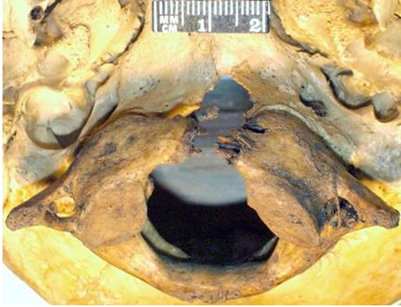
Figure 1. Entrance gunshot bullet injury of the 1st cervical vertebra and occipital bone, front view from below.
The nature and morphological properties of the fractures revealed the gunshot nature of the injuries (Fig. 1-3), and the following test findings were obtained: 1. by the contact diffusion method – on the fabric front side of the right, the left half of the jacket and on both corners of its collar (the outer layer of the corpse's clothing) were the areas with dust–like deposits of copper particles - the deposition of soot of a close shot. 2. by atomic emission spectral analysis - detection of increased copper, lead and tin content in the bone tissue edges and walls of the damaged bones fractures. In case of the contact diffusion method application, control contactograms of the front and back surfaces of the back side of the jacket were made; a fragment of the 7th cervical vertebra spinous process was used as a control sample when conducting an atomic emission spectral study.
The entrance firearm injury was practically irrelevant for the group identification of a firearm by the caliber and type.

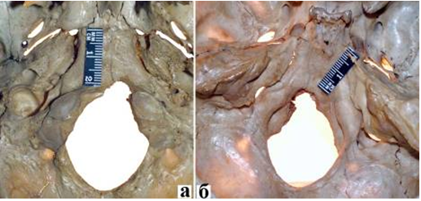
Figure 2. General view from the outer surface of the base of the skull (a) and its cavity (b) of the basilar part of the occipital bone with marginal entrance gunshot bullet injury.

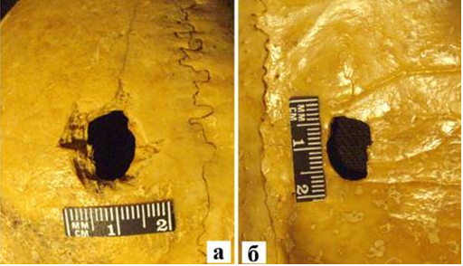
Figure 3. General view from the external (a) and internal (b) bone plates of the exit gunshot bullet perforated fracture of the left parietal bone

The exit gunshot injury was located in the left parietal bone, 66 mm from the intersection point of the coronal and sagittal sutures, and 11 mm from the apical part of the sagittal suture, represented by a perforated fracture with a bone defect of 12.79 x 10.5 mm.
This defect had a quadrangular shape, with a rounded rear end. Its edges on the side of the inner surface of the parietal bone were relatively smooth, without chipsing of the compact bone (Fig. 3b); on the side of the outer surface (Fig. 3a) – finely serrated, with pronounced chips of a compact bone up to 4 mm wide, which gave the entire injury an irregular funnel shape, expanding in the direction from inside to outside.
Perpendicular to the left, front and right segments of the defect edge, perforated linear cracks, extending to 29 mm, 25 mm and 11 mm were observed. The edges of these cracks had greater length and were relatively smooth, without chips of the compact layer. They were more clearly visualized on the outer bone plate.
The shape and dimensions of the perforated defect in the left parietal bone from the side of the inner bone plate (Fig. 4a) were visually similar to the lateral profile of the 9x18 PM cartridge shell bullet (Fig. 4b). The 9x18 PM cartridge shell bullet also has a certain visual and dimensional similarity with the 9x19Parabellum and 9x18 Ultra cartridge shell bullets (Fig. 6b).

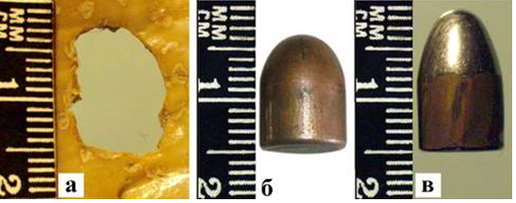
Figure 4. Detailed view from the side of the inner bone plate of a perforated defect in the left parietal bone (a); detailed views in the lateral profile of the 9x18 PM (b) and 9x19 Parabellum cartridge shell bullets (c).

E.N. Dmitriev and P.Yu. Ivanov indicated the possibility of comparative forensic examination by a superimposing method using digital photographic images [9]. The basis of the identification process in such a case is comparative investigation required both for analyzing the properties of each object, evaluating and comparing these properties. As noted by S.D. Kustanovich, a prerequisite for successful comparative study should be the same optical or photographic magnification with the equal intensity and light orientation of the compared objects.
The method of direct comparison involves the superposition (photographic, optical or natural) and combination of the compared objects, including the methods of comparing the estimated data — the comparison of the data on the findings, obtained by their separate visual assessment or measurements. There is no doubt that a direct comparison gives more accurate data and provides a higher evidence of the examination results [7].
Sometimes the caliber of the bullet which caused a perforated fracture of the skull, is determined by attempts to pass bullets of three close calibers through it: a bullet of a smaller caliber passes freely, a bullet of a larger caliber gets stuck, and a bullet of the same caliber that caused the injury passes through the hole with a slight pressure on it [1, 2].
This method is not recommended to be used in case of skeletal remains examination due to the risk of the defect edges contamination, which will cast doubts on the reliability of the investigation findings in case of shot metals detection by the contact diffusion and/or elemental analysis methods.
The comparative study by the method of superimposing (photo-placement) [7, 15] was carried out in accordance with the principles adopted in forensic examination [16, 17], and consisted of 4 stages.
At the first stage, standard bullets were selected from the ballistic collection - the 9x18 PM (Fig. 4b) and 9x19 Parabellum cartridges shell bullets (Fig. 4b).
At the second stage, digital photo images of the left parietal bone perforated fracture from the side of the inner bone plate (as the most fully preserved group properties of the traumatic object) and the 9x18 PM cartridge standard shell bullet from the side of the head and in the lateral profile were obtained from the same focal length and angle.
At the third and fourth stages, with the help of the graphic editor "Adope Photoshop 6.0", the images of the 9x18 PM cartridge standard shall bullet- from the side of the head and in the lateral profile were flipped into mirror images, which were subsequently superimposed on the image of a perforated fracture of the left parietal bone.
The following facts were discovered: 1. the largest lateral contours of the mirror-mapped 9x18 PM cartridge standard shell bullet were slightly smaller than the boundaries of the perforated fracture, which correspond to the dimensional characteristics of the traumatic object (Fig. 5a);
2. the contours of the lateral profile of the mirror-mapped 9x18 PM cartridge standard shell bullet almost completely corresponded to the boundaries of the perforated fracture, which correspond to the dimensional characteristics of the traumatic object. (Fig. 5b)

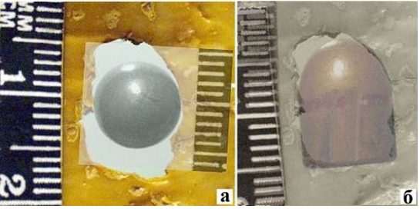

Figure 5. Determination of the caliber (a) and type (b) of a projectile (bullet) by overlay (photo-displacement) using the 9x18 PM cartridge standard shell bullet.
Stages from the 2nd to the 4th were repeated for the 9x19 Parabellum cartridge standard shell bullet (Fig. 6b). The largest lateral contours of the mirrored shell 9x19 Parabellum cartridge-bullet were slightly smaller than the boundaries of the perforated fracture, which reflected the dimensional characteristics of the traumatic object, but the contours of its lateral profile go beyond the boundaries of the perforated fracture (Fig. 6b).

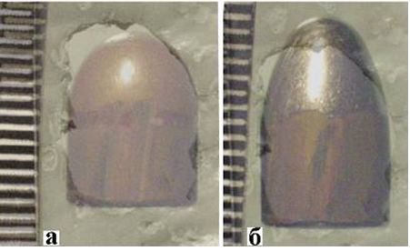
Figure 6. The comparative study findings by the superimposing method using the 9x18 PM (a) and 9x19 Parabellum (b) cartridge standard shell bullets
Thus, the morphometric characteristics of the exit injury, which reflected the shape and size of the firearm projectile, made it possible to successfully carry out group identification in order to determine the bullet caliber and type.
In the special literature, when considering the issues of gunshot bullet cranial vault bone fractures, the identification significance of the entrance injuries was mainly assessed [1-3, 8-14]. Morphological characteristics of the exit gunshot bullet fractures are generally used to establish the direction and number of shots.
The nature and localization of the entrance gunshot injury in the presented case permitted the experts only to approximately determine the caliber of the bullet, while the study of the exit gunshot injury allowed us to express our opinion not only about the possible caliber, but also about the type of bullet.
The described case from our practice has demonstrated the identification significance of the exit gunshot bullet perforated fracture in the flat bone of the skull, which should be taken into account in cases of combined through-penetrating gunshot bullet wounds of the neck and head ( or only the head), when the entrance bullet injuries of the cranial vault are either absent or not suitable for identification studies.
References
1. Molchanov V.I., Popov V.L., Kalmykov K.N. (1990) Ognestrel'nye povrezhdeniya i ih sudebno-medicinskaya ekspertiza: rukovodstvo dlya vrachej [Gunshot injuries and their forensic examination: a guide for physicians]. Leningrad: Medicina.
2. Popov V. L., Shigeev V.B., Kuznecov L. E. (2002) Sudebno-medicinskaya ballistika [Forensic ballistics]. St-Petersburg: Gippokrat.
3. Delannoy Y, Colard T, Le Garff E, Humez S, Gosset D, Hedouin V. (2016) The mechanism of the keyhole lesion reassessed: An experimental approach. J Forensic Leg Med. 37(1-7). https://doi.org/10.1016/j.jflm.2015.09.020
4. Marais A., Herman D. (2018) Utilization of X-ray Computed Tomography for the Exclusion of a Specific Caliber and Bullet Type in a Living Shooting Victim. // J. Forensic Sci., 64, 1556-4029. https://doi.org/10.1111/1556-4029.13805
5. Kryukov V. N. (1986) Mekhanika i morfologiya perelomov [Mechanics and morphology of fractures.]. Moscow: Medicina.
6. Kryukov V. N. (1995) Osnovy mekhano- i morfogeneza perelomov [Fundamentals of mechano- and morphogenesis of fractures]. Moscow: Folium.
7. Kustanovich S. D. (1975) Sudebno-medicinskaya trasologiya [Forensic traceology]. M.: Medicina.
8. Paschall A, Ross AH. (2017) Bone mineral density and wounding capacity of handguns: implications for estimation of caliber. Int J Legal Med., 131(1), 161-166. https://doi.org/10.1007/s00414-016-1420-6.
9. Shadymov A. B. (2000) Osobennosti sudebno-medicinskoj ekspertizy ognestrel'nyh pulevyh povrezhdenij mozgovogo cherepa [Features of forensic examination of cranial vault bullet injuries]. Sudebno-medicinskaya ekspertiza, 1, 14-19.
10. Dubrovin I. (2017) Sudebno-medicinskaya ocenka ognestrel'nyh perelomov ploskih kostej [Medico-legal evaluation of flat bones gunshot fractures]. LAP LAMBERT Academic Publishing RU.
11. DiMaio V.J.M. (2016) Gunshot Wounds. Practical Aspects of Firearms, Ballistics, and Forensic Techniques, 3d edition, CRC Press.
12. Wim K., Erwin M., Evelien Z., Oostra, R. (2020) Relationship between bullet diameter and bullet defect diameter in human calvariums. Int. J. Leg. Med., 134, 267-272. https://doi.org/10.1007/s00414-019-02197-9.
13. Berryman HE. (2019) A systematic approach to the interpretation of gunshot wound trauma to the cranium. Forensic Sci Int., 301, 306-317. https://doi.org/10.1016/j.forsciint.2019.05.019.
14. Leonov S.V., Mihajlenko A.V. (2014) Morfologicheskie priznaki ognestrel'nyh povrezhdenij ploskih kostej, pozvolyayushchie ustanovit' napravlenie vrashcheniya ognestrel'nogo snaryada [ Morphological features of gunshot injuries of flat bones allowing to establish the direction of rotation of a firearm], Medicinskaya ekspertiza i pravo, 1, 35–38
15. Tomilin V.V.(Ed.). (2000) Mediko-kriminalisticheskaya identifikaciya. Nastol'naya kniga sudebno-medicinskogo eksperta [Medical and Forensic Identification. The handbook of the forensic expert]. Moscow, Publishing group NORMA-INFRA.
16. Dmitriev E. I., Ivanov P. YU., Zudin S. I. (2000) Issledovanie ob"ektov kriminalisticheskih ekspertiz metodami cifrovoj obrabotki izobrazhenij: Uchebnoe posobie [Examination of forensic objects by methods of digital image processing: Textbook]. Moscow, GU EKC MVD Rossii.
17. Shashkin S.B., Vorob'ev S.A. (2000) Avtomatizaciya sravneniya metodom nalozheniya v tekhniko-kriminalisticheskoj ekspertize dokumentov [Automation of comparison by the superimposition method in forensic document examination]. Ekspertnaya praktika, 49, 22-30.

