Review Article

Holistic Perspective of the Impact of COVID-19 on Global Populations as Morbidity and Mortality: Are Humanities Ready to Face Future Pandemics?

Abstract
Currently, the spotlight is directing attention away from the recent Corona epidemic, but this should not pass without learning some important lessons. The pandemic continues to persist, with 662 million new cases by 2023. The arms race between nations has led to increased investment in bioweapons, highlighting human involvement. Despite advancements, humanity is ill-equipped to handle microbial epidemics, leading to a reevaluation of public health officials' safeguards. Current SARS-CoV-2 deaths are low, but some other viral diseases have high fatality rates. The WHO database provides a comprehensive view of COVID-19 cases and fatalities, enabling public health measures to be implemented globally according to a recent review until 2023. Major affected nations in terms of total morbidities and mortalities include the USA, India, France, Germany, Brazil, Japan, Russia, Turkey, Spain, Viet Nam, Australia, China, Argentina, Mexico, Indonesia, Poland, Colombia, Austria, Portugal, Greece, Ukraine, Chile, and Malaysia. The coronavirus seems to affect developed countries more than developing ones, but efficiency in case collection affects the credibility of the overall data interpretation. Despite progress, much must be done to combat the milder disease. Modeling disease spread helps understand community characteristics, aiding public health authorities in management and control measures. Collaboration and quantitative risk index projections are crucial for pandemic prevention and control.
Keywords: COVID-19, Morbidity, Mortality, Public Health, Pandemic, Modeling

Introduction
Importance of Projection for the Impact of COVID-19 on Human Health Globally
Despite the fact that the world has been watching the most recent horrific conflicts and catastrophes around the globe, particularly given the disastrous fallout that has negatively impacted the economies of nearly every nation on the planet^{1,2}. The media's preoccupation with the ongoing military and political conflicts, arms competition and the following economic distresses distracted them from covering the most recent updates about the coronavirus outbreak and its associated tragedies at all levels, including political and economic.By focusing on a holistic view, the realistic impact of the outbreak on human communities and countries could be understood and prediction of future catastrophic events could be made.
Humanity mightdeviate from sight of the reality that, despite widespread evidence of significant scientific and technological advancements, the world is still ill-equipped to handle microbial epidemics³. It is impossible to completely rule out the possibility of further deadly virus outbreaks in the future;thus, public health officials have to reevaluate their safeguards and readiness. When expressed as a daily mortality/morbidity percent of the infected population, the reported deaths from the severe acute respiratory syndrome coronavirus 2 (SARS-CoV-2) are very low, ranging from less than 5% to less than 2% in the current outbreak (if compared with other more dangerous viruses that might reach 50% to 80% lethality rates)^{4,5}. Fruit bats (Rousettusaegyptiacus) are a natural host of Marburg viral disease (MVD), an example of the latter with high case fatality rates.
To implement public health measures for the pandemic within the community, the chance to view the daily cases and fatalities recorded in the complete database of COVID-19 was therefore taken advantage of⁶. Data processing was carried out by calculating daily records throughout the WHO regions and countries subcategories, which will shed light on the holistic picture of the pandemic around the world till the beginning of the year 2023⁷. In the same vein, previous studies focused on cumulative datasets that provided different perspectivesfor pandemic data analysis¹⁻⁸. Figure 1 shows the distribution of disease severity based on the countries within the WHO categories.
Distribution and Pattern of the Recent Global COVID-19 Pandemic and What is behind It
Major affected nations—as total morbidities and mortalities—were shown, starting with the USA, followed by India, then France, Germany, Brazil, Japan, the Republic of Korea, Italy, Great Britain, the Russian Federation, Turkey, Spain, Viet Nam, Australia, China, Argentina, the Netherlands, the Islamic Republic of Iran, Mexico, Indonesia, Poland, Colombia, Austria, Portugal, Greece, Ukraine, Chile, and Malaysia. The European (EURO) and American (AMRO) regions contributed more than 65% of the total casualties^{6,8}. The comprehensive contribution, as illustrated in Figure 2, showed that the major affected countries were from the northern hemisphere of Western nations. Also, the number of affected populations increased every year from 2020 to 2022 globally.
The overall picture shows that the pandemic waves would not subside swiftly, and the virus finds its way to last for longer periods with variable symptoms, with the total sum of new emerging cases reaching a census of 662 million of the global population by the beginning of the year 2023⁹⁻¹¹. The arms race between the leading nations in military advancement has stimulated investment in the application of bioweapons with genetically modified virulent microbes as a source of weapons of mass destruction and devastation of life¹²⁻¹⁷. Thus, the role of human involvement in such incidents cannot be ruled out.
The COVID-19 pandemic has had a profound impact on global populations, both in terms of morbidity and mortality^{18,19}. As the virus continues to spread, it has become increasingly clear that humanity is ill-prepared to face such a devastating global health crisis. In order to effectively combat future pandemics, a holistic perspective is needed to address the various factors that contribute to their spread and severity²⁰.One important lesson that must be learned from the COVID-19 pandemic is the need for increased investment in public health infrastructure²¹⁻²⁵. This calls for a reevaluation of the safeguards put in place by public health officials, as well as a commitment to strengthening global health systems.
While the current fatality rate of SARS-CoV-2, the virus that causes COVID-19, is relatively low, other viral diseases have much higher fatality rates²⁶⁻²⁹. Therefore, it is crucial to take a comprehensive view of COVID-19 cases and fatalities in order to implement effective public health measures³⁰⁻³³. The World Health Organization's database provides valuable data that can be used to inform global pandemic response strategies.
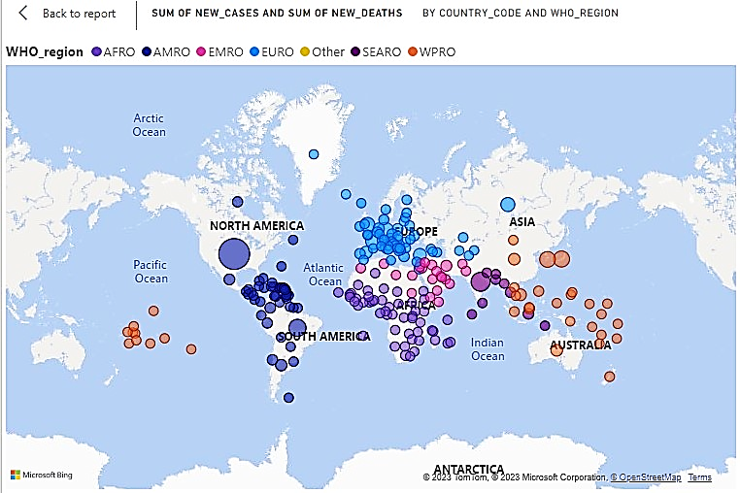
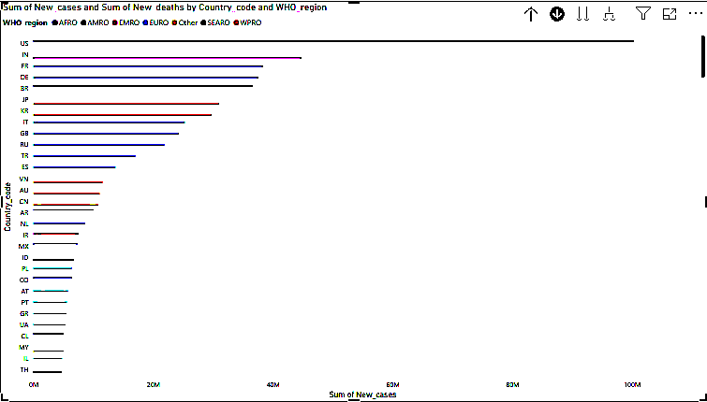
Figure 1: Sum of emerging cases and deaths globally by country and WHO regions
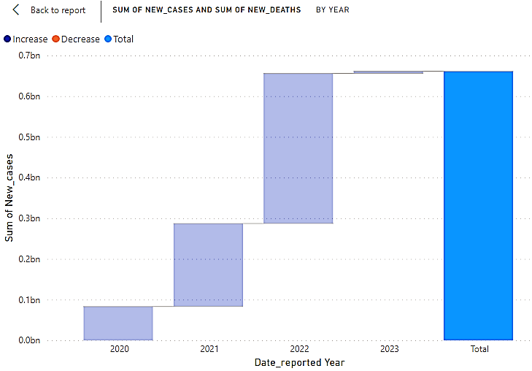
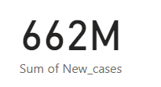
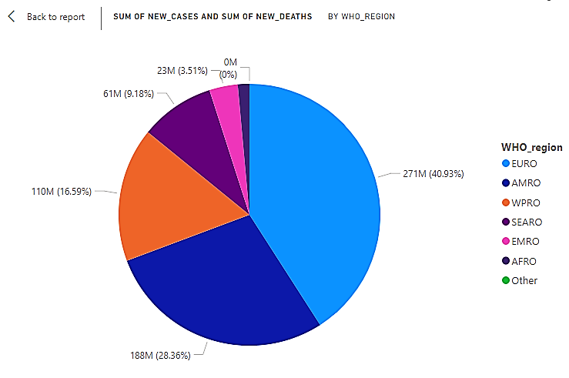
Figure 2: Contributions to total cases and deaths by time and WHO regions
Understanding Impact of COVID-19: A Drive for Preparedness for Future Catastrophes
In order to combat the spread of COVID-19 and future pandemics, it is crucial to understand how diseases spread within communities³⁴⁻³⁷. Tracking disease spread can provide valuable insights into community characteristics, which can then be used to inform public health authorities on management and control measures^{38,39}. Collaboration between countries and the use of quantitative risk index projections are essential for effective pandemic prevention and control^{40,41}. The consequences of the recent outbreak of coronavirus disease in 2019 on human populations can be psychosocial due to the mental health implications of increased stress, anxiety and depression⁴²⁻⁴⁴. Also, social isolation and loneliness affect well-beingand resilience⁴⁵⁻⁴⁷. Needless to say, under stressful situations of epidemics, stigmatization and discrimination would impact psychological health and access to healthcare facilities.
The economic impact of COVID-19 cannot be underestimated⁴⁸. For instance, consideration of unemployment and poverty would be challenging in accessing healthcare and essential resource⁴⁹. Moreover, disruption of supply chains with implications for food security and access to medications should also be borne in mind⁵⁰⁻⁵². Another aspect that should be emphasized is economic inequality and the associated exacerbation of existing disparities and social determinants of health⁵³⁻⁵⁵. Although the available information shows that developed countries are more affected by the coronavirus than developing countries in terms of the number of cases and deaths, the difference in the efficiency of the system of collecting cases by official authorities plays a major role in the credibility of the recorded information, yet socioeconomic, demographic and global health infrastructure factors cannot be ruled out⁵⁶⁻⁵⁹. They include a complex combination of community variables embracing:1-Disparities in access to healthcare, poverty, education level.2-Age, gender, pre-existing health conditions. 3-The capacity of healthcare systems and availability of resources, respectively.
Epidemicsand Modeling forEffects of Diseases on Communities
Modeling of the disease has helped in understanding the characteristics of the disease spreading through the community, and the theoretical aspects of the dissemination process should support the public health authorities in a holistic understanding of the management and control measures needed to mitigate the risk of the epidemic effect on the community and the consequent outcomes for the countries⁶⁰⁻⁶¹. This would be predisposing for the projection of a quantitative risk index to identify and control the influential factors that contribute to the persistence of the disease⁶³. In the end, national and international collaboration in the face of pandemics would be indispensable to save humanity during the time of catastrophic events to protect future generations and keep their rights to a safe and healthy life.
However, it cannot be underestimated that although many studies have been done regarding this epidemic, on the ground it cannot be ignored that despite the amazing progress that humanity has achieved in all areas of life, there is still much that must be done to establish effective foundations to confront epidemics practically, especially the much more dangerous types, taking into consideration that this disease is considered much milder than many others that have struck humanity before. This signals an alarm that should not be passed unnoticed; otherwise, the hard lessons that have been delivered by the latest pandemic will be wasted.
Conclusion
In conclusion, the COVID-19 pandemic has highlighted the need for a holistic perspective when assessing the impact of infectious diseases on global populations. The ongoing pandemic and the potential for future pandemics underscore the importance of investing in public health infrastructure and reevaluating current safeguards. The long-term psychological impact of the pandemic on human health might affect directly or indirectly the political and decision-making elites, with the consequent actions not affecting national states but spreading internationally to impact other countries with uncalculated effects. By taking a comprehensive approach to pandemic prevention and control, humanity can better prepare itself to face the challenges of more hazardous infectious diseases and fatal epidemic incidents.
Conflict of Interest
None to declare.
References
- Eissa ME, Rashed ER. Analysis and modeling of morbidity and mortality from coronavirus outbreak in Brazil: A case study of public health challenge using unique statistical tools. Journal of Health Science Research. 2023;8(2):57-61.https://doi.10.25259/JHSR_3_2023
- Eissa DE, Rashed ER, Eissa ME. A Study of Morbidity and Mortality from COVID-19 in India. SciMedicine Journal. 2022;4(1):25-38.https://doi.10.28991/SciMedJ-2022-0401-03
- Eissa ME. COVID-19 KINETICS BASED ON REPORTED DAILY INCIDENCE IN HIGHLY DEVASTATED GEOGRAPHICAL REGION: A UNIQUE ANALYSIS APPROACH OF EPIDEMIC. UJPR. 2022;7(6):58-62.https://doi.org/10.22270/ujpr.v7i6.870
- Eissa ME. Studies on Morbidities and Mortalities from COVID-19: Novel Public Health Practice During Pandemic Periods. Asian Journal of Applied Sciences. 2023;16(3):84-94.https://doi.10.3923/ajaps.2023.84.94
- Sibomana O, Kubwimana E. First‐ever Marburg virus disease outbreak in Equatorial Guinea and Tanzania: An imminent crisis in West and East Africa. Immunity, Inflammation and Disease. 2023 Aug;11(8):e980.https://doi.10.1002/iid3.980
- Eissa ME, Rashed ER, Eissa DE. Implementation of the Pareto principle in focus group generation based on global coronavirus disease morbidity and mortality rates. Highlights in BioScience. 2022;5.https://doi.10.36462/H.BioSci.202204
- EİSSA M. Descriptive epidemiological study of coronavirus disease distribution in specific geographic location: Unique public health practice in outbreak analysis. Turkish Journal of Public Health. 2023;21(1):144-51.https://doi.org/10.20518/tjph.1112614
- EİSSA D, RASHED E, EİSSA M. Measuring Public Health Effect of Coronavirus Disease 2019: A Novel Perspective in Healthcare in Pandemic Times. BatıKaradeniz Tıp Dergisi. 2023;7(2):266-8.https://doi.org/10.29058/mjwbs.1257163
- Telenti A, Arvin A, Corey L, Corti D, Diamond MS, García-Sastre A, Garry RF, Holmes EC, Pang PS, Virgin HW. After the pandemic: perspectives on the future trajectory of COVID-19. Nature. 2021;596(7873):495-504.https://doi.org/10.1038/s41586-021-03792-w
- Iftimie S, López-Azcona AF, Vallverdú I, Hernández-Flix S, de Febrer G, Parra S, Hernández-Aguilera A, Riu F, Joven J, Andreychuk N, Baiges-Gaya G. First and second waves of coronavirus disease-19: A comparative study in hospitalized patients in Reus, Spain. PloS one. 2021;16(3):e0248029.https://doi.org/10.1371/journal.pone.0248029
- Poongodi M, Malviya M, Hamdi M, Rauf HT, Kadry S, Thinnukool O. The recent technologies to curb the second-wave of COVID-19 pandemic. Ieee Access. 2021;9:97906-28.https://doi.org/10.3390/jcm10245799
- Rose S. The coming explosion of silent weapons. Naval War College Review. 1989 Jul 1;42(3):6-29.
- National Research Council. Globalization, biosecurity, and the future of the life sciences. National Academies Press; 2006 Jul 7.
- Clark DP, Pazdernik NJ. Biological warfare: infectious disease and bioterrorism. Biotechnology. 2016:687.
- Bera RK. COVID-19 Catalyzed Disruptions to Life and Livelihood. Available at SSRN 3935942. 2021 Oct 4.
- Lentzos F, Goodman MS, Wilson JM. Health security intelligence: engaging across disciplines and sectors. Intelligence and National Security. 2020;35(4):465-76.https://doi.org/10.1080/02684527.2020.1750166
- Dando M. The Chemical and Biological Nonproliferation Regime after the Covid-19 Pandemic: Dealing with the Scientific Revolution in the Life Sciences. Springer Nature; 2023 Feb 21.
- Banerjee A, Pasea L, Harris S, Gonzalez-Izquierdo A, Torralbo A, Shallcross L, Noursadeghi M, Pillay D, Sebire N, Holmes C, Pagel C. Estimating excess 1-year mortality associated with the COVID-19 pandemic according to underlying conditions and age: a population-based cohort study. The Lancet. 2020;395(10238):1715-25.https://doi.org/10.1016/S0140-6736(20)30854-0
- Aburto JM, Schöley J, Kashnitsky I, Zhang L, Rahal C, Missov TI, Mills MC, Dowd JB, Kashyap R. Quantifying impacts of the COVID-19 pandemic through life-expectancy losses: a population-level study of 29 countries. International journal of epidemiology. 2022 Feb 1;51(1):63-74.https://doi.org/10.1093/ije/dyab207
- Eissa M, Rashed E. Descriptive Analysis of Coronavirus Disease Cases Based on Geographical Distribution in Canadian Provinces/Territories: Statistical Investigation into Epidemiological Pattern. Academia Letters. 2022:2.https://doi.org/10.20935/AL5191
- Timmis K, Brüssow H. The COVID‐19 pandemic: some lessons learned about crisis preparedness and management, and the need for international benchmarking to reduce deficits. Environmental microbiology. 2020;22(6):1986.https://doi.10.1111/1462-2920.15029
- Ippolito G, Lauria FN, Locatelli F, Magrini N, Montaldo C, Sadun R, Maeurer M, Strada G, Vairo F, Curiale S, Lafont A. Lessons from the COVID-19 pandemic—Unique opportunities for unifying, revamping and reshaping epidemic preparedness of Europe’s public health systems. International Journal of Infectious Diseases. 2020;101:361-6.https://doi.org/10.1016/j.ijid.2020.10.094
- Garg S, Bhatnagar N, Singh MM, Borle A, Raina SK, Kumar R, Galwankar S. Strengthening public healthcare systems in India; Learning lessons in COVID-19 pandemic. Journal of Family Medicine and Primary Care. 2020;9(12):5853.http://doi.10.4103/jfmpc.jfmpc_1187_20
- Craven M, Sabow A, Van der Veken L, Wilson M. Not the last pandemic: Investing now to reimagine public-health systems. McKinsey Report. 2020 Jul. http://efaidnbmnnnibpcajpcglclefindmkaj/https://www.mckinsey.com/~/media/McKinsey/Industries/Public%20and%20Social%20Sector/Our%20Insights/Not%20the%20last%20pandemic%20Investing%20now%20to%20reimagine%20public%20health%20systems/Not-the-last-pandemic-Investing-now-to-reimagine-public-health-systems-F.pdf
- Haldane V, De Foo C, Abdalla SM, Jung AS, Tan M, Wu S, Chua A, Verma M, Shrestha P, Singh S, Perez T. Health systems resilience in managing the COVID-19 pandemic: lessons from 28 countries. Nature Medicine. 2021;27(6):964-80.https://doi.org/10.1038/s41591-021-01381-y
- Petersen E, Koopmans M, Go U, Hamer DH, Petrosillo N, Castelli F, Storgaard M, Al Khalili S, Simonsen L. Comparing SARS-CoV-2 with SARS-CoV and influenza pandemics. The Lancet infectious diseases. 2020;20(9):e238-44.https://doi.org/10.1016/S1473-3099(20)30484-9
- Khafaie MA, Rahim F. Cross-country comparison of case fatality rates of COVID-19/SARS-COV-2. Osong public health and research perspectives. 2020 Apr;11(2):74. http://doi. 10.24171/j.phrp.2020.11.2.03
- Rabi FA, Al Zoubi MS, Kasasbeh GA, Salameh DM, Al-Nasser AD. SARS-CoV-2 and coronavirus disease 2019: what we know so far. Pathogens. 2020;9(3):231.https://doi.org/10.3390/pathogens9030231
- Toyoshima Y, Nemoto K, Matsumoto S, Nakamura Y, Kiyotani K. SARS-CoV-2 genomic variations associated with mortality rate of COVID-19. Journal of human genetics. 2020;65(12):1075-82.https://doi.org/10.1038/s10038-020-0808-9
- Talic S, Shah S, Wild H, Gasevic D, Maharaj A, Ademi Z, Li X, Xu W, Mesa-Eguiagaray I, Rostron J, Theodoratou E. Effectiveness of public health measures in reducing the incidence of covid-19, SARS-CoV-2 transmission, and covid-19 mortality: systematic review and meta-analysis. bmj. 2021;375.https://doi.org/10.1136/bmj-2021-068302
- Hao W, Shah SM, Nawazb A, Barkat MQ, Souhail A. COVID-19 epidemic spread and the impact on public health & safety policy: an analysis of the adoption of preventive measures and effective management: evidence from Pakistan. Revista Argentina de ClínicaPsicológica. 2020;29(4):722-36. http://doi. 10.24205/03276716.2020.877
- Ayouni I, Maatoug J, Dhouib W, Zammit N, Fredj SB, Ghammam R, Ghannem H. Effective public health measures to mitigate the spread of COVID-19: a systematic review. BMC public health. 2021;21(1):1-4.https://doi.org/10.1186/s12889-021-11111-1
- De Foo C, Verma M, Tan SM, Haldane V, Reyes KA, Garcia F, Canila C, Orano J, Ballesteros AJ, Marthias T, Mahendradhata Y. COVID-19 public health and social measures: a comprehensive picture of six Asian countries. BMJ global health. 2022;7(11):e009863.http://dx.doi.org/10.1136/bmjgh-2022-009863
- Qian X, Ren R, Wang Y, Guo Y, Fang J, Wu ZD, Liu PL, Han TR, Members of Steering Committee, Society of Global Health, Chinese Preventive Medicine Association. Fighting against the common enemy of COVID-19: a practice of building a community with a shared future for mankind. Infectious Diseases of Poverty. 2020;9(02):8-13.
- Van Damme W, Dahake R, Delamou A, Ingelbeen B, Wouters E, Vanham G, Van De Pas R, Dossou JP, Ir P, Abimbola S, Van der Borght S. The COVID-19 pandemic: diverse contexts; different epidemics—how and why?. BMJ global health. 2020;5(7):e003098. http:// doi:10.1136/bmjgh-2020-003098
- Coccia M. Factors determining the diffusion of COVID-19 and suggested strategy to prevent future accelerated viral infectivity similar to COVID. Science of the Total Environment. 2020;729:138474.https://doi.org/10.1016/j.scitotenv.2020.138474
- Roche B, Garchitorena A, Guégan JF, Arnal A, Roiz D, Morand S, Zambrana‐Torrelio C, Suzán G, Daszak P. Was the COVID‐19 pandemic avoidable? A call for a “solution‐oriented” approach in pathogen evolutionary ecology to prevent future outbreaks. Ecology Letters. 2020 Nov;23(11):1557-60. https://doi.org/10.1111/ele.13586
- Ding C, Liu X, Yang S. The value of infectious disease modeling and trend assessment: a public health perspective. Expert Review of Anti-infective Therapy. 2021;19(9):1135-45.https://doi.org/10.1080/14787210.2021.1882850
- Boon-Itt S, Skunkan Y. Public perception of the COVID-19 pandemic on Twitter: sentiment analysis and topic modeling study. JMIR Public Health and Surveillance. 2020 Nov 11;6(4):e21978. http:://doi:10.2196/21978
- Chowdhury R, Heng K, Shawon MS, Goh G, Okonofua D, Ochoa-Rosales C, Gonzalez-Jaramillo V, Bhuiya A, Reidpath D, Prathapan S, Shahzad S. Dynamic interventions to control COVID-19 pandemic: a multivariate prediction modelling study comparing 16 worldwide countries. European journal of epidemiology. 2020;35:389-99.https://doi.org/10.1007/s10654-020-00649-w
- Zhou C, Su F, Pei T, Zhang A, Du Y, Luo B, Cao Z, Wang J, Yuan W, Zhu Y, Song C. COVID-19: challenges to GIS with big data. Geography and sustainability. 2020;1(1):77-87.https://doi.org/10.1016/j.geosus.2020.03.005
- Stankovska G, Memedi I, Dimitrovski D. Coronavirus COVID-19 disease, mental health and psychosocial support. Society Register. 2020;4(2):33-48.http://doi.10.14746/sr.2020.4.2.03
- Shah SM, Mohammad D, Qureshi MF, Abbas MZ, Aleem S. Prevalence, psychological responses and associated correlates of depression, anxiety and stress in a global population, during the coronavirus disease (COVID-19) pandemic. Community mental health journal. 2021;57:101-10.https://doi.org/10.1007/s10597-020-00728-y
- Dubey S, Biswas P, Ghosh R, Chatterjee S, Dubey MJ, Chatterjee S, Lahiri D, Lavie CJ. Psychosocial impact of COVID-19. Diabetes & Metabolic Syndrome: clinical research & reviews. 2020 Sep 1;14(5):779-88.https://doi.org/10.1016/j.dsx.2020.05.035
- Duyndam J, Pruchno RA. Social isolation and resilience. Innovation in Aging. 2018 Nov;2(suppl_1):25-.https://doi.org/10.1093/geroni/igy023.092
- Shah SS, Memon FA, Qureshi F, Soomro AB, Kemal AA, Shah AA. Mental well-being during COVID-19 pandemic: the role of fear, social isolation and psychological resilience. Cogent Psychology. 2022;9(1):2006993.https://doi.org/10.1080/23311908.2021.2006993
- Sánchez-Teruel D, Robles-Bello MA, Sarhani-Robles M, Sarhani-Robles A. Exploring resilience and well-being of family caregivers of people with dementia exposed to mandatory social isolation by COVID-19. Dementia. 2022;21(2):410-25.https://doi.org/10.1177/14713012211042187
- Khan A, Khan N, Shafiq M. The economic impact of COVID-19 from a global perspective. Contemporary Economics. 2021 Feb 3:64-75.
- Panneer S, Kantamaneni K, Palaniswamy U, Bhat L, Pushparaj RR, Nayar KR, Soundari Manuel H, Flower FL, Rice L. Health, economic and social development challenges of the COVID-19 pandemic: strategies for multiple and interconnected issues. InHealthcare 2022 Apr 21 (Vol. 10, No. 5, p. 770). MDPI.https://doi.org/10.3390/healthcare1005077
- Aday S, Aday MS. Impact of COVID-19 on the food supply chain. Food Quality and Safety. 2020;4(4):167-80.https://doi.org/10.1093/fqsafe/fyaa024
- Grandin T. Methods to prevent future severe animal welfare problems caused by COVID-19 in the pork industry. Animals. 2021;11(3):830.https://doi.org/10.3390/ani11030830
- Bogdanova E, Andronov S, Asztalos Morell I, Hossain K, Raheem D, Filant P, Lobanov A. Food sovereignty of the indigenous peoples in the Arctic zone of Western Siberia: response to COVID-19 pandemic. International journal of environmental research and public health. 2020 Feb;17(20):7570.https://doi.org/10.3390/ijerph17207570
- Bambra C, Riordan R, Ford J, Matthews F. The COVID-19 pandemic and health inequalities. J Epidemiol Community Health. 2020 Nov 1;74(11):964-8.http://dx.doi.org/10.1136/jech-2020-214401
- Green H, Fernandez R, MacPhail C. The social determinants of health and health outcomes among adults during the COVID‐19 pandemic: A systematic review. Public Health Nursing. 2021;38(6):942-52. https://doi.org/10.1111/phn.12959
- Abrams EM, Greenhawt M, Shaker M, Pinto AD, Sinha I, Singer A. The COVID-19 pandemic: adverse effects on the social determinants of health in children and families. Annals of Allergy, Asthma & Immunology. 2022;128(1):19-25.https://doi.org/10.1016/j.anai.2021.10.022
- Ahadu E. Novel corona virus Covid-19: Impact on economic development and mitigating solution for developing countries. Journal of Humanities and Social Sciences. 2020;8(3):86-91.http://doi.10.11648/j.hss.20200803.11
- World Health Organization. Analysing and using routine data to monitor the effects of COVID-19 on essential health services: practical guide for national and subnational decision-makers: interim guidance, 14 January 2021. World Health Organization; 2021.https://iris.who.int/bitstream/handle/10665/338689/WHO-2019-nCoV-essential_health_ services-monitoring-2021.1-eng.pdf
- Xavier DR, e Silva EL, Lara FA, e Silva GR, Oliveira MF, Gurgel H, Barcellos C. Involvement of political and socio-economic factors in the spatial and temporal dynamics of COVID-19 outcomes in Brazil: A population-based study. The Lancet Regional Health–Americas. 2022 Jun 1;10.https://doi.org/10.1016/j.lana.2022.100221
- Sharifi A, Khavarian-Garmsir AR. The COVID-19 pandemic: Impacts on cities and major lessons for urban planning, design, and management. Science of the total environment. 2020 Dec 20;749:142391.https://doi.org/10.1016/j.scitotenv.2020.142391
- Funk S, Salathé M, Jansen VA. Modelling the influence of human behaviour on the spread of infectious diseases: a review. Journal of the Royal Society Interface. 2010 Sep 6;7(50):1247-56.https://doi.org/10.1098/rsif.2010.0142
- Becker AD, Grantz KH, Hegde ST, Bérubé S, Cummings DA, Wesolowski A. Development and dissemination of infectious disease dynamic transmission models during the COVID-19 pandemic: what can we learn from other pathogens and how can we move forward?. The Lancet Digital Health. 2021;3(1):e41-50.https://doi.org/10.1016/S2589-7500(20)30268-5
- Cooper I, Mondal A, Antonopoulos CG. A SIR model assumption for the spread of COVID-19 in different communities. Chaos, Solitons & Fractals. 2020 Oct 1;139:110057.https://doi.org/10.1016/j.chaos.2020.110057
- Chan TC, Chou CC, Chu YC, Tang JH, Chen LC, Lin HH, Chen KJ, Chen RC. Effectiveness of controlling COVID-19 epidemic by implementing soft lockdown policy and extensive community screening in Taiwan. Scientific Reports. 2022 Jul 14;12(1):12053.https://doi.org/10.1038/s41598-022-16011-x

